ASSIGNMENT 15.2

1. Install Hive and set up necessary environment variables especially HIVE_HOME

2. Configure MySQL as the metastore for Hive by following the instructions in this blog http://syed-rizvi.blogspot.in/2016/02/mysql-configuration-as-hive-metastore-db.html

3. Start up hadoop using the command:
start-all.sh

And verify that all hadoop daemons are running using the command
jps

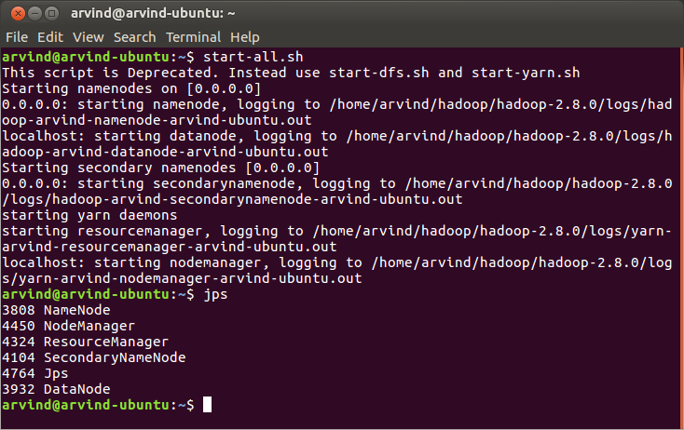
4. Make a new directory in HDFS using the command:
hadoop fs -mkdir -p /user/arvind/hive/acadgild/assignments/assignment_15.2/input

And verify using:
hadoop fs -ls -R /user/arvind/hive

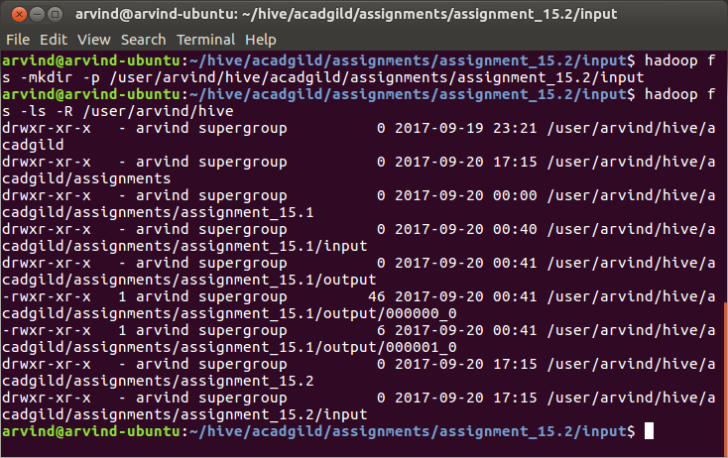

5. Upload input.csv to HDFS using:
hadoop fs -put ~/hive/acadgild/assignments/assignment_15.2/input/input.csv /user/arvind/hive/acadgild/assignments/assignment_15.2/input/input.csv

And verify using:
hadoop fs -ls /user/arvind/hive/acadgild/assignments/assignment_15.2/input/

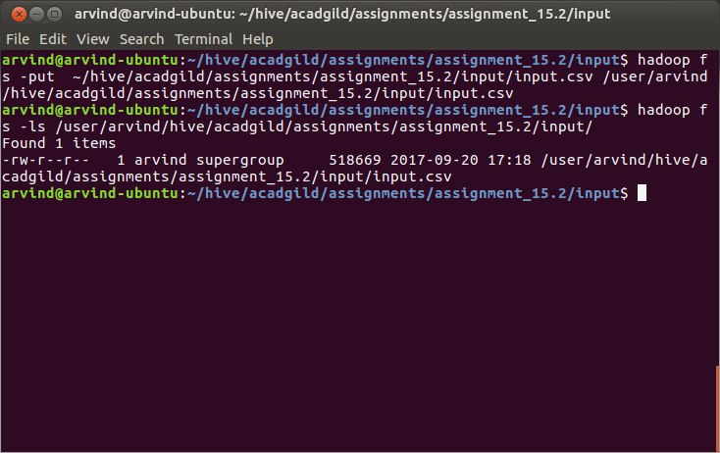
6. Navigate to the sources directory of the assignment using:
cd ~/hive/acadgild/assignments/assignment_15.1/sources/

7. Run assignment_15.2.hql as:
hive -f assignment_15.2.hql

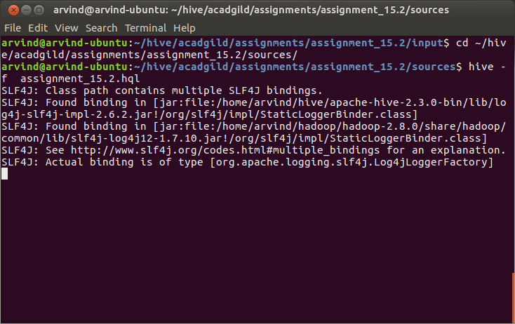

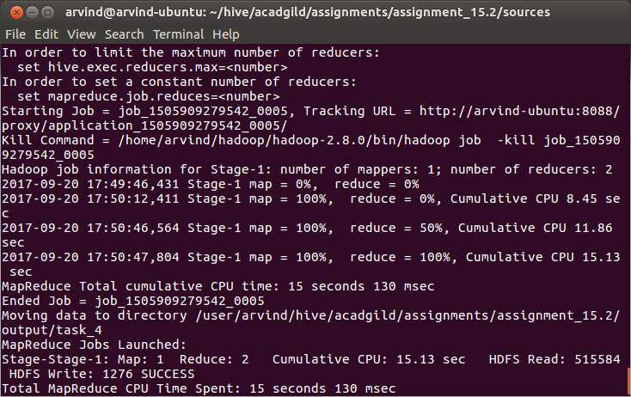
8. After successful execution of the hql script, check the contents of the /user/hive/warehouse directory in HDFS using either the hadoop fs -ls command or using the web UI hosted at port 50070. Check that assignment_15_2.db is one of the directories

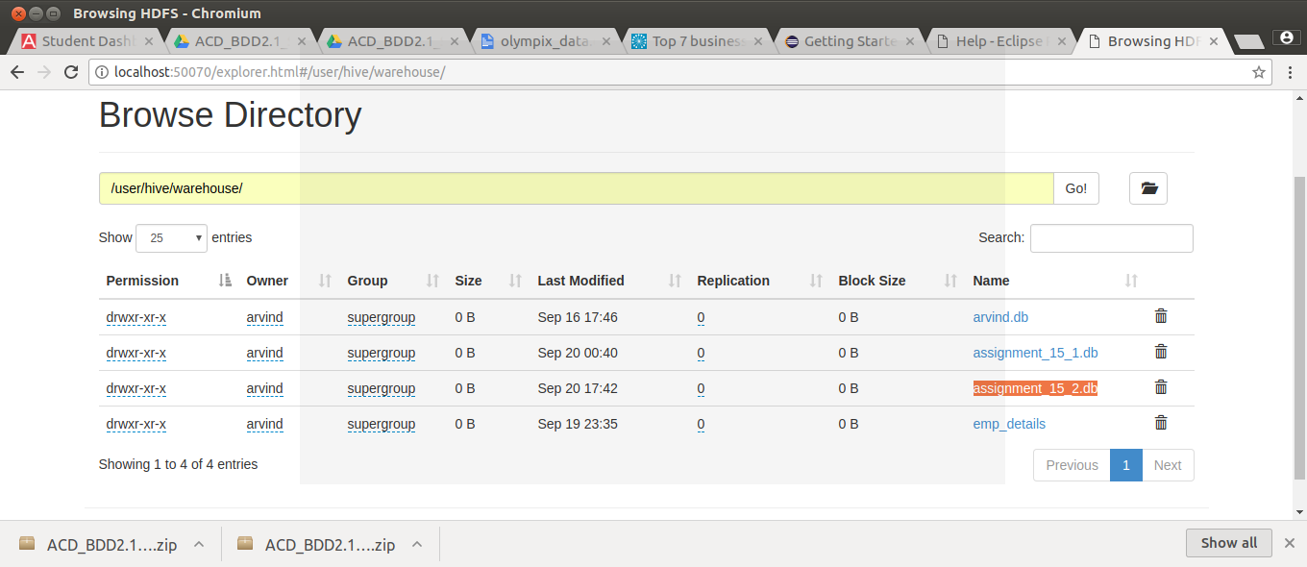
9. Navigate into the directory. You should be able to see one directory named olympics_data_partitioned

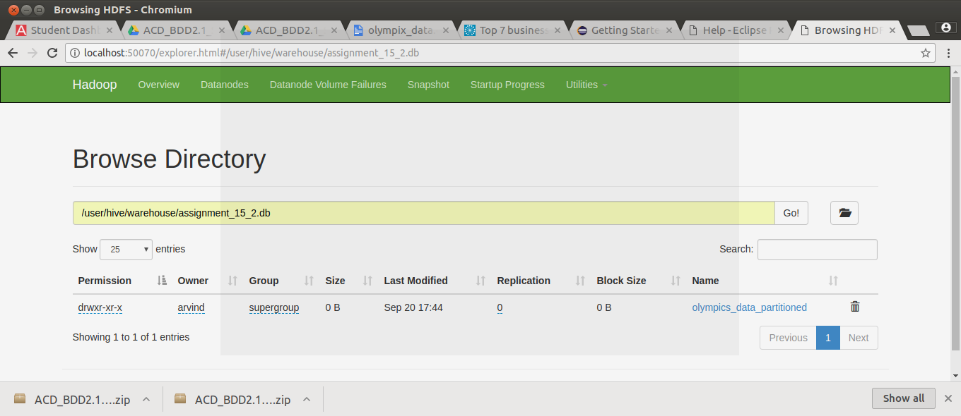

10. Navigate into the olympics_data_partitioned directory. You hsould be able to see one directory (one partition) created for each country

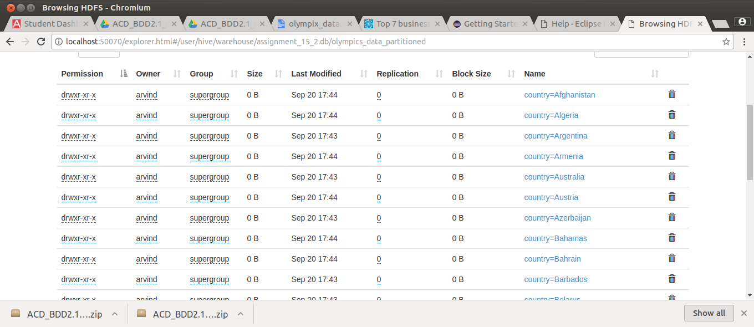

11. Navigate to the output folder of the assignment /user/arvind/hive/acadgild/assignments/assignment_15.2/output in the HDFS browser. You should be able to see 4 directories which are the output for the four tasks in the assignment

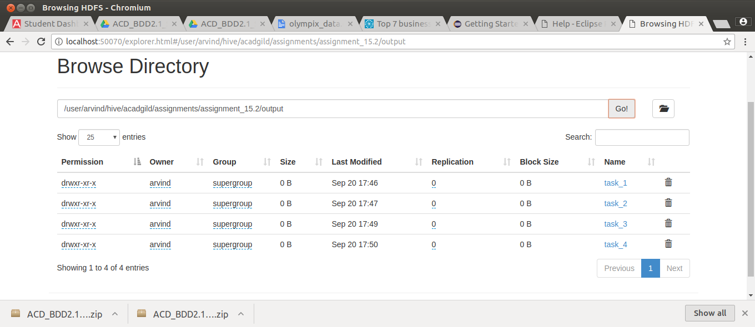

12. List out the contents of the files using the commands:
hadoop fs -cat /user/arvind/hive/acadgild/assignments/assignment_15.2/output/task_1/*
hadoop fs -cat /user/arvind/hive/acadgild/assignments/assignment_15.2/output/task_2/*
hadoop fs -cat /user/arvind/hive/acadgild/assignments/assignment_15.2/output/task_3/*
hadoop fs -cat /user/arvind/hive/acadgild/assignments/assignment_15.2/output/task_4/*

