ASSIGNMENT 16.1

I have divide this assignment into 2 tasks:
Task 1
Get a list of employees who receive a salary less than 100, compared
to their immediate employee with higher salary in the same unit

Task 2
List of all employees who draw higher salary than the average salary
of that department

1. Install Hive and set up necessary environment variables especially HIVE_HOME

2. Configure MySQL as the metastore for Hive by following the instructions in this blog http://syed-rizvi.blogspot.in/2016/02/mysql-configuration-as-hive-metastore-db.html

3. Start up hadoop using the command:
start-all.sh

And verify that all hadoop daemons are running using the command
jps

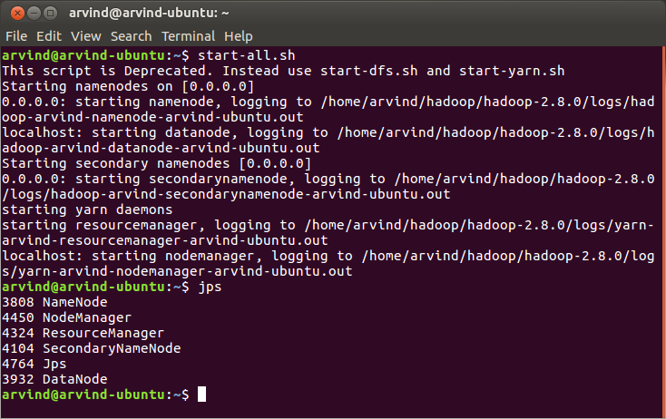

4. Make a new directory in HDFS using the command:
hadoop fs -mkdir -p /user/arvind/hive/acadgild/assignments/assignment_16.1/input

And verify using:
hadoop fs -ls /user/arvind/hive/acadgild/assignments/assignment_16.1
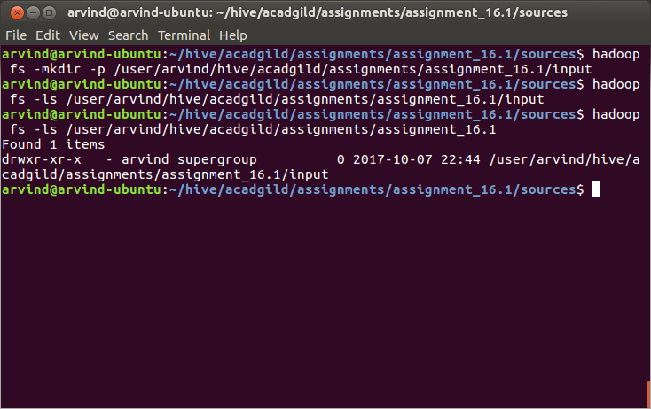

5. Upload Emp_Sal.txt to HDFS using:
hadoop fs -put ~/hive/acadgild/assignments/assignment_16.1/input/Emp_Sal.txt /user/arvind/hive/acadgild/assignments/assignment_16.1/input/Emp_Sal.txt

And verify using:
hadoop fs -ls /user/arvind/hive/acadgild/assignments/assignment_16.1/input/

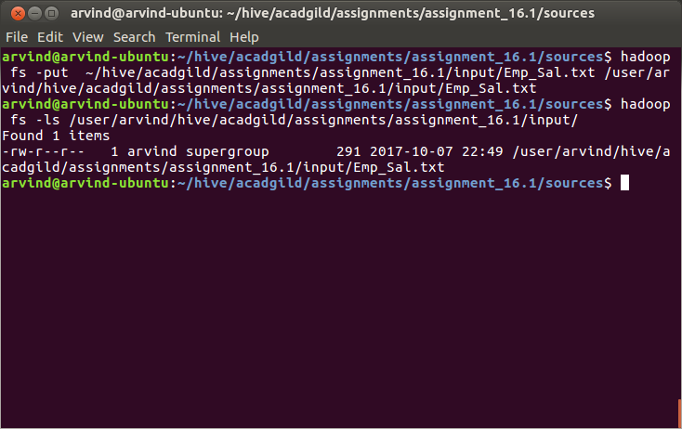

6. Navigate to the sources directory of the assignment using:
cd ~/hive/acadgild/assignments/assignment_16.1/sources/

7. Run assignment_16.1.hql as:
hive -f assignment_16.1.hql

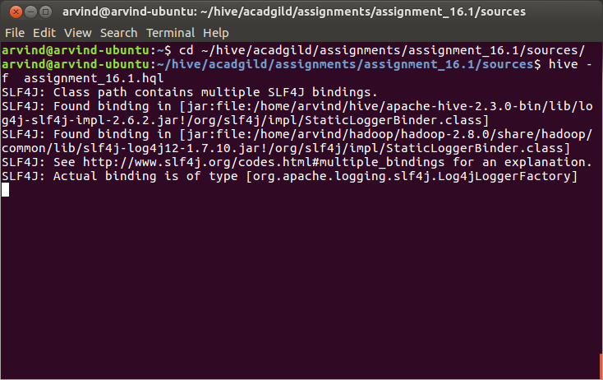

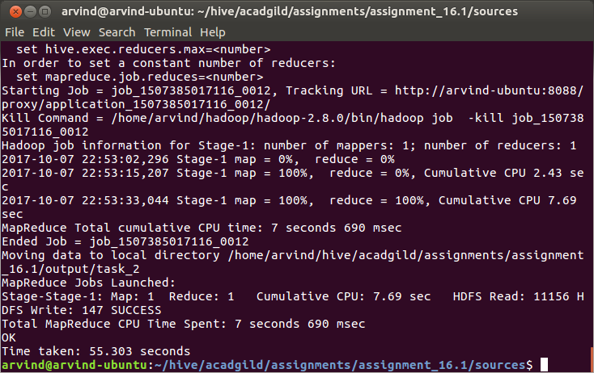

8. After successful execution of the hql script, check the contents of the /user/hive/warehouse directory in HDFS using either the hadoop fs -ls command or using the web UI hosted at port 50070. Check that assignment_16_1.db is one of the directories

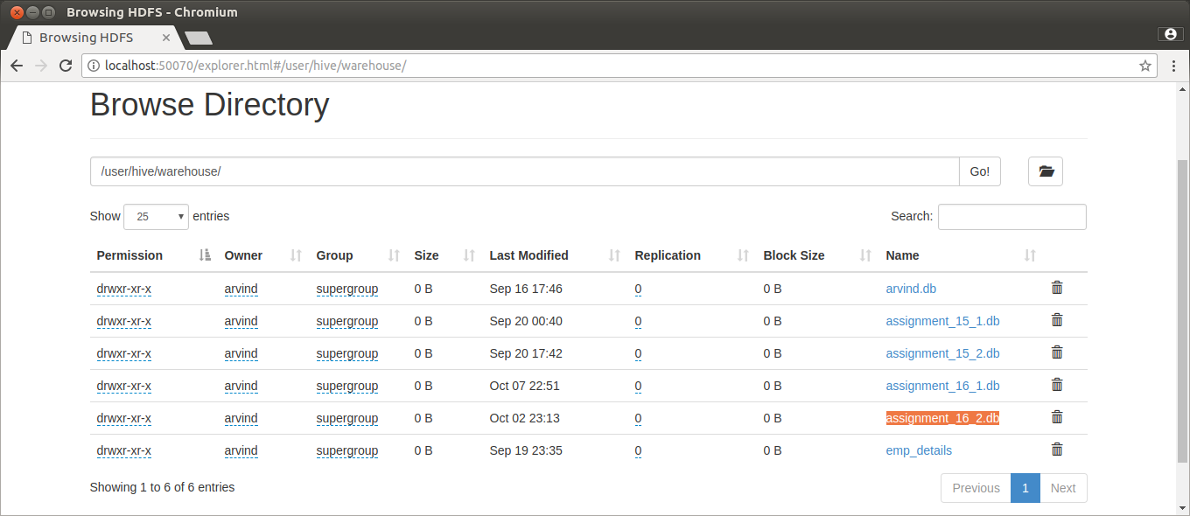

9. Navigate to the output folder of the assignment /home/arvind/hive/acadgild/assignments/assignment_16.1/output using :
cd /home/arvind/hive/acadgild/assignments/assignment_16.1/output/

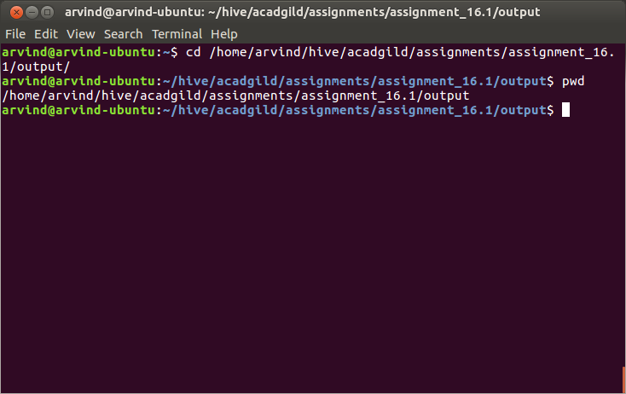

10. List out the contents of the output using the commands
cat task_1/000000_0
cat task_2/000000_0

