ASSIGNMENT 16.2

Assignment folders explanation:
- sources: This folder contains the hql fiile for executing the assignment and the Java file in which the UDF is implemented
- lib: This folder contains the JAR file which has been built to use the UDF
- input: contains the input.txt for this assignment. This file has 3 rows. Each row is an array whose elements are pipe separated
- output: contains the output of the assignment
- docs: Contains the document for the assignment

Steps to execute the assignment:
1. Install Hive and set up necessary environment variables especially HIVE_HOME

2. Configure MySQL as the metastore for Hive by following the instructions in this blog http://syed-rizvi.blogspot.in/2016/02/mysql-configuration-as-hive-metastore-db.html

3. Start up hadoop using the command:
start-all.sh

And verify that all hadoop daemons are running using the command
jps

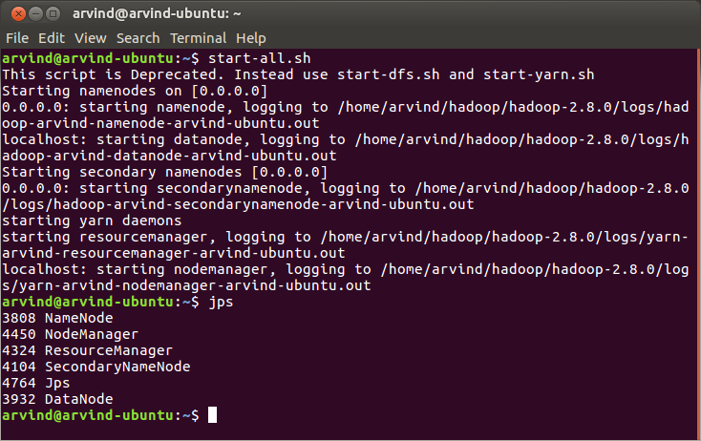
4. Make a new directory in HDFS using the command:
hadoop fs -mkdir -p /user/arvind/hive/acadgild/assignments/assignment_16.2/input

And verify using:
hadoop fs -ls /user/arvind/hive/acadgild/assignments/assignment_16.2

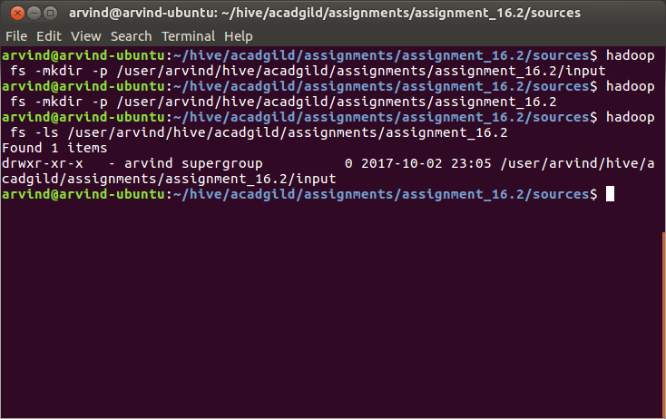

5. Upload input.txt to HDFS using:
hadoop fs -put ~/hive/acadgild/assignments/assignment_16.2/input/input.txt /user/arvind/hive/acadgild/assignments/assignment_16.2/input/input.txt

And verify using:
hadoop fs -ls /user/arvind/hive/acadgild/assignments/assignment_16.2/input/

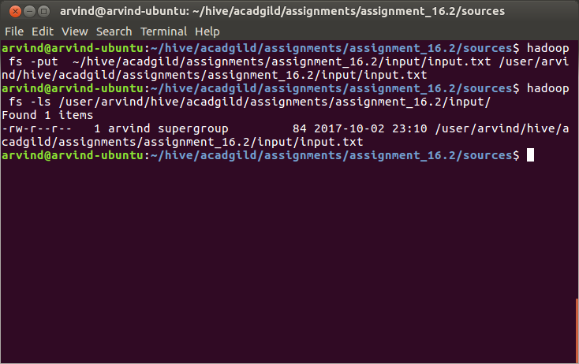

6. Open up Eclipse, create a project named hive-udf for the UDF that we are going to write and right click on the hive-udf project and click Export ...

7. In the Window that appears, select JAR file anc click Next
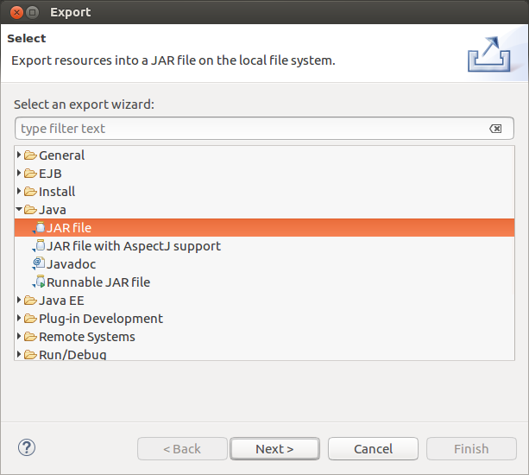

8. Specify the path (lib directory of the assignment) where you want to export the JAR file to and click Next :

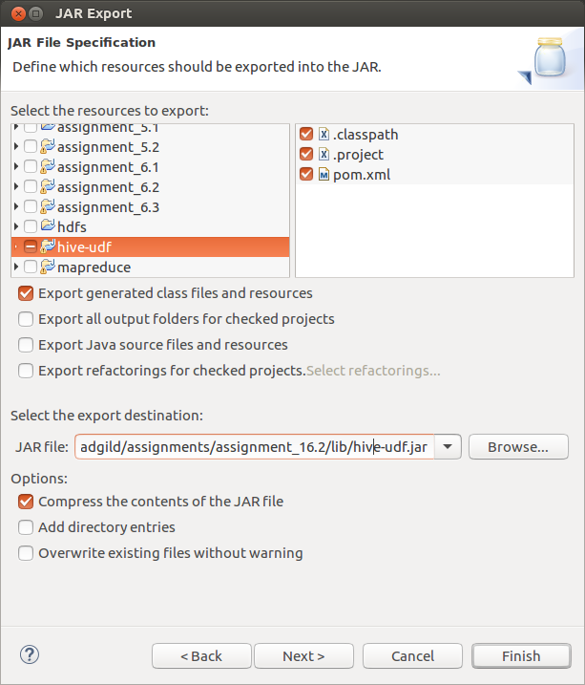

9. Click Next again

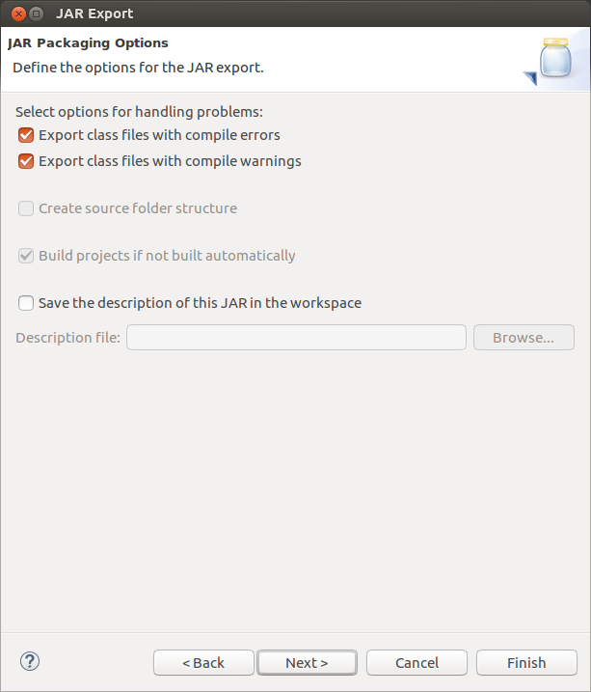

10. Click Finish

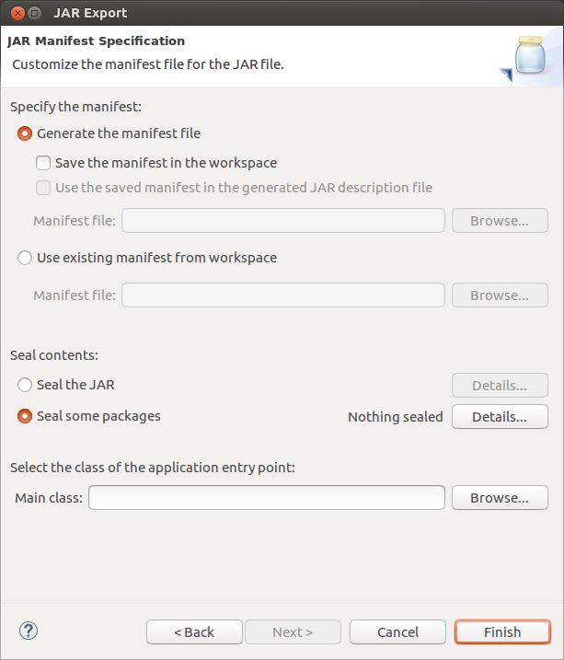

11. Navigate to the sources directory of the assignment using:
cd ~/hive/acadgild/assignments/assignment_16.2/sources/

12. Run assignment_16.2.hql as:
hive -f assignment_16.2.hql

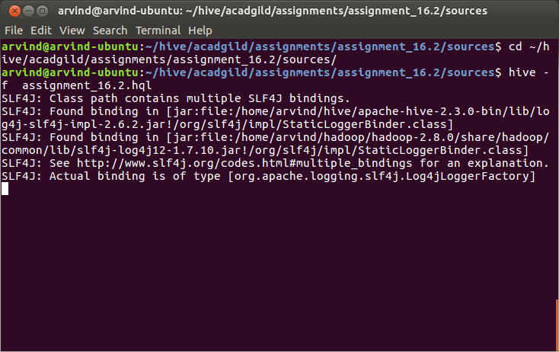

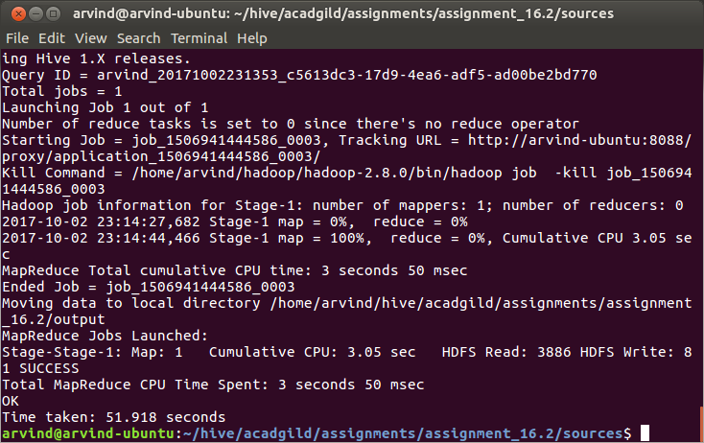

13. After successful execution of the hql script, check the contents of the /user/hive/warehouse directory in HDFS using either the hadoop fs -ls command or using the web UI hosted at port 50070. Check that assignment_16_2.db is one of the directories

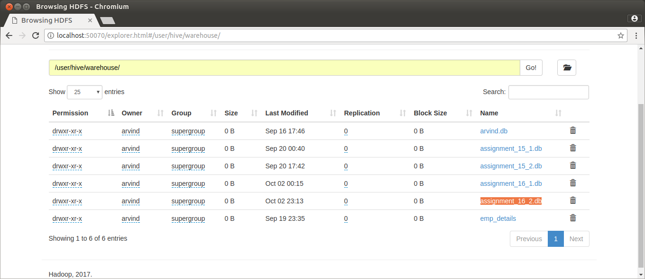

14. Navigate to the output folder of the assignment in the local file system using:
cd /home/arvind/hive/acadgild/assignments/assignment_16.2/output

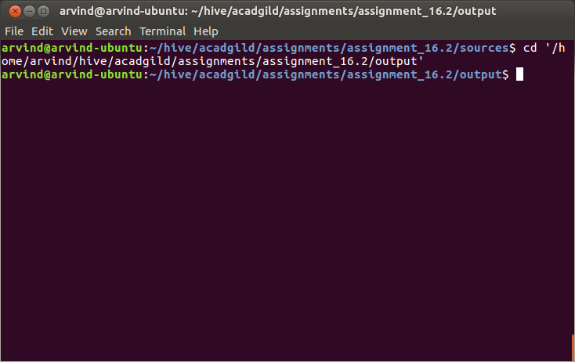

15. List out the contents of the files using the command:
cat 000000_0

