ASSIGNMENT 16.3

1. Install Hive and set up necessary environment variables especially HIVE_HOME

2. Configure MySQL as the metastore for Hive by following the instructions in this blog http://syed-rizvi.blogspot.in/2016/02/mysql-configuration-as-hive-metastore-db.html

3. Start up hadoop using the command:
start-all.sh

And verify that all hadoop daemons are running using the command
jps

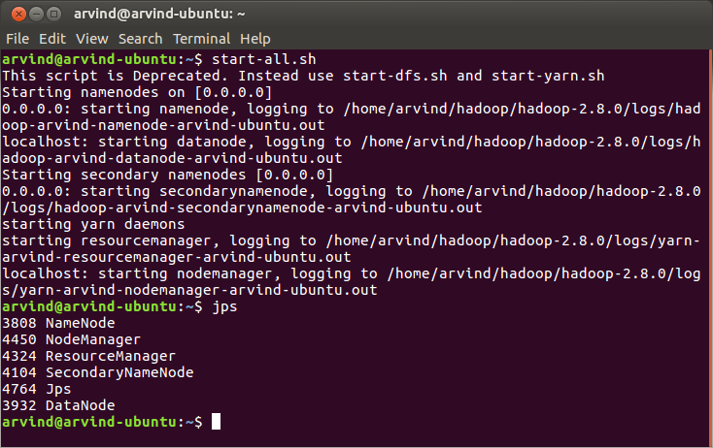
4. Startup hive shell using the command:
hive
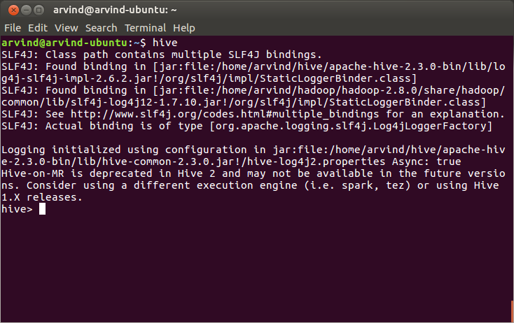

5. Set hive properties to support Hive transactions using the following commands:
set hive.support.concurrency = true;
set hive.enforce.bucketing = true;
set hive.exec.dynamic.partition.mode = nonstrict;
set hive.txn.manager = org.apache.hadoop.hive.ql.lockmgr.DbTxnManager;
set hive.compactor.initiator.on = true;
set hive.compactor.worker.threads = 4;

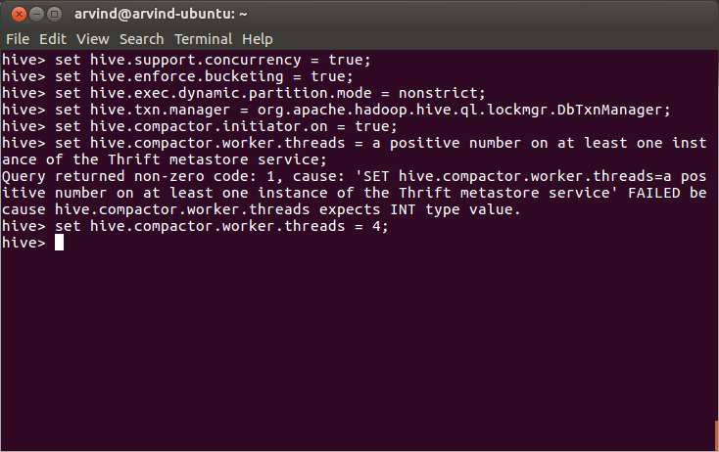
6. Create a table that supports Hive transactions
CREATE TABLE college(clg_id int,clg_name string,clg_loc string) clustered by (clg_id) into 5 buckets stored as orc TBLPROPERTIES('transactional'='true');

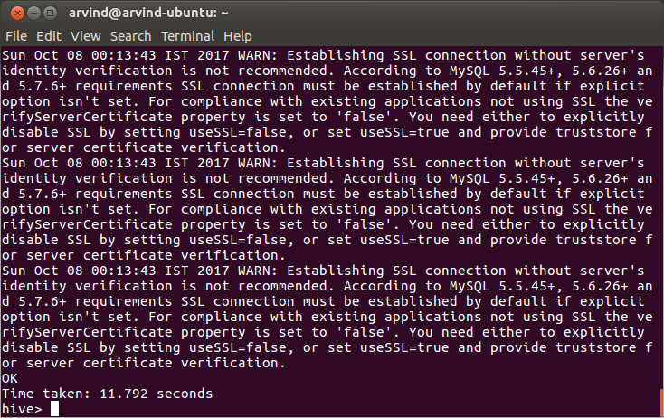

7. Verify that the table has been created using the show tables command

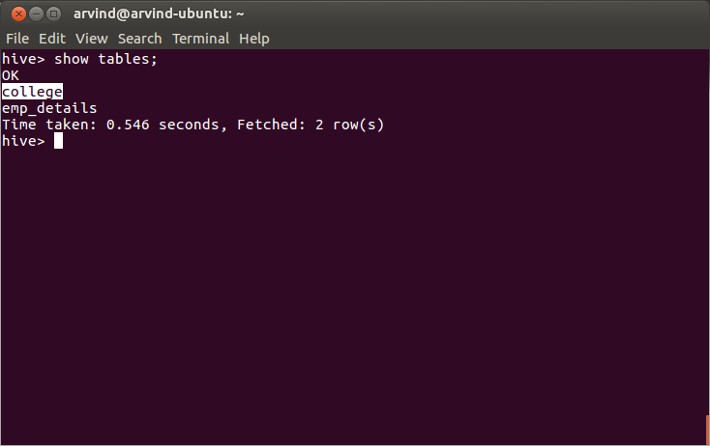
8. Insert data into the table using:
INSERT INTO table college values(1,'nec','nlr'),(2,'vit','vlr'),(3,'srm','chen'),(4,'lpu','del'),(5,'stanford','uk'),(6,'JNTUA','atp'),(7,'cambridge','us');

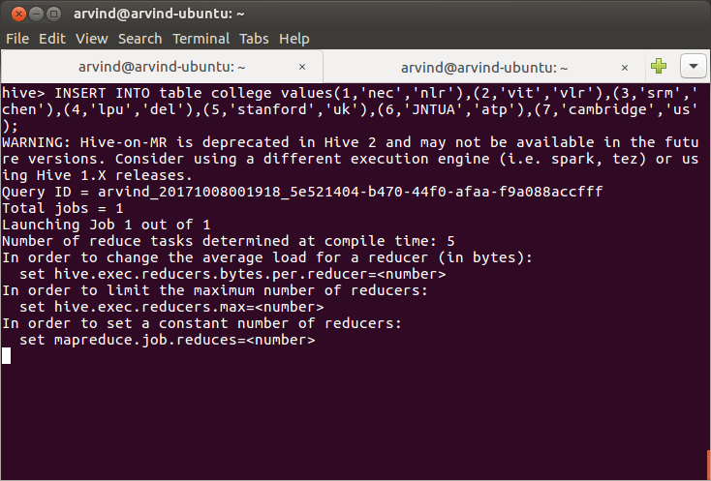

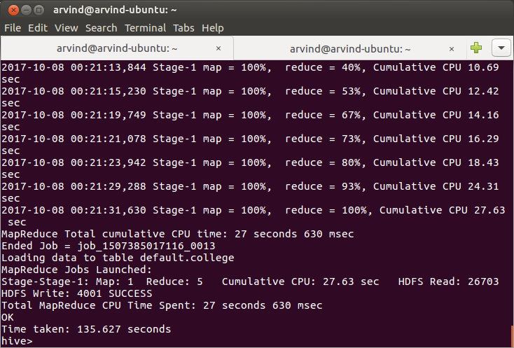
9. Verify that the data is inserted using:
select * from college

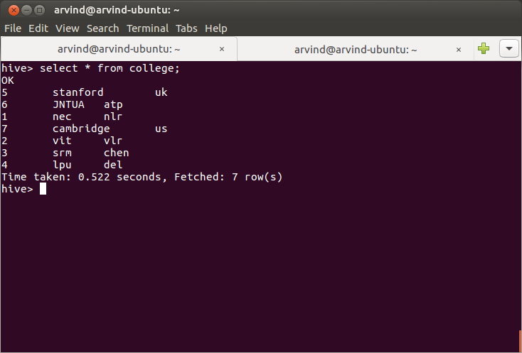

10. Try to update the column on which the table is bucketed. An error will be thrown
UPDATE college set clg_id = 8 where clg_id = 7;

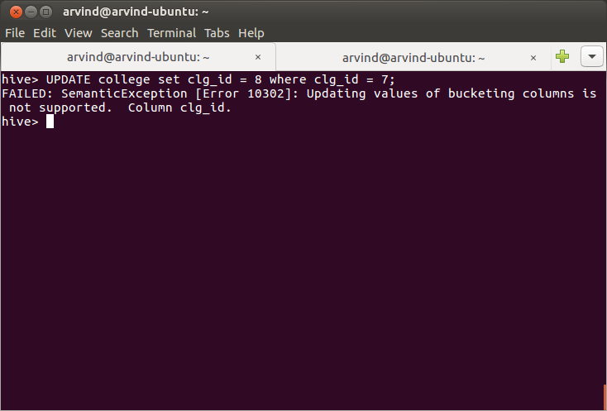
11. Perform update operation on a column which is not bucketed
UPDATE college set clg_name = 'IIT' where clg_id = 6;

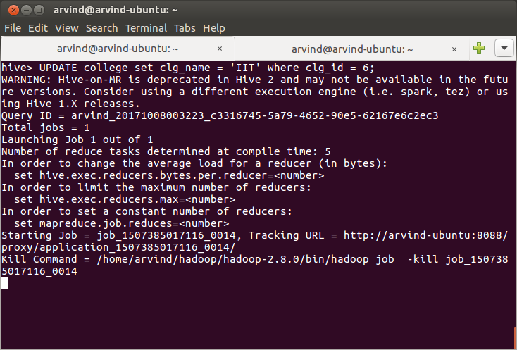

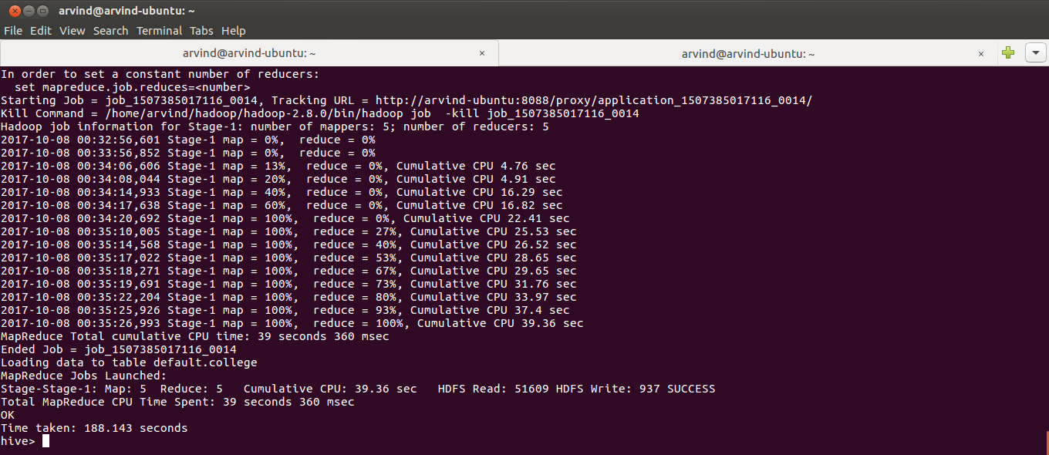
12. Verify that the data is updated by using:
select * from college;

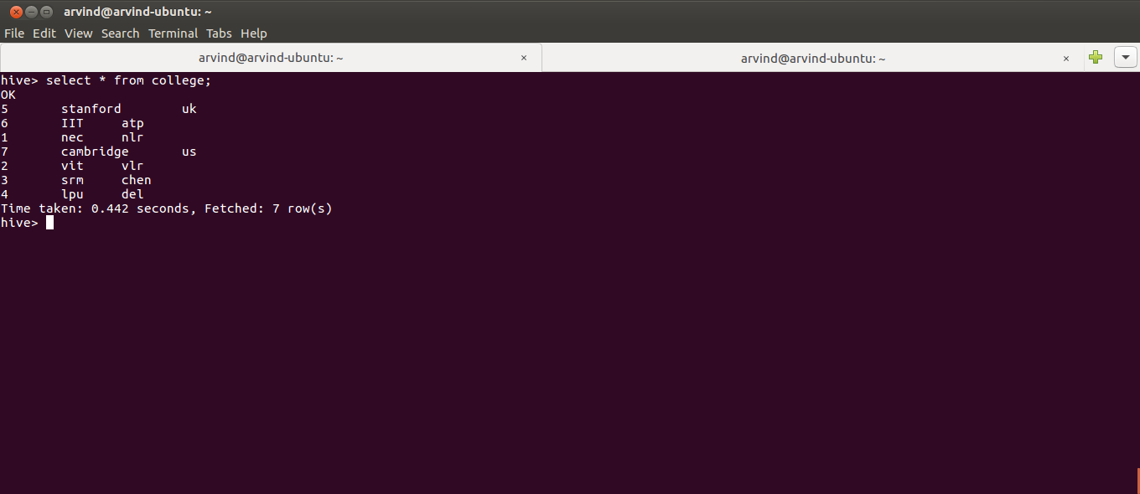
13. Perform a delete operation
delete from college where clg_id=5;

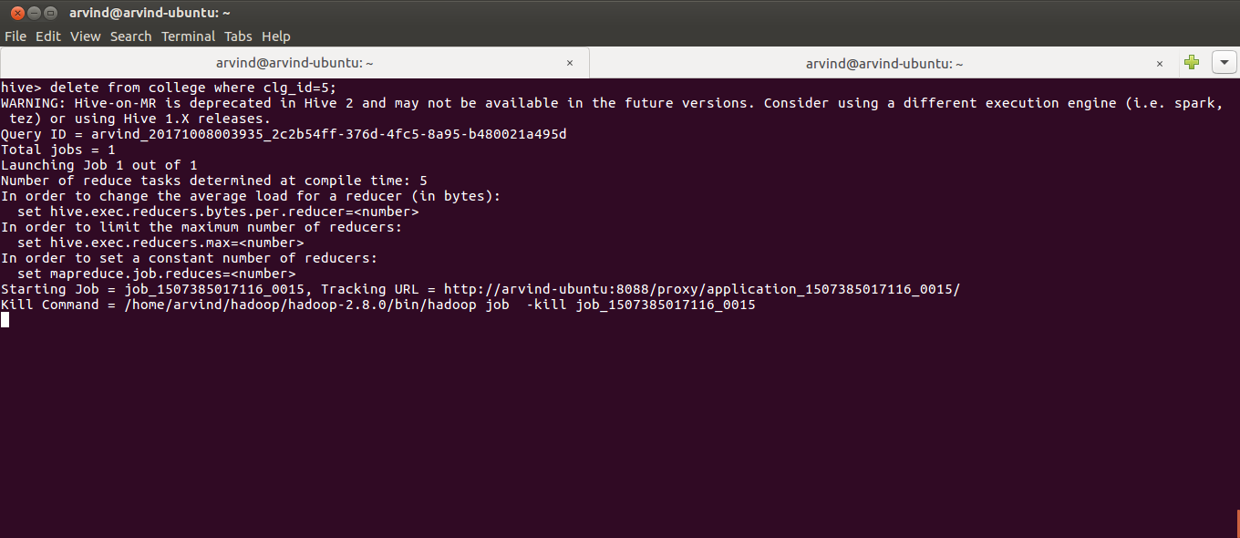

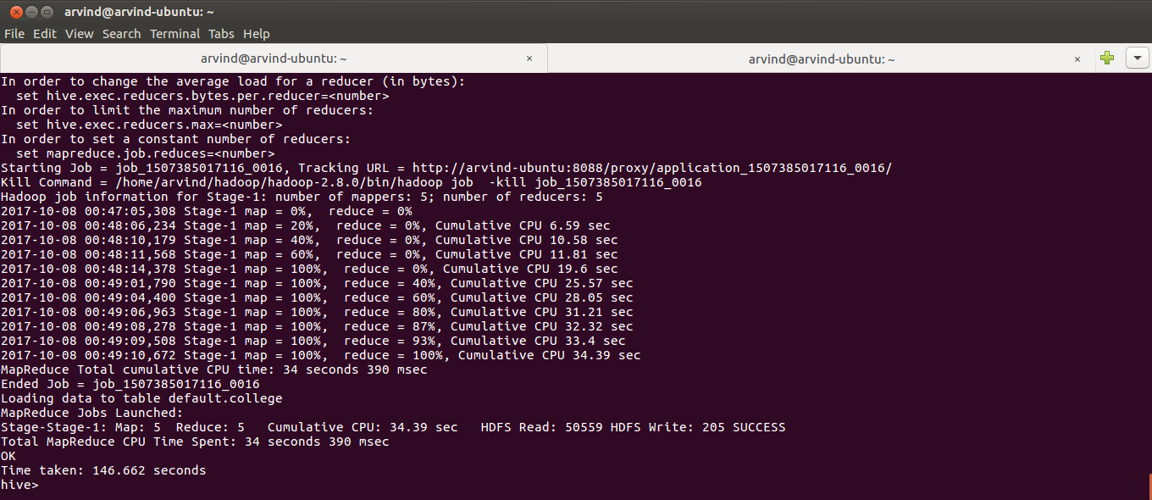
14. Verify that the row has been deleted using:
select * from college;

