ASSIGNMENT 17.2

1. Install HBASE according to the following blog
http://syed-rizvi.blogspot.in/2016/06/hbase-installation-in-fully-distributed.html
and add the HBASE_HOME environment variable. Also add HBASE_HOME/bin to the PATH environment variable

2. Boot the hadoop master node and slave nodes. Start the hadoop cluster using the command:
start-all.sh
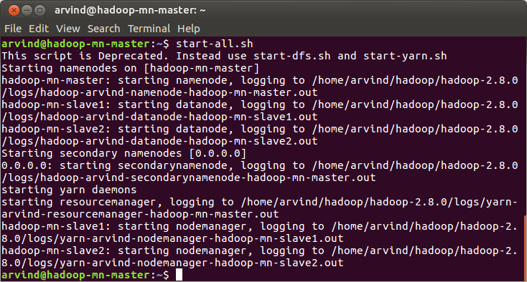

3. Start the job history server in the master node by using the command
mr-jobhistory-daemon.sh start historyserver

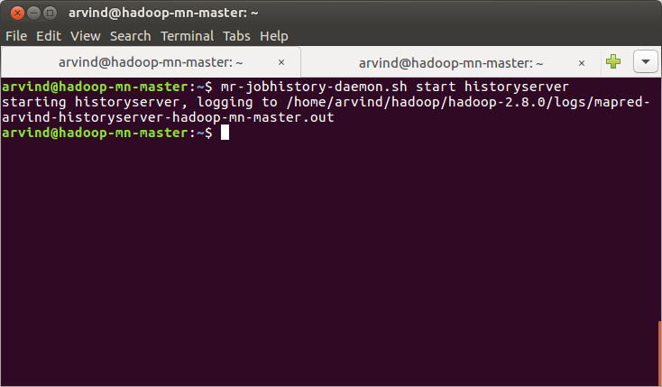

4. Open the master node and verify that Hadoop master daemons (that is, NameNode, SecondaryNameNode, ResourceManager and JobHistoryServer) are running using:
jps

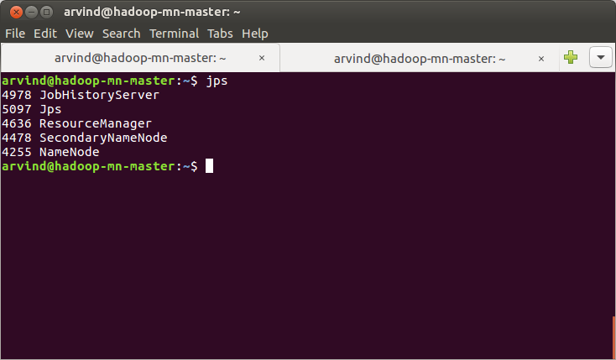

5. Open the slave nodes and verify that the Hadoop slave daemons (that is, NodeManager and DataNode) are running using the command:
jps
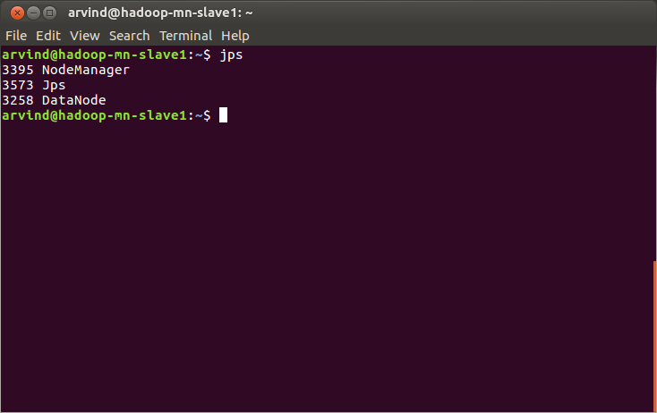

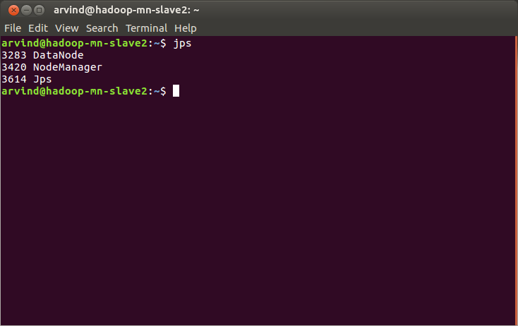

Note : There are 2 slave machines in this setup

6. Boot the Hbase master machine and start the hbase cluster using
start-hbase.sh

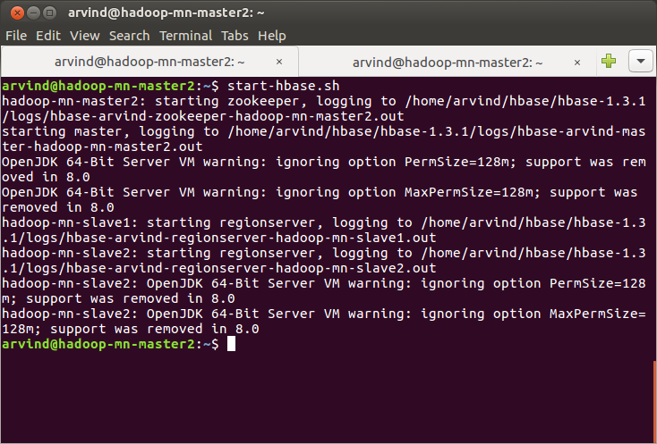

7. Verify that the Hbase master daemons(that is, Hmaster and HQuorumPeer) are running in the Hbase master machine using the command:
jps

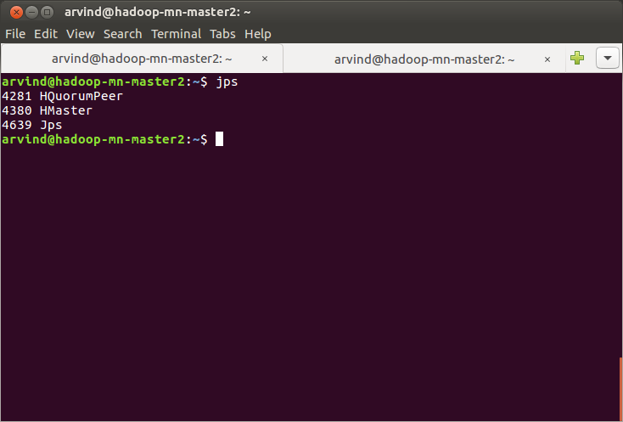

8. Verify that the Hbase slave daemons(that is, HRegionServer) are running in the Hbase slave machine using the command:
jps

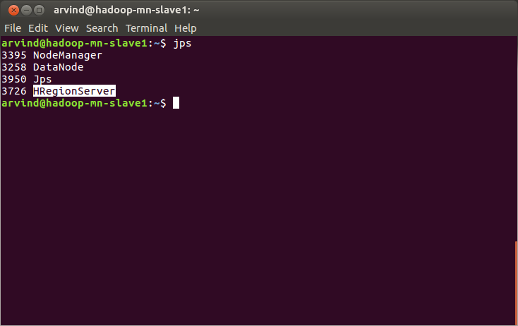

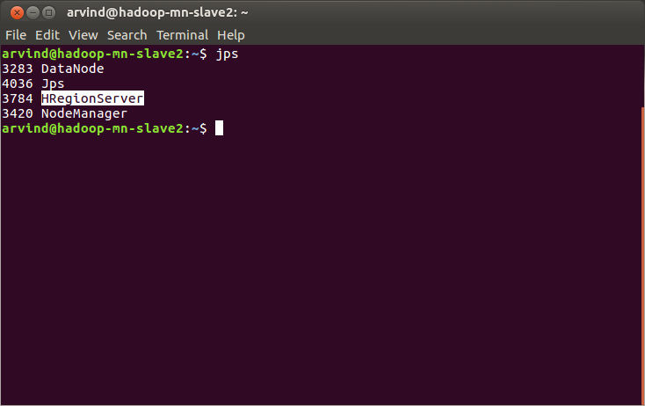

Note: There are 2 Hbase region servers in this setup. The Hbase slave machines are the same machines in which Hadoop slave daemons are running

9. Start the hbase shell in the hbase master machine using the command:
hbase shell

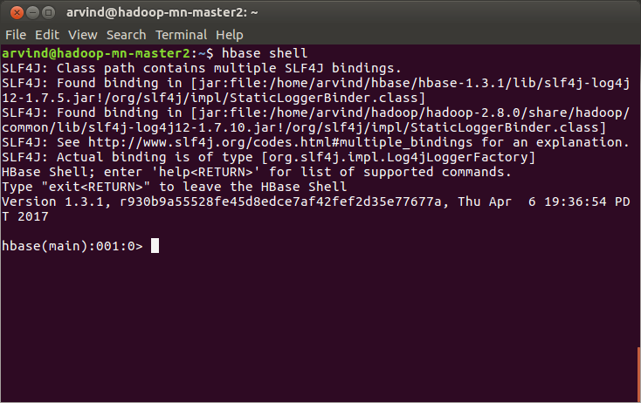

10. Check the status of the Hbase cluster using the Hbase command:
status

We should receive a reply that there is 1 active master and 2 servers as shown below

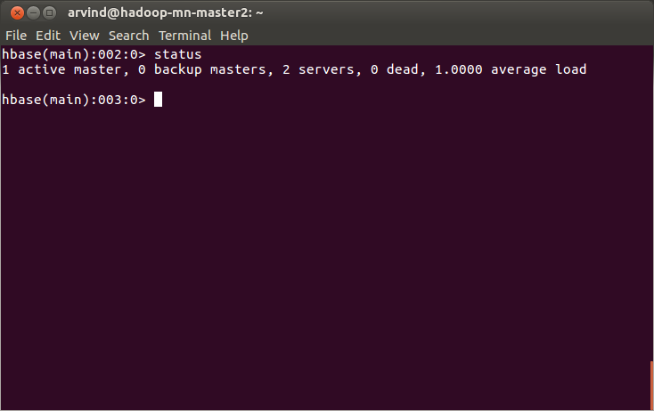

Problem 1: Create an HBase table named 'clicks' with a column family 'hits' such that it should be able to store last 5 values of qualifiers inside 'hits' column family.

11. Create a table ‘clicks’ with a single column family ‘hits’ which can store a maximum of 5 versions per row key. For this, use the Hbase command:
create 'clicks',{NAME=>'hits', VERSIONS=>5}

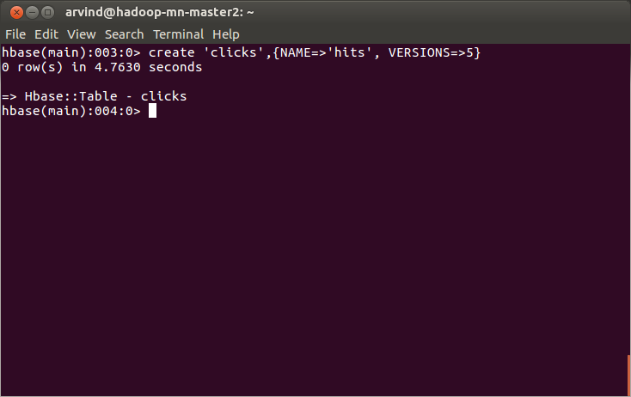

12. Verify the table has been created using the Hbase command:
list

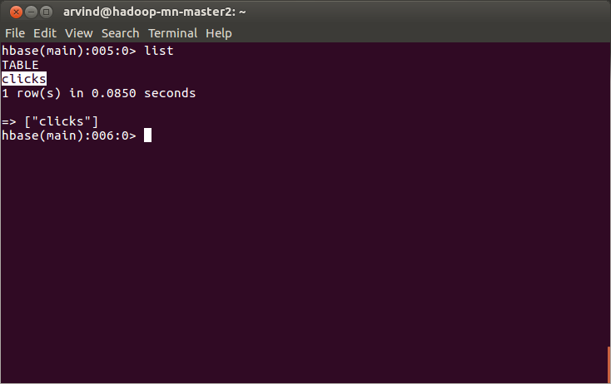

13. Verify the structure of the table using the command:
describe ‘clicks’

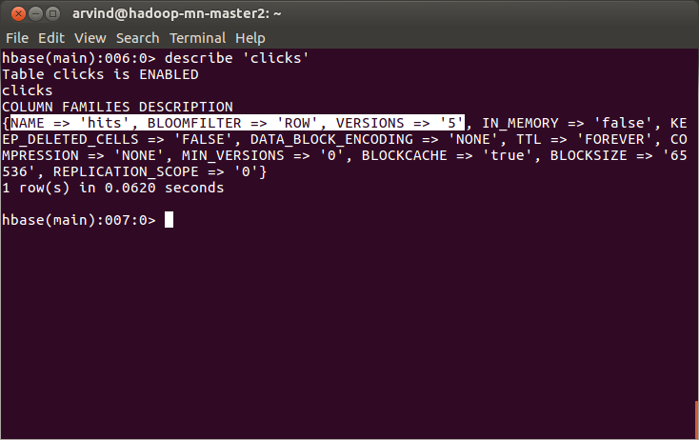

Problem 2: Add few records in the table and update some of them. Use IP Address as row-key. Scan the table to view if all the previous versions are getting displayed.

14. Add few records in the table using IP address as the row key. For this, use the following Hbase commands:
put 'clicks','192.168.1.1','hits:count',1
put 'clicks','192.168.1.2','hits:count',1
put 'clicks','192.168.1.3','hits:count',1

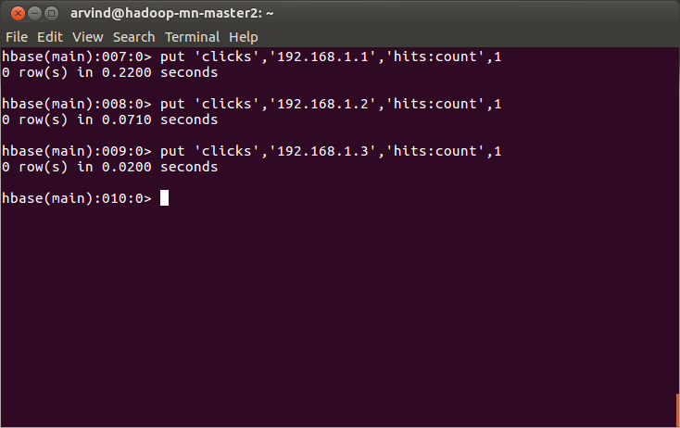

15. Verify that values are inserted using the command:
scan 'clicks',{COLUMN=>'hits:count'}

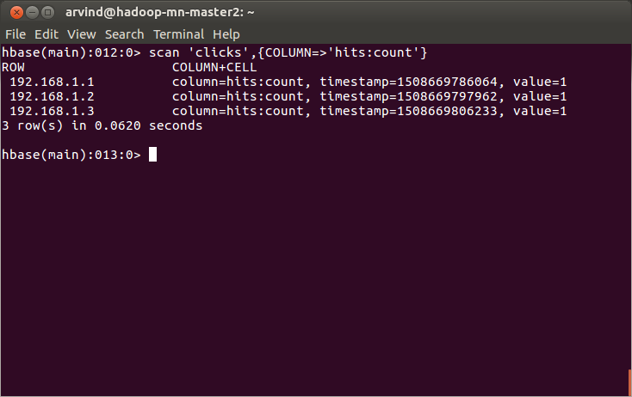

16. Update the hits:count column for row key 192.168.1.1 6 times using the commands:
put 'clicks','192.168.1.1','hits:count',2
put 'clicks','192.168.1.1','hits:count',3
put 'clicks','192.168.1.1','hits:count',4
put 'clicks','192.168.1.1','hits:count',5
put 'clicks','192.168.1.1','hits:count',6
put 'clicks','192.168.1.1','hits:count',7
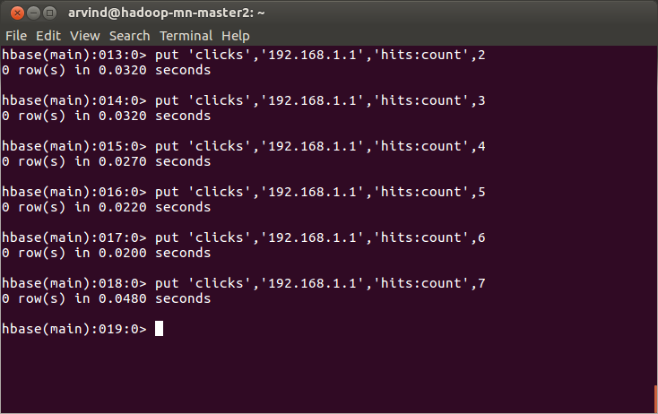

17. Update the hits:count column for row key 192.168.1.2 4 times using the commands:
put 'clicks','192.168.1.2','hits:count',2
put 'clicks','192.168.1.2','hits:count',3
put 'clicks','192.168.1.2','hits:count',4
put 'clicks','192.168.1.2','hits:count',5

18. Update the hits:count column for row key 192.168.1.3 2 times using the commands:
put 'clicks','192.168.1.3','hits:count',2
put 'clicks','192.168.1.3','hits:count',3

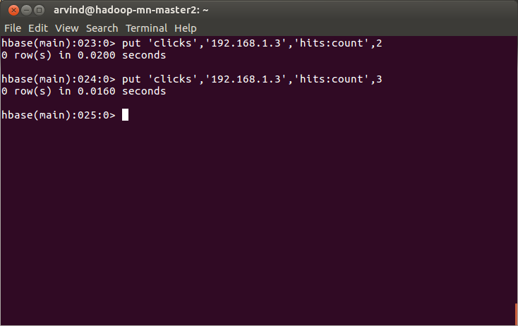

19. Display the updated values of hits:count column for all row keys using the command:
scan 'clicks',{COLUMN=>'hits:count'}
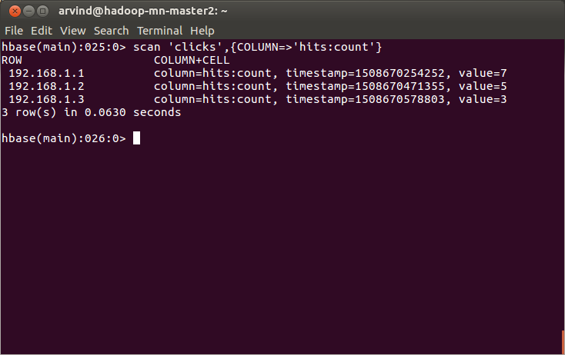

20. Display the last 5 versions of the hist:count column for each row key using the command:
scan 'clicks',{COLUMN=>'hits:count', VERSIONS=>5}

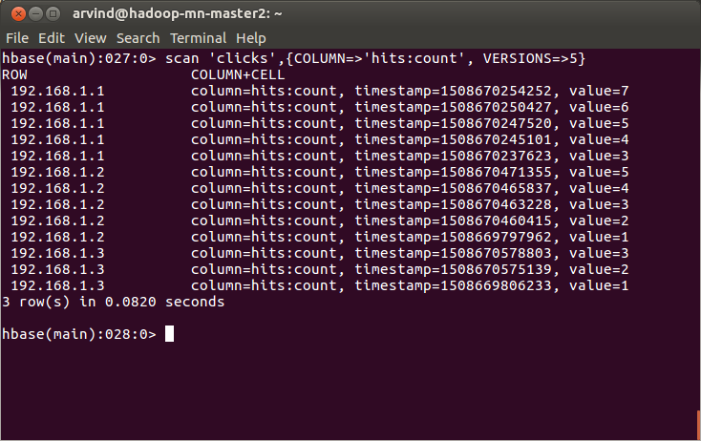

Note: For the row key ‘192.168.1.1’, we updated the value 6 times; so there are 7 versions but only 5 versions are displayed because according to this query we have fetched only the last 5 versions. For row key ‘192.168.1.2’ we have updated 4 times; so there are 5 versions and according to this query all versions are fetched. For row key ‘192.168.1.3’, we have updated 2 times; so there are 3 versions and according to this query all versions are fetched

21. Try to display the last 6 versions of the hist:count column for each row key using the command:
scan 'clicks',{COLUMN=>'hits:count', VERSIONS=>6}

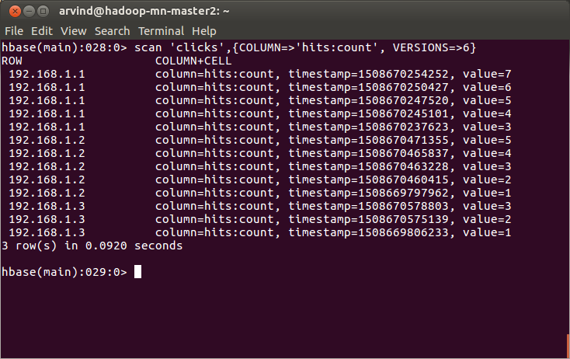

Note: For row key ‘192.168.1.1’, we updated the value 6 times; so there are 7 versions. Although we have specified in the query to fetch the last 6 versions, only 5 versions are displayed for this row key because the table ‘clicks’ was created to store a maximum of 5 versions(refer step 11) only.

