ASSIGNMENT 18.1

1. Install HBASE according to the following blog
http://syed-rizvi.blogspot.in/2016/06/hbase-installation-in-fully-distributed.html
and add the HBASE_HOME environment variable. Also add HBASE_HOME/bin to the PATH environment variable

2. Boot the hadoop master node and slave nodes. Start the hadoop cluster using the command:
start-all.sh
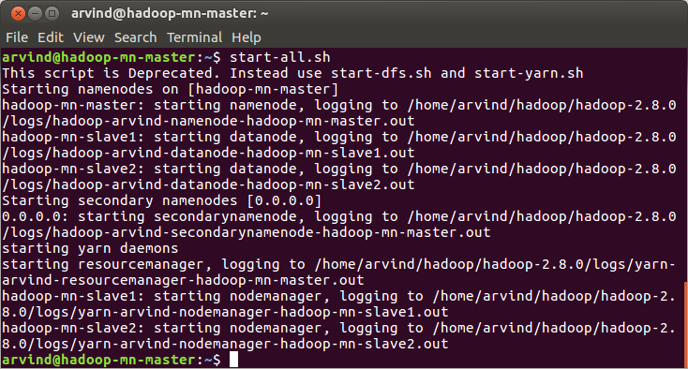
3. Start the job history server in the master node by using the command
mr-jobhistory-daemon.sh start historyserver

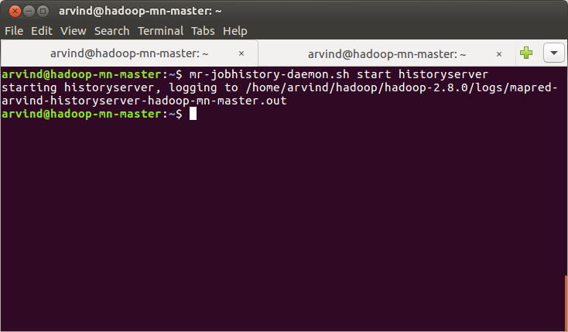
4. Open the master node and verify that Hadoop master daemons (that is, NameNode, SecondaryNameNode, ResourceManager and JobHistoryServer) are running using:
jps

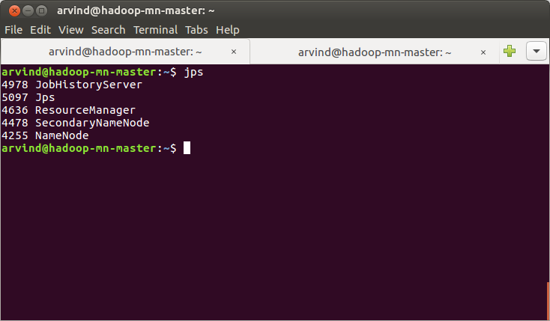
5. Open the slave nodes and verify that the Hadoop slave daemons (that is, NodeManager and DataNode) are running using the command:
jps
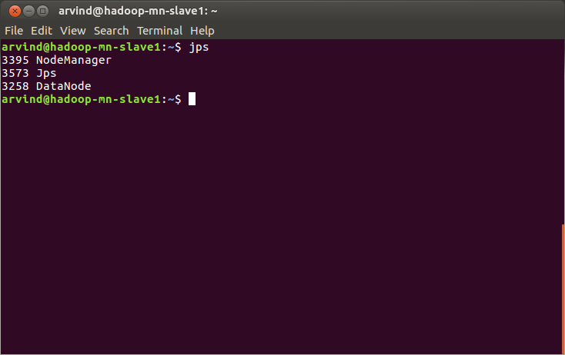

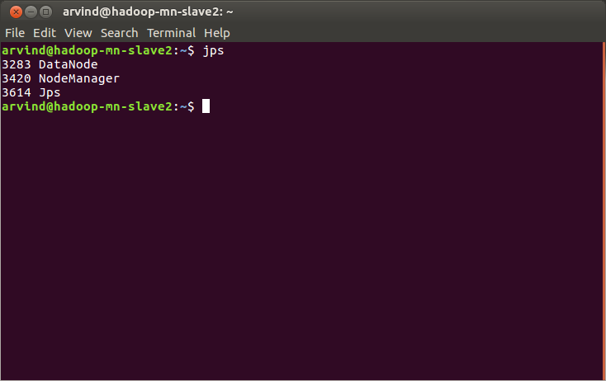

Note : There are 2 slave machines in this setup

6. Boot the Hbase master machine and start the hbase cluster using
start-hbase.sh

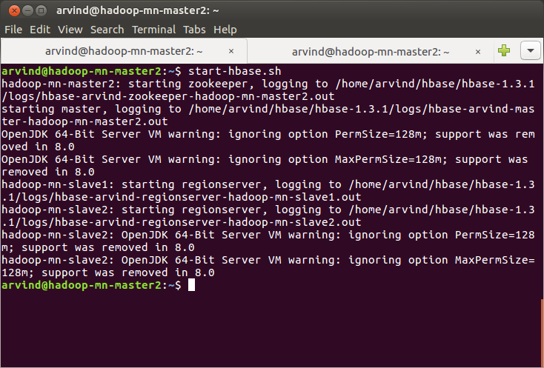

7. Verify that the Hbase master daemons(that is, Hmaster and HQuorumPeer) are running in the Hbase master machine using the command:
jps

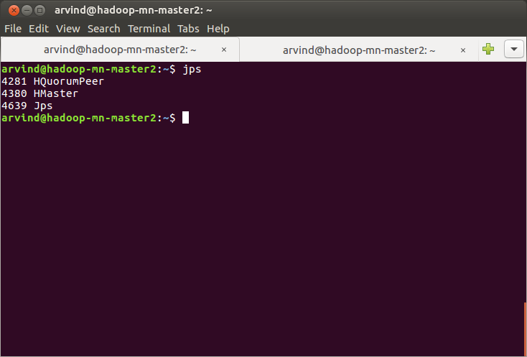

8. Verify that the Hbase slave daemons(that is, HRegionServer) are running in the Hbase slave machine using the command:
jps

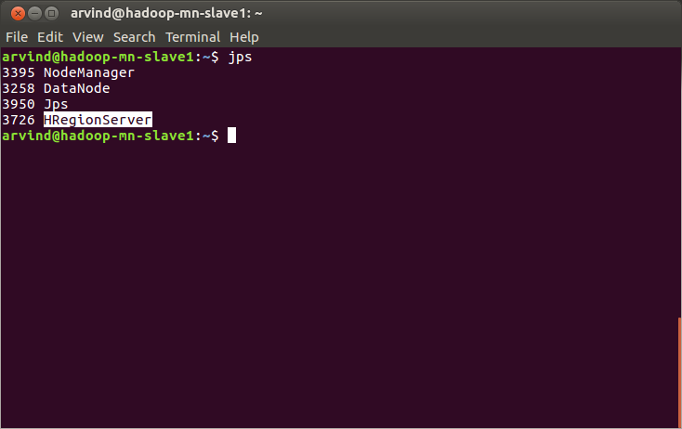

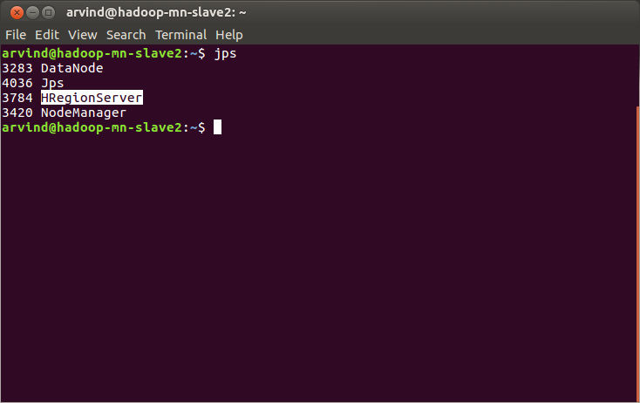

Note: There are 2 Hbase region servers in this setup. The Hbase slave machines are the same machines in which Hadoop slave daemons are running

9. Start the hbase shell in the hbase master machine using the command:
hbase shell

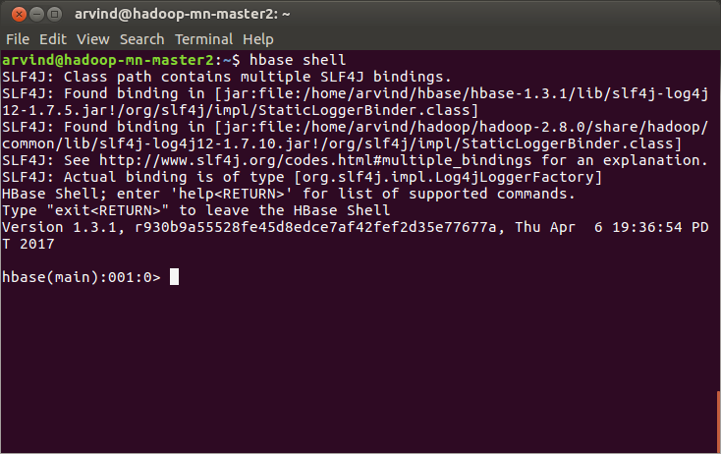

10. Check the status of the Hbase cluster using the Hbase command:
status

We should receive a reply that there is 1 active master and 2 servers as shown below

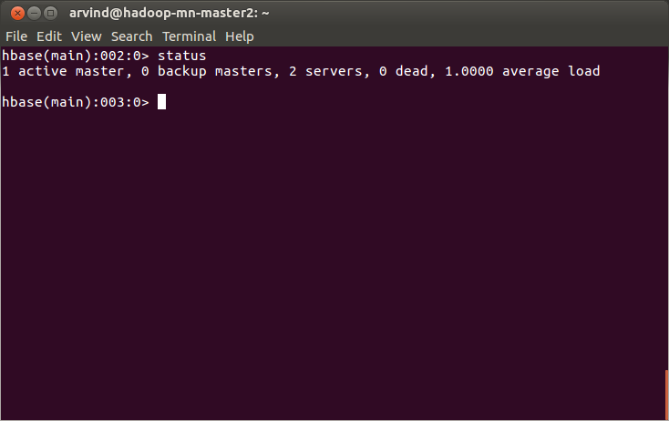

Problem: Create a HBase table 'customer' with one column family 'details'.

11. Check if there is already a table named customer using the Hbase command:
exists 'customer'

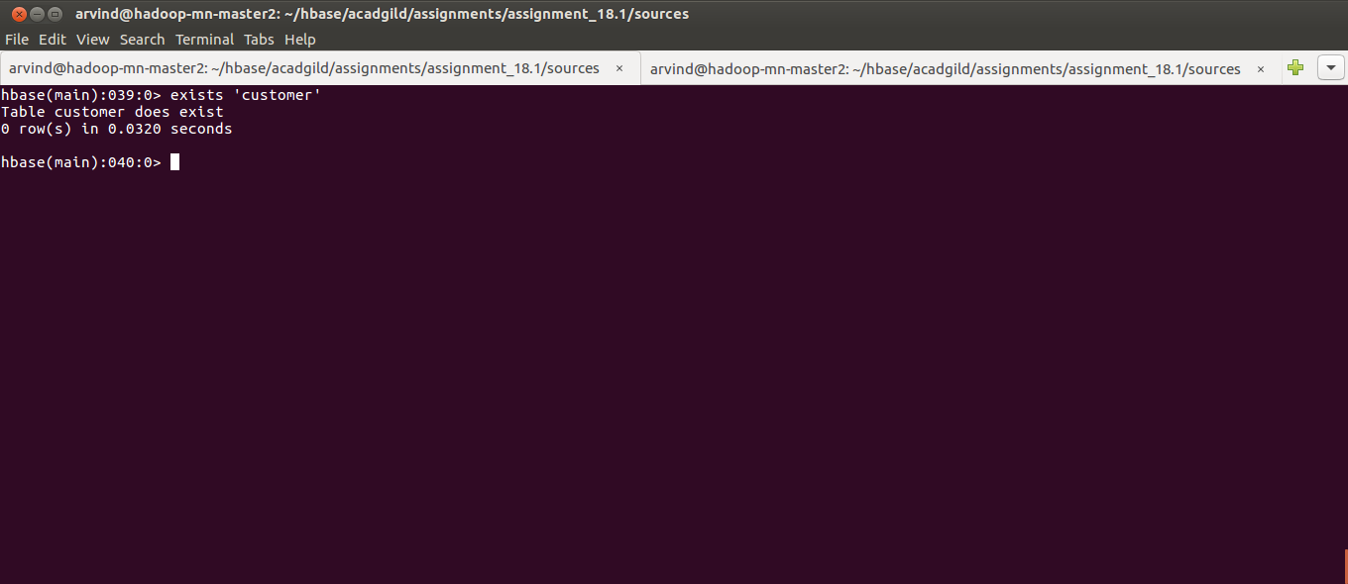

12. If the table exists, disable the table, drop the table and verify the table has been dropped using the following commands in the order:
disable ‘customer’
drop ‘customer’
list
exists ‘customer’

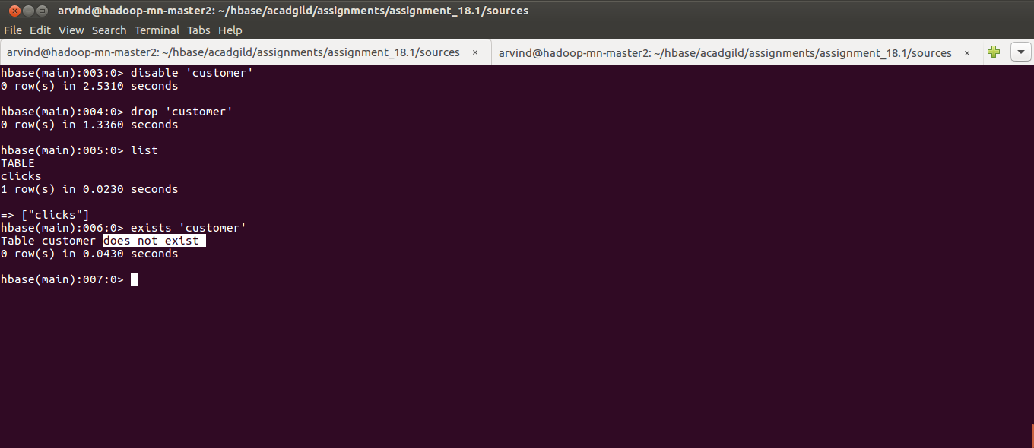

13. Create a HBase table 'customer' with one column family 'details', verify that the table has been created and exit from the Hbase shell using the following commands in order:
create ‘customer’,’details’
list
exists ‘customer’
describe ‘customer’
exit

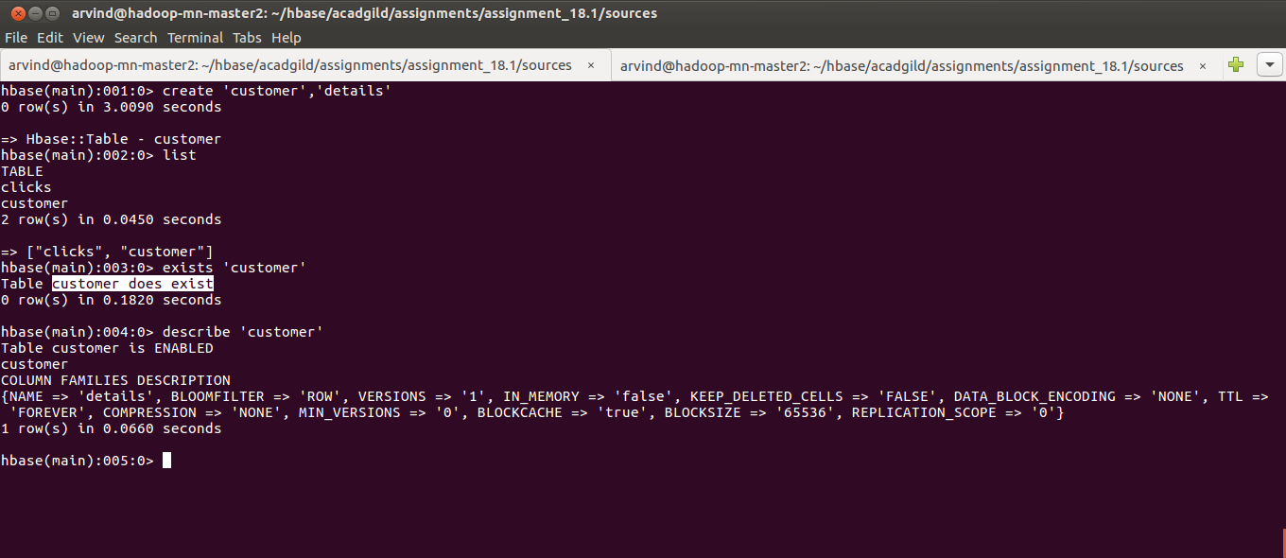

Problem: Write a shells script that loads the content of the file customers.dat in the HBase table.

14. Shell script is included in the assignment solution within the ‘sources’ directory and explantory comments are added to the script. Navigate to the directory and run that script using the commands:
cd /home/arvind/hbase/acadgild/assignments/assignment_18.1/sources
./assignment_18.1.sh

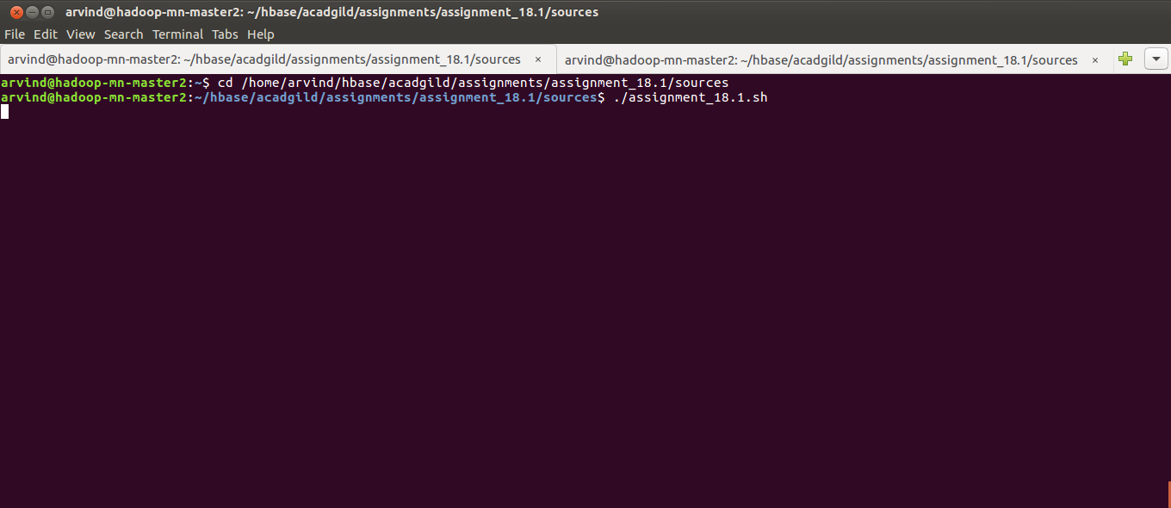

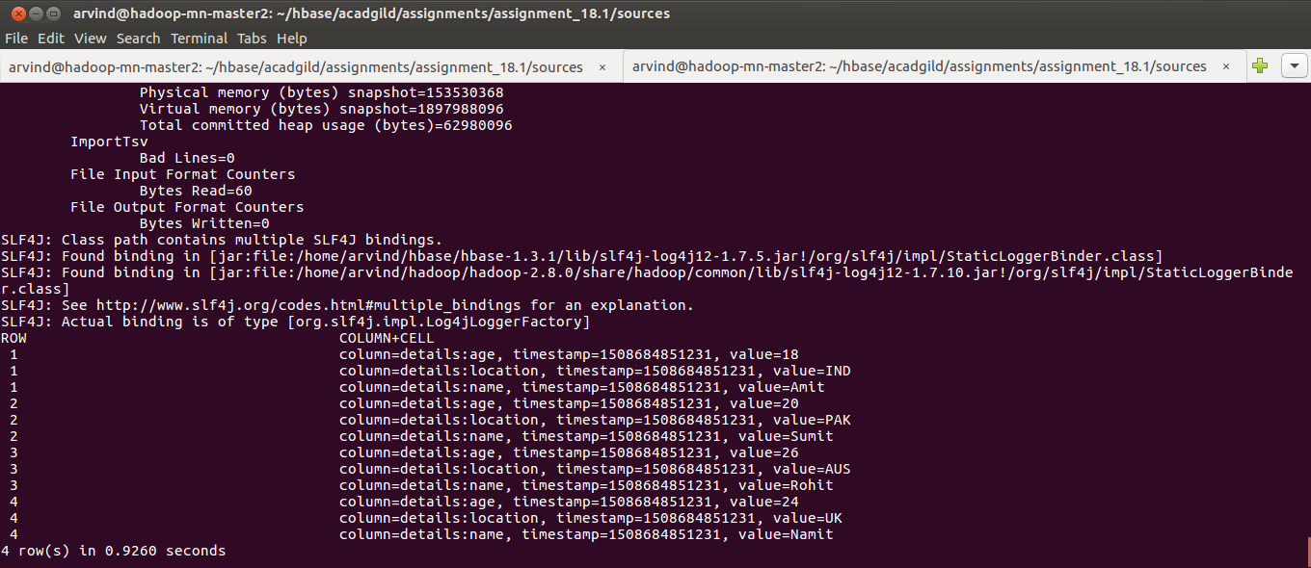

15. Open the hbase shell using the command “hbase shell” and type in the following hbase command:
scan ‘customer’
