ASSIGNMENT 18.2

1. Install HBASE according to the following blog
http://syed-rizvi.blogspot.in/2016/06/hbase-installation-in-fully-distributed.html
and add the HBASE_HOME environment variable. Also add HBASE_HOME/bin to the PATH environment variable. Instead of using one master and 3 slaves, install Hadoop in pseudo-distributed mode and Hbase master and slave in the same machine

2. Start hadoop daemons using the command:
start-all.sh

3. Verify that the hadoop daemons are running using the command:
jps
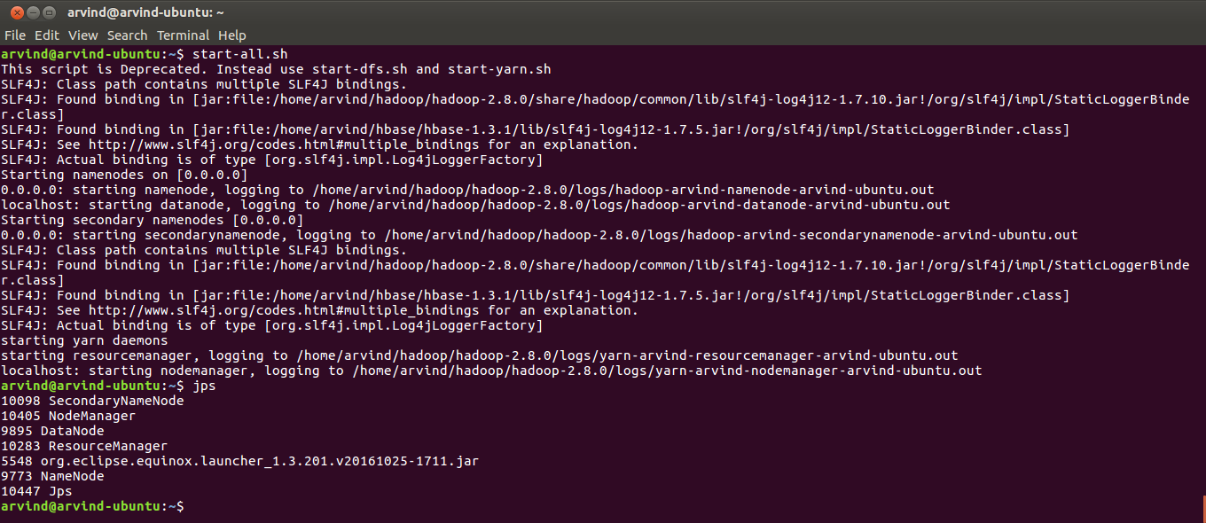

3. Start the job history server in the master node by using the command
mr-jobhistory-daemon.sh start historyserver

4. Verify the job history server daemon is running using:
jps

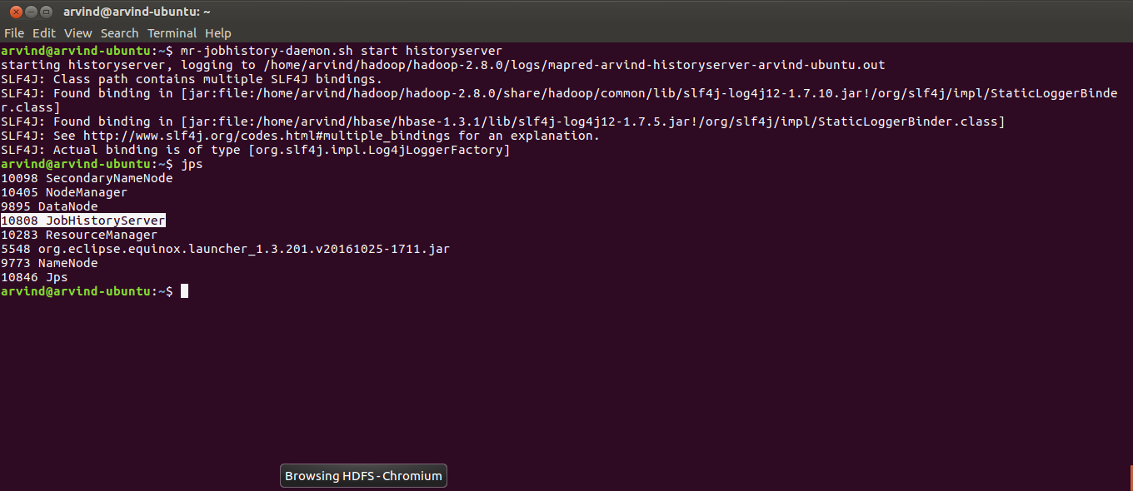

5. Start hbase daemons using the command:
start-hbase.sh

6. Verify that the Hmaster, HquorumPeer and HregionServer daemons are running using the command:
jps

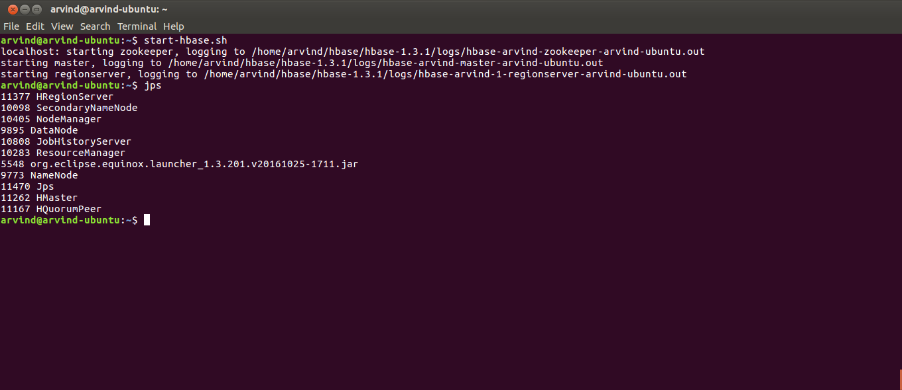

7. Start the hbase shell using the command:
hbase shell

8. List the tables using the hbase command:
list

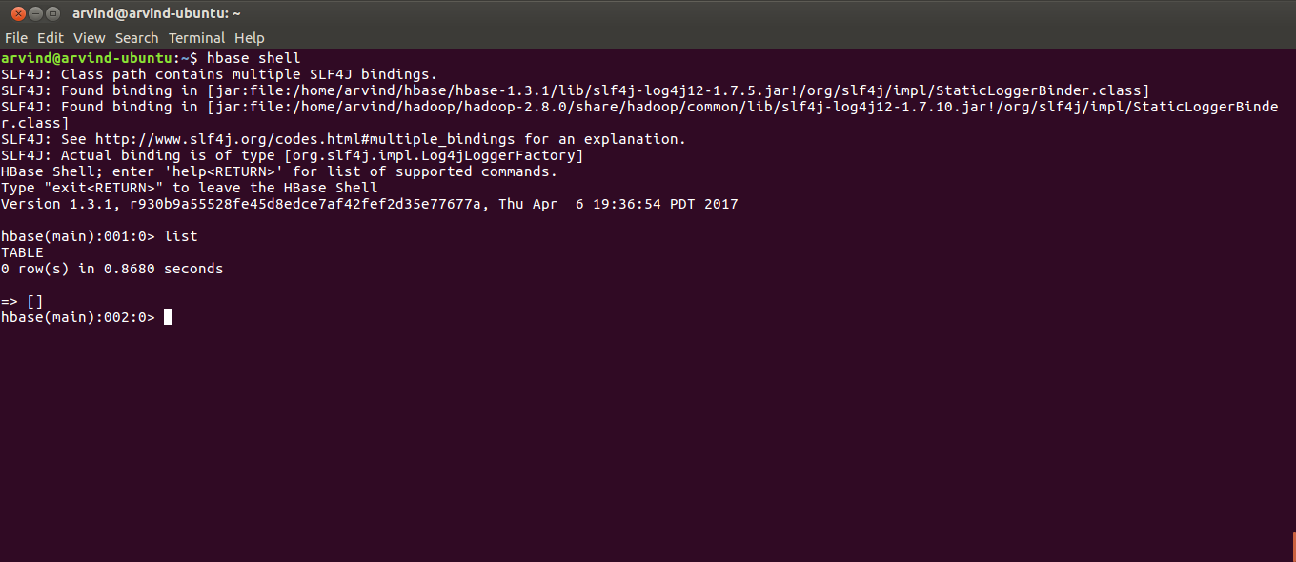

9. Create a table ‘customer’ with a single column family ‘details’ using the hbase command:
create 'customer','details'

10. Verify the table has been created using the hbase command:
list

11. Add some dummy rows to the table using the hbase commands:
put 'customer','1','details:name','Arvind'
put 'customer','2','details:name','Akash'

12. Verify that the rows have been inserted into the table using the hbase command:
scan ‘customer’
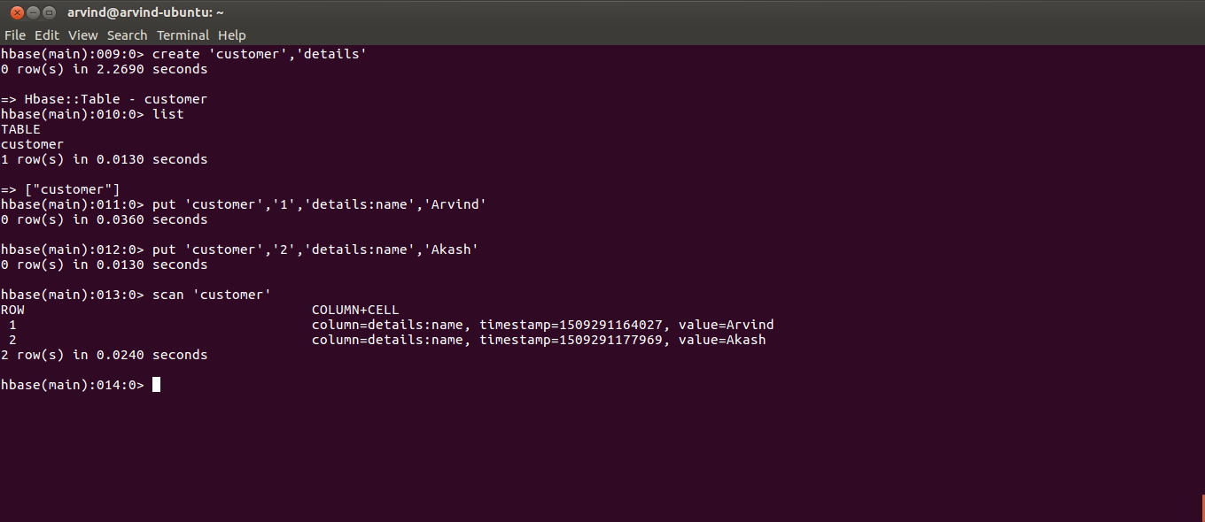

13. Open up eclipse and set up a Maven project with the name assignment_18.2. The pom.xml and the Java code have been included within the sources directory along with the assignment solution. Make sure that the class is placed inside “com.acadgild” package. The code was written following the blog:
https://acadgild.com/blog/data-bulk-loading-into-hbase-table-using-mapreduce/

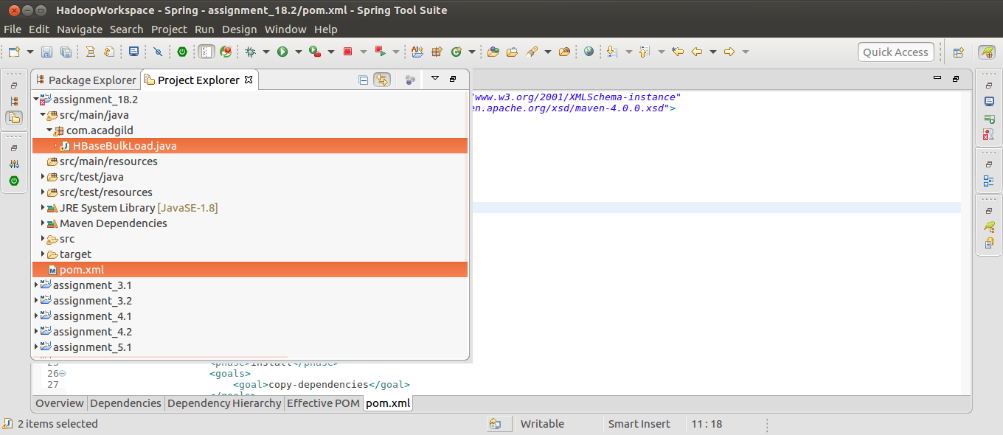

14. Open up a new terminal and navigate to the project location using the command:
cd ~/workspaces/HadoopWorkspace/assignment_18.2/

15. View the contents of the directory using the command:
ls

16. Ensure that a pom.xml is present in the directory:

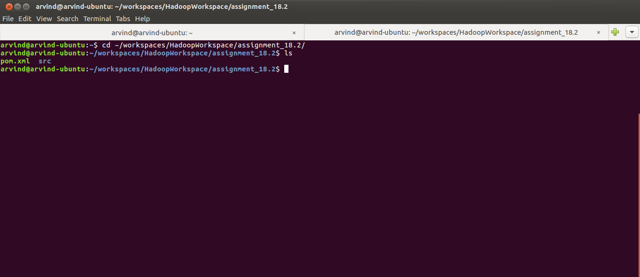

17. Build the project using the command:
mvn clean install

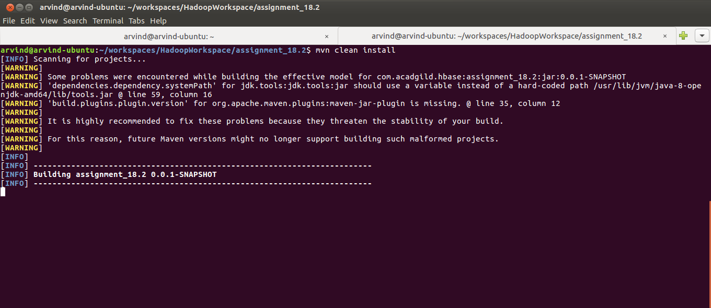

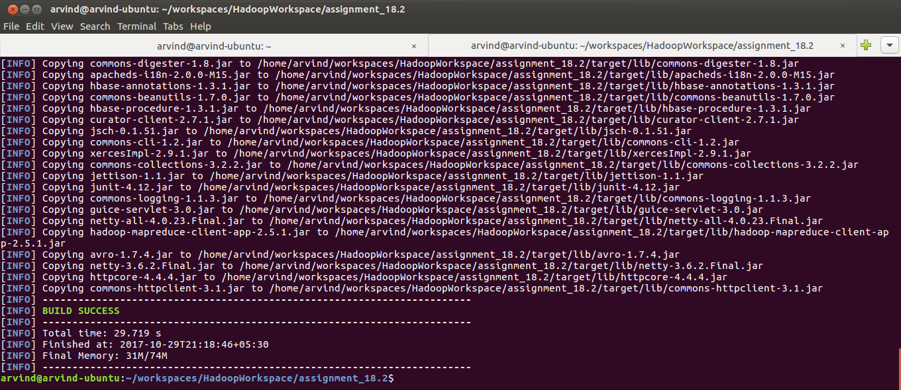

18. Verify that a directory named target has been created using the command:
ls

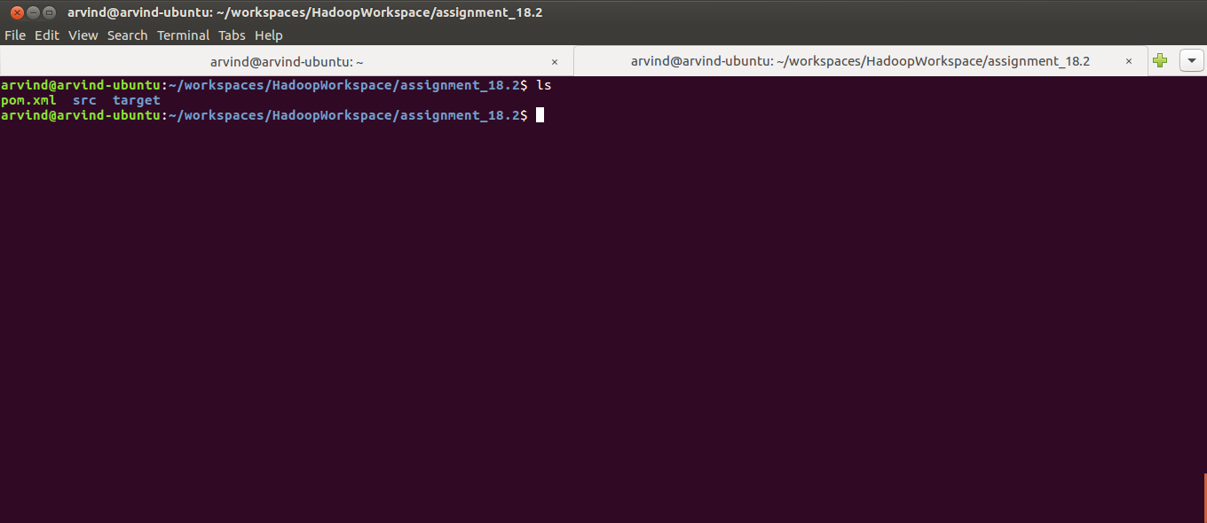

19. Create a directory in HDFS for this assignment and for the input using the command:
hadoop fs -mkdir -p /user/arvind/hbase/acadgild/assignments/assignment_18.2/input

20. Copy the input file from local file system to HDFS using the command:
hadoop fs -put /home/arvind/hbase/acadgild/assignments/assignment_18.2/input/customers.dat /user/arvind/hbase/acadgild/assignments/assignment_18.2/input/

21. Verify whether the file has been copied to HDFS using the command:
hadoop fs -ls /user/arvind/hbase/acadgild/assignments/assignment_18.2/input/

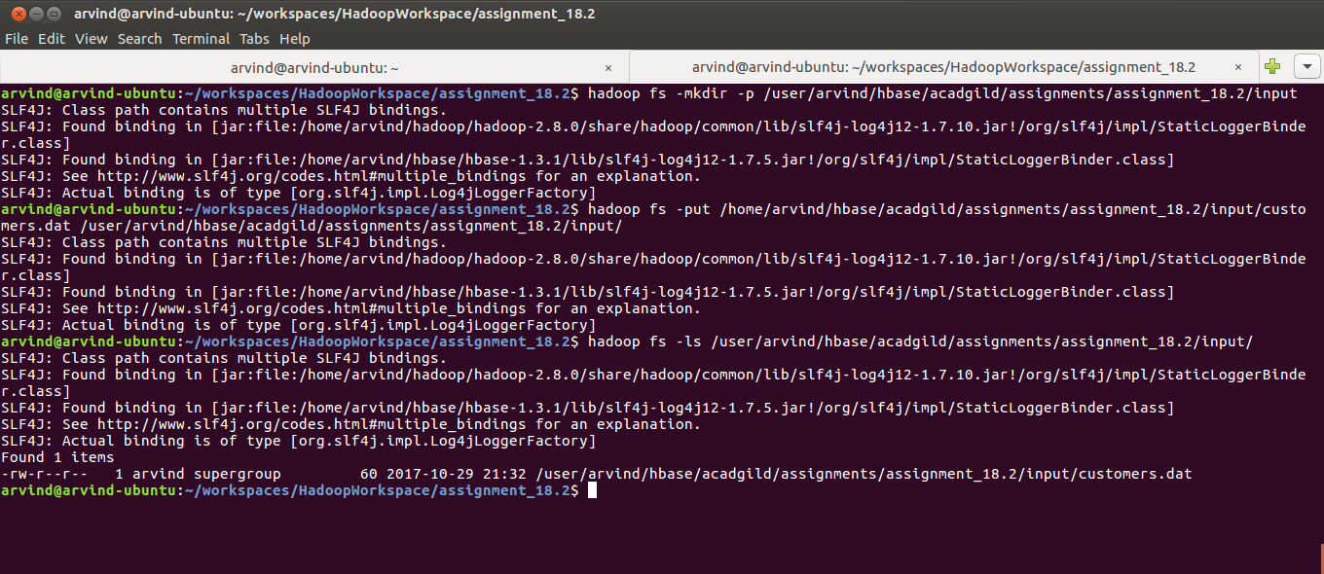

22. Set the hadoop classpath using the command:
export HADOOP_CLASSPATH=$HBASE_HOME/lib/*

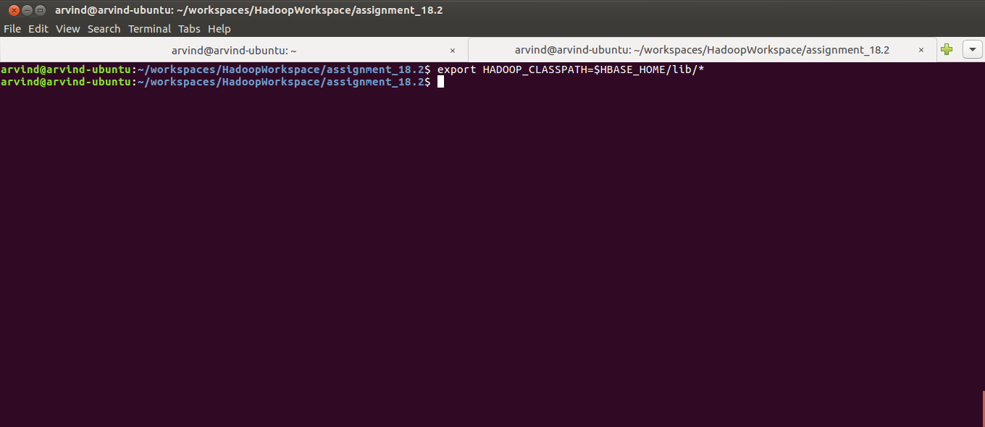

23. Run the hadoop job by using the command:
hadoop jar target/assignment_18.2-0.0.1-SNAPSHOT.jar

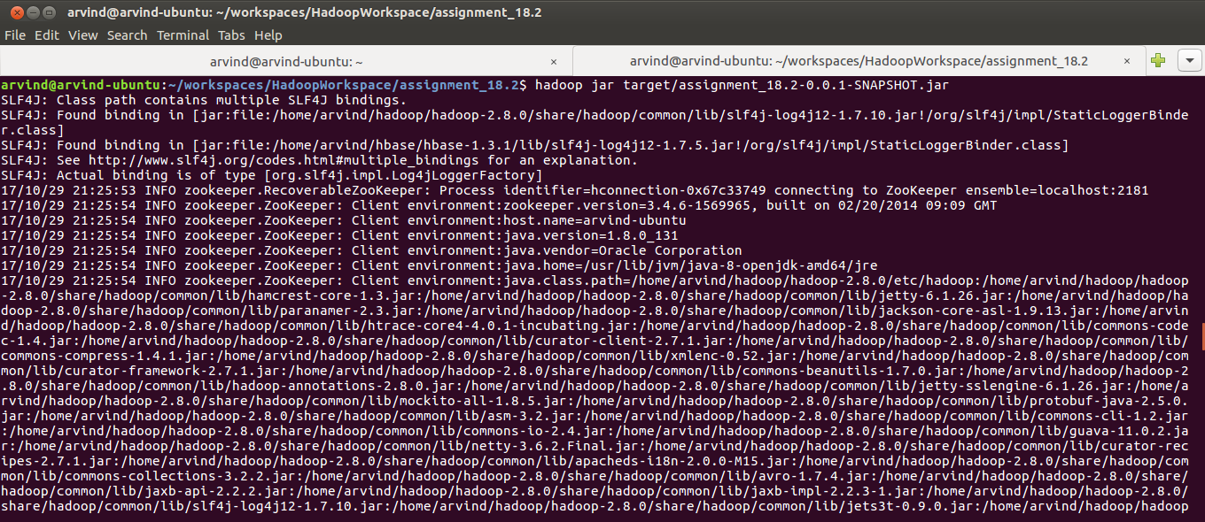

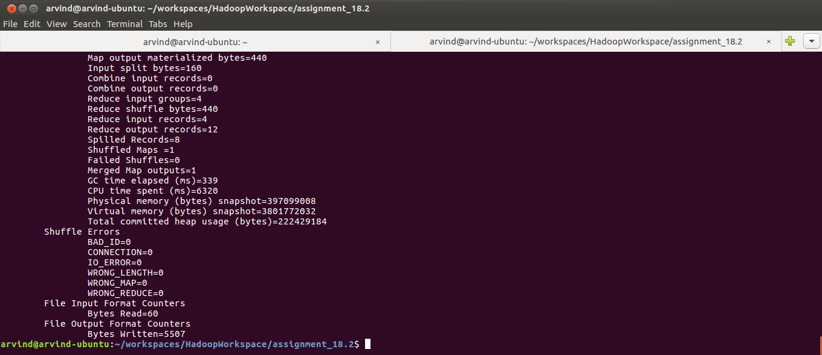

24. After successful execution of the job check the contents of the HDFS directory /user/arvind/hbase/acadgild/assignments/assignment_18.2/output and verify that it contains a folder named ‘details’ (which is the same name as that of the column family) using the command:
hadoop fs -ls /user/arvind/hbase/acadgild/assignments/assignment_18.2/output

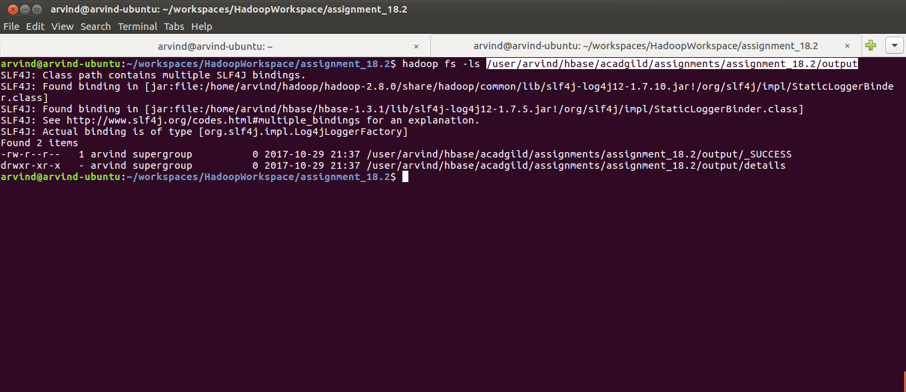

25. Switch back to the Hbase shell and check the list of tables using:
list

26. List the contents of the customer table using the command:
scan ‘customer’
We must get zero rows which indicates that the earlier table was dropped and a new one was created

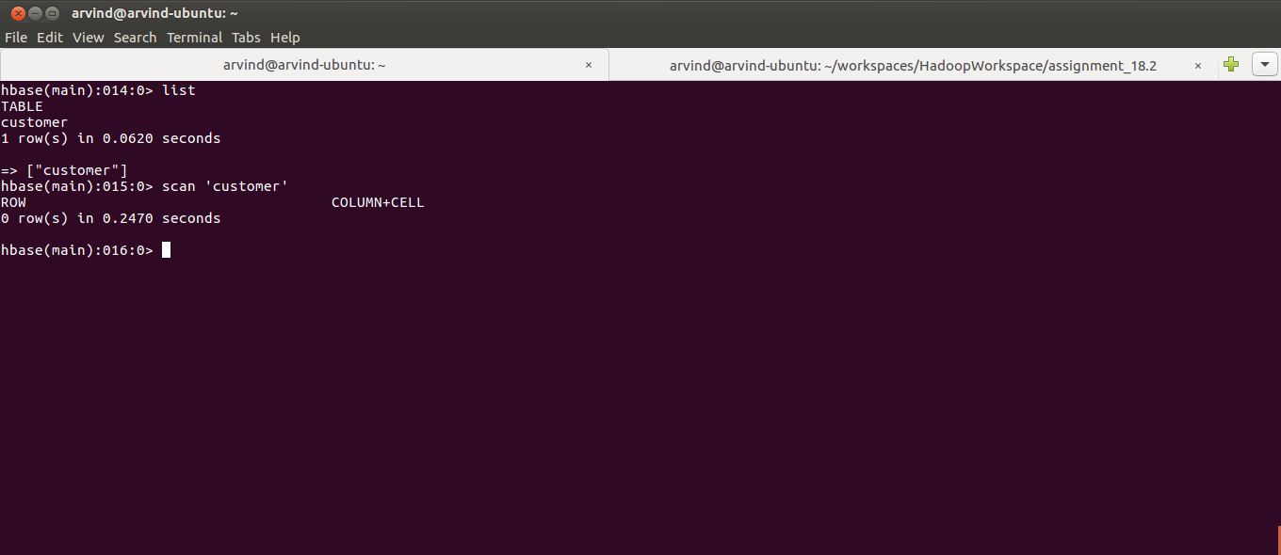

27. Switch to the Linux shell and load the contents of the Hfile into the Hbase table using the command:
hadoop jar target/lib/hbase-server-1.3.1.jar completebulkload /user/arvind/hbase/acadgild/assignments/assignment_18.2/output customer

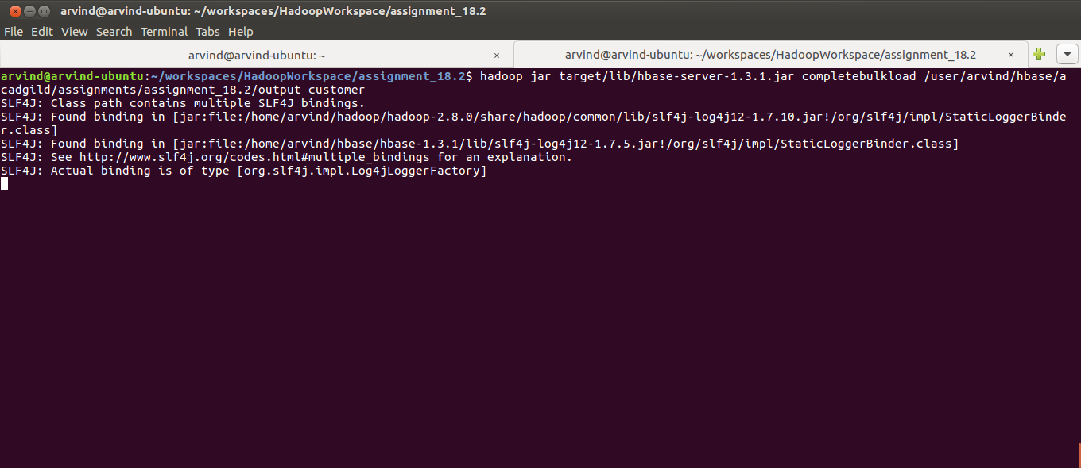

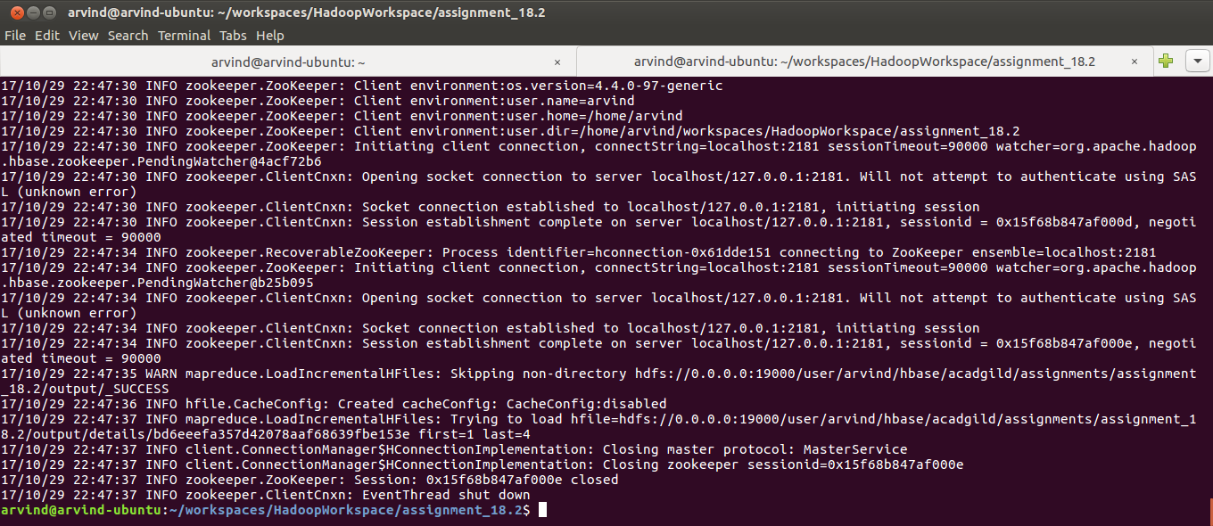

28. Switch to the hbase shell and check the contents of the customer table using the command:
scan ‘customer’

