ASSIGNMENT 19.1

1. Setup the environment and load the customer table by following assignment_18.2.odt included along with the docs folder in this assignment. The input files, jars and the source code for assignment 18.2 has been included in this assignment for reference. Further steps assume that the customer table is already loaded with the input data and hbase and hadoop are both running on the same machine in pseudo distributed mode.

2. Navigate to the sources directory by using the command
cd ~/hbase/acadgild/assignments/assignment_19.1/sources/

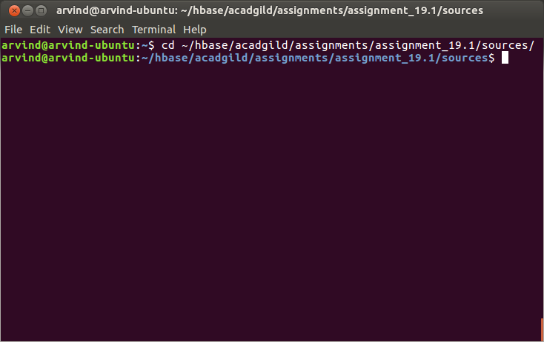

3. Execute the assignment for task 1 by running the command
hive -f task_1.hql

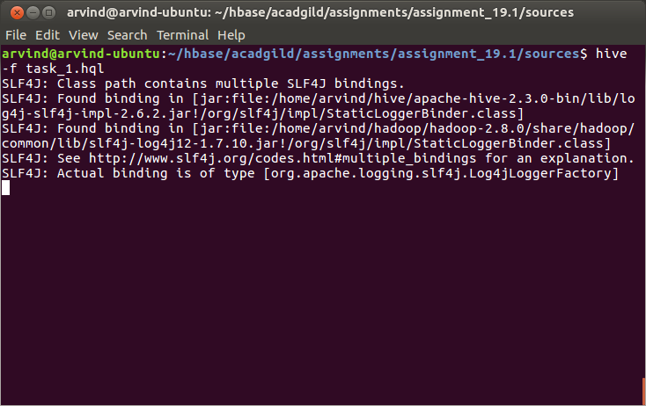
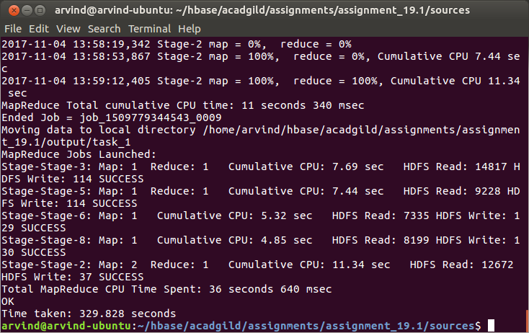

4. Execute the assignment for task 2 by running the command
pig task_2.pig

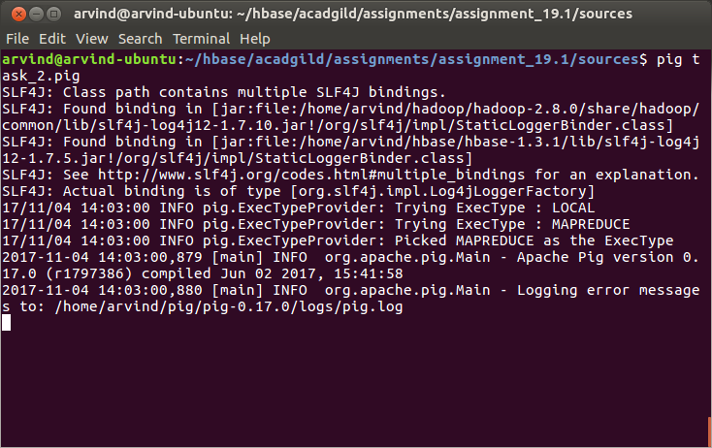
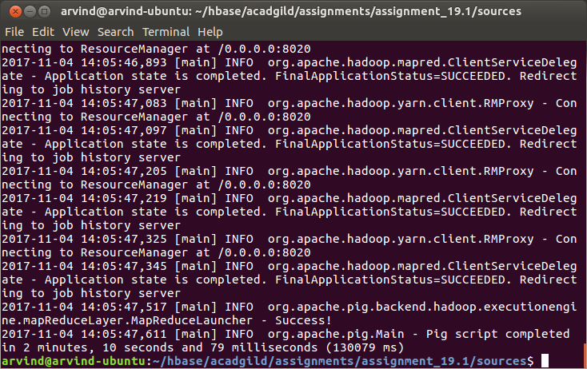
5. Navigate to the output directory of the assignment using the command
cd ../output

6. View the output of both tasks using the commands:
cat task_1/000000_0
cat task_2/part-m-0000*

