ASSIGNMENT 19.2

1. Setup the environment and load the customer table by following assignment_18.2.odt included along with the docs folder in this assignment. The input files, jars and the source code for assignment 18.2 has been included in this assignment’s source/assignment_18.2 directory for reference. Further steps assume that the customer table is already loaded with the input data and hbase and hadoop are both running on the same machine in pseudo distributed mode.

Task 3
2. Open up eclipse and set up a Maven project with the name assignment_19.2. The pom.xml and the Java code have been included within the sources/task_3 directory along with the assignment solution. Make sure that the class is placed inside “com.acadgild” package.

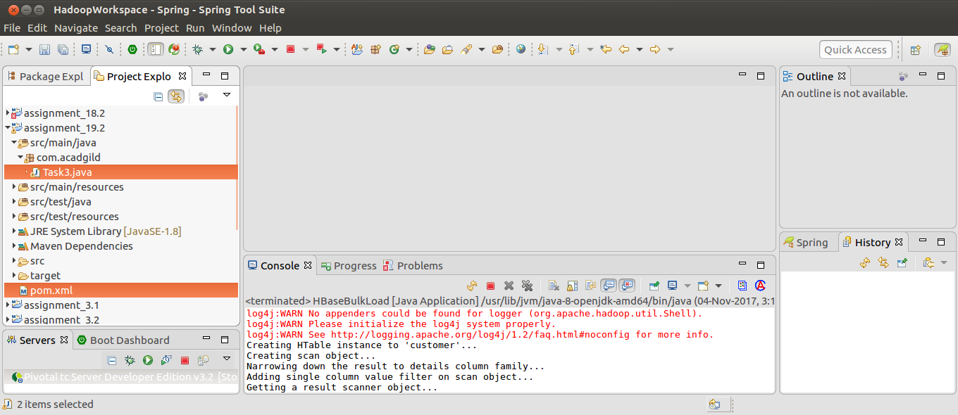

3. Open up a new terminal and navigate to the project location using the command:
cd ~/workspaces/HadoopWorkspace/assignment_19.2/

4. View the contents of the directory using the command:
ls

5. Ensure that a pom.xml is present in the directory
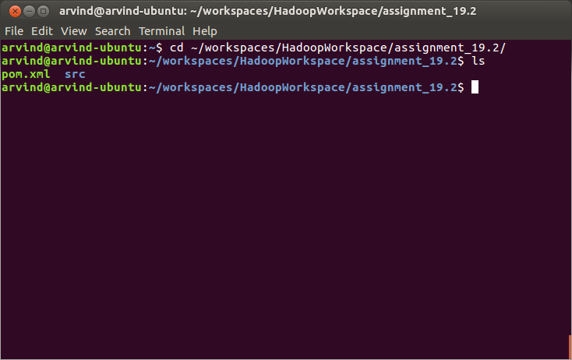
6. Build the project using the command:
mvn clean install

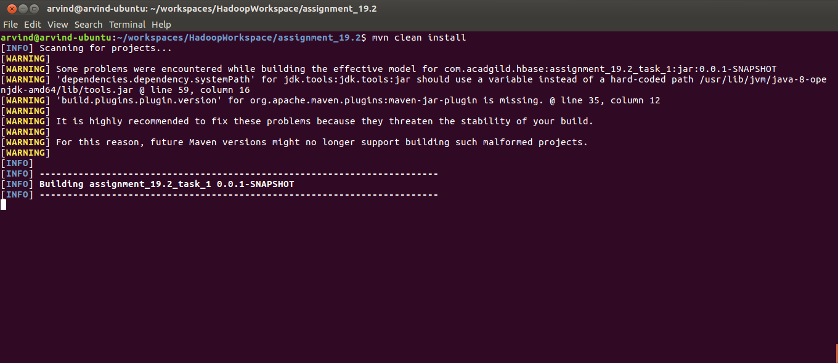

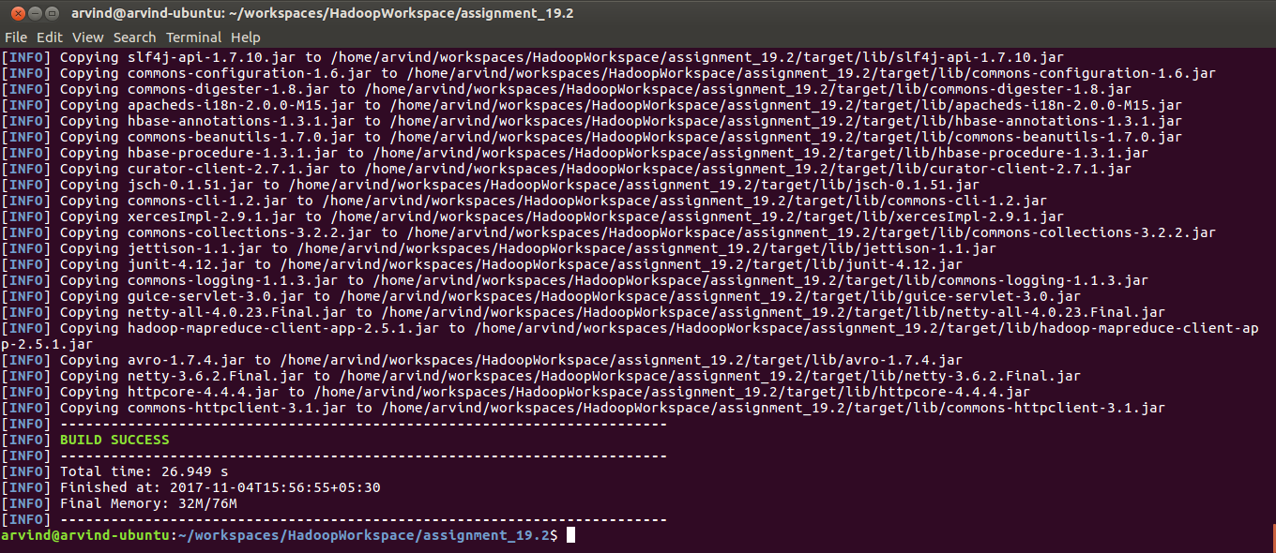

7. Verify that a directory named target has been created using the command:
ls

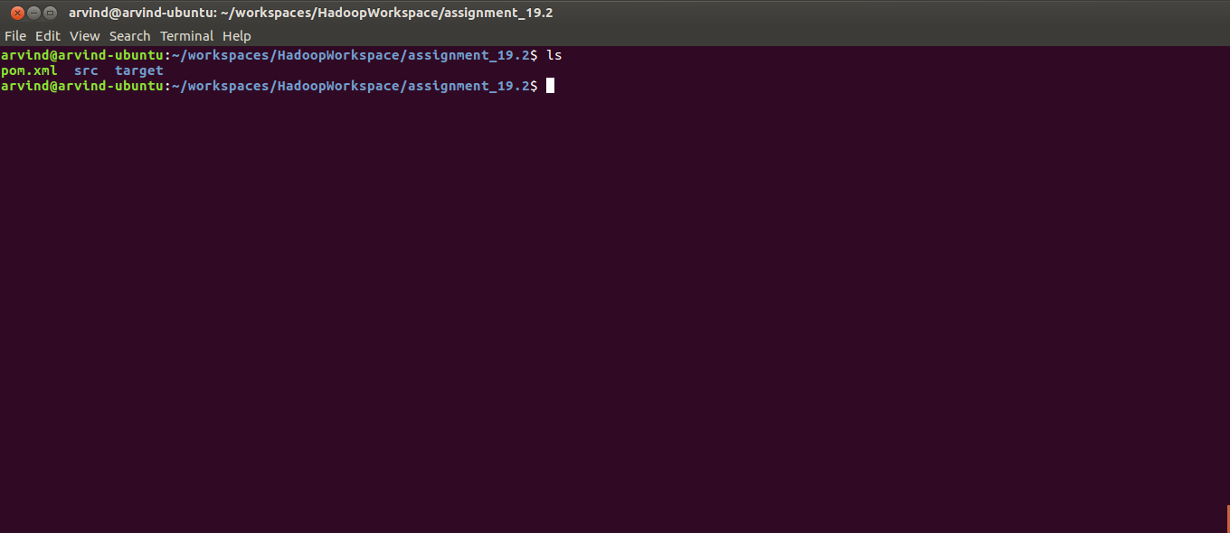

8. Run the JAR using the command
java -jar target/assignment_19.2_task_1-0.0.1-SNAPSHOT.jar

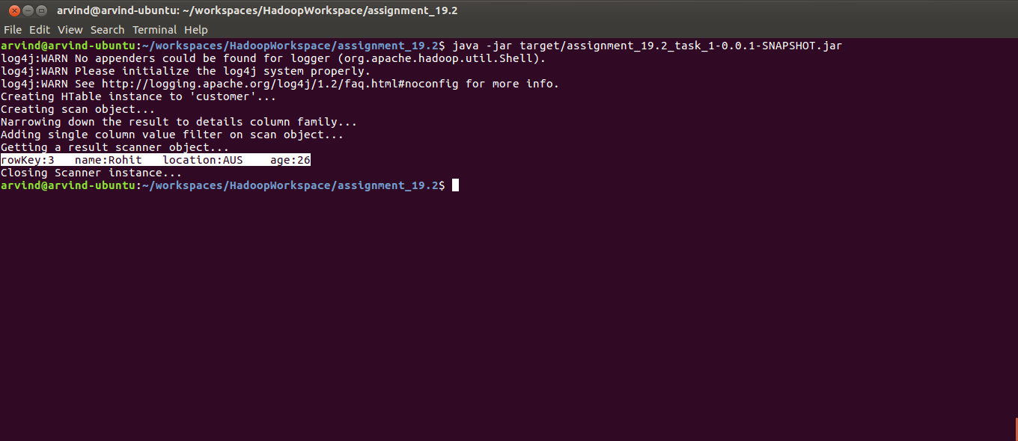

9. To verify if the output is correct, start the hbase shell using the command
hbase shell

10. List the tables using the hbase command
list

11. View the contents of the table using the hbase command
scan ‘customer’

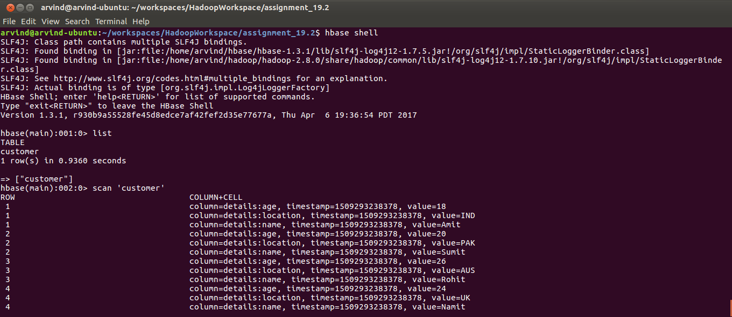
There are 4 rows in the table. Our program has correctly filtered for only those rows whose location value is ‘AUS’

Task 4

12. Navigate to the home directory and create a folder called thrift using:
mkdir thrift

13. Verify using:
ls -l | grep thrift

14. Navigate into the thrift directory using
cd thrift

15. Verify you are in the thrift directory using:
pwd

16. Download thrift server using the command
wget http://www-us.apache.org/dist/thrift/0.10.0/thrift-0.10.0.tar.gz

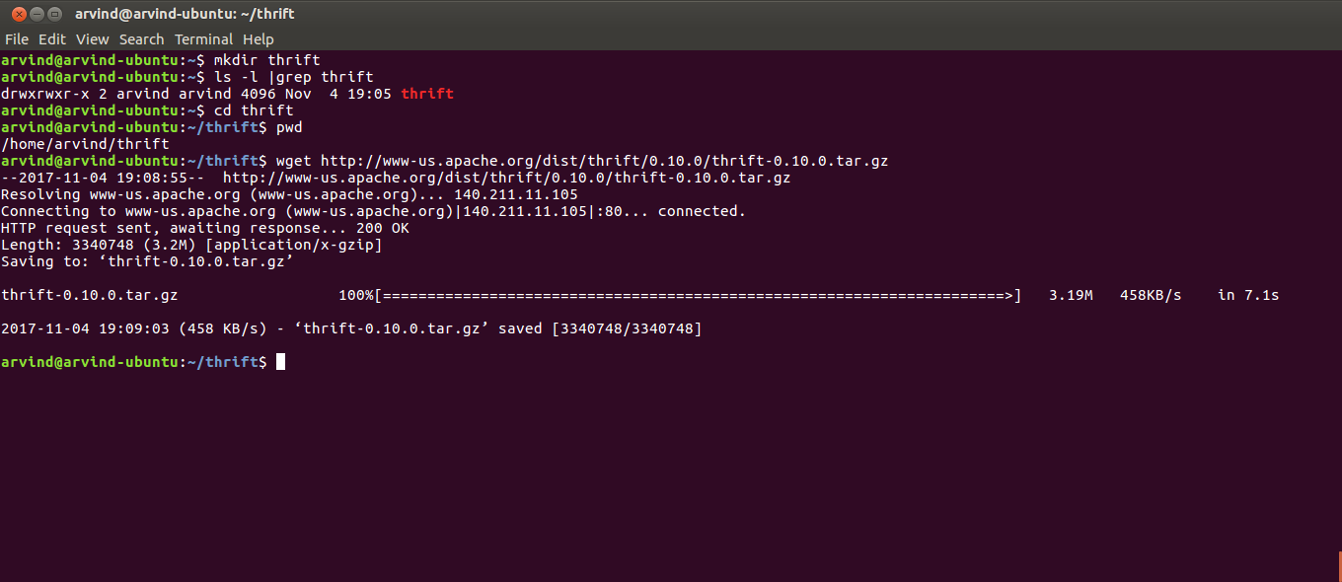

17. Verify thrift server has been downloaded using the command:
ls
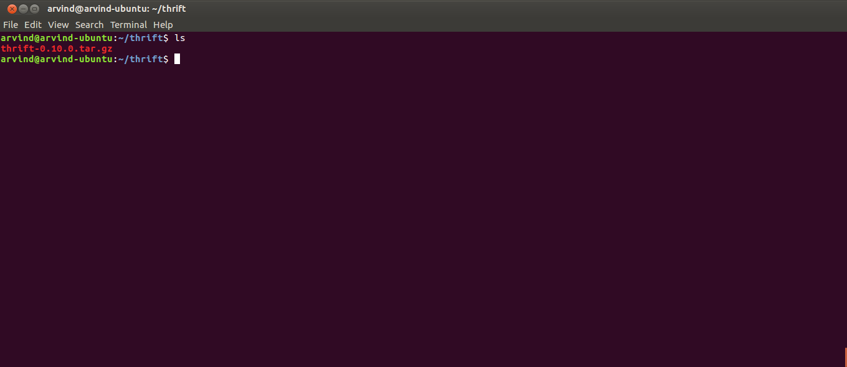
18. Extract the gz archive using:
tar xfz thrift-0.10.0.tar.gz

19. Verify it has extracted using:
ls

You should be able to see a directory named thrift-0.10.0

20. Navigate into the directory named thrift-0.10.0 using:
cd thrift-0.10.0

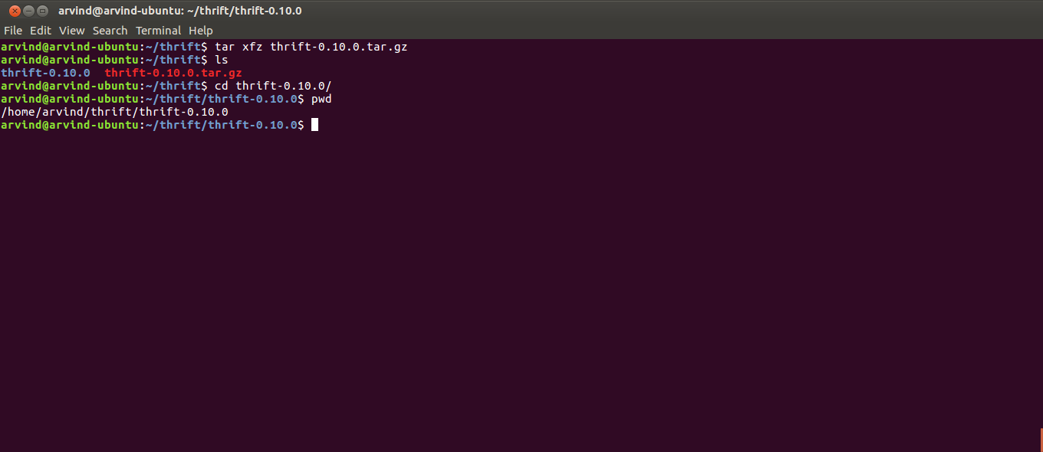

21. Prepare to build thrift in your machine by running
./configure

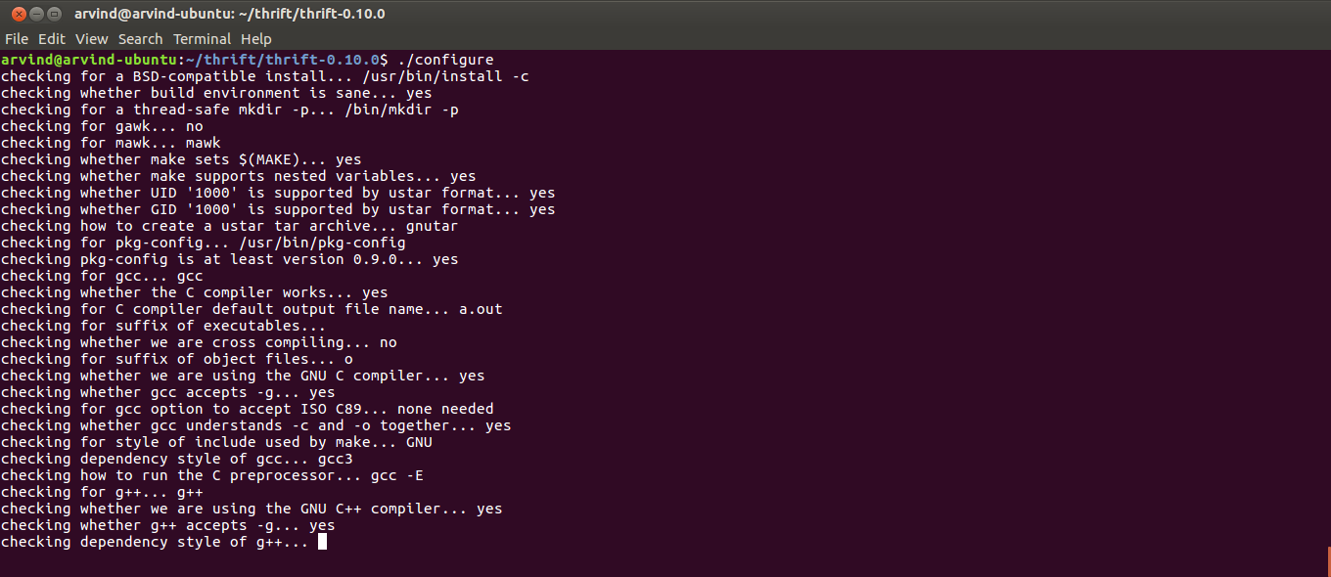
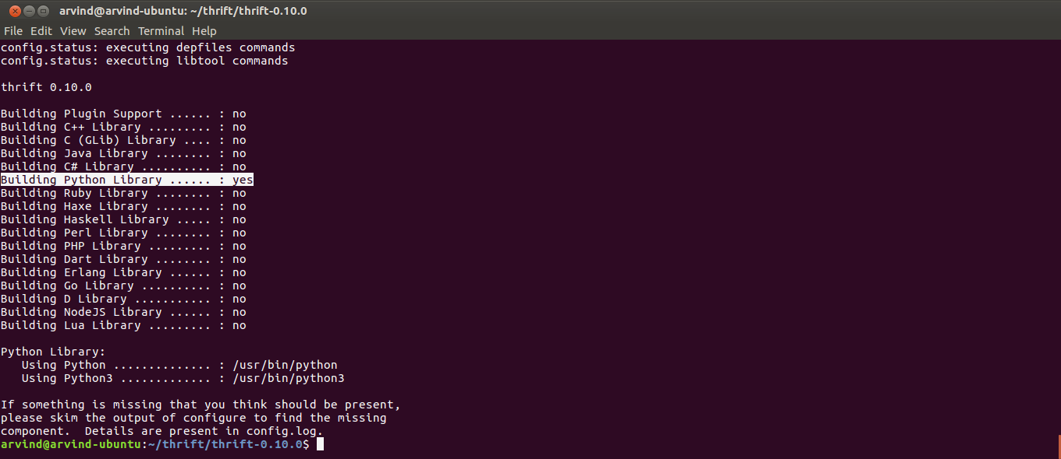
22. Build thrift by running
make

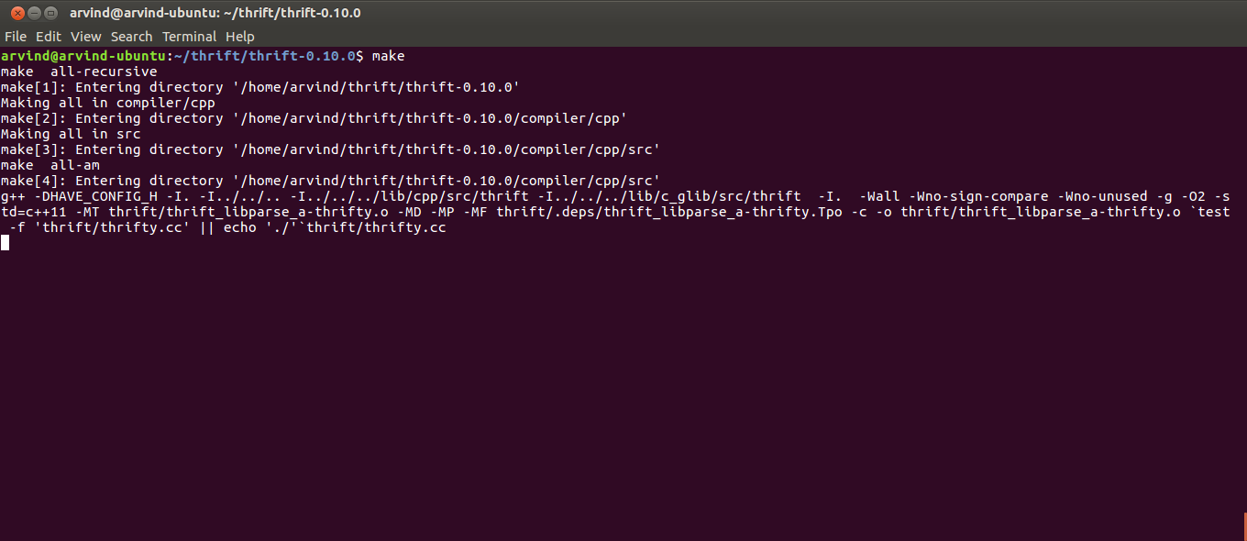
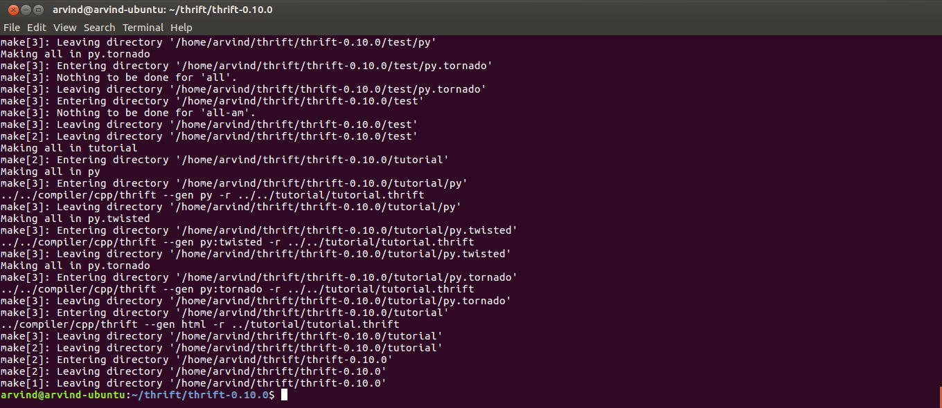
23. Copy the build to the appropriate directory by using:
sudo make install

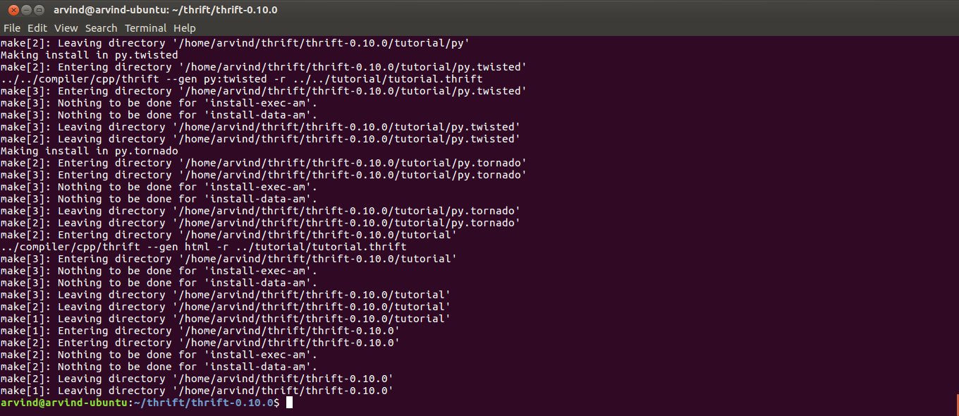

24. Start the Hbase thrift server using
hbase thrift start

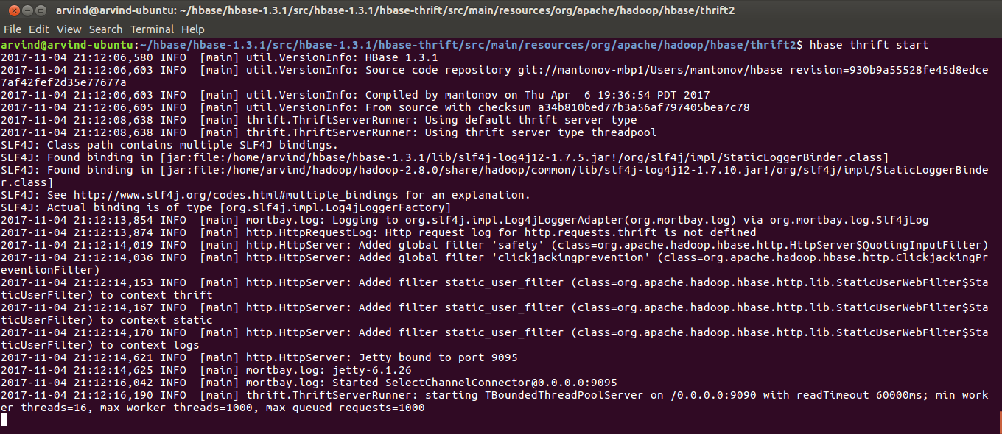
25. Open up a new terminal and navigate to the assignment sources directory
cd /home/arvind/hbase/acadgild/assignments/assignment_19.2/sources/task_4

26. Check if task_4.py has execute permissions using
ls -l

27. Grant task_4.py execute permissions using:
chmod u+x task_4.py

28. Verify again if task_4.py has execute permissions using
ls -l

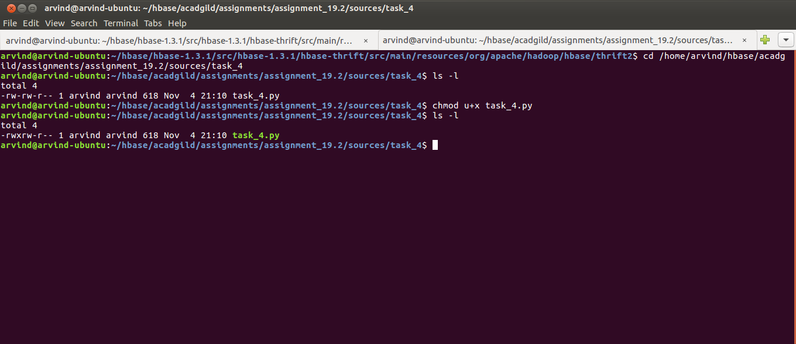

29. Install the pip (the python module installer) using
sudo apt-get install python-pip

30. Install the happybase module in python by
pip install happybase

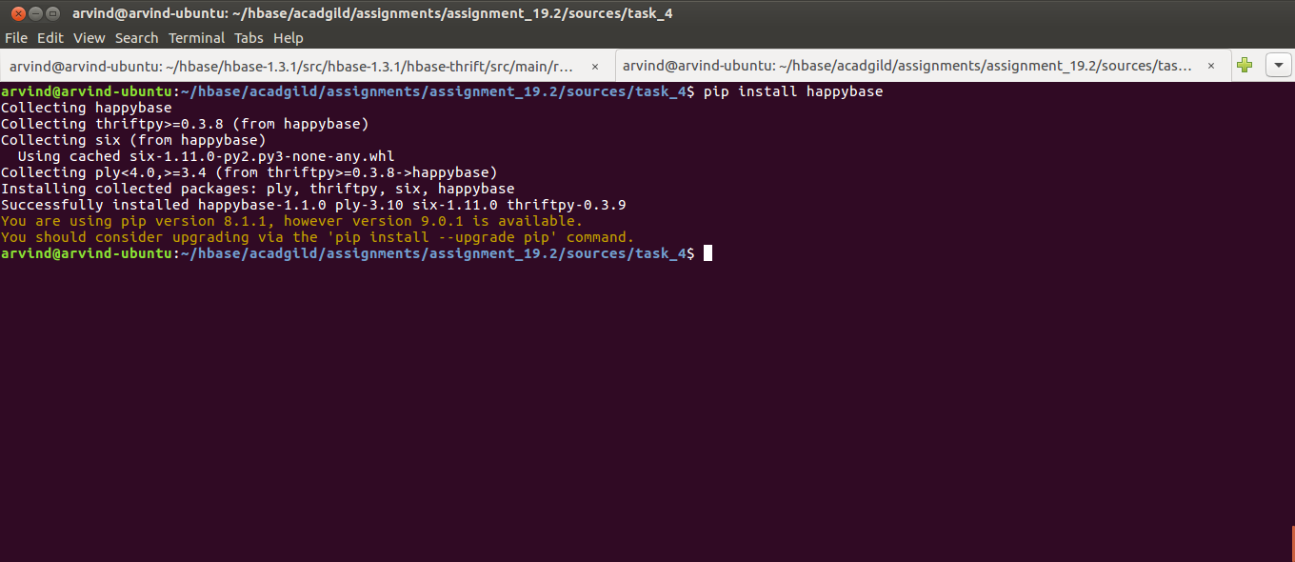

31. Execute task 4 of the assignment:
./task_4.py

