ASSIGNMENT 20.1

Note: This document assumes that Hadoop is already set up in pseudo-distributed mode and $HADOOP_HOME environment variable is also set up. Further, this document also assumes that $HADOOP_HOME/sbin and $HADOOP_HOME/bin are added to the PATH environment variable

1. Open up a new terminal and navigate to the home directory
cd ~

2. Create a new directory ‘sqoop’ in the home directory
mkdir sqoop

3. Navigate into the directory named ‘sqoop’
cd sqoop

4. Download sqoop
wget http://www-eu.apache.org/dist/sqoop/1.4.6/sqoop-1.4.6.bin__hadoop-2.0.4-alpha.tar.gz

5. Extract the downloaded tarball
tar -xzf sqoop-1.4.6.bin__hadoop-2.0.4-alpha.tar.gz

6. Navigate into the directory named sqoop-1.4.6.bin__hadoop-2.0.4-alpha
cd sqoop-1.4.6.bin__hadoop-2.0.4-alpha

7. Get the current working directory and copy it
pwd

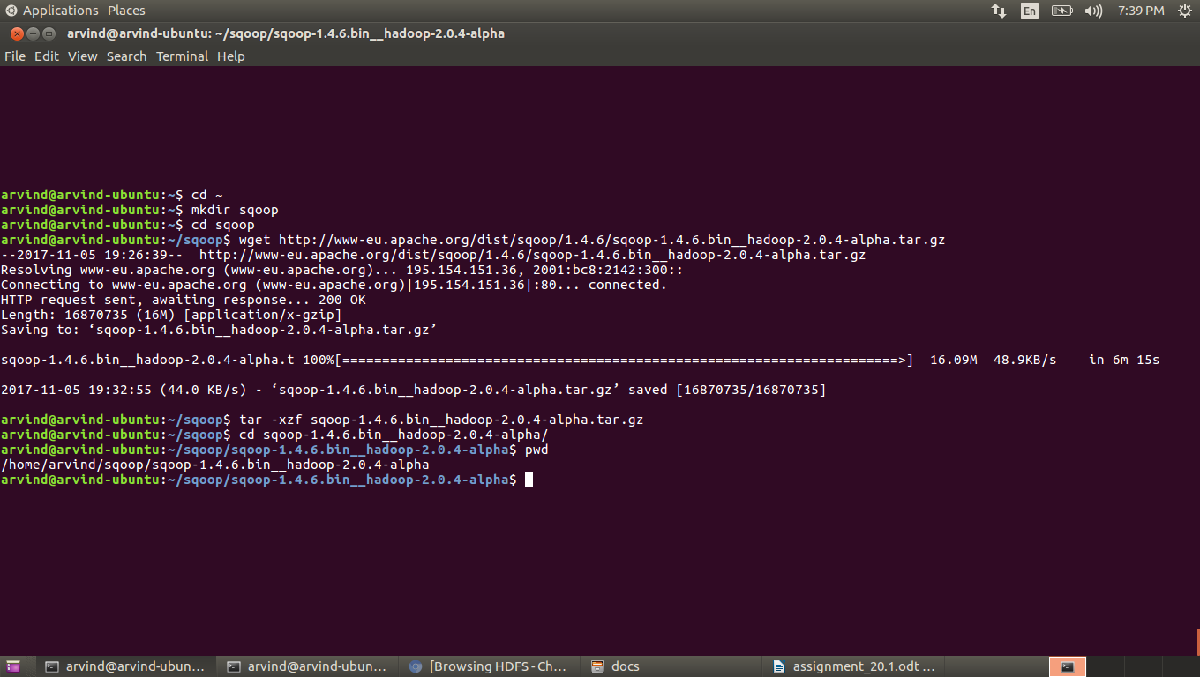
8. Open $HOME/.bashrc using vi and add an environment variable named SQOOP_HOME to it and give it the value of the current working directory copied in the previous step
vi $HOME/.bashrc

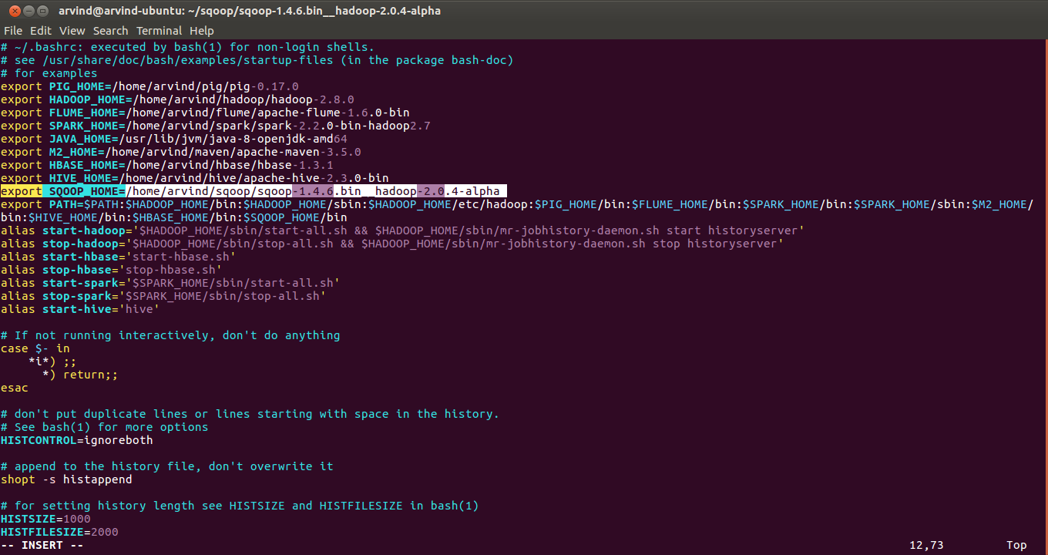
9. Add $SQOOP_HOME/bin to the PATH environment variable

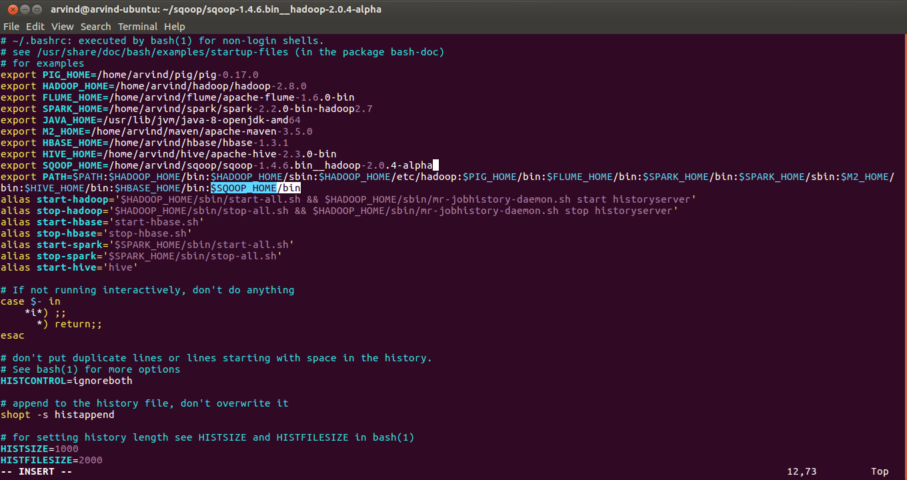
10. Save the file and exit from vi

11. Reload the .bashrc for your shell session
source $HOME/.bashrc

12. Check it has reloaded
echo $SQOOP_HOME

13. Check that sqoop binaries have been added to PATH environment variable
sqoop

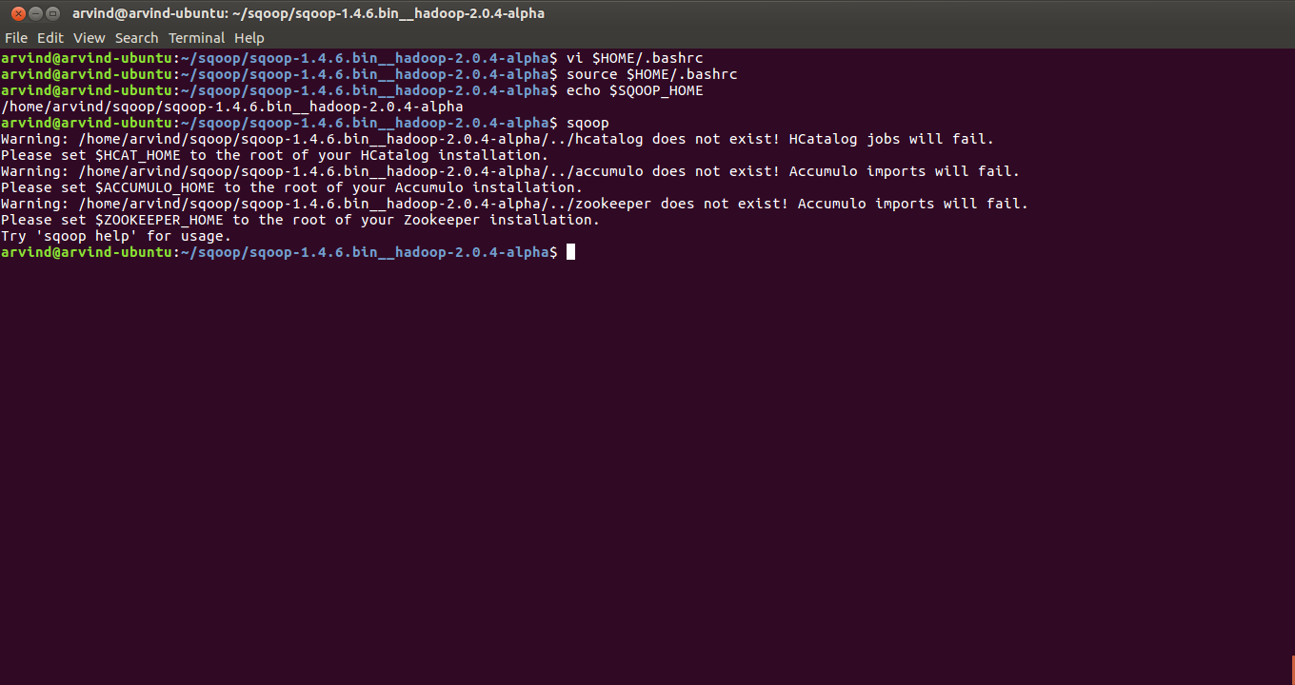
14. Create directories acagild/assignments under $HOME/sqoop
mkdir -p $HOME/sqoop/acadgild/assignments

15. Copy the assignment folder into the $HOME/sqoop/acadgild/assignments folder

16. Start hadoop daemons
start-all.sh

17. Start job history server daemon
mr-jobhistory-daemon.sh start historyserver

16. Create a directory in HDFS for the assignments
hadoop fs -mkdir -p /user/arvind/sqoop/acadgild/assignments/assignment_20.1/input

17. Verify that directories have been created in HDFS
hadoop fs -ls /user/arvind/sqoop/acadgild/assignments/assignment_20.1

18. The input folder given along with the assignment contains 2 CSV files. Both files contain employee data. Each row is of the format (id,name,age). input1.csv contains some data which will be loaded first, input2.csv contains data from input1.csv but the ages of employee with ids 3 and 4 are modified and also a new employee with id 6 is added. Make sure there are no blank lines in the files. Copy these files to HDFS
hadoop fs -put /home/arvind/sqoop/acadgild/assignments/assignment_20.1/input/* /user/arvind/sqoop/acadgild/assignments/assignment_20.1/input/

19. Verify that the files have been uploaded
hadoop fs -ls /user/arvind/sqoop/acadgild/assignments/assignment_20.1/input/
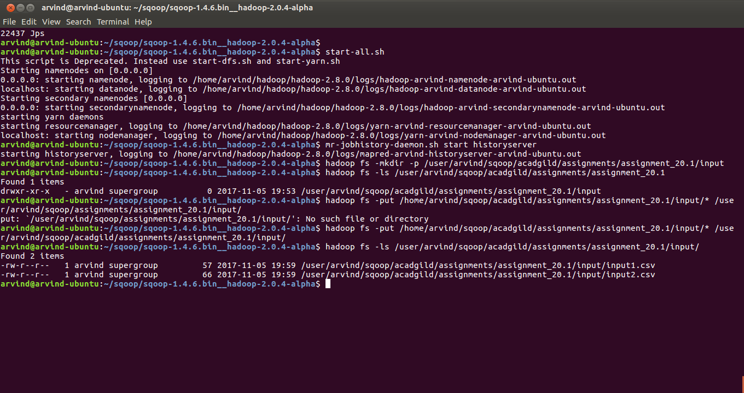
20. Keeping the earlier terminal as it is, open a new terminal and connect to mysql. When prompted for password enter the password of the mysql root user
mysql -u root -p

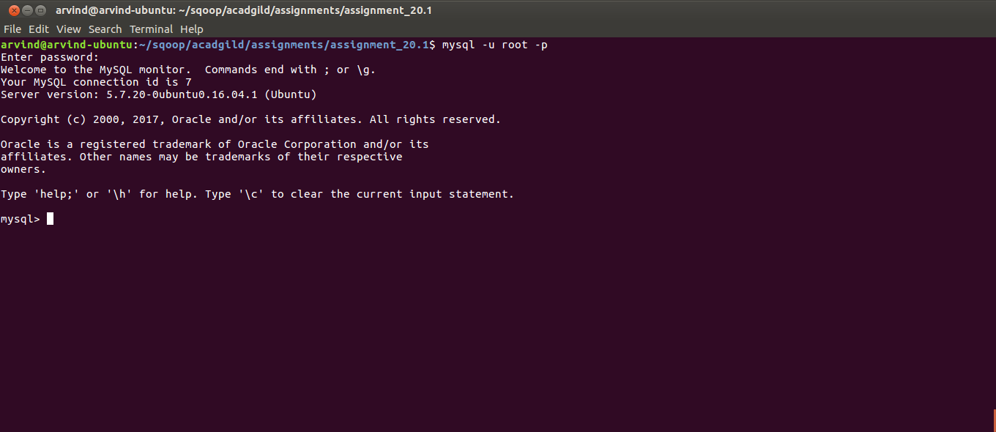
21. Create a database named ‘assignment_20.1’
create database if not exists `assignment_20.1`;

22. Verify that the database has been created
show databases;

23. Switch to the database just created
use `assignment_20.1`;

24. Create a table employees and make sure that the id column is primary key
create table if not exists employees (id int not null primary key,name varchar(50),age int);

25. Verify that the table has been created
show tables;

26. Verify the structure of the table
describe employees;

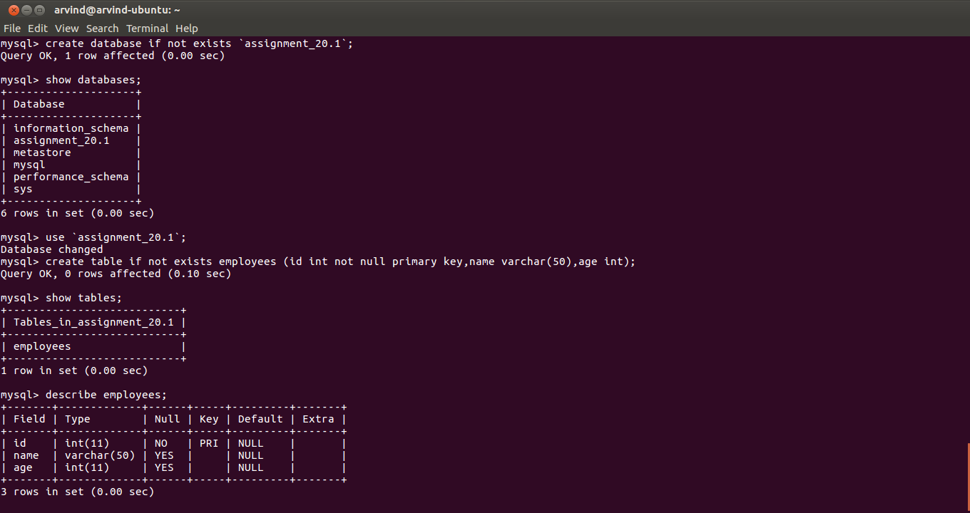
27. Check that the employees table is empty
select * from employees;

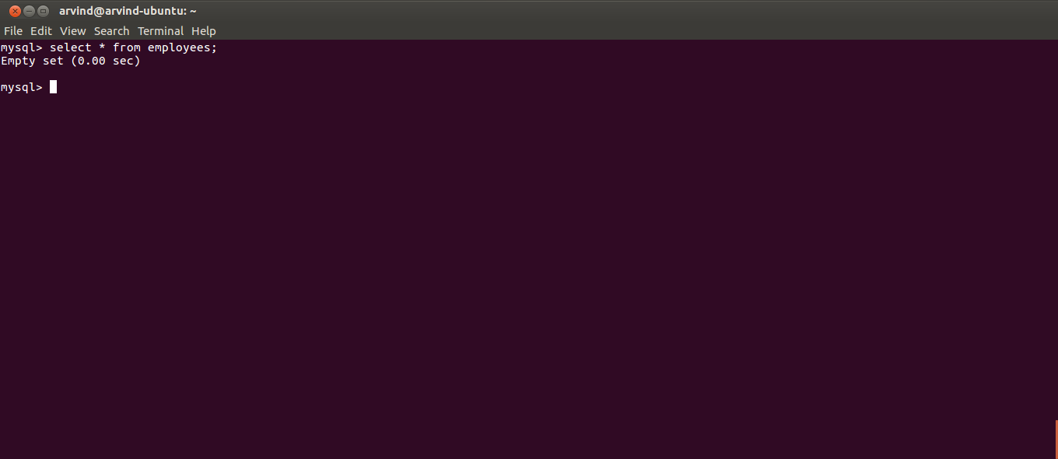
28. Download Mysql Java connector from https://dev.mysql.com/downloads/connector/j/5.1.html

29. Place the connector JAR file in $SQOOP_HOME/lib

30. Import data from input1.csv in HDFS to the employees table in MySQL. Switch to the earlier terminal and run the following command:

sqoop export --connect jdbc:mysql://localhost:3306/assignment_20.1 \
--username root \
--password root \
--table employees \
--update-mode allowinsert \
--update-key id \
--export-dir /user/arvind/sqoop/acadgild/assignments/assignment_20.1/input/input1.csv \
--input-fields-terminated-by ',' \
--columns id,name,age;

Explanation of the various options are:
--connect: the connection string of the MySQL database to which we want to export the data. Also includes the database/schema to which we are exporting the data
--username: username of the MySQL database to which we want to export the data
--password: password of the MySQL database to which we want to export the data
--table: table in the MySQL database to which we want to export the data
--update-mode: whether we want to allow only updates(updatesonly) or inserts too(allowinsert). If set to ‘allowinsert’ we can do updates + inserts(that is upserts)
--update-key: The column in the MySQL table based on which we decide whether a row has to be updated/inserted. If a row with this column value exists, it will be updated else a new row will be inserted. For the upsert to work properly, this should be a primary key or should have a unique constraint
--export-dir: HDFS path where the file to be exported to MySQL database exists. Contrary to the name, this can be a path to a directory or a file
--input-fields-terminated-by: field delimiter in the HDFS file(s).
--columns: comma separated list of columns in the MySQL table specified in the same order as that in the HDFS file name

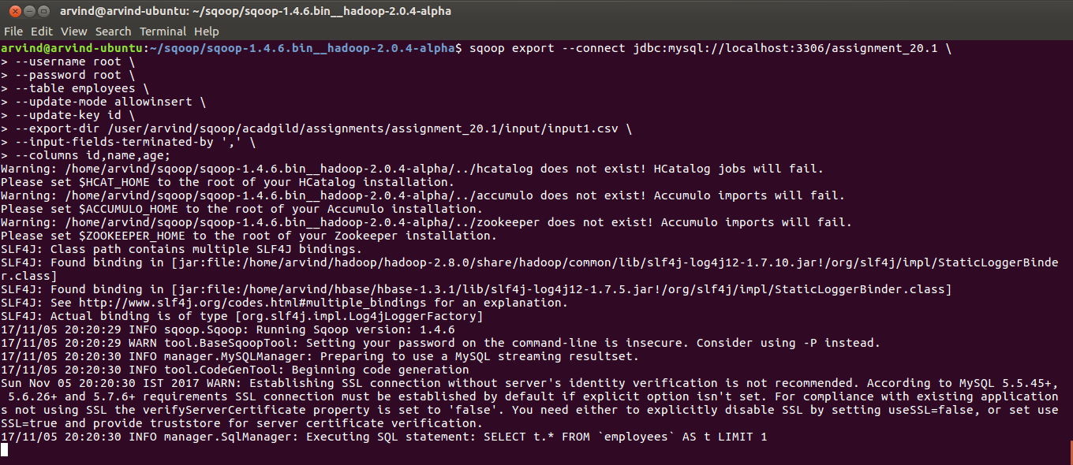
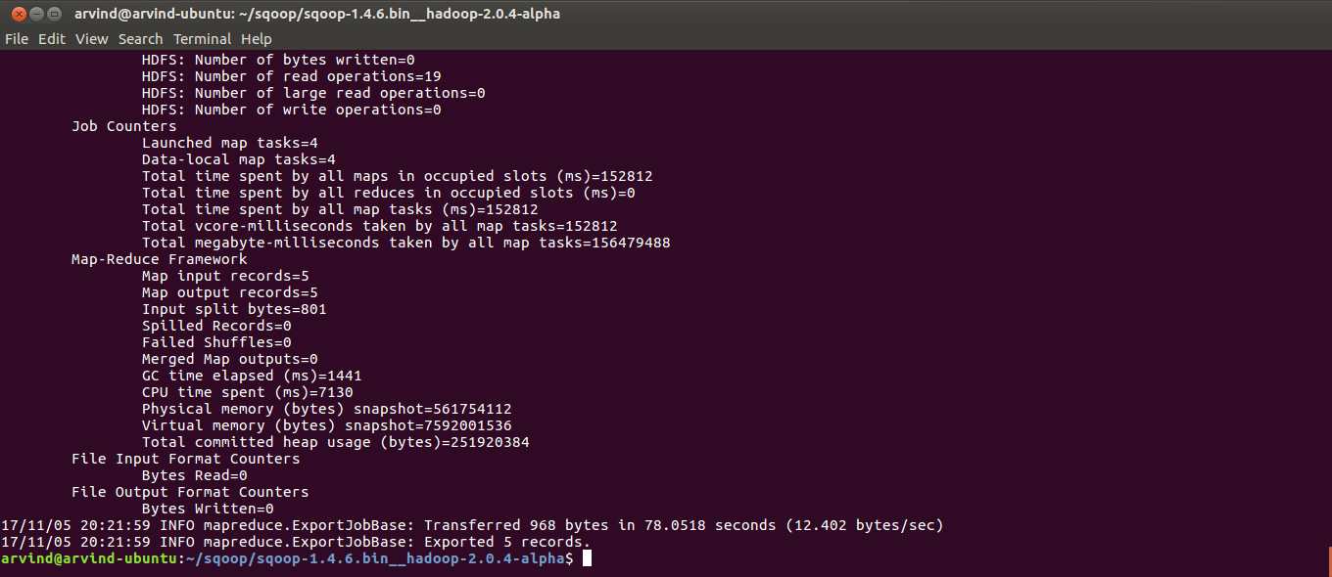
31. Switch to the terminal where the MySQL prompt is open and check the contents of the employees table. We should be able to see 5 records imported
select * from employees;

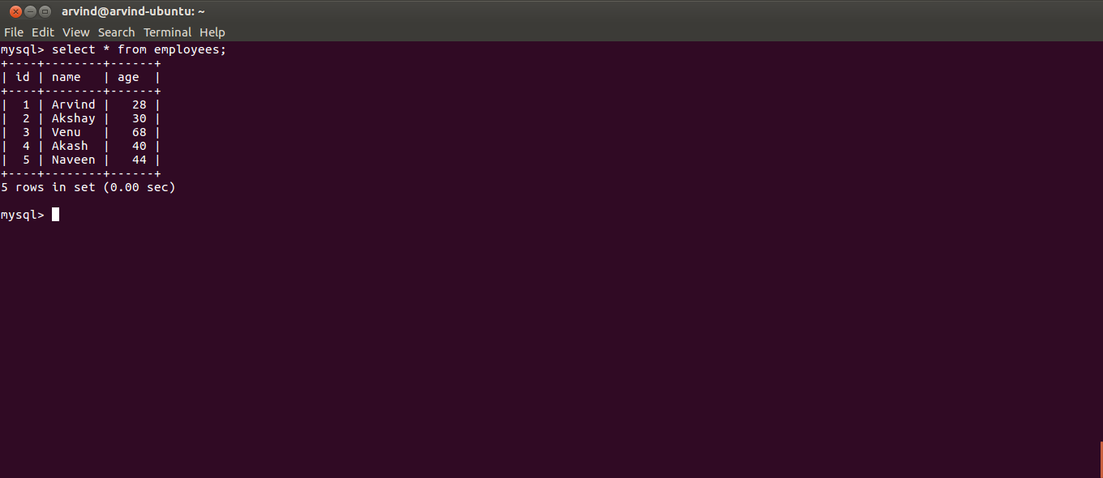

32. Switch to the Linux prompt and run step 30 again to check if duplicates are not inserted into the employees table

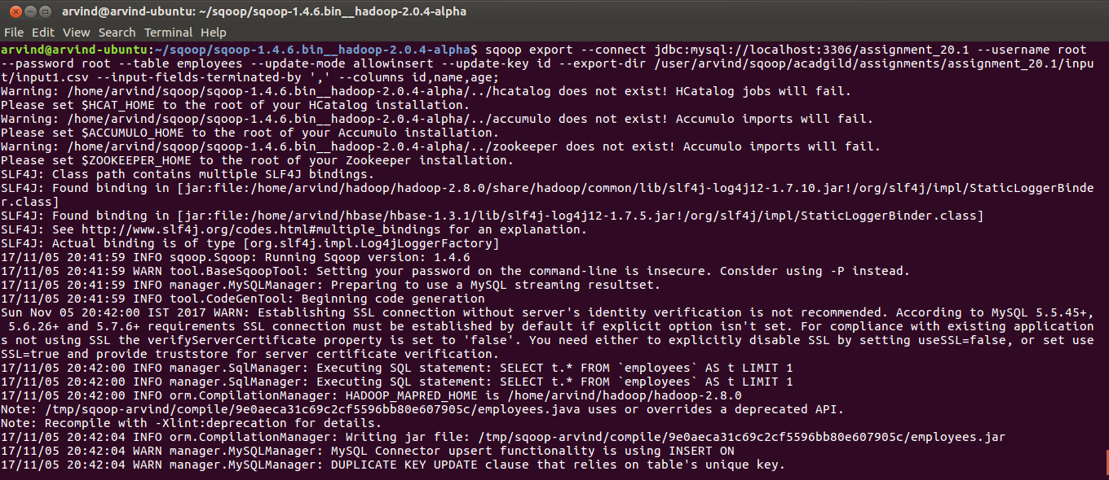
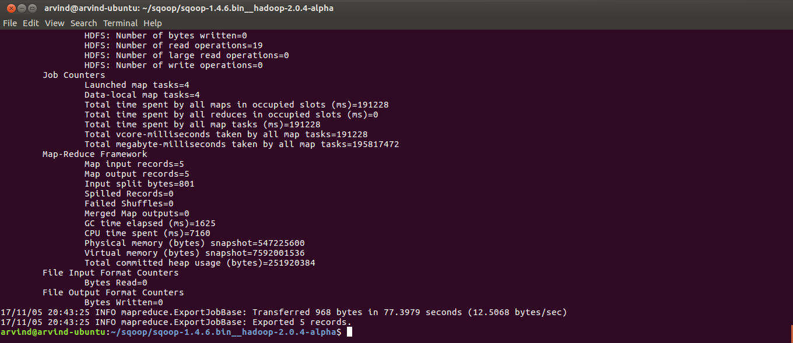
33. Switch to the MySQL prompt and check the contents of the employees table.
select * from employees;

Please note the following:
- We are able to see the same 5 rows.
- The ages of rows with ids 3 and 4 are 68 and 40 respectively
- The maximum employee id is 5

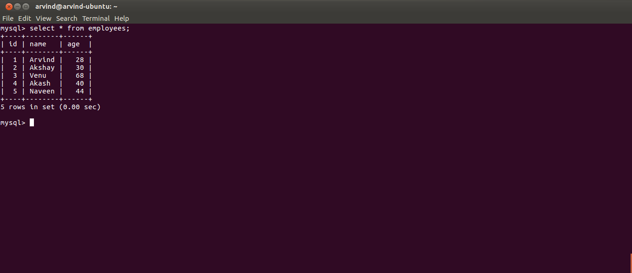
34. Switch to the Linux prompt and run the following command to export input2.csv from HDFS to the employees table. It is the same command as step 30 with only the –export-dir option changed to input2.csv
sqoop export --connect jdbc:mysql://localhost:3306/assignment_20.1 \
--username root \
--password root \
--table employees \
--update-mode allowinsert \
--update-key id \
--export-dir /user/arvind/sqoop/acadgild/assignments/assignment_20.1/input/input2.csv \
--input-fields-terminated-by ',' \
--columns id,name,age;

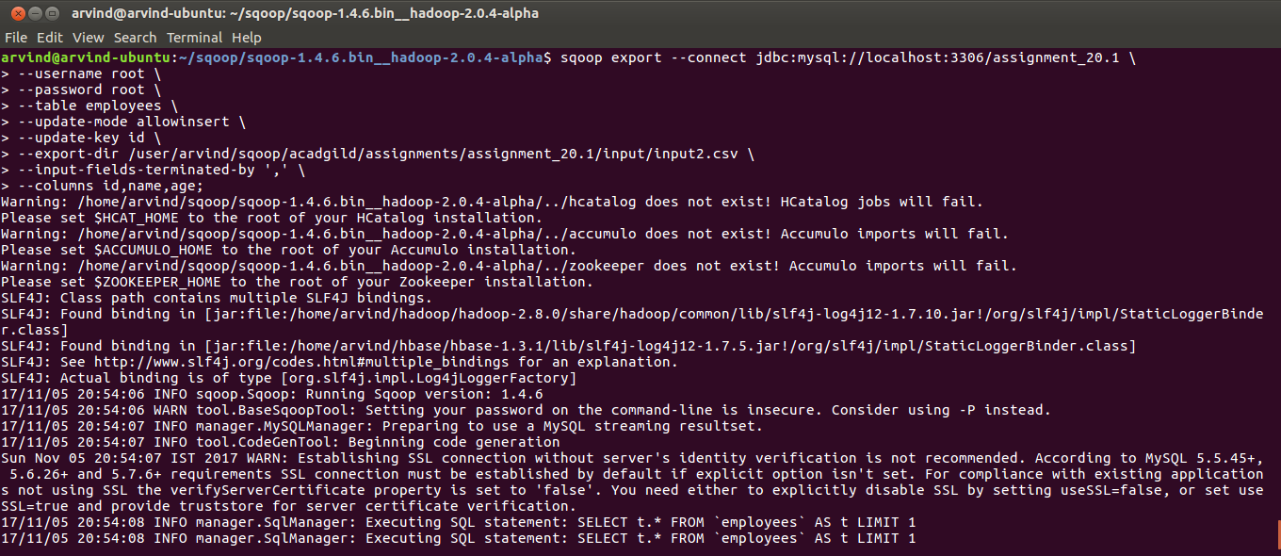

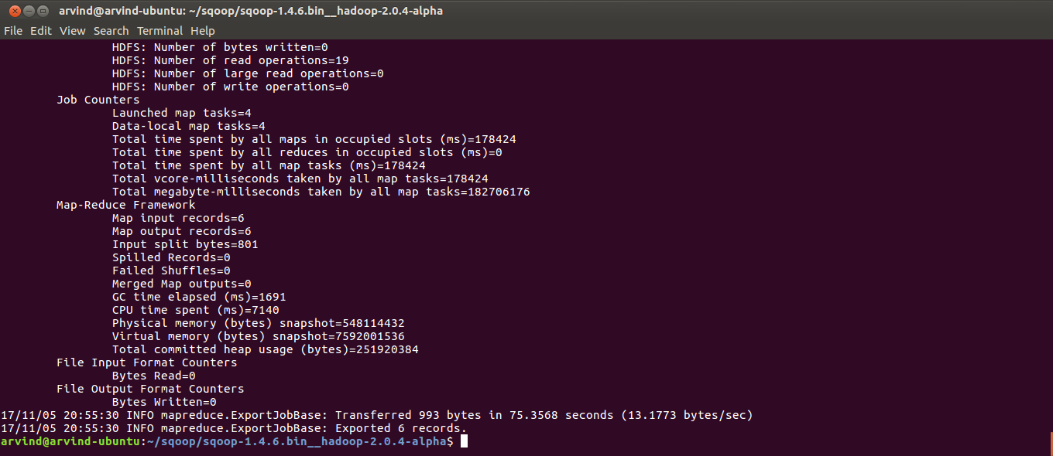
35. Switch to the MySQL prompt and check the contents of the employees table.
select * from employees;

Please note the following:
- There are 6 rows now as compared to 5 earlier
- The ages of employee with ids 3 and 4 are 67 and 42 respecively as compared to 68 and 40 earlier. So updates are successful
- The maximum id is 6 which means a new row has been inserted. So inserts are successful
So, with one command we have done both updates of existing rows and inserts of new rows. In other words, we have done an upsert.

