ASSIGNMENT 20.2

This document assumes that:
- Hadoop is already set up in pseudo-distributed mode and $HADOOP_HOME environment variable is also set up. Further, this document also assumes that $HADOOP_HOME/sbin and $HADOOP_HOME/bin are added to the PATH environment variable
- Sqoop is already set up and $SQOOP_HOME environment variable is also set up. Further, this document also assumes that $SQOOP_HOME/bin is added to the PATH environment variable
- Hive is set up and $HIVE_HOME environment variable is also set up. Further, this document also assumes that $HIVE_HOME/bin is added to the PATH environment variable
- MySQL is set up

1. Start hadoop daemons
start-all.sh

2. Start job history server daemon
mr-jobhistory-daemon.sh start historyserver

3. Create a directory in HDFS for the assignments
hadoop fs -mkdir -p /user/arvind/sqoop/acadgild/assignments/assignment_20.2/output

4. Verify that directories have been created in HDFS
hadoop fs -ls /user/arvind/sqoop/acadgild/assignments/assignment_20.2

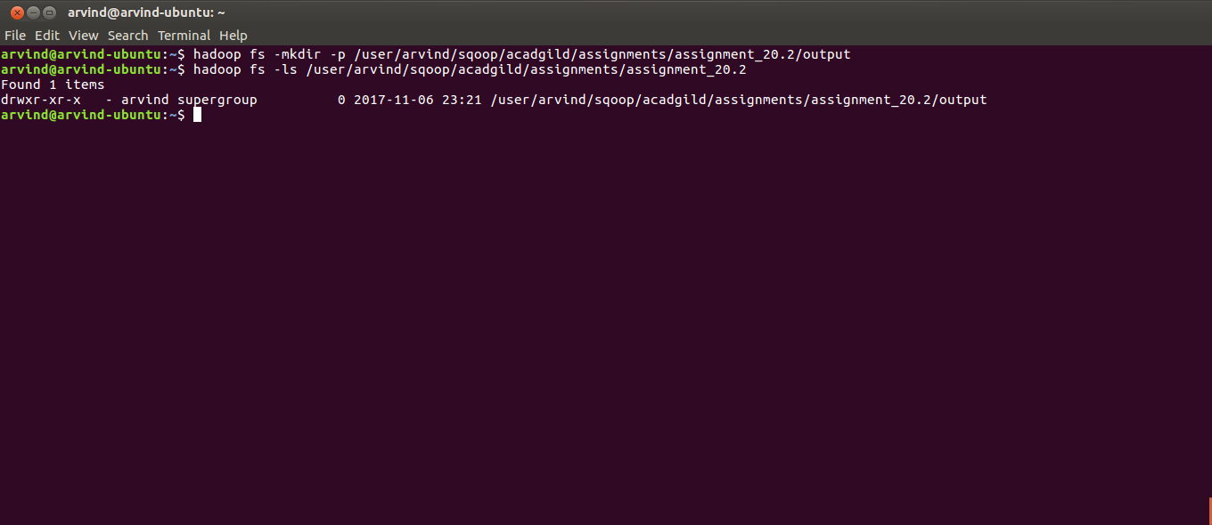
5. Open a new terminal and connect to mysql. When prompted for password enter the password of the mysql root user
mysql -u root -p

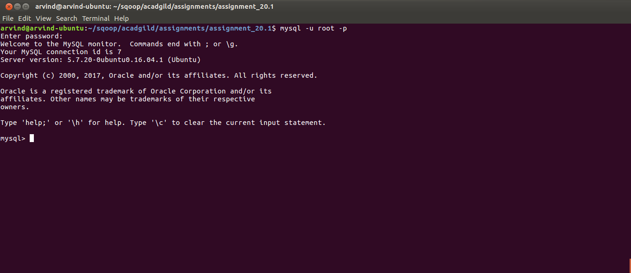
6. Create a database named ‘assignment_20.2’
create database if not exists `assignment_20.2`;

7. Verify that the database has been created
show databases;

8. Switch to the database just created
use `assignment_20.2`;

9. Create a table employees and make sure that the id column is primary key
create table if not exists employees (id int not null primary key,name varchar(50),age int);

10. Verify that the table has been created
show tables;

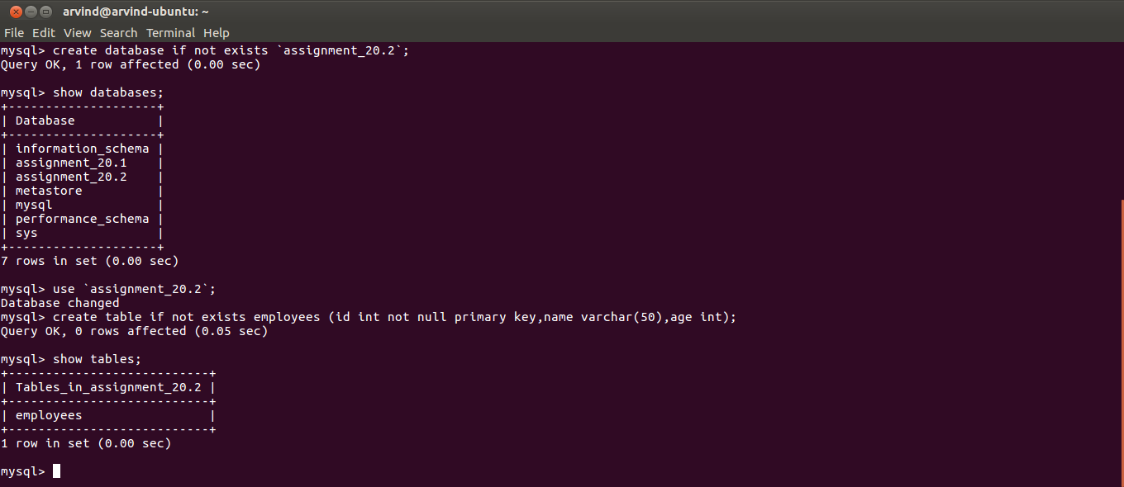
11. Insert some rows into the employees table
INSERT INTO employees(id,name,age) VALUES(1,'Arvind',28),(2, 'Ram',29),(3,'Krunal', 25);

12. Verify that the rows have been inserted
select * from emplyees;

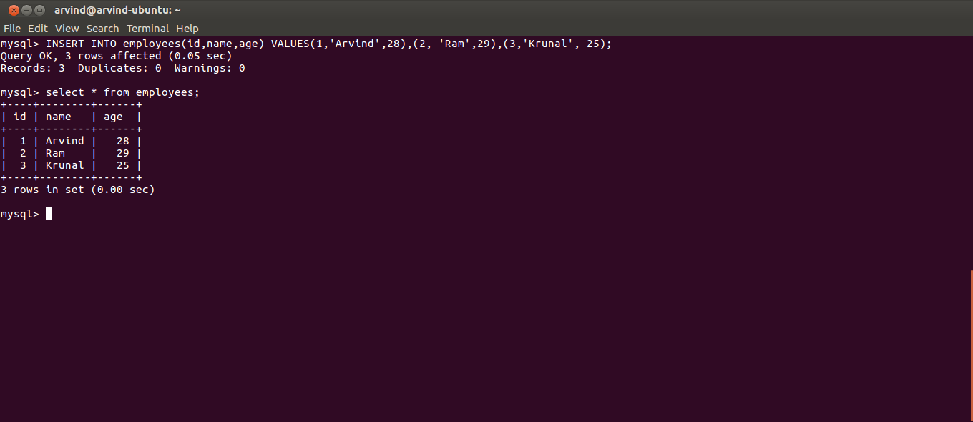
13. Incremental import to Hive via Sqoop is not currently supported. So, as a workaround we will create an external table in Hive which will refer to a location in HDFS. In a later step we will do a Sqoop incremental import to HDFS to the same location. Open a new terminal, start the hive shell and execute the following command

create EXTERNAL table IF NOT EXISTS employees
(
id int,
name string,
age int
)
row format delimited
fields terminated by '\t'
LOCATION '/user/arvind/sqoop/acadgild/assignments/assignment_20.2/output';

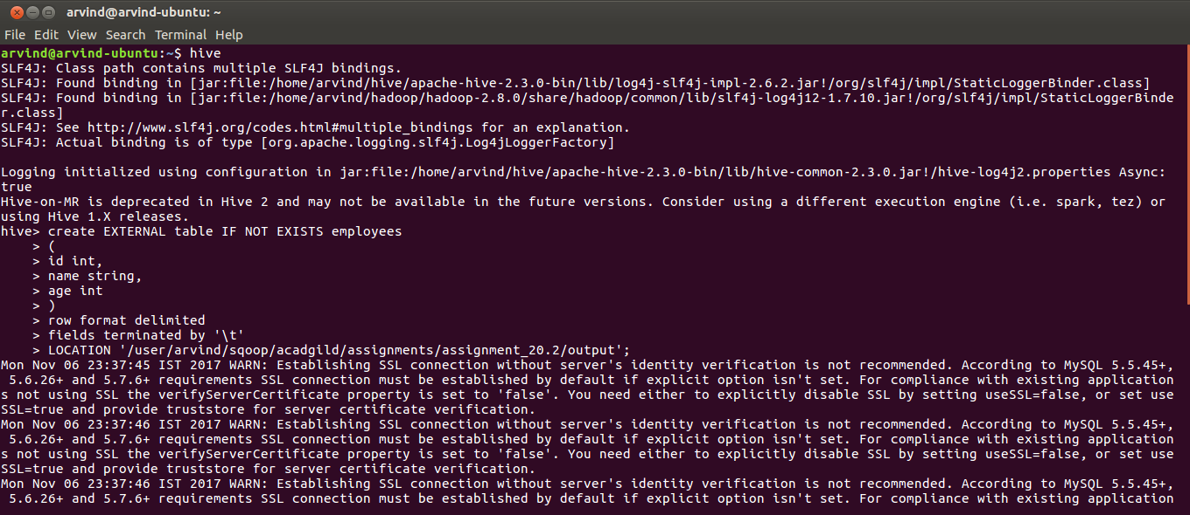

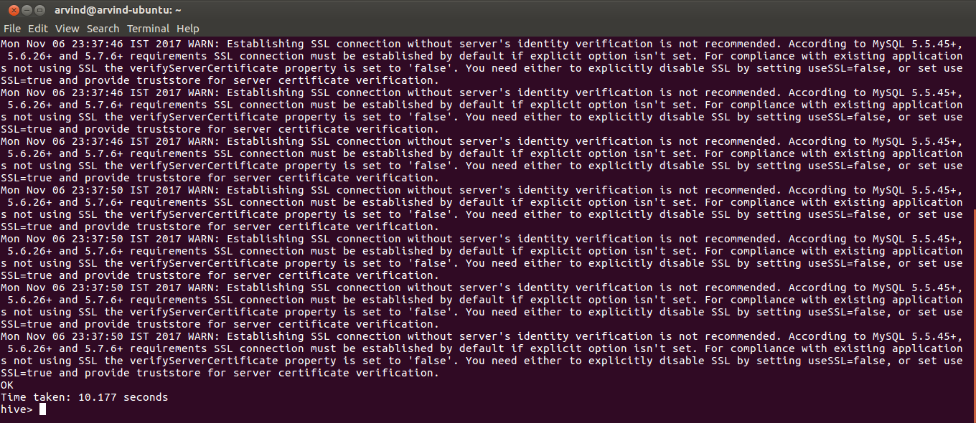
14. Download Mysql Java connector from https://dev.mysql.com/downloads/connector/j/5.1.html

15. Place the connector JAR file in $SQOOP_HOME/lib

16. Switch to the Linux prompt and create a job to import data from MySQL to HDFS

sqoop job --create assignment_20_2_job \
-- \
import --connect jdbc:mysql://localhost:3306/assignment_20.2 \
--username 'root' --P \
--table 'employees' \
--target-dir '/user/arvind/sqoop/acadgild/assignments/assignment_20.2/output' \
--incremental append \
--fields-terminated-by '\t' \
--check-column id \
-m 2;

Explanation of the various options are:
--connect: the connection string of the MySQL database from which we want to import the data. Also includes the database/schema from which we are importing the data
--username: username of the MySQL database from which we want to import the data
--P: this will prompt the user for the MySQL password when running the job
--table: table in the MySQL database from which we want to import the data
--target-dir: HDFS path where the data will be imported
--incremental: When this value is specified as append it means that new rows will be added as per the –check-column option
--fields-terminated-by: field delimiter in the HDFS file(s).
--check-column: column in MySQL table based on which Sqoop decides if a row is new or existing

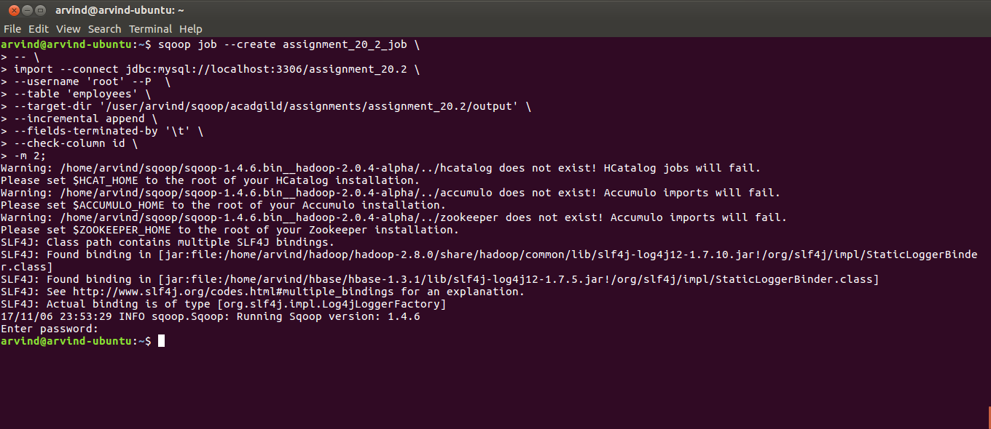
17. Execute the job as
sqoop job --exec assignment_20_2_job

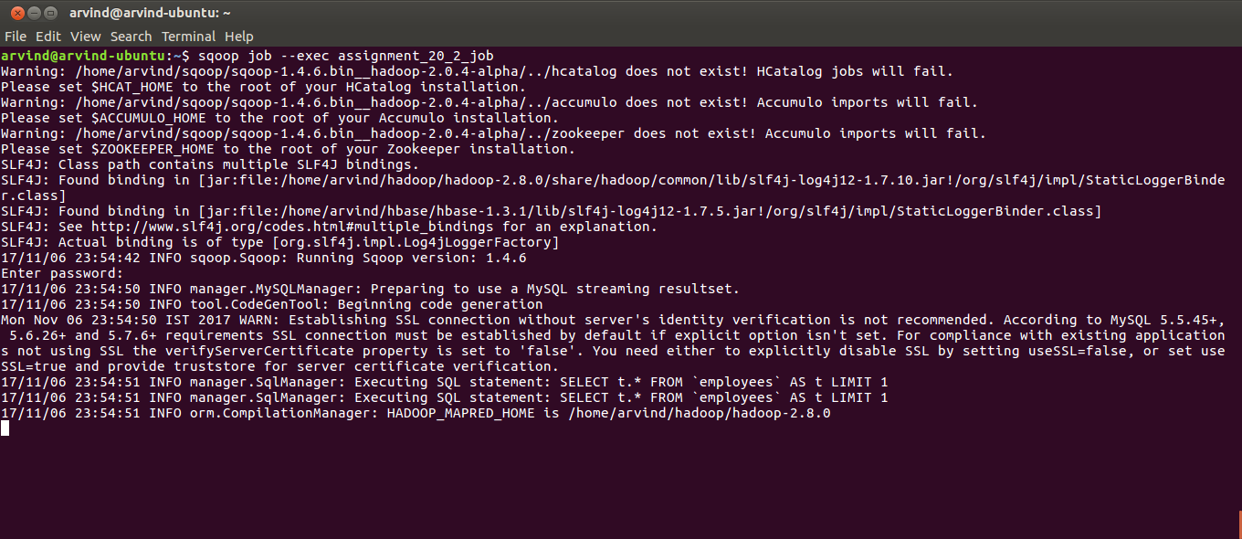

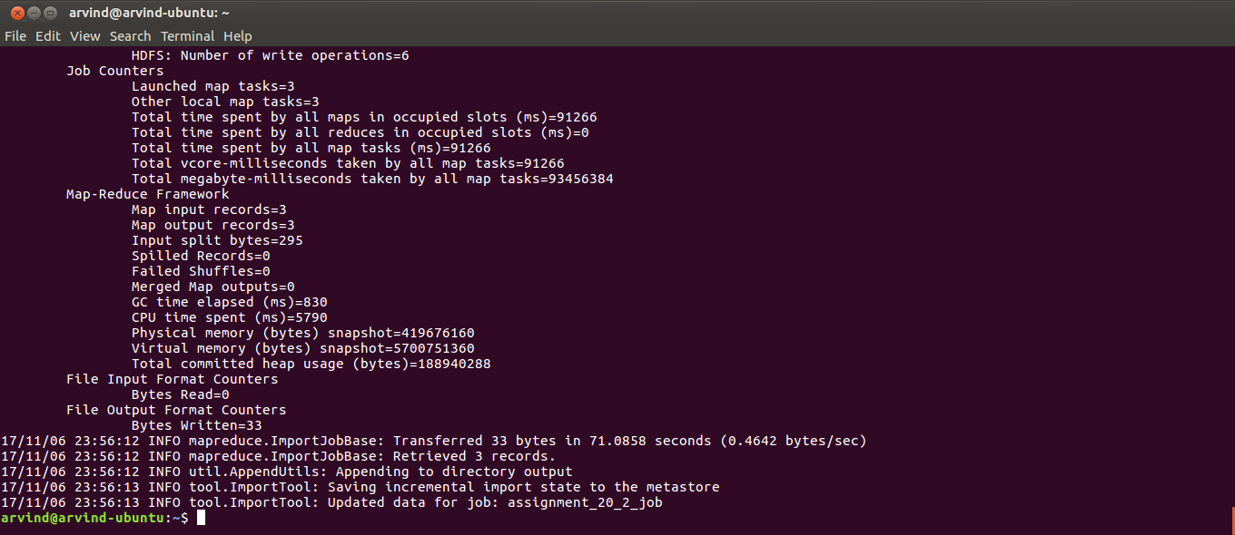

18. Switch to the Hive prompt and check the contents of the employees table
select * from employees

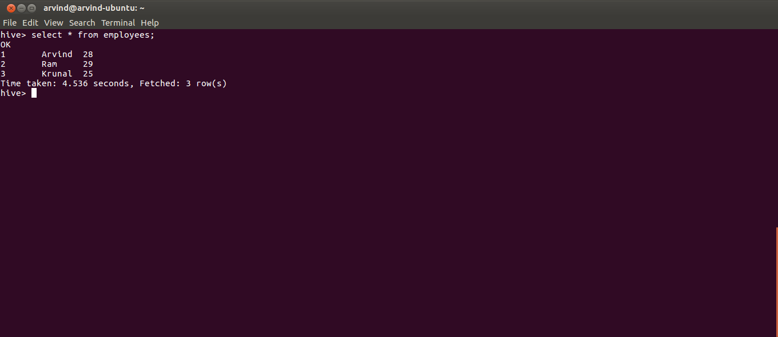
19. Switch to the MySQL prompt and insert a new row into the employees table
INSERT INTO employees(id,name,age) VALUES(4,'Krishna', 40);

20. Verify that the new row has been added
select * from employees;

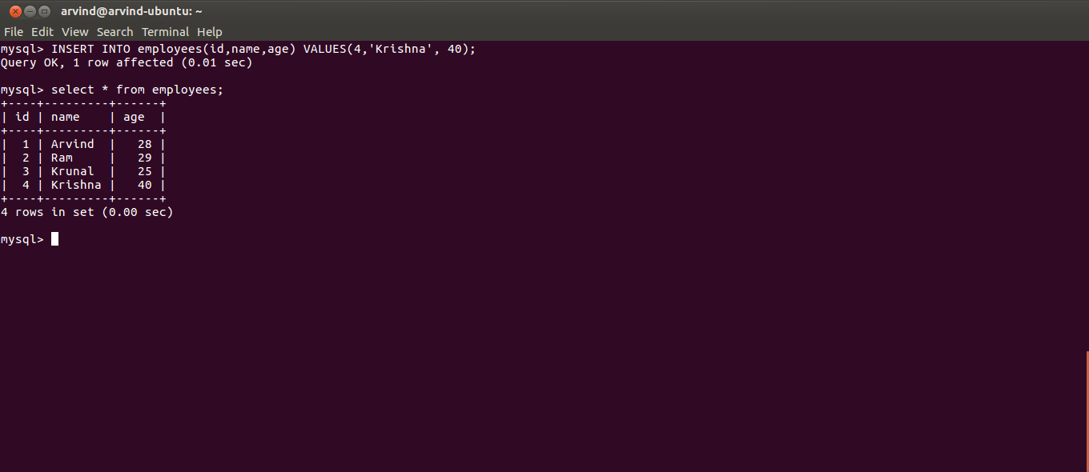
21. Switch to the Linux prompt and run the Sqoop import job again
sqoop job --exec assignment_20_2_job

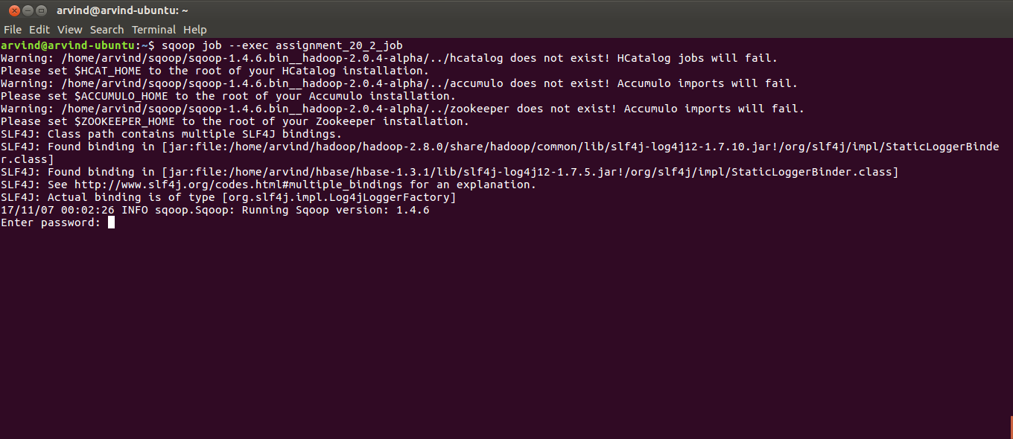
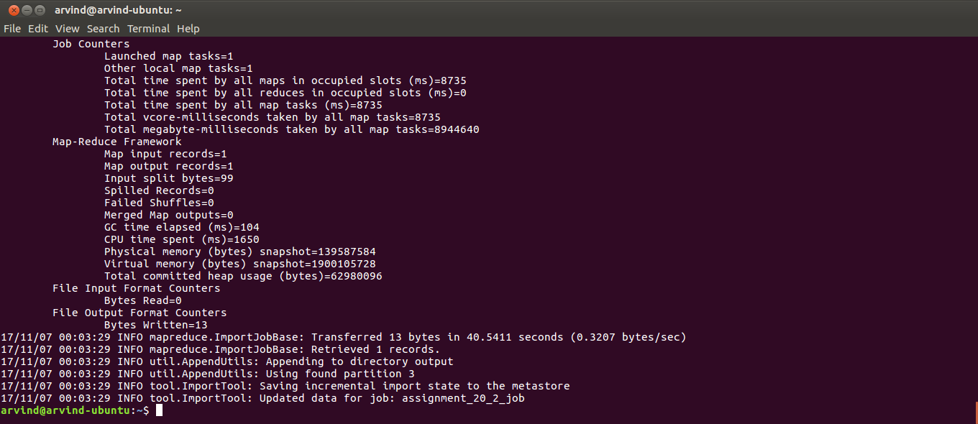
22. Switch to the Hive prompt and verify that the new row has been added to the Hive employees table
select * from employees;

Note: Incremental import has been done successfully in Hive using Sqoop
