**make_remote_dirs_and_copy_input.sh take 2 inputs, the assignment number and task number..**

1. It verifies if the input file and the jar for the assignment are kept in the appropriate location in the local file system using ls -l command.
2. Delete input and output directories in the hdfs for this assignment and task if already exists using hadoop fs -rm -r command(delete the folder and all its contents recursively)
3. Create a directory in HDFS for this assignment and task using hadoop fs -mkdir -p command
4. Copy the input from local file system to hdfs using hadoop fs -put command
5. Finally verify using hadoop fs -ls command if the input file has been copied into the HDFS

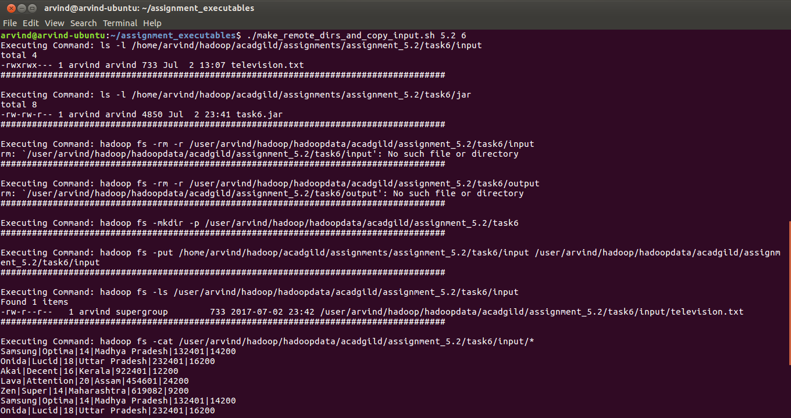

**mapred_process also takes assignmetn number and task number as input**

1. It executes the JAR from the local file system using hadoop jar command

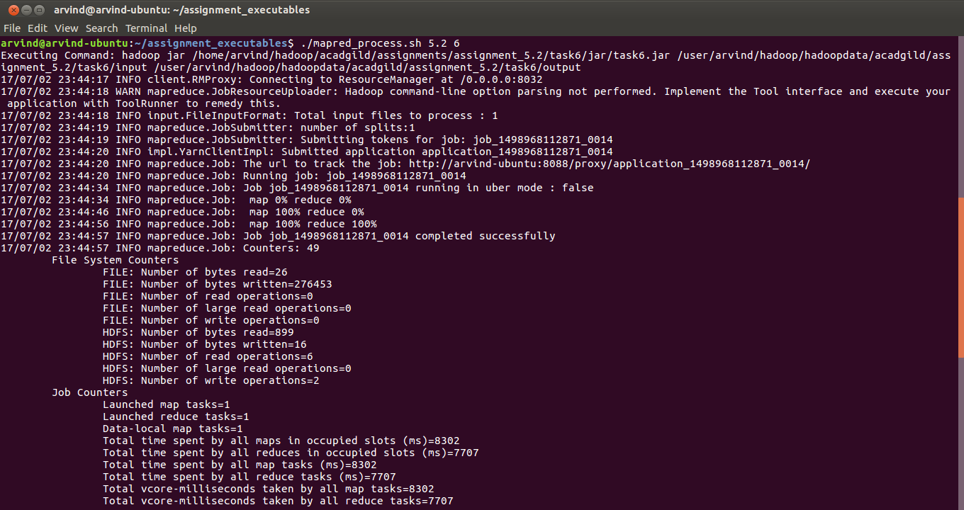

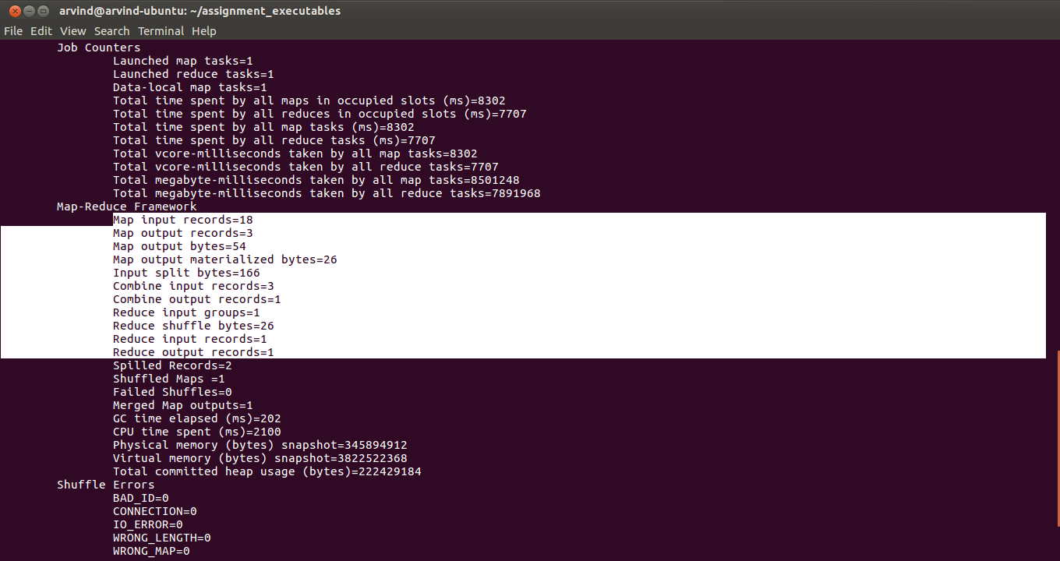

Please note that since we are using combiner you can see certain records in Combine input records and Combine output records counter

**output.sh also takes assignmetn number and task number as input**

1. It lists all teh files in the output directory for this assignment and task job in HDFS.
2. It displays the content of all the output files
3. Finally it copies the output files fromHDFS to local file system

