PROJECT 1.2– TITANIC DATA ANALYSIS

- There are a total of 3 tasks in this project. They are listed as 1 to 3. So, corresponding to each task, 1 source file is created (task_1.pig, task_2.pig amd so on) inside the “source” directory
- Corresponding to each task a task_<x>.properties and task_<x>_mr.properties file is also created inside the sources/task_config directory. These .properties file will be passed as -param_file command line option while invoking the pig script. task_<x>.properties will be used for local mode execution while task_<x>_mr.properties for mapreduce mode execution
- Each file was executed using the command “pig -x local -param_file task_config/task_<x>.properties task_<x>.pig” from within the sources directory. For example, for task 1, the command was pig -x local -param_file task_config/task_1.properties task_1.pig. Alternatively we can invoke it in mapreduce mode by omitting the -x local option as follows “pig -param_file task_config/task_<x>_mr.properties task_<x>.pig”
- For each task there is a sub-directory inside the “output” directory as task_<x>. For example for task 1, there is a subdirectory called “task_1” inside the “output” directory
- Explanatory comments are added in the corresponding .pig file itself
- File was copied into HDFS using flume(the configuraton file is available in the flume-conf directory). Command used to execute the agent was:
flume-ng agent -n agent1 -f spool_dir.conf
- Screenshot of the input folder in HDFS after ingesting:
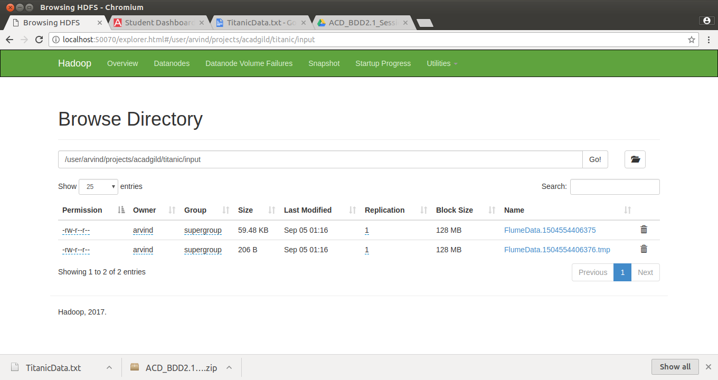

- Screenshots of HDFS output directory

