PROJECT 1.3– TWITTER SENTIMENT ANALYSIS

Following steps were followed for this assignment
1. Download files from twitter and store them in HDFS using Flume. The following command was executed:
flume-ng agent -n TwitterAgent -f flume-conf.properties

2. Copy the AFINN file into HDFS using following command:
hadoop fs -put AFINN.txt /user/arvind/projects/acadgild/twitter/input/AFINN.txt

3. Follow the steps mentioned in the blog

4. Execute the pig file using the command:
pig -x local -param_file task.properties task.pig

Or in mapreduce mode:
pig -param_file task_mr.properties task.pig

HDFS input screenshot
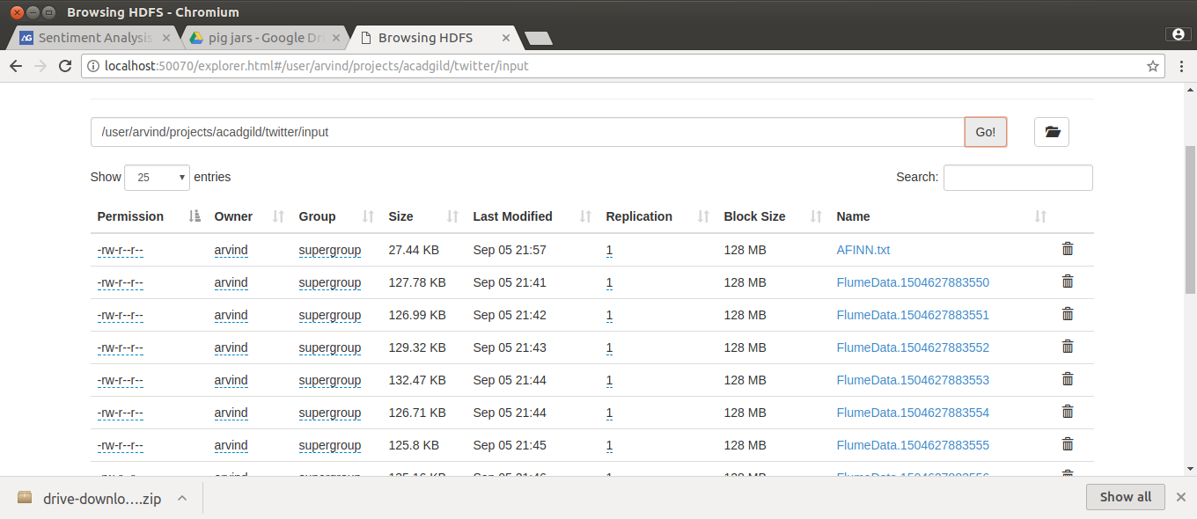
HDFS output screenshot
