PROJECT 2.1

This document assumes that:
- Hadoop is set up and HADOOP_HOME environment variable is added to $HOME/.bashrc. Also HADOOP_HOME/bin, HADOOP_HOME/sbin, HADOOP_HOME/etc/hadoop is added to PATH environment variable
- Flume is set up and FLUME_HOME environment variable is added to $HOME/.bashrc. Also FLUME_HOME/bin is added to PATH environment variable
- Sqoop is set up and SQOOP_HOME environment variable is added to $HOME/.bashrc. Also SQOOP_HOME/bin is added to PATH environment variable
- MySQL is set up

1. Start the Hadoop daemons
start-all.sh

2. Start the job history daemon
mr-jobhistory-daemon.sh start historyserver

3. Check if the dameons are running
jps

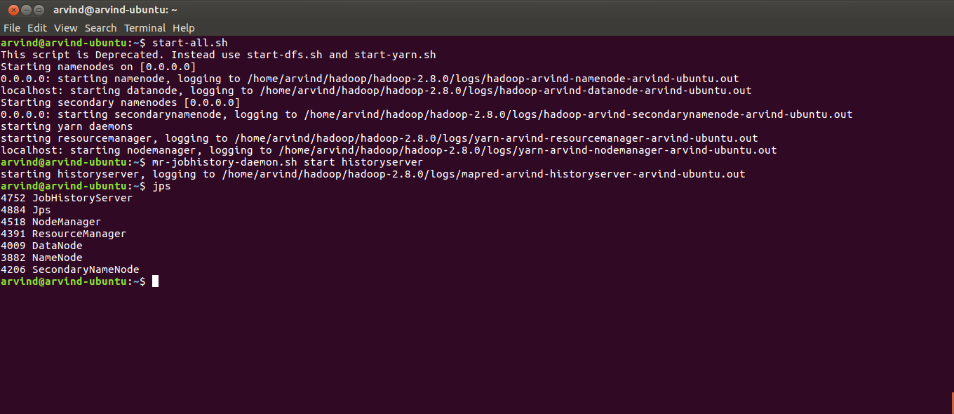
4. To set up input directories in HDFS (steps 4 to 6), we can run the prepare_hdfs.sh included under directly. But for purposes of explanation, all the commands in that file are explained below.

Create an input directory for the project
hadoop fs -mkdir -p /user/arvind/projects/acadgild/project_2.1/input;

5. Delete any files from any previous ingestion
hadoop fs -rm /user/arvind/projects/acadgild/project_2.1/input/*;

6. Delete any output directory from any previous ingestion
hadoop fs -rm -r /user/arvind/projects/acadgild/project_2.1/output;

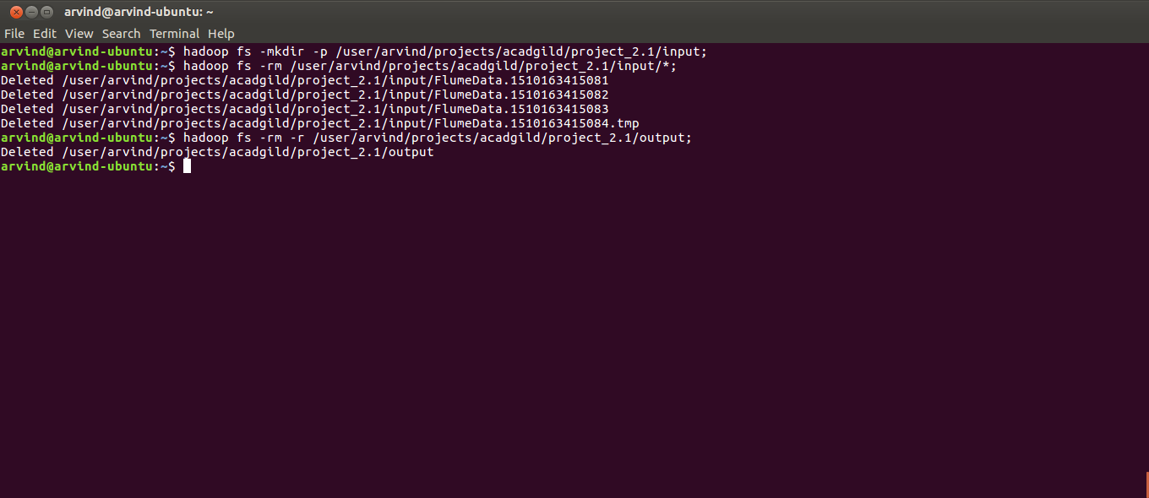
7. Copy the project_2.1_flume.conf file into the project’s flume-conf folder and copy the input Consumer_Complaints.csv into the project’s input folder

8. Run the flume agent to copy the input file from local file system to HDFS. project_2.1_flume.conf is included with the project solution under the flume-conf directory
flume-ng agent -n project_2_1_agent -f ~/projects/acadgild/project_2.1/flume conf/project_2.1_flume.conf

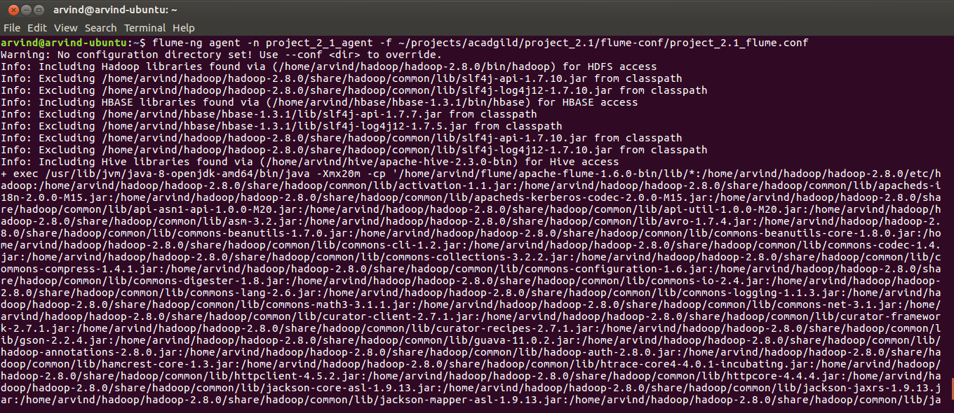
9. Wait for the flume agent to run till Consumer_Complaints.csv is renamed to Consumer_Complaints.csv.COMPLETED. Once this happens, terminate the flume agent by pressing Ctrl + Z

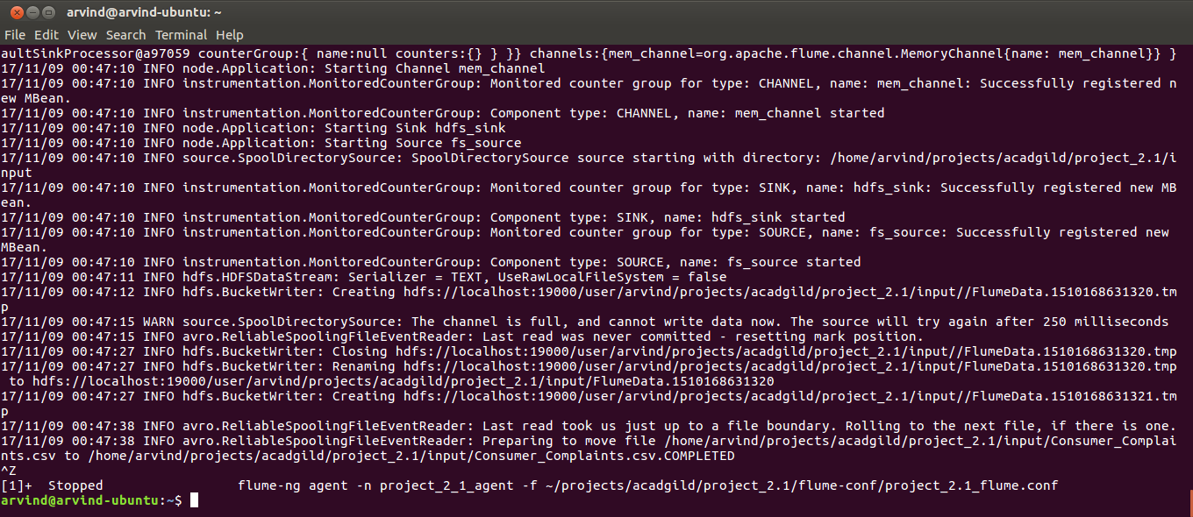
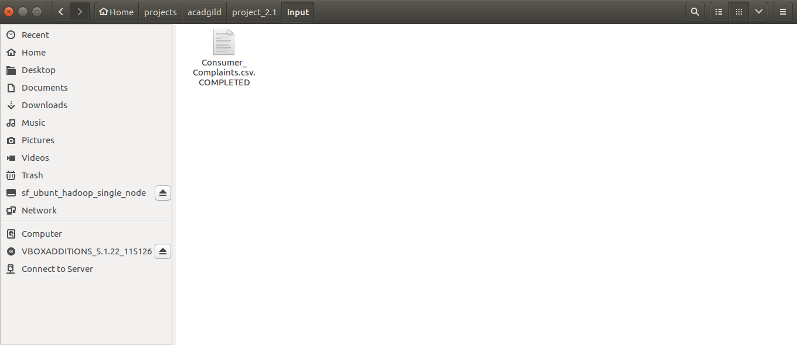
10. Check the contents of the HDFS directory /user/arvind/projects/acadgild/project_2.1/input/
hadoop fs -ls /user/arvind/projects/acadgild/project_2.1/input/

11. As a cross check, compare the number of lines in the input file from local file system and the number of lines in HDFS. Both should match.
cat /home/arvind/projects/acadgild/project_2.1/input/Consumer_Complaints.csv.COMPLETED | wc -l
hadoop fs -cat /user/arvind/projects/acadgild/project_2.1/input/* | wc -l
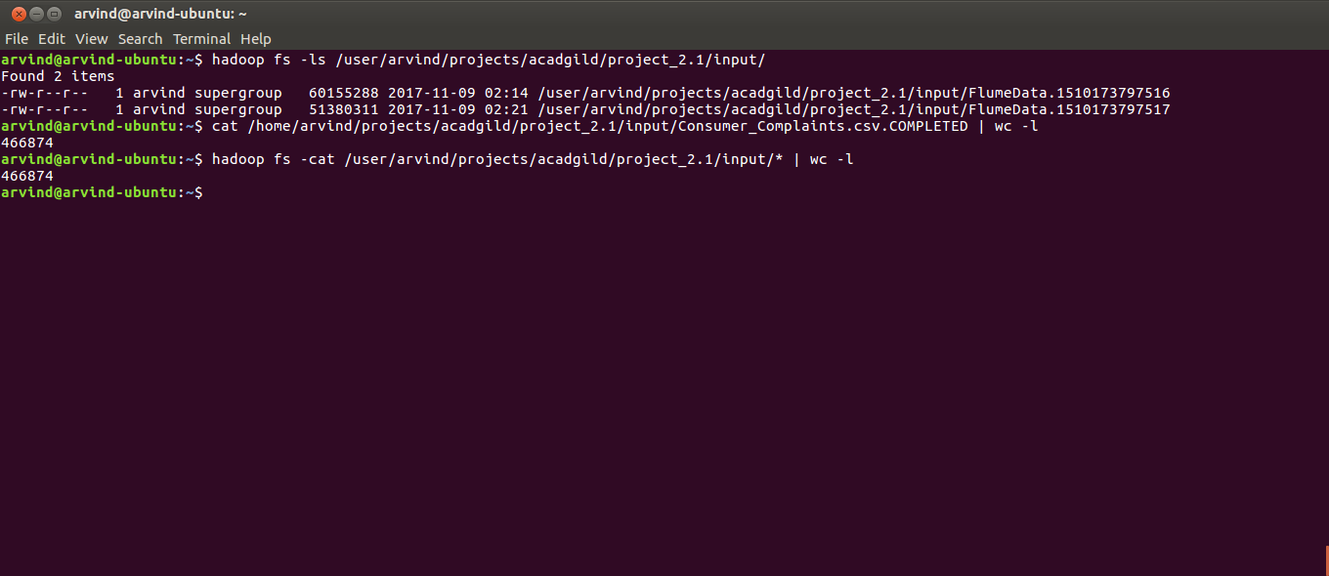
12. Now to perform the tasks in the project, the file export_to_mysql.sh can be run. But for explaining the steps, we will exexute the lines in the shell file step by step

Run the pig script project_2.1.pig. Self explanatory comments have been added to the file and the code for all 4 tasks have been included in a single file. project_2.1.pig is given with the project in the sources directory
pig /home/arvind/projects/acadgild/project_2.1/sources/project_2.1.pig;

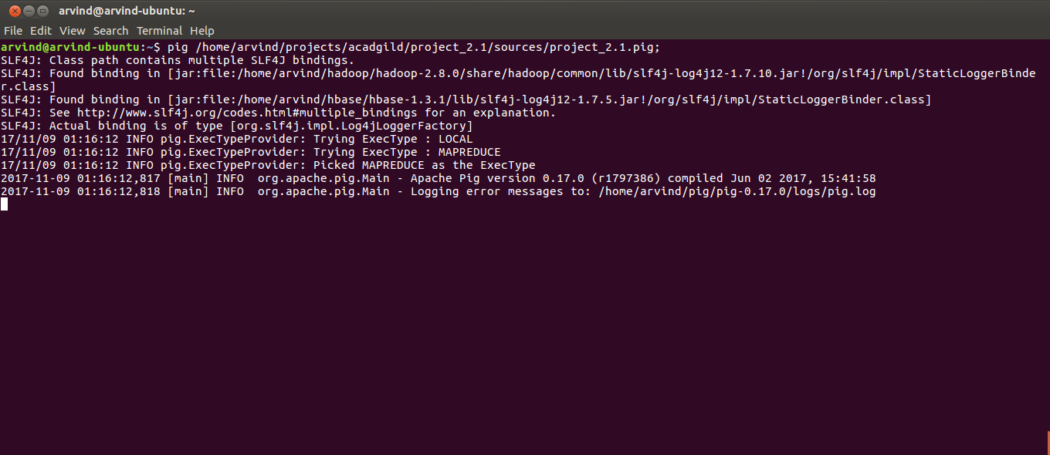
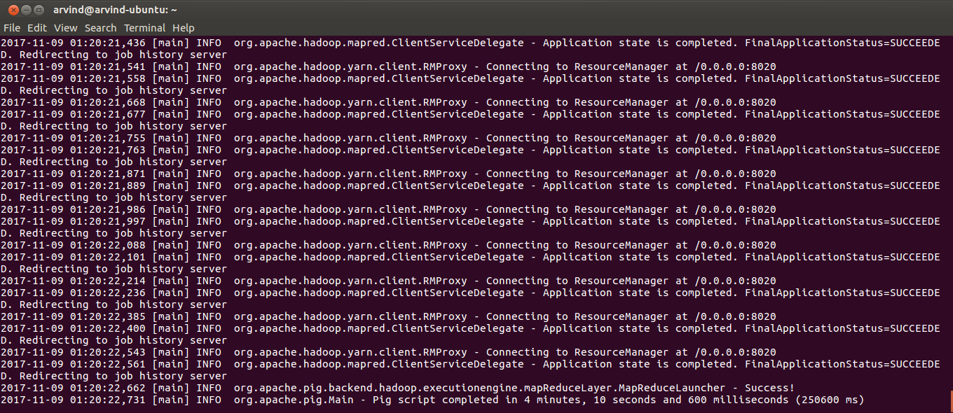
13. Check the output generated
hadoop fs -cat /user/arvind/projects/acadgild/project_2.1/output/task_1/*
hadoop fs -cat /user/arvind/projects/acadgild/project_2.1/output/task_2/*
hadoop fs -cat /user/arvind/projects/acadgild/project_2.1/output/task_3/*
hadoop fs -cat /user/arvind/projects/acadgild/project_2.1/output/task_4/*

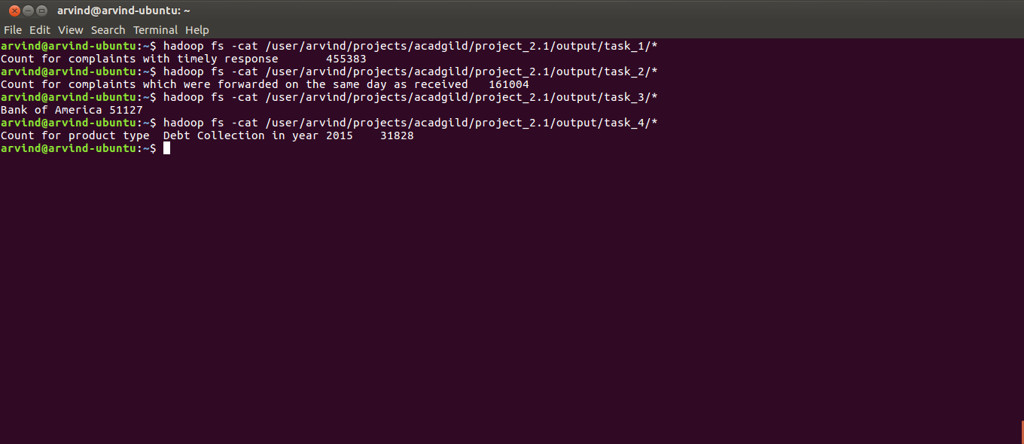
14. Create tables in MySQL to export the data to. When prompted for password enter the password of the root MySQL user. The create_tables.sql is provided with the project in the sources directory
mysql -u root -p < /home/arvind/projects/acadgild/project_2.1/sources/create_tables.sql;

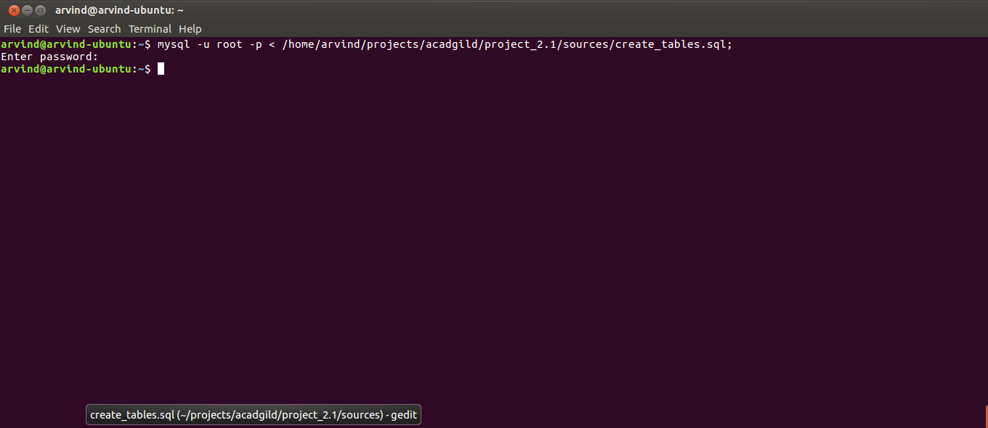
15. Open a new terminal and connect to mysql
mysql – u root -p

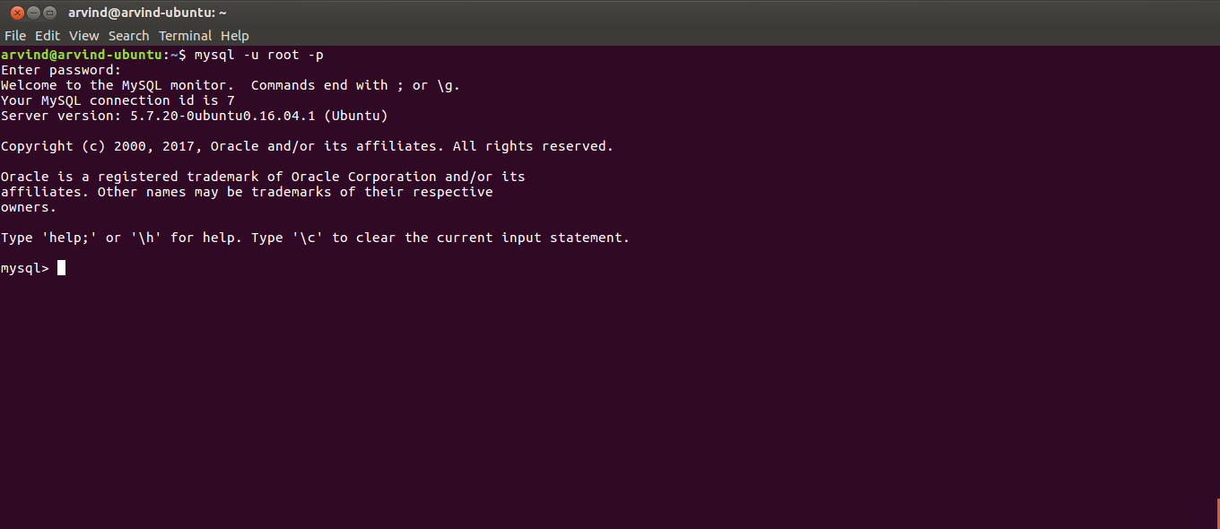
16. Verify database has been created
show databases;

17. If it exists in the list switch to the database `project_2.1`
use project_2.1

18. List the tables
show tables;

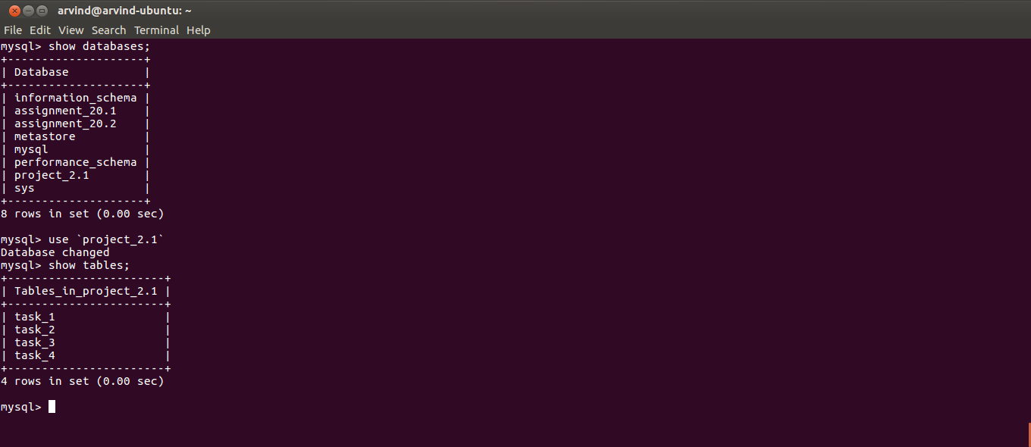
19. Switch to the Linux prompt and delete _SUCCESS file present in the output folder of task_1

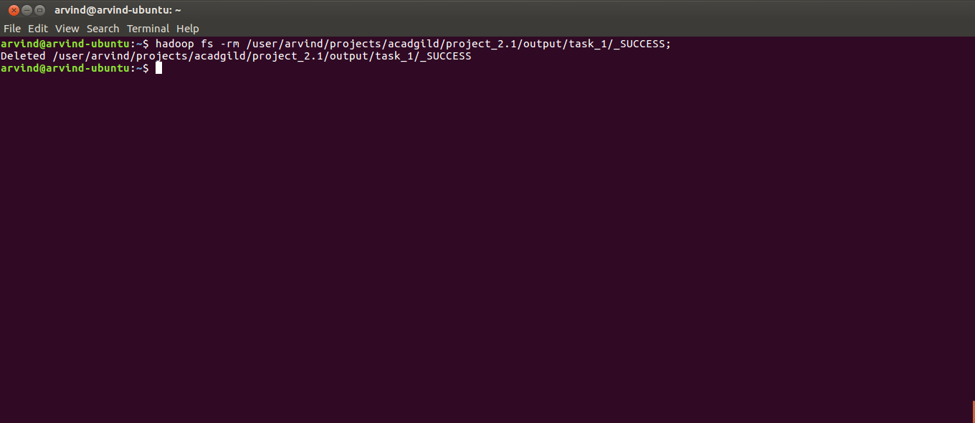
20. Export to the MySQL task_1 table using Sqoop and when prompted for password enter the MySQL root user password

sqoop export --connect jdbc:mysql://localhost:3306/project_2.1 \
--username root \
--P \
--table task_1 \
--export-dir /user/arvind/projects/acadgild/project_2.1/output/task_1 \
--input-fields-terminated-by '\t' \
--columns 'description,count';

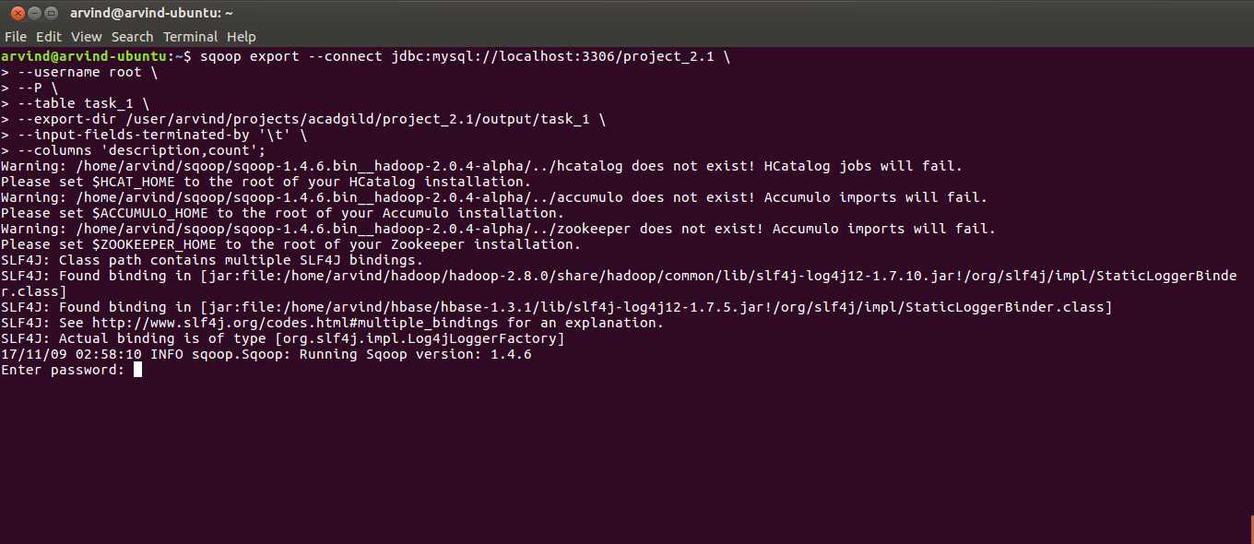
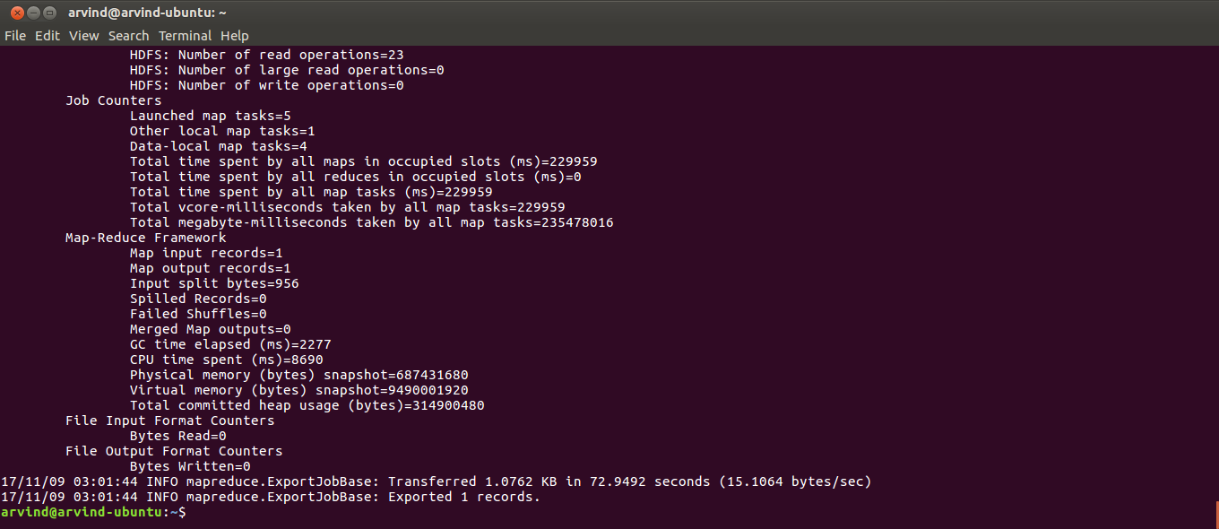
21. Delete _SUCCESS in output folder for task 2
hadoop fs -rm /user/arvind/projects/acadgild/project_2.1/output/task_2/_SUCCESS;

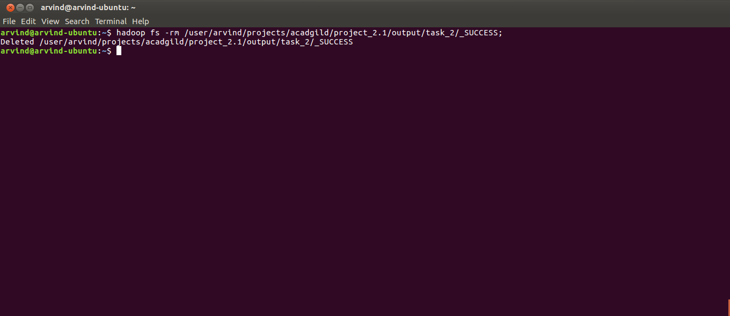

22. Run sqoop export for task 2
sqoop export --connect jdbc:mysql://localhost:3306/project_2.1 \
--username root \
--P \
--table task_2 \
--export-dir /user/arvind/projects/acadgild/project_2.1/output/task_2 \
--input-fields-terminated-by '\t' \
--columns 'description,count';

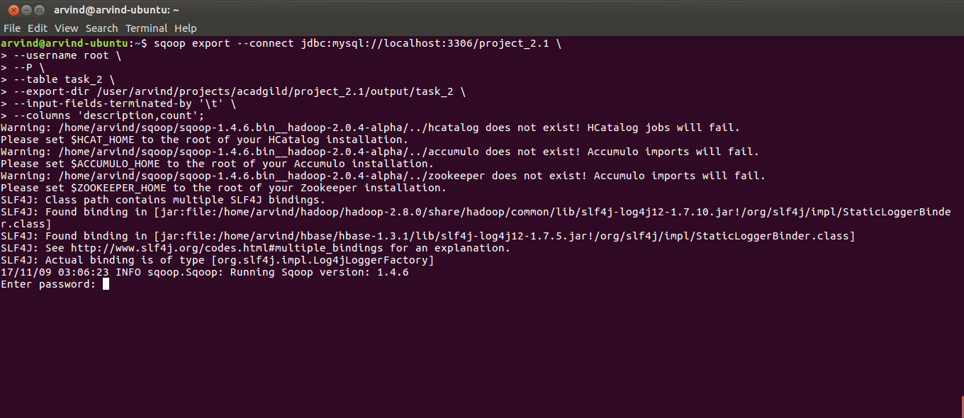
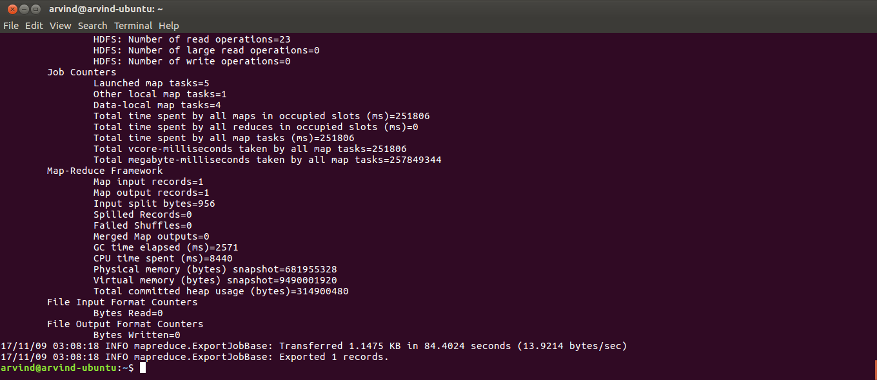
23. Delete _SUCCESS for task 3
hadoop fs -rm /user/arvind/projects/acadgild/project_2.1/output/task_3/_SUCCESS;
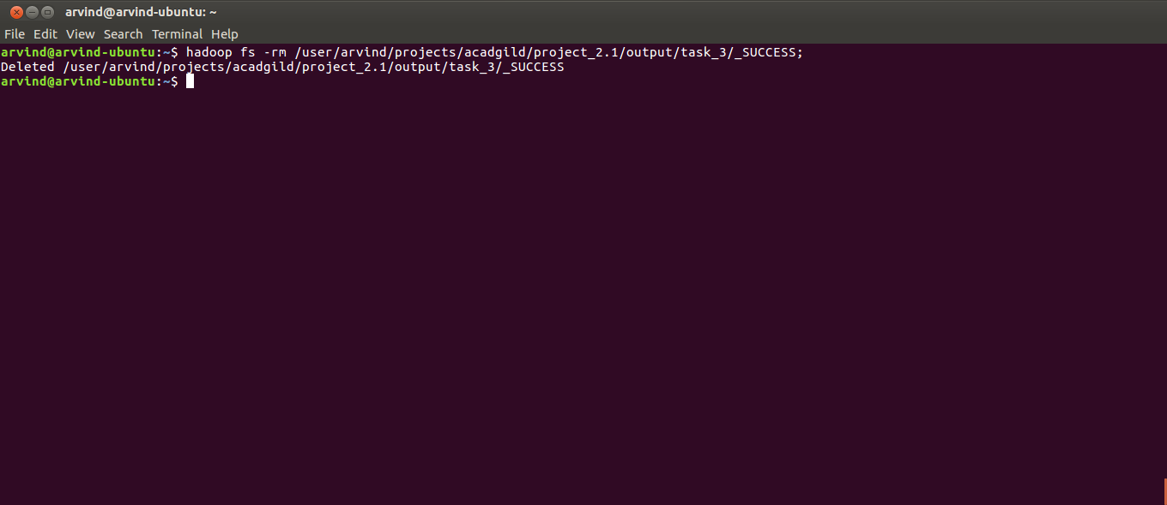

24. Run Sqoop export for task 3
sqoop export --connect jdbc:mysql://localhost:3306/project_2.1 \
--username root \
--P \
--table task_3 \
--export-dir /user/arvind/projects/acadgild/project_2.1/output/task_3 \
--input-fields-terminated-by '\t' \
--columns 'company,complaint_count';

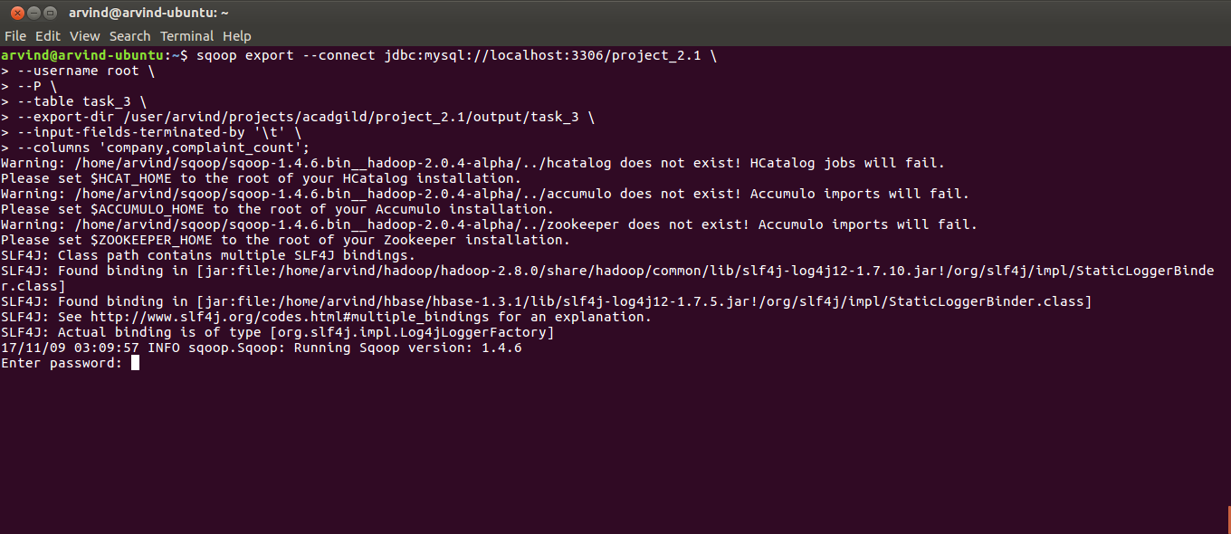

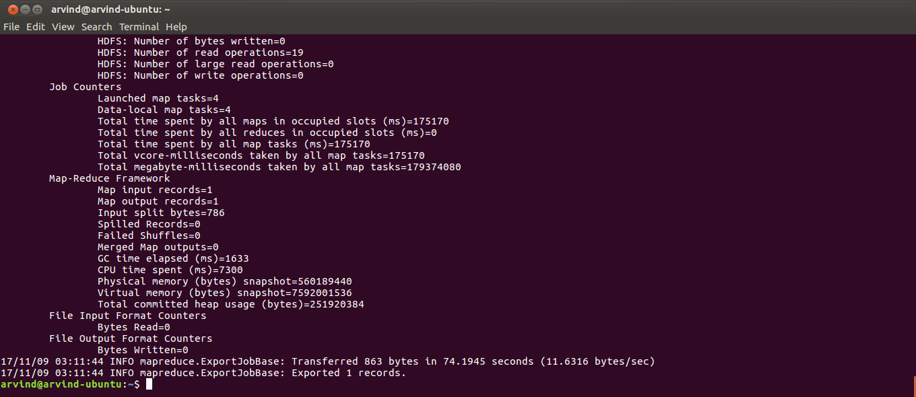
25. Delete _SUCCESS for task 4
hadoop fs -rm /user/arvind/projects/acadgild/project_2.1/output/task_4/_SUCCESS;

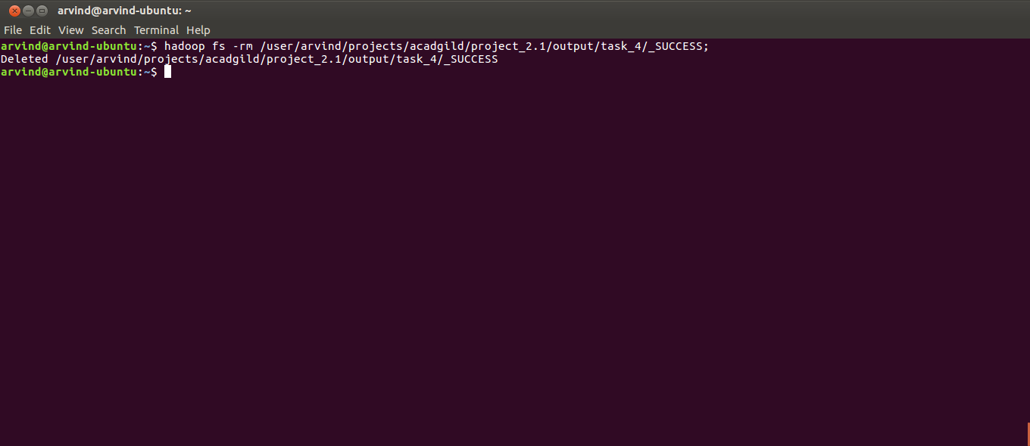
26. Run Sqoop export for task 4
sqoop export --connect jdbc:mysql://localhost:3306/project_2.1 \
--username root \
--P \
--table task_4 \
--export-dir /user/arvind/projects/acadgild/project_2.1/output/task_4 \
--input-fields-terminated-by '\t' \
--columns 'description,count';

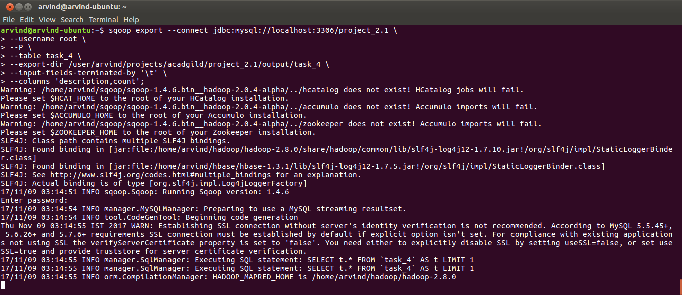
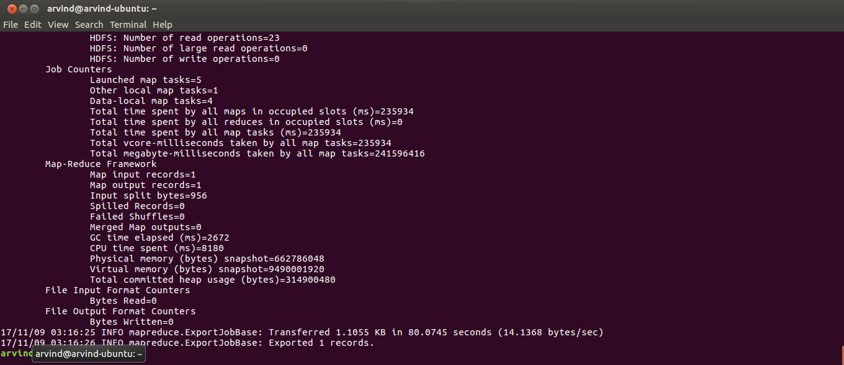
27. Switch to the MySQL prompt and check the contents of the tables
select * from task_1
select * from task_2
select * from task_3
select * from task_4

