Community Library Membership & Book Lending System
Comprehensive System Specification & Requirement Understanding Document
Document Context: System Analysis, Relational Schema, and Implementation Design
Target Framework: .NET Core Console App & Entity Framework Core (EF Core 9.0+)
Database Engine: PostgreSQL
Architecture Pattern: N-Tier Architecture (Presentation, Business Logic, Data Access)
1. Project Overview & Business Objectives
The Community Library Membership and Book Lending System is a centralized database solution designed to automate operations for a local community library. Manual tracking of books, memberships, return deadlines, and fines often results in database inconsistencies, lost inventory, and inefficient book circulation. This system addresses these challenges by establishing strict business policies for membership categories, tracking physical copies rather than abstract titles, managing late-return penalties, and providing detailed administrative reports. Built as a .NET Core Console Application, it uses Entity Framework Core (EF Core) as its Object-Relational Mapper (ORM) and PostgreSQL as its underlying transactional database engine. This combination ensures enterprise-grade data persistence, fast query execution, and robust transactional integrity.
2. Core System Boundaries & Access Tiers
The system segregates functions between two primary operational perspectives: the Customer/Member and the Library Administrator. These tiers operate via a unified Console CLI interface, authenticating members securely by email verification.
System Entry (Authentication)
When the application is launched, users are presented with a secure portal interface to register, log in, or access administrative tools.
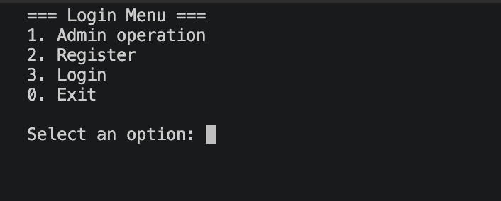
Figure: Console Login and Authentication Portal
Customer & Member Functions
- Member Self-Registration: Allows readers to create an account by submitting their name, a unique email address, and active telephone digits.
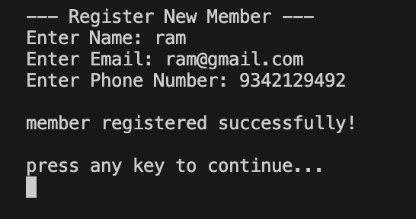
Figure: Member Registration Screen
- Membership Status & Profile: Allows logged-in readers to review their active status, membership tier, start date, and expiration timeline.
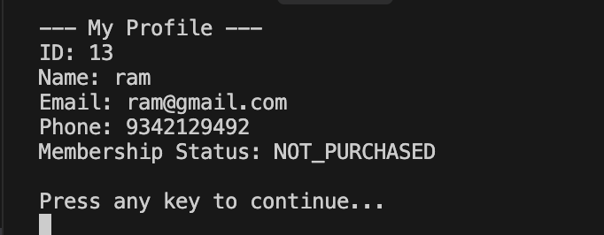
Figure: Member Profile and Status Summary
- Membership Purchases: Enables members to acquire or upgrade to one of three premium structured packages (Basic, Student, Premium) to expand checkout privileges.
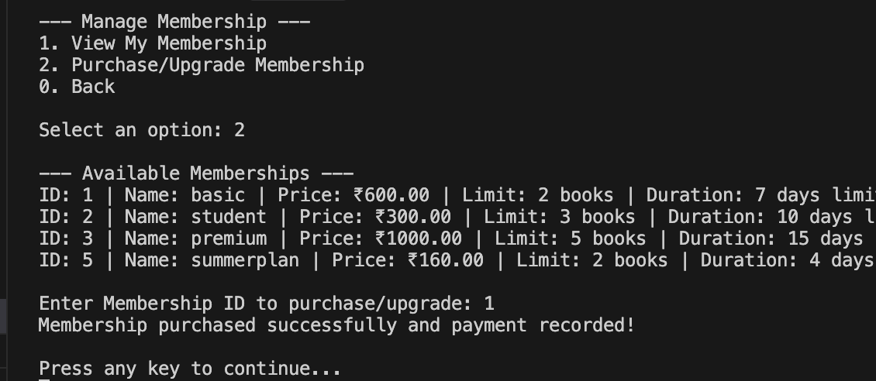
Figure: Membership Subscription Catalog and Purchase Menu
- Real-Time Stock Availability: Filters the catalog to only show titles with physical copies currently on shelves (status AVAILABLE).
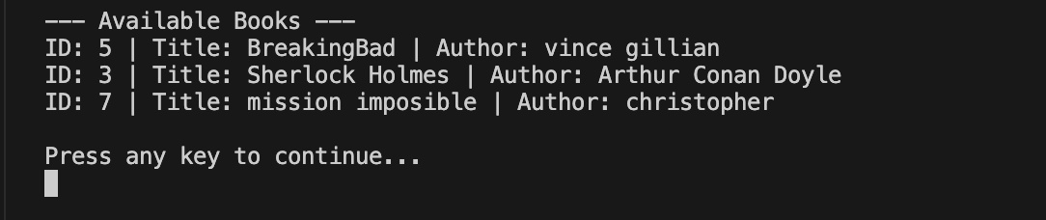
Figure: Available Book Inventory Catalog
- Structured Borrowing: Enables the user to check out a book copy if all membership criteria, borrowing rules, and outstanding fine constraints are met.
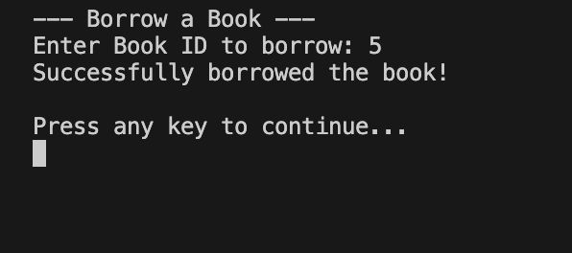
Figure: Borrow Book Action Screen
- Active Checkouts Listing: Displays outstanding checkouts alongside target return dates to assist readers in avoiding fines.
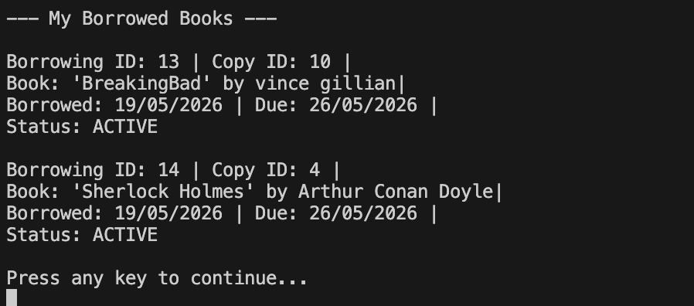
Figure: Active Borrowed Book Records for Logged-In User
- Self-Service Returns: Handles the digital check-in of a physical book copy and triggers late return fine calculations if the due date has passed.
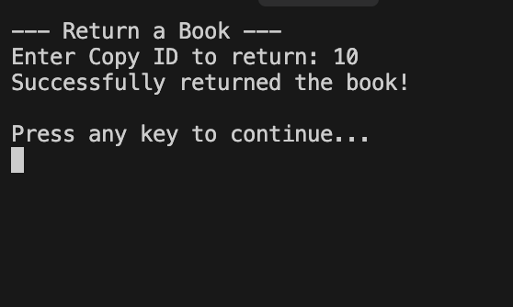
Figure: Return Book Action Screen
Library Administrator Functions
- Admin Operations Overview: Provides a restricted command portal containing catalog control, membership definitions, damage assessments, and audit reporting tools.
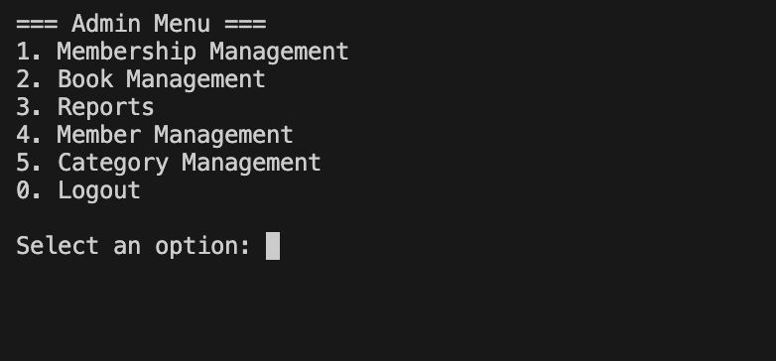
Figure: Library Admin Main Control Menu
- Book Catalog Management: The operational hub for adding abstract titles and managing underlying copy inventory.
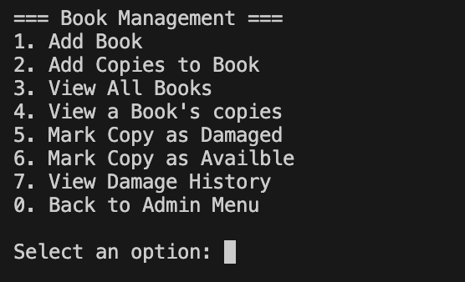
Figure: Book Catalog Management Portal
- Physical Copy Expansion: Enables generating multiple physical copies of an existing book title, assigned with unique physical tracker numbers.
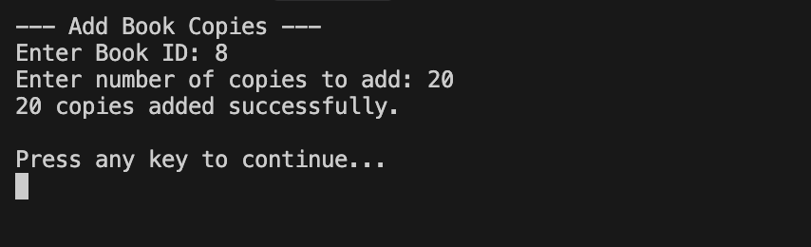
Figure: Add Physical Book Copies
- Physical Catalog Listing: Lists the complete inventory of abstract titles and all associated physical copy numbers alongside current physical statuses.
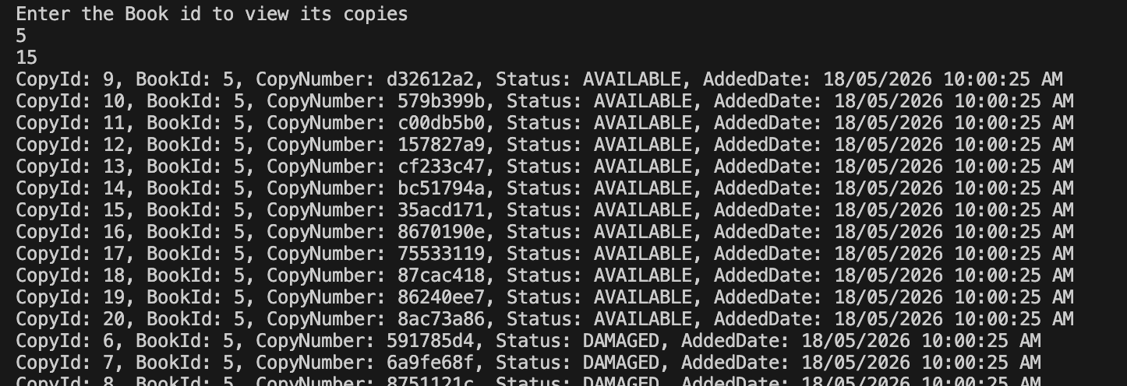
Figure: Abstract Titles and Physical Copy Catalog Listing
- Membership Management Portal: Provides administrative controls to construct, view, or manage the properties of subscription tiers.
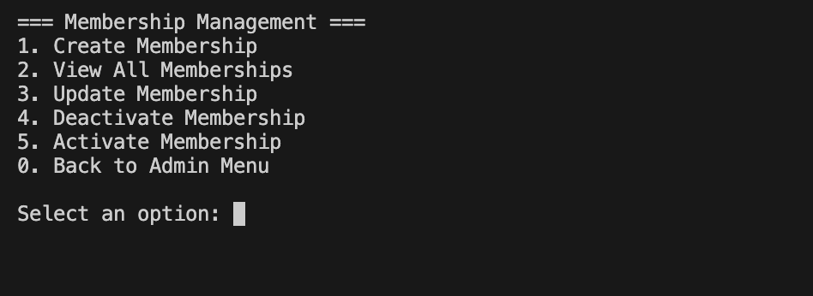
Figure: Membership Administration Panel
- Tier Level Definition: Allows creating new membership levels with custom borrow limits, subscription prices, and loan durations.
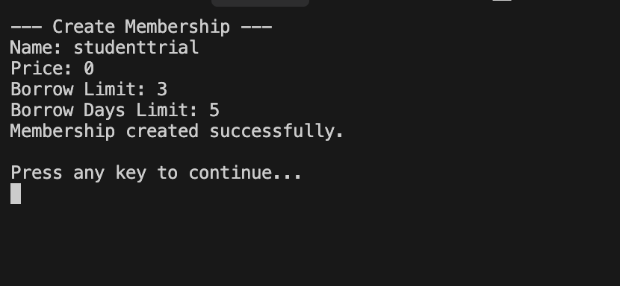
Figure: Membership Tier Creation Screen
- Active Membership Tier Listing: Displays the existing membership options alongside their parameters.
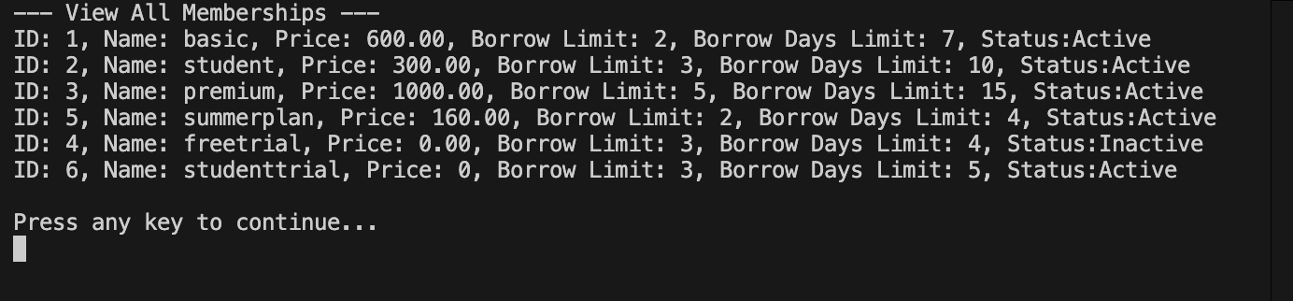
Figure: Seeded Membership Tiers Listing
- Inventory Damage Audit & Flagging: Enables administrators to mark a specific physical book copy as damaged, changing its status and automatically generating a fine balance.
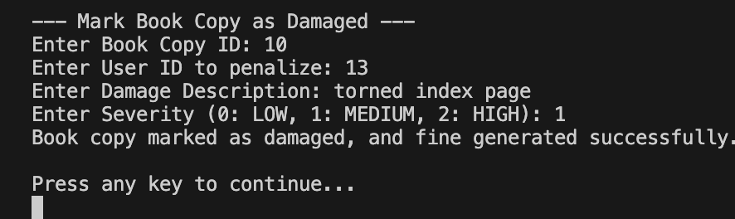
Figure: Flag Book Copy as Damaged
- Copy Damage Assessment Logging: Tracks physical damage histories, severity levels, and description logs for individual assets.
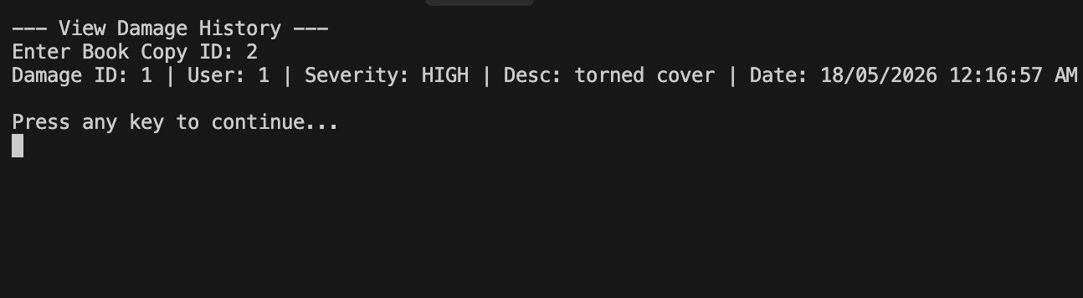
Figure: Physical Book Damage History Logging
3. Database Schema & Model Definitions
The relational database schema is structured to capture every aspect of library operations, ensuring high normalization, referential integrity, and data consistency. PostgreSQL is used to enforce data types, primary and foreign key constraints, and cascading rules where appropriate.
Database Tables and Structural Definition
Table Name | Primary Key | Foreign Keys / Relational Fields | Key Fields & Purpose
Memberships | MembershipId | None | MembershipName, MembershipPrice, BorrowLimit, BorrowDaysLimit. Represents the subscription tiers (Basic, Student, Premium).
Members | MemberId | MembershipId (FK -> Memberships) | Name, Email (Unique), PhoneNumber, MembershipStatus, MembershipStartDate/EndDate, IsActive (Soft-delete flag).
BookCategories | CategoryId | None | CategoryName. Handles library classifications like Fantasy, Sci-Fi, Mystery, Non-Fiction.
Books | BookId | CategoryId (FK -> BookCategories) | Title, Author, ISBN, PublishedYear. Represents abstract book titles.
BookCopies | CopyId | BookId (FK -> Books) | CopyNumber (Unique code), CopyStatus (Enum: AVAILABLE, BORROWED, DAMAGED, LOST), AddedDate.
Borrowings | BorrowingId | MemberId (FK -> Members), CopyId (FK -> BookCopies) | BorrowDate, DueDate, ReturnedDate (Nullable), Status (Enum: ACTIVE, RETURNED). Tracks lending leases.
Fines | FineId | BorrowingId (FK -> Borrowings) | FineAmount, Reason (Enum: LATE_RETURN, DAMAGED_BOOK), PaidStatus (Enum: PAID, PENDING), CreatedAt. Holds penalty balances.
FinePayments | PaymentId | FineId (FK -> Fines) | PaymentAmount, PaymentDate, PaymentMethod. Tracks transactional payments of fines.
MembershipPayments | PaymentId | MemberId (FK -> Members) | AmountPaid, PaymentDate, TierNamePurchased. Keeps records of subscription upgrades.
BookDamageHistories | DamageId | CopyId (FK -> BookCopies), MemberId (FK -> Members) | DamageSeverity (Enum: LOW, MEDIUM, HIGH), Description, FineCharged, ReportedDate. Tracks damage incidents.
4. Key Business Logic & Borrowing Constraints
To protect inventory and guarantee fair book circulation, the system applies strict business logic before allowing a checkout transaction. These constraints are evaluated sequentially inside the Business Logic Layer.
Membership Tier Parameters
Membership Tier | Subscription Price | Maximum Active Books | Maximum Loan Duration
Basic | ₹500 | 2 books | 7 Days
Student | ₹1,000 | 3 books | 10 Days
Premium | ₹2,000 | 5 books | 15 Days

Unified Core Borrowing Constraints
- Inactive Membership Prohibition: Deactivated accounts cannot authenticate or carry out any operations.
- No Active Membership: Members without a purchased or active membership tier are restricted from borrowing books entirely.
- Borrow Limit Enforcement: A member's checkout is blocked if they currently have outstanding active borrowings equal to their membership limit.
- Fine Limit Prohibition: Members who have unpaid fine records (status PENDING) totaling strictly more than ₹500 are blocked from borrowing.
- Duplicate Book Check: To maintain equal access to books, a reader cannot borrow another copy of a book they already currently check out.
- Inventory Availability Check: The specific book copy being requested must have the status AVAILABLE. If all copies are BORROWED or DAMAGED, checkout is denied.
Return & Overdue Fine Logic
- Status Reversion: When a copy is checked back in, its status returns to AVAILABLE, and the Borrowing status changes to RETURNED.
- Timestamp Capture: The ReturnedDate is captured as the current system time.
- Overdue Fine Generation: If the check-in date is strictly greater than the calculated DueDate, a Fine record is automatically generated.
- Fine Formula: Late return fines are calculated at a fixed rate of ₹10 per day late. Formula: Fine = (ReturnDate - DueDate).Days * 10.
5. Transaction Architecture for Borrowing
A book checkout involves multiple database modifications: validating the member, checking their fines, checking active borrow counts, finding an available book copy, creating a borrowing record, and updating the copy's status to BORROWED. To prevent issues like two members checking out the same copy simultaneously, the system uses an EF Core Database Transaction.
The borrowing workflow is implemented as a single Atomic, Consistent, Isolated, and Durable (ACID) transaction. If any step fails due to validation or database issues, the entire transaction is rolled back, restoring the database to its pre-transaction state.
Borrowing Transaction Verification Steps
1. Start Transaction: _context.Database.BeginTransaction()
2. Validate Member Existence & Active Status: Retrieves member and checks IsActive and MembershipStatus. If invalid, aborts.
3. Validate Fine Limit: Calls the get_total_unpaid_fine PostgreSQL function via EF Core. If total unpaid fines exceed ₹500, throws ValidationException and aborts.
4. Check Active Borrow Limit: Computes count of ACTIVE borrowings. If count >= BorrowLimit, aborts.
5. Prevent Duplicate Borrowings: Checks if an active borrowing exists for the same MemberId and BookId. If duplicate, aborts.
6. Allocate Copy: Retrieves an AVAILABLE copy for the BookId. If null, aborts.
7. Create Borrowing: Inserts a new record into Borrowings with status ACTIVE, BorrowDate, and calculated DueDate.
8. Update Copy Status: Sets the CopyStatus of the allocated BookCopy to BORROWED.
9. Save Changes & Commit: Invokes SaveChanges() and calls transaction.Commit().
10. Exception Rollback: If an exception occurs, the transaction is caught, transaction.Rollback() is called, and the exception bubbles up.
Borrowing Service Code Implementation
public void BorrowBook(int memberId, int bookId)
{
using var transaction = _context.Database.BeginTransaction();
try
{
// 1. Verify Member exists and is active
var member = _memberRepository.GetById(memberId);
if (member == null) throw new DataNotFoundException("Member", memberId);
if (!member.IsActive) throw new ValidationException("Member is inactive.");
if (member.MembershipStatus != MembershipStatus.ACTIVE || member.Membership == null)
{
throw new ValidationException("Member does not have an active membership.");
}
// 2. Call PostgreSQL stored function to check outstanding fines
decimal totalUnpaid = _context.Database.SqlQueryRaw<decimal>(
"SELECT get_total_unpaid_fine({0})", memberId
).ToList().FirstOrDefault();
if (totalUnpaid > 500)
{
throw new ValidationException("Member has unpaid fines exceeding \u20b9500. Please pay fines to continue.");
}
// 3. Verify borrowing limit
var activeCount = _borrowingRepository.GetBorrowingsByMemberId(memberId)
.Count(b => b.Status == BorrowingStatus.ACTIVE);
if (activeCount >= member.Membership.BorrowLimit)
{
throw new ValidationException("Member has reached the maximum borrow limit.");
}
// 4. Check duplicate active borrowing of the same book
var alreadyBorrowed = _context.Borrowings.Any(
b => b.MemberId == memberId && b.Status == BorrowingStatus.ACTIVE && b.BookCopy.BookId == bookId
);
if (alreadyBorrowed)
{
throw new ValidationException("You have already borrowed this book and have not returned it yet.");
}
// 5. Check and acquire available copy
var availableCopy = _bookCopyRepository.GetAvailableCopy(bookId);
if (availableCopy == null) throw new ServiceException("No available copies for this book.");
// 6. Write borrowing record
var borrowing = new Borrowing
{
MemberId = memberId,
CopyId = availableCopy.CopyId,
BorrowDate = DateTime.Now,
DueDate = DateTime.Now.AddDays(member.Membership.BorrowDaysLimit),
Status = BorrowingStatus.ACTIVE
};
_borrowingRepository.Add(borrowing);
// 7. Update copy status to BORROWED
availableCopy.CopyStatus = BookCopyStatus.BORROWED;
_bookCopyRepository.UpdateBookCopy(availableCopy);
_context.SaveChanges();
transaction.Commit();
}
catch (Exception)
{
transaction.Rollback();
throw;
}
}
6. PostgreSQL Stored Function Integration
A core requirement of the project is integrating native database logic with the application. We implemented the PostgreSQL function `get_total_unpaid_fine(member_id)`, which returns the total unpaid fines for a member. This runs directly in the database engine for optimal speed and reliability, and the result is called within our EF Core service layer.
PostgreSQL PL/pgSQL Function Schema
CREATE OR REPLACE FUNCTION get_total_unpaid_fine(member_id integer)
RETURNS numeric AS $$
DECLARE
v_total numeric;
BEGIN
SELECT COALESCE(SUM(f."FineAmount"), 0)
INTO v_total
FROM "Fines" f
JOIN "Borrowings" b ON f."BorrowingId" = b."BorrowingId"
WHERE b."MemberId" = member_id AND f."PaidStatus" = 1;
RETURN v_total;
END;
$$ LANGUAGE plpgsql;
Calling the Custom Database Function in EF Core
Using EF Core, we call the custom database function using SqlQueryRaw. This compiles and executes the select statement directly on the PostgreSQL server, shielding our application from downloading heavy datasets of unpaid fines for evaluation:
decimal totalUnpaid = _context.Database.SqlQueryRaw<decimal>(
"SELECT get_total_unpaid_fine({0})", memberId
).ToList().FirstOrDefault();
7. Exception Handling Architecture
The system employs a robust, three-tier exception handling architecture that enforces a clean Separation of Concerns across the Presentation, Business Logic, and Data Access layers. This structure shields the front-end from raw SQL/DB errors while providing detailed diagnostic context to developers and clear, colorized, user-friendly alerts to system users.
Tiered Exception Boundaries
- Data Access Layer (DALLibrary): Catches database or connection errors from raw save requests, translating them into a unified, system-wide RepositoryException. This prevents EF Core specific leakage into higher layers.
- Business Logic Layer (BLLibrary): Throws custom validation exceptions when business logic constraints are violated. When service methods execute, they intercept RepositoryException instances and wrap them inside a ServiceException to protect system integrity.
- Presentation Layer (FELibrary): The Console application intercepts bubbled exceptions using a centralized helper, ConsoleHelper.HandleException. It logs details and prints clean, user-friendly error alerts without technical stack traces.
Unified Custom Exception Framework
- ValidationException: Thrown by the BLL when validation or borrowing constraints fail. Prints: [Validation Error] Context details.
- DataNotFoundException: Thrown when a requested entity ID (Member, Book, or Category) cannot be resolved. Prints: [Not Found] Context details.
- RepositoryException: Wraps underlying EF Core DbUpdateException instances. Keeps system error tracking clean and standard.
- ServiceException: Wraps service method failures or caught repository exceptions. Prints: [Service Error] Context details.
8. Verification Scenarios & Console Workflows
The system has been verified using a wide range of test scenarios. The workflows represent different stages of standard operations.
Scenario 1: Member Registration
Inputs: Name = "vikram", Email = "vikram@gmail.com", Phone Number = "9003847839"
--- Register New Member ---
Enter Name: vikram
Enter Email: vikram@gmail.com
Enter Phone Number: 9003847839
member registered successfully!
Scenario 2: Searching the Book Catalog
Inputs: Query = "harry"
--- Search Books ---
Enter Title or Author to search: harry
ID: 1 | Title: Harry Potter and the Sorcerer's Stone | Author: J.K. Rowling | Category: Fantasy
Scenario 3: Attempting Duplicate Borrowing
Setup: Member checks out Dune (Book ID 5) and tries to borrow another copy of Dune before returning it. The duplicate check catches this and throws an exception.
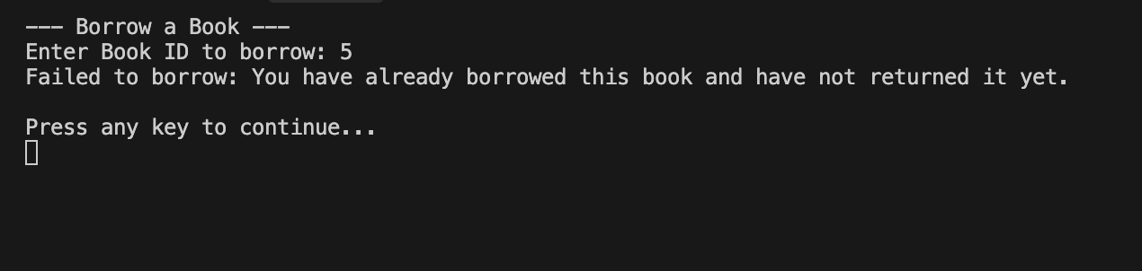
Figure: Duplicate Borrowing Warning Screen
Scenario 4: Reaching Membership Tier Limit
Setup: Basic member (limit 2) attempts to borrow a 3rd book. The system checks the limit and blocks the transaction.
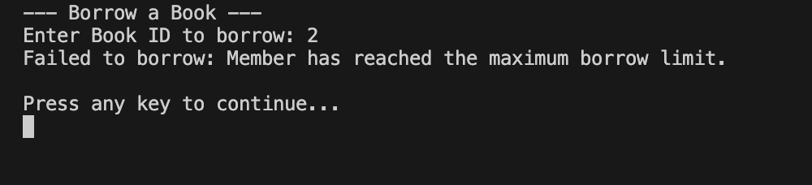
Figure: Borrow Limit Reached Warning Screen
Scenario 5: Outstanding Fine Restriction
Setup: Member has unpaid fines of ₹600 (exceeding the ₹500 limit). Checkout is blocked until fines are cleared.
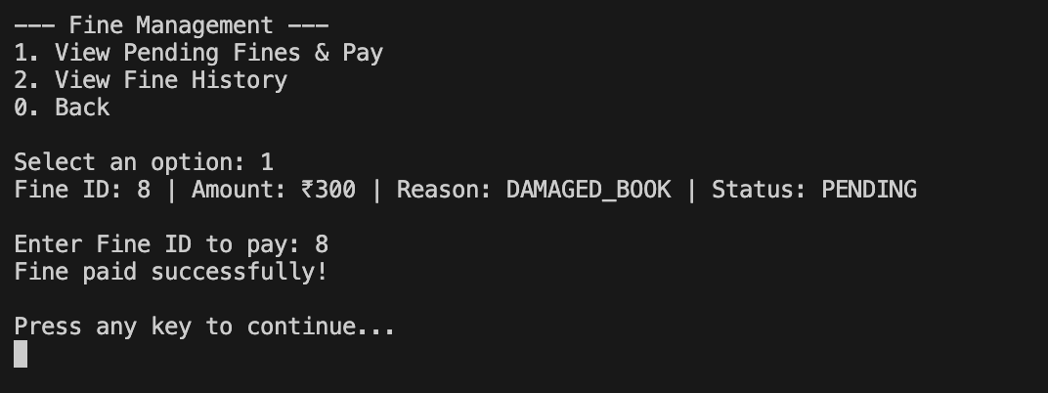
Figure: Blocked by Unpaid Fines Warning Screen
Scenario 6: Return Processing & Late Fine Assessment
Setup: Member returns a checked-out book past its due date. System automatically calculates late return fine at ₹10 per day late, marks copy as AVAILABLE, and records the return date.
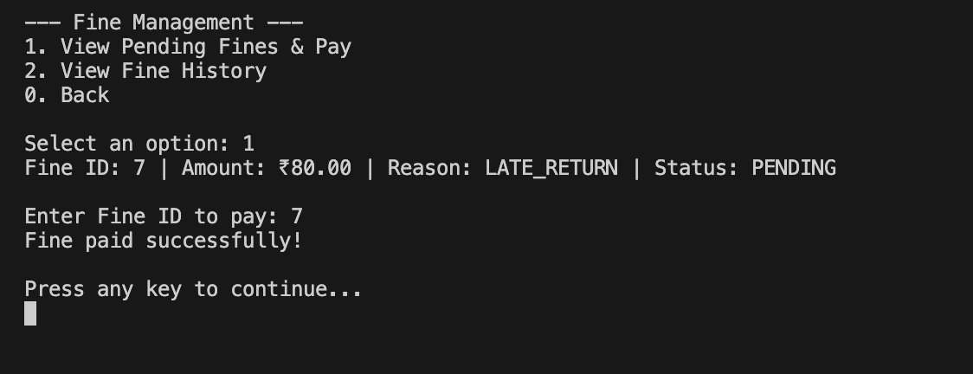
Figure: Late Return Fine Generation Screen
Scenario 7: Member Deactivation
Setup: Soft-deactivating a member. Revokes active status, rendering them unable to log in.
--- Delete Member ---
Enter Member ID: 5
Are you sure you want to deactivate member 5? (y/n): y
Member deactivated successfully!
---
Select an option: 3
Enter your email: tony@gmail.com
[Not Found] Member with 'Email : tony@gmail.com' not found.
9. Administrative Verification Reports
The system enables running high-level administrative reports to review active transactions, overdue items, member details, and catalog statistics.
Report A: Books Currently Borrowed
Lists all copies currently checked out, showing the borrow date, due date, copy number, and the member's details.
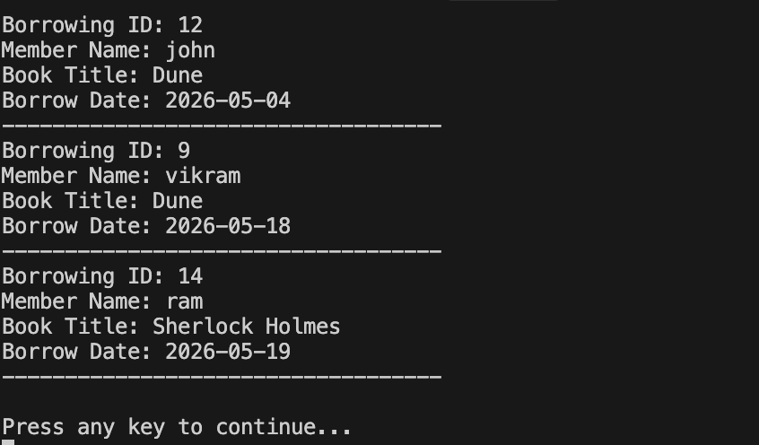
Figure: Books Currently Checked Out Report
Report B: Overdue Book Copies
Highlights copies that have not been returned past their due dates, calculating the delay duration.
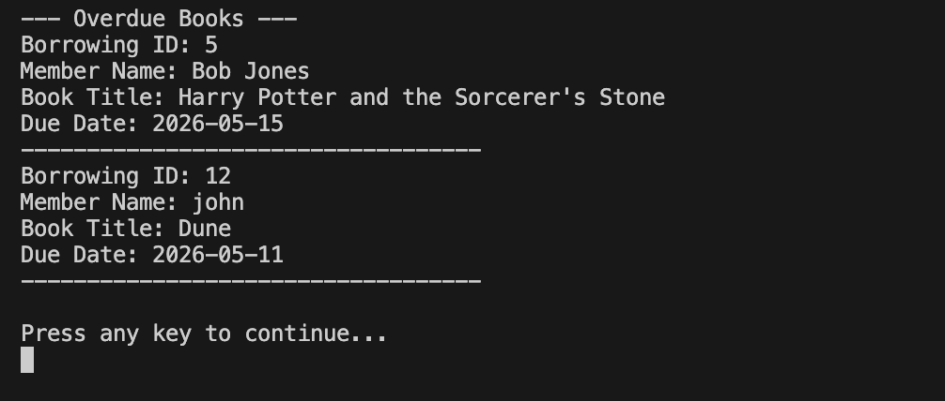
Figure: Overdue Book Copies Report
Report C: Members with Pending Fines
Identifies members with unpaid fines (status PENDING), indicating the outstanding balances.
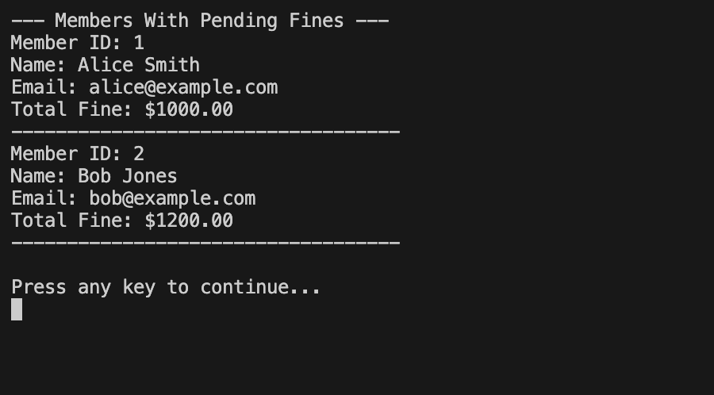
Figure: Members with Unpaid Fines Report
Report D: Member Borrowing History Audit
Provides a detailed timeline of checkouts, check-ins, and fines generated for a given member.
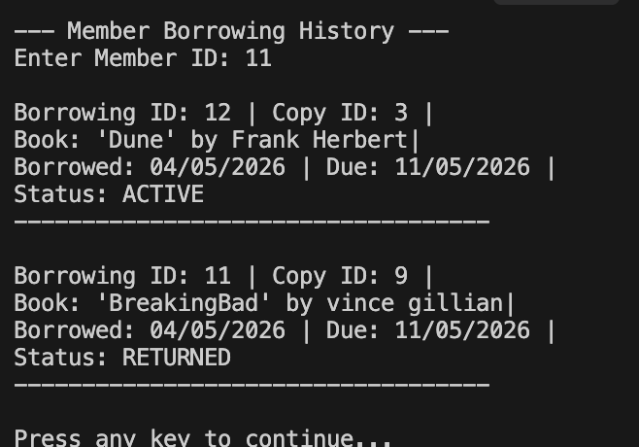
Figure: Member Transaction History Report
10. System Deliverables & Summary Checklist
This system is fully operational and structured to meet your educational case study requirements. Below is the checklist of deliverables available in the project:
- 1. Solution Architecture: Fully working N-Tier layout split into ModelLibrary, DALLibrary, BLLibrary, and FELibrary.
- 2. Database Integration: Fully configured with primary keys, unique constraints, index tables, and seeded records.
- 3. Stored DB Functions: get_total_unpaid_fine(member_id) deployed in PL/pgSQL and called in EF Core.
- 4. EF Core ACID Transactions: Handles the checkout workflow seamlessly and rolls back if validations fail.
- 5. Custom Exception Library: ValidationException, DataNotFoundException, RepositoryException, ServiceException.
- 6. Verification Logs & Output: Covers checkouts, returns, overdue fines, and comprehensive admin reports.
Date of Documentation: May 19, 2026
Prepared for: Community Library Membership & Lending System Evaluation

