

A S A East Region
This is to certify that
BusheyAmateur Swimming Club
is affiliated to
ASA East Region
with an approved constitution
YEAR 2007


Chairman 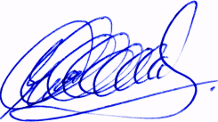 Date July 2007

