Hi, for some reason, I can’t seem to extract the full file. This is a sample of the VBA script using the test data and sampling lastrow = 1000.

Sheet (A)

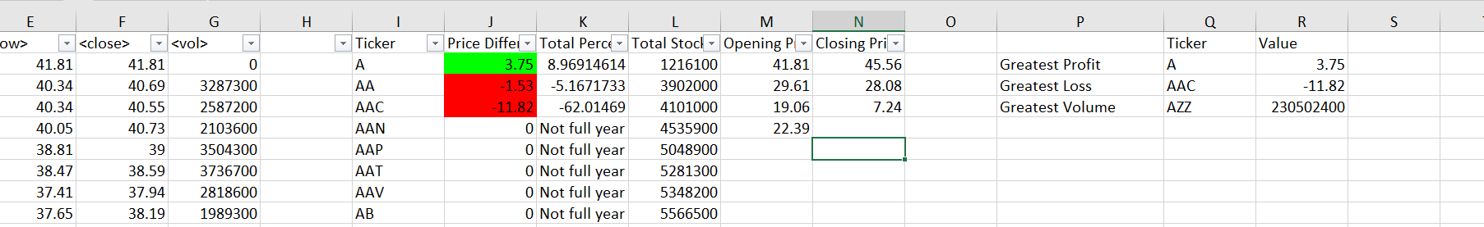

Sheet (B)



Sheet (C )



Sheet (D )



Sheet (E)



Sheet (F)



Sheet (P)

