Software Requirements Specification

Version 1.0

17.6.2020

TOURS AND TRAVEL MANAGEMENT SYSTEM

Arwa Alissa

Enass khwam

Dania sheikh-al-souk

# Table of Contents

Table of Contents i

List of Figures ii

1.0. Introduction 1

1.1. Purpose 1

1.2. Scope of Project 1

1.3. Glossary 1

1.4. References 1

1.5. Overview of Document 2

2.0. Overall Description 3

2.1 System Environment 3

2.2 Functional Requirements Specification 3

2.2.1 System user Use Case 3

Use case: Validating user 3

2.2.2 Authorized Customer……………………………………………………….........4

Use case: View tour details…………………………………………………………………………..4

Reservation For tour………………………………………………………………………4

Maintain Reservation……………………………………………………………………...4

Make payment…………………………………………………………………………….4

New tour information……………………………………………………………………..4

2.2.3 Staff Use case………………………………………………………………………………5

Use case: Receive Reservepackges details………………………………………………………….5

Receive Customer………………………………………………………………………..5

Provide Services…………………………………………………………………………5

2.2.4 Adminstrator Use case………………………………………………………………………..6

Use case: sign In…………………………………………………………………………………..6

Maintain tour service……………………………………………………………………6

2.3 User characteistics………………………………………………………………………………….7

2.4 Non-Functional Requirements……………………………………………………………………..8

3.0. Requirements Specification 9

3.1 External Interface Requirements 9

3.2 Functional Requirements 10

3.2.1 Select The tour 10

3.3 Detailed Non-Functional Requirements 11

3.3.1 Logical Structure of the Data 11

3.3.2 Security 11

# List of Figures

Figure 1 - System Environment 3

Figure 2 – Use Cases 3

Figure 3 - Logical Structure of the Data 5

# 1.0. Introduction

## 1.1. Purpose

The purpose of this document is to present a detailed description of the MANAGEMENT TOURS AND TRAVEL It will explain the purpose and features of the system, the interfaces of the system, what the system will do, the constraints under which it must operate . This document is intended for both the stakeholders and the developers of the system.

## 1.2. Scope of Project

This program saves time for customers to choose the right trips for it.

## 1.3. Glossary

|  |  |
| --- | --- |
| **Term** | **Definition** |
| Authorized Customer | An authorized user is any person who has permission to view tour , maintain ,make payment and new tour information. |
| Staff | everyone who works at a management tours and travel and provide Services. |
| Database | Collection of all the information monitored by this system. |
| Adminstrator | a person who manages a computer network or system |
| System user | is similar in concept to a server **user** but resides in the **system** database as an OUser record. Like a database **user**, a **system user** is assigned roles that are comprised of resources and permissions |

## 

## 1.4. References

IEEE. *IEEE Std 830-1998 IEEE Recommended Practice for Software Requirements Specifications.* IEEE Computer Society, 1998.

## 1.5. Overview of Document

The next chapter, the Overall Description section, of this document gives an overview of the functionality of the product. It describes the informal requirements and is used to establish a context for the technical requirements specification in the next chapter

The third chapter, Requirements Specification section, of this document is written primarily for the developers and describes in technical terms the details of the functionality of the product

Both sections of the document describe the same software product in its entirety, but are intended for different audiences and thus use different language

# 2.0. Overall Description

## 2.1 System Environment

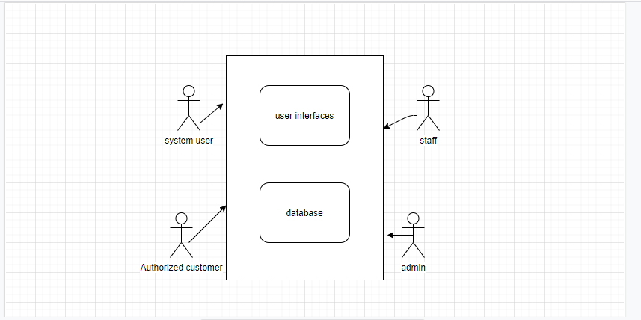

Figure 1 - System Environment

We have four actors in this system

The user can search for tours and their details by interacting with the interface

## 2.2 Functional Requirements Specification

This section shows us usage cases for people who interact with the system.

### 2.2.1

System user use case:

2.2.2

Authorized Customer use case

**2.2.3**

Staff user case

**2.2.4**

Adminstrator use case

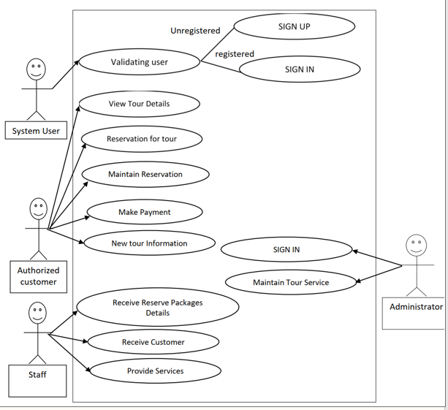

Figure 2-use case

Brief description

The user will deal with the interface, enter his information,

and return the appropriate trip for him

**Initial Step-By-Step Description**

1- The user enters the flight information he wants with his personal data

2- The search is done within the database.

3- The system reviews the trip based on the data

**Xref** :Section 3.2.1

2.3 User Characteristics

The foreign user's language must be good and able to interact with the computer and mobile phone.

2.4 Non-Functional Requirements

One of the most important requirements in this app is the reliability of the information: that is, the tour information is taken correctly.

Information security: that is, maintaining the integrity of the information stored within the database

3.0 Requirements Specification

3.1 External Interface Requirements

3.2 Functional Requirements

3.2.1 Select the tour

|  |  |
| --- | --- |
| Use case Name | Select The tour |
| Xref | Section 3.2.1 Select The tour |
| Trigger | The user enter information |
| Precondition |  |
| Basic Path | 1- The user enters the flight information he wants with his personal data  2- The search is done within the database.  3- The system reviews the trip based on the data |
| Alternative Paths |  |
| Postcondition | The tours was shown to the user |
| Exception Paths | The user closes the program at any time |
| Others |  |

3.3 Detailed Non-Functional Requirements

3.3.1 Logical Structure of the Data

The logical structure of data is stored in a user-defined database

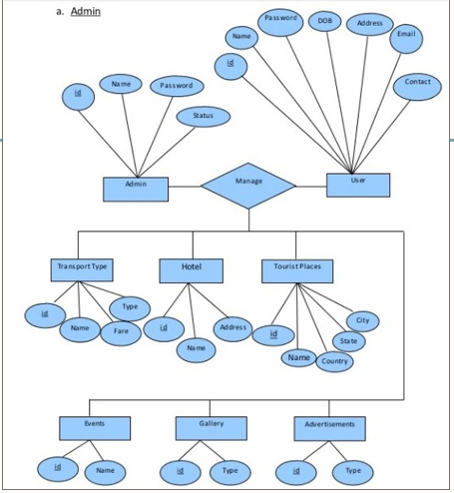

Figure 3-logical structure of the Data

3.3.2 Security

The data base must be protected so that no one can modify it.