Project Features 1
1. AI in Budgeting and Forecasting 1
1.1. Generating a Budget Forecast 2
1.1.1. Use Case 3
1.1.2. Business Process Diagram (BPMN) 1
1.1.3. User Stories 1
1.2. Explaining an AI prediction(XAI) 1
1.2.1. Use Case 3
1.2.2. BPMN 1
1.2.3. User Stories 1
Field Requirements / Business Rules 1
Wireframe 3
Test Cases 24
Updated work after Experts Feedback: 28
Updated User Stories: Business Process 1 28
Updated User Stories: Business Process 2 29
Updated Wireframes: Business Process 1 30
Updated Wireframes: Business Process 2 43

Project Features

AI in Budgeting and Forecasting
The AI in Budgeting and Forecasting feature is an intelligent module within the accounting system that transforms traditional budgeting and forecasting processes by integrating multiple Artificial Intelligence technologies, including ML, DL, NLP, RPA, and XAI. The feature replaces manual, time-consuming, and error-prone forecasting approaches with automated, data-driven predictions that improve accuracy, responsiveness to market changes, and decision-making quality.
The focus of this feature is to balance predictive accuracy with transparency and interpretability addressing the black-box challenge of AI in financial decision-making. Through XAI techniques such as SHAP and LIME, the feature ensures that decision makers can not only receive accurate forecasts but also understand how each prediction was generated, fostering trust and accountability in AI-driven budgeting.
The feature supports four main user roles: the Financial Analyst, who initiates and reviews forecasts; the Budget Manager, who reviews explanations and approves budgets; the System Administrator, who manages model performance and interpretability; and the Data Engineer, who ensures data quality before model training.
The feature covers two main business processes: first is Generating a Budget Forecast and second Explaining an AI Prediction

Generating a Budget Forecast
This business process shows how a budget forecast is created.The Financial Analyst logs into the system and requests a budget forecast.Then, the Financial Analyst selects forecast length, department/project scope, and preferred forecasting method. Before the models are trained data quality is checked by the Data Engineer of historical budget data using RPA. RPA cleans, standardizes, and validates data. Once the data quality is acceptable, AI System fetches historical financial data and trains the models. Data Engineer checks for any data issue and reviews data. once data is validated AI System trains multiple ML models using ML models which are created DL Algorithms to create Budget forecasts based on historical data, ML ensemble methods are used to predict expense trends Combining multiple models together to create more accurate forecasts and clustering algorithms are used to Analyze historical spending patterns to see where we can save costs and cluster similar spendings. When forecast is generated Financial analyst reviews the forecasted budget. If analyst approves forecast they will submit the budget Forecast along with Variance Analysis Report to Budget manager for approval. Variance Analysis report is created using NLP Highlights Key Variances and determines forecast accuracy.If the forecast is denied, the financial analyst will redefine the parameters of the forecast and regenerate forecast. Budget manager can either approve the budget or send it back to the financial analyst for changes.

Use Case
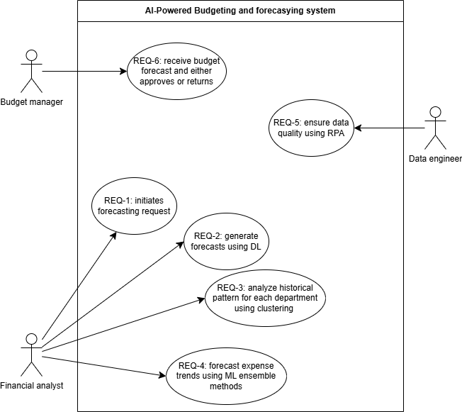

Business Process Diagram (BPMN)

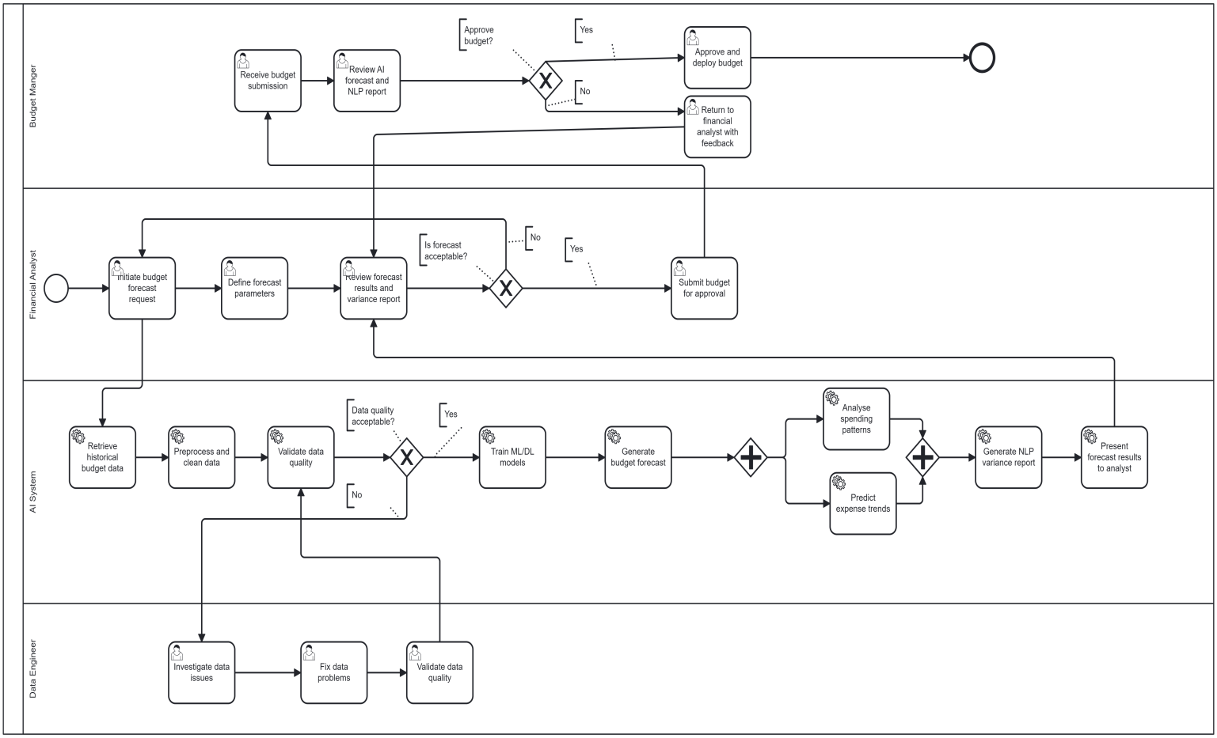

User Stories
Requirement ID | Epic | User Story Summary
REQ-BP1-1 | Budget Forecast Generation | As a financial analyst, I want to initiate a budget forecast request and define the forecast parameters including forecast horizon, department scope, and forecasting method so that the system generates forecasts relevant to my planning needs.
REQ-BP1-2 | Budget Forecast Generation | As a financial analyst, I want to generate budget forecasts using historical data with the DL algorithm so that I can create more accurate budget plans.
REQ-BP1-3 | Budget Forecast Generation | As a financial analyst, I want to analyse historical spending patterns of each department using clustering algorithms so that I can group similar spending behaviours to identify opportunities for saving cost and enhance resource allocation.
REQ-BP1-4 | Budget Forecast Generation | As a financial analyst, I want to forecast expense trends using ML ensemble methods so that I can estimate future spending patterns and prepare accurate budgets by combining multiple model predictions.
REQ-BP1-5 | Data Quality | As a data engineer, I want to ensure data quality using RPA before model training so that the AI system produces reliable forecasts based on clean, accurate data.
REQ-BP1-6 | Budget Review & Approval | As a budget manager, I want to receive the submitted budget forecast with an AI-generated variance analysis report produced using NLP so that I can review the deviations, assess forecast reliability, and decide whether to approve or return it with feedback..

Explaining an AI prediction(XAI)
This process describes how a budget manager requests and receives an explanation for a forecast made by an AI system. This portion of the budget manager’s activities begins with the completion of Business Process 1 when the budget forecast is submitted to Budget Manager. Budget managers use the system to initiate an explanation request. The AI system then uses two XAI methods to develop the explanation requested: the first method is SHAP to develop a global explanation of the overall feature importance of the features used in the model to create the
forecasted budget outcome for all instances included in the model. Using SHAP, the budget manager will determine the key drivers of the budget outcome as it relates to their forecasted budget. The second method is LIME which is used to generate a local explanation for a specific prediction. LIME shows which features contributed most to that individual forecast and by how much each feature pushed the prediction in a particular direction. Using NLP, the AI System is capable of generating interactive visualizations such as a visual representation showing feature importance, summarizing information, and providing explanations for individual predictions. The Budget Manager will utilize these global SHAP explanations, local LIME explanations, and other interactive visualizations to determine whether or not the AI system’s predictions
are reasonable enough. If everything appears in order, this concludes the process and the Budget Manager will initiate approval workflow of Business Process 1. However, if explanations provided by the AI System contain issues such as a feature that has an unexpected impact on predictions, or the model’s accuracy is low then the Budget Manager will submit an issue concerning the quality of the explanation to the System Administrator andThe system administrator monitors explanation quality and model interpretability over time using ML performance metrics. When the quality of the explanation degrades, the administrator triggers
a model reconfiguration and validates the updated explanation quality, after which SHAP and LIME are rerun to produce explanations.

Use Case
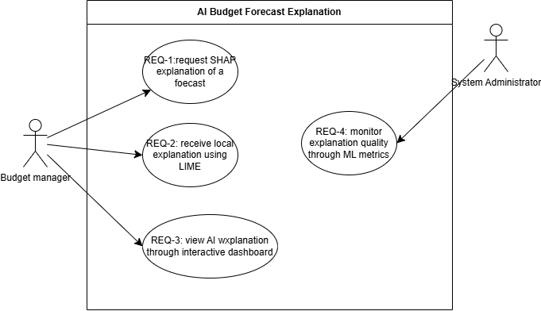

BPMN
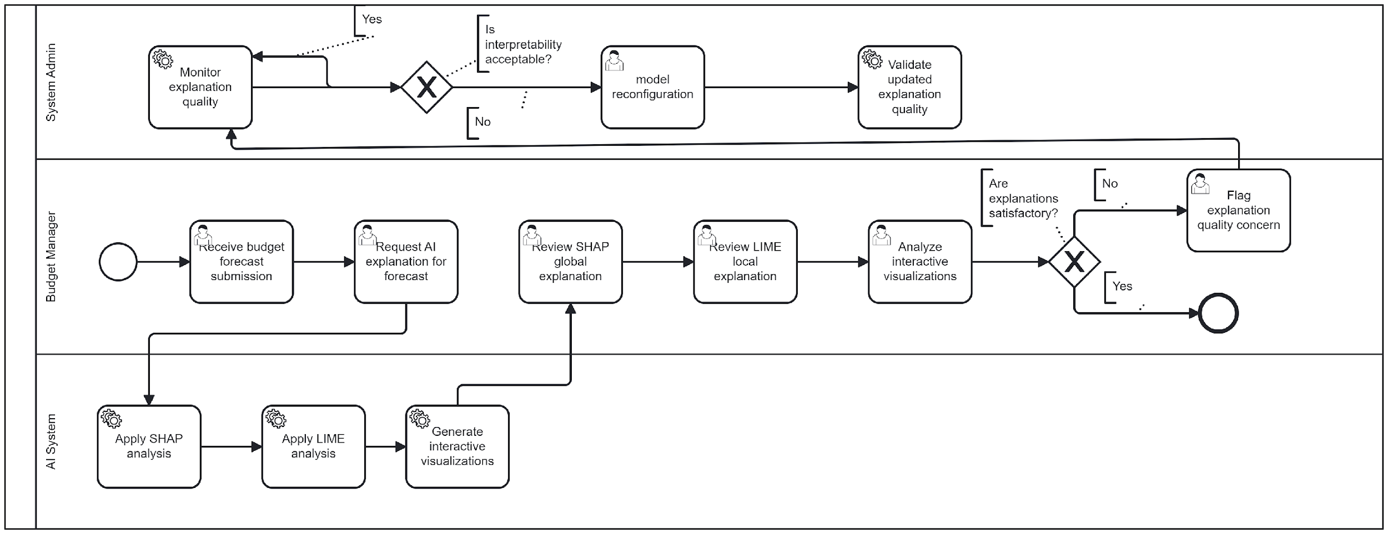

User Stories
Requirement ID | Epic | User Story Summary
REQ-BP2-1 | Explainability & Transparency | As a budget manager, I want to request an explanation of an AI-generated forecast using SHAP so that I can see which features had the most influence on the overall predictions and understand the global drivers of budget outcomes.
REQ-BP2-2 | Explainability & Transparency | As a budget manager, I want to receive a local explanation of a specific budget prediction using LIME so that I can understand which factors contributed to that individual forecast outcome and by how much each factor influenced the prediction.
REQ-BP2-3 | Forecast Reporting & Visualization | As a budget manager, I want to view the AI explanations through interactive visualizations including feature importance charts and prediction breakdowns generated using NLP so that I can easily interpret the results without technical expertise.
REQ-BP2-4 | Model Interpretability Management | As a system administrator, I want to monitor explanation quality and model interpretability using ML performance metrics so that I can trigger model reconfiguration when explanations become less meaningful due to model drift.

Field Requirements / Business Rules
Rule ID | User  Story | Field | Business Rule
BR-BF-01 | REQ-BP1-1 | Forecast Name | Every budget forecast request must specify: Forecast Name, Department Scope, Forecast Horizon, Historical Data Range, and Forecasting Method
BR-BF-02 | REQ-BP1-1 | Forecast Period Start Date  Forecast Period End Date | Forecast Period End Date must be later than Forecast Period Start Date.
BR-BF-03 | REQ-BP1-2 | Historical Data Range | Deep Learning forecasts require a minimum of 12 months of historical data; requests below this threshold must be rejected.
BR-BF-04 | REQ-BP1-2 | -Training Epochs  -Hidden Layers -Number of Clusters  -Number of Top Features  -Sampling Size | All numeric model parameters (Training Epochs, Hidden Layers, Number of Clusters, Number of Top Features, Sampling Size) must be positive integers greater than zero.
BR-BF-05 | REQ-BP1-2 | ConfidenceThreshold | Confidence Threshold values must be between 0% and 100%.
BR-BF-06 | REQ-BP1-5 | Data Quality Status | A forecast cannot proceed to model training if the data quality check has failed; data issues must be resolved by the Data Engineer before model training.
BR-BF-07 | REQ-BP1-6 | Variance Report | Each submitted forecast must include an AI-generated NLP variance report before reaching the Budget Manager review queue.
BR-BF-08 | REQ-BP2-1  REQ-BP1-2 | Forecast Status | An AI explanation SHAP/LIME cannot be generated unless a forecast has been successfully produced by the system.
BR-BF-09 | REQ-BP2-1 | Target Prediction | LIME local explanations require the user to select an existing prediction from the system; no explanation is generated without a target prediction.
BR-BF-10 | REQ-BP2-4 | Interpretability Score | When a model’s interpretability score falls below the critical threshold, the system must automatically alert the System Administrator and flag affected forecasts.
BR-BF-11 | REQ-BP1-1  REQ-BP1-6  REQ-BP2-1 | Audit Log | All forecast generation, explanation, and approval actions must be recorded in an audit log with userID, timestamp, and action type.

Wireframe
The wireframes for each user story were built using Lovable. Each user story has two screens: an input screen showing what the user provides to the system, and an output screen showing what the system returns.
Wireframes Link: https://chum-page-builder.lovable.app/
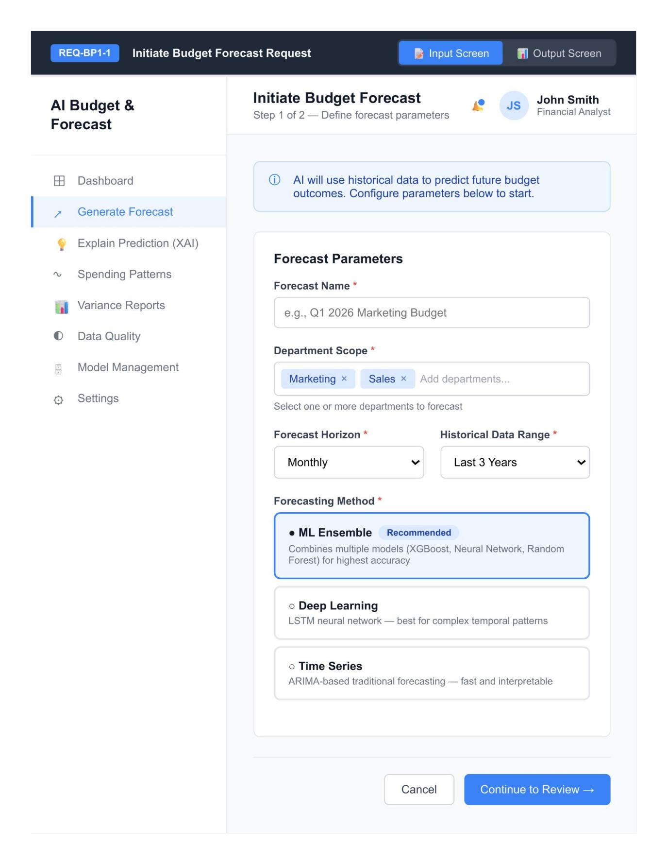
REQ-BP1-1 Input Screen — Initiate Budget Forecast Request
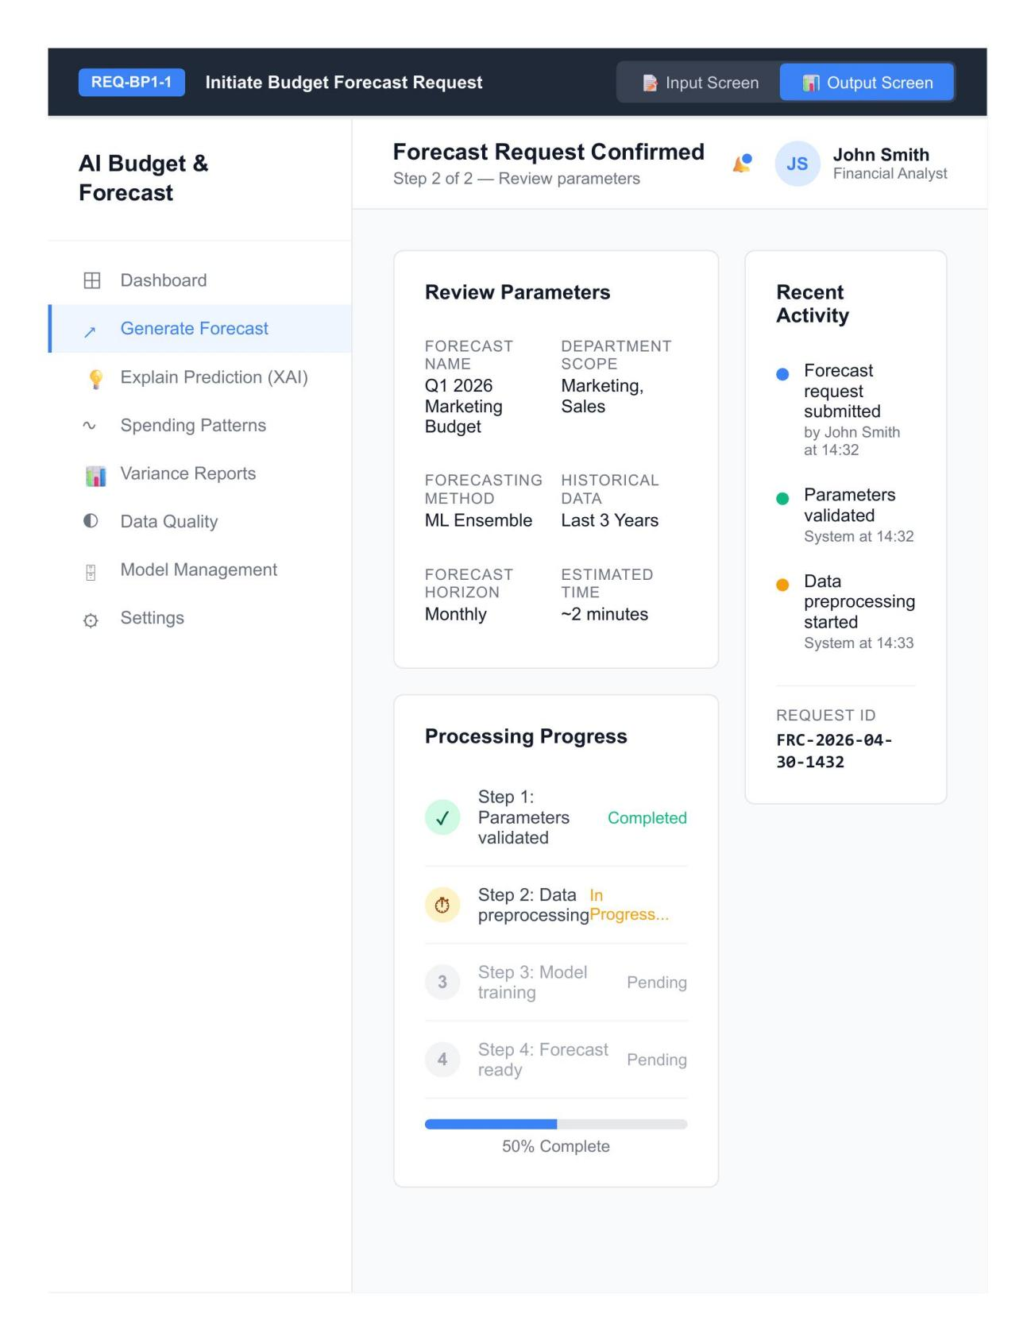
REQ-BP1-1 Output Screen — Initiate Budget Forecast Request
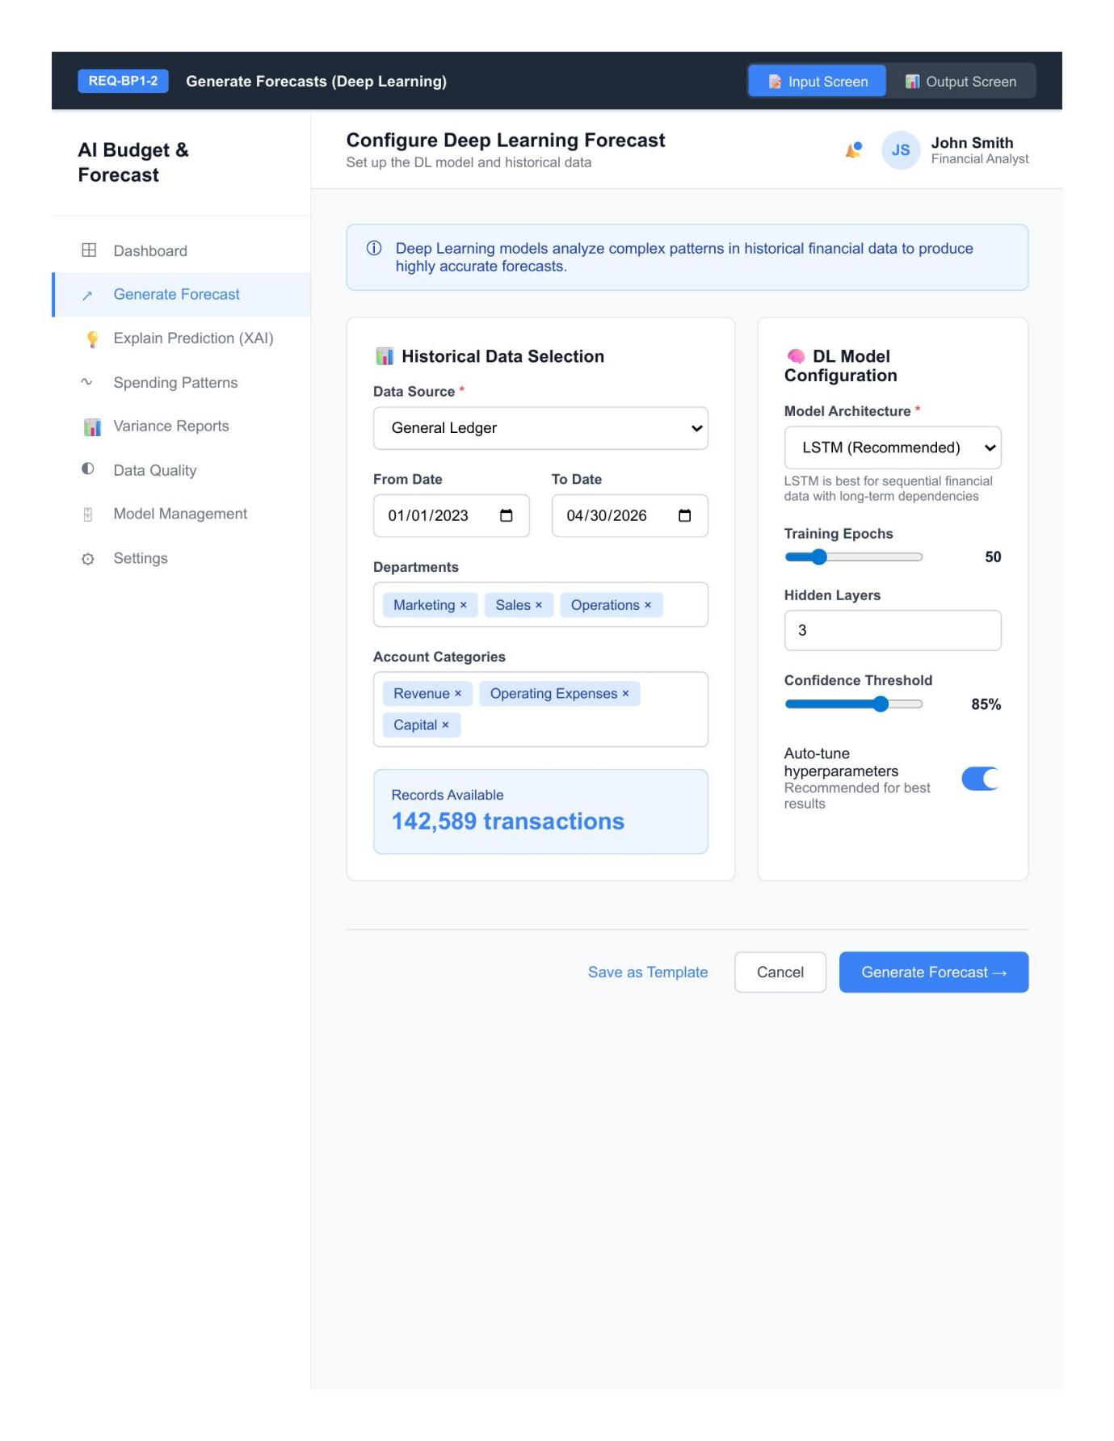
REQ-BP1-2 Input Screen — DL Forecast Configuration
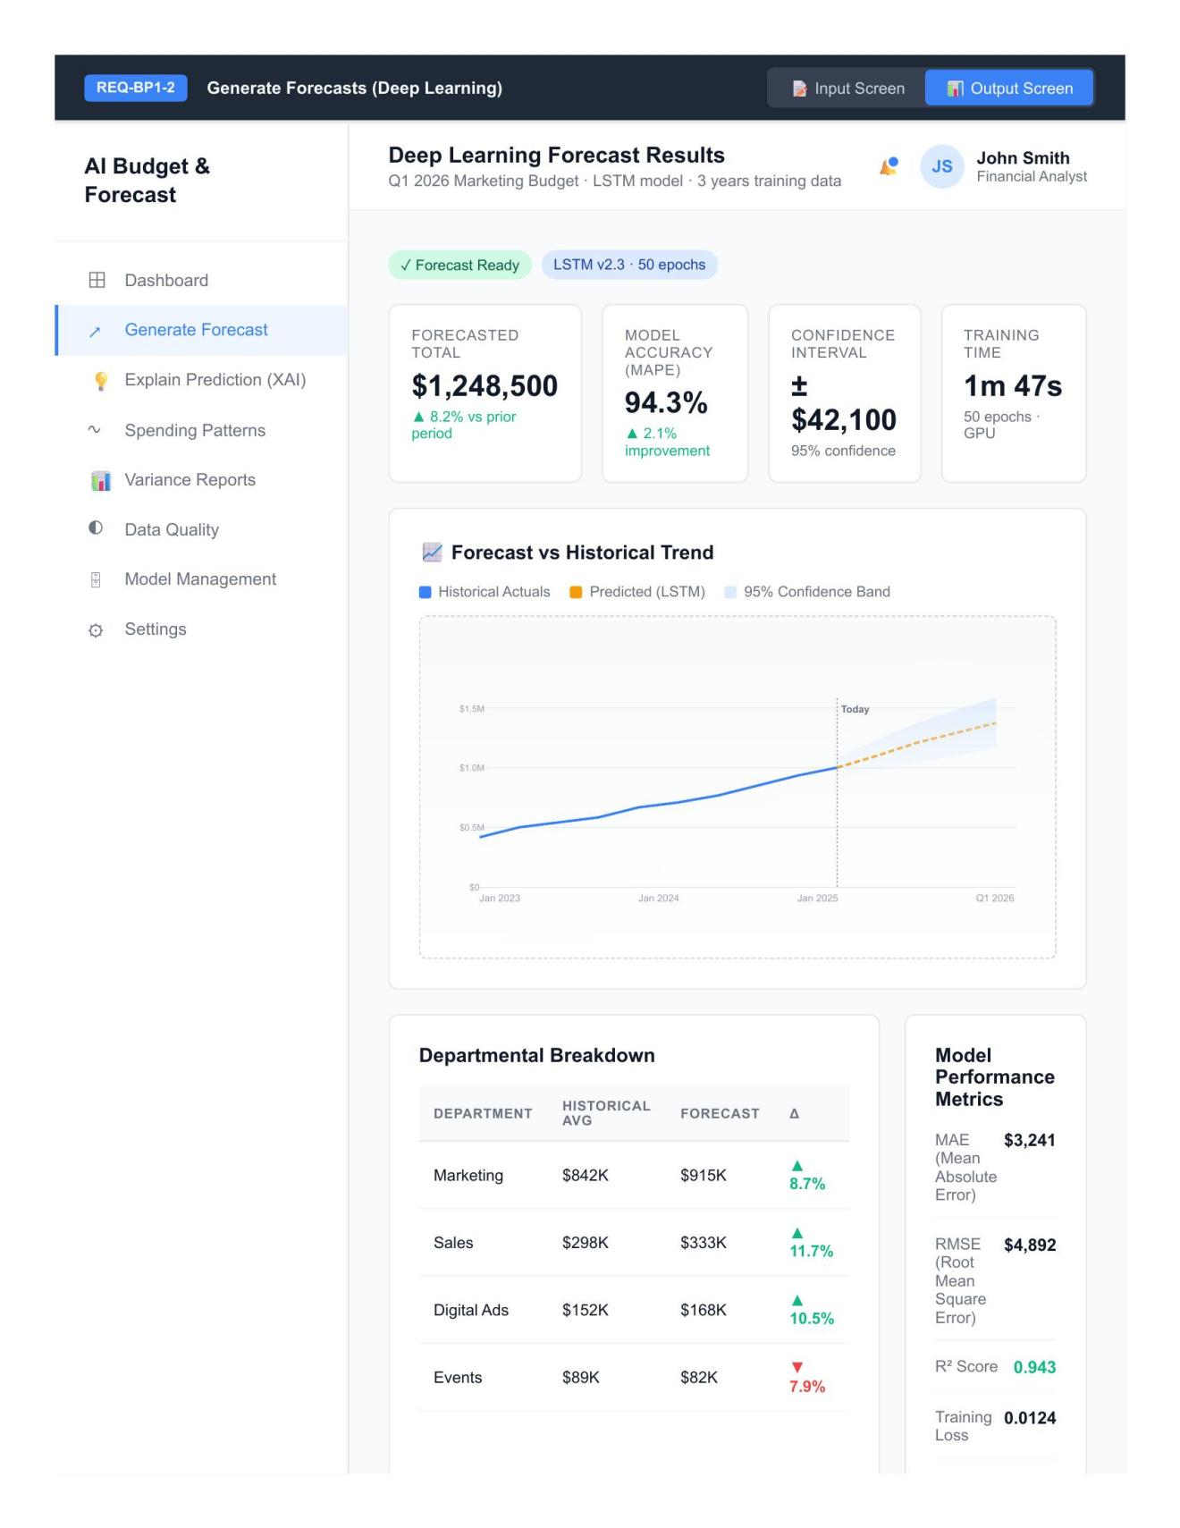
REQ-BP1-2 Output Screen — DL Forecast Configuration
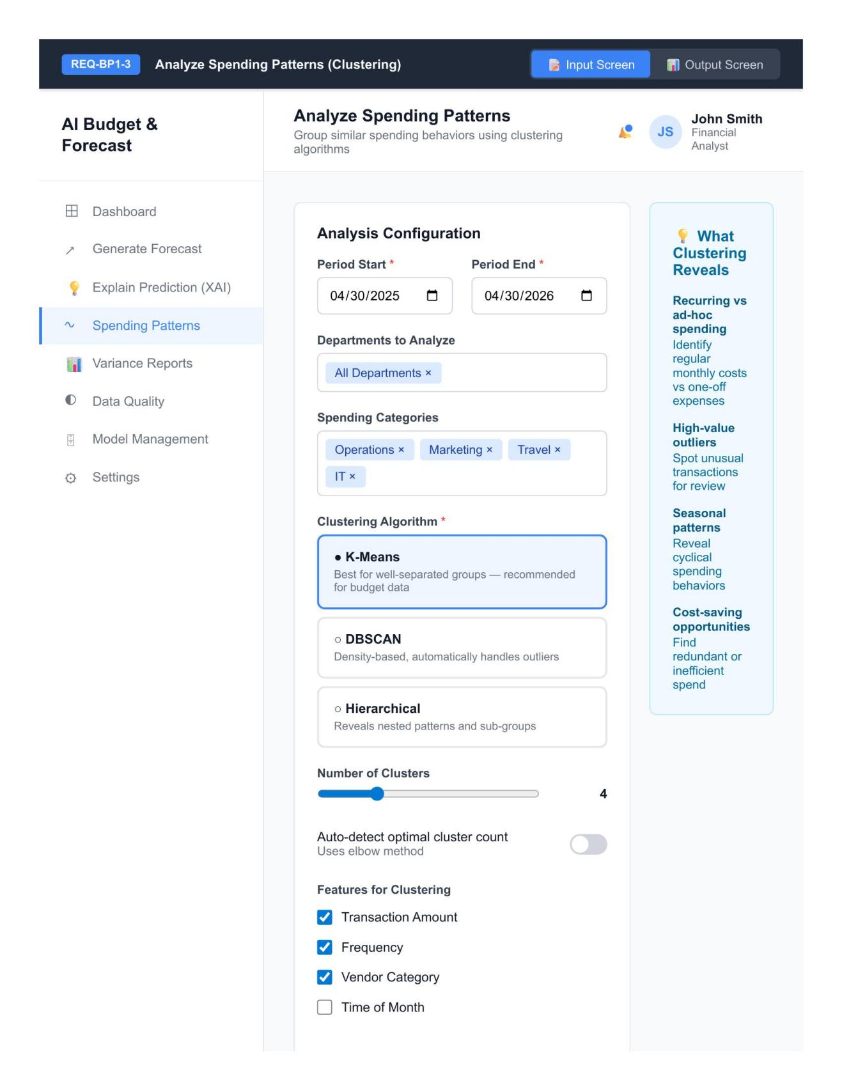
REQ-BP1-3 Input Screen — Clustering Analysis
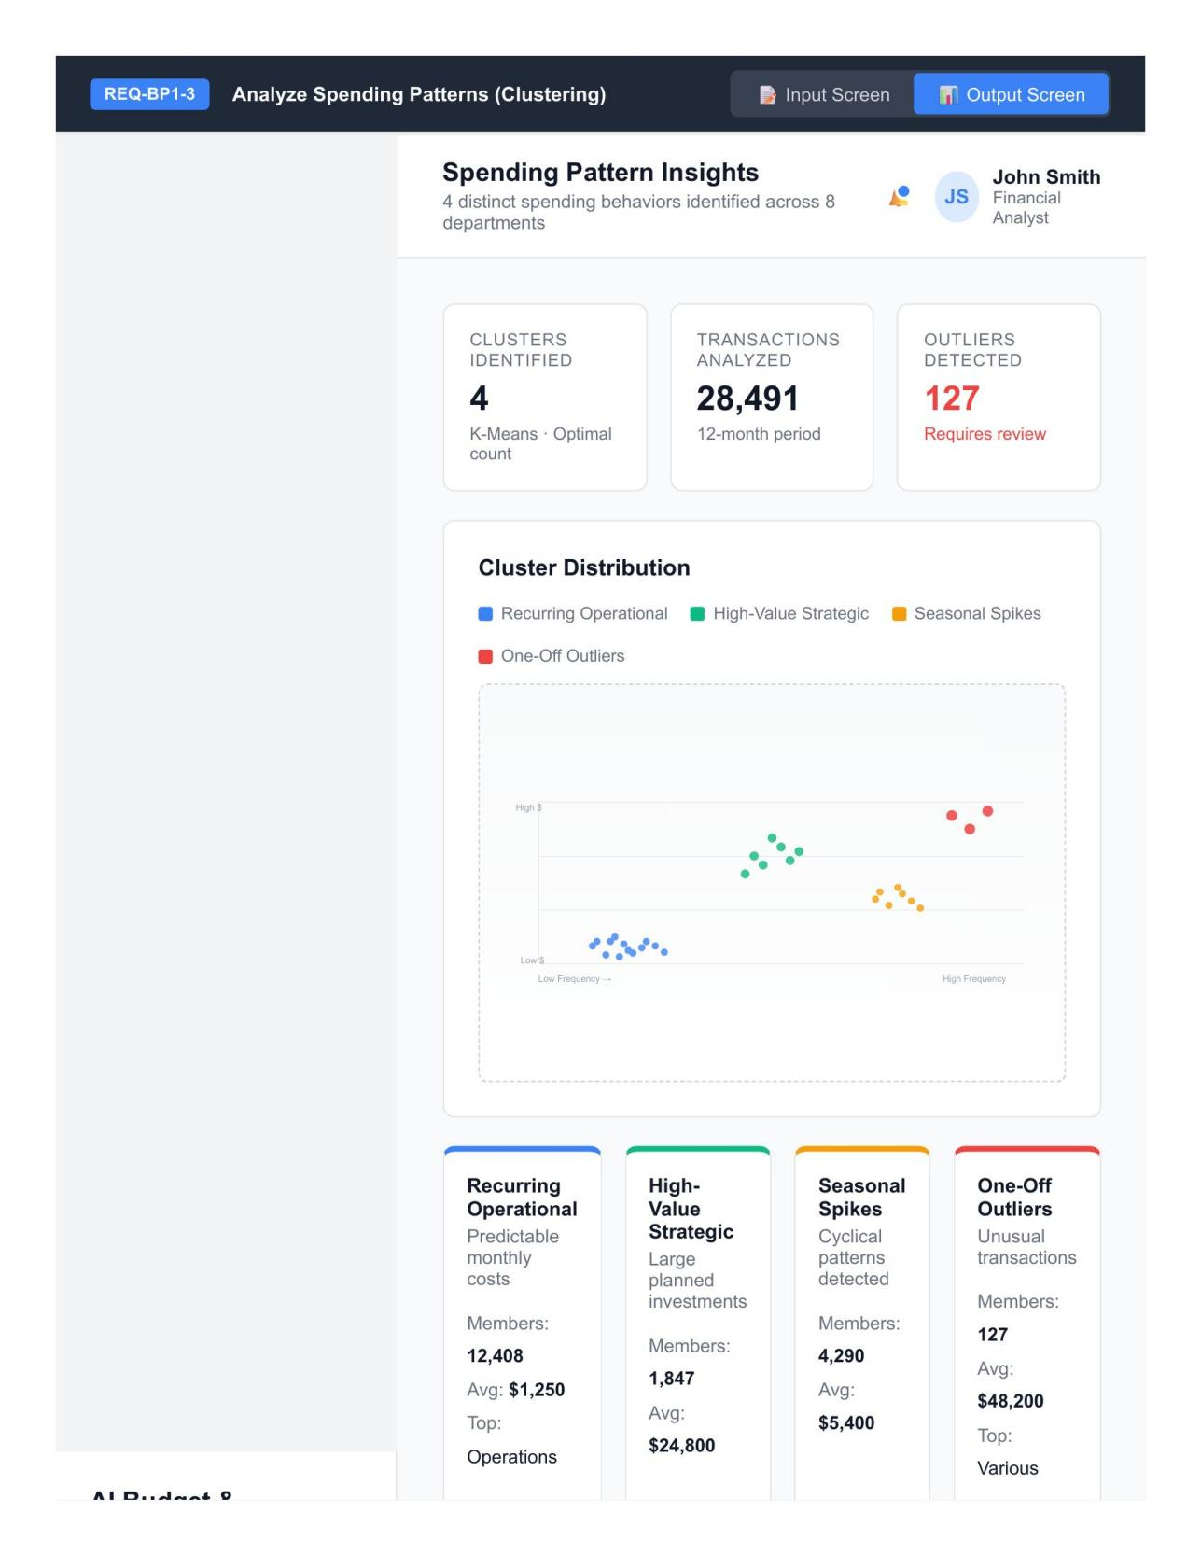
REQ-BP1-3 Output Screen — Clustering Analysis
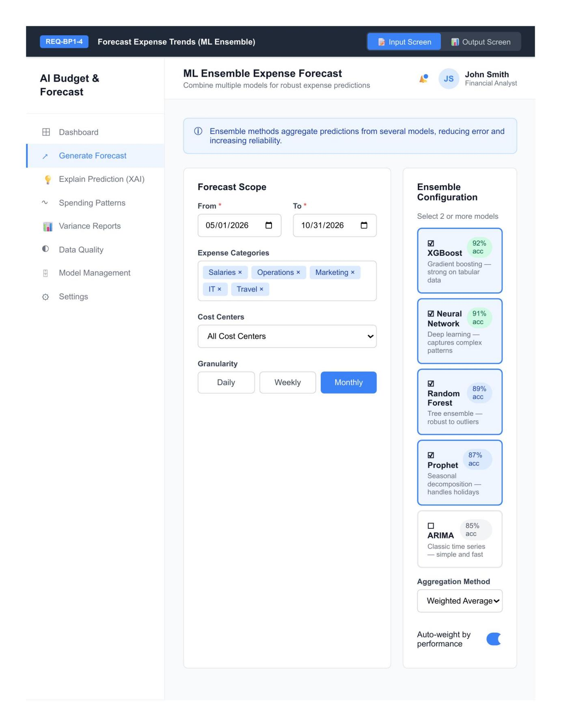
REQ-BP1-4 Input Screen — ML Ensemble Forecast
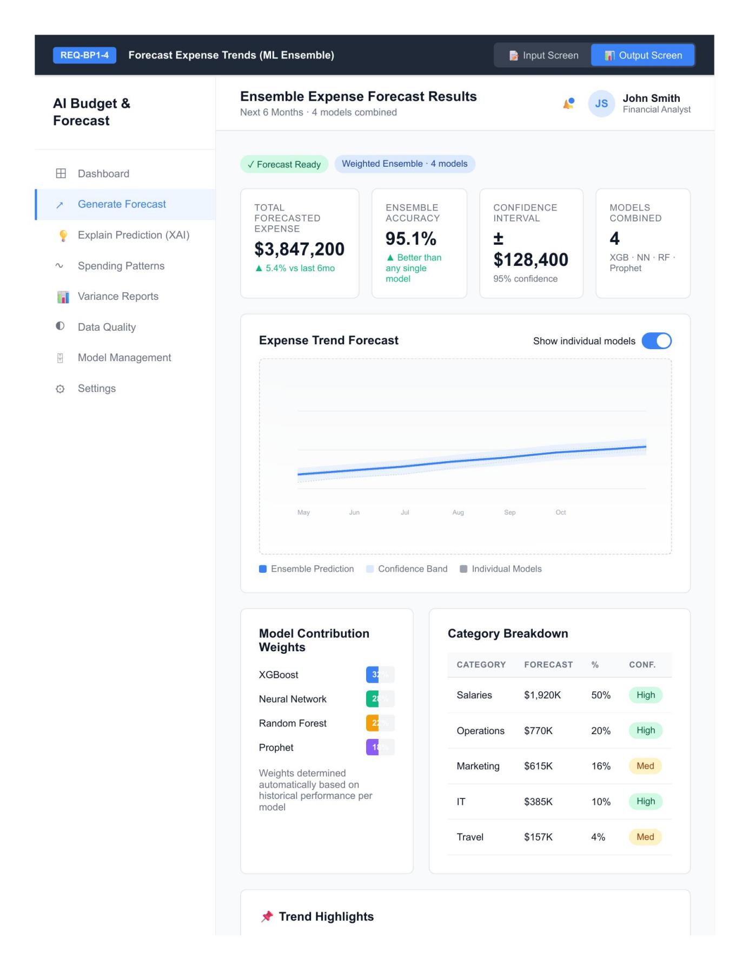
REQ-BP1-4 Output Screen — ML Ensemble Forecast
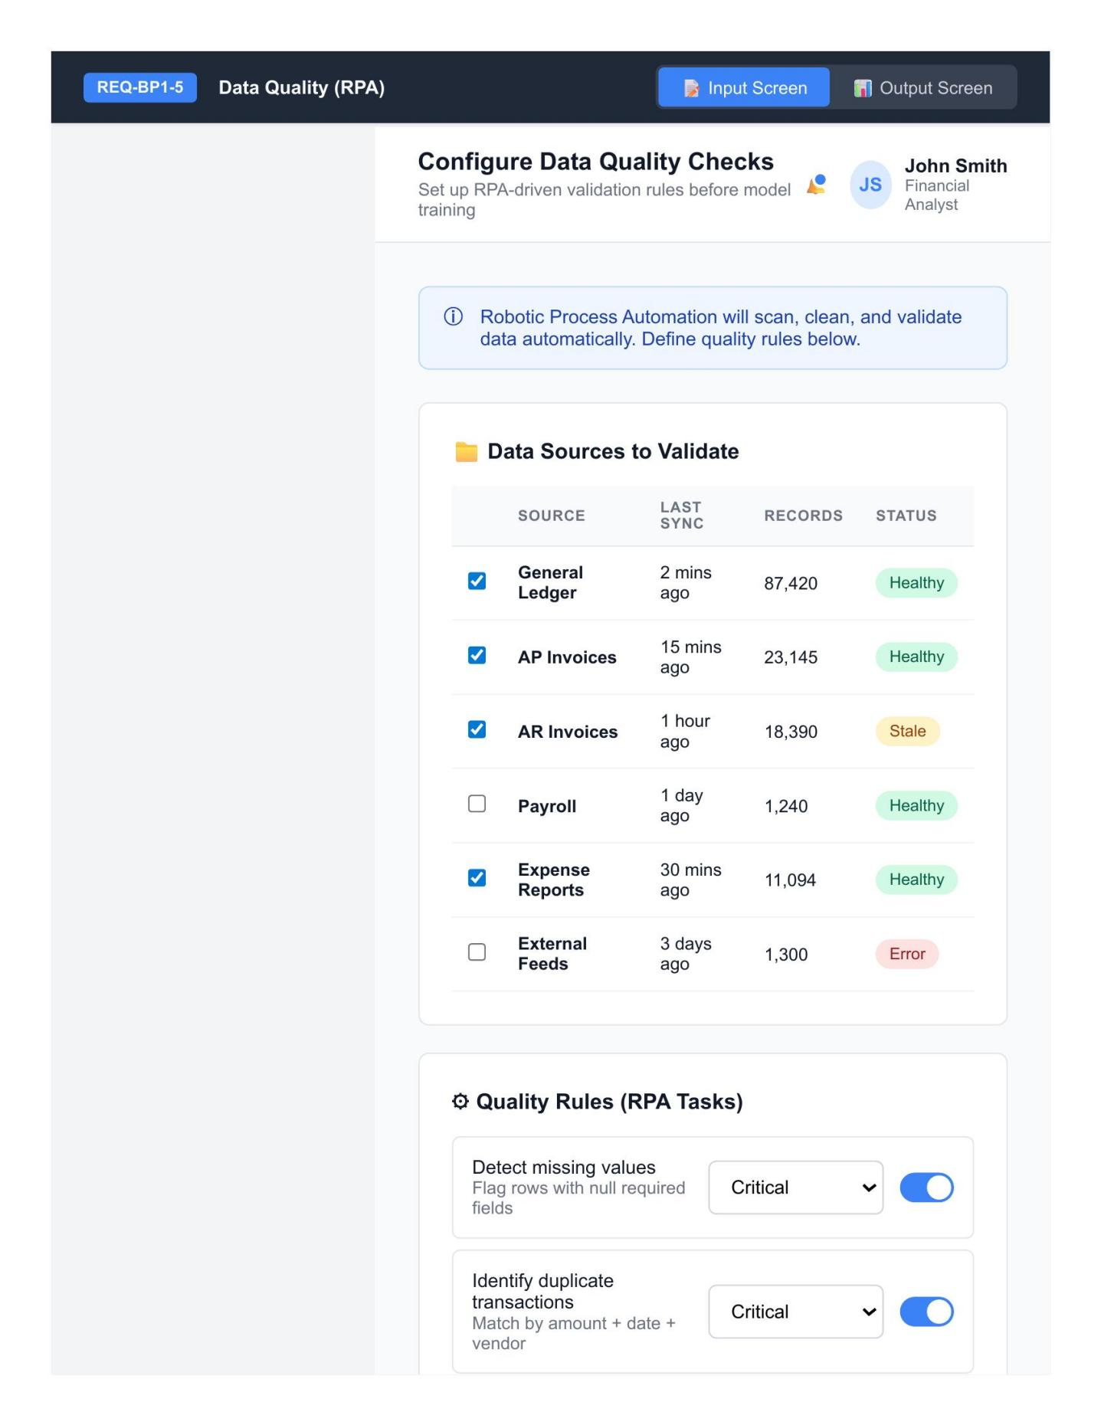
REQ-BP1-5 Input Screen — Data Quality Check
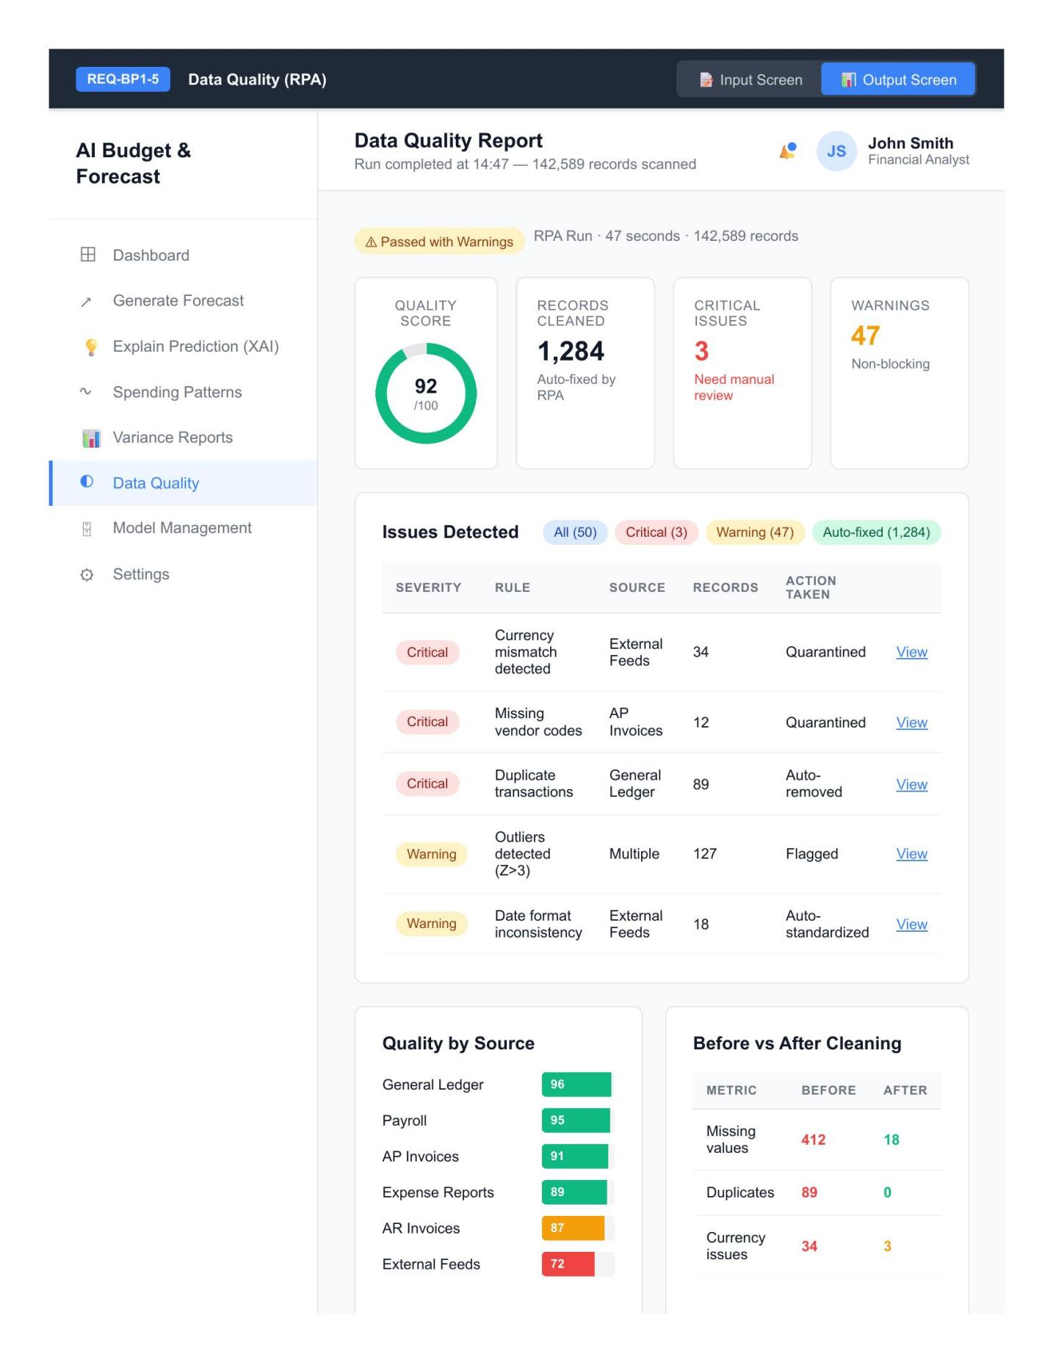
REQ-BP1-5 Output Screen — Data Quality Check
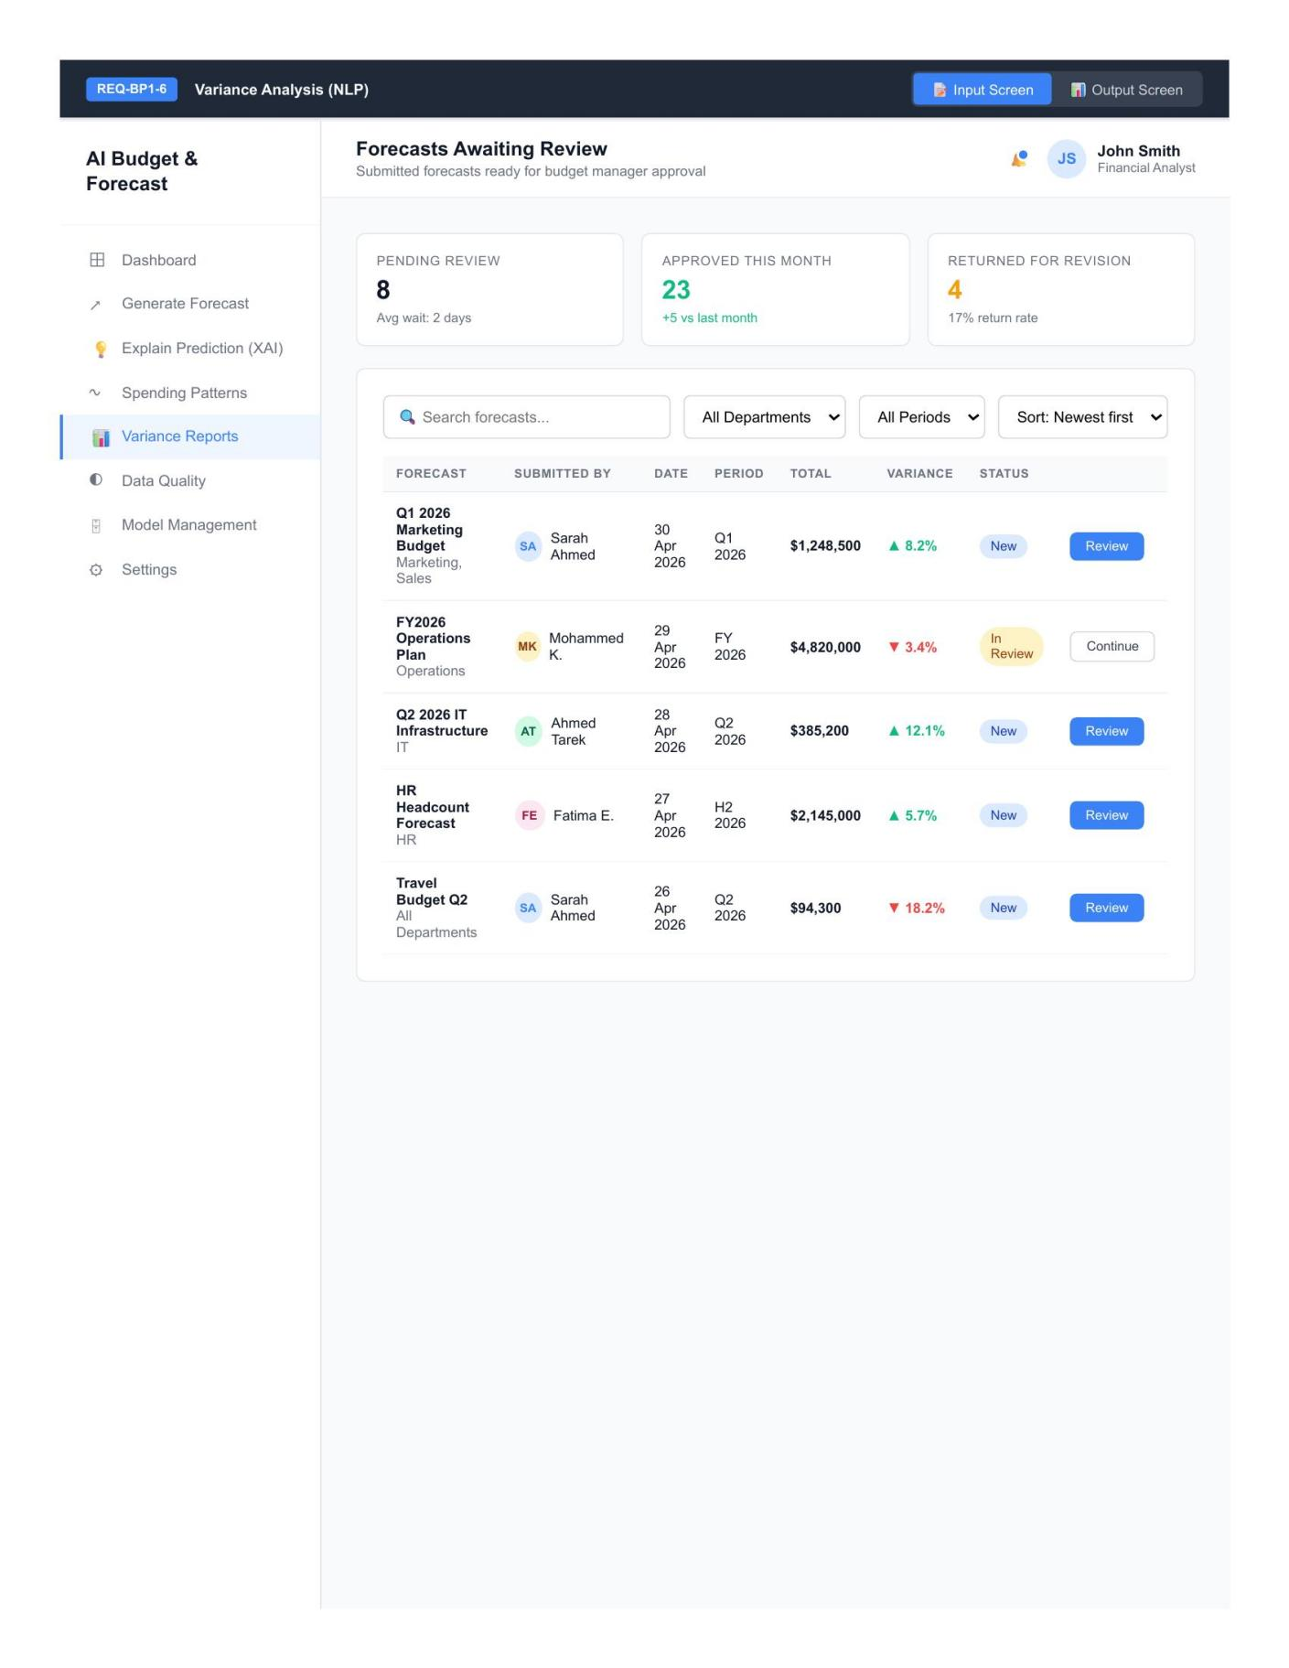
REQ-BP1-6 Input Screen — Variance Analysis & Approval
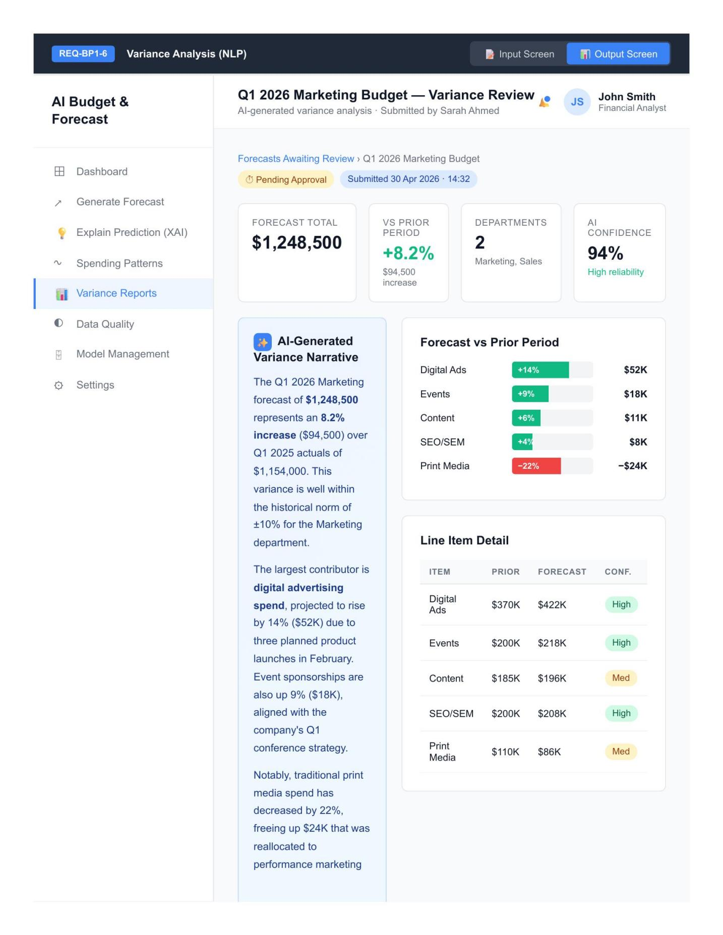
REQ-BP1-6 Output Screen — Variance Analysis & Approval
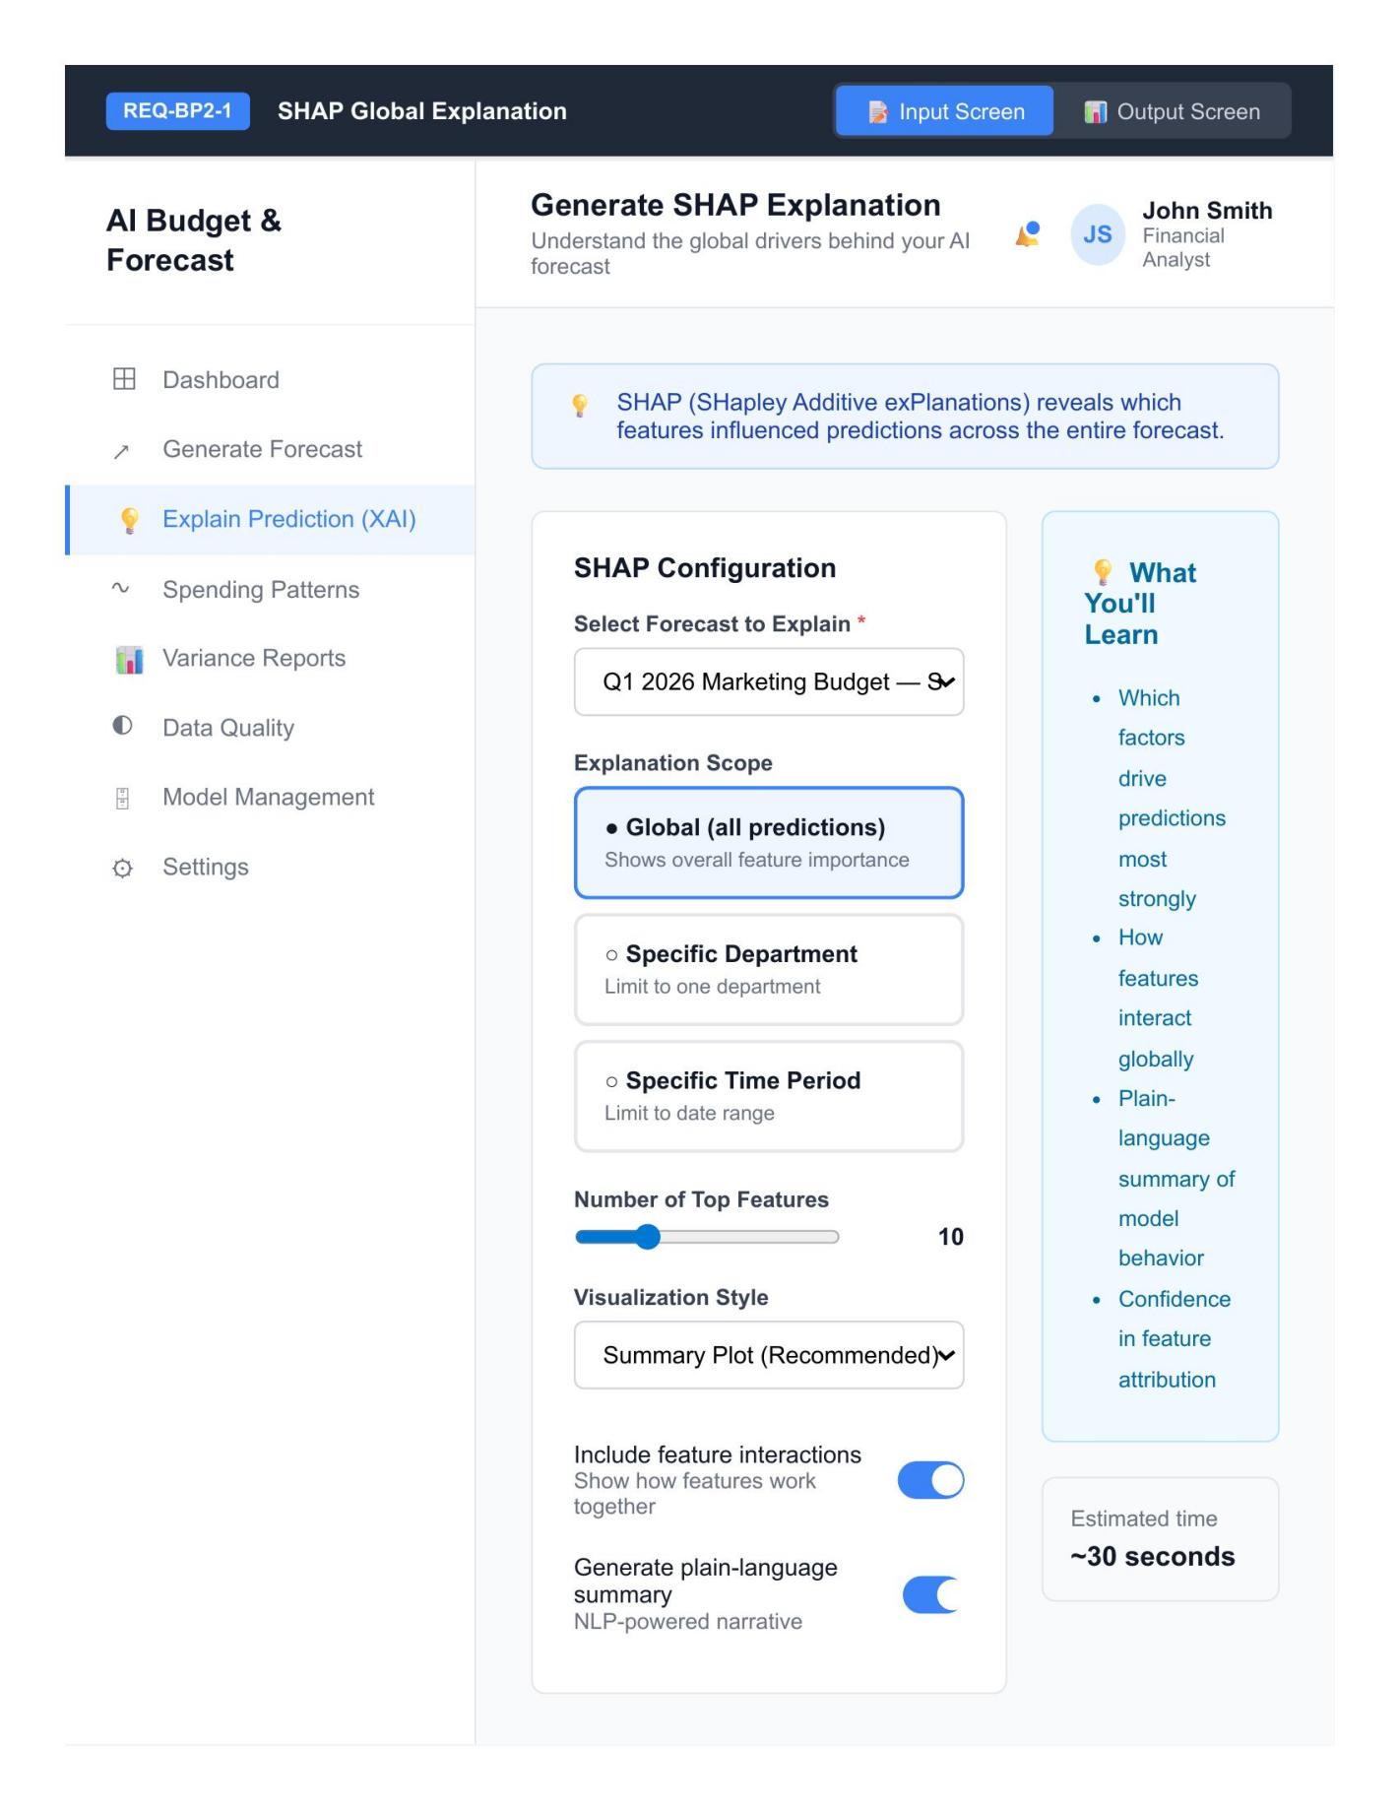
REQ-BP2-1 Input Screen — SHAP Explanation
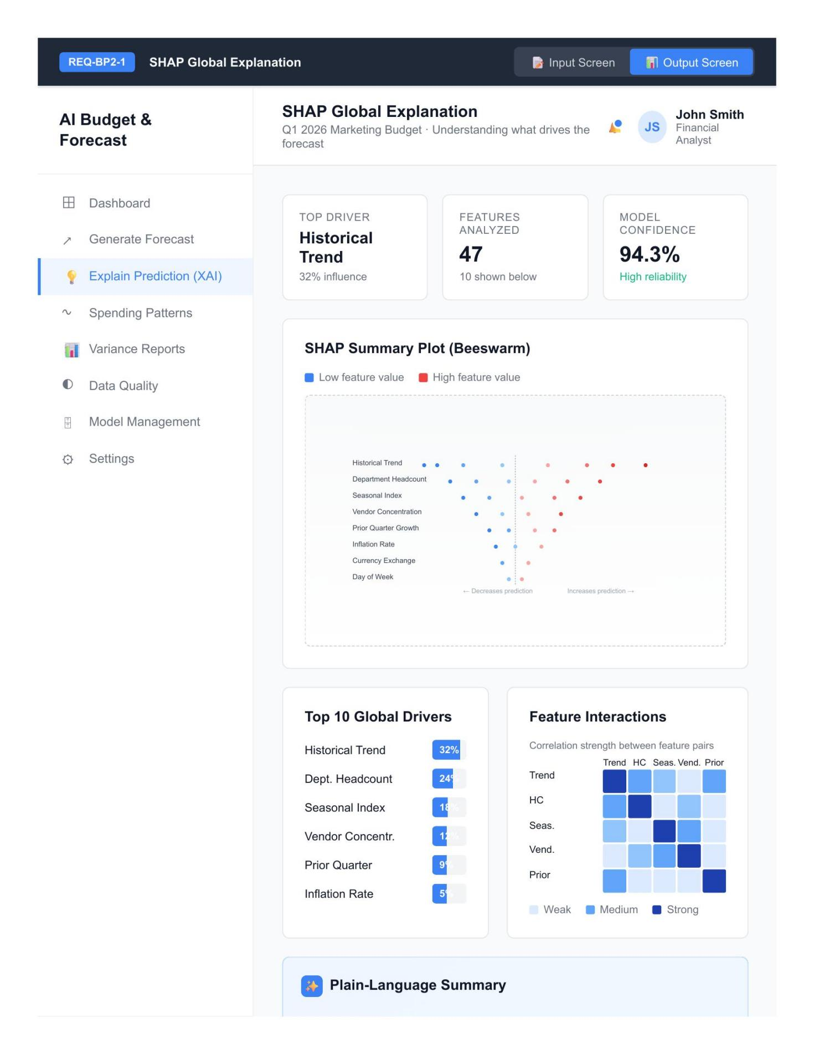
REQ-BP2-1 Output Screen — SHAP Explanation
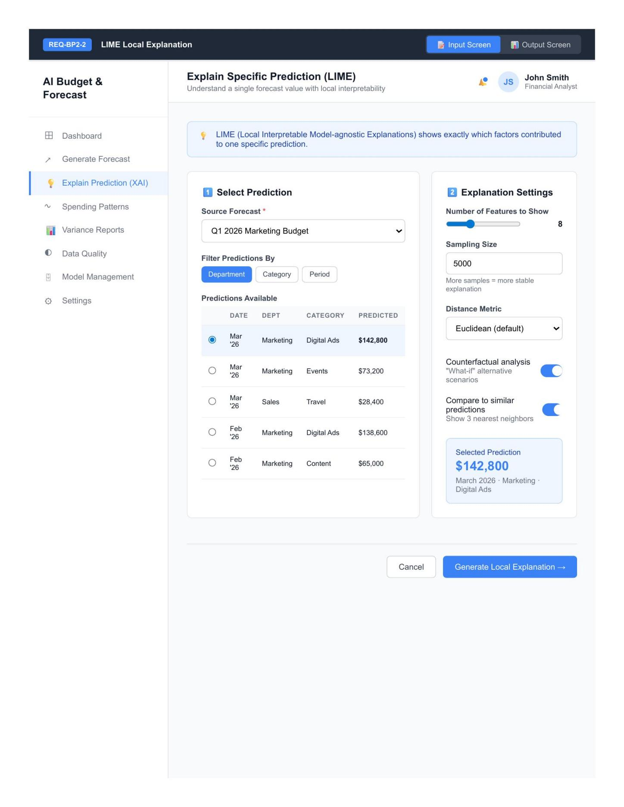
REQ-BP2-2 Input Screen — LIME Explanation
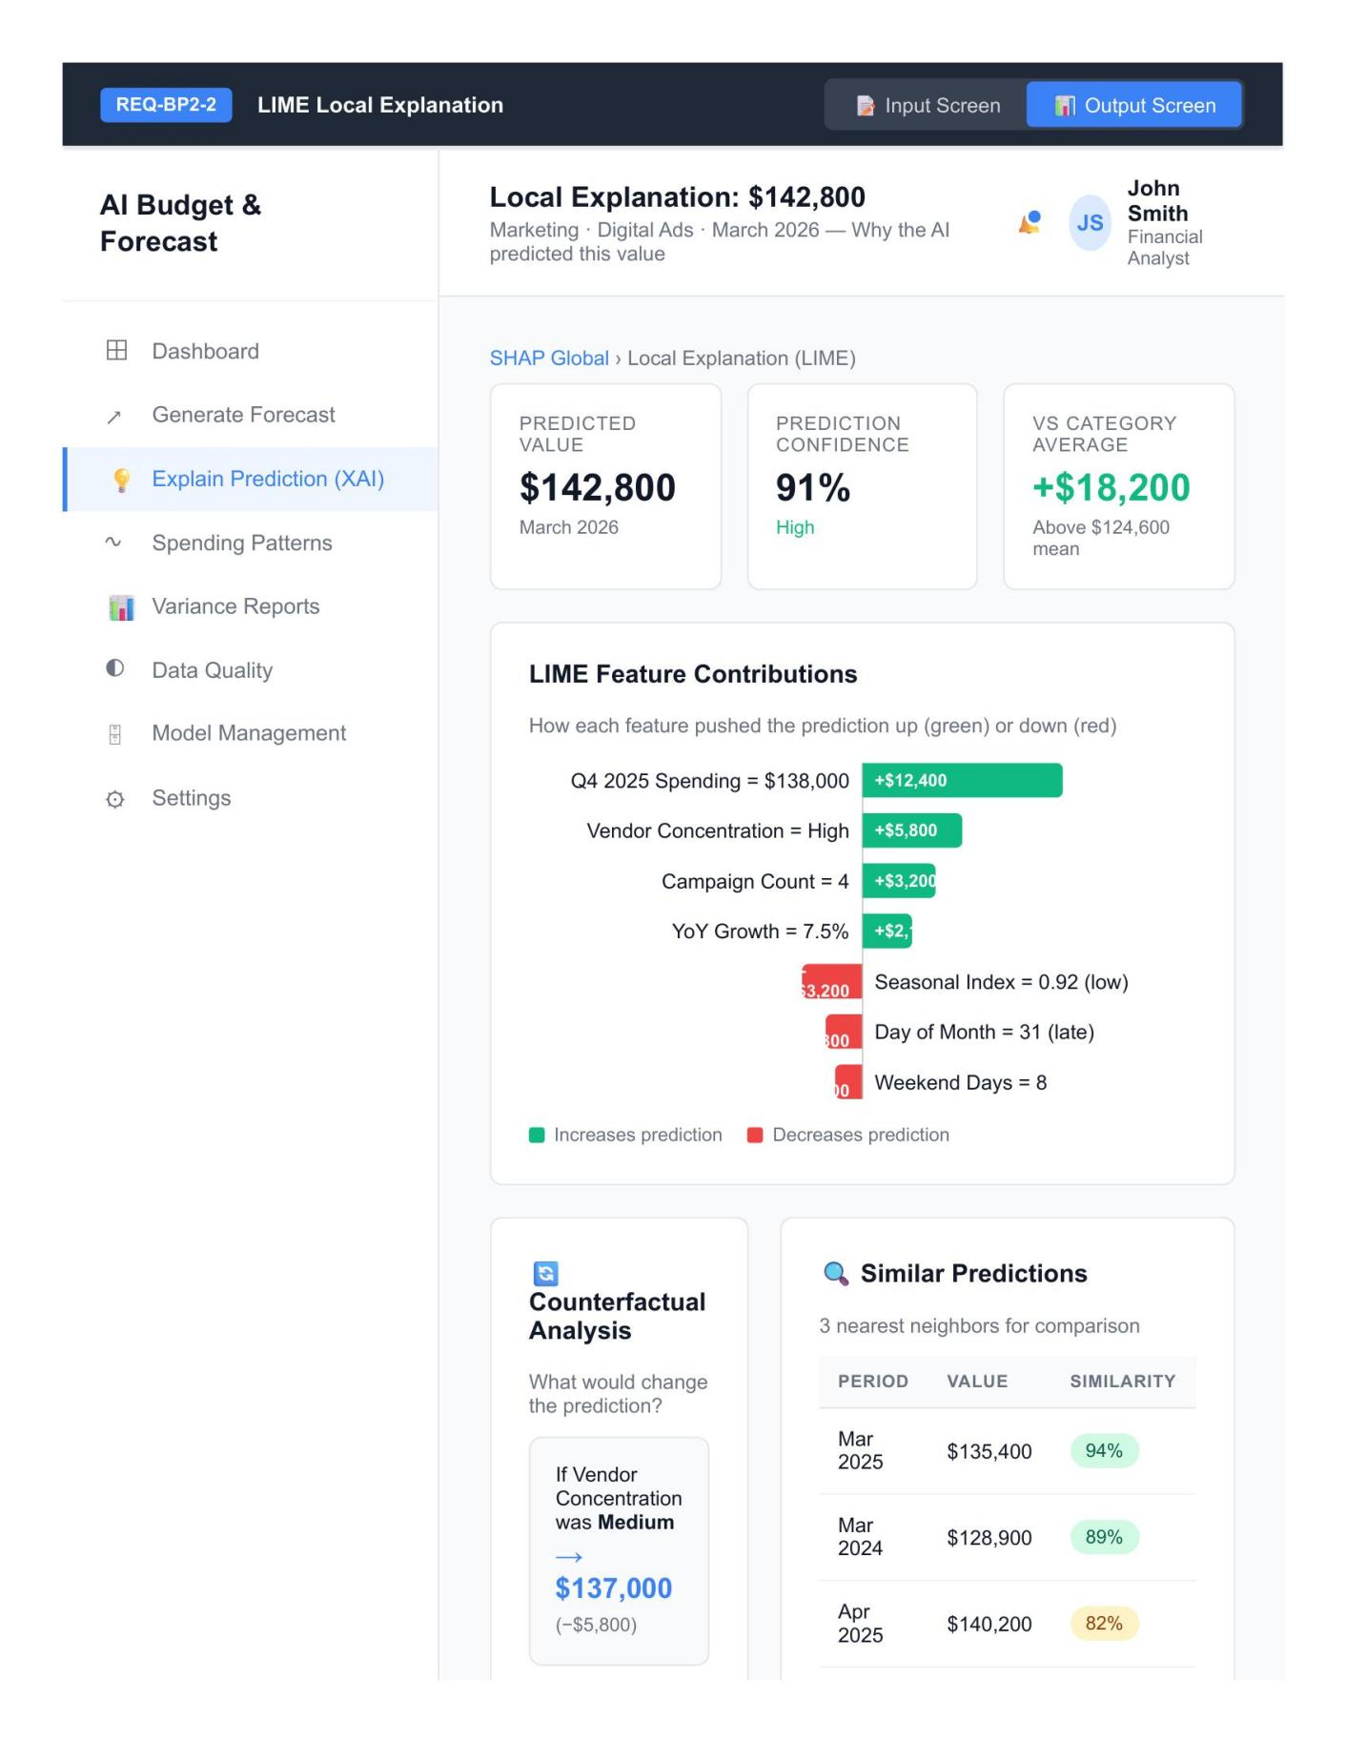
REQ-BP2-2 Output Screen — LIME Explanation
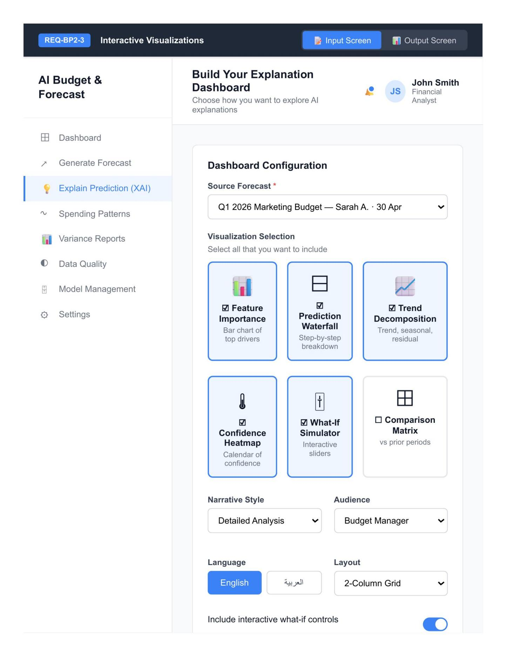
REQ-BP2-3 Input Screen — Explanation Dashboard
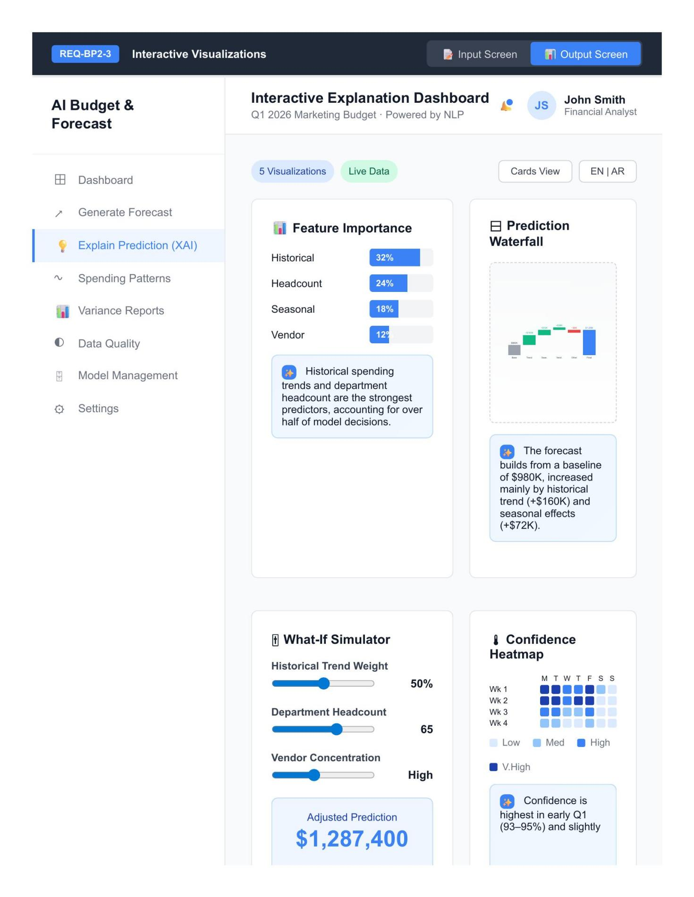
REQ-BP2-3 Output Screen — Explanation Dashboard
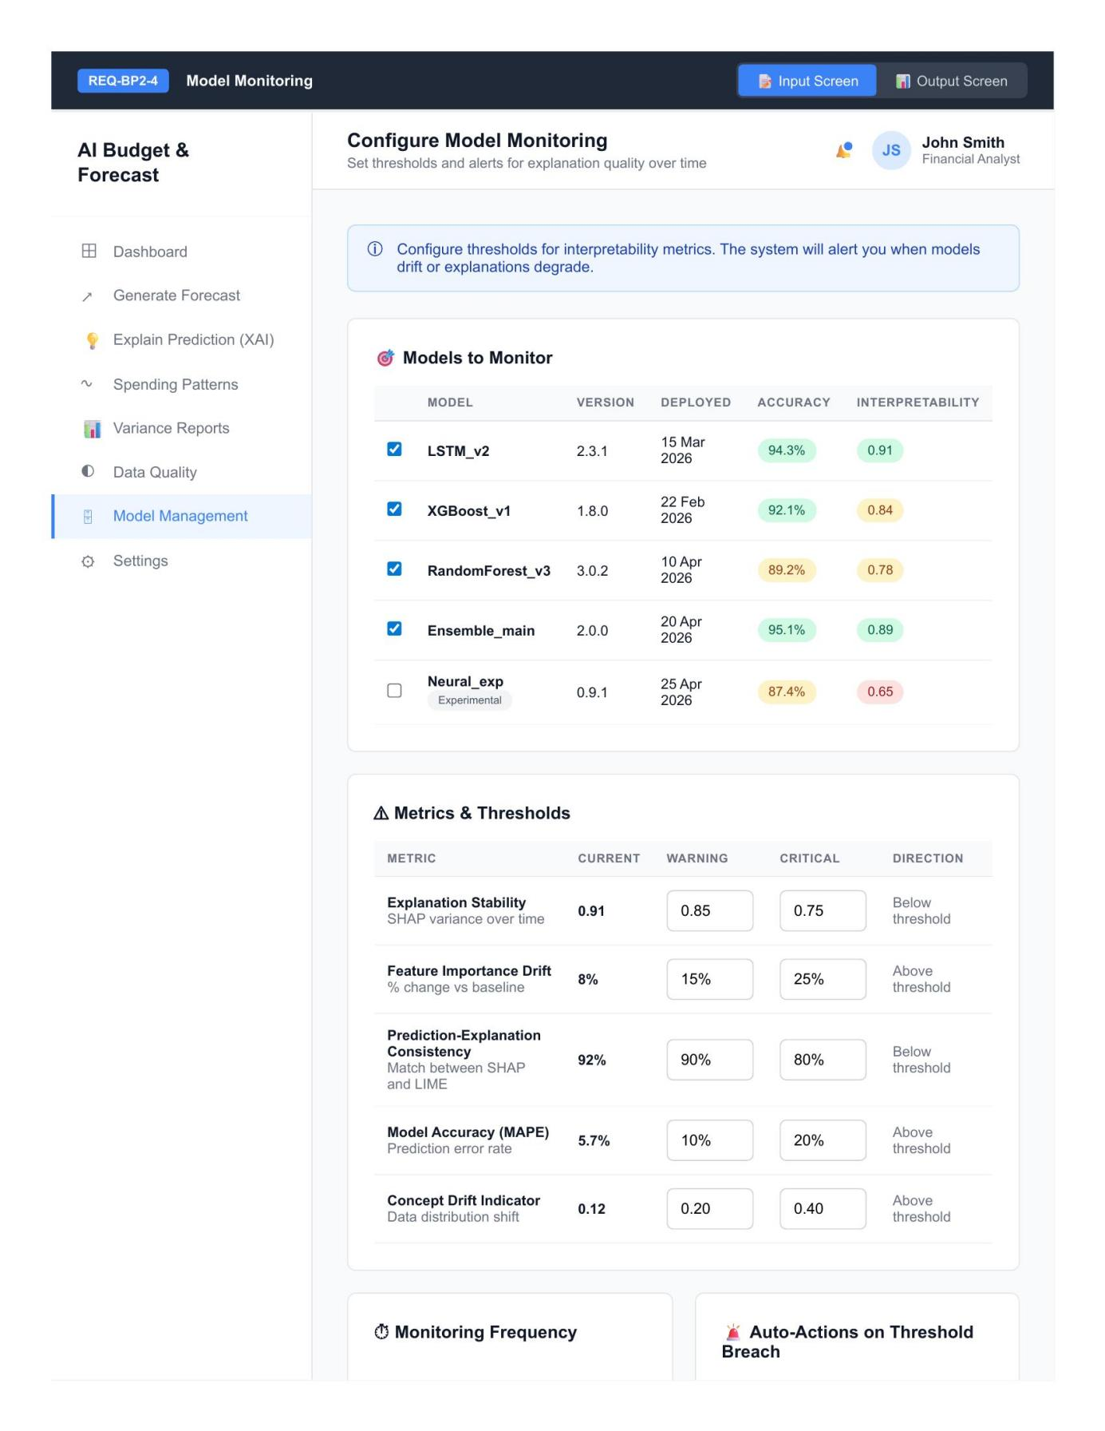
REQ-BP2-4 Input Screen — Model Monitoring
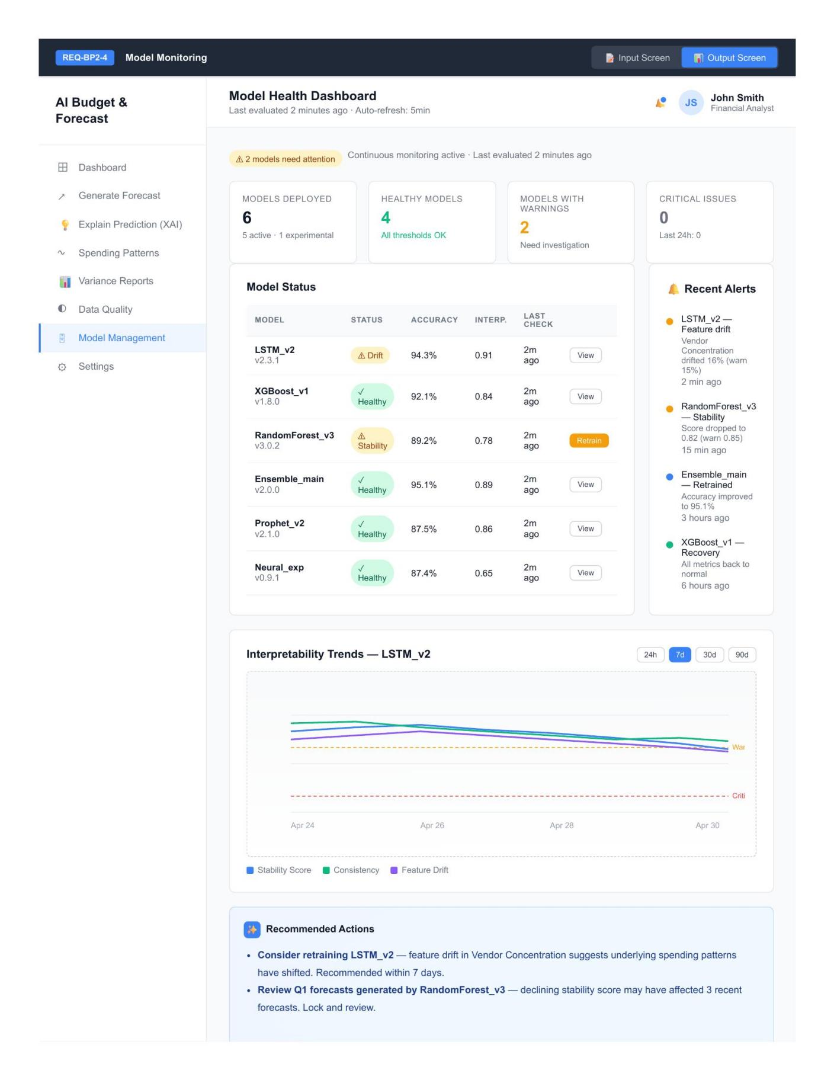
REQ-BP2-4 Output Screen — Model Monitoring

Test Cases
Test Case ID | User  Story | Test Scenario | Test Steps | Expected Result
TC-BP1-1 | REQ-BP1-1 | Initiate forecast with all valid parameters | 1. Log in as Financial Analyst.  2. Navigate to Generate Forecast.  3. Enter Forecast Name 'Q1 2026 Marketing Budget'.  4. Select Department Scope (Marketing, Sales).  5. Select Forecast Horizon: Quarterly.  6. Select Historical Data Range: Last 3 Years.  7. Select Forecasting Method: ML Ensemble.  8. Click 'Continue to Review'. | System navigates to the Review Parameters output screen displaying all selected values correctly. Status shown as 'Ready for forecast generation'.
TC-BP1-2 | REQ-BP1-1 | Submit form with missing required field | 1. Leave Forecast duration empty.  2. Fill all other required fields.  3. Click 'Continue to Review'. | System rejects submission. Inline error message: 'Forecast Name is required'. Form remains on the input screen.
TC-BP1-3 | REQ-BP1-2 | Run DL forecast with valid configuration | 1. Open Generate Forecasts (Deep Learning).  2. Set From Date and To Date covering 36 months of history.  3. Select departments and account categories.  4. Set Training Epochs = 50, Hidden Layers = 3, Confidence Threshold = 95%.  5. Click 'Generate Forecast'. | System trains the DL model and displays the forecast output screen with predicted values and confidence intervals. Action buttons available: Export to Excel, View Explanation (XAI), Submit for Review.
TC-BP1-4 | REQ-BP1-2 | Submit generated forecast for review | 1. After forecast generation, view the output screen.  2. Click 'Submit for Review'. | Forecast submitted to Budget Manager queue.  Confirmation message dis  played. Status changes to “Pending Review”.
TC-BP1-5 | REQ-BP1-3 | Run clustering analysis with valid configuration | 1. Open Analyze Spending Patterns (Clustering).  2. Select Departments to analyze.  3. Select Spending Categories.  4. Set Number of Clusters = 4.  5. Select Features for Clustering.  6. Click 'Run Analysis'. | System performs clustering and displays the output screen with cluster groupings, identified patterns, and a chart visualization.
TC-BP1-6 | REQ-BP1-3 | Run analysis with no features selected | 1. Select departments and categories.  2. Leave 'Features for Clustering' empty.  3. Click 'Run Analysis'. | System rejects submission. Error: “Select at least one feature for clustering
TC-BP1-7 | REQ-BP1-4 | Run ML ensemble forecast with valid configuration | 1. Open Forecast Expense Trends (ML Ensemble).  2. Select Expense Categories and Cost Centers.  3. Choose Granularity: Monthly.  4. Choose Aggregation Method.  5. Click 'Run Ensemble Forecast'. | System runs the ensemble model and displays  trend output with predicted  expense lines and combined model confidence.
TC-BP1-8 | REQ-BP1-5 | Run automated data quality check | 1. Log in as Data Engineer.  2. Open Data Quality (RPA).  3. Configure quality check rules.  4. Click 'Run Quality Check'. | RPA bots execute all checks. Output displays  quality report with pass/fail  status per rule, total issues, and rows affected.
TC-BP1-9 | REQ-BP1-5 | Add custom data quality rule | 1. Click '+ Add Custom Rule'.  2. Define rule (e.g., 'Spending amount must be > 0').  3. Save the rule.  4. Run Quality Check. | Custom rule appears in the rule list and is executed. Results reflected in the output report.
TC-BP1-10 | REQ-BP1-5 | Block forecast generation when data quality fails | 1. Run Quality Check on a dataset with critical errors.  2. Attempt to start a forecast in REQ-BP1-2. | System blocks forecast generation. Message:“Data quality issues must be resolved before model training.” Data Engineer is  notified
TC-BP1-11 | REQ-BP1-6 | Budget Manager reviews submitted forecast | 1. Log in as Budget Manager.  2. Open Variance Analysis (NLP).  3. From the 'Forecasts Awaiting Review' list, click 'Review' on a forecast row. | System opens review screen  showing forecast values, variance percentages, and  NLP-generated narrative summary
TC-BP1-12 | REQ-BP1-6 | Return forecast for revision | 1. Open a forecast in review.  2. Click 'Return for Revision'.  3. Provide feedback comments and confirm. | Forecast status changes to  “Returned for Revision”. The Financial Analyst is notified with feedback.
TC-BP2-1 | REQ-BP2-1 | Generate SHAP global explanation | 1. Log in as Budget Manager.  2. Open Explain Prediction (XAI) - SHAP Global Explanation.  3. Set Explanation Scope.  4. Set Number of Top Features = 10.  5. Choose Visualization Style.  6. Click 'Generate Explanation'. | System computes SHAP values and displays global  feature importance ranking  with visualization. Action  buttons: Export as PDF, View Local Explanations  (LIME), Approve Explanation
TC-BP2-2 | REQ-BP2-2 | Generate LIME explanation for a specific prediction | 1. Open Explain Specific Prediction (LIME).  2. Set Filter Predictions By: Department.  3. Choose a prediction from the list.  4. Set Number of Features to Show = 8.  5. Set Sampling Size and Distance Metric.  6. Click 'Generate Local Explanation'. | System generates LIME local explanation showing  the contribution of each feature to the specific prediction (positive and negative)
TC-BP2-3 | REQ-BP2-3 | Build explanation dashboard with valid configuration | 1. Open Build Your Explanation Dashboard.  2. Select visualizations to include.  3. Choose Narrative Style and Audience.  4. Choose Language: English.  5. Choose Layout.  6. Click 'Build Dashboard'. | The system generates the dashboard. Buttons available: Cards View, EN  / AR toggle,Share Dashboard, Export as PDF,  Save View.
TC-BP2-4 | REQ-BP2-4 | Save monitoring configuration with valid thresholds | 1. Log in as System Administrator.  2. Open Model Monitoring.  3. Select models to monitor.  4. Set thresholds (e.g., Explanation Stability warning, Feature Importance Drift, Prediction-Explanation Consistency, MAPE, Concept Drift).  5. Click 'Save Monitoring Configuration'. | Configuration saved. Monitoring becomes active. Output dashboard displays monitored models with  current metrics and direction indicators.

Updated work after Experts Feedback:
Following expert evaluation, the original user stories were revised and three new requirements were added to Business Process 1 and one to Business Process 2 as well as reforming the original ones. Items marked (NEW) did not appear in the first user requirements.

Updated User Stories: Business Process 1
Requirement ID | Epic | User Story Summary
REQ-BP1-1 | Budget Forecast Generation | As a financial analyst, I want to initiate a budget forecast request and define the forecast parameters relevant to my business such as forecast horizon and department scope, so that the system generates forecasts aligned with my planning needs without requiring me to choose the forecasting method.
REQ-BP1-2 | Budget Forecast Generation | As a financial analyst, I want to generate budget forecasts that combine historical data with external factors such as inflation rates, currency exchange rates, and macroeconomic indicators, using a model automatically selected by the system from a pool of time series methods (Prophet, ARIMA), gradient boosting, and DL so that I can create accurate budget plans.
REQ-BP1-3 | Budget Forecast Generation | As a financial analyst, I want to analyze historical spending patterns of each department using clustering, with the optimal number of clusters auto-suggested by the system through the elbow method or silhouette score, so that I can group similar spending behaviours to identify opportunities for saving cost and enhance resource allocation.
REQ-BP1-4 | Budget Forecast Generation | As a financial analyst, I want to forecast expense trends using ensemble methods configured automatically by the system, so that I can estimate future spending patterns and prepare accurate budgets by combining multiple model predictions.
REQ-BP1-5 | Data Quality | As a data engineer, I want to ensure data quality using ML based validation techniques (schema validation, statistical profiling, anomaly detection, and entity resolution), reviewed jointly with a representative from each department before model training, so that the AI system produces reliable forecasts based on data that is both technically clean and operationally accurate.
REQ-BP1-6 | Budget Review & Approval | As a budget manager, I want to receive the submitted budget forecast with an AI-generated variance analysis report produced using extractive text summarization using NLP, and review it together with managers from other relevant departments, so that the approval reflects multiple stakeholder validation of the deviations and forecast reliability.
REQ-BP1-7 (NEW) | Data Preparation | As a data engineer, I want the system to detect anomalies in historical spending data before model training, so that outlier periods are flagged for review and do not distort the resulting forecasts.
REQ-BP1-8 (NEW) | Model Lifecycle | As an ML engineer, I want to validate forecast models through backtesting against historical data before deployment, so that only models meeting acceptable accuracy thresholds are released to financial analysts.
REQ-BP1-9 (NEW) | Model Lifecycle | As a financial analyst, I want to compare past forecasts against actual outcomes over time, so that forecast accuracy is tracked continuously and the performance data feeds back into model retraining.

Updated User Stories: Business Process 2
Requirement ID | Epic | User Story Summary
REQ-BP2-1 | Explainability & Transparency | As a budget manager, I want to request an explanation of a generated forecast using SHAP, so that I can see which features had the most influence on the overall predictions and understand the global drivers of budget outcomes.
REQ-BP2-2 | Explainability & Transparency | As a budget manager, I want to receive a local explanation of a specific budget prediction using LIME, presented through a simplified interface without exposing the underlying technical configuration, so that I can understand which factors contributed to that individual forecast outcome and by how much each factor influenced the prediction.
REQ-BP2-3 | Forecast Reporting & Visualization | As a budget manager, I want to view the AI explanations through interactive visualizations including feature importance charts and prediction breakdowns generated using NLP, so that I can easily interpret the results without technical expertise.
REQ-BP2-4 | Model Interpretability Management | As a system administrator, I want to monitor explanation quality and model interpretability using ML performance metrics so that I can trigger model reconfiguration when explanations become less meaningful due to model drift; in parallel, a business specialist reviews the substantive accuracy and correctness of the explanations and has the authority to reverse decisions where explanations are found to be misleading.
REQ-BP2-5 (NEW) | Forecast Reporting & Visualization | As a budget manager, I want to receive reports from each department and environmental analysis reports alongside the generated explanations, so that I can interpret predictions in the context of the external factors and operational conditions affecting the budget.

Updated Wireframes: Business Process 1
Following the business expert's recommendation that budget forecasting should not rely solely on historical data, the wireframe for REQ-BP1-1 was updated to include an External Factors panel.Users can now incorporate inflation rates, currency exchange rates, and environmental indicators alongside historical inputs when initiating a forecast.
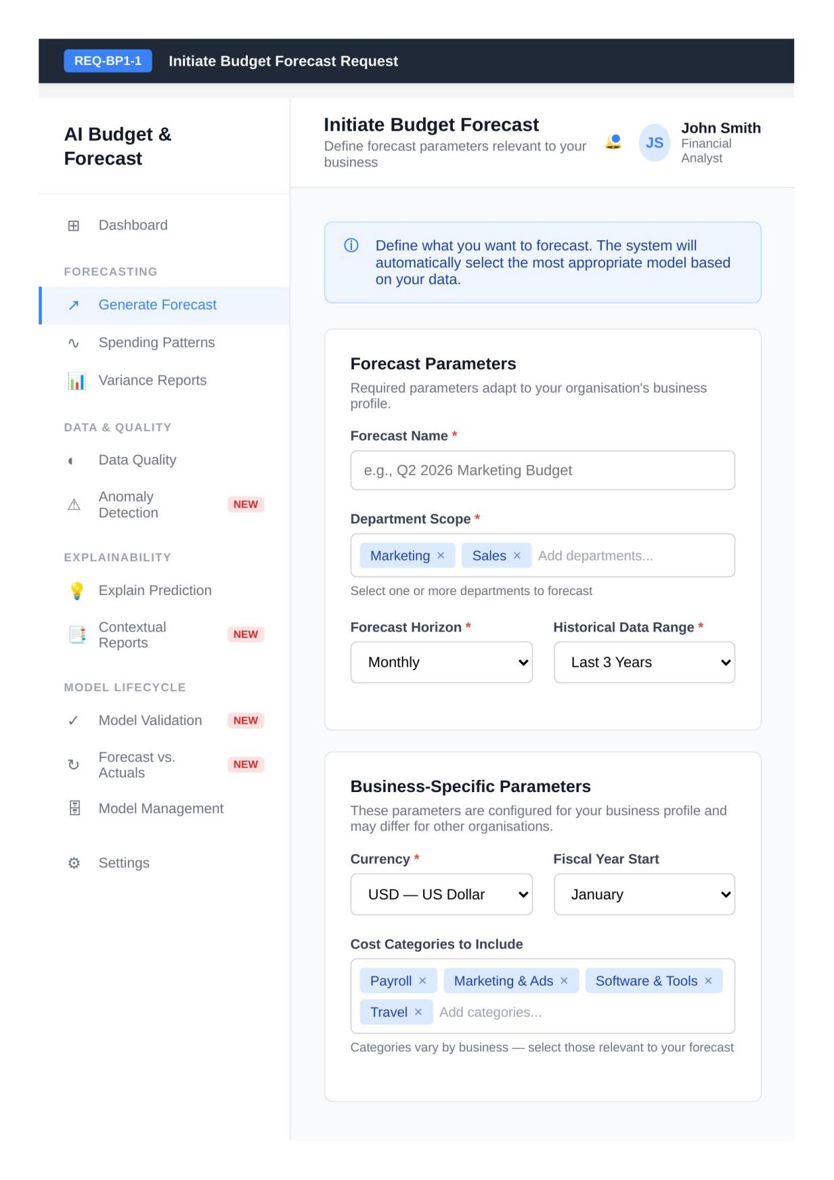
Updated wireframe for REQ-BP1-1 — Initiate Budget Forecast (Revised)

Both experts recommended that technical parameters should not be exposed to Financial Analysts. The wireframe for REQ-BP1-2 was split into a Basic and an Advanced view.
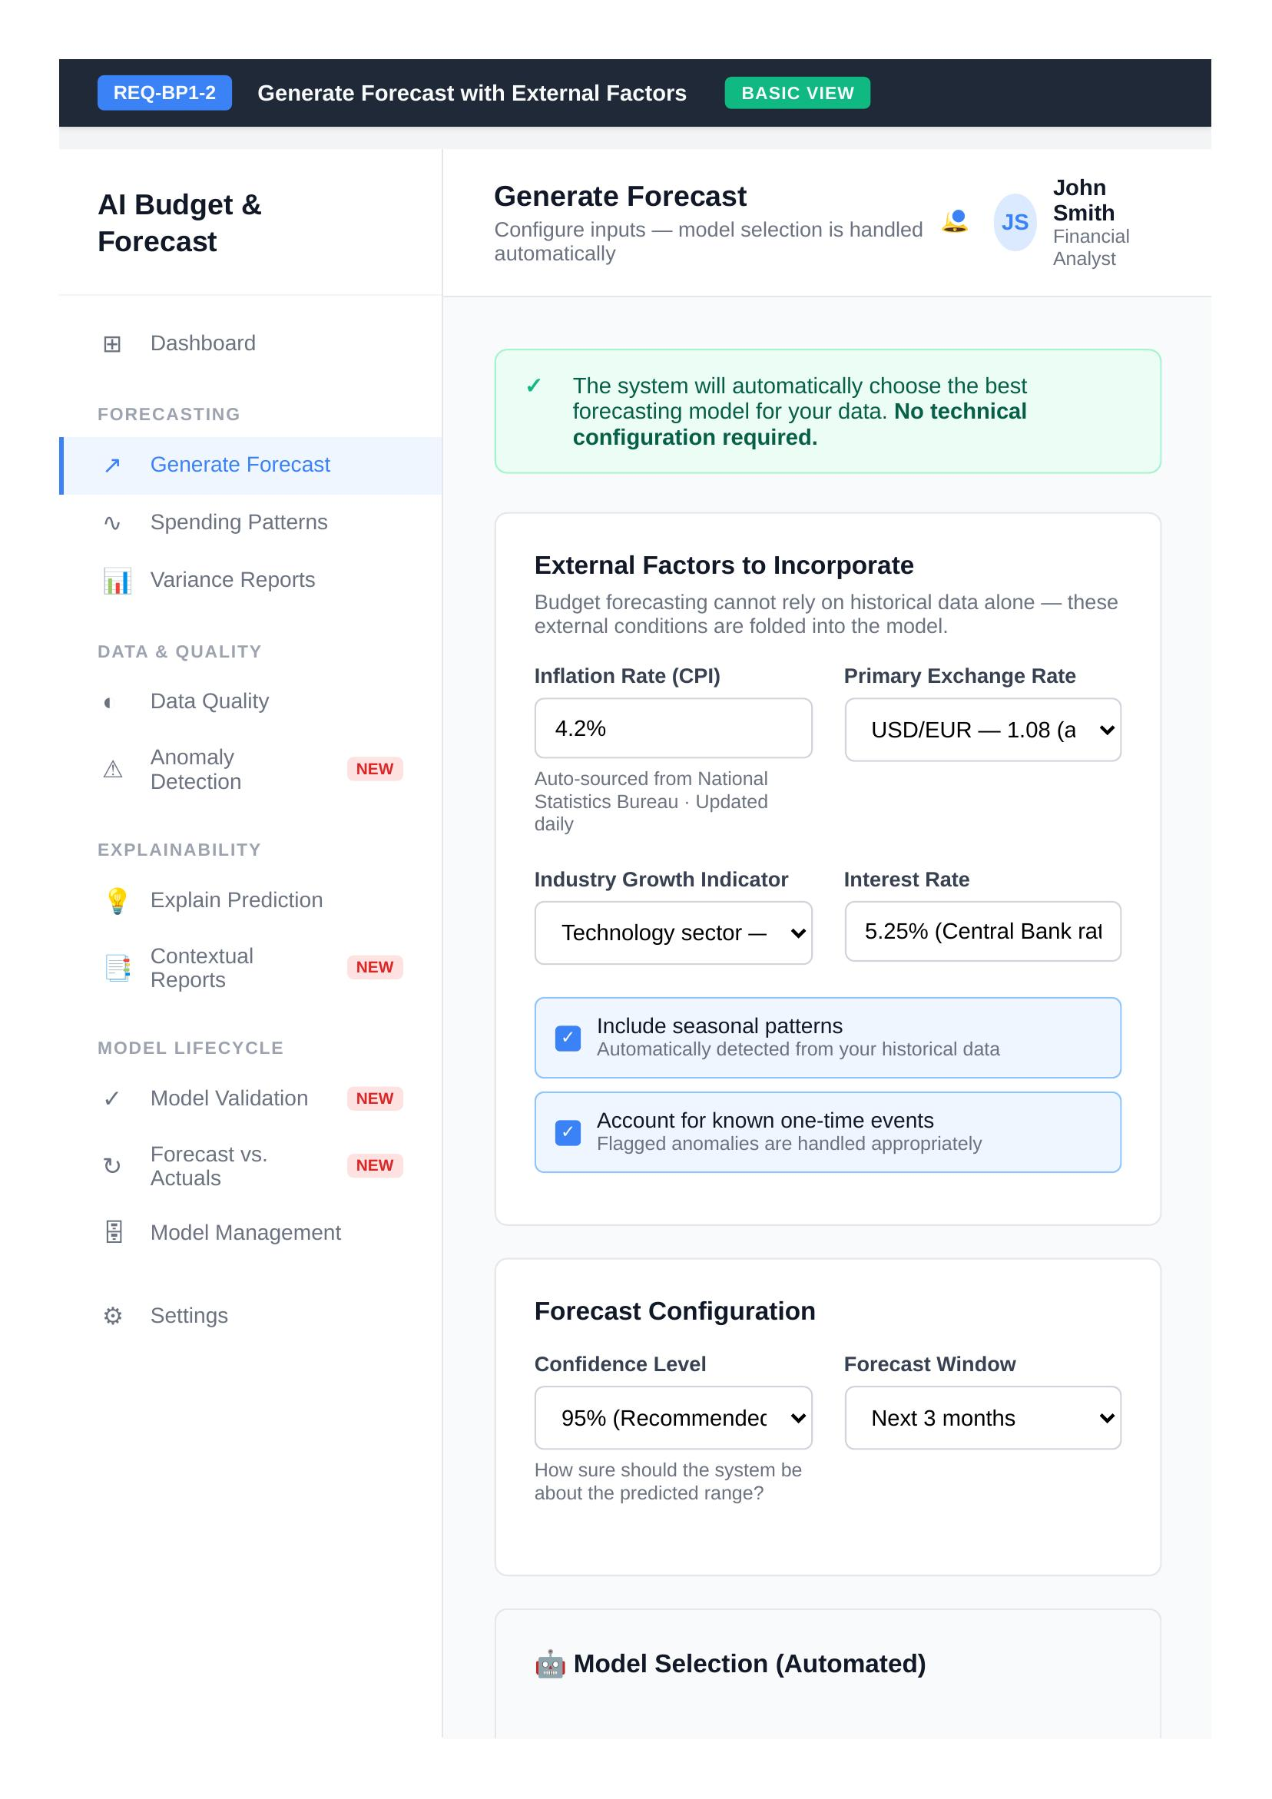
Updated wireframe for REQ-BP1-2 — Forecast Generation, Basic View (Revised)
The Advanced view exposes the model pool and selection strategy, train/test split, seasonality and outlier handling, and deep learning configuration.
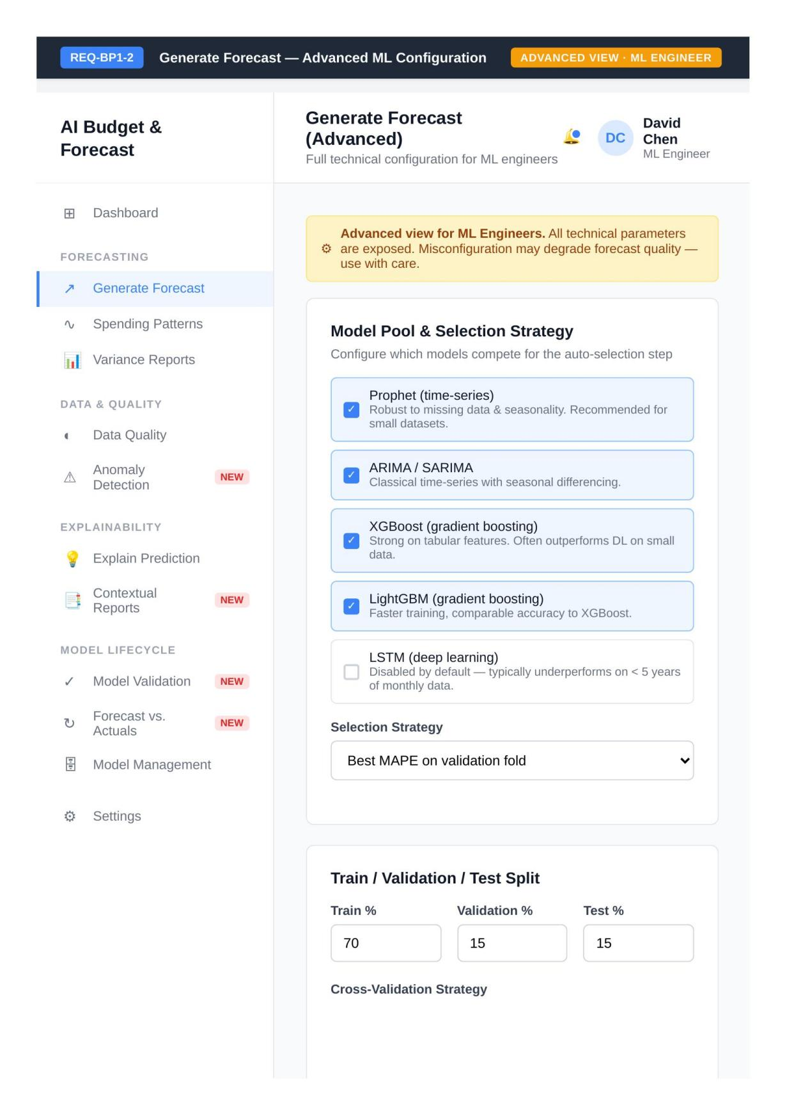
Updated wireframe for REQ-BP1-2 — Forecast Generation, Advanced View (Revised)
The wireframe for REQ-BP1-3 was split into two views. The Basic view presents the identified spending patterns without exposing the clustering algorithm.
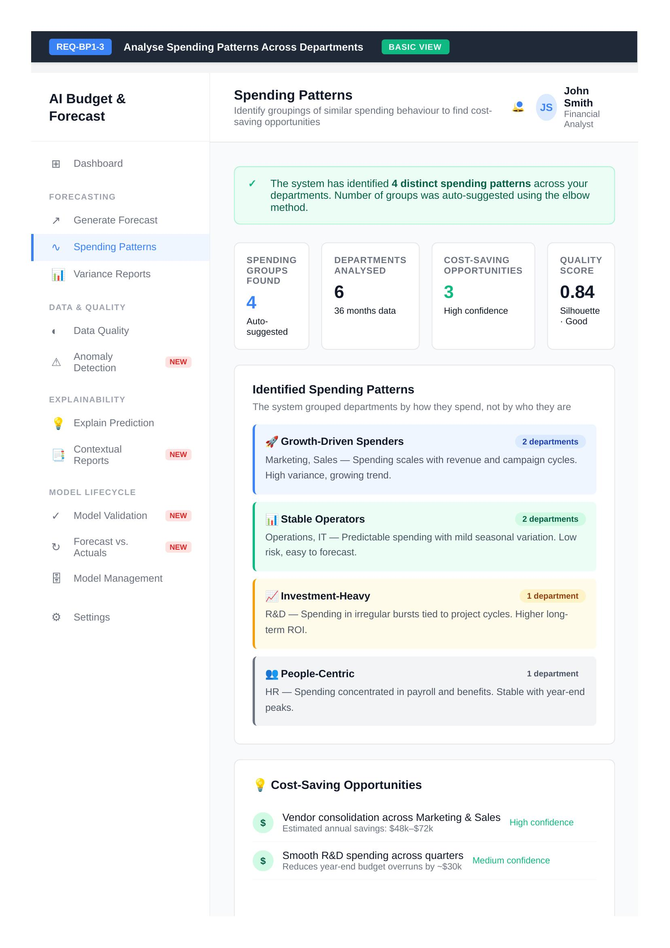
Updated wireframe for REQ-BP1-3 — Spending Patterns, Basic View (Revised)
The Advanced view exposes the clustering algorithm selection, the number of clusters with an auto suggested default, and feature engineering controls.
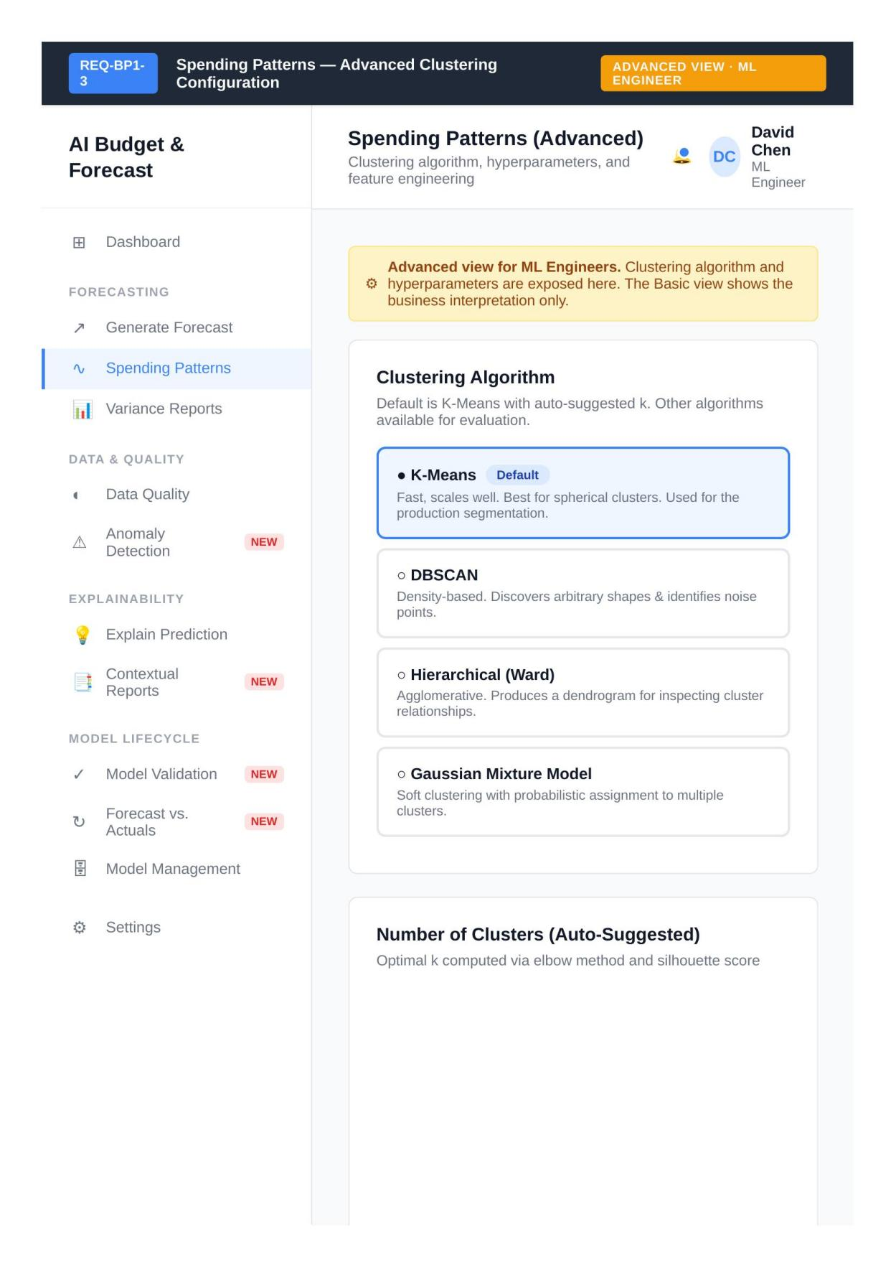
Updated wireframe for REQ-BP1-3 — Spending Patterns, Advanced View (Revised)
The Basic view for REQ-BP1-4 presents the expense trend forecast, a departmental breakdown, and an explanation of how the ensemble model generated its output.
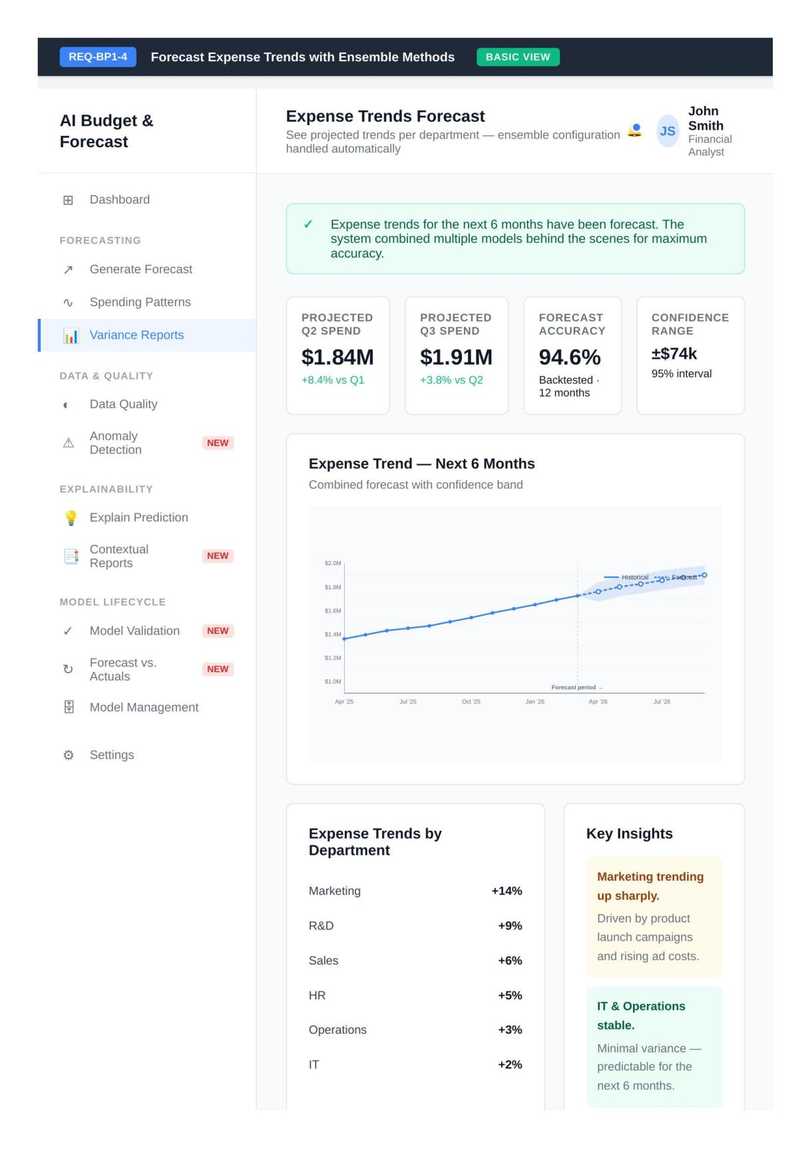
Updated wireframe for REQ-BP1-4 — Expense Trends Forecast, Basic View (Revised)
The Advanced view exposes the ensemble composition with individual model weights for XGBoost, LightGBM, and Prophet.
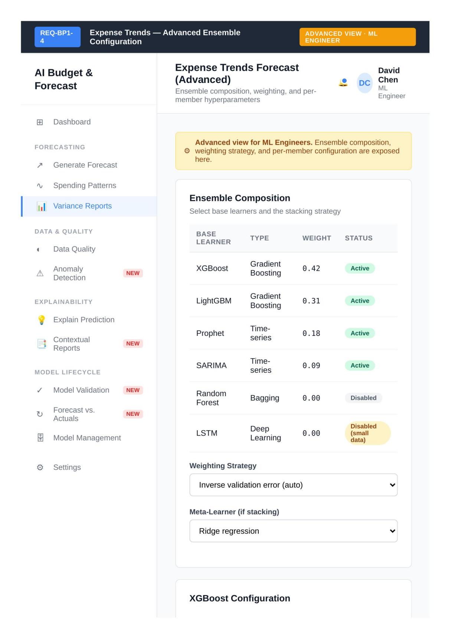
Updated wireframe for REQ-BP1-4 — Expense Trends Forecast, Advanced View (Revised)
The wireframe was corrected. The title now reads "ML-Based Validation Checks" and the RPA workflow was replaced with statistical and ML validation techniques.
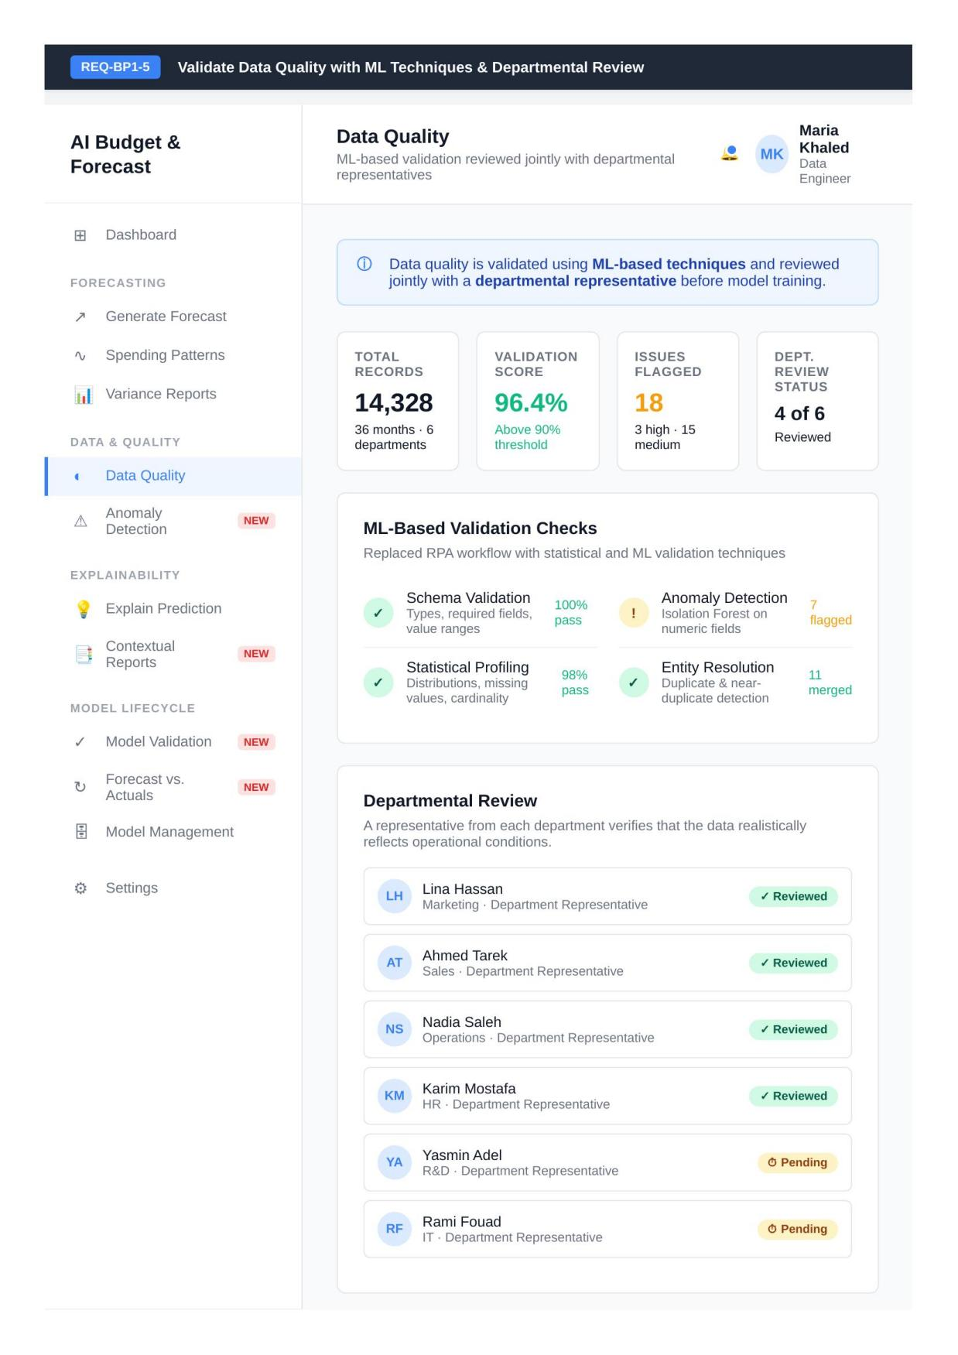
Updated wireframe for REQ-BP1-5 — Data Quality (Revised)
This wireframe was revised to require multi-stakeholder validation: managers from each department must review the forecast before final sign-off.
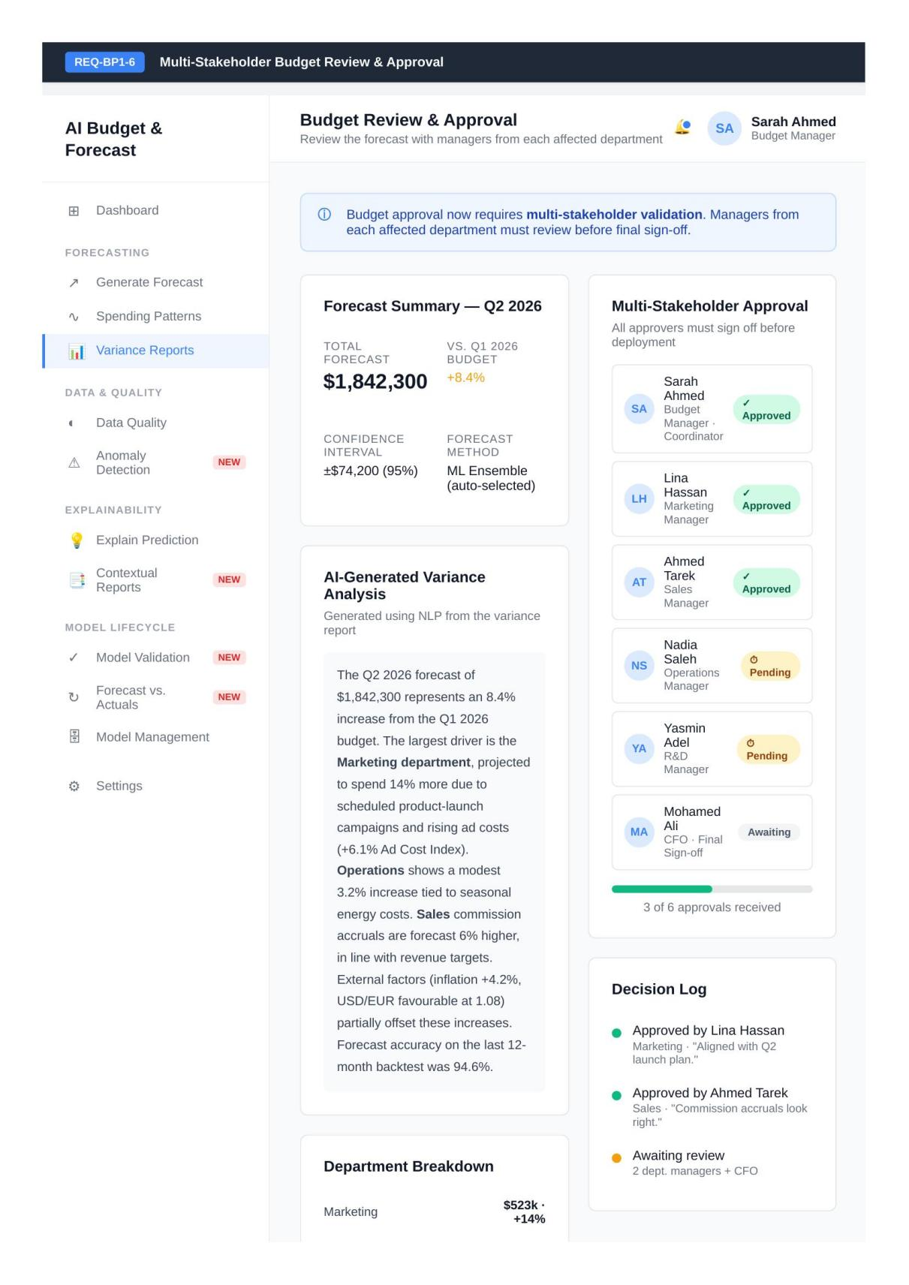
Updated wireframe for REQ-BP1-6 — Budget Review & Approval (Revised)
REQ-BP1-7 addresses anomaly detection. The screen displays detected anomalies, presents recommended actions, and provides configurable detection settings.
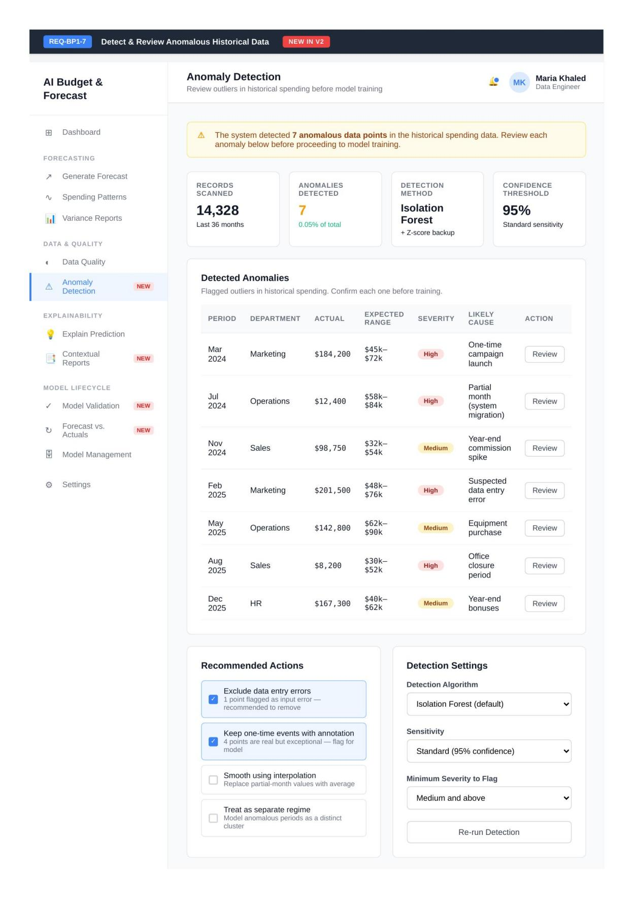
New wireframe for REQ-BP1-7 — Anomaly Detection (New)
REQ-BP1-8 displays a backtest chart comparing predicted and actual values, per-department accuracy scores, and acceptance criteria.
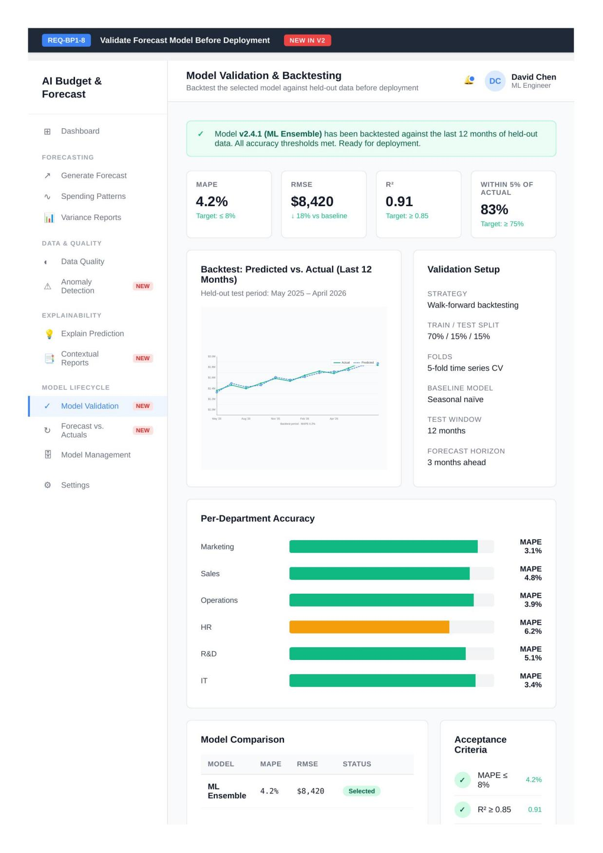
New wireframe for REQ-BP1-8 — Model Validation & Backtesting (New)
REQ-BP1-9 tracks forecast accuracy over time, breaks down accuracy by department, and includes a retraining feedback loop.
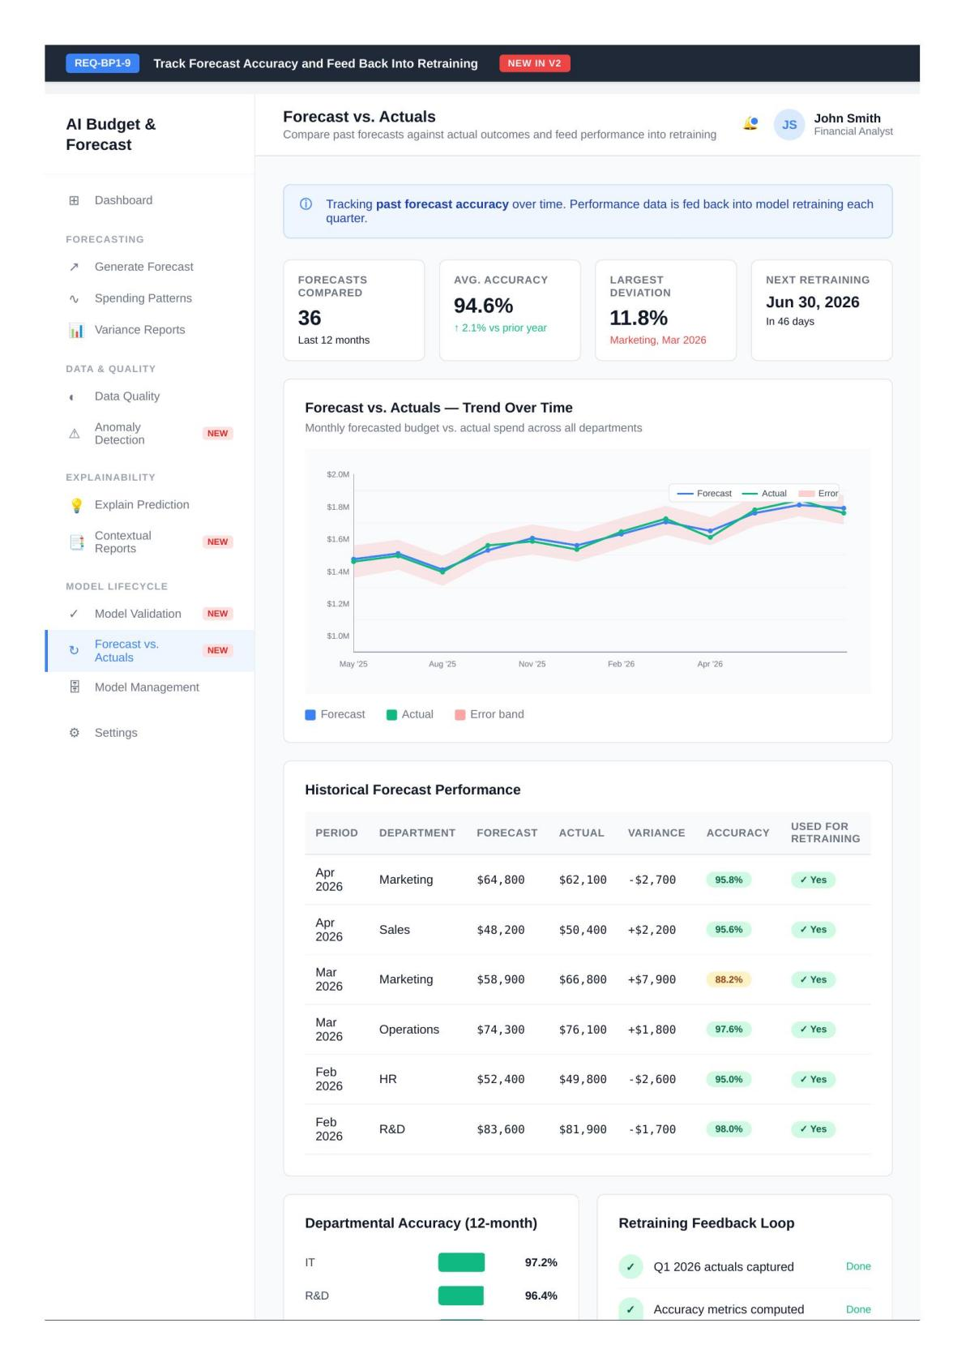
New wireframe for REQ-BP1-9 — Forecast vs. Actuals (New)

Updated Wireframes: Business Process 2
The wireframe for REQ-BP2-1 displays global feature importance using SHAP values. A summary accompanies the visualisation so that non-technical users can interpret the output.
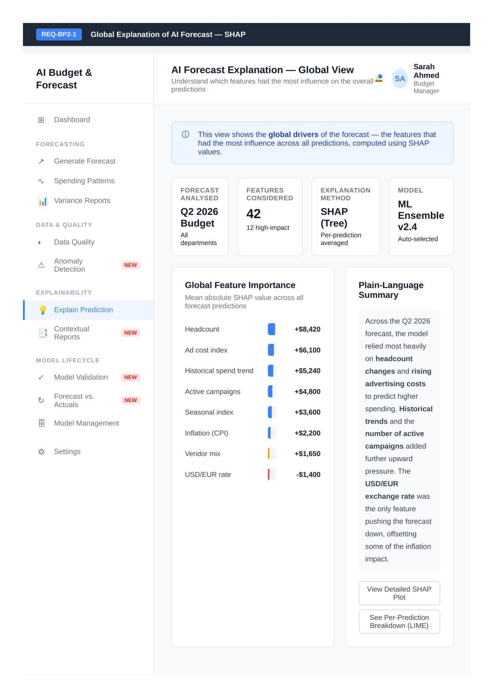
Wireframe for REQ-BP2-1 — Explain Prediction using SHAP
The view for REQ-BP2-2 was split into Basic and Advanced screens. The Basic view presents what pushed the prediction up or down without exposing configuration parameters.
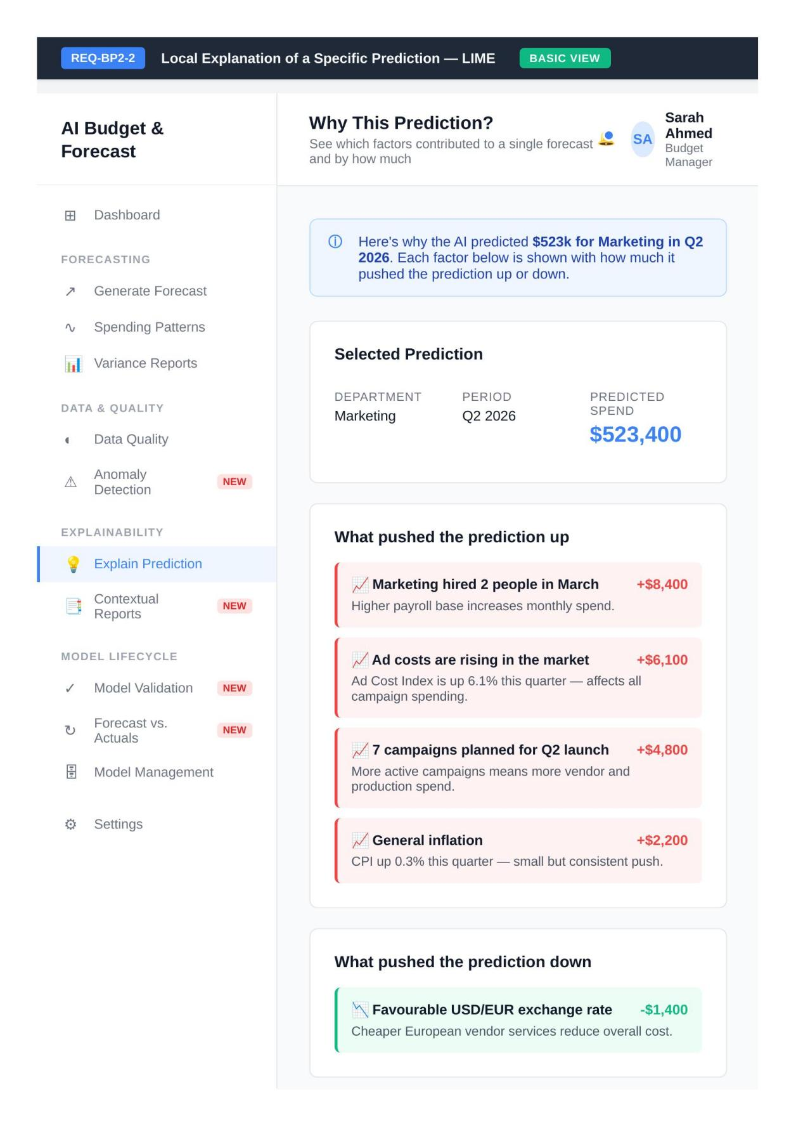
Updated wireframe for REQ-BP2-2 — LIME, Basic View (Revised)
The Advanced view exposes LIME configuration settings including top-k features, neighbourhood size, kernel width, and a cross-check panel comparing LIME against SHAP.
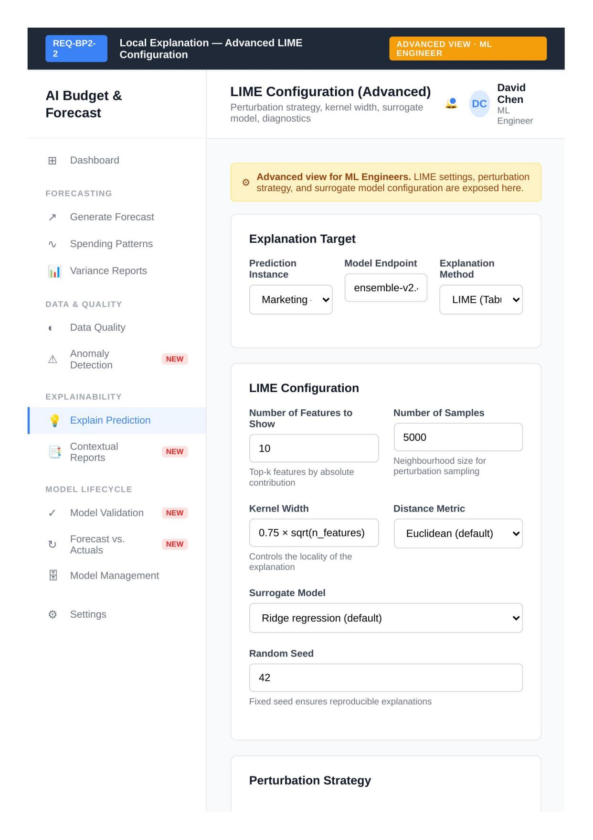
Updated wireframe for REQ-BP2-2 — LIME, Advanced View (Revised)
The wireframe for REQ-BP2-3 presents the forecast visualisation with a historical trend comparison, an NLP generated narrative, and a variance heatmap.
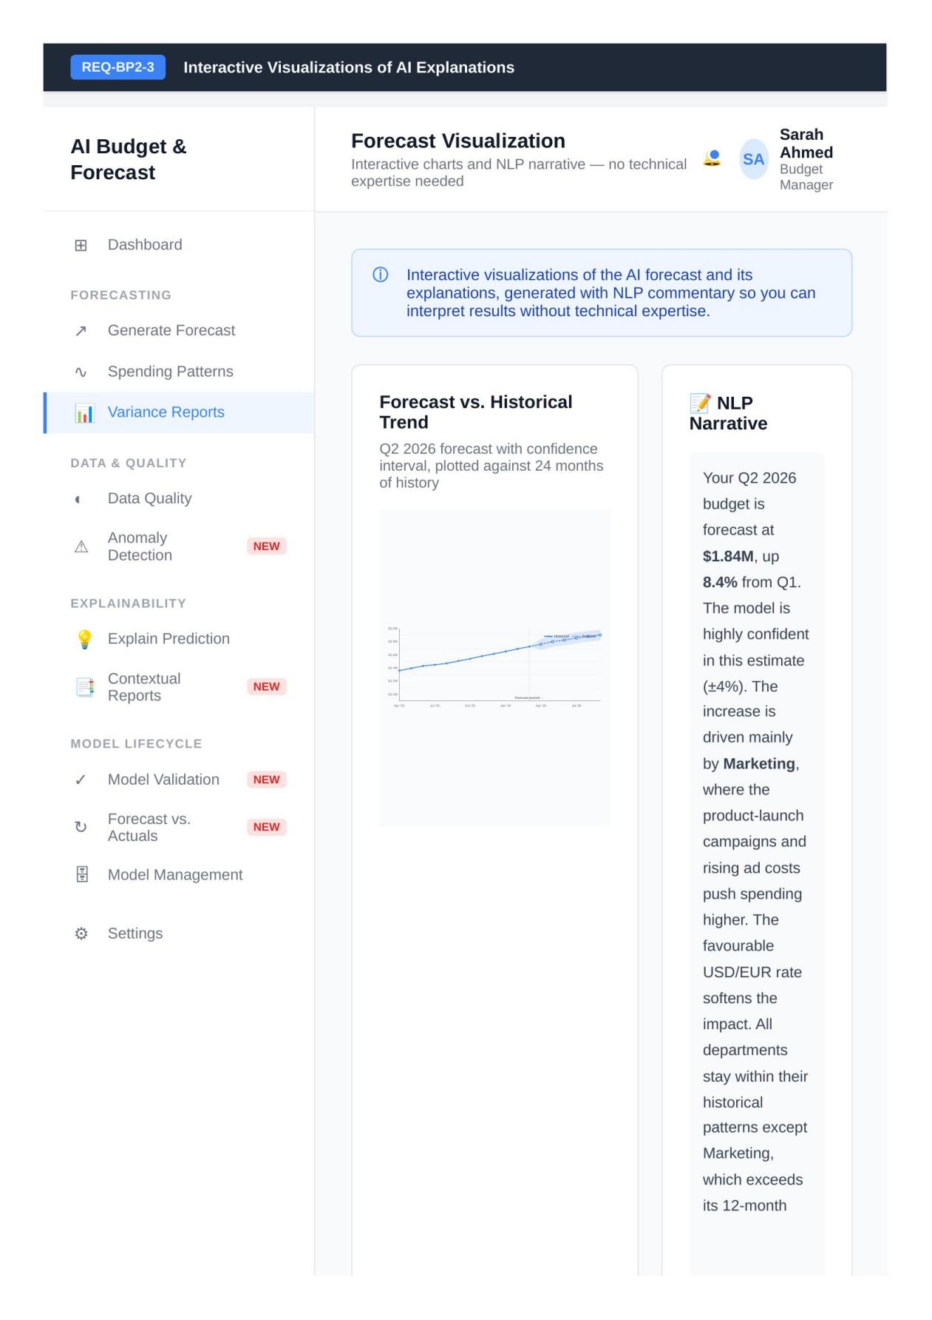
Wireframe for REQ-BP2-3 — Forecast Visualisation
The wireframe for REQ-BP2-4 separates model monitoring into two tracks: a technical track for System Administrators and a substantive review track for Business Specialists.
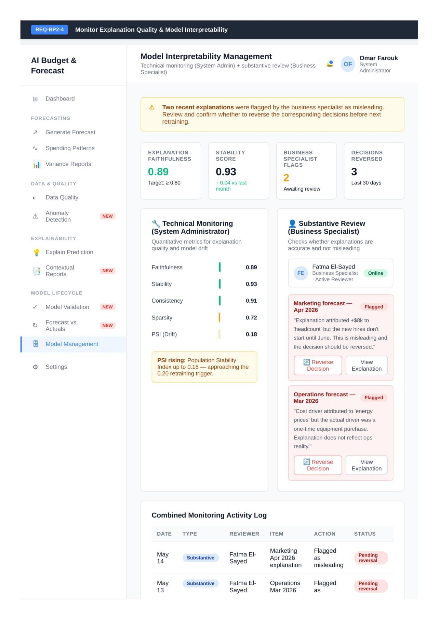
Wireframe for REQ-BP2-4 — Model Interpretability Management
The wireframe for REQ-BP2-5 generates reports per department, an environmental analysis report, and AI explanation combining SHAP and LIME outputs.
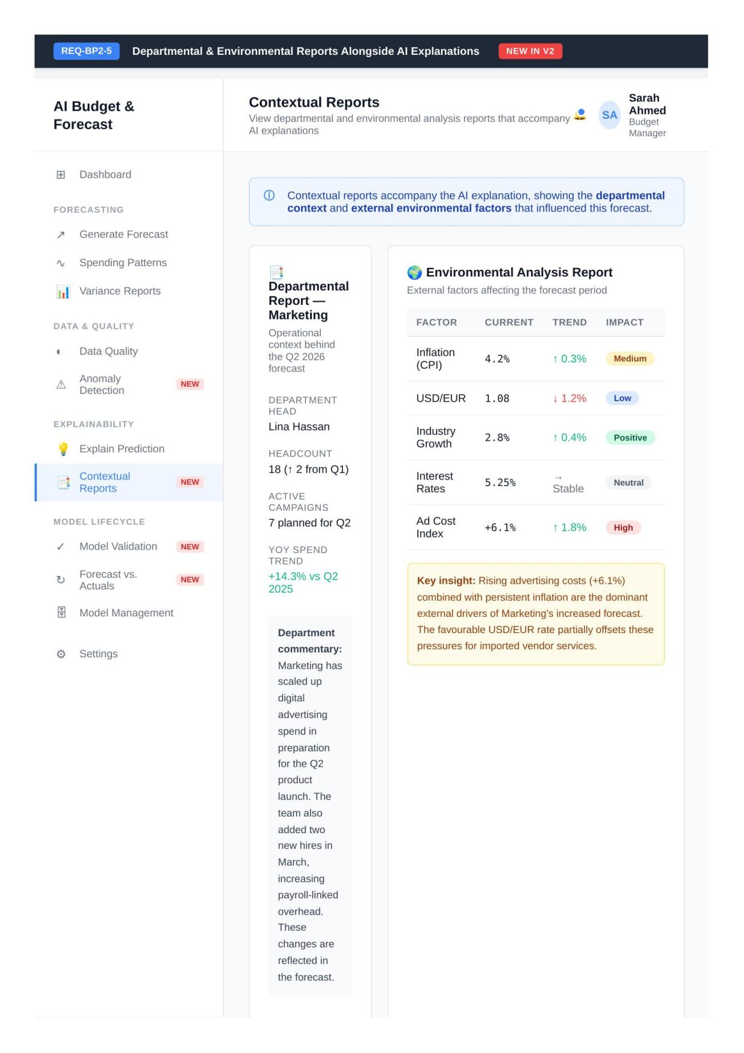
New wireframe for REQ-BP2-5 — Contextual Reports (New)

