**Gather:**

When a geophysicist speaks about pre-stack data, they are usually talking about a particular class of gather. A gather is a collection of seismic traces which share some common geometric attribute. The term gather usually refers to a common image point (CIP) or common mid-point (CMP) gather. Gathers are sorted from field records in order to examine the dependence of amplitude, signal:noisee, move-out, frequency content, phase, and other seismic attributes, on offset, incidence angle, azimuth, and other geometric attributes that are important for data processing and imaging.This process is called CMP sorting for 2D surveys and binning for 3D surveys.

**common-shot gather**

When the next shot is fired, we do the same, record with the instrument and then

write the data onto tape. We say that the data is shot ordered. A section as shown in

figure 3.2 is commonly called a common-shot gather, or common-shot panel. we show the recorded wave field for one shot.

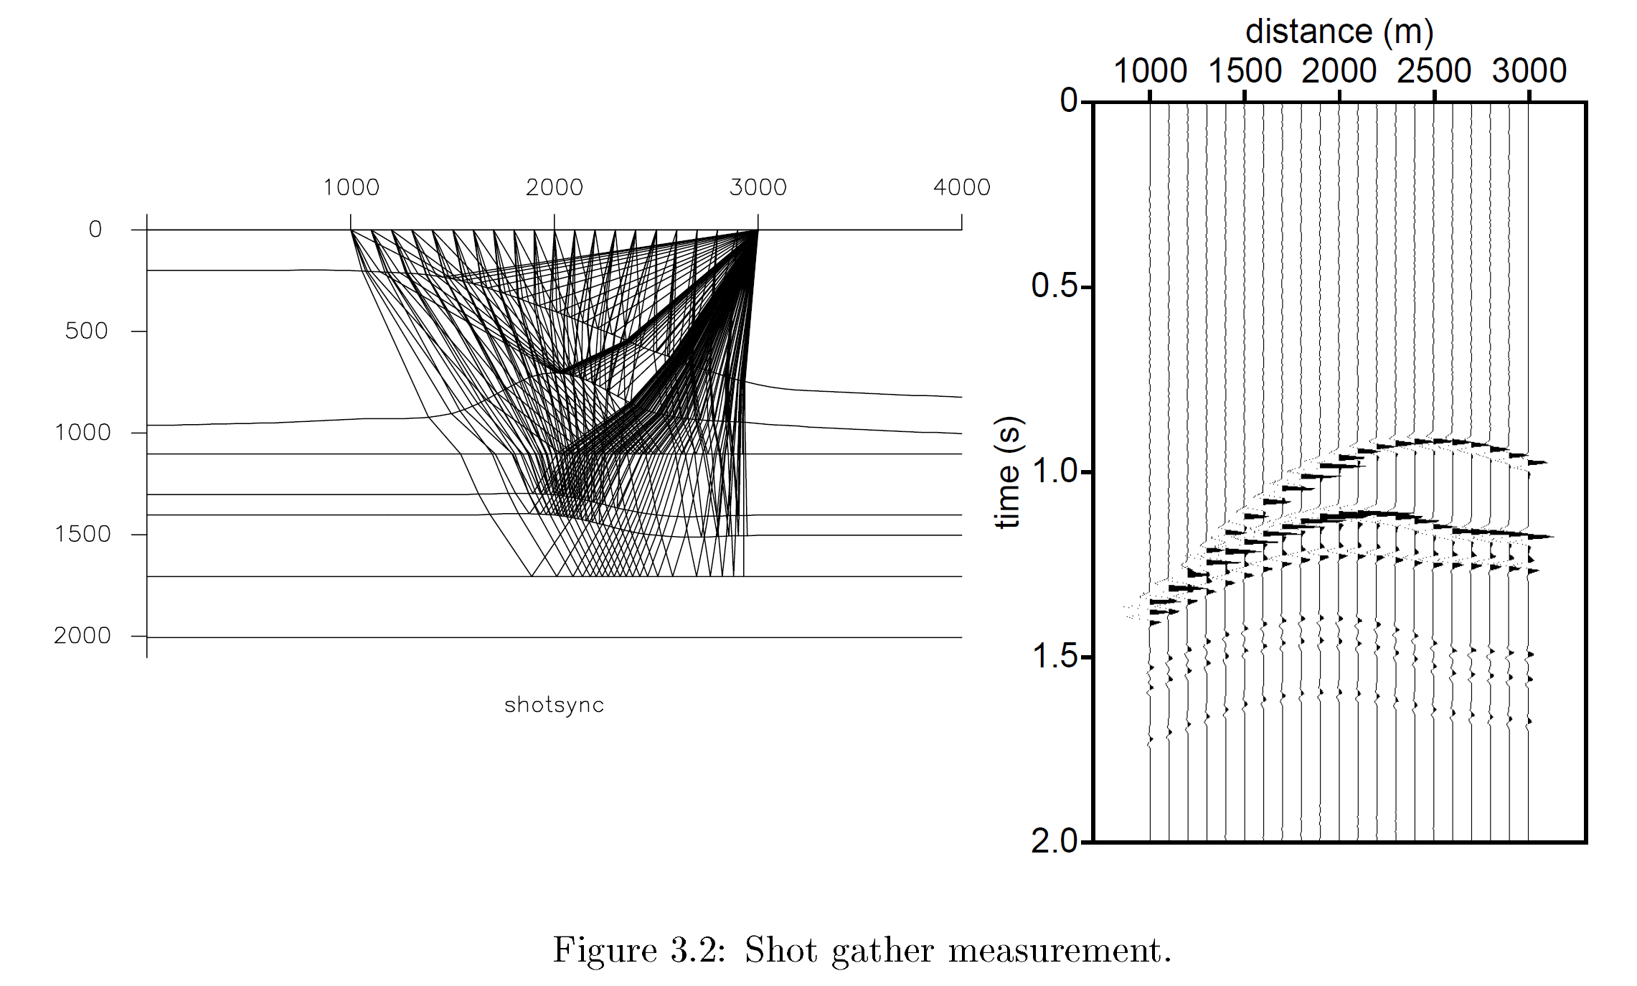

A nice feature about a common-shot gather is to see whether a receiver position has a higher elevation than its neighbors and thus gives an extra time shift in its record.

This effect is called "statics". Therefore common-shot gathers are good for detecting geophone statics. It is very easy to inspect traces in these displays for bad receivers or bad shots.

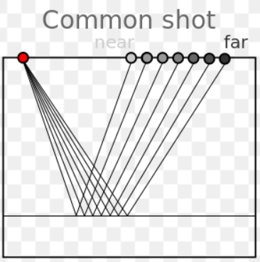

**common-receiver gather (or panel):**

One could get all the shots together, of course in an increasing shot position, belonging to one receiver position. Such a gather is called a common-receiver gather (or panel). However, this assumes that during acquisition the same receiver position is covered by different shots.

In practice, we often make use of reciprocity: interchanging source and receiver will give exactly the same response (if the directional properties of the source and receiver can be considered identical).

In fact figure 3.2 can also be considered as a common receiver gather, where all ray paths from different shots come together at one receiver position.

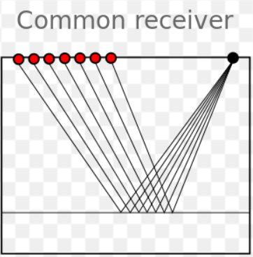

we can see on common receiver gathers whether a shot was set deeper than the neighboring shot positions, and therefore common-receiver gathers are good for detecting shot statics.

**Common midpoint gathers**

A commonly used way of sorting the data is in common-midpoint gathers. A mid-point is

here defined as the mid-point between source and receiver position. An illustration of the

mid-point is given in figure.

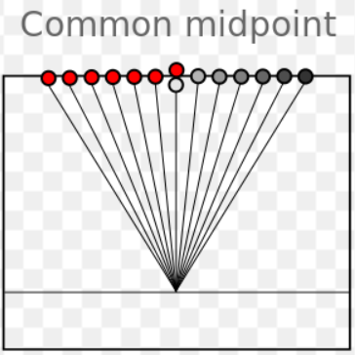

traces or sorted by surface geometry to approximate a single reflection point in the earth. Data from several shots and receivers are combined into a single gather. The traces are sorted by offset in order to perform velocity analysis for data processing and hyperbolic moveout correction. Only shot–receiver geometry is required to construct this type of gather.

In a flat layered earth the waves from the shot point are reflected to the receiver from a point located midway between shot and receiver, hence the term **CMP**.

A more sophisticated sorting that takes dipping reflector geometry into account. Not doing so can cause a mis-positioned events, poor imaging, and unfocused reflections. In this case, a priori information about the subsurface, usually a velocity model, must be applied with the shot–receiver geometry in order to construct this type of gather. Common depth point (**CDP**) is another common term; it's basically synonymous with Common image point gathers (**CIP**).

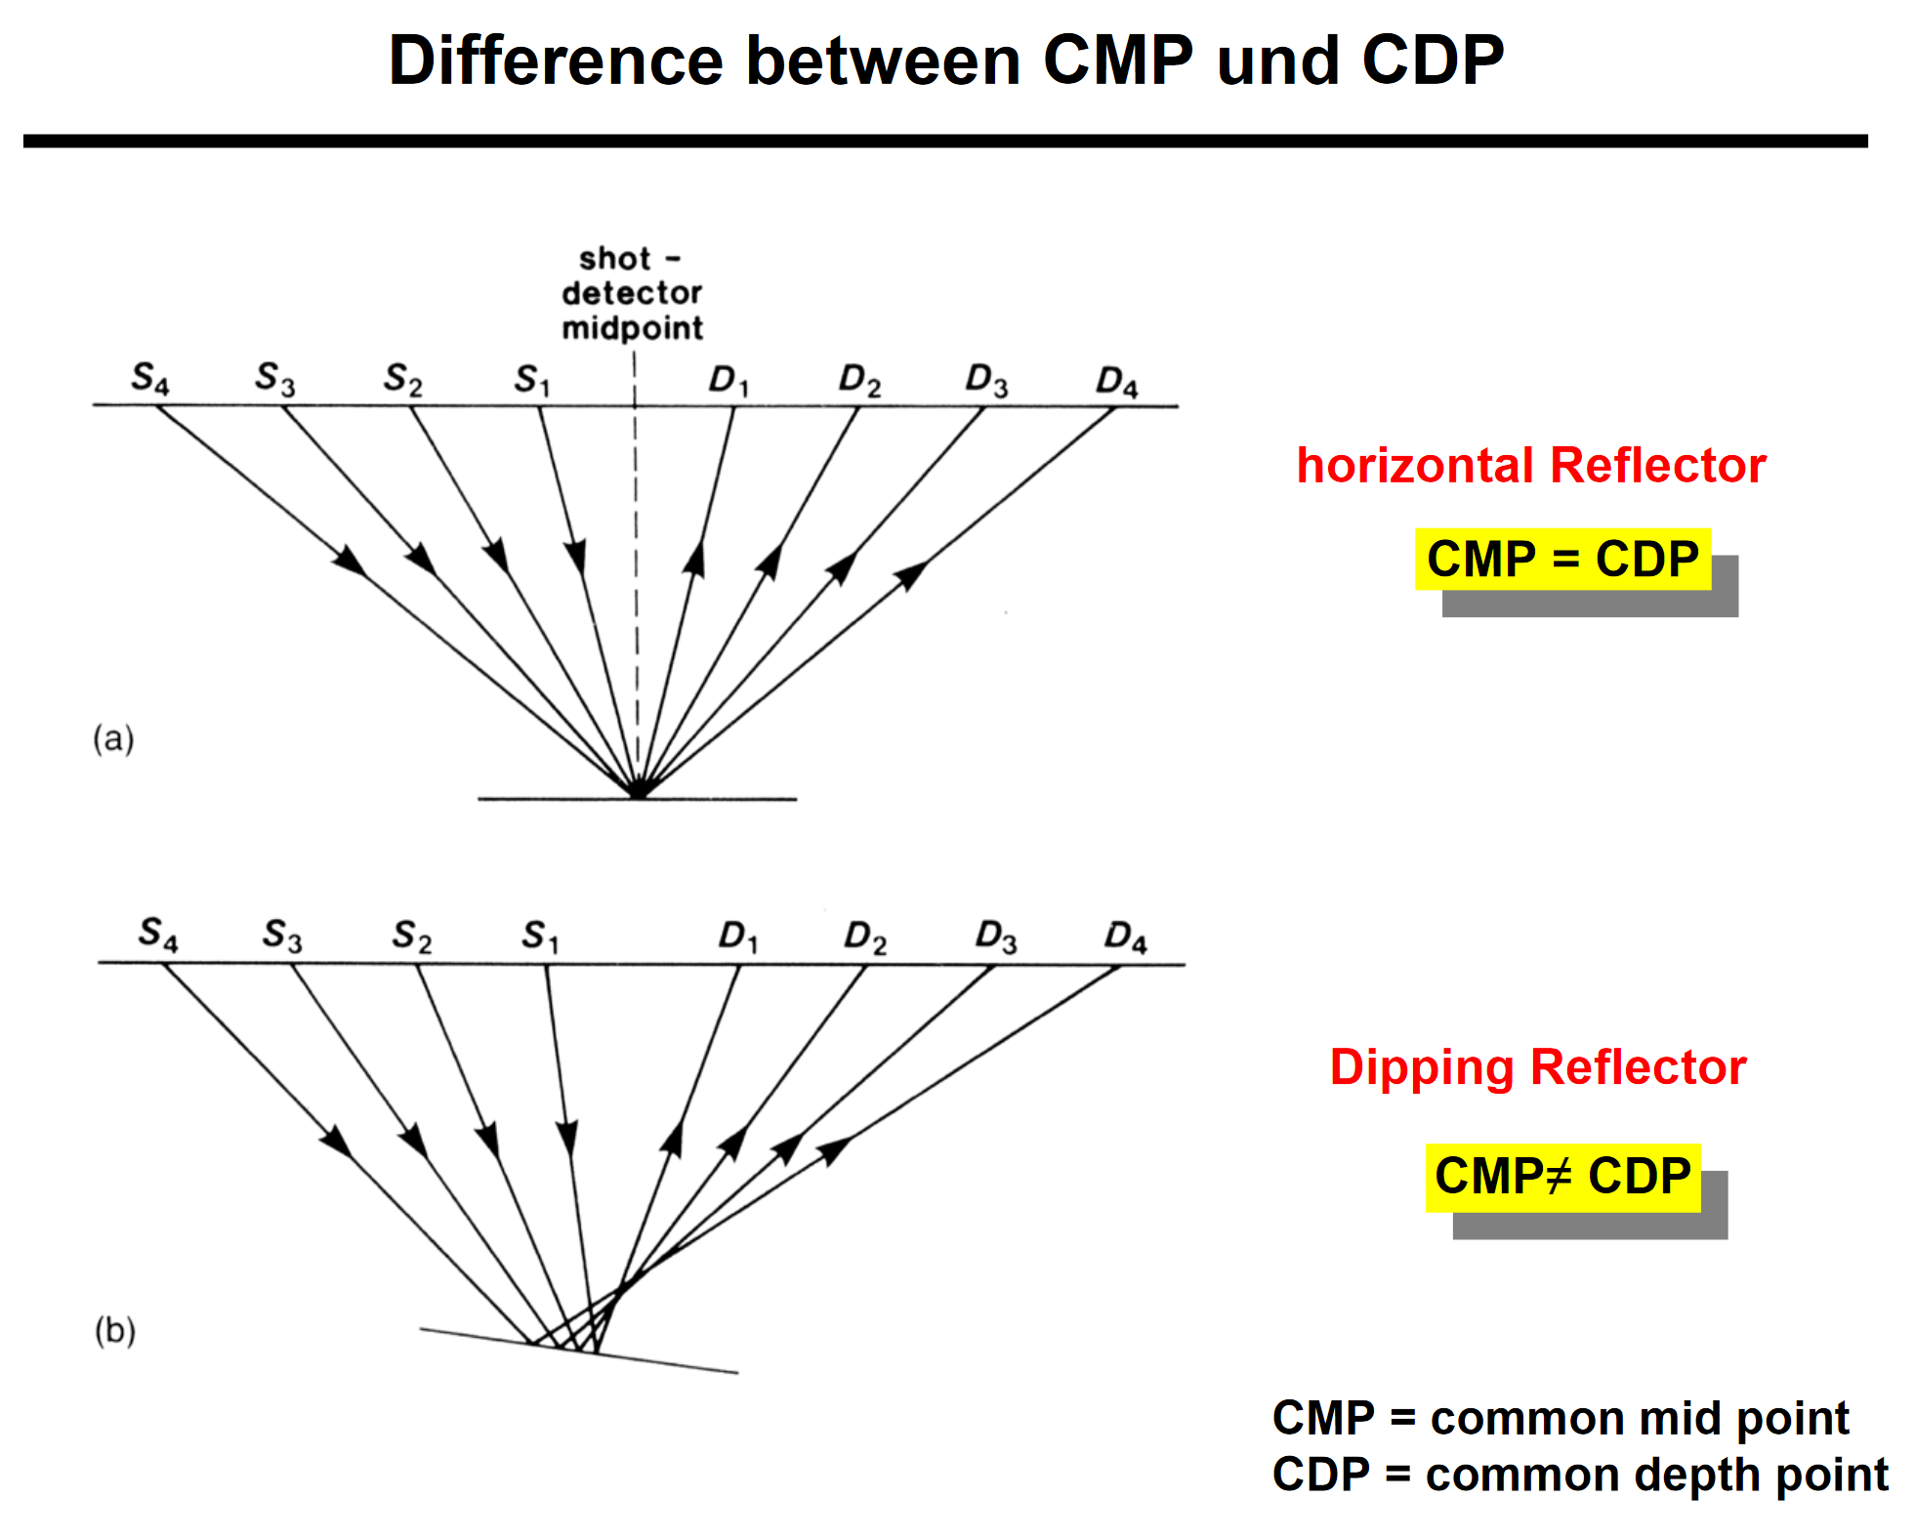

we will see that corrections can be included for dipping reflectors, such that this midpoint smear is corrected for (DMO).

**Dipping reflector**

The need to invoke seismic processing methods beyond simply sorting surface geometries is shown from the ray paths caused by a dipping reflector. In the presence of dipping events, ray paths of a CMP gather do not correspond to a single point in the subsurface. If untreated, this gather causes poor focusing, and inaccurate imaging. The common image point (CIP) gather represents a non-intuitive range of sources and receivers, which is obtain only after iterative applications of migration.

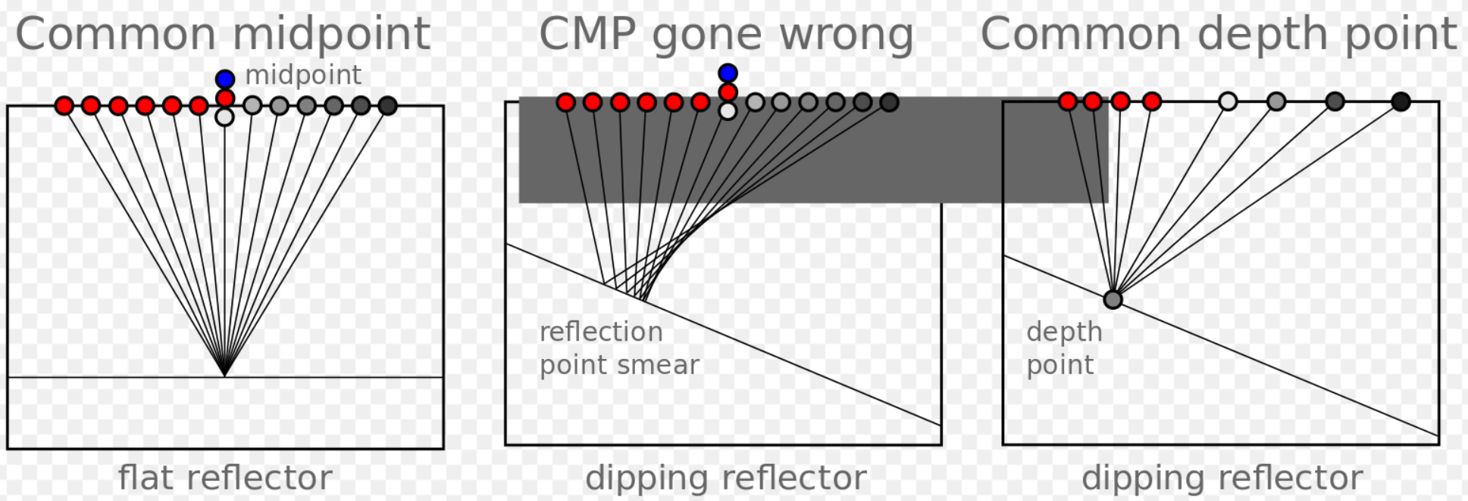

**Common offset gathers**

As can be expected, we can also form a common-offset gather, a gather in which we collect all those source-receiver pairs that have a certain offset in common. Usually, we shoot with fixed distances between source and receivers, and so we will have as many traces in our common-offset gather as there are shots, thus often quite a large amount.

Note that in the zero offset section the general structures can already be recognized. Common offset gathers are used in prestack migration algorithms since it can give a check on velocities. Migrating a common-offset gather for a small offset should give the same image as a migration of such a gather for a large offset, otherwise the velocity used in the migration is not the right one. The zero offset section takes a special place in the seismic processing, as a stacked section is supposed to resemble a zero offset section.

In other words, used for basic quality control, because it approximates a structural section. Since all the traces are at the same offset, it is also sometimes used in AVO analysis; one can quickly inspect the approximate spatial extent of a candidate AVO anomaly. If the near offset trace is used for each shot, this is called a brute stack.

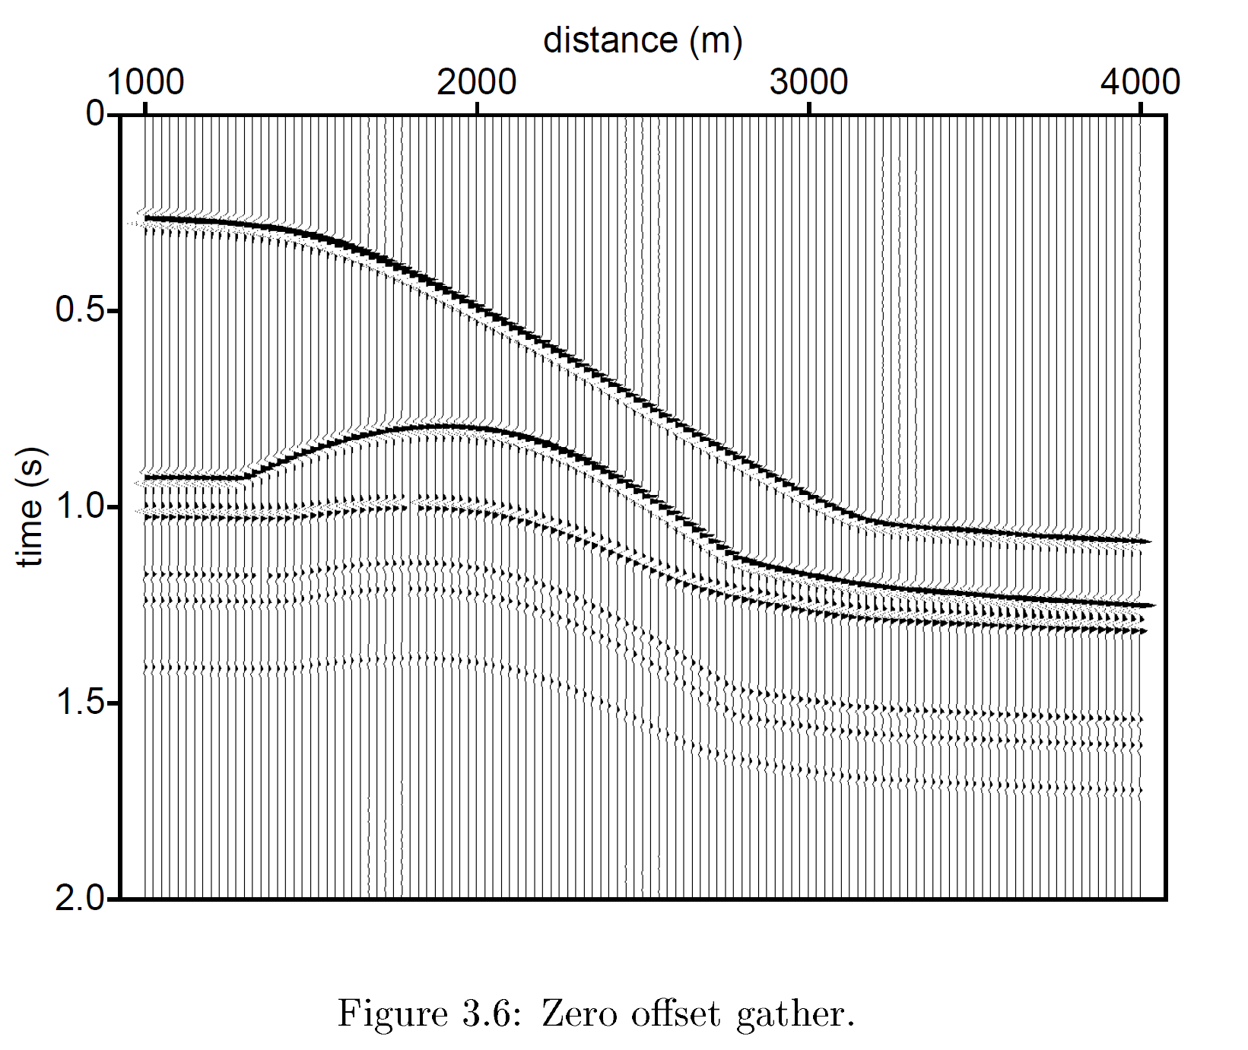

**Common azimuth gathers**

If the offset between source and receiver is constant, but the azimuth is varied, the gather can be used to study variations in travel-time anisotropy from the presence of elliptical stress fields or reservoir fracturing. The fast and slow traveltime directions can be mapped from the sinsoidal curve. It can also be used as a pre-stack data quality indicator.

Common-offset or Common-angle gathers with variable azimuth within each sector: this shows the amplitudes at a fixed offset with varying azimuth, and is useful for determining travel time variation due to anisotropy

• Common-azimuth gathers with variable offset within each sector: this identifies azimuthally varying AVO amplitude anomalies.

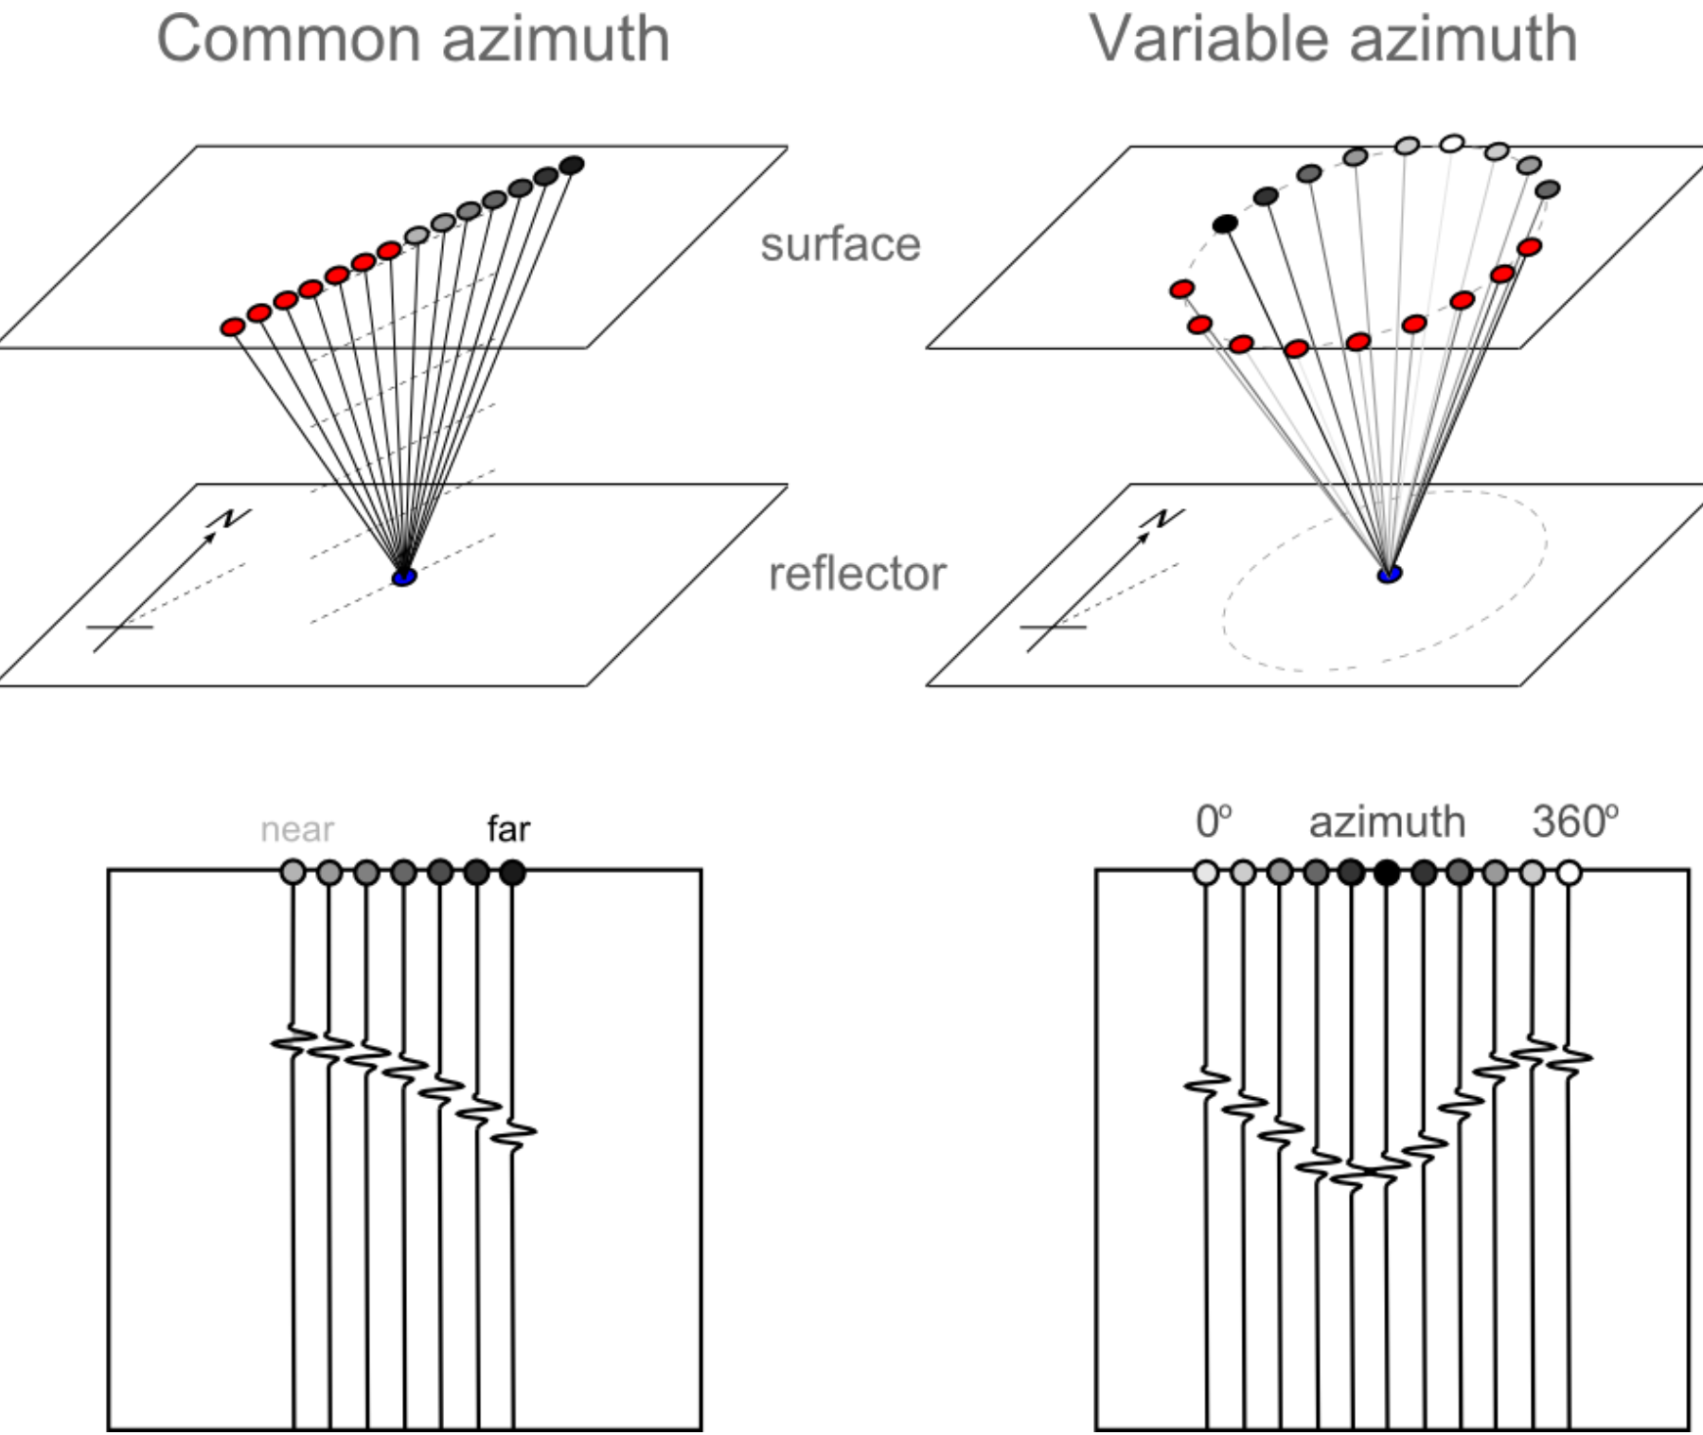

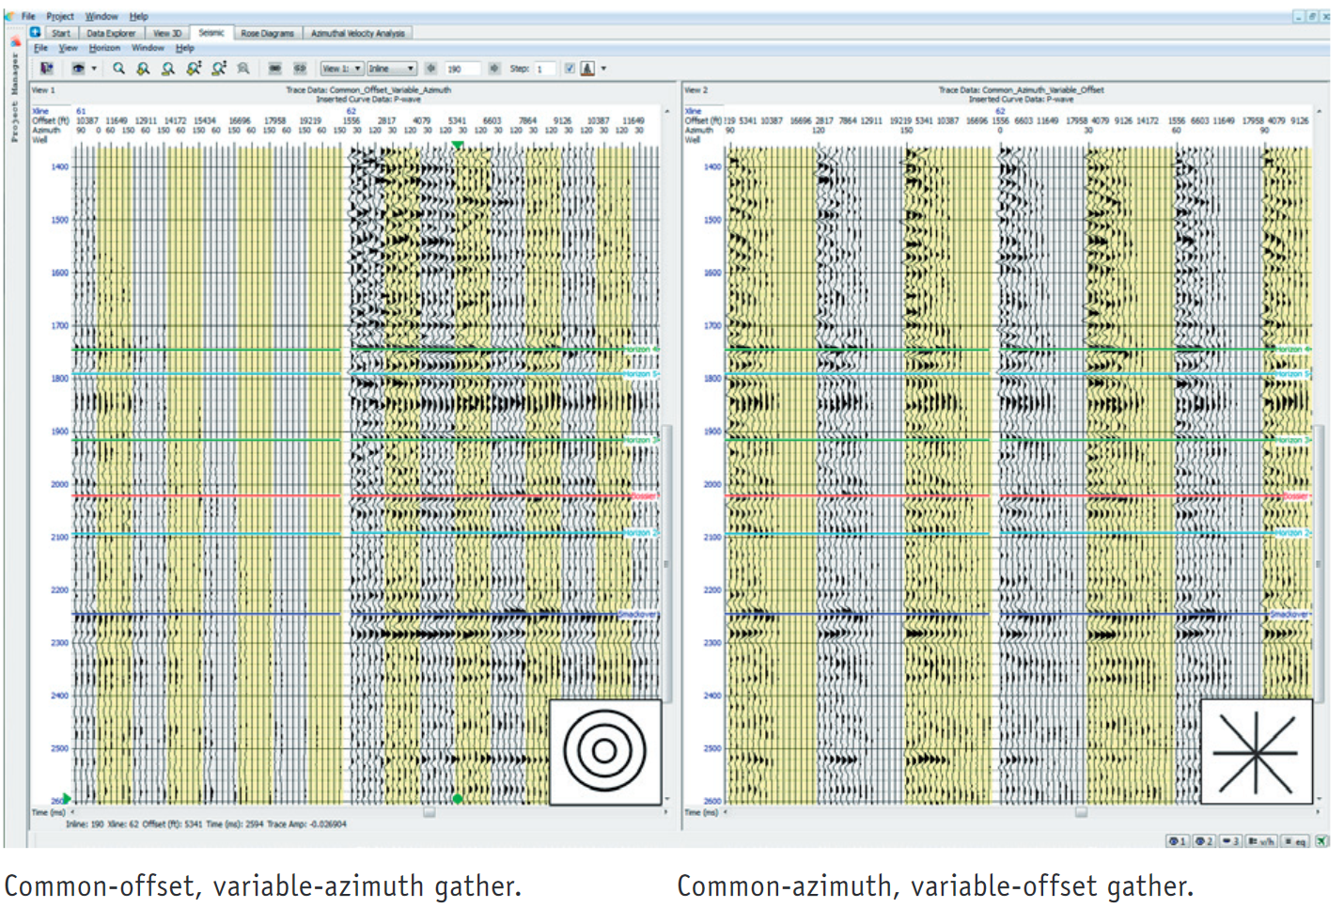

**Data seismic processing:**

we will discuss mainly functions in digital form.

We will also discuss both continuous and digital functions.

Geophysicists consider waveforms in two different domains:

1. Time or (distance) domain – t (or X)
2. Temporal (or spatial) frequency domain – f ( or k)

These are simply two different ways of describing any waveform.

Waveforms are not normally simple sine waves – they are usually much more complicated.

Three types of mathematical operations constitute the heart of most data processing:

1. Fourier transforms: convert data from time domain to frequency domain and vice versa without lost any information in this procedure.
2. Convolution: is the operation of replacing each element of an input with a scaled output function; it is the mathematical equivalent to filtering.
3. Correlation: is a method of measuring the similarity between two data sets. A common application is determining the time shift that will maximize the similarity. Correlation is also the means for extracting short signals of known waveshape from long wavetrains, as is used in vibroseis processing