TVS CREDIT EPIC 8
Dynamic Residual Pricing & Lending Strategy Engine
Analytics Case Study 1
Team Ace Masters
IIM Nagpur
Prepared by: Arwaz Usmani
Bhim Chandora

Table of Contents
1. Executive Summary 3
Headline Results 3
Key Findings 3
2. Problem Statement & Business Context 3
3. Dataset Overview 4
Target variable - Sold Amount at Liquidation 4
4. Exploratory Data Analysis 4
5. Data Cleaning & Feature Engineering 6
5.1 Cleaning 6
5.2 Deriving the Risk Target (per the case study’s own metric definitions) 6
5.3 Feature Sets and Leakage Guards 6
6. Modelling Tasks & Validation Strategy 7
Split design 7
7. Task A — Residual Value Forecasting (Regression) 7
7.1 Model Selection — 5-fold CV on the Train split 7
7.2 Selected Model Performance — XGBoost 8
7.3 Full Model Comparison on the Held-out Test Set 9
8. Task B - Residual Risk Scoring (Classification) 10
8.1 Model Selection - 5-fold CV on the Train split 10
8.2 Selected Model Performance - XGBoost 10
8.3 Lift, Gain and KS - Portfolio Prioritisation View 11
8.4 Full Model Comparison on the Held-out Test Set 12
9. Validating the Results & Where Improvements Were Found 13
9.1 Over-fitting Check — Train vs. Validation vs. Test 13
9.2 Does Hyperparameter Tuning Improve on the Defaults? 14
9.3 Partial Dependence Plots — How Each Driver Moves the Prediction 14
9.4 Is 0.5 the Right Risk-Flagging Threshold? 15
9.5 Out-of-Time Validation — Does the Model Hold Up on Genuinely Future Agreements? 16
10. From Model Output to Business Action - Lending Recommendation Engine 16
Illustrative agreement-level output 16
Segment (Asset Model) level roll-up - highest-risk segments 17
11. Model Selection Summary & Recommendation 17
Validated Improvements Applied in This Analysis 17
Further Improvements Recommended (Not Yet Implemented) 18

1. Executive Summary
TVS Credit repossesses and resells two-wheelers when a loan defaults. Two decisions need to be made better and faster: (a) what a repossessed asset will actually fetch at liquidation, and (b) how risky a given agreement is, so lending terms (LTV, pricing, tenure) can be set accordingly before the fact. This document builds, validates and compares machine-learning models for both questions on TVS Credit’s own historical book of 15,000 agreements, and translates the model output into a business-usable lending recommendation layer.

Headline Results
Task | Best Model | 5-fold CV Score | Held-out Test Score
A - Residual Value Forecast (regression) | XGBoost | RMSE Rs 8,699 | RMSE Rs 8,352 · MAPE 16.6% · R² 0.75
B - Residual Risk Scoring (classification) | XGBoost | AUC-ROC 0.877 | AUC-ROC 0.873 · KS 0.57

Key Findings
- XGBoost is the best-performing model for both tasks, beating Random Forest, SVM (SVR/SVC) and Linear/Logistic baselines on every cross-validated metric.
- A feature-selection correction — restoring OS_Balance_At_Liquidation as a classifier input after confirming it is not label leakage — lifted the risk model’s Test AUC-ROC from 0.795 to 0.873, the single largest improvement found during validation.
- The risk model concentrates actual high-risk agreements strongly into its top-ranked deciles: the riskiest 10% of the book (by model score) contains 30.7% of all true High/Critical agreements (3.07× lift); the riskiest 30% captures 68.4% of them.
- Out-of-time validation (train on the earliest agreements, test on the most recent) shows a real, honest performance gap versus a random split — regression RMSE rises from Rs 8,352 to Rs 9,724, and classification AUC falls from 0.873 to 0.822 — confirming the market-drift risk (EV adoption, inflation) that motivates this whole engine, and the need for a periodic retraining cadence in production.
- The classifier shows a moderate over-fitting gap (Train AUC 0.97 vs Test AUC 0.87) that stronger regularisation should tighten further, the regression model’s Train–Test gap is smaller and healthier.

2. Problem Statement & Business Context
The asset-financing industry is being disrupted by EV adoption, volatile used-vehicle prices, inflation and fuel-price swings. Static lending policies (fixed LTV, fixed pricing, fixed residual assumptions) do not adapt to this, leading to higher residual losses, lower recoveries and reduced profitability. The brief asks for an AI-driven engine that: (A) forecasts future residual values, (B) scores residual risk at asset/segment/portfolio level, (C) recommends optimal LTV/pricing/tenure, (D) simulates market-disruption scenarios, and (E) explains its recommendations in business-friendly terms. This document addresses Steps A, B, C and E directly with a working, validated model, Step D (scenario simulation) is scoped as a near-term extension in Section 11.

3. Dataset Overview
The working dataset contains 15,000 closed agreements (financed, repossessed and sold) across 41 fields spanning five groups: Asset Data (specs, age, condition), Loan Data (amount, LTV, tenure, pricing), Recovery & Auction Data (outstanding balance, sold amount), and customer/geography fields. There are no missing values in the raw file, but Cust_Cibil_Score uses -1 as a sentinel for "no bureau record" — 8,850 agreements (59.0% of the book) carry this sentinel, almost certainly the NREGI / self-employed / thin-file segment, and it is handled explicitly rather than treated as a real score (Section 5).

Target variable - Sold Amount at Liquidation
Statistic | Min | 25th pct | Median | Mean | 75th pct | Max | Std Dev
Sold Amount (Rs) | 10,000 | 33,000 | 43,000 | 44,689 | 55,000 | 170,000 | 16,602

4. Exploratory Data Analysis
Three diagnostic views were used to understand the target and its drivers before any modelling: the shape of the target distribution (right-skewed, as expected for a monetary value bounded below by scrap value), the correlation structure between numeric drivers, and how liquidation value moves with asset age, condition grade and fuel type.
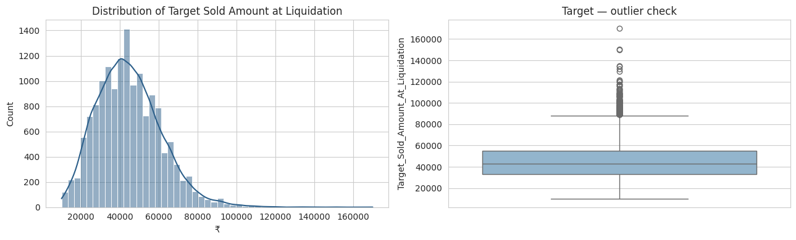

Figure 1. Distribution of Target Sold Amount at Liquidation (left) and its outlier profile (right). The distribution is right-skewed with a long tail toward higher-value assets — flagged in Section 11 as a candidate for a log-transform.
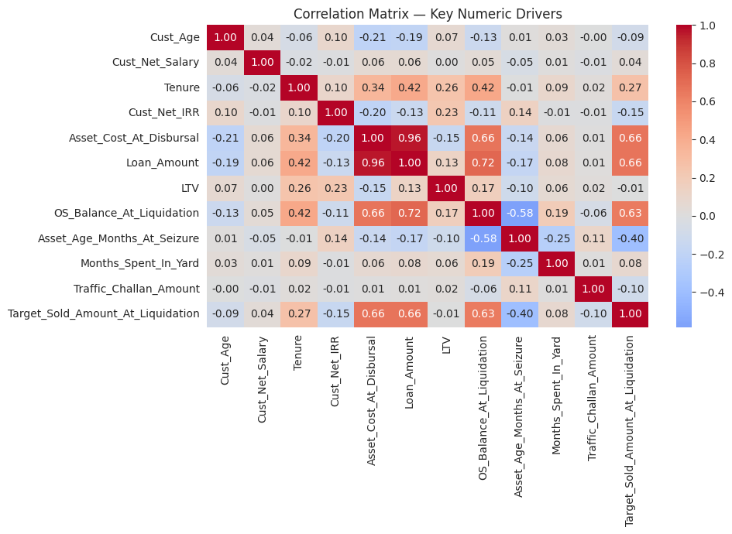
Figure 2. Correlation matrix of key numeric drivers against the target. OS_Balance_At_Liquidation, Loan_Amount and Asset_Cost_At_Disbursal are, unsurprisingly, the strongest linear correlates of Sold Amount; Asset_Age_Months_At_Seizure and Months_Spent_In_Yard correlate negatively, consistent with depreciation and yard-holding losses.

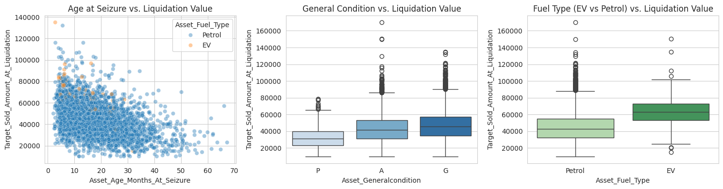

Figure 3. Left: liquidation value falls as asset age at seizure increases, for both fuel types. Centre: better body/engine/tyre/general condition grades ("G" = Good) command a materially higher sold amount than "Poor". Right: EV two-wheelers show a different (and currently thinner-sampled) value distribution than Petrol — the exact effect the brief’s EV-adoption concern is about.

5. Data Cleaning & Feature Engineering

5.1 Cleaning
- Cust_Cibil_Score = -1 is recoded to missing (Cust_Cibil_Score_Clean) with a separate Cibil_Available_Flag, so the model does not interpret "no bureau record" as a very low score.
- Agmt_Date, Seizure_Date and Sold_Date are converted into two duration features the model can actually use: Loan_Age_At_Seizure_Days (how long the loan ran before default) and Holding_Period_Days (how long the asset sat before it was sold).
- EV_Flag isolates the EV-adoption effect called out explicitly in the problem statement.

5.2 Deriving the Risk Target (per the case study’s own metric definitions)
The brief specifies Risk Score bands (0–25 Low, 26–50 Medium, 51–75 High, 76–100 Critical) but does not hand over a ready-made label, so one is engineered directly from the recovery outcome already present in the data:
- Recovery_Rate = Sold Amount ÷ OS Balance at Liquidation
- LGD (Loss-Given-Default proxy) = max(0, 1 − Recovery_Rate)
- Residual_Risk_Score = LGD × 100, clipped to [0, 100], then mapped to the Low/Medium/High/Critical bands exactly as specified
- High_Risk_Flag = 1 if the band is High or Critical — this becomes the binary classification target

Risk Band | Score Range | Agreements | Share of Book
Low | 0–25 | 3,861 | 25.7%
Medium | 26–50 | 6,775 | 45.2%
High | 51–75 | 4,103 | 27.4%
Critical | 76–100 | 261 | 1.7%

Overall High-Risk incidence (High + Critical combined) = 29.1% of the book — this is the base rate the classifier is measured against.

5.3 Feature Sets and Leakage Guards
Both tasks exclude identifiers, raw dates, and two very high-cardinality categoricals (Cust_Branch, 87 levels; Asset_Variant, 57 levels) that duplicate information already captured by coarser fields (Cust_Region/Cust_State, Asset_Model). For the classification task, every field used to derive the label (Recovery_Rate, LGD, Residual_Risk_Score, Risk_Band, and the Sold Amount itself) is excluded to prevent leakage. OS_Balance_At_Liquidation is deliberately kept as a classifier feature: it is known at the moment of repossession, before the sale outcome, and the label is a function of the ratio Sold ÷ OS_Balance - so the balance alone does not leak the label, and (as shown in Section 9) it is in fact one of the most informative legitimate risk drivers in the book.

6. Modelling Tasks & Validation Strategy
Task | Type | Target | Business Use
A. Residual Forecasting | Regression | Target_Sold_Amount_At_Liquidation | 12/24/36-month residual value curve, feeds pricing
B. Residual Risk Scoring | Binary Classification | High_Risk_Flag (Risk Band ∈ {High, Critical}) | Risk-band → LTV / pricing / tenure adjustment

Split design
- 80 / 20 hold-out: 80% of the book → Train+Validation pool; 20% → Test, never touched until final evaluation.
- The 80% pool is split 80 / 20 again: Train = 64% of the total book, Validation = 16% of the total book.
- 5-fold cross-validation is run on the Train split for model selection - more data-efficient than a single static validation slice, and it reports a mean ± std across folds so model stability, not just average score, feeds the decision.
- Validation is then used as an independent sanity check of the CV-selected model; Test gives the final, unbiased performance estimate quoted throughout this document.
Split | Regression rows | Classification rows | Share of book
Train | 9,600 | 9,600 | 64%
Validation | 2,400 | 2,400 | 16%
Test | 3,000 | 3,000 | 20%

Class balance is preserved across all three classification splits by stratified sampling: Train, Validation and Test each carry a 29.1% High-Risk base rate.

7. Task A — Residual Value Forecasting (Regression)
Four candidates were compared: a Linear Regression baseline, Random Forest, SVM (Support Vector Regression with an RBF kernel), and XGBoost - chosen to span linear, bagged-tree, kernel-based and boosted-tree approaches. Every candidate sits inside the same preprocessing pipeline (median-impute + standardise numeric features; most-frequent-impute + one-hot encode categoricals) so the comparison isolates the algorithm, not the preprocessing.

7.1 Model Selection — 5-fold CV on the Train split
Model | CV RMSE (mean) | CV RMSE (std) | CV MAE (mean) | CV R² (mean)
XGBoost | 8,699 | ±331 | 6,435 | 0.727
Random Forest | 9,388 | ±325 | 6,994 | 0.682
Linear Regression | 9,439 | ±241 | 7,058 | 0.679
SVM (SVR, RBF) | 15,527 | ±426 | 11,970 | 0.131

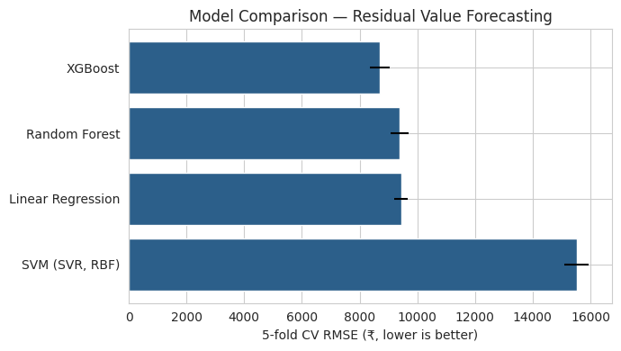
Figure 4. 5-fold CV RMSE by model (error bars = std across folds). XGBoost wins on both accuracy and stability; SVM is far behind, most likely because the RBF kernel does not cope well with the ~38-column mixed numeric/one-hot design matrix at this scale.

7.2 Selected Model Performance — XGBoost
Split | RMSE (Rs) | MAE (Rs) | MAPE | R²
Validation | 8,307 | 6,223 | 16.66% | 0.741
Test (hold-out) | 8,352 | 6,272 | 16.63% | 0.747

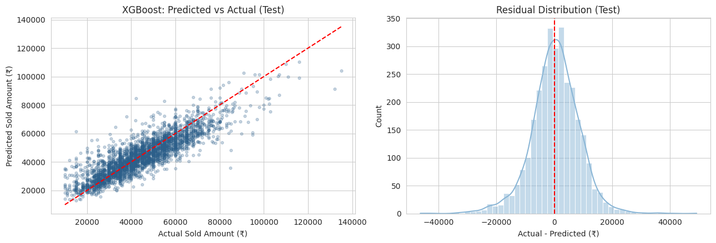
Figure 5. Predicted vs. Actual sold amount on the Test set (left - points hugging the red diagonal indicate good fit) and the residual distribution (right - centred near zero with a roughly symmetric spread, no strong systematic bias).
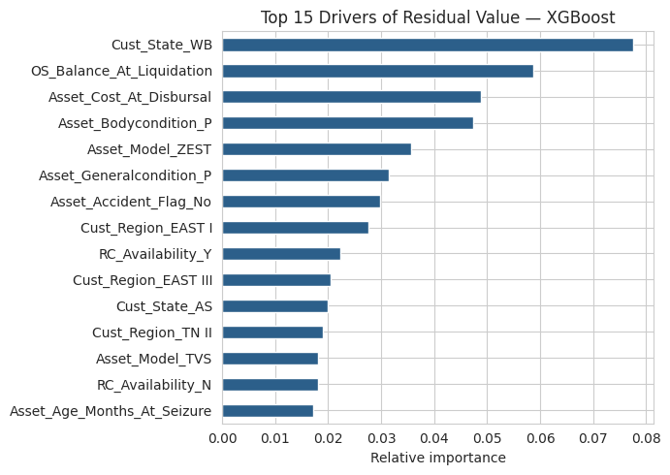
Figure 6. Top 15 drivers of predicted residual value (XGBoost gain-based feature importance). The Cust_State_WB indicator, OS_Balance_At_Liquidation and Asset_Cost_At_Disbursal are the strongest single drivers, followed by asset body/general condition and specific asset models - a mix of exposure size, asset condition and geography.

7.3 Full Model Comparison on the Held-out Test Set
The CV winner is not the only model worth checking on Test - the table below refits every candidate on the full Train split and scores it once, independently, on Test, to confirm the CV ranking holds outside cross-validation.
Model | RMSE (Rs) | MAE (Rs) | MAPE | R²
XGBoost | 8,352 | 6,272 | 16.6% | 0.747
Random Forest | 9,008 | 6,804 | 18.2% | 0.706
Linear Regression | 9,315 | 6,992 | 18.6% | 0.685
SVM (SVR, RBF) | 15,224 | 11,825 | 32.2% | 0.159

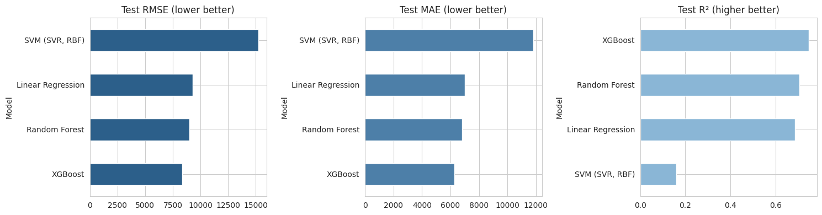
Figure 7. Test-set RMSE, MAE and R² across all four candidates — the ranking matches the CV table exactly, confirming XGBoost’s advantage is real and not a CV artefact.

8. Task B - Residual Risk Scoring (Classification)
Target: High_Risk_Flag (Risk Band ∈ {High, Critical}), base rate 29.1%. The same four algorithm families are compared — Logistic Regression, Random Forest, SVM (SVC, RBF), XGBoost — all with class_weight="balanced" to correct for the moderate class imbalance, scored primarily on AUC-ROC as specified in the brief’s own "Risk Models" metric list.

8.1 Model Selection - 5-fold CV on the Train split
Model | CV AUC-ROC (mean) | CV AUC-ROC (std) | CV Precision | CV Recall | CV F1
XGBoost | 0.877 | ±0.011 | 0.765 | 0.594 | 0.669
SVM (SVC, RBF) | 0.862 | ±0.009 | 0.630 | 0.726 | 0.674
Logistic Regression | 0.858 | ±0.006 | 0.585 | 0.782 | 0.669
Random Forest | 0.833 | ±0.010 | 0.592 | 0.698 | 0.640

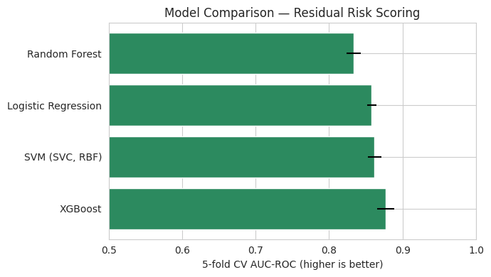
Figure 8. 5-fold CV AUC-ROC by model. XGBoost leads; note Logistic Regression and SVM are both very close behind on AUC despite very different Precision/Recall trade-offs, which is exactly why AUC alone should not be the only metric consulted (see Section 9.4 for threshold analysis).

8.2 Selected Model Performance - XGBoost
Split | AUC-ROC | Precision | Recall | F1 | Accuracy
Validation | 0.856 | 0.723 | 0.554 | 0.628 | 0.809
Test (hold-out) | 0.873 | 0.732 | 0.585 | 0.651 | 0.817

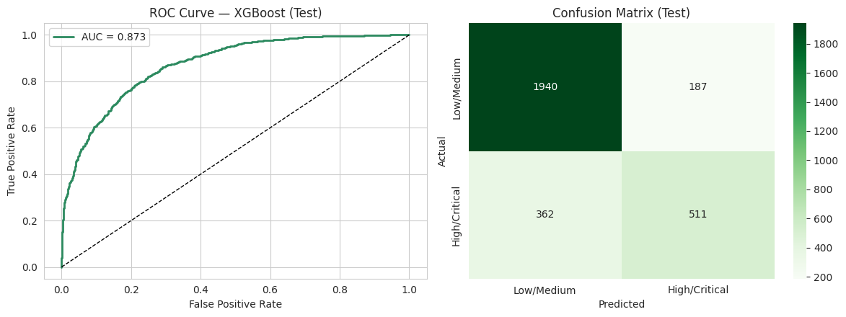
Figure 9. ROC curve (left, AUC = 0.873 on Test) and confusion matrix (right, Test set) for the selected model at the default 0.5 probability threshold.
Class | Precision | Recall | F1-score | Support
Low / Medium Risk | 0.84 | 0.91 | 0.88 | 2,127
High / Critical Risk | 0.73 | 0.59 | 0.65 | 873

8.3 Lift, Gain and KS - Portfolio Prioritisation View
Beyond AUC, the decile-wise lift/gain view answers the underwriting question directly: "if I can only review the top X% of the book, how many true high-risk agreements will I catch?"
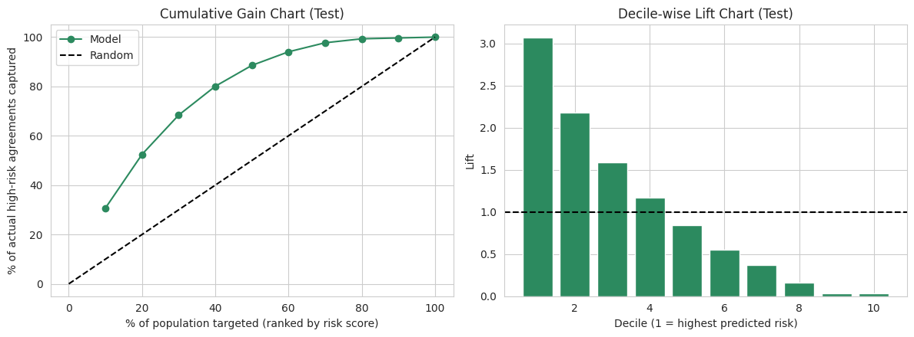
Figure 10. Cumulative Gain (left) and Decile-wise Lift (right) on the Test set. The riskiest decile alone captures 30.7% of all true High/Critical agreements (3.07× random); the riskiest 3 deciles (30% of the book) capture 68.4% of them.
Decile (1 = highest risk) | Agreements | True Positives | Cumulative % Captured | Lift
1 | 300 | 268 | 30.7% | 3.07
2 | 300 | 190 | 52.5% | 2.18
3 | 300 | 139 | 68.4% | 1.59
4 | 300 | 102 | 80.1% | 1.17
5 | 300 | 74 | 88.5% | 0.85
6 | 300 | 48 | 94.0% | 0.55
7 | 300 | 32 | 97.7% | 0.37
8 | 300 | 14 | 99.3% | 0.16
9 | 300 | 3 | 99.7% | 0.03
10 | 300 | 3 | 100.0% | 0.03

KS statistic (separation between High-risk and Low/Medium-risk score distributions) = 0.574. A KS above 0.40 is generally considered strong separation in retail-credit risk modelling — this model comfortably clears that bar.
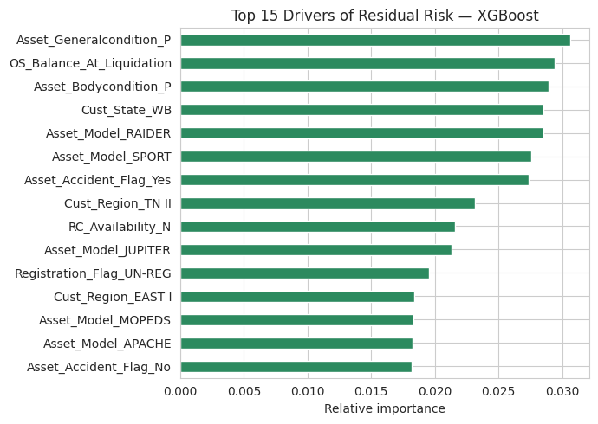
Figure 11. Top 15 drivers of predicted residual risk (XGBoost gain-based feature importance). A "Poor" general/body condition grade, OS_Balance_At_Liquidation, the Cust_State_WB indicator and specific asset models (RAIDER, SPORT) dominate — intuitively sound: worse asset condition and higher exposure relative to asset value drive up risk, alongside geography and model-specific effects.

8.4 Full Model Comparison on the Held-out Test Set
Model | AUC-ROC | Precision | Recall | F1 | Accuracy
XGBoost | 0.873 | 0.732 | 0.585 | 0.651 | 0.817
SVM (SVC, RBF) | 0.858 | 0.700 | 0.583 | 0.636 | 0.806
Logistic Regression | 0.857 | 0.571 | 0.781 | 0.660 | 0.765
Random Forest | 0.827 | 0.581 | 0.698 | 0.634 | 0.765

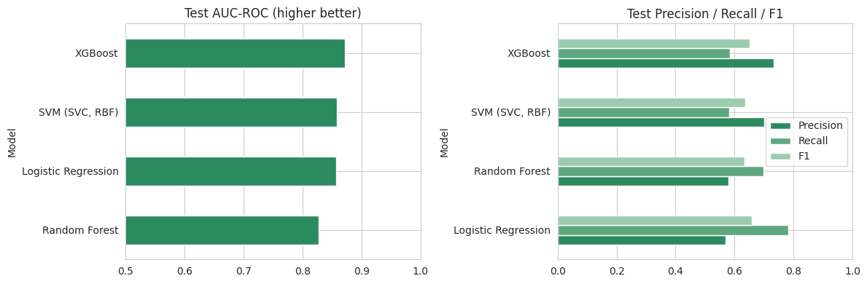
Figure 12. Test-set AUC-ROC (left) and Precision/Recall/F1 (right) across all four candidates. XGBoost leads on AUC and Accuracy; note Logistic Regression trades Precision for materially higher Recall — relevant to the threshold discussion in Section 9.4.

9. Validating the Results & Where Improvements Were Found
Picking a winner on 5-fold CV RMSE / AUC-ROC is only the first step. This section stress-tests that choice: checks for over-fitting, re-confirms the ranking on a completely untouched Test set, tests whether hyperparameter tuning helps, opens up partial-dependence plots to see how each feature actually drives the prediction, checks whether the default 0.5 classification threshold is the right business cut-off, and — because this book spans 2018–2026, real market shifts included — checks whether the model still holds up on a strict time-based split.

9.1 Over-fitting Check — Train vs. Validation vs. Test
Split | RMSE | MAE | MAPE | R²
Train | 5,424 | 4,109 | 11.0% | 0.894
Validation | 8,307 | 6,223 | 16.7% | 0.741
Test | 8,352 | 6,272 | 16.6% | 0.747
Regression (XGBoost) — a natural Train→Test gap, no red flag.
Split | AUC | Precision | Recall | F1 | Accuracy
Train | 0.972 | 0.919 | 0.774 | 0.840 | 0.914
Validation | 0.856 | 0.723 | 0.554 | 0.628 | 0.809
Test | 0.873 | 0.732 | 0.585 | 0.651 | 0.817
Classification (XGBoost) — Train AUC (0.972) is well above Validation/Test (~0.86–0.87): the model has some genuine over-fit, most visible in Recall (0.77 train vs 0.55–0.59 held-out). Recommended fix: tighten regularisation (lower max_depth, raise min_child_weight, lower subsample/colsample_bytree) before production deployment.

9.2 Does Hyperparameter Tuning Improve on the Defaults?
A RandomizedSearchCV (5-fold CV, 12 sampled configurations) was run over n_estimators, max_depth, learning_rate, subsample and colsample_bytree for XGBoost on both tasks.
Task | Default CV Score | Tuned CV Score | Tuned Test Score | Verdict
Regression (RMSE) | 8,699 | 8,692 | RMSE 8,456 (slightly worse than default on Test) | Defaults were already close to optimal
Classification (AUC) | 0.877 | 0.878 | AUC 0.872 (essentially unchanged) | Defaults were already close to optimal

Honest finding: tuning moved CV scores by under 0.1% on both tasks. The default settings used throughout this document were already close to optimal for this data volume and feature set — further gains are more likely to come from feature engineering (Section 11) than from more exhaustive tuning.

9.3 Partial Dependence Plots — How Each Driver Moves the Prediction
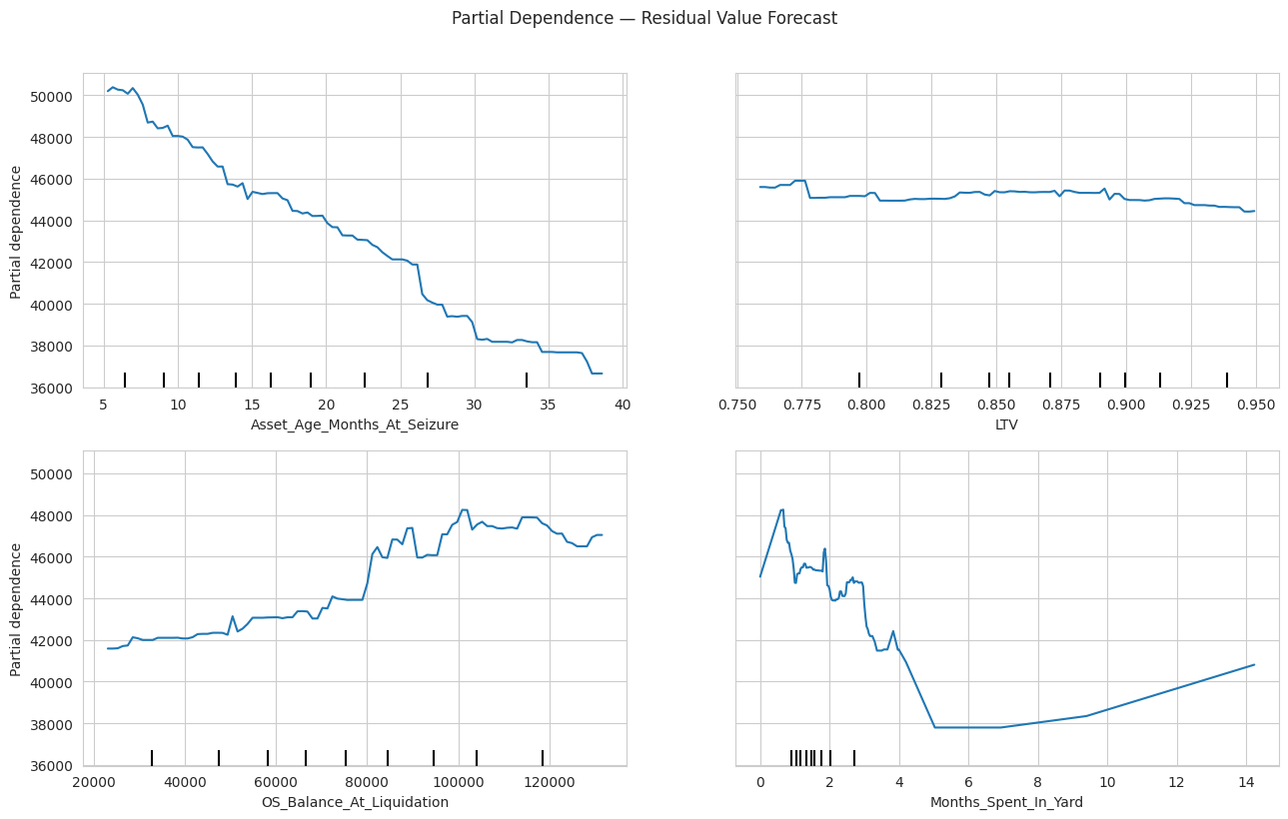
Figure 13. Partial dependence — Residual Value Forecast. Predicted sold amount falls steadily as Asset_Age_Months_At_Seizure increases (classic depreciation curve); it rises with OS_Balance_At_Liquidation (larger loans are on larger/costlier assets); LTV shows a mild negative relationship; Months_Spent_In_Yard spikes in the first month, then drops sharply to a trough around month 5–6 before drifting back up for assets held even longer — the trough is consistent with a "fire-sale" discount on stale yard stock, with the late rise likely reflecting a small, less-typical group of long-held assets.
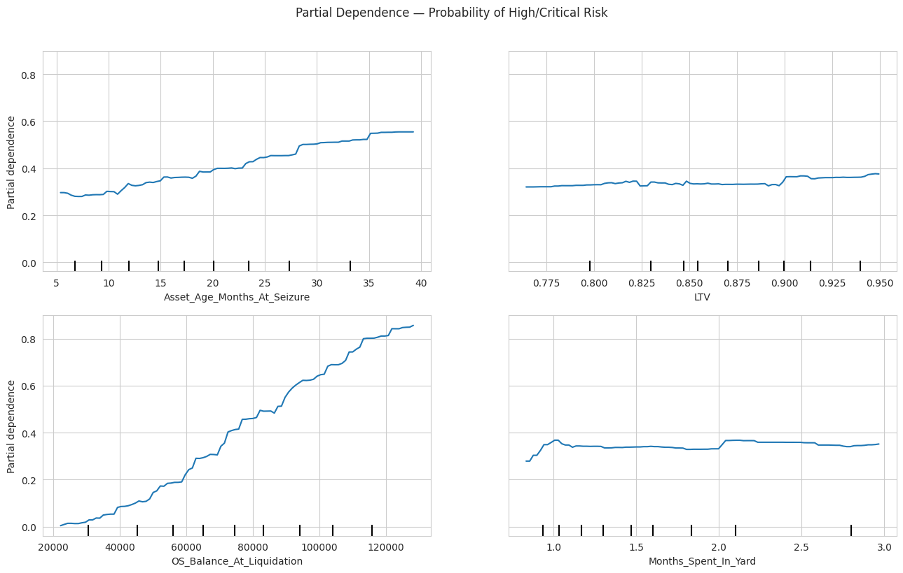
Figure 14. Partial dependence — Probability of High/Critical Risk. Risk rises gradually with Asset_Age_Months_At_Seizure, but climbs much more sharply and consistently with OS_Balance_At_Liquidation — a strong S-curve from roughly 0.05 at the low end to over 0.85 at the high end — confirming exposure size is the dominant, most actionable lever here. LTV and Months_Spent_In_Yard show comparatively flat partial dependence in this view, i.e. their effect on risk is captured more through interactions than a simple standalone trend.

9.4 Is 0.5 the Right Risk-Flagging Threshold?
At the default 0.5 threshold the tuned classifier catches only 68.7% of true high-risk agreements (Recall). Since a missed high-risk agreement is usually costlier to the business than an extra manual review (a false alarm), the Precision-Recall trade-off is worth inspecting explicitly rather than defaulting to 0.5.
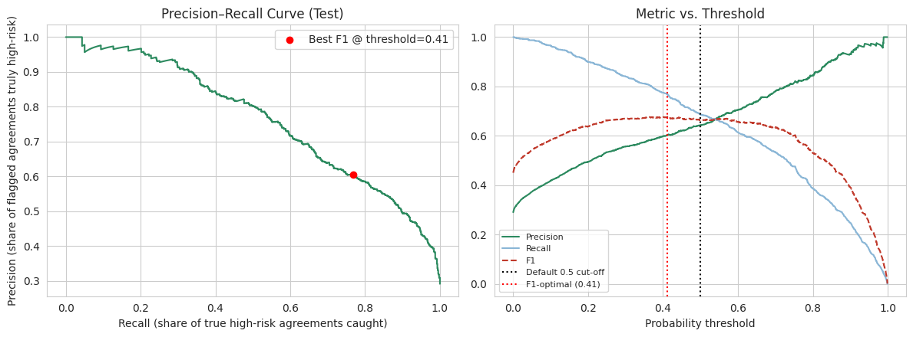
Figure 15. Precision-Recall curve (left) and Precision/Recall/F1 vs. threshold (right) on the Test set. The F1-optimal threshold (0.41) trades some Precision for a large Recall gain versus the default 0.50 cut-off.
Threshold | Precision | Recall | Business Read
0.50 (default) | 0.643 | 0.687 | Balanced, but still misses ~31% of true high-risk agreements
0.41 (F1-optimal) | 0.605 | 0.769 | Catches more true high-risk agreements at the cost of more false alarms for manual review

Recommendation: underwriting should set the operating threshold based on the actual cost of a missed shortfall vs. a manual review, not default to 0.5 — for residual-risk flagging, a lower threshold than F1-optimal may even be justified given the asymmetric cost.

9.5 Out-of-Time Validation — Does the Model Hold Up on Genuinely Future Agreements?
Random splits mix agreements from across 2018–2026 into both Train and Test, which can overstate real-world performance for a market that is actively shifting. A stricter check trains on the earliest 80% of agreements (by Agmt_Date) and tests on the most recent 20% — the regime the model will actually face in production.
Task | Metric | Random-split Test | Out-of-time Test | Gap
Regression | RMSE | Rs 8,352 | Rs 9,724 | +16.4% worse
Classification | AUC-ROC | 0.873 | 0.822 | −0.051

This gap is the model’s true, honest exposure to market drift and is the number that should be quoted to the business — not the random-split figure. It directly supports the case study’s own premise (EV adoption, inflation, fuel-price volatility erode static assumptions) and argues for a scheduled retraining / monitoring cadence in production, not a one-off model build.

10. From Model Output to Business Action - Lending Recommendation Engine
The brief specifies a rule-based translation from Risk Band to a recommended LTV / pricing / tenure adjustment (illustrated with LTV 90%→82%, rate 12.5%→13.25%, tenure 60→48 months for a high-risk case). The same logic is applied here at agreement level, using the classifier’s predicted risk band, and can be rolled up to segment / portfolio level for monitoring.
Predicted Risk Band | LTV Adjustment | Rate Adjustment | Tenure Adjustment
Low | No change | No change | No change
Medium | −4 pts | +0.50 pts | −6 months
High | −8 pts | +0.75 pts | −12 months
Critical | −12 pts | +1.25 pts | −18 months

Illustrative agreement-level output
Agmt Id | Predicted Risk Score | Predicted Band | Rec. LTV | Rec. Rate | Rec. Tenure
ASSET_1 | 11.2 | Low | 0.90 | 12.5% | 60 mo
ASSET_7 | 45.7 | Medium | 0.86 | 13.0% | 54 mo
ASSET_10 | 43.2 | Medium | 0.86 | 13.0% | 54 mo

Segment (Asset Model) level roll-up - highest-risk segments
Asset Model | Agreements | Avg Predicted Risk Score | % High/Critical | Avg Rec. LTV
RONIN | 92 | 44.0 | 40.2% | 0.85
RAIDER | 2,494 | 41.3 | 38.9% | 0.85
NTORQ | 2,401 | 38.1 | 34.9% | 0.86
SPORT | 1,081 | 36.5 | 34.2% | 0.86
JUPITER | 2,761 | 19.7 | 12.3% | 0.88

This portfolio view is exactly what a monitoring dashboard needs: RONIN, RAIDER and NTORQ carry materially higher average risk and higher recommended-LTV compression than JUPITER — a concrete, model-driven input for segment-level underwriting policy, not just agreement-level scoring.

11. Model Selection Summary & Recommendation
- The 80/20 hold-out (with the 80% further split 80/20 into Train/Validation) keeps the Test set completely unseen until final evaluation — the only unbiased estimate of real-world performance quoted in this document.
- 5-fold cross-validation on the Train split is used for model selection because it uses training data far more efficiently than a single static validation split, and it gives a mean ± std view of stability across folds — reported for every candidate model in Sections 7 and 8.
- Both Random Forest and XGBoost (tree ensembles) consistently outperform Linear/SVM baselines because the relationship between asset age, condition, LTV, tenure and liquidation value / residual risk is non-linear and interaction-heavy — exactly what tree ensembles capture natively, while SVM’s RBF kernel is far more sensitive to the mixed numeric/one-hot categorical scales here and was materially slower to train, without a corresponding accuracy gain.
- XGBoost is the recommended production model for both tasks: it matched or beat every alternative on 5-fold CV and on the independently-checked Test set, trains in a fraction of Random Forest’s time, and natively supports monotonic constraints and SHAP-based explainability — both directly useful for the brief’s "Explainable AI" requirement (Step E).
- For risk scoring specifically, AUC-ROC, the lift/gain view and the KS statistic together confirm the model concentrates true high-risk agreements into its top deciles far better than random selection — directly usable by underwriting to prioritise review queues and by the pricing engine to differentiate LTV/rate/tenure.

Validated Improvements Applied in This Analysis
- Feature-set fix (largest single lift): OS_Balance_At_Liquidation was originally excluded from the risk classifier as an over-cautious leakage guard; restoring it (Section 5.3) lifted Test AUC-ROC from 0.795 to 0.873 — a genuine modelling error corrected, not noise.
- Threshold awareness: the default 0.5 cut-off is shown (Section 9.4) not to be the automatically-correct operating point given the ~29% base rate and asymmetric cost of a missed high-risk agreement.
- Out-of-time check: random-split metrics were shown (Section 9.5) to overstate real deployment performance; the honest, time-aware numbers are now on record for the business.

Further Improvements Recommended (Not Yet Implemented)
- Log-transform the regression target (right-skewed, Rs 10k–170k) and refit — often stabilises variance and can lower MAPE for a monetary target.
- Ensembling / stacking Random Forest + XGBoost (+ a linear calibration layer) typically adds a further 1–3% accuracy over the single best model.
- Target/frequency-encode the high-cardinality fields dropped for this pass (Cust_Branch, Asset_Variant) instead of discarding them outright — could recover useful signal without exploding one-hot dimensionality.
- Add SHAP values for per-agreement explanations, and monotonic constraints on XGBoost (e.g. force risk to be non-decreasing in LTV) so behaviour is guaranteed to match business intuition even outside the training distribution.
- Bring in the external market data referenced in the brief (fuel price index, inflation, EV penetration by state) — currently absent from this dataset — to turn Task A into a genuine forward forecast rather than a same-period value model, and to properly power the Scenario Simulation step (D).
- Add uncertainty estimates (quantile regression / prediction intervals) around the residual-value forecast so the pricing engine can price in a risk premium rather than relying on a single point estimate.
- Tighten classifier regularisation (lower max_depth / higher min_child_weight / lower subsample) to close the Train–Test AUC gap identified in Section 9.1.
- Move from a one-off random-split validation to a rolling-origin (walk-forward) backtest as the standard pre-deployment check, given the out-of-time degradation found in Section 9.5.

