- Clock Manager block is used to buffer BCLK with BUFG and to generate system clock (I chose 80 MHz for now, this can be changed) from external 50 MHz reference. Clock Manager also generates synchronous system reset signal, that will be asserted for 16 cycles. One peculiarity is that DCM needs reset upon power-up and whenever input clock is stopped, so there’s another 16-bit shift register, its MSB is used to reset DCM when needed.

- If you need to change system clock, please note that you can’t use any arbitrary frequency, because sys_clk is (50 MHz * M / D), where M and D can only be small integer numbers, actual frequency can be observed in the clocking wizard. If you need another clock, say 80/2=40 MHz, you can enable CLK_OUT2 and route it out of the Clock Manager module.

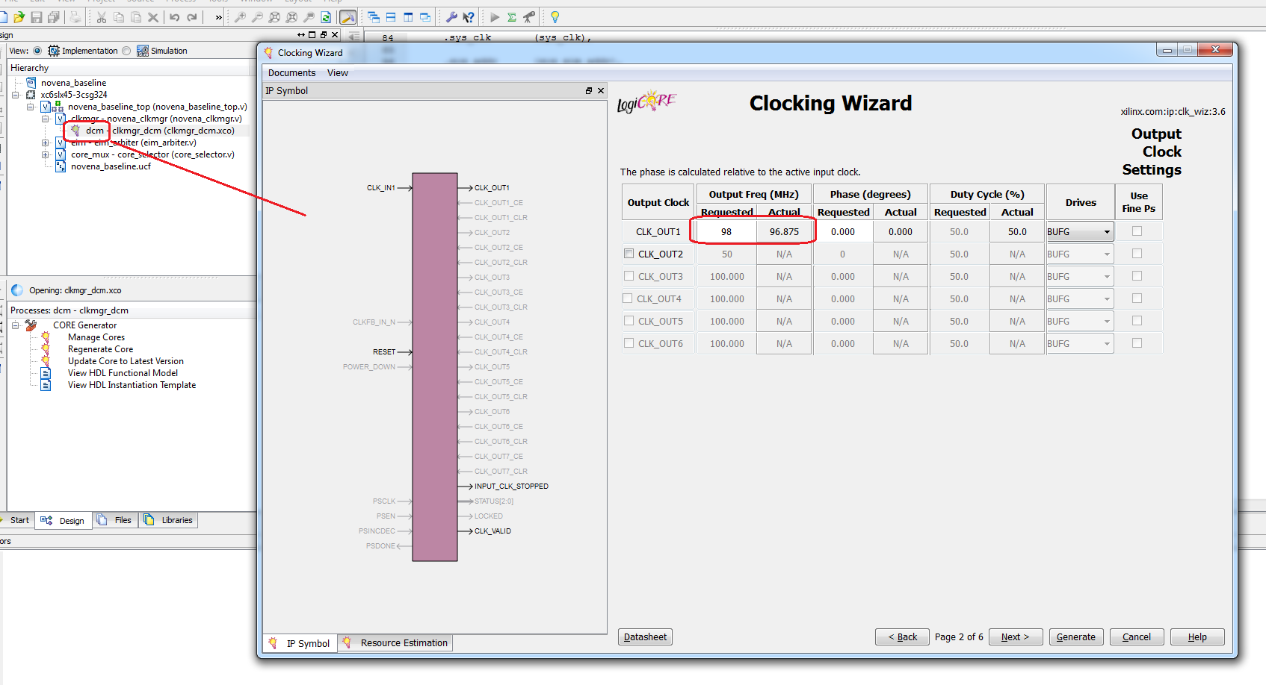
- EIM arbiter is written using an FSM to handle transactions from the CPU. In bunnie’s hardware design three out of four FPGA banks are connected to SDRAM and expansion connector, so he could not route separate address and data buses to the remaining bank. Moreover he did not have enough pins to connect entire 32-bit data bus, so he connected only 16 lower bits. This makes our arbiter complicated, because we have to process three separate data beats (address, lower 16 bits, higher 16 bits). In our alpha board we should try to avoid this situation.

- In the baseline project 16 address bits [15:0] are used. Because we can only transfer 32-bit words, we effectively have 14 address bits, address bits [1:0] should always be 2’b00. Bunnie squeezed in three more address bits [18:16], I’m not using them right now, we can connect them later if we run out of address space.

- Your idea of having standard interface for all the cores looks very nice. I can suggest the following example of address space layout.

ADDR[15:0] | ADDR[15:12] | ADDR[11:10] | ADDR[9:2] | ADDR[1:0] | Comment
Offset | Core | Page | Register | Zero
0x0000 | 0x0 | 0 | 0x00 | 0 | Board ID
0x0004 | 0x0 | 0 | 0x01 | 0 | FW Version
0x0008 | 0x0 | 0 | 0x02 | 0 | FPGA DNA
... | 0x0 | 0 | ... | 0 | ...
0x1000 | 0x1 | 0 | 0x00 | 0 | Core Name
0x1004 | 0x1 | 0 | 0x01 | 0 | Core Ver.
... | 0x1 | 0 | ... | 0 | ...
0x1400 | 0x1 | 1 | 0x00 | 0 | Block
... | 0x1 | 1 | ... | 0 | ...
0x1800 | 0x1 | 2 | 0x00 | 0 | Digest
... | 0x1 | 2 | ... | 0 | ...
0x1C00 | 0x1 | 3 | 0x0 | 0 | Debug
... | 0x1 | 3 | ... | 0 | ...
0x2000 | 0x2 | 0 | 0x00 | 0 | Core Name
0x2004 | 0x2 | 0 | 0x01 | 0 | Core Ver.
... | 0x2 | 0 | ... | 0 | ...
0x2400 | 0x2 | 1 | 0x00 | 0 | Block
... | 0x2 | 1 | ... | 0 | ...
0x2800 | 0x2 | 2 | 0x00 | 0 | Digest
... | 0x2 | 2 | ... | 0 | ...
0x2C00 | 0x2 | 3 | 0x0 | 0 | Debug
... | 0x2 | 3 | ... | 0 | ...
0x3000 | 0x3 | 0 | 0x00 | 0 | Core Name
... | ... | ... | ... | ... | ...

Because we have 32-bit interface and transfer four bytes at a time, two lower address bits are always zero. We can use four upper address bits to distinguish between individual cores. Every core will have four pages of registers, so two additional address bits are needed. We have 16-(2+4+2)=8 address bits remaining, so every register page will contain 256 registers. Page 0 may contain core name, version, control and status registers and so on. Page 1 is used to store input data block, page 2 is used to store calculated digest, I believe it should be read-only. Page 3 might contain debugging information, such as internal state registers.
Instead of 0x0 core we can place a page of global registers, such as board ID, firmware version and so on. We can have for example different Xilinx and Altera boards, that will report different values in these registers. Master program in the CPU can use these registers to detect on what board it is running. Another nice thing that has already been proposed on the mailing list is that the master program can quickly read addresses 0x1000, 0x2000 and so on to get core names and find out what cores are actually available and use them as needed.

