🕌 Marry A Muslim - Complete System Overview

📋 Executive Summary
Yeh ek Muslim Matrimonial Platform hai jahan:
- Women = FREE (no payment)
- Men = €259/year (paid upfront)
- Privacy-First: Photos sirf mutual interest ke baad dikhte hain
- Female-First: Female hamesha male ki photo pehle dekhti hai
- 72-hour deadlines har action pe

🔄 COMPLETE USER FLOW

PHASE 1: Registration & Intake
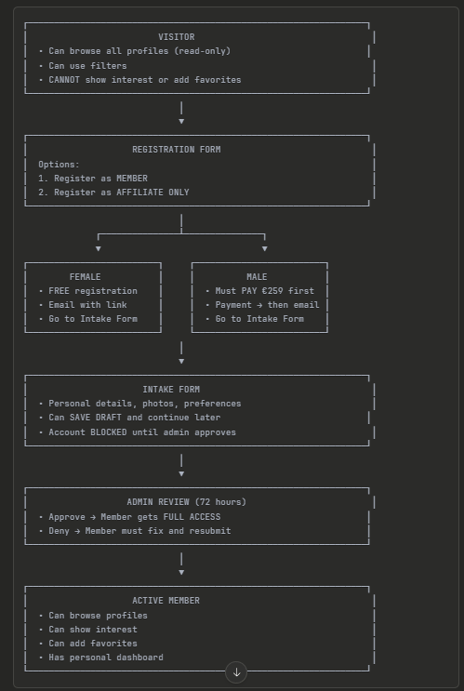
PHASE 2: Interest System (Text Profile)
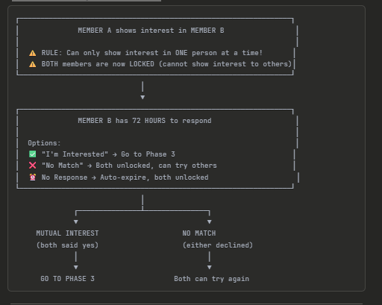
PHASE 3: Photo Exchange (FEMALE-FIRST System)
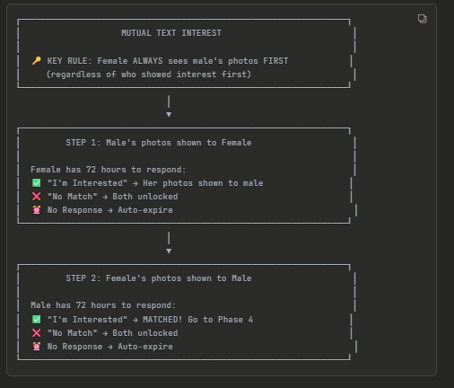
PHASE 4: Online Meeting & Final Decision
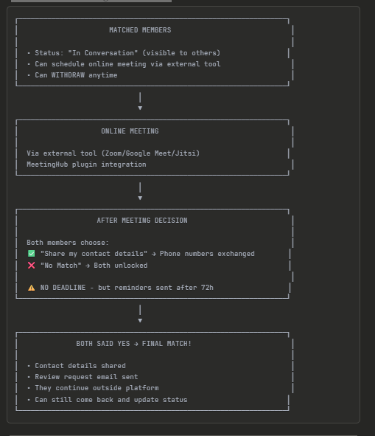

👥 USER ROLES
Role | Access | Can Do
Visitor | No login | Browse profiles (read-only), use filters
Member | Login required | Show interest, favorites, edit profile, affiliate dashboard
Affiliate Only | Login required | ONLY see affiliate dashboard, NO profile access
Admin | Backoffice | Approve intake, manage users, subscriptions, payouts

📊 STATUS SYSTEM

Profile Statuses (Public)
Status | Color | Meaning
New Member | Label | First 7 days only
Available | 🟢 Green | Open for interest
In Conversation | 🟠 Orange | Talking to someone
Paused/Inactive | ⚫ Grey | Hidden by member

Interaction Statuses (Personal - only you see)
Status | Color | Meaning
No Match | 🔴 Red | Someone declined
No Response | 🟣 Purple | Deadline expired
Matched | 🟡 Yellow | After meeting, pending final
Seen | Label | You viewed this profile
New to You | Label | Haven't viewed yet

System Statuses (Admin only)
Status | Meaning
Intake Open | Registered but intake not done
Intake Denied | Admin rejected, must resubmit
Active | Full access
Suspended | Admin paused account
Blocked | Cannot do anything
Deleted | GDPR/fraud removal

💰 SUBSCRIPTION & PAYMENT

Pricing
- Women: FREE (12 months)
- Men: €259/year (Mollie payment)

Flow for Men
Register → Pay €259 → Email confirmation → Intake Form → Admin Approval → Active

Flow for Women
Register → Email with link → Intake Form → Admin Approval → Active

Subscription Features
- 12 month duration
- Auto-expire (no auto-renewal for MVP)
- Renewal reminders before expiry
- Admin can manually extend

🤝 AFFILIATE SYSTEM

How It Works
- Every member gets a unique discount code
- Code can be used by new MALE members only
- New male gets discount on €259
- Recruiter gets payout (commission)

Affiliate-Only Accounts
- Register as "Affiliate Only"
- Get FREE account
- Get unique code
- See ONLY affiliate dashboard
- NO profile access
- NO intake form needed

Admin Controls
- View all codes
- See referral counts
- Mark payouts as paid
- Activate/deactivate codes

🎛️ DASHBOARD COMPONENTS
- Personal Status Block - Current status with colored avatar
- Action Center - Pending actions (max 3)
- Notifications - Time-sensitive reminders
- Profile Overview - Quick links to profile, favorites, intake
- Affiliate Section - Code, referrals, payouts
- Language Toggle - Dutch/English

🛠️ TECHNICAL REQUIREMENTS

Database Tables Needed
- profiles - Member profiles
- photos - Profile photos (secure)
- interests - Interest tracking
- matches - Matched pairs
- meetings - Meeting schedules
- subscriptions - Payment status
- affiliates - Affiliate codes & referrals
- notifications - System notifications
- activity_log - All actions logged
- favorites - Saved profiles

Key Rules to Implement
- 72-hour deadlines with auto-expire
- One interest at a time lock
- Female-first photo reveal
- 30-day cooldown after multiple declines
- Photo privacy - no downloads, secure URLs

Integrations
- Mollie - Payment gateway
- MeetingHub - Video meetings (Zoom/Meet/Jitsi)
- Email system - Automated notifications
- Push notifications - Mobile alerts

✅ SMTP Options for MAM

Recommended Plugins (Free)
Plugin | Features
WP Mail SMTP | Most popular, easy setup
Post SMTP | Email logs, debugging
FluentSMTP | Lightweight, multiple providers

Recommended SMTP Services
Service | Free Tier | Best For
Brevo (Sendinblue) | 300 emails/day | Beginners
Mailgun | 5,000/month (3 months) | Developers
SendGrid | 100/day | Scalability
Amazon SES | 62,000/month (if using EC2) | High volume
Gmail SMTP | 500/day | Small sites

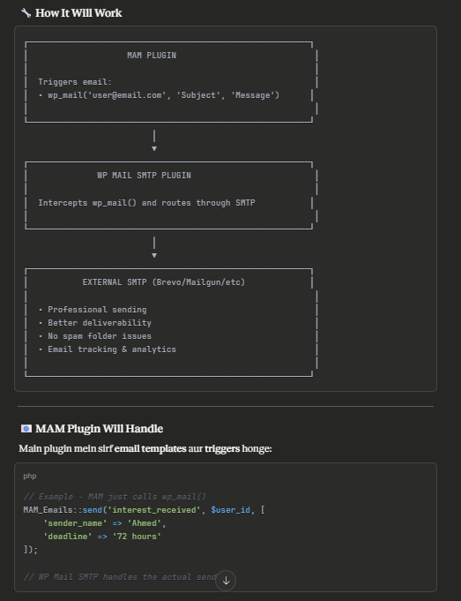
Email Templates Needed:
Trigger | Email
Registration (Women) | Welcome + activation link
Registration (Men) | Payment confirmation + activation
Intake Submitted | "We received your form, 72h review"
Intake Approved | "Account activated!"
Intake Denied | "Please fix and resubmit"
Interest Received | "Someone showed interest!"
Interest Withdrawn | "Interest withdrawn"
Mutual Interest | "You both liked each other!"
Photo Shared | "View their photos now"
No Response Warning | "24 hours left to respond"
Deadline Expired | "Time expired, try again"
Meeting Scheduled | "Meeting details"
Match Confirmed | "Congratulations! Contact shared"
Review Request | "How was your experience?"
Subscription Expiring | "Renew in 14 days"
Subscription Expired | "Your access has ended"

💡 My Recommendation
Use Brevo (Sendinblue) because:
- ✅ 300 free emails/day (enough for start)
- ✅ Easy WordPress integration
- ✅ Email templates builder
- ✅ Good deliverability
- ✅ Analytics & tracking
- ✅ Affordable scaling

✅ Final Answer
MAM Plugin will:
- Define email templates (HTML)
- Trigger emails at right moments
- Use standard wp_mail() function
External SMTP Plugin will:
- Route emails through professional service
- Handle delivery, tracking, logs
Client needs to:
- Install WP Mail SMTP plugin
- Create account on Brevo/Mailgun/etc
- Configure SMTP settings

Haan bhai, main samajh gaya! Let me explain back to you what I understood:

🎯 MAM Plugin - Complete Understanding

🎨 DESIGN REQUIREMENTS

Color Scheme (from screenshots)
Primary: #0d3d3d (Dark Teal)
Primary Light: #1a5555 (Lighter Teal)
Accent: #c9a55c (Gold)
Text: #ffffff (White)
Cards: rgba(26, 74, 74, 0.85) (Glass effect)

Profile Cards (Image 1)
- Grid layout with photo cards
- Hover effect: "Bekijk Profiel" button
- Shows: Name, Age, Location, Short bio
- Search bar + Filters button
- "8 profielen gevonden" counter
- Responsive grid (4 columns → 2 → 1)

Profile Detail Page (Image 2)
- Left: Large photo + Name, Location + "Ik Ben Geïnteresseerd" button
- Right: Personal Information grid with icons
  - Beroep (Profession)
  - Opleiding (Education)
  - Lengte (Height)
  - Burgerlijke staat (Marital status)
  - Kinderen (Children)
  - Roken (Smoking)
  - Religieuze achtergrond (Religious background)
  - Intentie (Intention/Timeline)
- About section
- Hobbies & Interests (tags)
- "Op Zoek Naar" (Looking for) section
- Bottom CTA: "Interesse in [Name]?" with button

🌐 POLYLANG INTEGRATION

Every Text Editable in Elementor
┌─────────────────────────────────────────────────────────────────┐
│ ELEMENTOR WIDGET │
│ │
│ All labels/texts as controls: │
│ ┌─────────────────────────────────────────────────────────┐ │
│ │ Title Text: [Create an Account ] │ │
│ │ Subtitle: [Start your journey...] │ │
│ │ Male Label: [Male ] │ │
│ │ Female Label: [Female ] │ │
│ │ Button Text: [Register ] │ │
│ │ Error Message: [Please select gender ] │ │
│ └─────────────────────────────────────────────────────────┘ │
│ │
│ Admin can change ANY text in Elementor editor │
│ Polylang translates per language page │
└─────────────────────────────────────────────────────────────────┘

How Translation Works
/mam-register/ → Dutch version (NL texts in Elementor)
/en/mam-register/ → English version (EN texts in Elementor)

Same widget, different text per language page!

📄 AUTO-GENERATED PAGES
Plugin will automatically create these pages on activation:
Page | Slug | Purpose
Register | /mam-register/ | Registration form
Login | /mam-login/ | Login form
Payment | /mam-payment/ | Mollie payment
Intake | /mam-intake/ | Intake form
Dashboard | /mam-dashboard/ | Member dashboard
Profiles (Men) | /mam-profiles-male/ | Browse male profiles
Profiles (Women) | /mam-profiles-female/ | Browse female profiles
Profile Detail | /mam-profile/ | Single profile view
Favorites | /mam-favorites/ | Saved profiles
Settings | /mam-settings/ | Member settings

🛠️ ELEMENTOR WIDGETS (All Editable)
Widget | Editable Controls
MAM Register | All labels, messages, button texts, URLs
MAM Login | All labels, messages, button texts
MAM Intake Form | All step labels, field labels, messages
MAM Profiles Grid | Title, filters label, card labels, button texts
MAM Profile Detail | All section headings, labels, button texts
MAM Dashboard | All section titles, action texts, status labels
MAM Payment | Price text, button, success/error messages
MAM Auth Button | Login/Register texts, dropdown menu texts
MAM Affiliate | All affiliate section texts

👨‍💼 ADMIN PANEL (Full CRUD)

Admin Menu Structure
MAM Plugin
├── 📊 Dashboard (Overview stats)
├── 👥 Members (Full CRUD)
│ ├── View all members
│ ├── Filter by status/gender
│ ├── Edit member details
│ ├── View member activity
│ └── Block/Suspend/Delete
├── 📝 Intakes (Pending reviews)
│ ├── View submitted intakes
│ ├── Approve/Deny with message
│ └── Filter by status
├── 💕 Interests (All interactions)
│ ├── View all interests
│ ├── See who→who, status, dates
│ └── Override actions
├── 🤝 Matches (Successful matches)
│ ├── View matched pairs
│ ├── Meeting status
│ └── Final decision status
├── 💳 Subscriptions
│ ├── View all subscriptions
│ ├── Payment status
│ ├── Manual extend/cancel
│ └── Transaction history
├── 🎯 Affiliates
│ ├── All affiliate codes
│ ├── Referral counts
│ ├── Payout management
│ └── Activate/Deactivate codes
├── 📧 Email Logs
│ ├── Sent emails
│ └── Failed emails
├── ⚙️ Settings
│ ├── Subscription price
│ ├── Mollie API keys
│ ├── Email templates
│ ├── Deadline settings (72h)
│ └── Page URLs
└── 📋 Activity Log
└── All system actions

Admin Can See Everything
┌─────────────────────────────────────────────────────────────────┐
│ ADMIN DASHBOARD │
│ │
│ ┌──────────┐ ┌──────────┐ ┌──────────┐ ┌──────────┐ │
│ │ Members │ │ Pending │ │ Active │ │ Revenue │ │
│ │ 245 │ │ Intakes │ │ Matches │ │ €12,450 │ │
│ └──────────┘ │ 12 │ │ 34 │ └──────────┘ │
│ └──────────┘ └──────────┘ │
│ │
│ Recent Activity: │
│ • Ahmed showed interest in Fatima (2 min ago) │
│ • Yusuf paid €259 (15 min ago) │
│ • Layla completed intake (1 hour ago) │
│ • Omar & Amina matched! (3 hours ago) │
│ │
│ Pending Actions: │
│ • 12 intakes to review │
│ • 3 affiliate payouts pending │
│ • 5 subscriptions expiring this week │
└─────────────────────────────────────────────────────────────────┘

🔒 SECURITY FEATURES
- Photo Privacy
  - Secure URLs with tokens
  - No direct file access
  - Photos only visible after mutual interest
- User Data
  - All inputs sanitized
  - Nonce verification on all forms
  - Prepared SQL statements
- Payment
  - Mollie handles sensitive data
  - Webhook verification
  - No card data stored
- Access Control
  - Role-based permissions
  - Blocked users can't access
  - Admin overrides available

📱 RESPONSIVE DESIGN
Desktop (1200px+) Tablet (768px) Mobile (480px)
┌─┬─┬─┬─┐ ┌─┬─┐ ┌─┐
│ │ │ │ │ │ │ │ │ │
├─┼─┼─┼─┤ ├─┼─┤ ├─┤
│ │ │ │ │ │ │ │ │ │
└─┴─┴─┴─┘ └─┴─┘ └─┘
4 columns 2 columns 1 column

✅ SUMMARY - What I Will Build
Feature | Status
Modern glass UI design (dark teal + gold) | ✅
All texts editable in Elementor (Polylang ready) | ✅
Auto-generate all required pages | ✅
Complete registration flow (M/F different) | ✅
Intake form with save draft | ✅
Interest system with 72h deadlines | ✅
Female-first photo reveal | ✅
Matching system | ✅
Affiliate system with payouts | ✅
Mollie payment integration | ✅
Full admin CRUD panel | ✅
Activity logging | ✅
Email triggers (wp_mail for SMTP) | ✅
Secure photo system | ✅
Responsive design | ✅

💡 My Recommendations for Each Point

1️⃣ Meeting Integration

Options:
Option | Pros | Cons | Cost
A) MeetingHub Plugin | Auto-create meetings, integrated | Complex setup, dependency | Free + Zoom/Meet account
B) Simple External Link | Easy, no maintenance | Manual scheduling | Free
C) Calendly Integration | Professional, auto-scheduling | Monthly cost | €10-15/month

✅ My Recommendation: Option B - Simple External Link (MVP)
┌─────────────────────────────────────────────────────────────────┐
│ MEETING FLOW (Simple) │
│ │
│ 1. Both members matched │
│ 2. Dashboard shows: "Schedule your meeting" │
│ 3. Admin creates Google Meet/Zoom link manually OR │
│ System generates Jitsi link automatically (free, no account) │
│ 4. Both members see link + can pick time via simple form │
│ 5. Email confirmation sent │
│ │
│ Later Phase: Integrate Calendly or MeetingHub │
└─────────────────────────────────────────────────────────────────┘
Why? MVP ke liye simple rakho. Jitsi links auto-generate ho sakte hain (free, no account needed). Complex integration baad mein add kar sakte ho.

2️⃣ Push Notifications

Options:
Option | Pros | Cons | Cost
A) Mobile App | Real push notifications | Need separate app development | €5,000+
B) Email Only | Simple, works everywhere | May go to spam, delayed | Free (SMTP)
C) Web Push (OneSignal) | Browser notifications | Needs opt-in, limited | Free tier
D) Email + Web Push | Best coverage | Slightly complex | Free

✅ My Recommendation: Option D - Email + Web Push (OneSignal)
┌─────────────────────────────────────────────────────────────────┐
│ NOTIFICATION SYSTEM │
│ │
│ PRIMARY: Email (via SMTP - Brevo/Mailgun) │
│ ├── Interest received │
│ ├── Deadline reminders │
│ ├── Match notifications │
│ └── All important updates │
│ │
│ SECONDARY: Web Push (OneSignal - Free) │
│ ├── Instant browser notifications │
│ ├── Works on desktop + mobile browsers │
│ └── "Someone showed interest!" popup │
│ │
│ FUTURE: Mobile App with Firebase Push │
└─────────────────────────────────────────────────────────────────┘
Why? Email is reliable, Web Push is instant. OneSignal free tier = 10,000 subscribers. Mobile app baad mein phase 2 mein.

3️⃣ Invoice Generation

Options:
Option | Pros | Cons | Cost
A) PDF Invoices (Auto) | Professional, legal compliance | Development time | Free
B) Mollie Invoices | Handled by payment provider | Limited customization | Included
C) Manual Invoices | Simple | Not scalable | Free

✅ My Recommendation: Option A - Auto PDF Invoices
┌─────────────────────────────────────────────────────────────────┐
│ INVOICE SYSTEM │
│ │
│ ┌─────────────────────────────────────────┐ │
│ │ MARRY A MUSLIM │ │
│ │ Invoice #MAM-2024-0001 │ │
│ │─────────────────────────────────────────│ │
│ │ Customer: Ahmed Khan │ │
│ │ Email: ahmed@email.com │ │
│ │ Date: 16 Jan 2026 │ │
│ │─────────────────────────────────────────│ │
│ │ Annual Membership €259.00 │ │
│ │ Discount (10%) -€25.90 │ │
│ │─────────────────────────────────────────│ │
│ │ TOTAL €233.10 │ │
│ │─────────────────────────────────────────│ │
│ │ Payment: Mollie (iDEAL) │ │
│ │ Status: PAID │ │
│ └─────────────────────────────────────────┘ │
│ │
│ • Auto-generated on payment │
│ • Emailed to customer │
│ • Downloadable from dashboard │
│ • Admin can download all invoices │
└─────────────────────────────────────────────────────────────────┘
Why? Netherlands/EU requires proper invoices. Builds trust. Using TCPDF or DOMPDF library (free).

4️⃣ Intake Form Fields

✅ My Recommended Complete Field List:
┌─────────────────────────────────────────────────────────────────┐
│ INTAKE FORM STRUCTURE │
└─────────────────────────────────────────────────────────────────┘

STEP 1: BASIC INFORMATION
├── First Name (private - for admin only)
├── Username (public display name)
├── Date of Birth → Age calculated
├── Gender (already from registration)
├── City
├── Country
└── Phone Number (private - shared only after final match)

STEP 2: PERSONAL DETAILS
├── Height (cm)
├── Marital Status (Never married / Divorced / Widowed)
├── Children (None / 1 / 2 / 3+)
├── Want Children (Yes / No / Maybe)
├── Education Level (Secondary / Bachelor / Master / PhD)
├── Profession/Occupation
├── Smoking (Never / Occasionally / Trying to quit)
├── Relocation (Willing / Not willing / Open to discuss)
└── Languages Spoken (multi-select)

STEP 3: RELIGIOUS BACKGROUND
├── Religious Background (Sunni / Shia / Other)
├── Madhab (Hanafi / Maliki / Shafi / Hanbali / Other / Not specific)
├── Prayer Frequency (5 times / Sometimes / Rarely)
├── Hijab/Beard (For display)
├── Halal Lifestyle Importance (Very / Somewhat / Flexible)
└── Islamic Knowledge (Basic / Intermediate / Advanced)

STEP 4: ABOUT ME
├── Bio/About Me (textarea - 500 chars)
├── Hobbies & Interests (multi-select tags)
│ ├── Fitness, Reading, Travel, Cooking, Sports
│ ├── Technology, Art, Music, Nature, Photography
│ └── Volunteering, Gaming, Fashion, Cars, etc.
├── What I'm Looking For (textarea - 500 chars)
└── Marriage Timeline (ASAP / Within 1 year / 1-2 years / Flexible)

STEP 5: PHOTOS (1-5 photos)
├── Photo 1 (Primary - required)
├── Photo 2-5 (optional)
└── Photo guidelines displayed

STEP 6: PREFERENCES (Partner Filters)
├── Age Range (min-max)
├── Height Range (min-max)
├── Location Preference (multi-select countries/cities)
├── Education Preference
├── Marital Status Preference
├── Children Preference
└── Religious Background Preference
Admin should be able to add/edit these fields from settings!

5️⃣ Discount Percentage (Affiliates)

Market Research:
Platform | Affiliate Discount
Dating apps | 10-20%
SaaS products | 10-30%
Muslim matrimony sites | 10-15%

✅ My Recommendation: 10% Discount
┌─────────────────────────────────────────────────────────────────┐
│ DISCOUNT CALCULATION │
│ │
│ Base Price: €259 │
│ Discount (10%): -€25.90 │
│ ───────────────────────────── │
│ New Member Pays: €233.10 │
│ │
│ Why 10%? │
│ • Attractive enough to use code │
│ • Not too high to hurt revenue │
│ • Easy to calculate │
│ • Industry standard │
└─────────────────────────────────────────────────────────────────┘
Admin setting: Make it configurable (5%, 10%, 15%, 20%) so client can adjust later.

6️⃣ Payout Amount (Commission)

Options:
Model | Amount | Pros | Cons
Fixed Amount | €20-30 per referral | Simple, predictable | May feel low
Percentage | 10-15% of payment | Scales with price | Complex
Tiered | €20 (1-5), €30 (6+) | Motivates more referrals | Complex

✅ My Recommendation: €25 Fixed per Referral
┌─────────────────────────────────────────────────────────────────┐
│ AFFILIATE ECONOMICS │
│ │
│ New Male Member Pays: €233.10 (after 10% discount) │
│ Platform Receives: €233.10 │
│ Affiliate Payout: -€25.00 │
│ ───────────────────────────────── │
│ Net Revenue: €208.10 │
│ │
│ Without Affiliate: │
│ Revenue: €259.00 │
│ │
│ Affiliate Cost: €50.90 (discount + payout) │
│ But: Customer acquired without marketing spend! │
│ │
│ Example Affiliate Earnings: │
│ ├── 10 referrals = €250 │
│ ├── 50 referrals = €1,250 │
│ └── 100 referrals = €2,500 │
└─────────────────────────────────────────────────────────────────┘
Admin setting: Make it configurable so client can adjust.

📋 FINAL RECOMMENDATION SUMMARY
Point | Recommendation | Configurable?
1. Meeting | Simple link + Jitsi (auto-generate) | ✅ Yes
2. Notifications | Email + OneSignal Web Push | ✅ Yes
3. Invoices | Auto PDF generation | ✅ Yes
4. Intake Fields | Complete list above | ✅ Yes (admin can add/edit)
5. Discount | 10% | ✅ Yes (admin setting)
6. Payout | €25 fixed | ✅ Yes (admin setting)

⚙️ Admin Settings Panel Will Have:
┌─────────────────────────────────────────────────────────────────┐
│ MAM SETTINGS │
│ │
│ SUBSCRIPTION │
│ ├── Annual Price: [€259 ] │
│ ├── Currency: [EUR ▼ ] │
│ └── Duration (months): [12 ] │
│ │
│ AFFILIATE │
│ ├── Discount Percentage: [10% ▼ ] │
│ ├── Payout per Referral: [€25 ] │
│ └── Minimum Payout Threshold: [€50 ] │
│ │
│ DEADLINES │
│ ├── Interest Response: [72 hours ] │
│ ├── Photo Response: [72 hours ] │
│ └── Rematch Cooldown: [30 days ] │
│ │
│ MEETINGS │
│ ├── Provider: [Jitsi ▼ ] │
│ └── Auto-generate Link: [✓ Enabled ] │
│ │
│ NOTIFICATIONS │
│ ├── OneSignal App ID: [xxxxxxxx ] │
│ └── OneSignal API Key: [xxxxxxxx ] │
│ │
│ [Save Settings] │
└─────────────────────────────────────────────────────────────────┘

