MAM
Marry A Muslim
Complete Plugin Documentation & Testing Guide

Version 1.5.9
January 2025
Developed by CodeReve

Table of Contents
Table of Contents 2
1. Introduction 4
1.1 Key Features 4
1.2 Business Model 4
2. Plugin Installation 5
2.1 Requirements 5
2.2 Installation Steps 5
2.3 After Activation 5
3. Admin Dashboard 7
3.1 Statistics Overview 8
3.2 Quick Actions 8
4. Plugin Settings 10
4.1 Subscription Settings 11
4.2 Affiliate Settings 11
4.3 Timing & Deadlines 11
4.4 Mollie Payment Integration 12
4.5 Dummy Data Management 12
5. Member Management 14
5.1 Viewing All Members 14
5.2 Member Profile View 14
5.3 Reviewing Intakes 16
6. Complete User Journey 17
6.1 Registration 17
After Registration Redirects: 17
6.2 Profile Creation (Intake Form) 17
6.3 User Dashboard 18
6.4 Browsing Profiles 18
6.5 Sending Interest 19
6.6 Photo Exchange Process 20
Photo Exchange Flow: 20
6.7 Meeting System 20
6.8 Final Decision 21
7. Elementor Widgets 22
7.1 Available Widgets 22
7.2 Customizing Widget Text 22
8. Testing Checklist 23
8.1 Installation & Setup 23
8.2 User Registration 23
8.3 Profile Creation 23
8.4 Admin Approval 23
8.5 Interest System 23
8.6 Photo Exchange 24
8.7 Meeting System 24
8.8 Final Decision 24
9. Troubleshooting 25
9.1 Common Issues 25
Pages show 404 errors 25
Emails not being received 25
Photos not uploading 25
Elementor widgets not appearing 25
Payment not processing 25
9.2 Database Tables 25
10. Support & Contact 26

1. Introduction
MAM (Marry A Muslim) is a comprehensive WordPress plugin designed for Islamic matrimonial websites. It provides a complete, privacy-focused matchmaking system that respects Islamic values and principles.

1.1 Key Features
- Complete member registration and profile management
- Privacy-first photo system (female photos private by default)
- Structured interest and matching system
- Meeting scheduling with video call integration
- Final decision process with contact sharing
- Affiliate system with commission tracking
- Mollie payment integration for subscriptions
- Full Elementor widget integration
- Multi-language support via Polylang

1.2 Business Model
Account Type | Pricing | Access
Male Members | €259/year (configurable) | Full access after payment
Female Members | FREE | Full access immediately
Wali (Guardian) | FREE | Manage family profiles

2. Plugin Installation

2.1 Requirements
- WordPress 6.0 or higher
- PHP 7.4 or higher
- Elementor (Free or Pro)
- MySQL 5.6 or higher

2.2 Installation Steps
- Go to WordPress Admin → Plugins → Add New
- Click "Upload Plugin" button
- Select the mam-starter-plugin.zip file
- Click "Install Now"
- After installation, click "Activate Plugin"
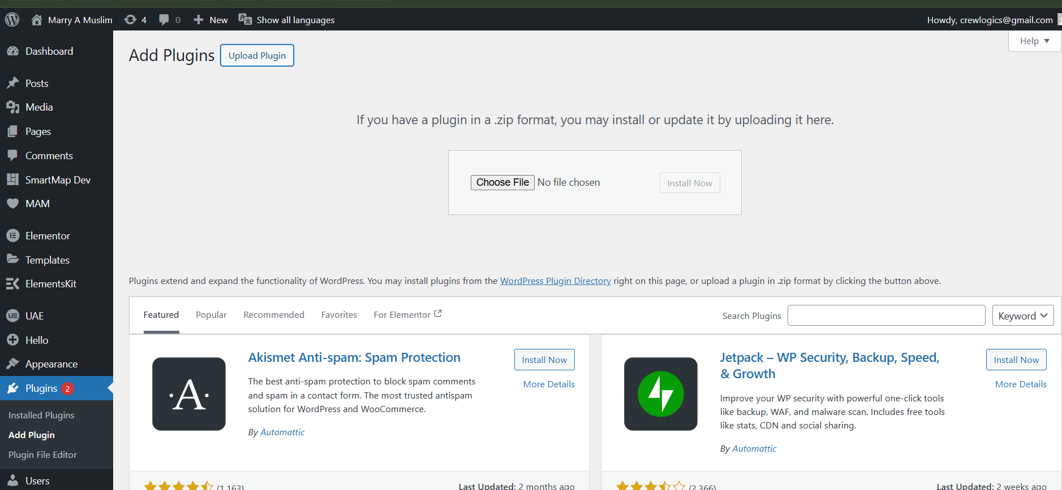
Figure: WordPress Plugins > Add New > Upload Plugin screen

2.3 After Activation
After activating the plugin, you will see a new "MAM" menu in your WordPress admin sidebar. The plugin automatically creates all required database tables.
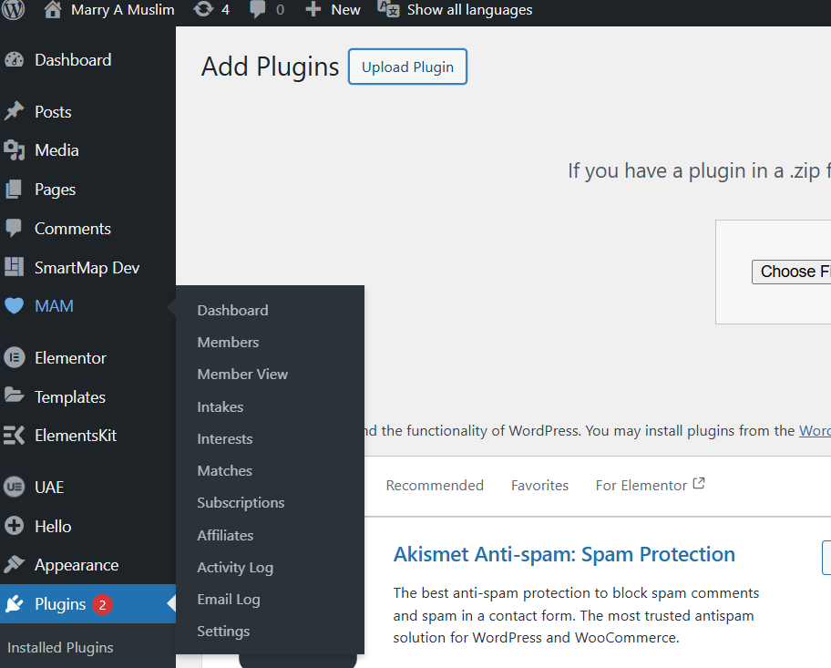
💡 Tip: After activation, go to Settings → Permalinks and click "Save Changes" to ensure all URLs work correctly.

3. Admin Dashboard
The Admin Dashboard provides a complete overview of your matrimonial platform. Access it via MAM → Dashboard in the WordPress admin menu.
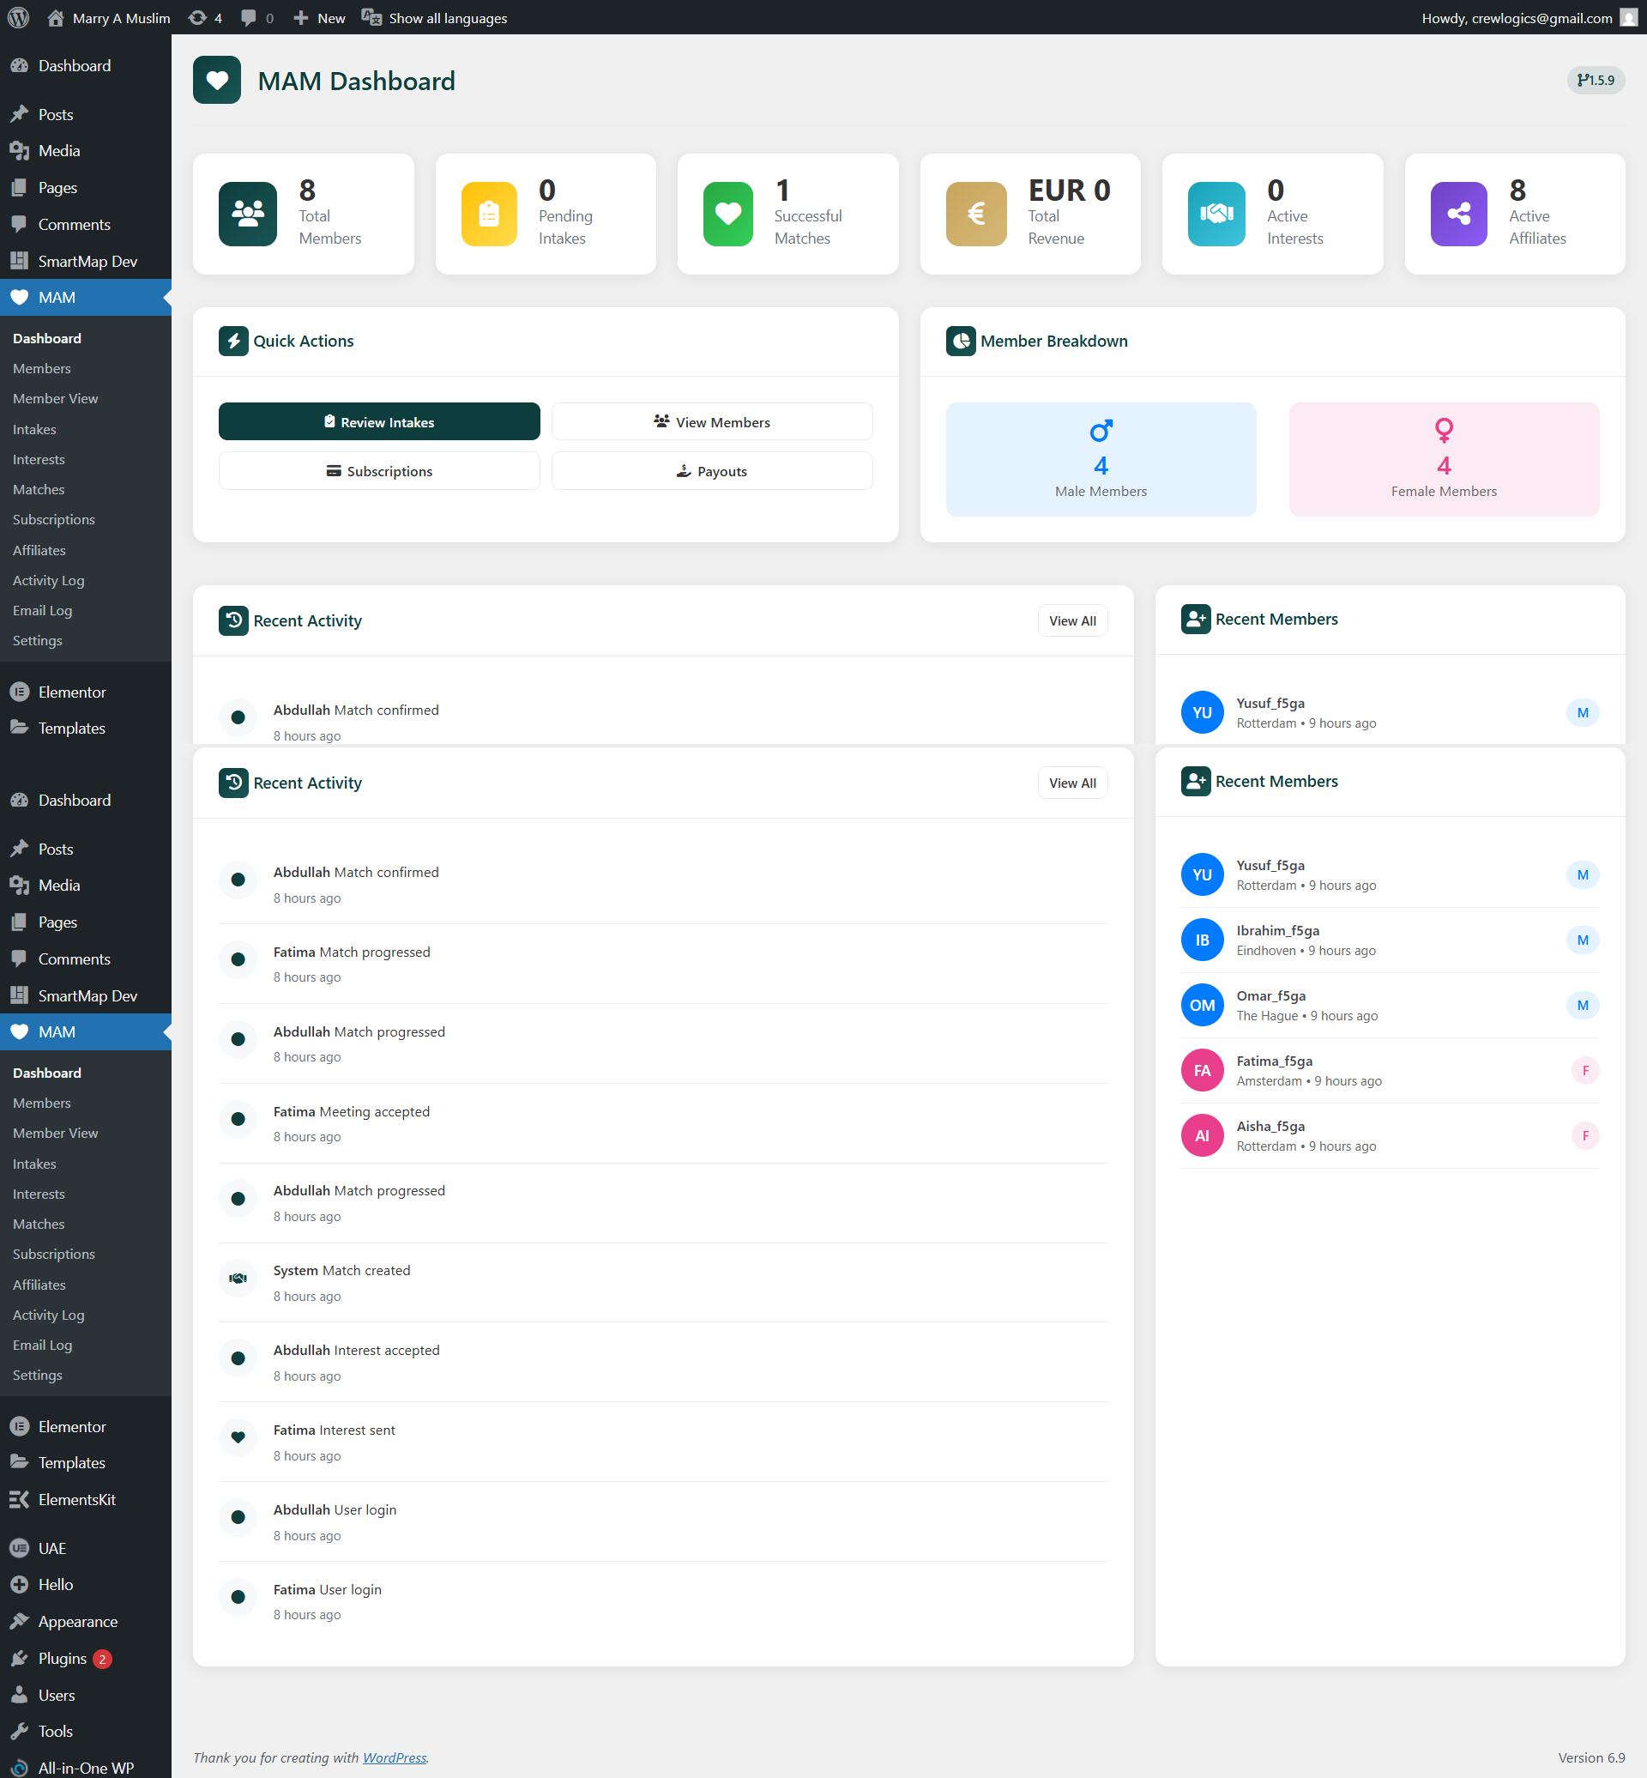
Figure: MAM Admin Dashboard - Full View

3.1 Statistics Overview
The dashboard displays key metrics in stat cards:
Statistic | Description
Total Members | Total registered profiles (male + female)
Pending Intakes | Profiles awaiting admin approval
Successful Matches | Completed matches where both parties said Yes
Total Revenue | Sum of all active subscriptions
Active Interests | Pending interest requests awaiting response
Active Affiliates | Number of active affiliate partners
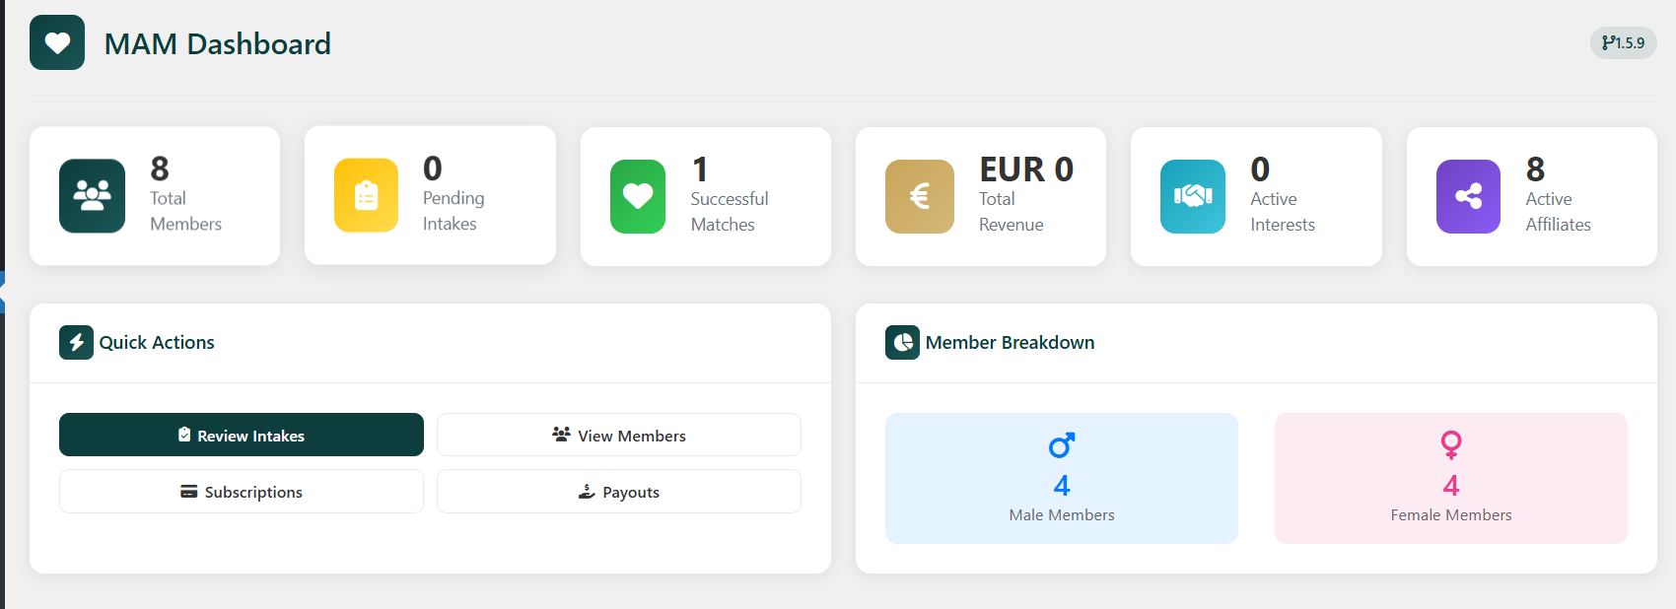
Figure: Dashboard Statistics Cards - Close up

3.2 Quick Actions
- Review Intakes: Approve or reject new profile submissions
- View Members: Browse and manage all members
- Subscriptions: Manage payment subscriptions
- Payouts: Process affiliate commission payouts
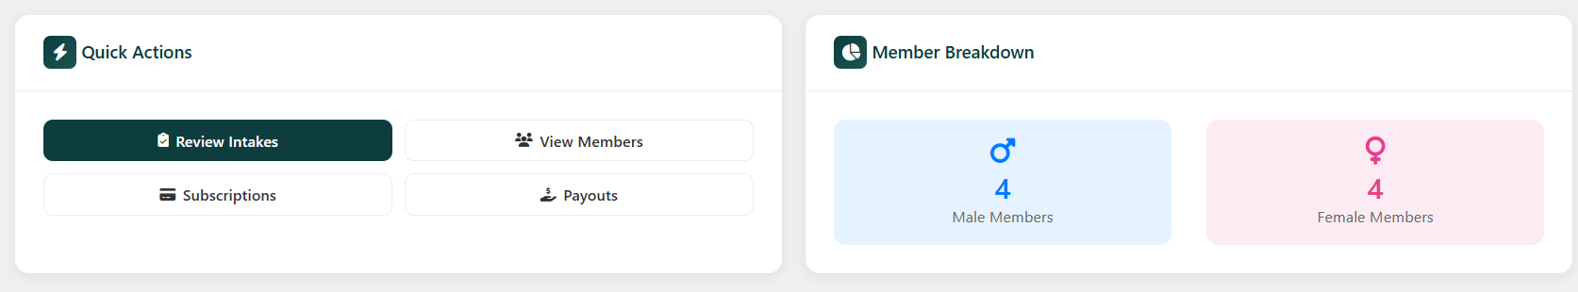
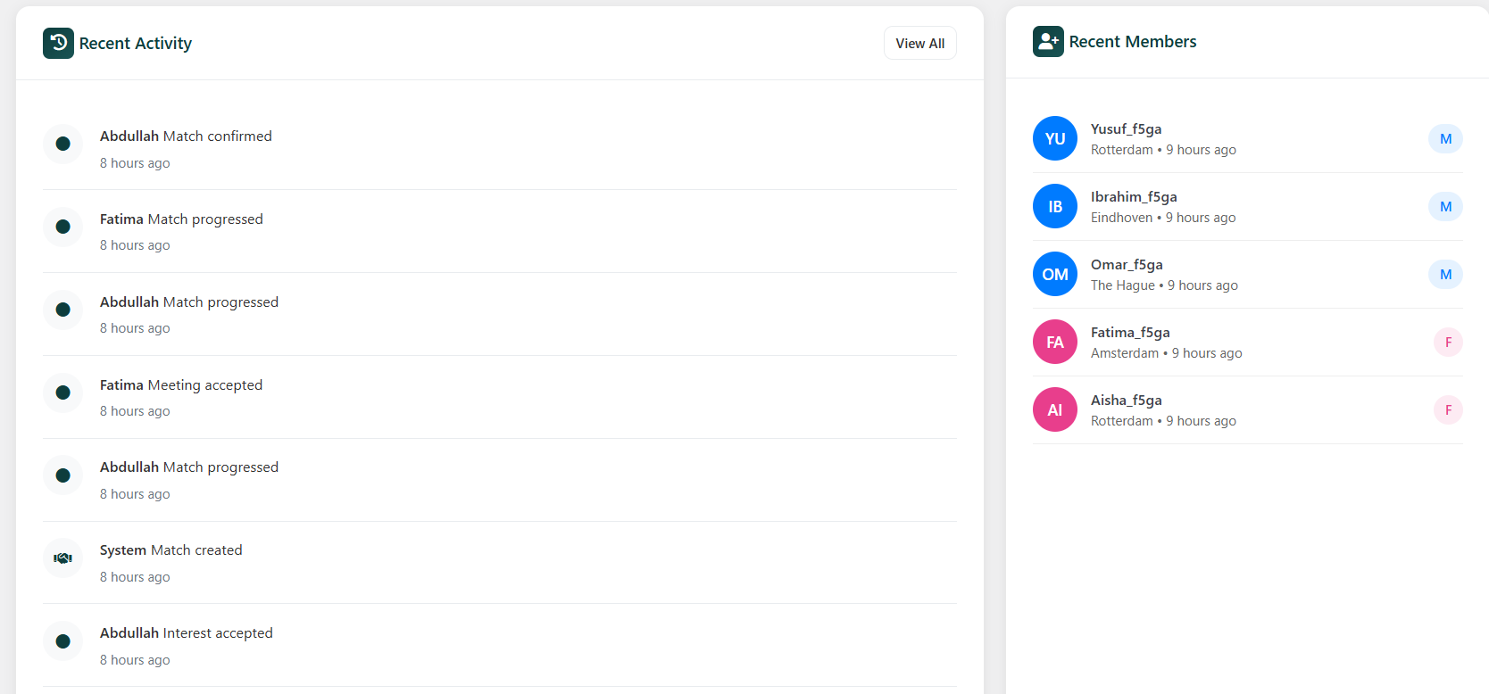
Figure: Quick Actions section

4. Plugin Settings
Access plugin settings via MAM → Settings. Configure all aspects of your matrimonial platform here.
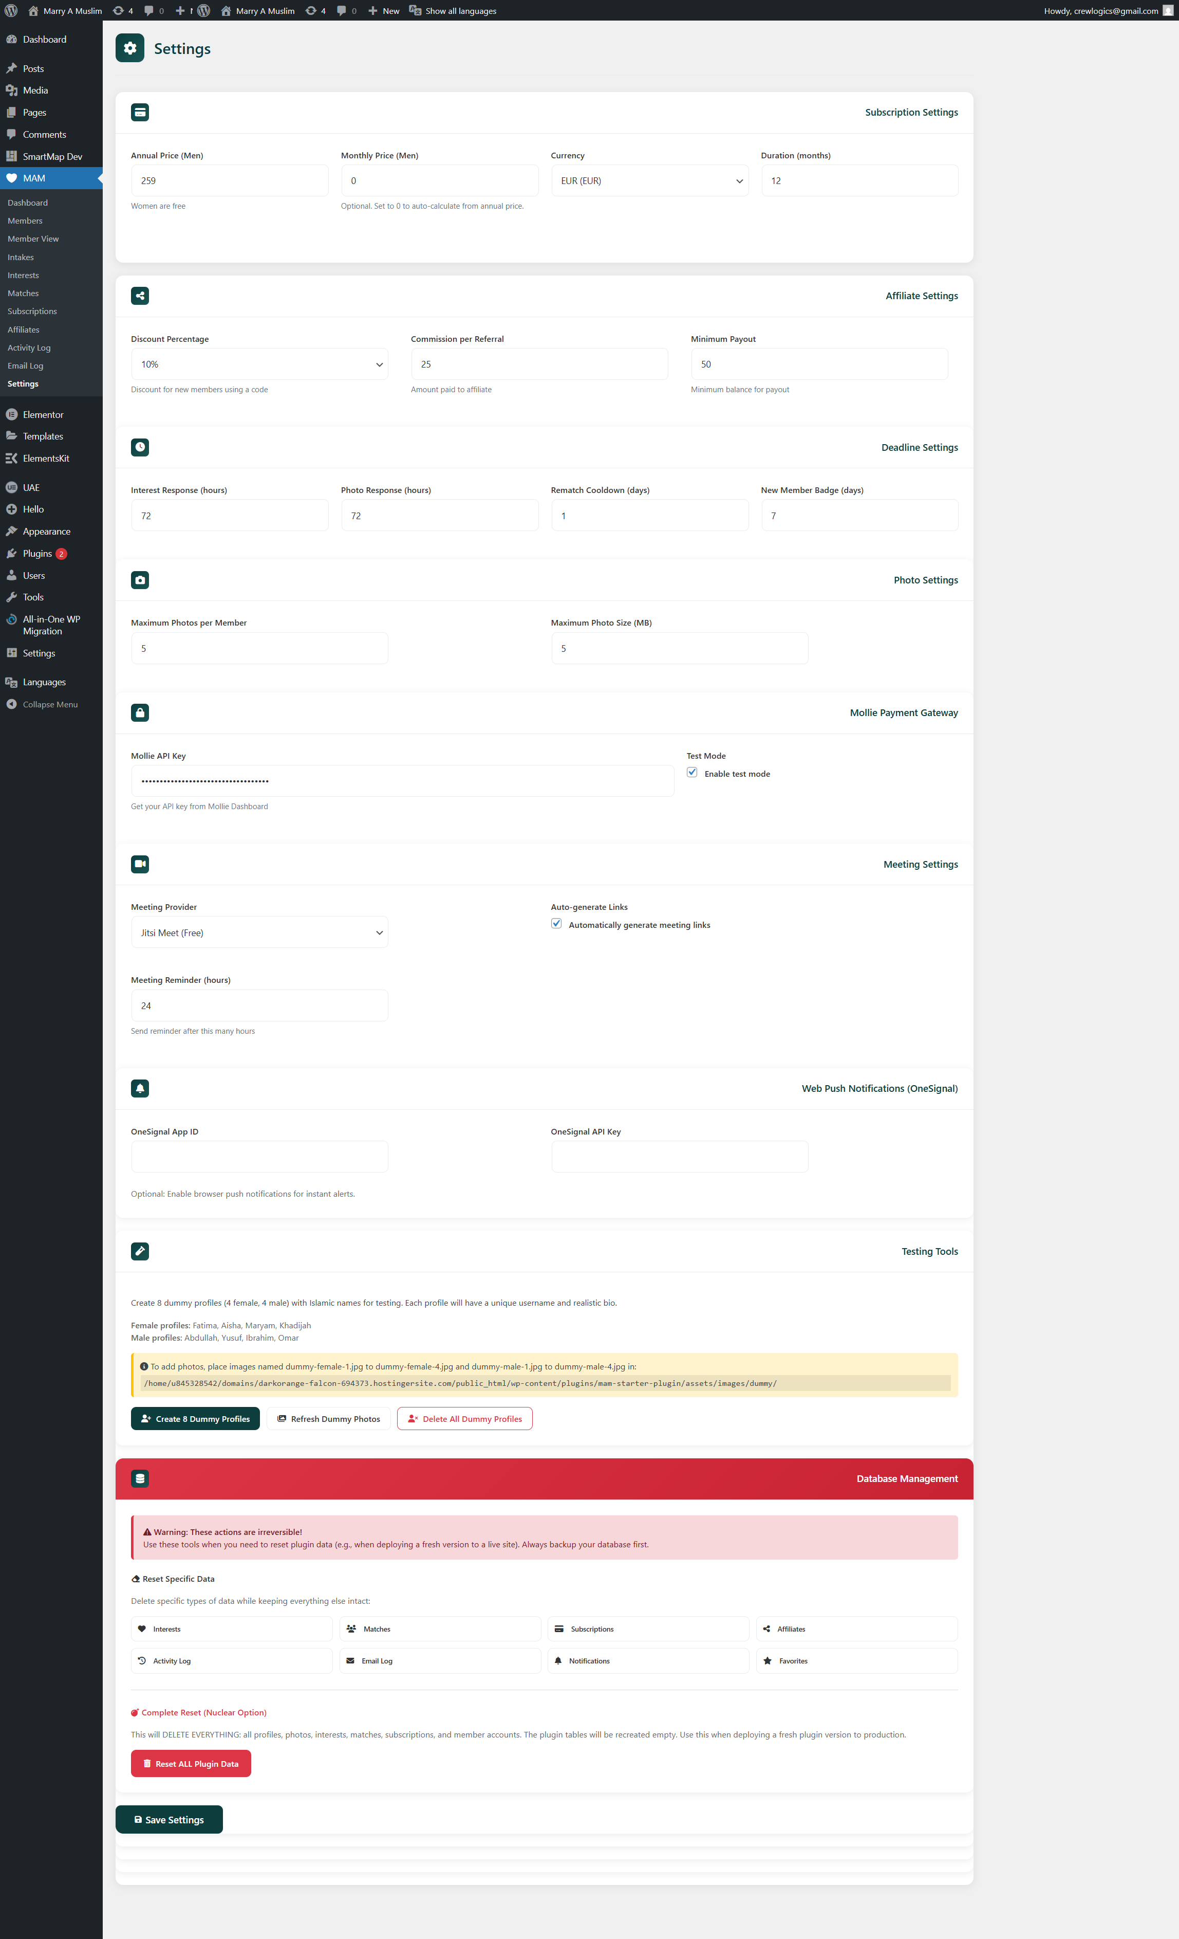Figure: MAM Settings Page - Full View

4.1 Subscription Settings
Setting | Default | Description
Annual Price (Men) | €259 | Yearly subscription price for male members
Monthly Price | Auto-calculated | Optional monthly pricing (set 0 for auto)
Currency | EUR | EUR, USD, or GBP
Duration | 12 months | Subscription duration (1-24 months)
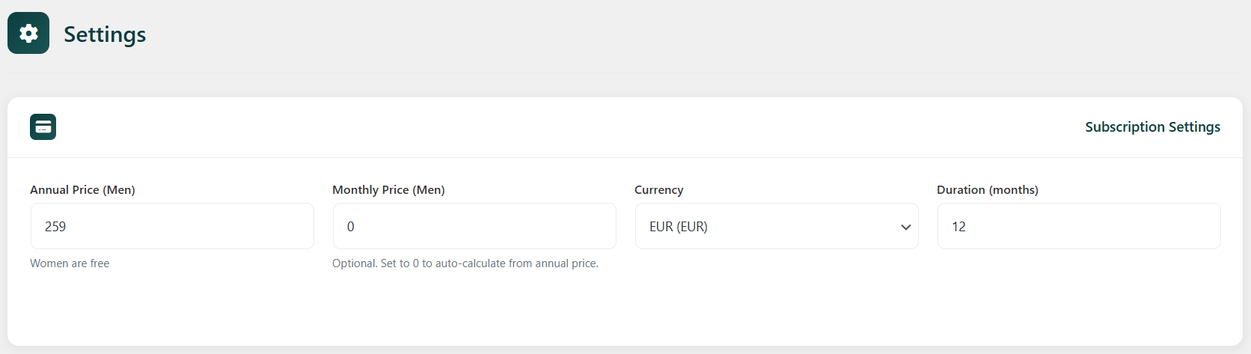Figure: Subscription Settings Section

4.2 Affiliate Settings
Setting | Default | Description
Discount % | 10% | Discount for new members using affiliate code
Commission | €25 | Fixed amount earned per referral
Min Payout | €50 | Minimum balance required for payout
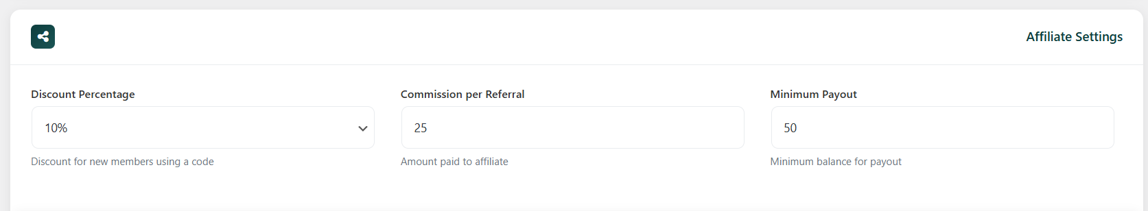Figure: Affiliate Settings Section

4.3 Timing & Deadlines
Setting | Default | Description
Interest Deadline | 72 hours | Time to respond to interest request
Photo Deadline | 72 hours | Time to share photos after acceptance
Rematch Cooldown | 30 days | Wait time before re-matching with same person
New Member Badge | 7 days | Days to show "New" badge on profiles
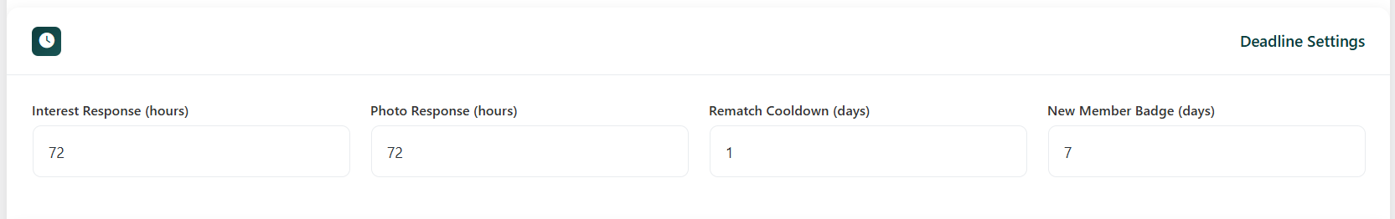 Timing & Deadlines Settings
Figure: Timing & Deadlines Settings

4.4 Mollie Payment Integration
Configure Mollie payment gateway for processing subscriptions:
- API Key: Enter your Mollie API key (test or live)
- Test Mode: Enable for testing (use test API key)
⚠️ Important: Always test with Test Mode enabled first. Use live API key only in production.
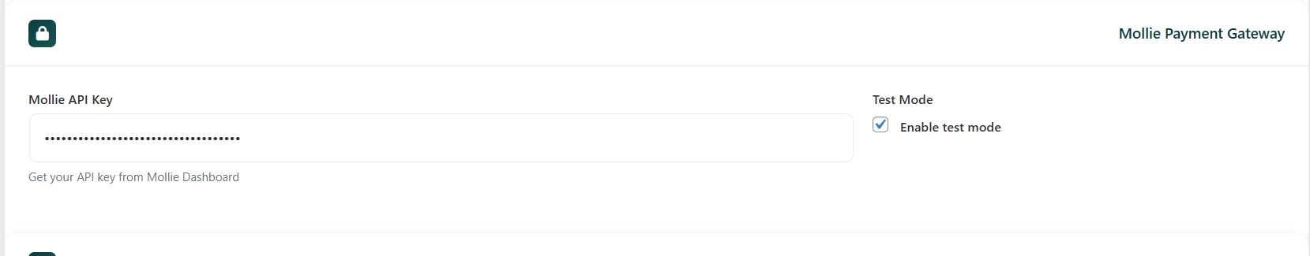Figure: Mollie Payment Settings

4.5 Dummy Data Management
For testing purposes, you can create dummy profiles:
- Create 8 Dummy Profiles: Creates 4 male + 4 female test profiles
- Refresh Dummy Photos: Reloads photos from assets folder
- Delete All Dummy Profiles: Removes all test data
📁 Place test photos in: wp-content/plugins/mam-starter-plugin/assets/images/dummy/
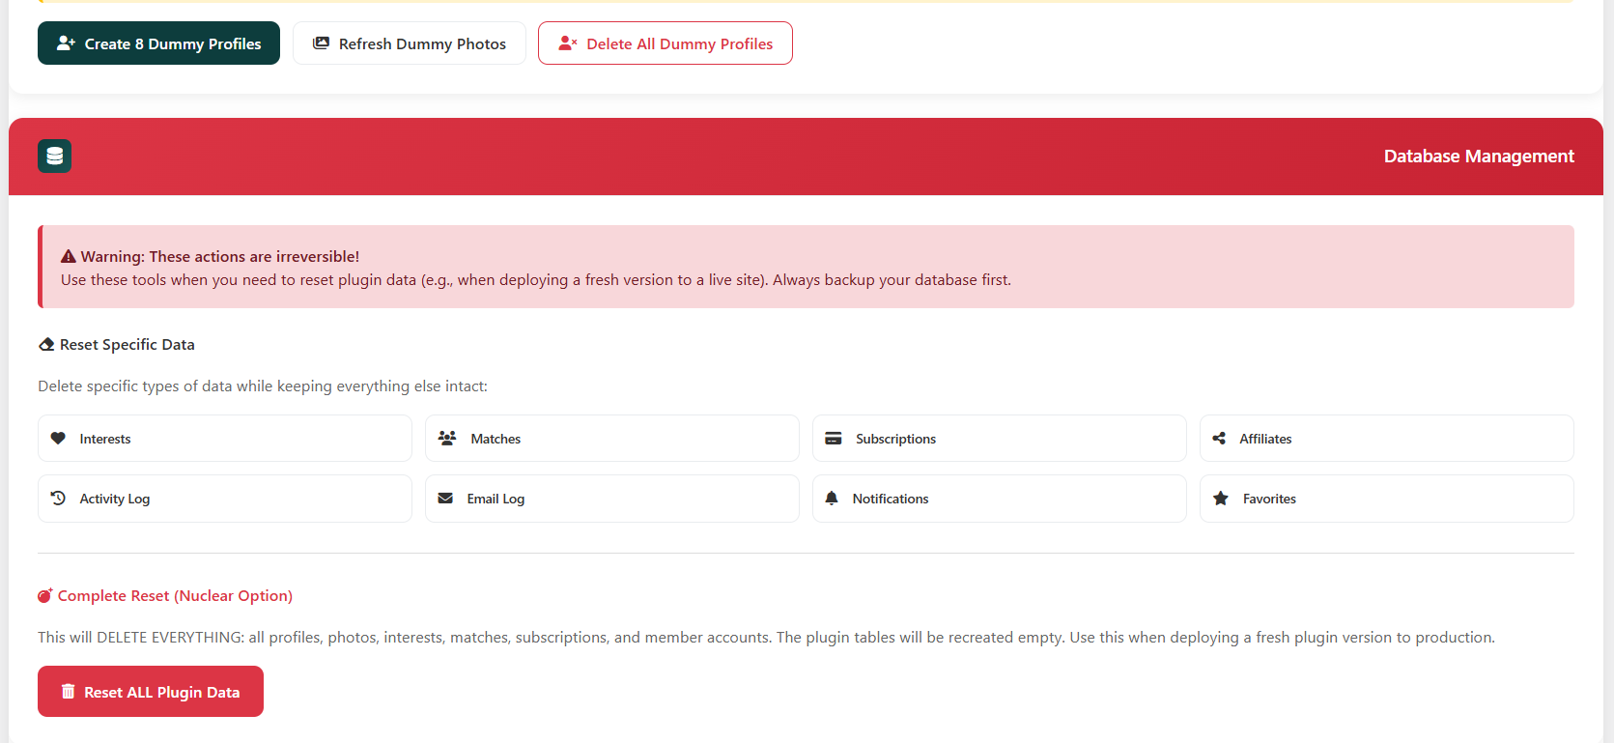Figure: Dummy Data Management Section

5. Member Management

5.1 Viewing All Members
Access MAM → Members to view all registered profiles. Use filters to find specific members.
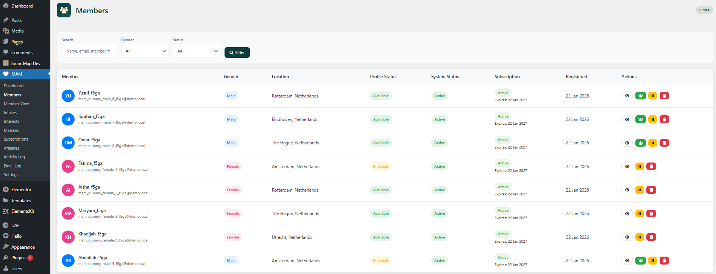Figure: Members List View with Filters

5.2 Member Profile View
Click on any member to view their complete profile including:
- Personal information and photos
- Religious background and preferences
- Interest history and current matches
- Activity log and subscription status
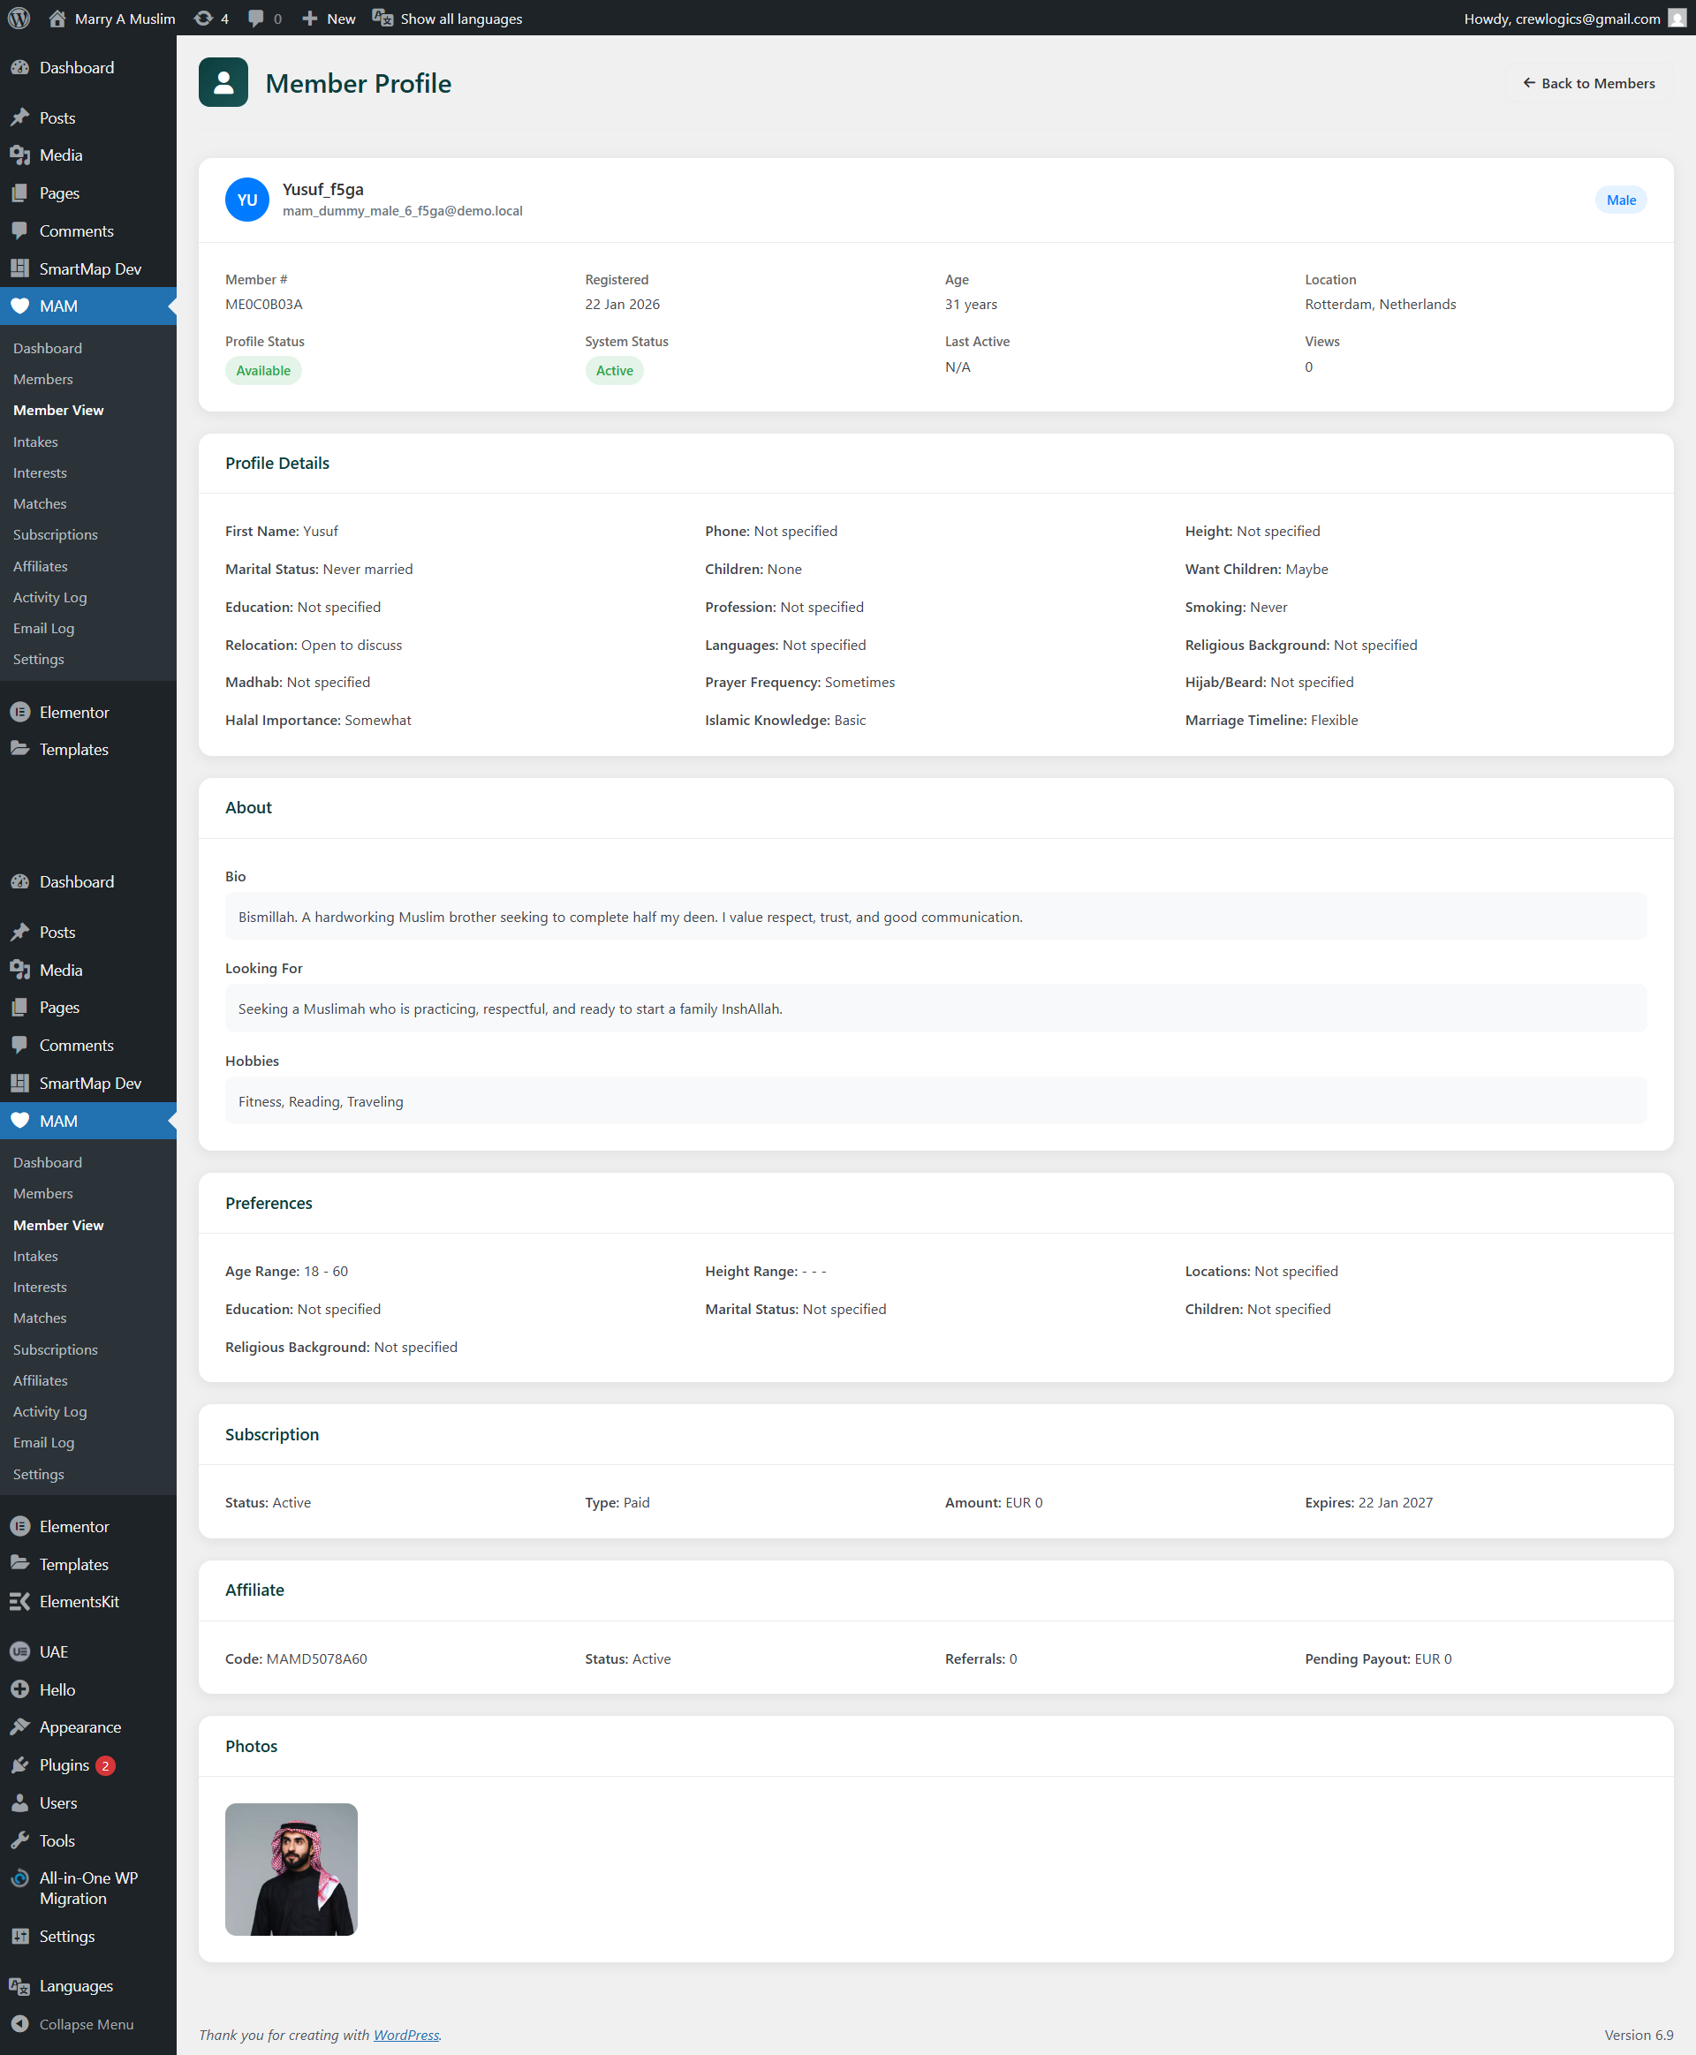
Figure: Individual Member Profile View

5.3 Reviewing Intakes
New profiles require admin approval. Access MAM → Intakes to review pending submissions.
- Review profile information for completeness
- Check photos for appropriateness
- Click "Approve" to activate the profile
- Or click "Reject" with a reason if needed
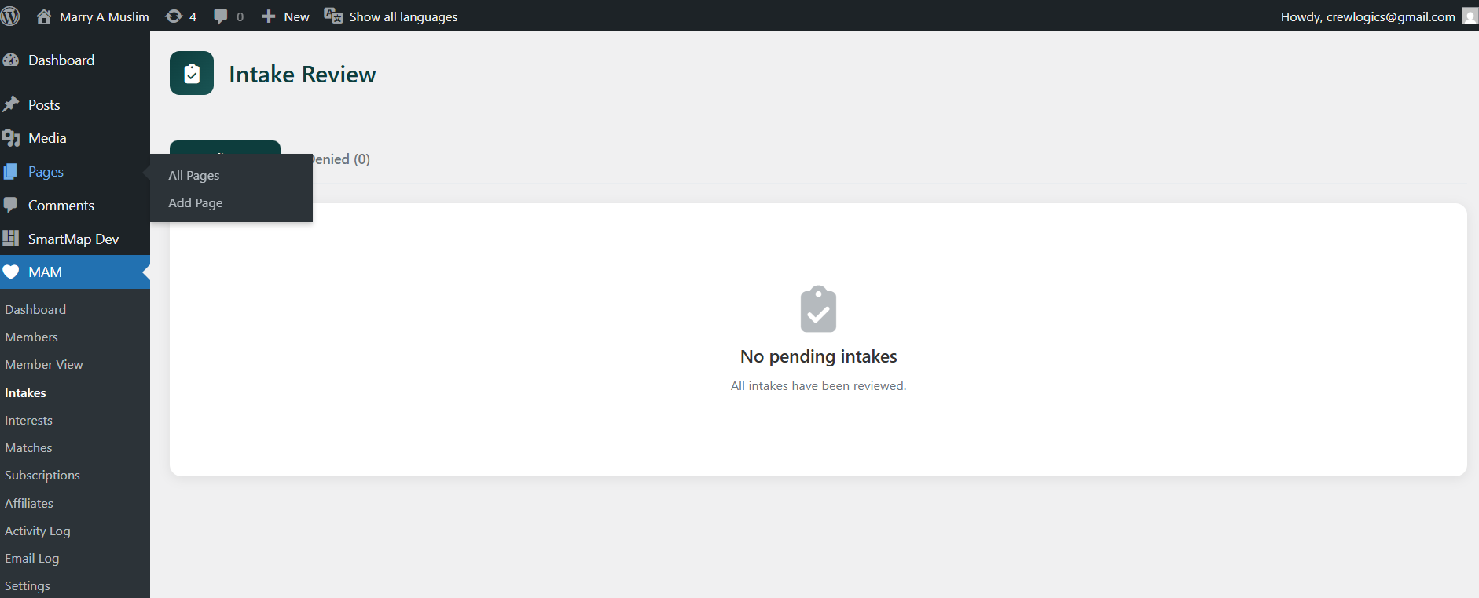
Figure: Intake Review Screen

6. Complete User Journey
This section explains the complete flow from registration to successful match.

6.1 Registration
Users register on the registration page with basic information:
- Full Name, Email, Password
- Gender Selection (Male/Female)
- Account Type (Self/Wali)
- Terms Agreement
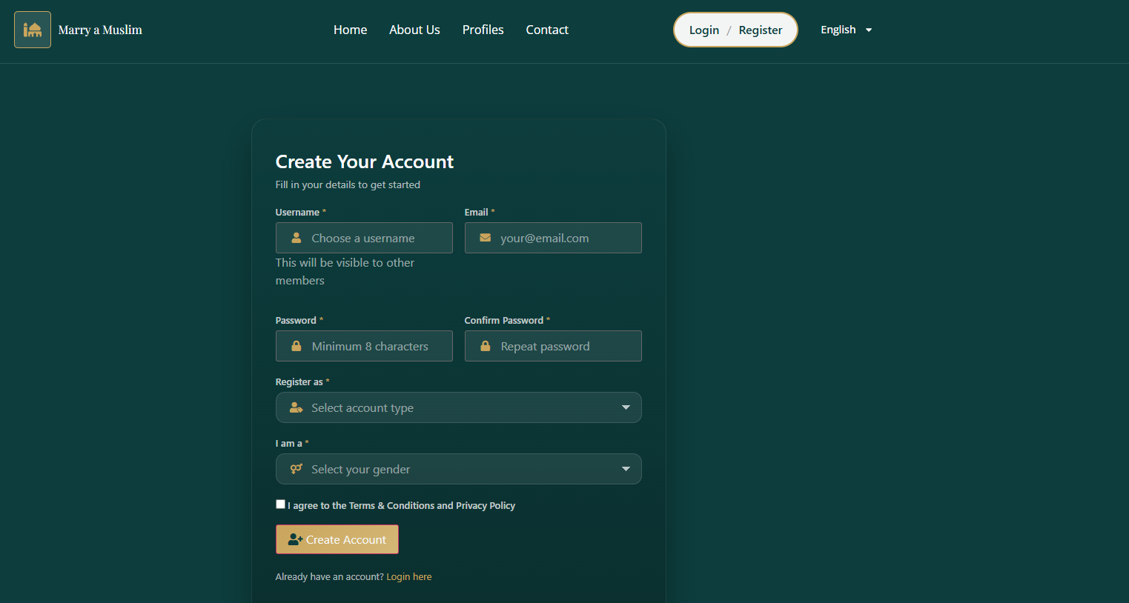Figure: Registration Form (Frontend)

After Registration Redirects:
- Male: → Payment Page (must pay to continue)
- Female: → Intake Form (free access)
- Wali: → Dashboard

6.2 Profile Creation (Intake Form)
After payment (for males) or registration (for females), users complete their profile:

6.3 User Dashboard
The dashboard is the central hub showing:
- Profile Status Card: Shows current status (Pending/Available/In Conversation/Matched)
- Your Match Section: Current match details and actions
- Action Center: Pending actions requiring attention
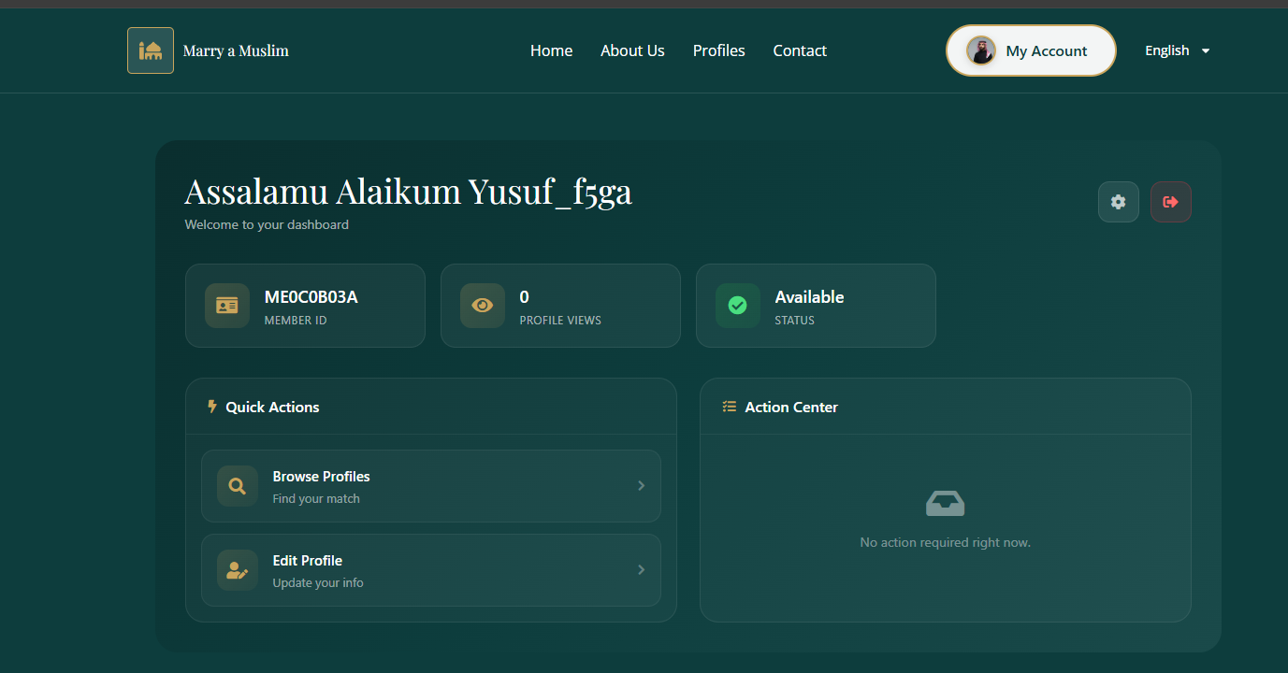
Figure: User Dashboard - Full View

6.4 Browsing Profiles
Users can browse profiles of opposite gender with filters for location, age, education, etc.
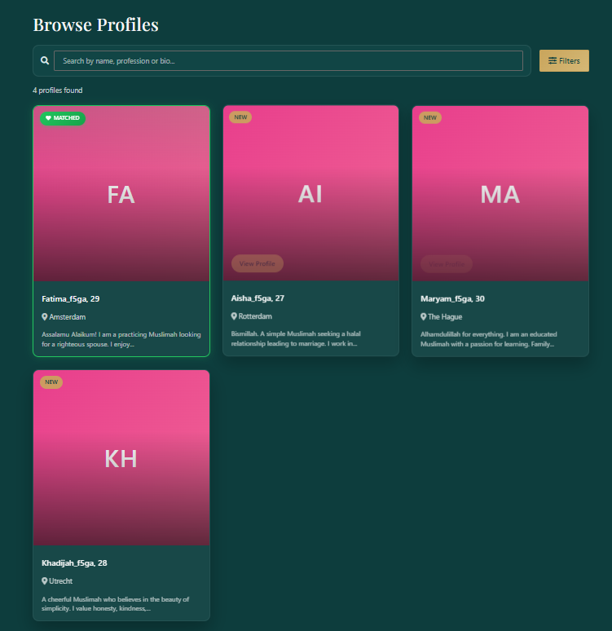
Figure: Profiles Browse Page with Filters

6.5 Sending Interest
- User clicks "Send Interest" on a profile
- Interest is sent to the other person
- User is now "locked" (cannot send more interests until resolved)
- Receiver gets email notification
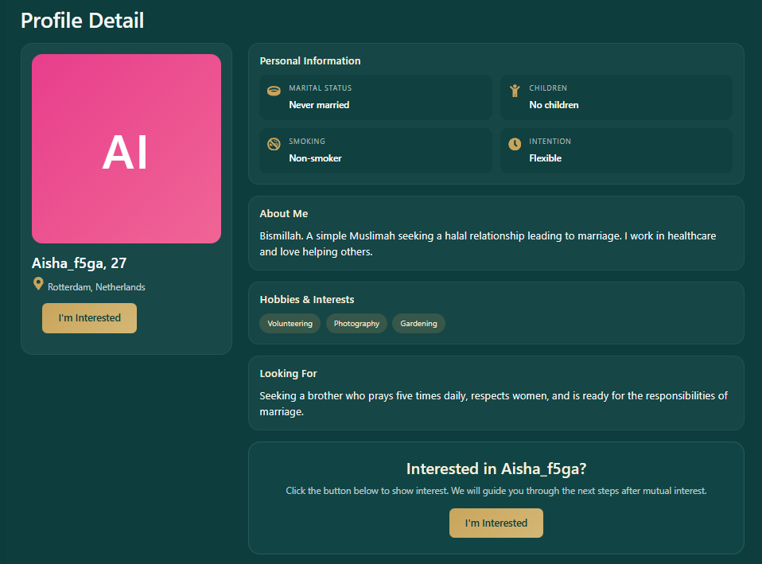
Figure: Single Profile View with Send Interest Button

6.6 Photo Exchange Process
🔒 Privacy Rule: Female photos are ALWAYS private. Males share first, then females decide.

Photo Exchange Flow:
- Interest is accepted
- Female can already see male's photos
- Female decides to share her photos or decline
- If shared, male can now view female's photos
- Match is created after both photo exchanges complete

6.7 Meeting System
- male can propose a meeting
- other party accepts or declines
- Both parties join the meeting

6.8 Final Decision
After the meeting, both parties make their final decision:
User 1 | User 2 | Result
YES | YES | ✅ MATCH CONFIRMED - Contact Shared
YES | NO | ❌ Match Declined
NO | YES | ❌ Match Declined
NO | NO | ❌ Match Declined
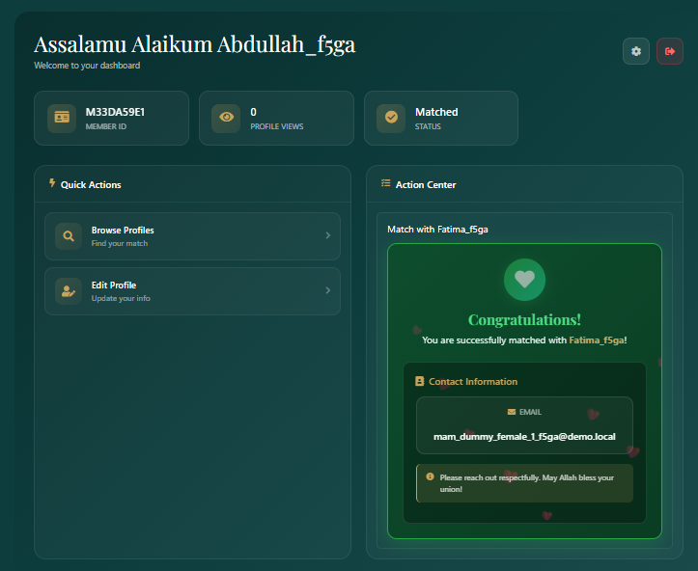
Figure: Final Decision Screen

7. Elementor Widgets
MAM provides custom Elementor widgets for all frontend pages. All text is customizable through Elementor controls.

7.1 Available Widgets
Widget | Purpose
MAM Login | User login form
MAM Register | User registration form
MAM Forgot Password | Password reset request
MAM Reset Password | New password form
MAM Intake | Profile creation form
MAM Dashboard | User dashboard with actions
MAM Profiles | Browse all profiles
MAM Profile | Single profile view
MAM My Profile | View/edit own profile
MAM Payment | Subscription payment
MAM Favorites | Saved profiles list
MAM Settings | User settings page
MAM Auth Button | Login/Logout button
Figure: Elementor Editor showing MAM Widgets

7.2 Customizing Widget Text
- Edit page with Elementor
- Click on the MAM widget
- Find text fields in the left panel under "Content" tab
- Change the text as needed
- Save/Publish the page
Figure: Elementor Widget Settings Panel

8. Testing Checklist
Use this checklist to verify all plugin functionality on your site.

8.1 Installation & Setup
- ☐ Plugin installs without errors
- ☐ MAM menu appears in admin sidebar
- ☐ Dashboard shows statistics
- ☐ Settings page loads correctly
- ☐ All admin pages accessible

8.2 User Registration
- ☐ Male registration → redirects to Payment
- ☐ Female registration → redirects to Intake
- ☐ Email validation works
- ☐ Password requirements enforced
- ☐ Welcome email received

8.3 Profile Creation
- ☐ Intake form loads all fields
- ☐ All dropdowns populated with options
- ☐ Photo upload works
- ☐ Form validation messages display
- ☐ Profile appears in admin Intakes

8.4 Admin Approval
- ☐ Intakes list shows pending profiles
- ☐ Approve button works
- ☐ Reject button works
- ☐ User receives approval email
- ☐ Profile status changes to Active

8.5 Interest System
- ☐ Browse profiles page works
- ☐ Filters work correctly
- ☐ Send Interest button works
- ☐ User gets locked after sending interest
- ☐ Interest appears in receiver's Action Center
- ☐ Accept/Decline buttons work

8.6 Photo Exchange
- ☐ Female can see male photos after acceptance
- ☐ Female photo share prompt appears
- ☐ Share photos button works
- ☐ Male can view female photos after share
- ☐ Match created notification appears

8.7 Meeting System
- ☐ Propose Meeting button works
- ☐ Partner receives meeting proposal
- ☐ Accept/Reject meeting works
- ☐ Admin can schedule meeting
- ☐ Meeting link is shared with both users

8.8 Final Decision
- ☐ Final decision buttons appear after meeting
- ☐ Both YES = Contact shared
- ☐ Any NO = Match declined
- ☐ Users return to Available status after decline

9. Troubleshooting

9.1 Common Issues

Pages show 404 errors
Solution: Go to Settings → Permalinks and click "Save Changes" without changing anything.

Emails not being received
Solution: Install WP Mail SMTP plugin and configure with your email provider (Gmail, SendGrid, etc.)

Photos not uploading
Solution: Check wp-content/uploads folder permissions (should be 755). Also verify PHP upload_max_filesize setting.

Elementor widgets not appearing
Solution: Clear Elementor cache (Elementor → Tools → Regenerate CSS), deactivate and reactivate MAM plugin.

Payment not processing
Solution: Verify Mollie API key is correct. For testing, enable Test Mode and use test API key.

9.2 Database Tables
The plugin creates these database tables:
- wp_mam_profiles - User profiles
- wp_mam_photos - User photos
- wp_mam_interests - Interest requests
- wp_mam_matches - Confirmed matches
- wp_mam_subscriptions - Payment subscriptions
- wp_mam_affiliates - Affiliate data
- wp_mam_activity_log - Activity tracking
for testing the male profile use this logins, created just for testing purpose:
mam_dummy_male_6_f5ga@demo.local
mam123456
mam_dummy_male_7_f5ga@demo.local
mam1234567

10. Support & Contact
For technical support, bug reports, or feature requests:
Developer: CodeReve
Website: https://codereve.com
Plugin Version: 1.5.9
— End of Document —

