1.- Initial Menu
1.1 Configuration:
Set up players names, colors and position.
Select map.
Load, save, delete and modify profile.
Load or start game.
1.2 Save profile
Define name.
Set as default.
Continue/Cancel.
1.3 Load Game
Select saved game.
Delete saved game.
1.4 Confirmation
Continue/cancel action
1.1.- Configuration

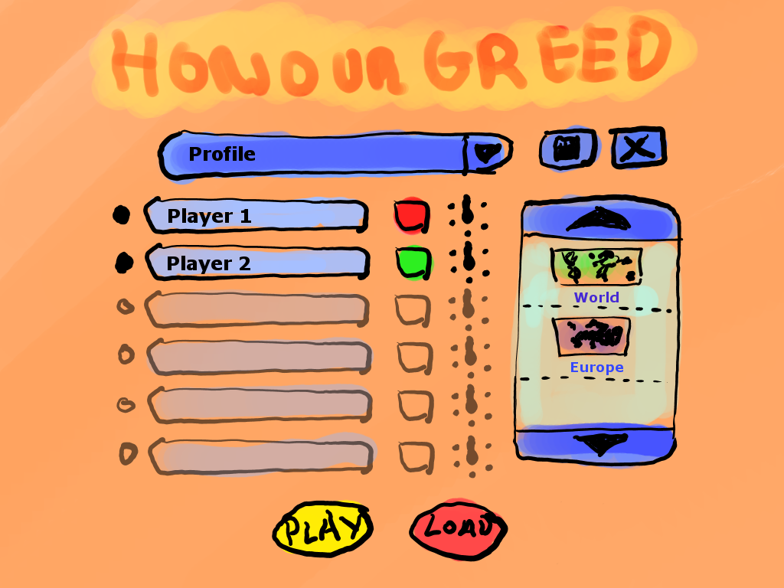
A
B
C
D
E
F
G
H
I
Letter | Name | Action
A | Players configuration | By clicking the black left button the player will be activated. By clicking the player name button the keyboard will appear to change player name.
B | Profile menu | Displays profile menu with profiles list
C | Player color configuration | By clicking the button player color changes
D | Player position configuration | Points the player position around the device
E | Save profile | Shows 1.2 menu
F | Delete profile | Deletes profile
G | Possible maps | Map selected will be remarked.
H | Load game | Shows 1.3 menu
I | Play game | Starts game if the actual config is valid.

1.2.- Save profile
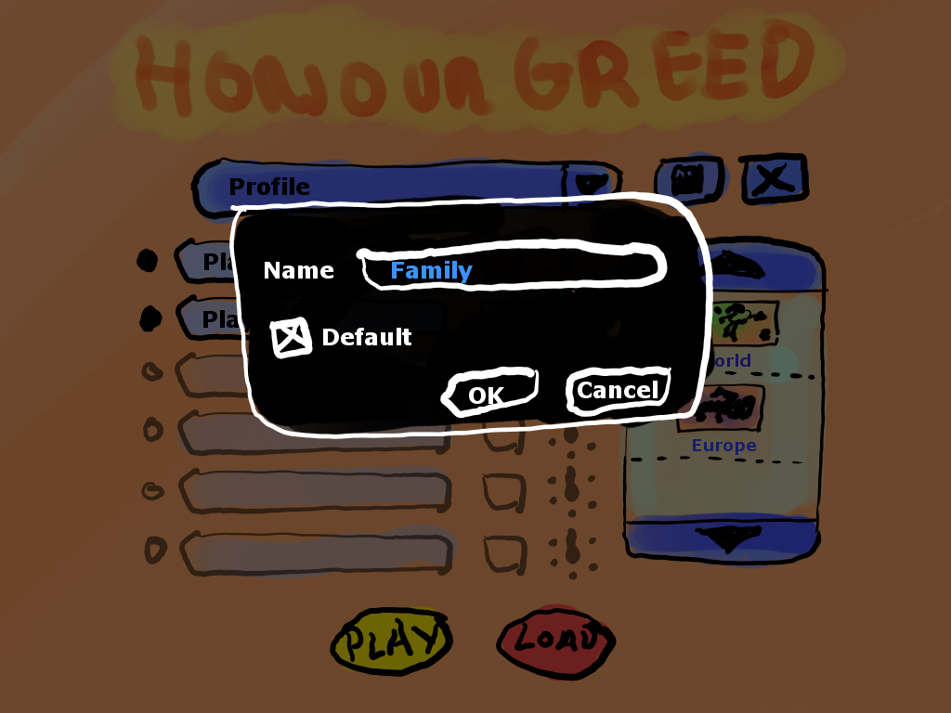
A
B
C
D
Comes from 1.1.E

Letter | Name | Action
A | Set profile as defaul | This profile will be shown as marked in 1.1.B
B | Profile name.
C | Cancel button: | Back to 1.1 without changes
D | Ok button | Back to 1.1 with profile changes

1.3.- Load Game

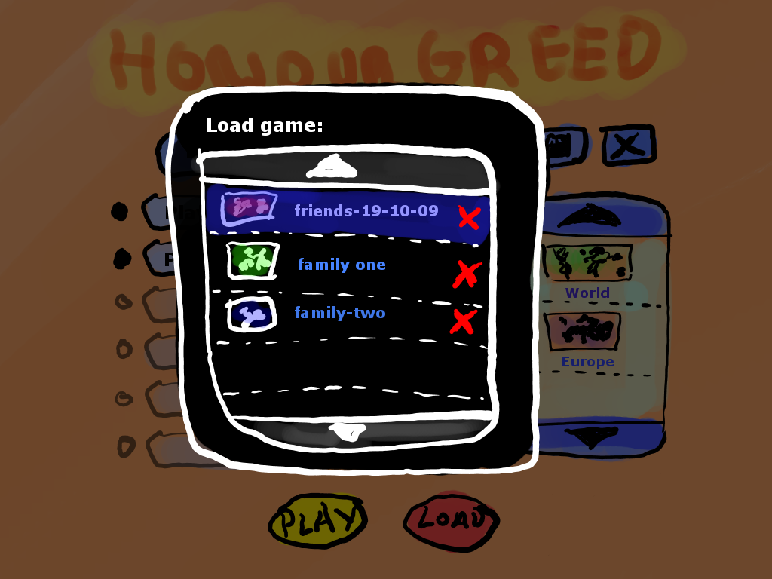
Comes from 1.1.H
A
B
C

Letter | Name | Action
A | Map preview | Little picture of the kind of map played in this game.
B | Up/Down buttons
C | Delete saved game.

1.4.- Confirmation

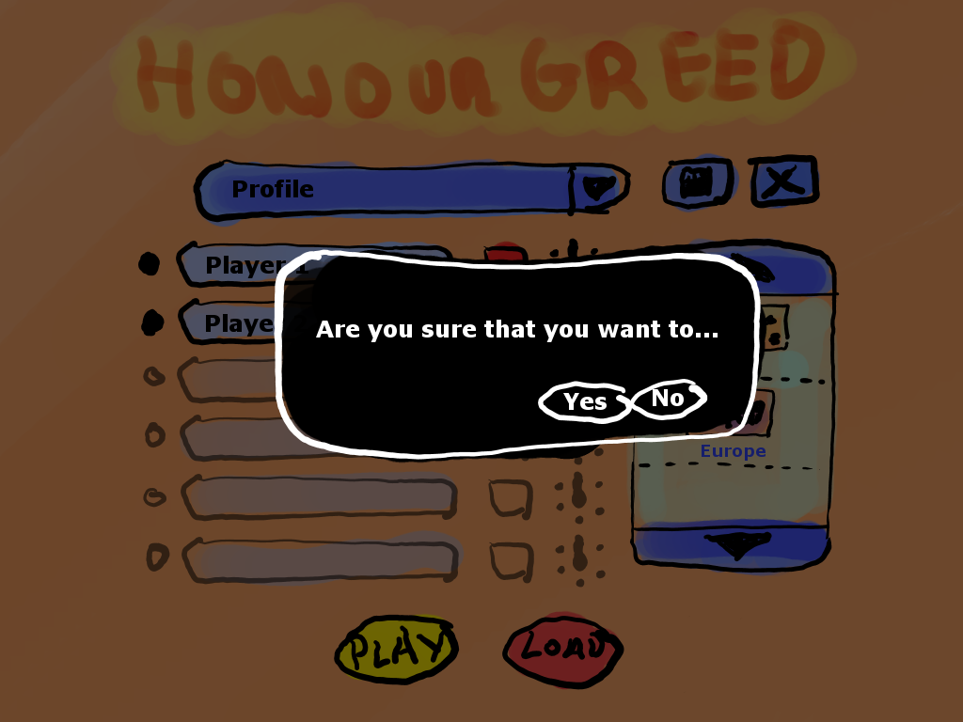
A
B
Comes from 1.2.D, 1.3 and 1.1.I

Letter | Name | Action
A | Confirm
B | Cancel

