1.- Main Menu
1.1 Configuration
Set up players names, colors and position.
Select map.
Load, save, delete and modify profile.
Load or start game.
1.2 Save profile
Define name.
Set as default.
Continue/Cancel.
1.3 Load Game
Select saved game.
Delete saved game.
1.4 Confirmation
Continue/cancel action

2.- Game Player Menu
  - Overview
Gives player's options at the moment.
  - Objective
Shows player's objective
  - Cards
Shows player's cards
  - Cards selection
Cards can be selected and used.

3.- Init Phase
  - Objectives deal
Objectives are dealt to each player.
  - Player positions
  - View objective active
View objective button is active.
  - Next button active
  - Troops placement
Regions are dealt and troops can be placed.
  - Finish troops placement - Next button active

4.- Ingame menu

5.- Game Round
  - Reinforcement phase.
  - Cards use
Player can use cards in the reinforcement phase.
  - Attack phase
  - Attack phase – region selected
Shows possible attacks
  - Movement phase

6.- Battle
  - Defender reinforcement
  - Reinforcement ends
Time for preparing the battle.
  - Battle starts
  - Soldier movement
  - Retreat activates
  - Wall placement
1.- Main Menu
1.1.- Configuration

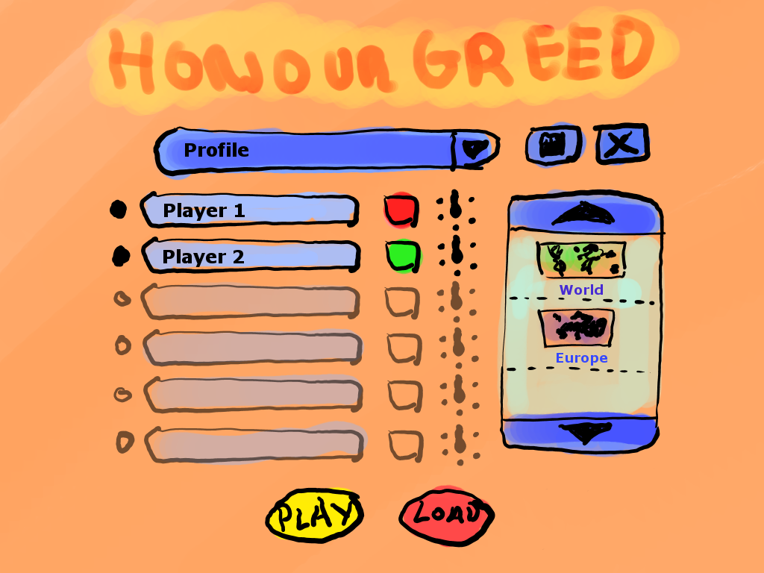
A
B
C
D
E
F
G
H
I
Letter | Name | Action
A | Players configuration | By clicking the black left button the player will be activated. By clicking the player name button the keyboard will appear to change player name.
B | Profile menu | Displays profile menu with profiles list
C | Player color configuration | By clicking the button player color changes
D | Player position configuration | Points the player position around the device
E | Save profile | Shows 1.2 menu
F | Delete profile | Deletes profile
G | Possible maps | Map selected will be remarked.
H | Load game | Shows 1.3 menu
I | Play game | Starts game if the actual config is valid.

1.2.- Save profile
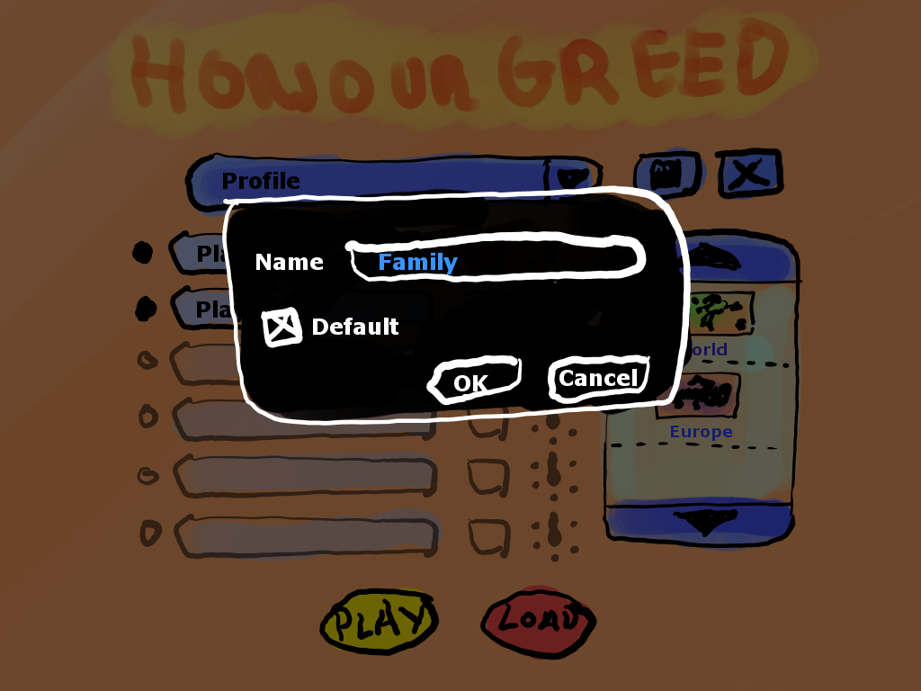
A
B
C
D
Comes from 1.1.E

Letter | Name | Action
A | Set profile as defaul | This profile will be shown as marked in 1.1.B
B | Profile name.
C | Cancel button: | Back to 1.1 without changes
D | Ok button | Back to 1.1 with profile changes

1.3.- Load Game

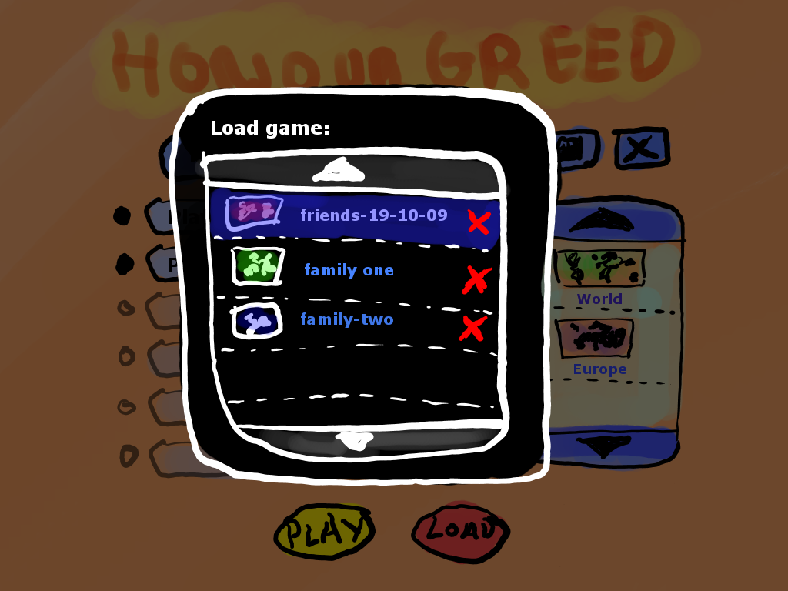
Comes from 1.1.H
A
B
C

Letter | Name | Action
A | Map preview | Little picture of the kind of map played in this game.
B | Up/Down buttons
C | Delete saved game.

1.4.- Confirmation

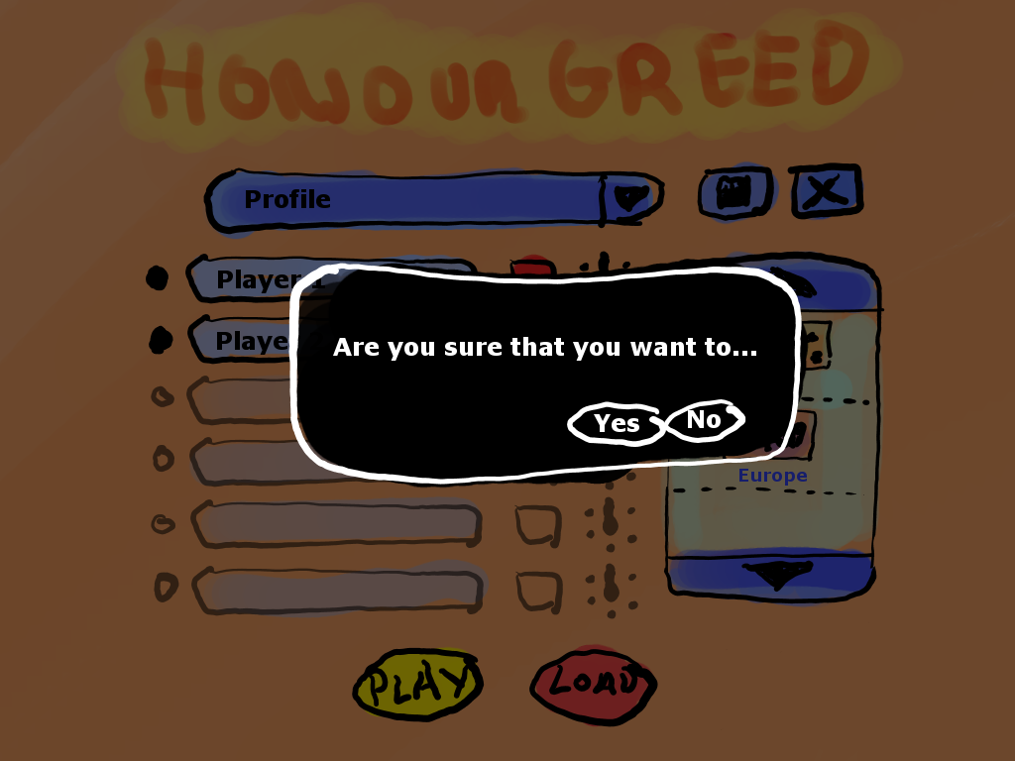
A
B
Comes from 1.2.D, 1.3 and 1.1.I

Letter | Name | Action
A | Confirm
B | Cancel

2.- Game Player Menu
2.1.- Overview

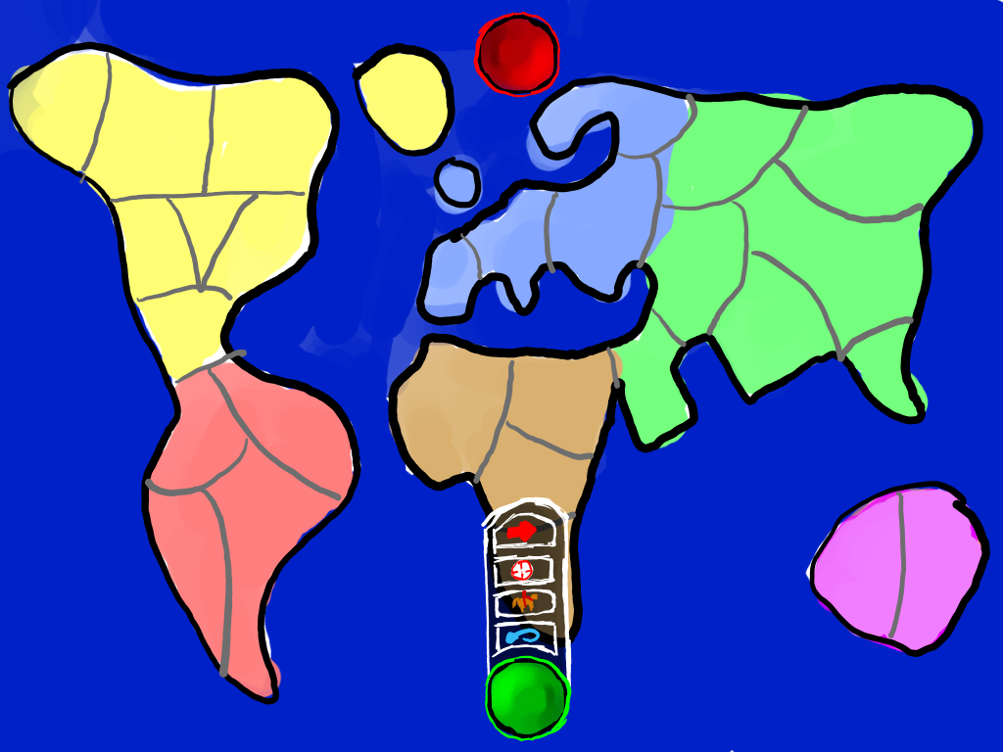
A
B
C
D
E
B

Letter | Name | Action
A | Player menu button | Shows the menu with options [B,E]
B | “Next” button | Perform the action “next” if avaliable
C | “Objective” button | Shows objective (2.2)
D | “Cards” button | Shows cards (2.3)
E | “Undo” button | Undo the previous action.

2.2.- Objective

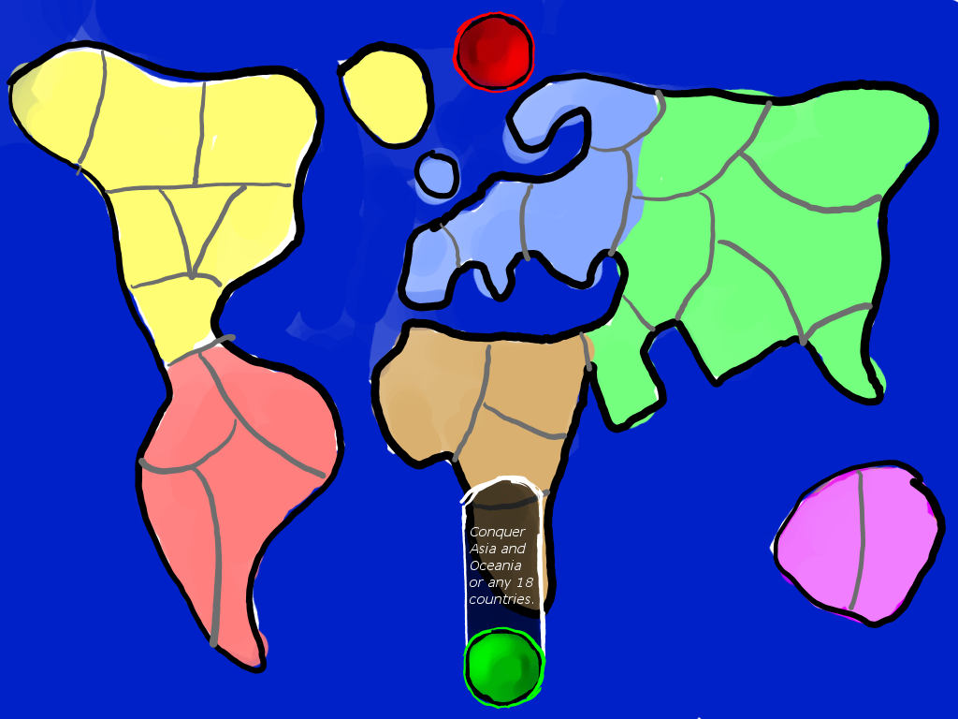
A

Letter | Name | Action
A | Objective text | Hides the objective text
2.3.- Cards

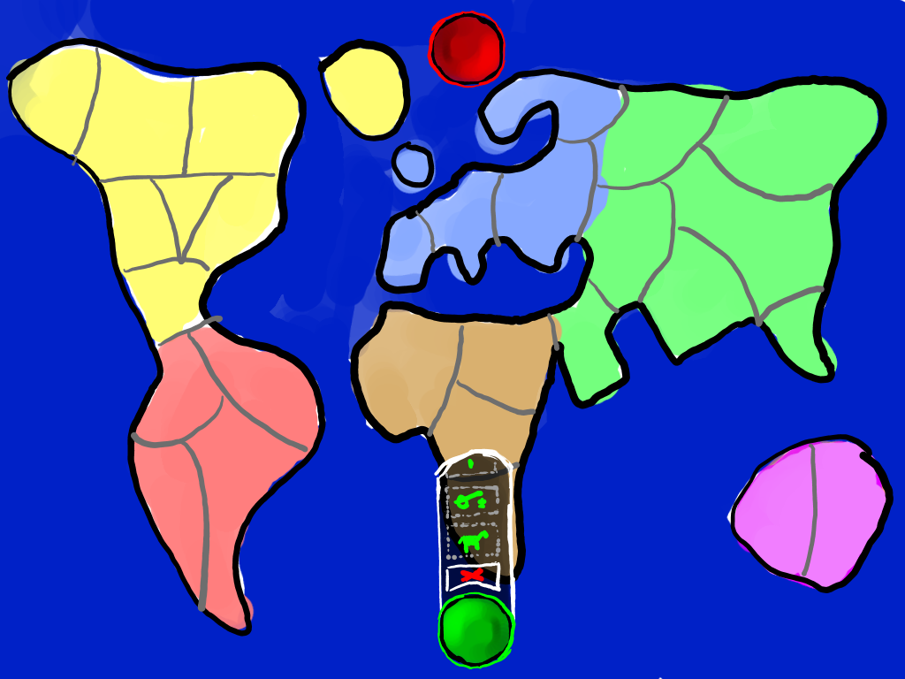
A
B

Letter | Name | Action
A | Cards | Select the cards that the player owns.
B | “Exit” button | Dropps the selected cards.

2.4.- Cards selection

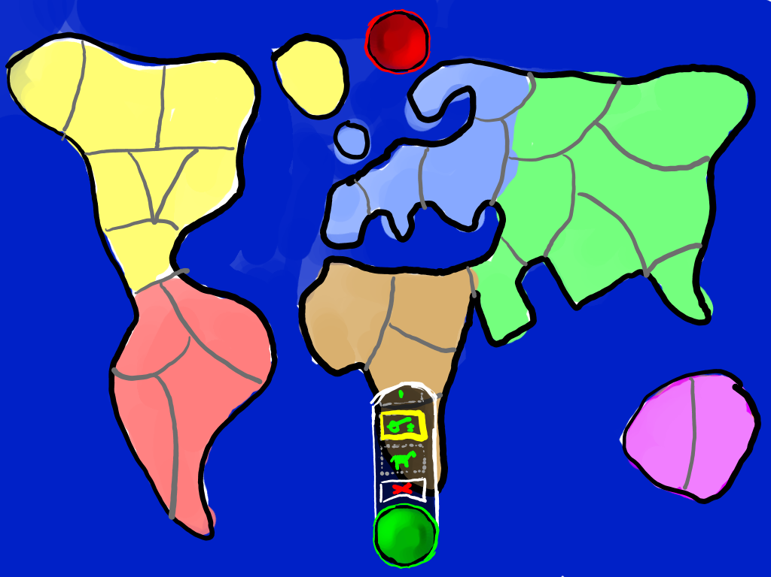
A

Letter | Name | Action
A | Card | Unselected card.

3.- Init Phase
3.1.- Objectives deal

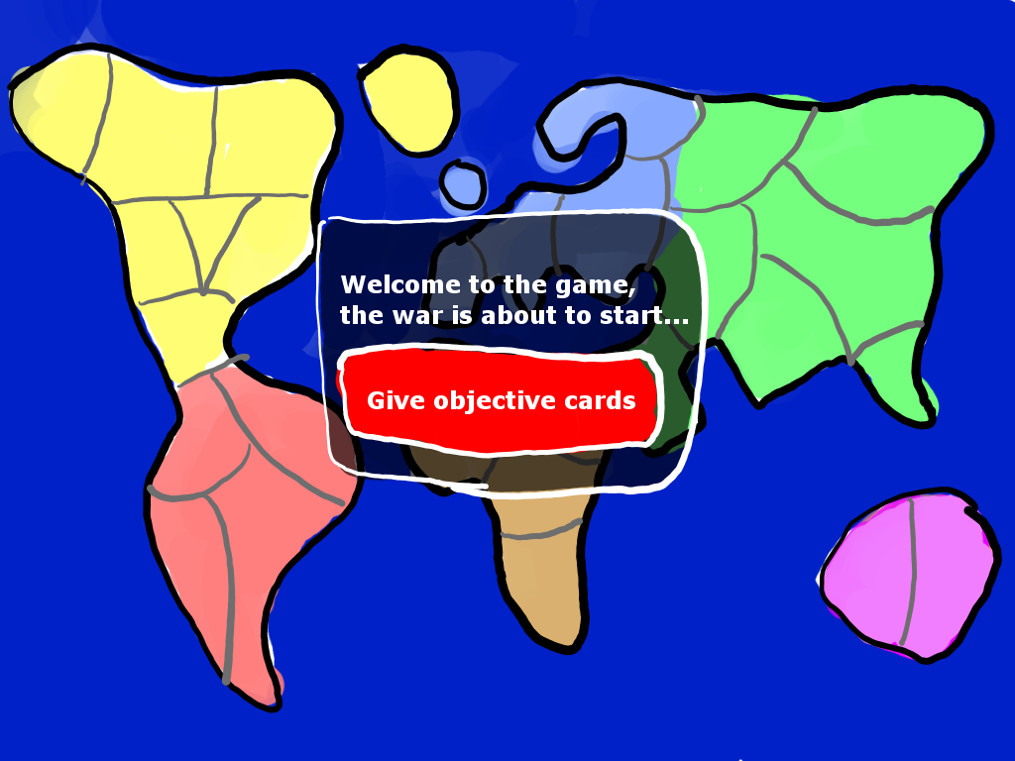
A

Letter | Name | Action
A | Give objective | Deals an objective to each player.
3.2.- Player positions

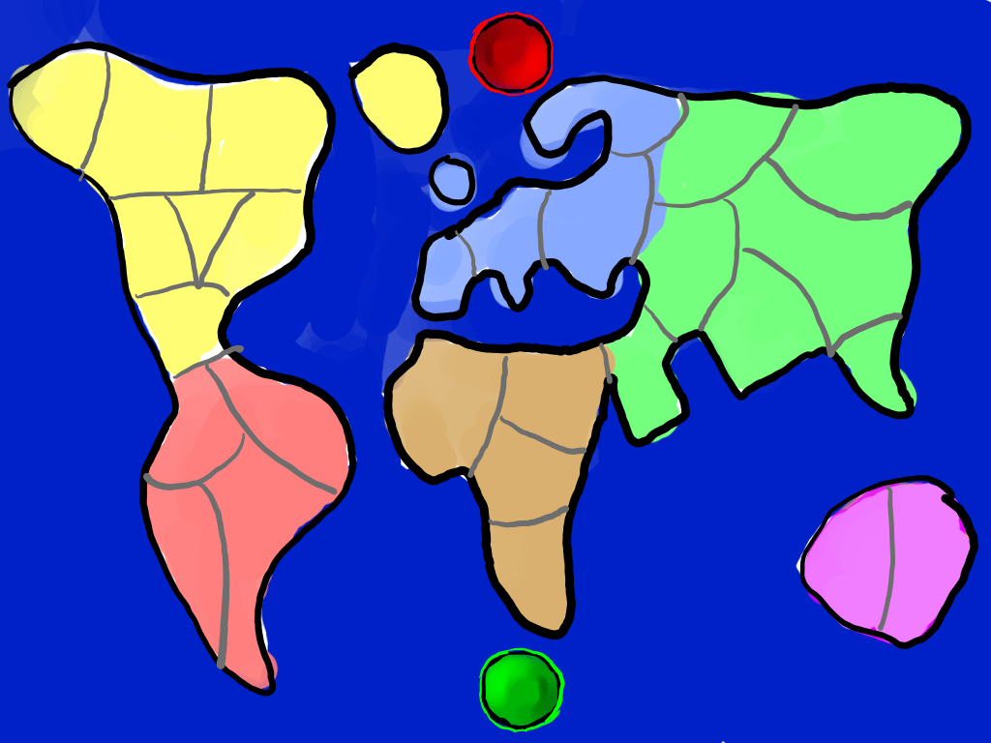
A

Letter | Name | Action
A | Player menu | Display player menu (2)
3.3.- View objective active

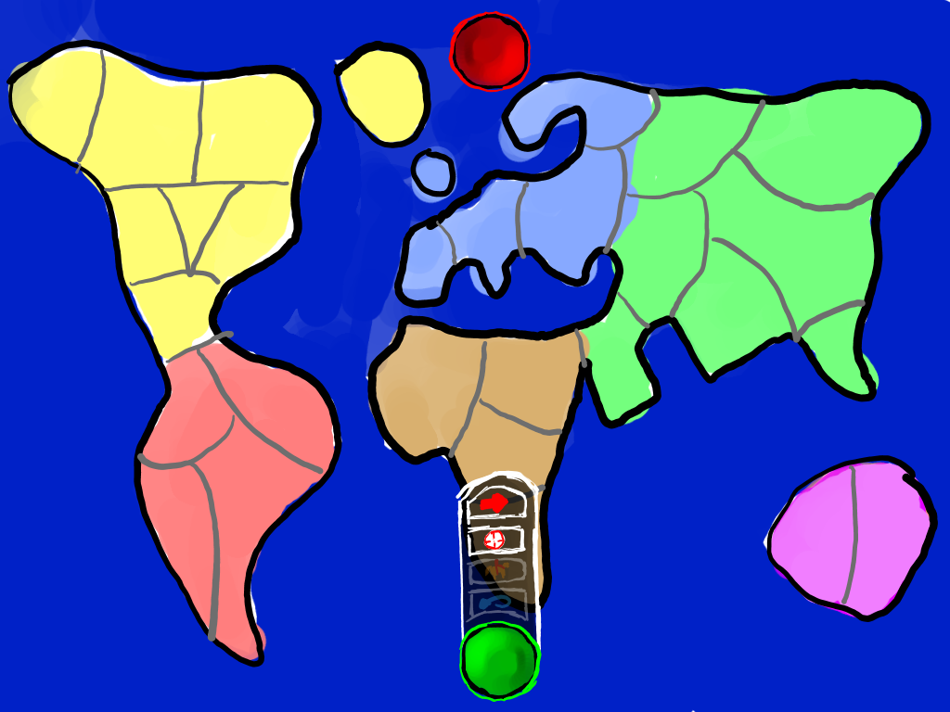
A
B

Letter | Name | Action
A | Next | Goes to 3.4
B | Show objective | Goes to 2.2
3.4.- Next button active

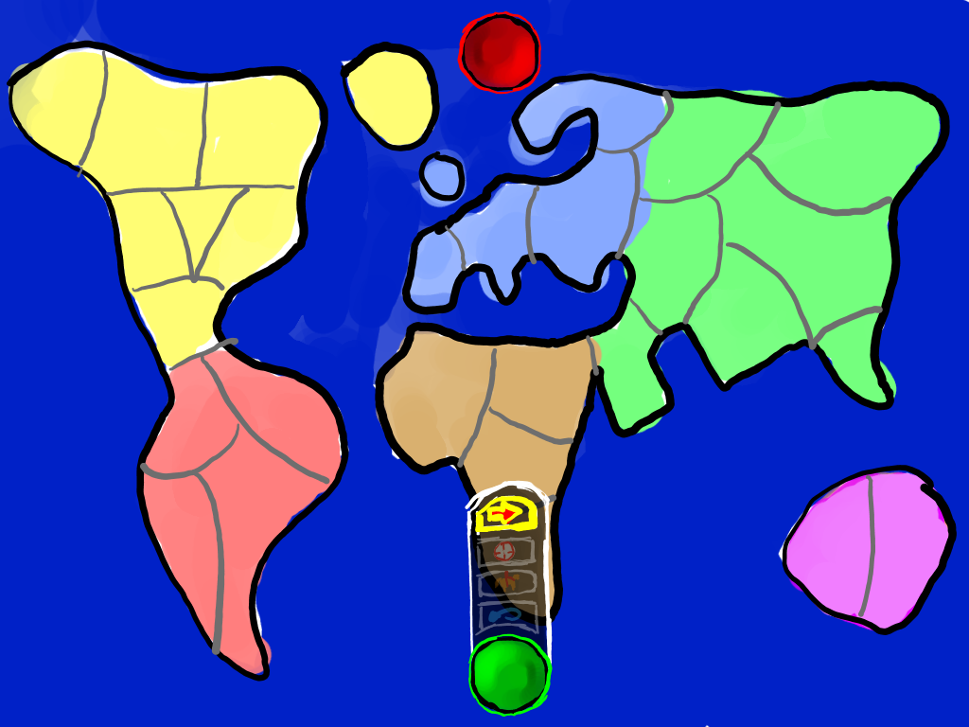
A

Letter | Name | Action
A | Next button selected | Goes to 3.5
3.5.- Troops placement

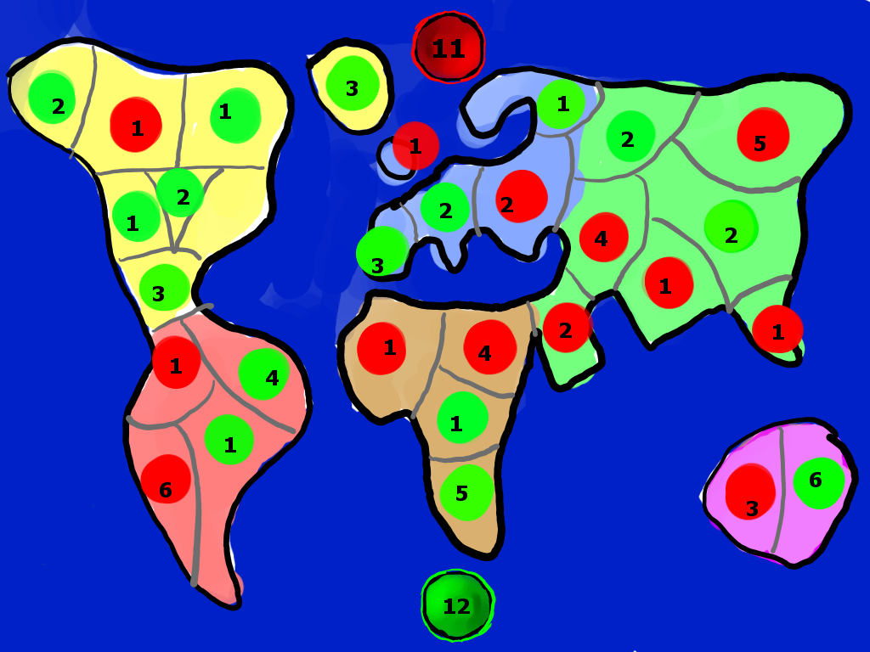
A
B
C

Letter | Name | Action
A | Red region troops | Increases number of troops in tha region decreasing the availible troops of that player.
B | Green region troops | Idem for green.
C | Troops left to place by player green.
3.6.- Finish troop placement - Next button active

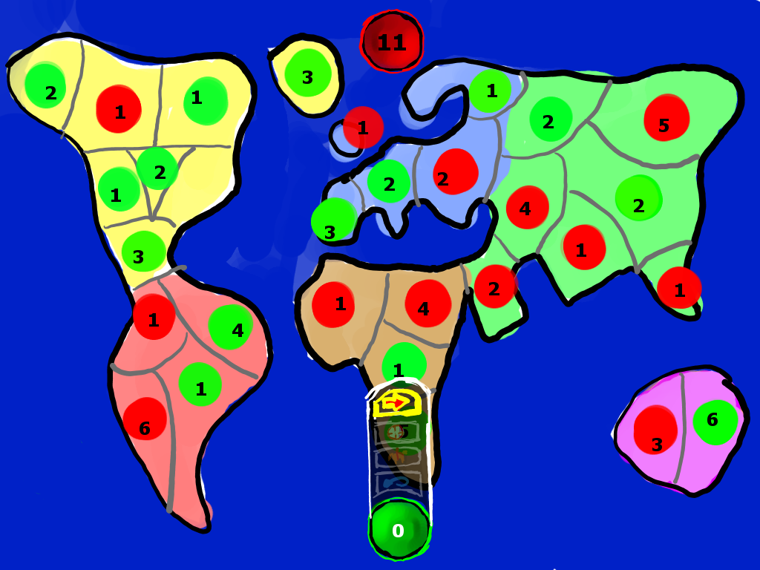
A
B

Letter | Name | Action
A | Next button | Finish init phase.
B | Green region troops | Activates next button when reaches 0.

4.- Ingame menu

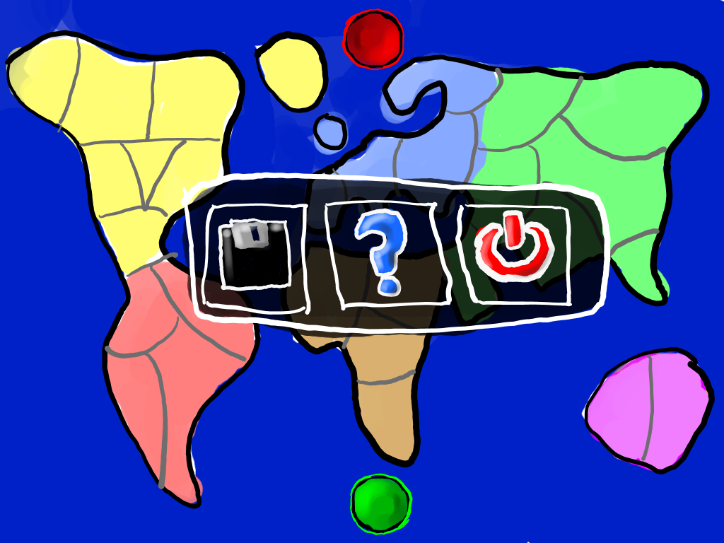
A
B
C

Letter | Name | Action
A | Save | Saves the game.
B | Help | Shows the help menu.
C | Power | Finish the game.

5.- Game Round
5.1.- Reinforcement

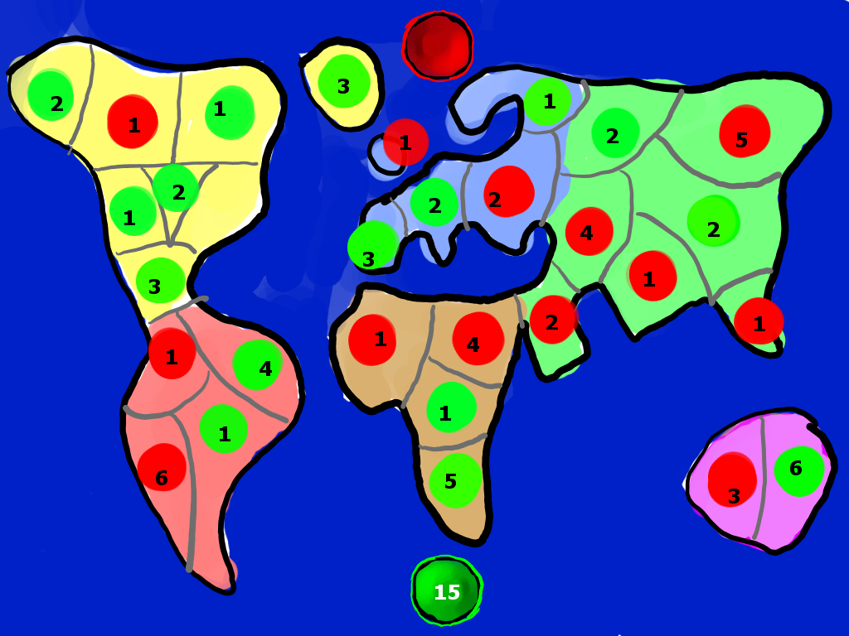
A

Letter | Name | Action
A | Troops left
5.2.- Cards use

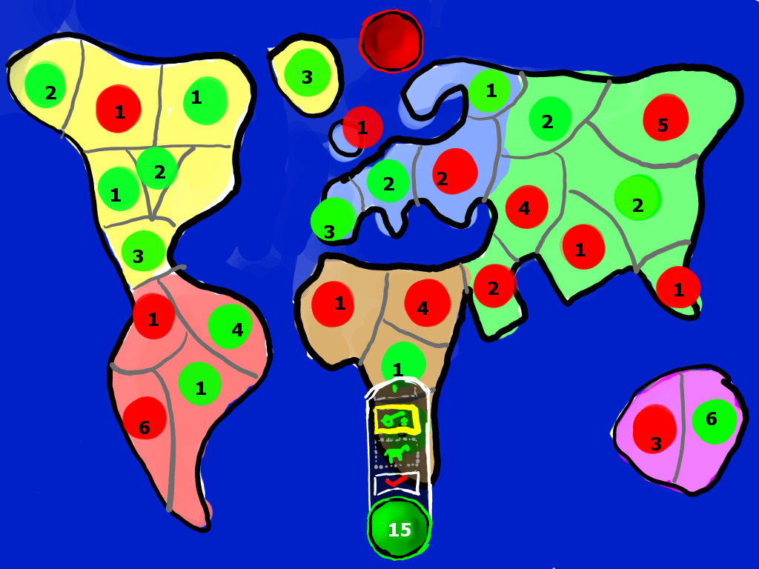
A

Letter | Name | Action
A | Done button | If the card selected make a valid combination, the result of troops is add to the number available.
5.3.- Attack phase

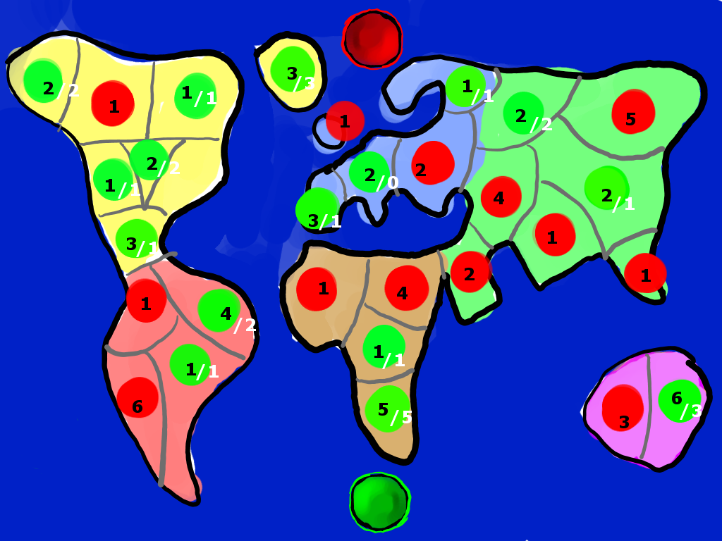
A
B

Letter | Name | Action
A | Troops in region
B | Troops available | Troops available to move.
5.4.- Attack phase – region selected

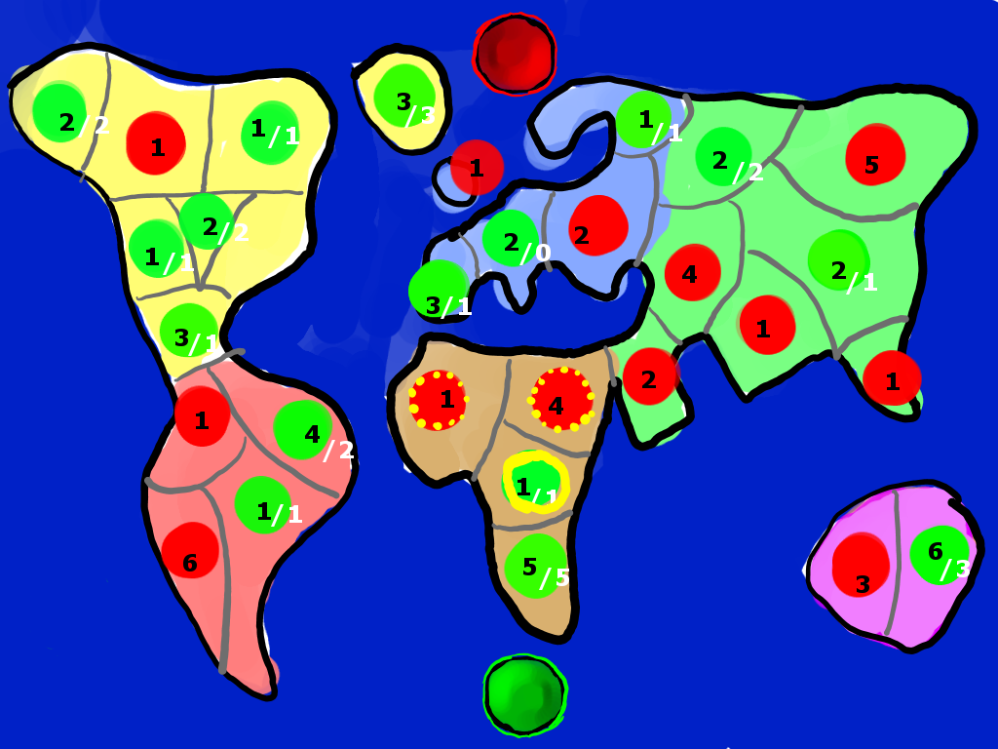
A
B

Letter | Name | Action
A | Defenders | Regions that are able to be attacked
B | Attacker | Region that is going to attack. Makes “Defenders” more visible when clicked.
5.5.- Movement phase

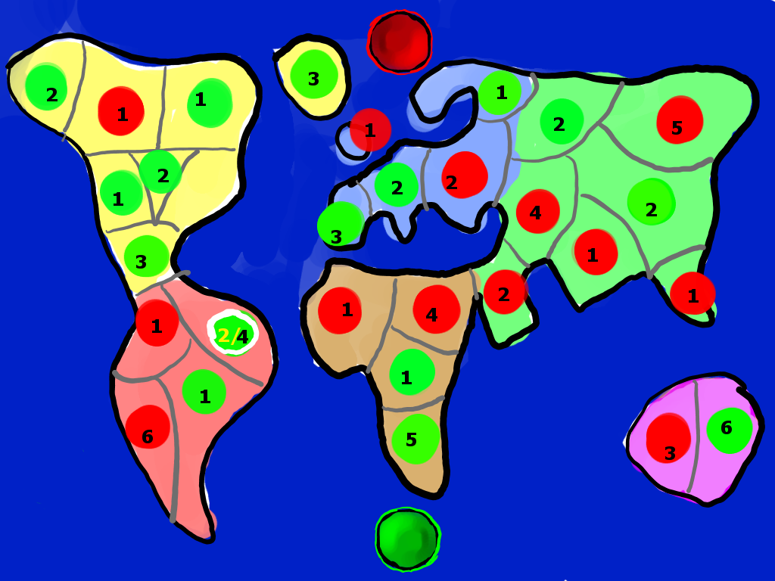
A
C
B

Letter | Name | Action
A | Selected region
B | Moveable units
C | Total units
6.- Battle
6.1.- Defender reinforcement

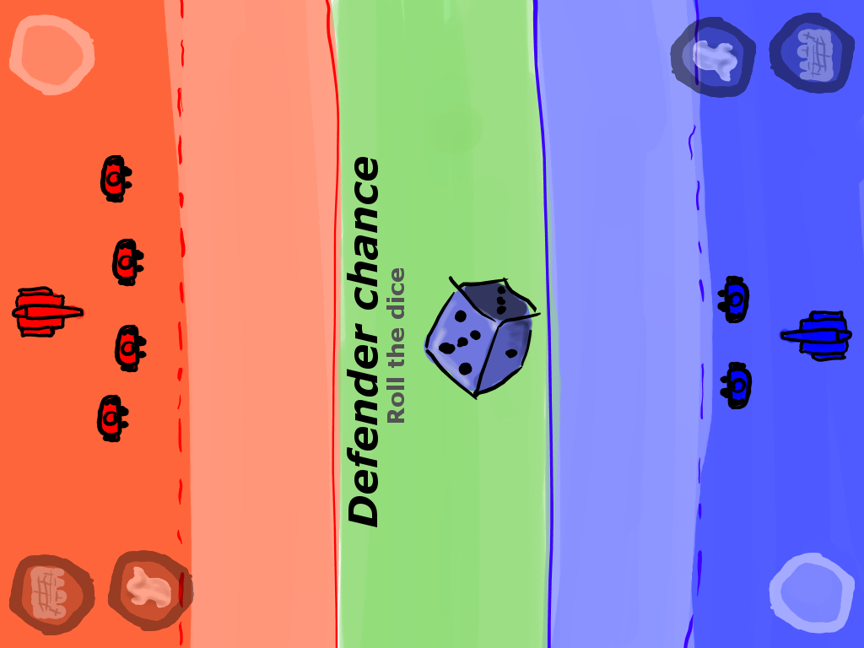
A

Letter | Name | Action
A | Dice | Roll when clicked.
6.2.- Reinforcement ends

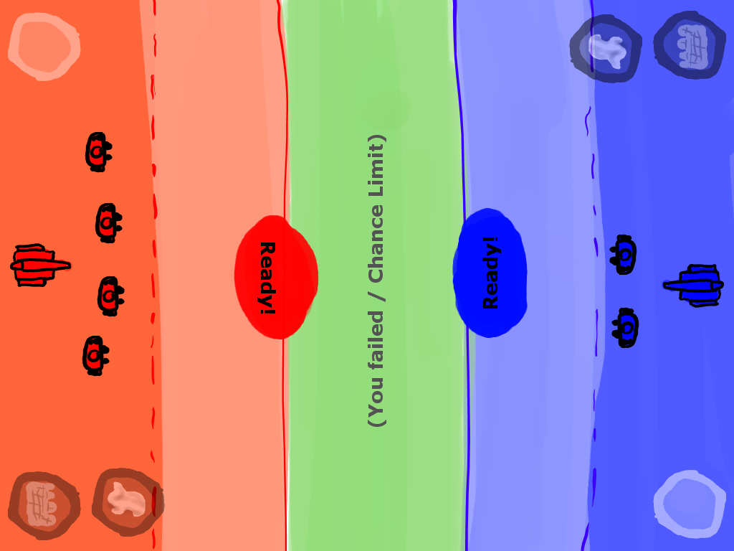
A

Letter | Name | Action
A | Alert message | Starts the battle when both players have clicked it.
6.3.- Battle starts

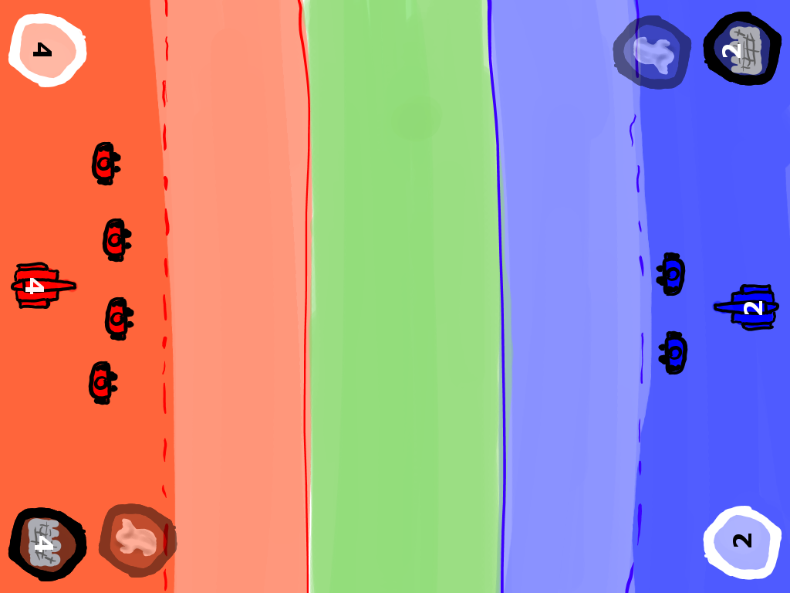
A
B
C
D

Letter | Name | Action
A
B | Cannonballs available | Shoots cannon.
C | Troops available | Goes to 6.4
D | Walls available | Goes to 6.6
6.4.- Soldier movement

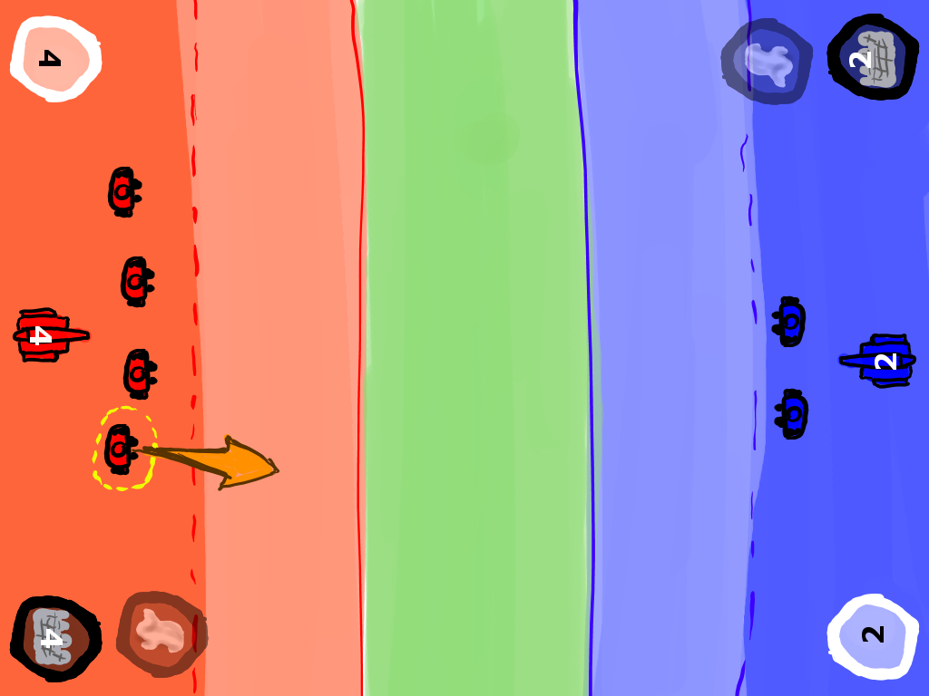
A
B

Letter | Name | Action
A | Troop selected | Shows direction arrow.
B | Direction arrow | Moves the troop in the selected direction.
6.5.- Retreat activates

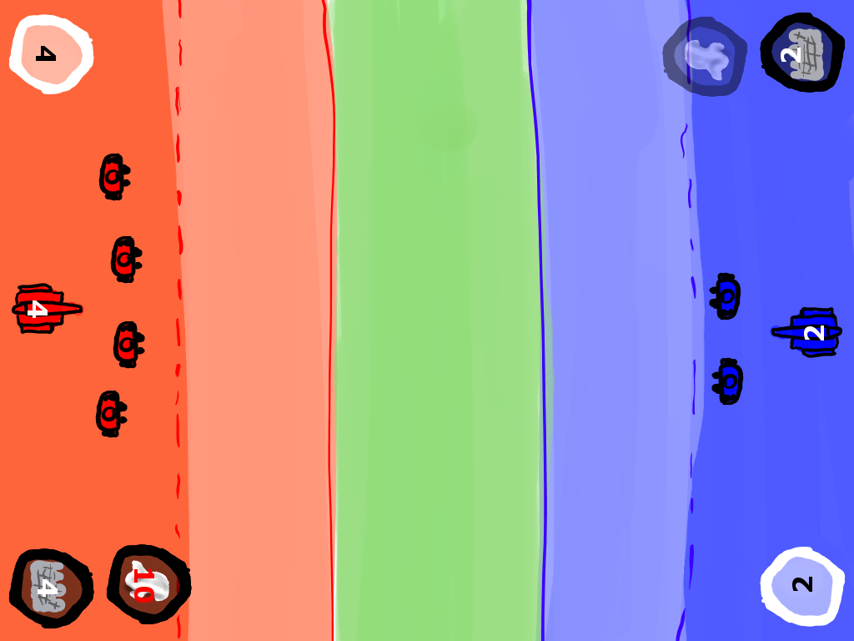
A

Letter | Name | Action
A | Retreat countdown | Retreats the attacker if clicked when available.
6.6.- Wall placement

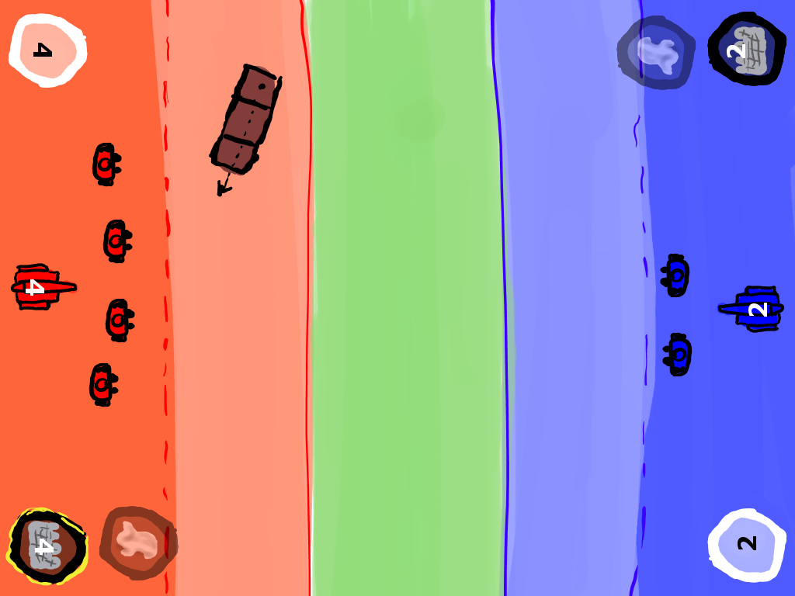
A
B

Letter | Name | Action
A | Wall
B | Wall direction | Click and drag to place the wall.

