Report

# Names

Ahmed Mohamed Nassar , SEC:1 , B.N. : 5

Ahmed Mahmoud Mohamed Abdelfattah , SEC:1 , B.N. : 7

Sofyan Mahmoud , SEC:1 , B.N. : 26

Mohamed Mokhtar Abdelrazek , SEC:2 , B.N. : 19

# Design

You will find the design file attached and called “Design.pdf”

# What is not implemented :

* Branch prediction is designed but not implemented , but we handled it by making stalling .
* Cache memory is not implemented .
* Hazard detection is not working with branch **only , and working with the rest instructions.**
* **Everything else works well.**

# Analysis

* The do files and screenshots of all test cases required is given in the report folder (except for cache memory test case).
* To run the test case you will find “IR.txt” and “do file.txt” in every test case folder you should replace the IR in the “project\Pipelined-MIPS” directory with that IR and run the do file .
* The wave form will contain flags , pc , clk , sp , reset , registers(0 -> 7) , Ex:

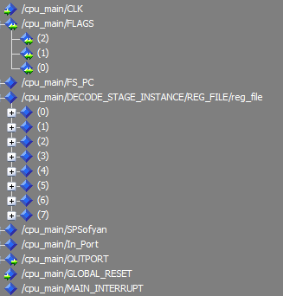

Where “cpu_main/DECODE_STAGE_INSTANCE/REG_FILE/reg_file” are the registers , and flags(0) -> Z flag , flags(1) -> N flag , flags(2) -> C flag

# Hazard detection and forwarding Analysis

* Our hazard detection unit stalls 1 cycle when it finds load use case

Or hazard in (swap , push , STD) instructions

* Our forwarding unit handles hazards without stalling in all instructions except swap , push , std as they are handled in hazard detection unit
* We didn`t handle hazards in branch instructions so we should add 3 NOP operations (software solution) if there was a hazard.
* In branch prediction we designed it however we couldn`t implement it on time so we handled it by stalling .
* An example for hazard handling and forward unit : Given these instructions and the expected with hazard handled outputs using NOP vs hazard outputs

Correct Output

|  |
| --- |
|  |
|  | NOP #No change |
|  | NOT R1 #R1 =FFFFFFFF #R1 =FFFFFFFF |
|  | inc R1 #R1 =00000000 #R1 =00000001 |
|  | in R1 #R1= 5 #R1= 5 |
|  | in R2 #R2= 5 #R2= 5 |
|  | NOT R2 #R2= FFFFFFFA #R2= FFFFFFFF |
|  | inc R1 #R1= 6 #R1= 6 |
|  | Dec R2 #R2 FFFFFFF9 #R2 = 4 |
|  |  |

Data hazards

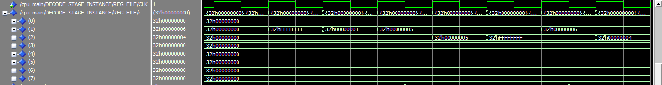

Incorrect outputs

We can solve these hazards using NOP operations where we can change the code to work :

|  |  |
| --- | --- |
|  | NOP #No change |
|  | NOT R1 #R1 =FFFFFFFF  NOP  NOP |
|  | inc R1 #R1 =00000000 |
|  | in R1 #R1= 5 |
|  | in R2 #R2= 5  NOP  NOP |
|  | NOT R2 #R2= FFFFFFFA |
|  | inc R1 #R1= 6  NOP |
|  | Dec R2 #R2 FFFFFFF9 |

Data hazards

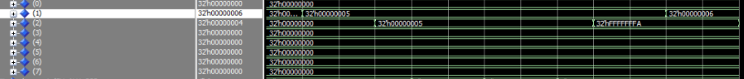

Correct outputs using NOP

We can also solve these hazards using forward unit where we can forward data without adding NOP

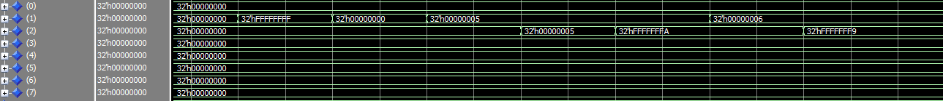

Correct outputs using forward unit and hazard detection

Example 2:

Correct Output

inc R1 #R1= 1 #R1= 1

push R1 MEM[4000] = 1 MEM[4000] = 0

NOT R1 #R1 = FFFFFFFFE #R1= FFFFFFFFF

inc R1 #R1 = FFFFFFFFF #R1= 2

pop R1 #R1 = 1 #R1= 0 load use case

NOT R1 #R1 = FFFFFFFE #R1 = 0

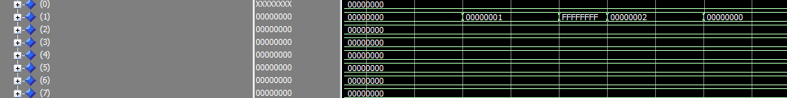

Incorrect output due to hazard

We can also solve these hazards using forward unit where we can forward data without adding NOP

inc R1 #R1= 1

NOP

NOP

NOP

push R1 MEM[4000] = 1

NOT R1 #R1 = FFFFFFFFE

NOP

NOP

NOP

inc R1 #R1 = FFFFFFFFF

pop R1 #R1 = 1

NOP

NOP

NOP

NOT R1 #R1 = FFFFFFFE

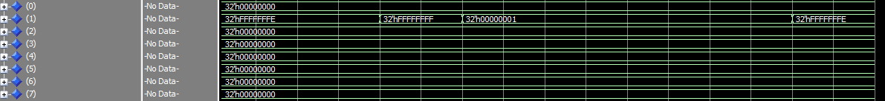

Handling hazards with NOP

We can use Forwarding unit and hazard detection unit to solve hazards without adding NOP

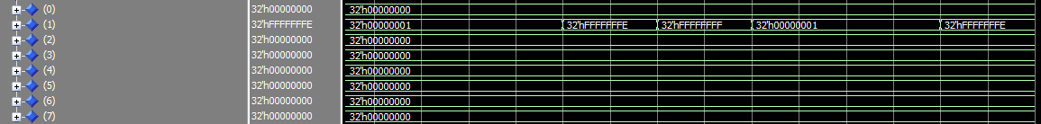

Handling with Forwarding and hazard detection