PL/SQL_Excercise

EXERCISE -1

# Scenario 1: Apply Interest Rate Discount for Customers Over 60

Question:  
Write a PL/SQL block that loops through all customers, checks their age, and if they are above 60, apply a 1% discount to their current loan interest rates.

Solution:

DECLARE  
 CURSOR cur_customers IS  
 SELECT customer_id  
 FROM customers  
 WHERE age > 60;  
  
BEGIN  
 FOR cust IN cur_customers LOOP  
 UPDATE loans  
 SET interest_rate = interest_rate - 1  
 WHERE customer_id = cust.customer_id;  
  
 DBMS_OUTPUT.PUT_LINE('Applied 1% discount for customer ID: ' || cust.customer_id);  
 END LOOP;  
  
 COMMIT;  
END;

Output: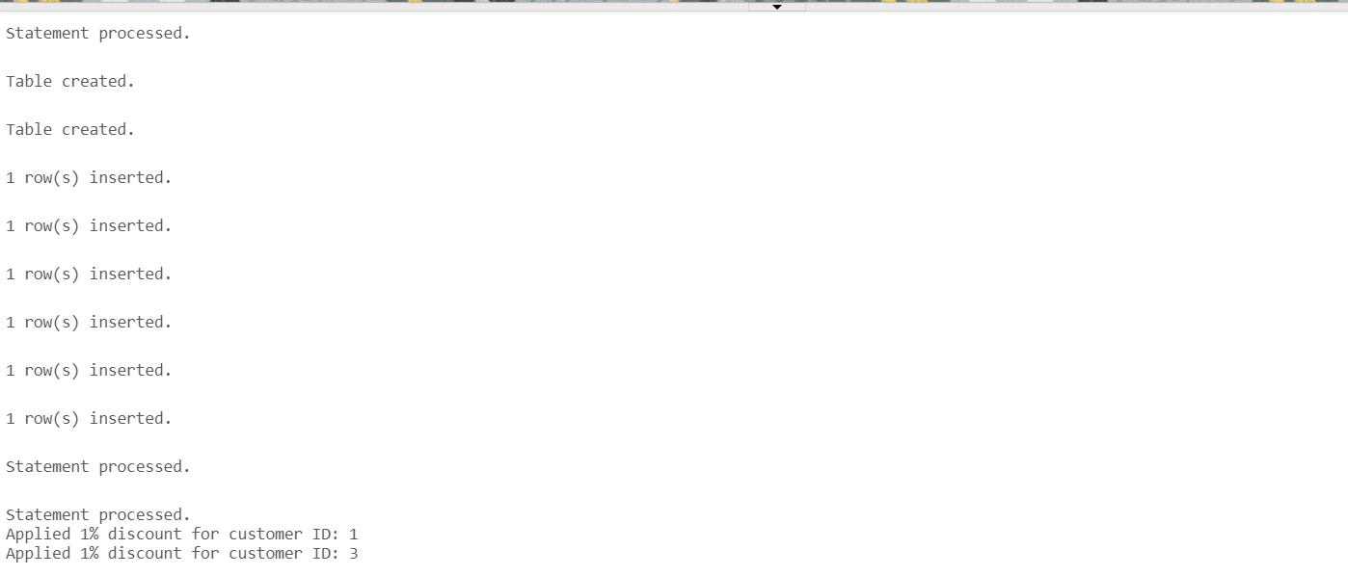

# Scenario 2: Promote Customers to VIP if Balance > $10,000

Question:  
Write a PL/SQL block that iterates through all customers and sets a flag IsVIP to TRUE for those with a balance over $10,000.

Solution:

DECLARE  
 CURSOR cur_customers IS  
 SELECT customer_id, balance  
 FROM customers  
 WHERE balance > 10000;  
  
BEGIN  
 FOR cust IN cur_customers LOOP  
 UPDATE customers  
 SET isvip = 'TRUE'  
 WHERE customer_id = cust.customer_id;  
  
 DBMS_OUTPUT.PUT_LINE('Customer ID ' || cust.customer_id || ' promoted to VIP.');  
 END LOOP;  
  
 COMMIT;  
END;

Output:

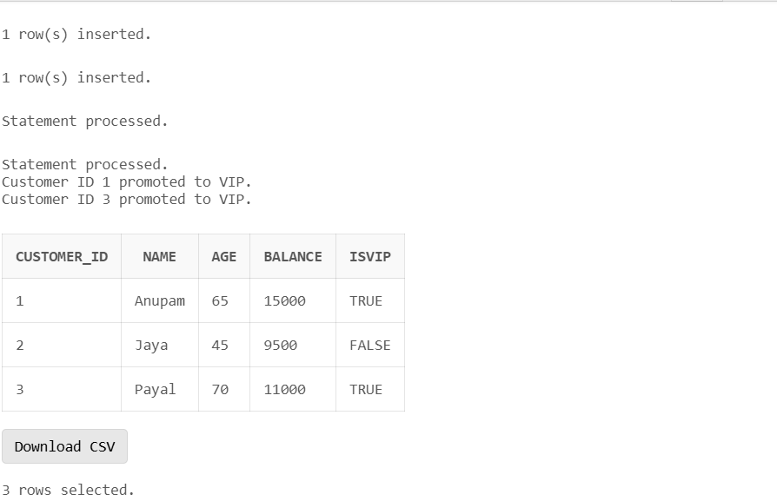

# Scenario 3: Loan Reminders for Due Dates Within 30 Days

Question:  
Write a PL/SQL block that fetches all loans due in the next 30 days and prints a reminder message for each customer.

Solution:

DECLARE  
 CURSOR cur_loans IS  
 SELECT loan_id, customer_id, due_date  
 FROM loans  
 WHERE due_date BETWEEN SYSDATE AND SYSDATE + 30;  
  
 v_customer_name VARCHAR2(100);  
BEGIN  
 FOR loan_rec IN cur_loans LOOP  
 SELECT name INTO v_customer_name  
 FROM customers  
 WHERE customer_id = loan_rec.customer_id;  
  
 DBMS_OUTPUT.PUT_LINE('Reminder: Loan ID ' || loan_rec.loan_id ||  
 ' for customer ' || v_customer_name ||  
 ' is due on ' || TO_CHAR(loan_rec.due_date, 'DD-MON-YYYY'));  
 END LOOP;  
END;

OUTPUT:

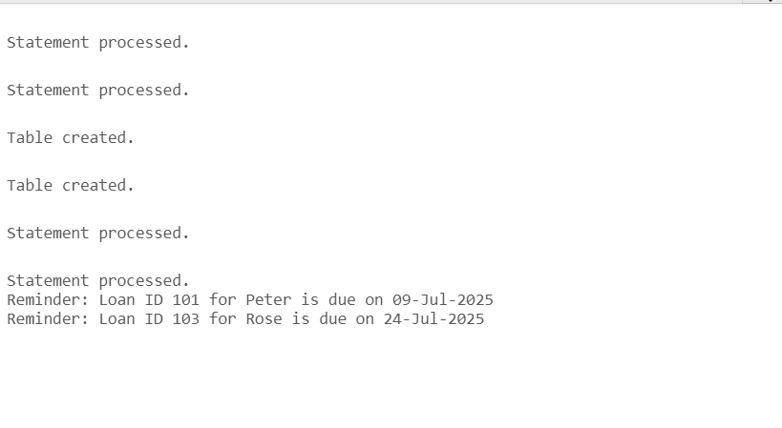

**EXCERCISE– 3**

**Scenario 1: The bank needs to process monthly interest for all savings accounts**.

* + **Question:**

Write a stored procedure **ProcessMonthlyInterest** that calculates and updates the balance of all savings accounts by applying an interest rate of 1% to the current balance.

CREATE TABLE savings_accounts (

account_id NUMBER PRIMARY KEY,

customer_id NUMBER,

balance NUMBER

);

INSERT INTO savings_accounts VALUES (1, 101, 1000);

INSERT INTO savings_accounts VALUES (2, 102, 2000);

CREATE OR REPLACE PROCEDURE ProcessMonthlyInterest AS

BEGIN

UPDATE savings_accounts

SET balance = balance + (balance * 0.01);

DBMS_OUTPUT.PUT_LINE('Monthly interest applied to all savings accounts.');

END;

/

BEGIN

ProcessMonthlyInterest;

END;

/

OUTPUT:

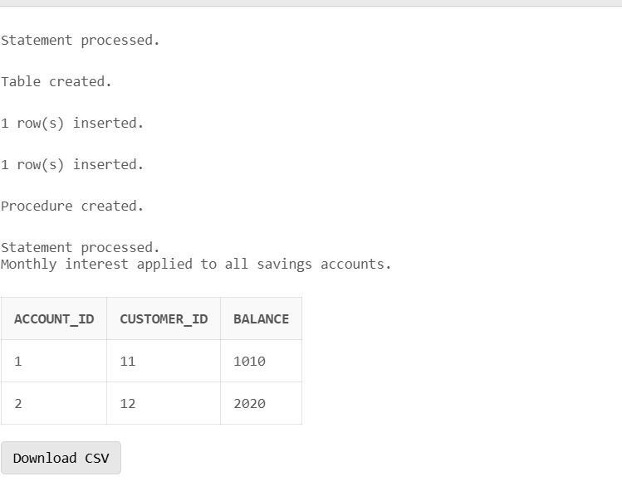

**Scenario 2:** The bank wants to implement a bonus scheme for employees based on their performance.

* + **Question:**

Write a stored procedure **UpdateEmployeeBonus** that updates the salary of employees in a given department by adding a bonus percentage passed as a parameter.

CREATE OR REPLACE PROCEDURE UpdateEmployeeBonus(

p_department IN VARCHAR2,

p_bonus_pct IN NUMBER

) AS

BEGIN

UPDATE employees

SET salary = salary + (salary * p_bonus_pct / 100)

WHERE department = p_department;

DBMS_OUTPUT.PUT_LINE('Bonuses updated for department: ' || p_department);

END;

OUTPUT:

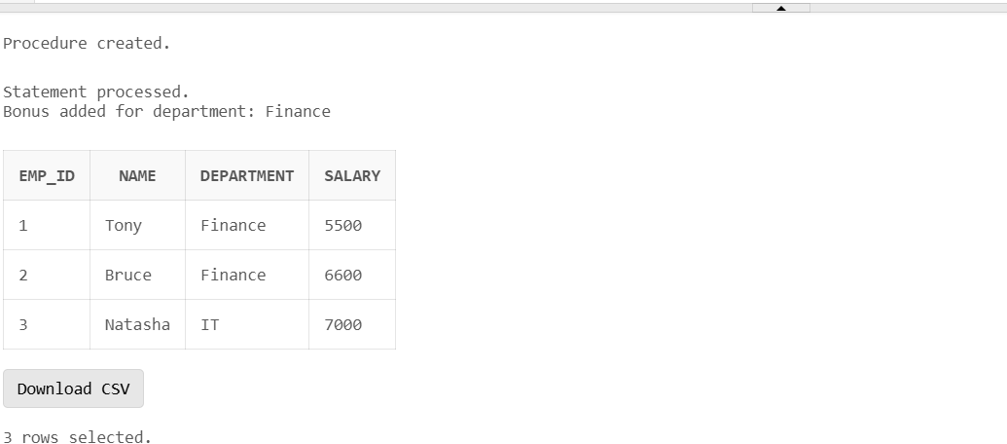

**Scenario 3: Customers should be able to transfer funds between their accounts**.

**Question:**

Write a stored procedure **TransferFunds** that transfers a specified amount from one account to another, checking that the source account has sufficient balance before making the transfer.

CREATE OR REPLACE PROCEDURE TransferFunds(

p_from_account IN NUMBER,

p_to_account IN NUMBER,

p_amount IN NUMBER

) AS

v_balance NUMBER;

BEGIN

-- Check balance of source account

SELECT balance INTO v_balance

FROM bank_accounts

WHERE account_id = p_from_account;

IF v_balance < p_amount THEN

RAISE_APPLICATION_ERROR(-20001, 'Insufficient balance.');

END IF;

-- Deduct from source

UPDATE bank_accounts

SET balance = balance - p_amount

WHERE account_id = p_from_account;

-- Add to destination

UPDATE bank_accounts

SET balance = balance + p_amount

WHERE account_id = p_to_account;

DBMS_OUTPUT.PUT_LINE('Transfer successful: ' || p_amount || ' transferred from ' || p_from_account || ' to ' || p_to_account);

END;

OUTPUT: