ReactJS Mandatory Hands-on-Week 7

Lab 1: ES6 and ReactJS Fundamentals
Objectives:
- List the features of ES6
- Explain let, const, var
- Define class and inheritance in ES6
- Define ES6 arrow functions and use map()
- Apply destructuring and merging arrays
Task:
Create a React Application “cricketapp” with:
1. Component “ListofPlayers”:
- List 11 players and their scores using map()
- Filter players with score < 70 using arrow functions
2. Component “IndianPlayers”:
- Merge T20 and Ranji players using spread operator
- Use destructuring to split odd/even players
3. Show both components based on a flag variable.
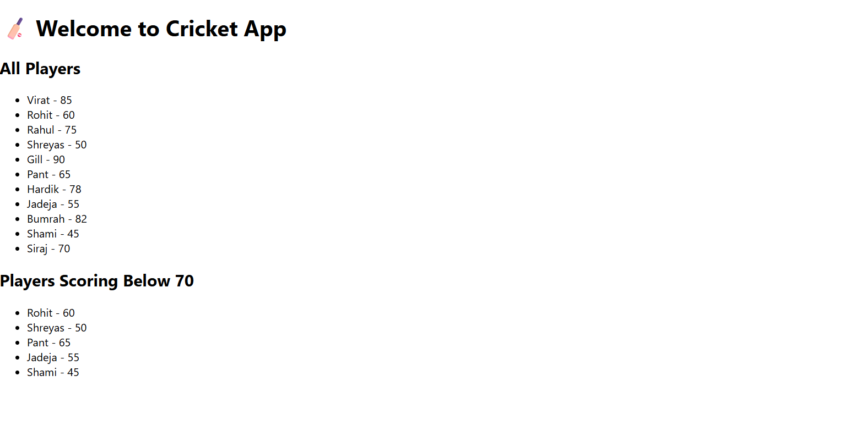

Student Solution:
Implemented using map(), arrow functions, destructuring, and conditional rendering in App.js using a flag.

Lab 2: JSX & Inline CSS in React
Objectives:
- Define JSX and React.createElement()
- Use JavaScript expressions in JSX
- Apply inline CSS styling
Task:
Create a React App “officespacerentalapp” that:
- Displays a heading using JSX
- Shows office image via attribute
- Renders office object with name, rent, and address
- Lists office items using map()
- Colors rent red if < 60000, green otherwise using inline CSS

Student Solution:
Used JSX to embed expressions, created office list, and applied dynamic inline styles using ternary logic.
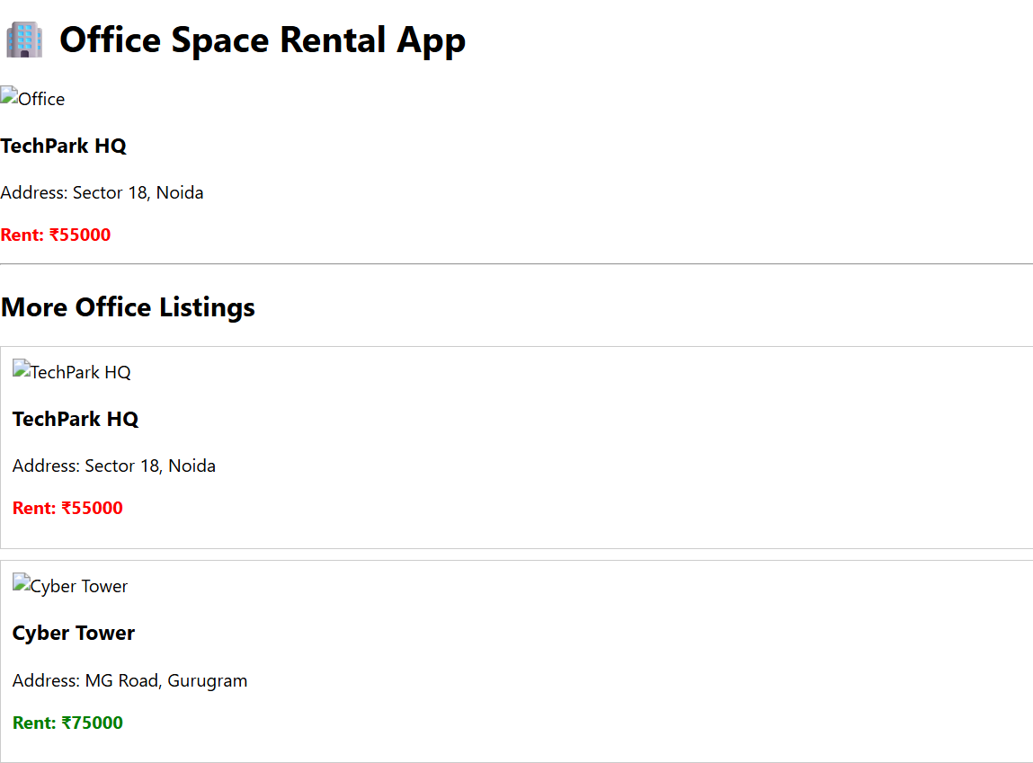

Lab 3: React Event Handling
Objectives:
- Implement React event handling
- Use 'this' keyword and synthetic events
Task:
Create a React App “eventexamplesapp”:
- Create Increment/Decrement counter buttons
- Increment button invokes two functions (increment and sayHello)
- Create "Say Welcome" button that takes an argument
- Use synthetic event to show "I was clicked"
- Add CurrencyConverter to convert INR to EUR

Student Solution:
Used class-based components, bound 'this', handled events via props and synthetic handlers. CurrencyConverter used form and input handling.
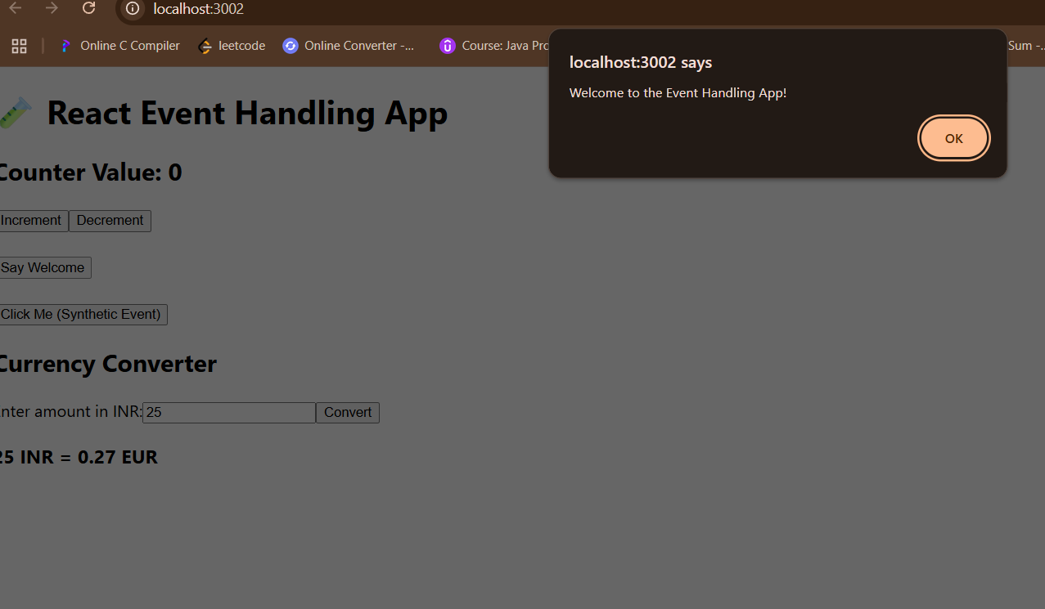

Lab 4: Conditional Rendering - Login Flow
Objectives:
- Implement conditional rendering
- Use element variables to show different views
Task:
Create React App “ticketbookingapp”:
- Guest can view flight details
- Logged-in user can book tickets
- Login/Logout button toggles views

Student Solution:
Used useState to manage login state and toggle between GuestPage and UserPage components using if/else and ternary operator.

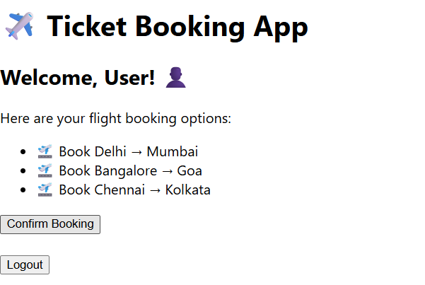
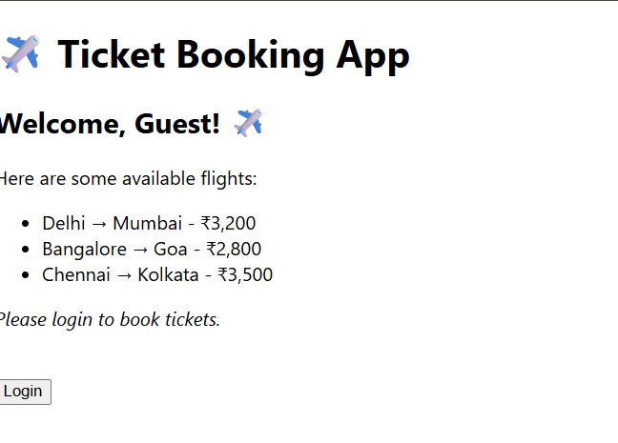

Lab 5: Conditional Rendering & List Components
Objectives:
- Use various conditional rendering techniques
- Use map(), keys, and component extraction
Task:
Create React App “bloggerapp” with:
- BookDetails, BlogDetails, and CourseDetails components
- Render based on button selection
- Use if/else, ternary, && operator, and dynamic content

Student Solution:
Each section conditionally rendered using multiple methods. List components were displayed using map() and proper key usage.
