GLOBAL CANCER PATIENT

1. Introduction
Cancer remains one of the most critical global health challenges, affecting millions annually. With increasing data availability, tools like Microsoft Power BI enable healthcare professionals to analyze patterns, improve decision-making, and enhance patient outcomes.This project develops a Global Cancer Patient Analytics Dashboard to transform raw healthcare data into meaningful insights. The dashboard integrates demographic, clinical, and financial data to provide a comprehensive overview of cancer trends worldwide.

2. Objectives of the Project

- Analyze global cancer patient data
- Understand survival trends and outcomes
- Study age-wise and gender-wise distribution
- Evaluate treatment cost patterns
- Identify high-risk regions using geographic visualization
- Apply DAX for advanced analytics

3. Dataset Description
The dataset includes:
- Patient demographics (Age, Gender, Country)
- Medical details (Cancer Type, Stage, Survival Years)
- Financial data (Treatment Cost)
This allows multi-dimensional analysis of cancer trends.

4. Tools and Technologies Used
- Microsoft Power BI – Dashboard creation
- Excel – Data preprocessing
- DAX – Calculations and measures
- Data Modeling – Relationship building

5. Dashboard Design and Visualizations
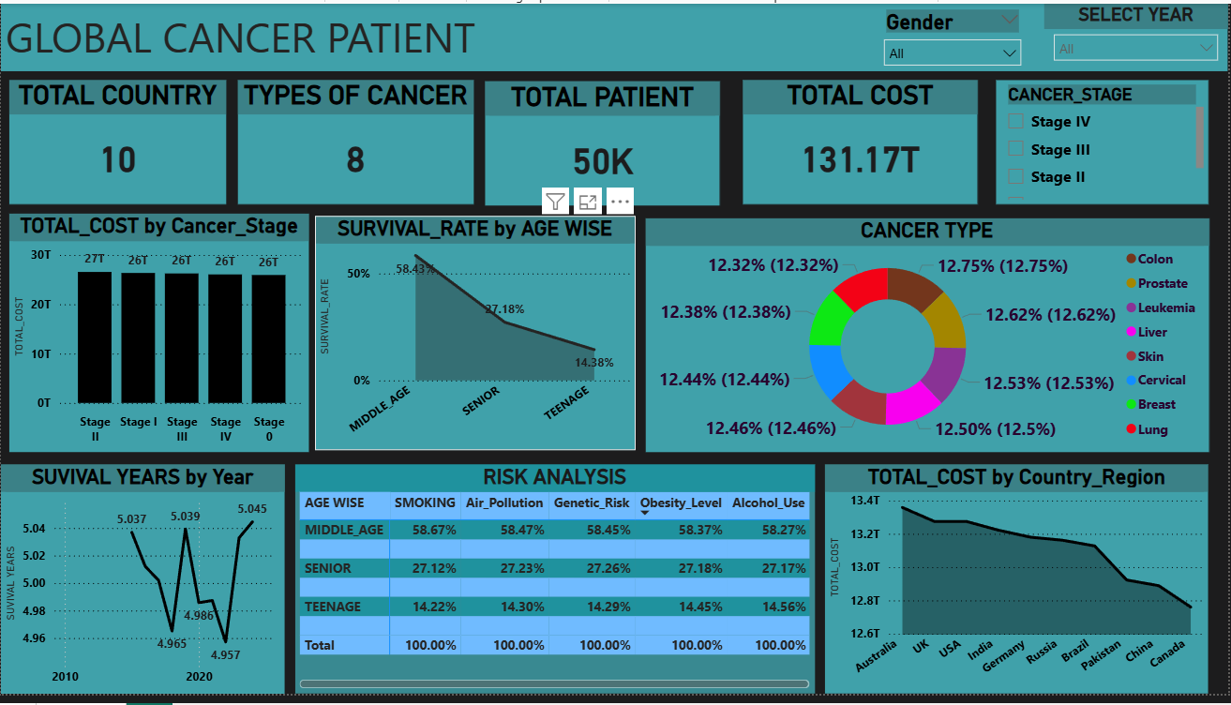

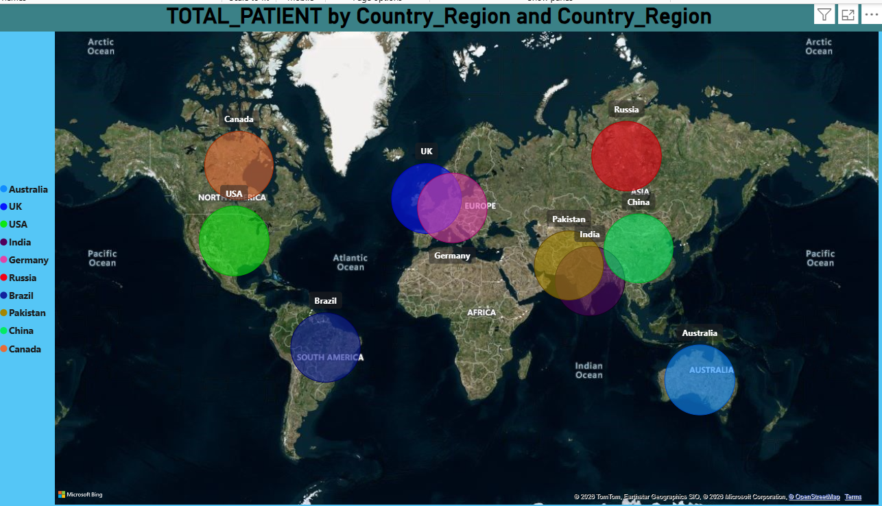

5.1 KPI Overview (Main Dashboard)
From your dashboard:
- Total Countries: 10
- Cancer Types: 8
- Total Patients: 50K
- Total Cost: 131.17T

Insights
- Large dataset indicates significant analytical scope
- High treatment cost reflects economic burden
- Multiple cancer types show disease diversity

5.2 Age Group & Survival Rate Analysis
1. Age Group Classification (AGE WISE)

DAX Formula
AGE WISE =
IF(global_cancer_patients_2015_2024[Age] < 18, "CHILDREN",
IF(global_cancer_patients_2015_2024[Age] < 30, "TEENAGE",
IF(global_cancer_patients_2015_2024[Age] < 71, "MIDDLE_AGE",
IF(global_cancer_patients_2015_2024[Age] >= 70, "SENIOR"))))

Explanation
This calculated column is used to divide patients into different age groups based on their age.

Working Logic
- Age < 18 → CHILDREN
- Age 18–29 → TEENAGE
- Age 30–70 → MIDDLE_AGE
- Age ≥ 70 → SENIOR

Usage in Dashboard
- Helps in analyzing patient distribution by age
- Used in charts and comparisons
- Supports survival and risk analysis by age group

2. Cancer Type Count (CANCER TYPE)

DAX Formula
CANCER TYPE =
DISTINCTCOUNT(global_cancer_patients_2015_2024[Cancer_Type])

Explanation
This measure calculates the total number of unique cancer types in the dataset.

Working Logic
- Counts only distinct values
- Ignores duplicate cancer types

Usage in Dashboard
- Displayed as KPI
- Shows cancer diversity
- Helps in overall summary analysis

3. Survival Rate Classification (SURVIVAL_RATE)

DAX Formula
SURVIVAL_RATE =
IF(global_cancer_patients_2015_2024[Survival_Years] < 4, "LOW SURVIVAL CHANCE",
IF(global_cancer_patients_2015_2024[Survival_Years] < 7, "MEDIUM_LEVEL OF SURVIVAL",
IF(global_cancer_patients_2015_2024[Survival_Years] >= 7, "HIGH RATE OF CHANCE")))

Explanation
This calculated column categorizes patients based on their survival duration.

Working Logic
- Survival < 4 years → LOW
- Survival 4–6 years → MEDIUM
- Survival ≥ 7 years → HIGH

Usage in Dashboard
- Helps classify patient outcomes
- Used in survival analysis visuals
- Makes interpretation easier

4. Average Survival Years

DAX Formula
SUVIVAL YEARS AVG average per Year 2 =
AVERAGE(global_cancer_patients_2015_2024[Survival_Years])

Explanation
This measure calculates the average survival years of all patients.

Working Logic
- Adds all survival years
- Divides by total number of records

Usage in Dashboard
- Displayed as KPI
- Indicates overall treatment effectiveness
- Helps track survival trends

5. Total Treatment Cost (TOTAL_COST)

DAX Formula
TOTAL_COST =
SUM(global_cancer_patients_2015_2024[Treatment_Cost_USD])

Explanation
This measure calculates the total amount spent on cancer treatment.

Working Logic
- Adds all treatment cost values

Usage in Dashboard
- Shows total healthcare expenditure
- Helps compare cost across regions and stages
- Important for financial analysis

6. Total Patient Count (TOTAL_PATIENT)

DAX Formula
TOTAL_PATIENT =
COUNTA(global_cancer_patients_2015_2024[Patient_ID])

Explanation
This measure counts the total number of patients in the dataset.

Working Logic
- Counts all non-empty Patient IDs

Usage in Dashboard
- Displays total number of patients
- Used in KPI summary
- Helps understand dataset size

5.3 Cancer Type Distribution
From donut chart:
- All cancer types are fairly evenly distributed (~12–13%)
- Includes:
  - Lung
  - Breast
  - Cervical
  - Colon
  - Leukemia
  - Skin
  - Prostate

Insights
- No single dominant cancer type
- Indicates balanced dataset
- Suggests equal importance for all cancer categories

5.4 Cancer Stage vs Cost Analysis
From bar chart:
- Treatment cost is consistently high across all stages (~26T–27T)

Insights
- Even early-stage treatment is expensive
- Cost does not drastically reduce in early diagnosis
- Late stages slightly increase cost

5.5 Survival Years Trend
From line chart:
- Survival years range between 4.95 – 5.05 years

Insights
- Slight fluctuations over time
- No major improvement trend
- Indicates stable but stagnant survival outcomes

5.6 Risk Factor Analysis Table
From dashboard:
Age Group | Smoking | Air Pollution | Genetic Risk | Obesity | Alcohol
Middle Age | ~58% | ~58% | ~58% | ~58% | ~58%
Senior | ~27% | ~27% | ~27% | ~27% | ~27%
Teenage | ~14% | ~14% | ~14% | ~14% | ~14%

Insights
- Middle-aged group has highest exposure to risk factors
- Lifestyle factors play a major role
- Risk distribution aligns with survival trends

5.7 Country-wise Patient Distribution (Map Analysis)
From your map visualization:
- High patient concentration:
  - USA
  - China
  - Russia
- Moderate:
  - India
  - Germany
  - UK

Lower:
  - Australia
  - Brazil
  - Pakistan
Insights
- Developed and highly populated countries show higher cases
- Could reflect better reporting systems
- Geographic disparity highlights healthcare inequality

5.8 Cost by Country Region
From line chart:
- Highest cost:
  - Australia
  - UK
  - USA
- Lowest cost:
  - China
  - Canada

Insights
- Developed countries have higher treatment costs
- Developing nations show lower spending
- Indicates affordability gap in healthcare

6. Key Insights and Findings
- Middle-aged population is most affected
- Survival rates decrease with age
- Cancer types are evenly distributed
- Treatment costs are extremely high globally
- Geographic trends show concentration in major countries
- Lifestyle risks strongly influence cancer occurrence

7. Conclusion
The Global Cancer Patient Analytics Dashboard successfully demonstrates how Power BI can convert complex healthcare data into meaningful insights.
By integrating DAX calculations and interactive visuals, the dashboard enables:
- Better understanding of cancer trends
- Identification of high-risk populations
- Improved healthcare planning
This project highlights the importance of data-driven healthcare decisions in improving survival outcomes and reducing global cancer burden.

