**RECEIPT OF HOUSE RENT**

(Under Section 1 (13-A) of Income Tax Act)

This is to certify that I have received from ________________________________________ a sum of INR __________________ /-

(in words, Rupees ______________________________________________ towards the rent @ INR _____________ per month for

period of ____________ to ____________ in respect of House No. ____________________________________ situated at _______  
  
___________________________________________________________________________________________________________

__________________________________________________________________________________________________________.

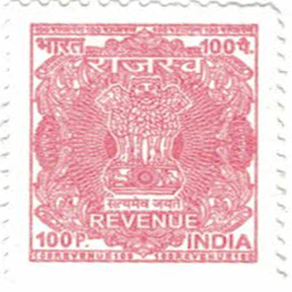

Signature of House Owner

Date:

Name:

PAN No. _____________________

**RECEIPT OF HOUSE RENT**

(Under Section 1 (13-A) of Income Tax Act)

This is to certify that I have received from ________________________________________ a sum of INR __________________ /-

(in words, Rupees ______________________________________________ towards the rent @ INR _____________ per month for

period of ____________ to ____________ in respect of House No. ____________________________________ situated at _______  
  
___________________________________________________________________________________________________________

__________________________________________________________________________________________________________.



Signature of House Owner

Date:

Name:

PAN No. _____________________