CALCULATING MIXED STRATEGY -

LIBRARY REQUIREMENTS - gambit and pulp

The approach is loosely based on the Lemke-Hawson algorithm discussed in class.

The game is initially rescaled by adding the most negative element in both the row player and column player utilities. This process does not affect the calculated mixed startegies.

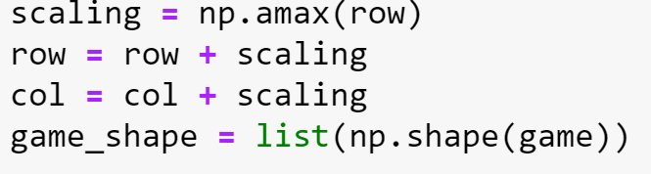

The rows of the row utility matrix are multiplied respectively row wise with the probabilities in chronological order of the column player. Same is done with the column utility matrix which is column wise multiplicated with the row probabilities. This is done by matrix multiplying appropriately the utility matrices with the define pulp variables.

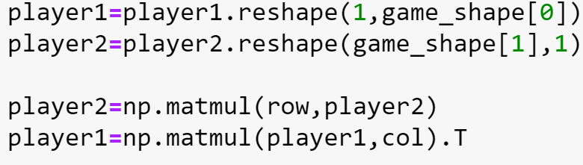

This operation yields a system of a linear programs , and our intent is to maximize the sum of variables in the linear program. The library "PULP" is used to calculate the required result of the linear programs.

Finally the output of pulp is rescaled so as to meet the requirement that the summation of probabilities of a player equals 1.

Time complexity – Except for pulp linear program there are only single loops. Pulp is expected to have polynomial time complexity. Worst case is O(2^n).

