MESHA · GOAT OS
CEO & Leadership
What you own, what you can decide, and what you deliberately cannot

For the CEO and CXO group · Full visibility across both parks

This handbook shows what you see on the Mesha phone app, what you are
responsible for, and exactly which buttons to press for each job.
Every picture is a real screen from the app.

What this job is
You see everything and you plan the work. You are the only person who can raise a weighing round, you close finished vaccination drives, you decide on births, deaths and moves, and you can read every proof video and every verdict on the system.
There is exactly one thing you cannot do, and it is on purpose. You cannot approve or reject a proof video. You can watch every one of them, see who decided what and when, and act on the result — but the yes/no belongs to the Verifier alone. A second check is not a check if the people being checked can sign it themselves.

Your areas on the phone
Area | What it gives you | Buttons along the bottom
Vaccination | The whole vaccination picture and the button that closes a drive | Overview · Calendar · Videos · Alerts
Weighing | Every weighing task across both parks, plus weight and growth read-outs | Tasks · Videos · Weights · Growth · Alerts
Herd Operations | Recording births, deaths and moves | Birth · Death · Shifting
Feed | The daily sheet, the packing list and the transport list | Feed Direction · Feed Packing · Feed Transport
Health | Animals under treatment | Adults · Kids
Milk | Kid milk preparation, feeding and colostrum | Milk Prep · Milk Feeding · Colostrum
Approvals | The birth, death and shifting decisions waiting on you | Approval
Breeding | Marked Soon — not built yet | —

You will not see a scan button in Weighing
You plan weighing rounds; you do not carry them out. The app deliberately keeps the scanning screen away from you, because you are never the person assigned to a shed and the submission would be refused anyway. Your reopen and close powers are unaffected.

Getting into the app
Everyone signs in the same way. What you see after signing in depends on your job.
Step 1 · Open the Mesha app and sign in  Use your Mesha work email and password, or tap Continue with Google if your account is set up that way. If you forget your password, tap Forgot password? and follow the email.  - You can change the app language at the bottom of this screen.  - Sign in once — the app keeps you signed in on that phone. | 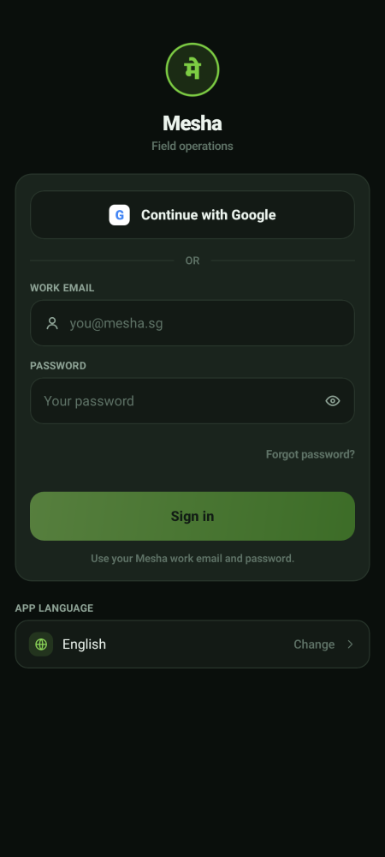  Sign-in screen

Step 2 · Land on your home screen  You land in Vaccination, on today's sheds across your parks. The row of buttons across the bottom is your menu — those are the only places this job needs to go. | 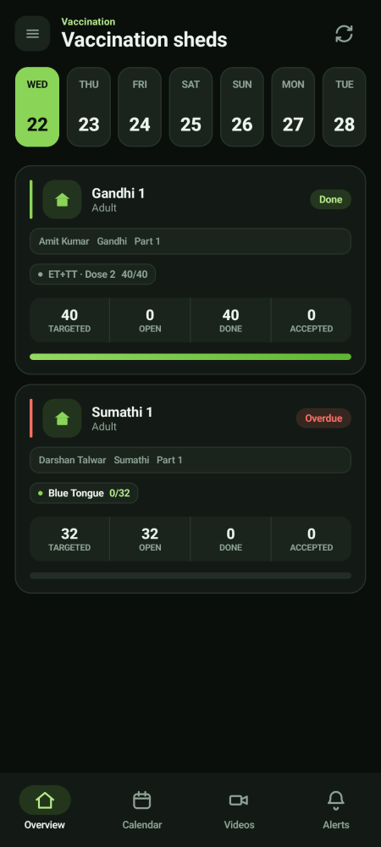  Your home screen

Step 3 · Switch between your areas of work  If you look after more than one area, a menu button (☰) appears at the top left. Tap it to slide open your list of areas and switch between them. Your name and Sign out sit at the bottom of that panel.  - Areas marked Soon are not built yet — they are there so you know what is coming.  - If you look after only one area there is no menu button, and everything you need is already on the bottom bar. | 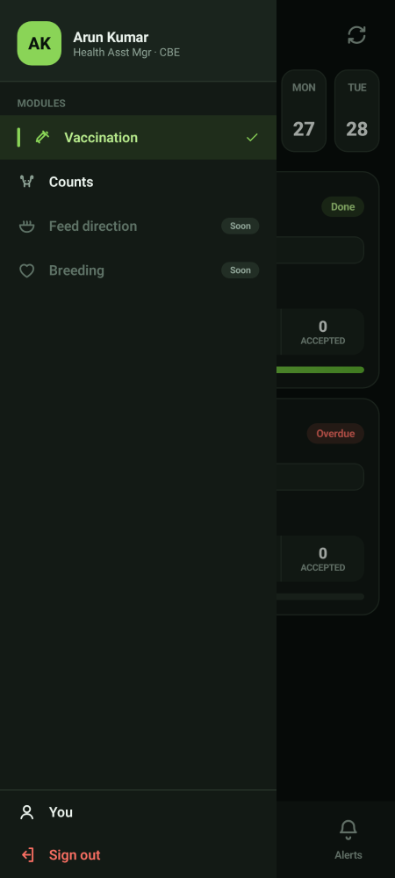  The areas panel

Vaccination · running the picture and closing drives
Step 1 · Read the Overview  The Overview is your daily read of vaccination. The big green card is process integrity — how much of what was scheduled has actually been given. Below it are doses given, doses pending, today's sheds, the backlog by vaccine, and anything needing a decision.  - All parks at the top switches between both parks and one park.  - Data gaps takes you to records that are incomplete.  - Verified · ready to close at the bottom is the list you act on. | 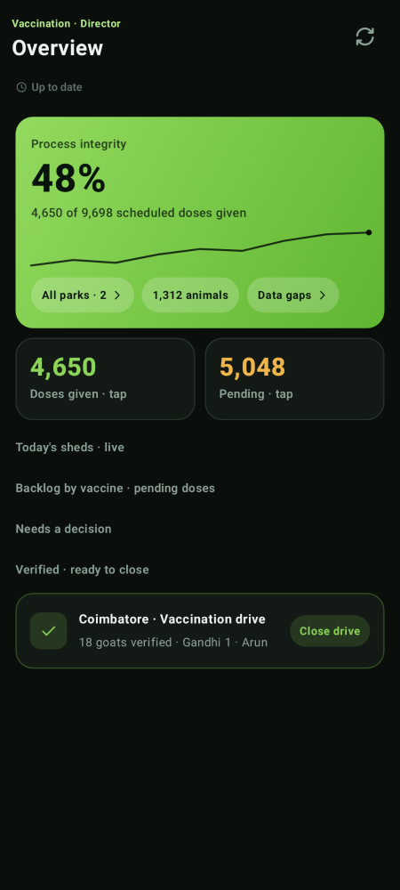  Vaccination Overview

Step 2 · Close a drive that has been verified
When a drive shows under Verified · ready to close, the field work is done and the Verifier has passed the videos. Check the line — how many animals were verified, which shed, which operator — then tap Close drive.
- Only close a drive that appears in this list. If it is not there, something is still waiting on the Verifier.
- Closing is a leadership act. Operators cannot do it.

Step 3 · Use the Calendar to look ahead  The Calendar shows the week or the month. A dot under a date means work exists that day. Tap a date to see what is due, and tap through into a specific drive. | 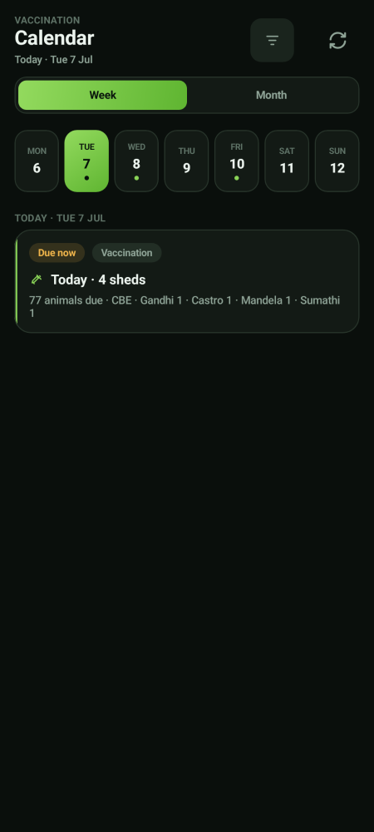  Calendar

Step 4 · Watch the overdue list  Overdue work is split into two, and the difference matters:  - In buffer (amber) — late, but there is still time to fit the animals into a compatible drive. No dose has been missed. Reschedule it.  - Missed (red) — the dose window has closed. Those animals did not get the vaccine in time, and that needs a decision, not a reschedule. | 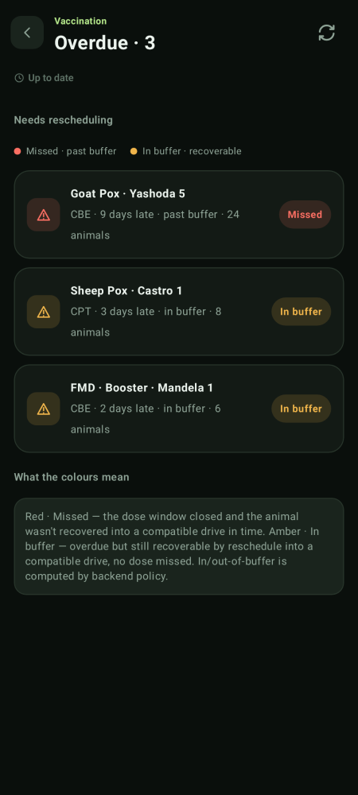  Overdue work

Weighing · you are the only person who can raise a round
Weighing is planned centrally. Nobody else — not the Growth Director, not a Park Head — can raise a weighing task. The Growth Director oversees the operators and can weigh; you decide that a round happens at all.
Step | Who does it
Raise the weighing round and assign each shed to one operator | You
Weigh the animals and record the videos | The assigned operator (or the Growth Director)
Approve or reject each video | The Verifier
Close the shed once every video has passed | You or the Growth Director
Reopen a closed shed so more animals can be added | You or the Growth Director

One shed, one operator
Every weighing shed belongs to exactly one person. If a park needs more hands, the answer is more sheds in the plan — never two operators on the same shed. A rejected video always goes back to that same person.

Your Weights and Growth tabs are the read-outs of all this: average weight by breed, sex and stage, and growth over time. They are yours as the planner; the Growth Director does not carry them.

Approvals · births, deaths and moves
Work the Approvals queue  Open Approvals. Each row is a request raised in the field: a birth, a death, or a move between sheds. Read the summary — who raised it, which shed, how many animals — and decide.  - Birth approved → the animal joins the herd. Death approved → it leaves.  - A move needs your approval *and* the operator's video. Whichever comes second is the moment the animals actually change shed.  - The queue only shows you the kinds of request you are allowed to decide. | 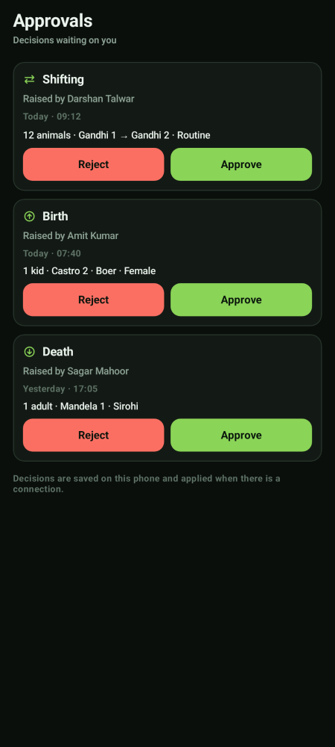  The approvals queue

Videos · what you can and cannot do
You see the whole trail, not just the open items  The Videos tab shows the complete evidence trail for the area you are in — pending, approved, rejected and already closed. Filter by Due, Approved and Rejected, and move the date across the top.  - You can watch any clip and see the verdict that was recorded against it.  - You cannot cast the verdict yourself. If work is stuck waiting, the fix is to get the Verifier to review it.  - You can send the underlying job back for re-work and reassign it — that is the leadership lever, and it is separate from the verdict. | 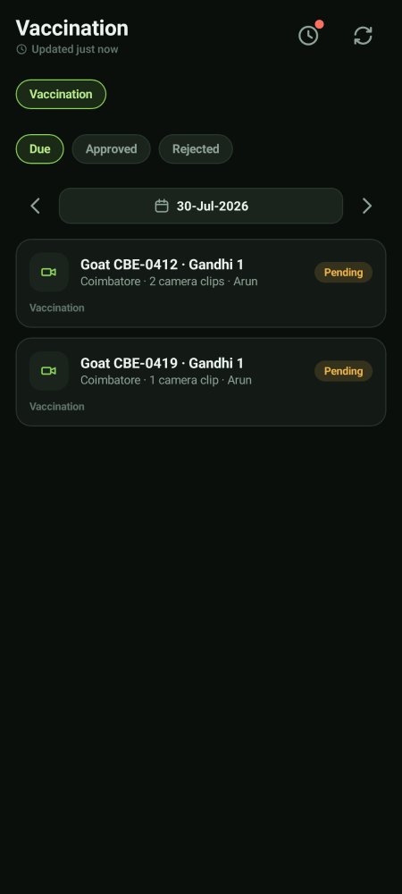  The evidence trail

What only you can do
Decision | Where
Raise a weighing round and assign the sheds | Weighing · Tasks
Close a vaccination drive once verified | Vaccination · Overview
Close or reopen a weighing shed | Weighing
Approve or reject a birth, a death or a move | Approvals
Change the vaccination schedule | On the laptop
Change the ration grid | On the laptop (shared with the Feed Director)
Change treatment protocols | On the laptop (shared with the Health Director)

What you cannot do, and why
You cannot… | Because | Who can
Approve or reject a proof video | The check must be independent of the people being checked | The Verifier, and only the Verifier
Scan animals in a weighing shed | You are never the assigned operator, so the submission would be refused | The assigned operator, or the Growth Director
Close a weighing shed with videos still waiting | The gate is unconditional — there is no override anywhere in the app | Nobody. Get the videos reviewed first
Force a shed move through without the video | The video is the proof the move happened | Nobody

Your account and settings
The You screen  Tap You (in the bottom bar, or at the bottom of the areas panel) to see your name, the parks you cover, your app language, and Sign out. | 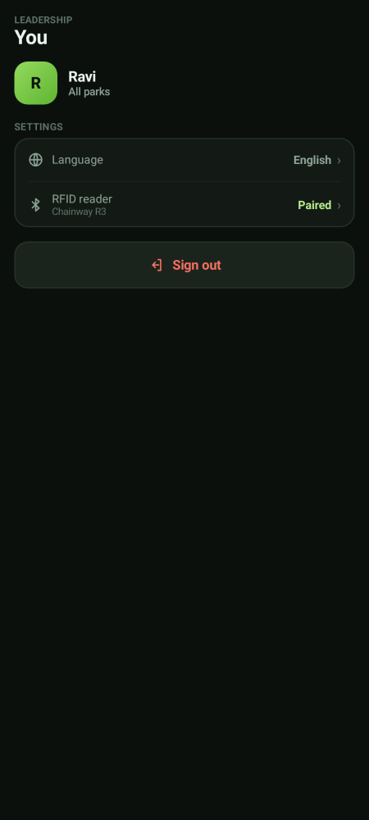  Your account

If you lose network
Keep working — nothing is lost  If the phone goes offline you will see a yellow bar at the top. Keep working. Everything you record is saved on the phone and sends itself the moment signal comes back.  - Do not sign out while the bar is showing — sign out only after it clears.  - Videos also queue up and upload in the background.  - Pull down or tap the refresh icon once you are back in signal. | 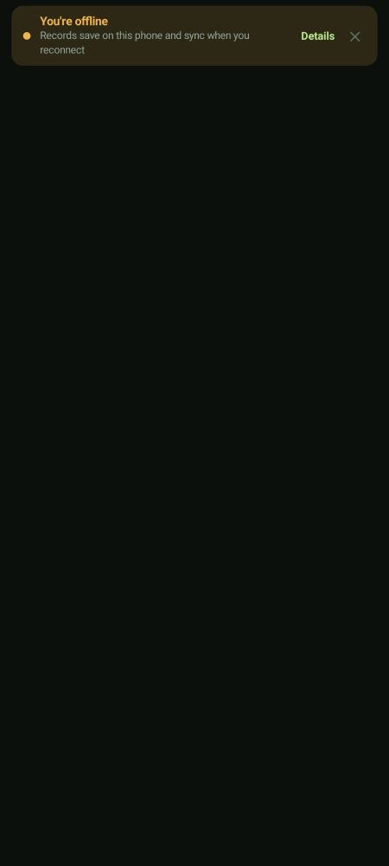  Offline notice

