MESHA · GOAT OS
Preventive Care Director
Vaccination is yours. Here is how you run it.

For the Preventive Care Director · Vaccination across both parks

This handbook shows what you see on the Mesha phone app, what you are
responsible for, and exactly which buttons to press for each job.
Every picture is a real screen from the app.

What this job is
You own Vaccination. You watch the schedule, you keep the drives moving, you can go out and scan and submit yourself, and you close a drive once the proof has passed. You also carry Health — you can diagnose an animal and set it on a treatment course.
Preventive Care and Health are two different departments
You are the Preventive Care Director. The Health Director is a different person with a different remit, and the two jobs are deliberately kept apart. You do not get Feed, Weighing execution, or the herd register.

Your areas on the phone
Area | What you get | Buttons along the bottom
Vaccination | The calendar, the evidence trail and the drive-closing controls | Calendar · Videos · Alerts
Weighing | Notices only, so you are not blind to it | Alerts
Health | Animals under treatment, adults and kids | Adults · Kids

Getting into the app
Everyone signs in the same way. What you see after signing in depends on your job.
Step 1 · Open the Mesha app and sign in  Use your Mesha work email and password, or tap Continue with Google if your account is set up that way. If you forget your password, tap Forgot password? and follow the email.  - You can change the app language at the bottom of this screen.  - Sign in once — the app keeps you signed in on that phone. | 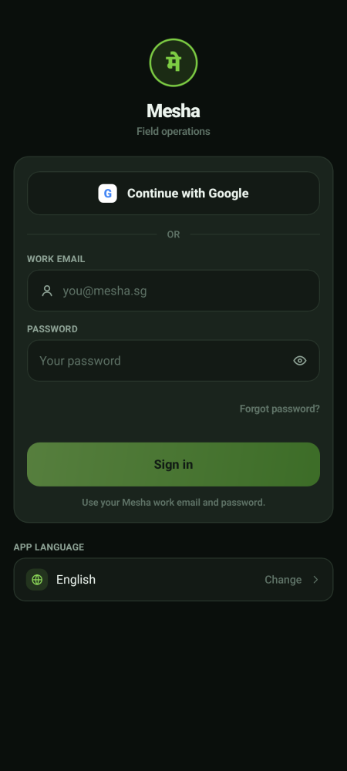  Sign-in screen

Step 2 · Land on your home screen  You land in Vaccination. The row of buttons across the bottom is your menu — those are the only places this job needs to go. | 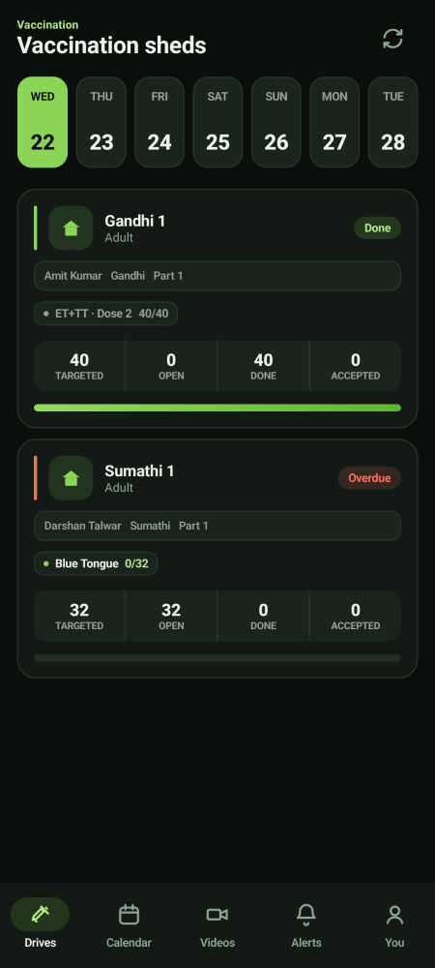  Your home screen

Step 3 · Switch between your areas of work  If you look after more than one area, a menu button (☰) appears at the top left. Tap it to slide open your list of areas and switch between them. Your name and Sign out sit at the bottom of that panel.  - Areas marked Soon are not built yet — they are there so you know what is coming.  - If you look after only one area there is no menu button, and everything you need is already on the bottom bar. | 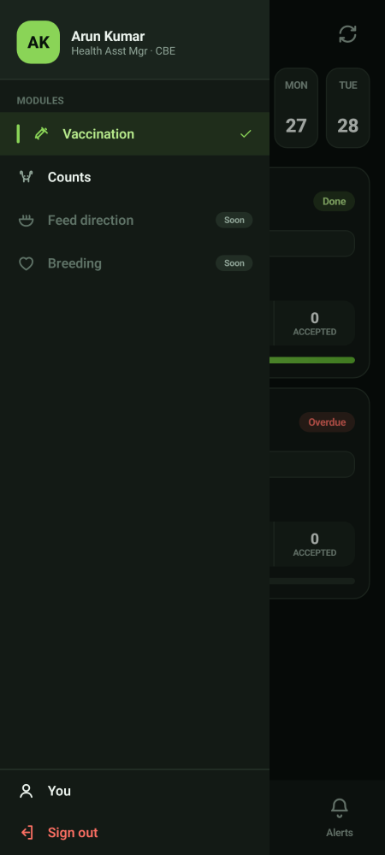  The areas panel

Running the vaccination week
Step 1 · Start on the Calendar  The Calendar is your planning view. Switch between Week and Month. A dot under a date means work exists that day. Tap a date to see the sheds and the animal counts, and tap through into a drive.  - Due now in amber is work that should be happening today.  - The line under each entry names the park and the sheds so you can see the shape of the day at a glance. | 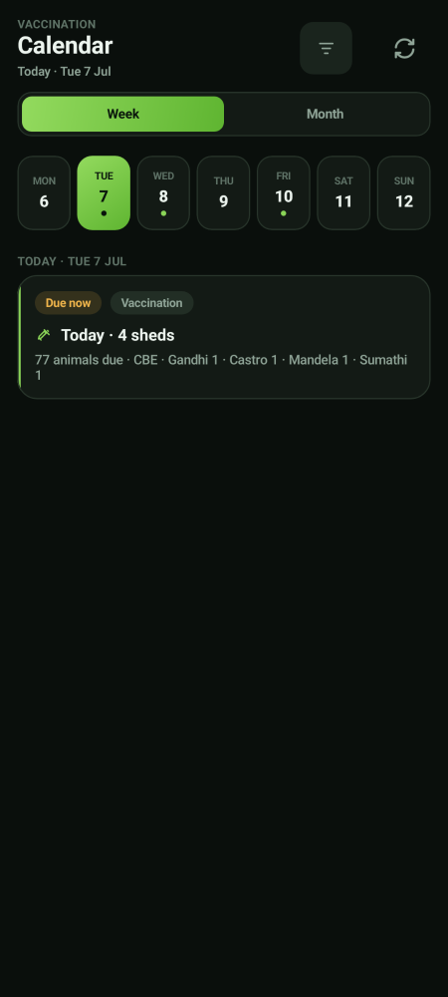  Vaccination calendar

Step 2 · Read the day's sheds  Inside a day you get one card per shed: how many animals are targeted, how many are still open, how many are done, and how many the Verifier has already accepted. The grey line names the operator and the partition.  - A red Overdue label means that shed was due earlier and still is not done. Chase it.  - The green bar across the bottom of a card is that shed's progress. | 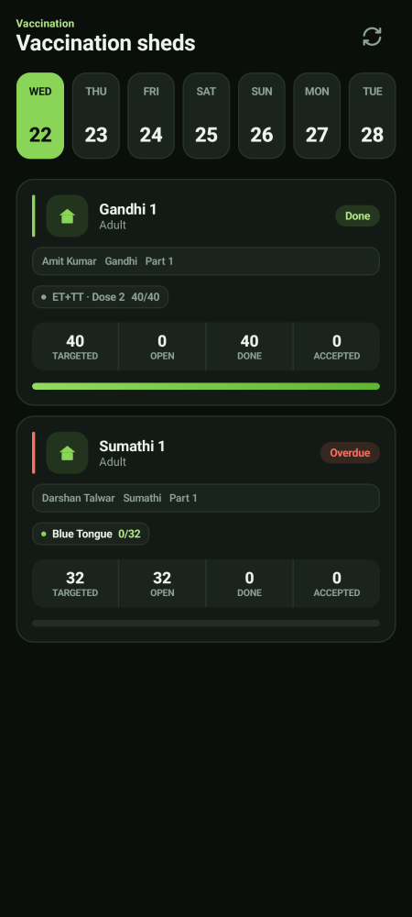  A day's sheds

Step 3 · Deal with overdue work properly  Overdue work is not all the same:  - In buffer (amber) — late but recoverable. Reschedule those animals into a compatible drive and no dose is missed.  - Missed (red) — the window closed. That is a clinical fact to be acted on, not a scheduling problem. | 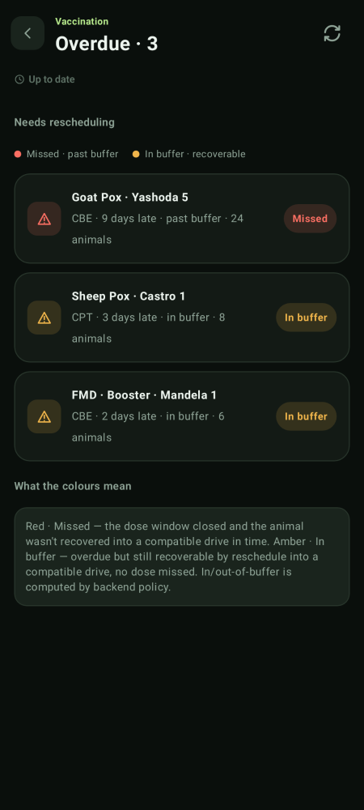  Overdue, split by whether it is still recoverable

If you go out and vaccinate yourself
You are allowed to scan and submit like an operator. The flow is identical to theirs: open the shed, scan the tag, the camera opens by itself, film the injection, submit the clip, and finalise the shed at the end.
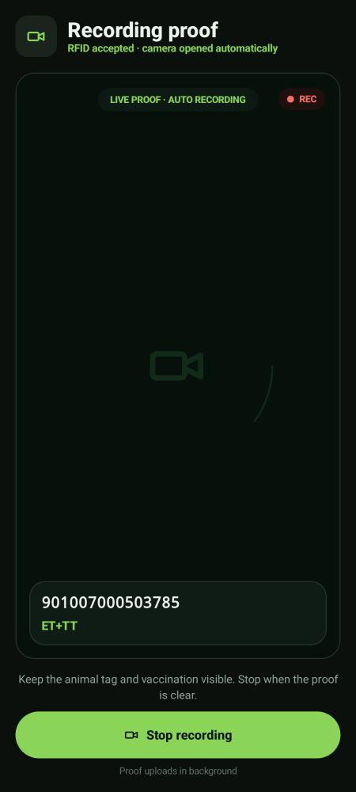  The camera opens on a valid scan | 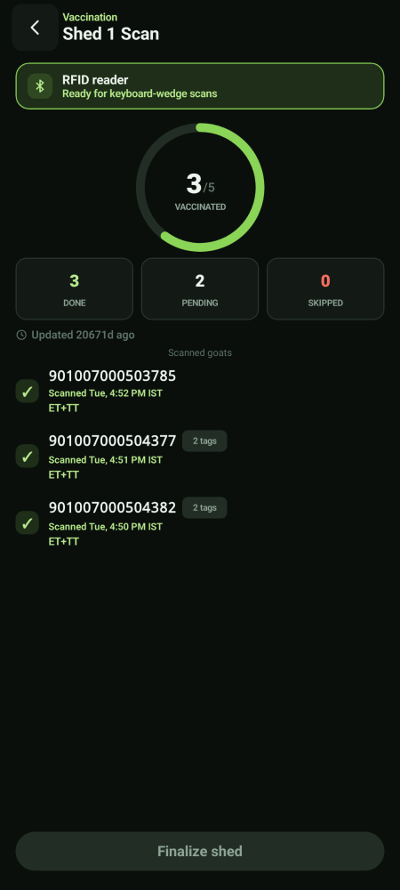  Accepted animals build up | 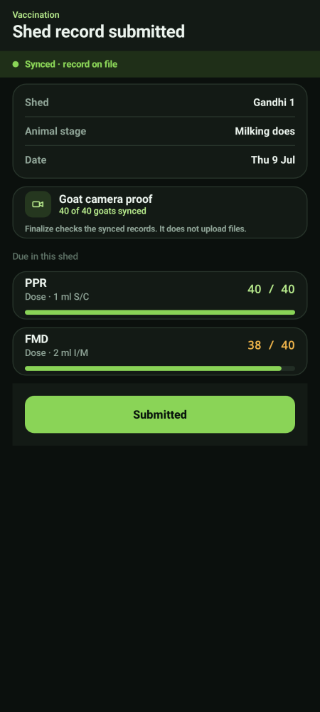  Submitted and synced

The refusals apply to you too
Already scanned, Unknown tag and Wrong shed stop the camera opening. That is the same protection the operators get and it is not something your job overrides.

Closing a drive
Step 1 · Find what is ready  On the Overview, the Verified · ready to close section lists drives where the field work is finished and the Verifier has passed the videos. The line tells you how many animals were verified, in which shed, by which operator. | 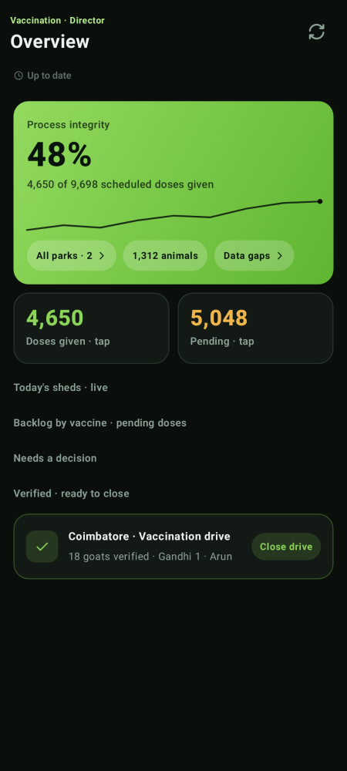  Ready to close

Step 2 · Close it
Tap Close drive. That is the end of the job.
- If a drive is not in this list, something is still with the Verifier. Chase the review — there is no way to close around it.

How progress is counted, so the numbers make sense
A drive reads 100% once the animals have been vaccinated and the proofs submitted — because the field work genuinely is done. The outstanding video review is carried as its own status, not by holding the percentage down. An operator who has finished every animal should never be shown 0%.

Videos · you see everything, you decide nothing
The evidence trail  Your Videos tab shows the complete trail — pending, approved, rejected and already closed — filtered by Due, Approved and Rejected, with a date picker.  - You can watch every clip and see every verdict.  - You cannot approve or reject. That belongs to the Verifier alone, so that the check on your department is independent of your department.  - You can send a job back for re-work and reassign it. That is your lever. | 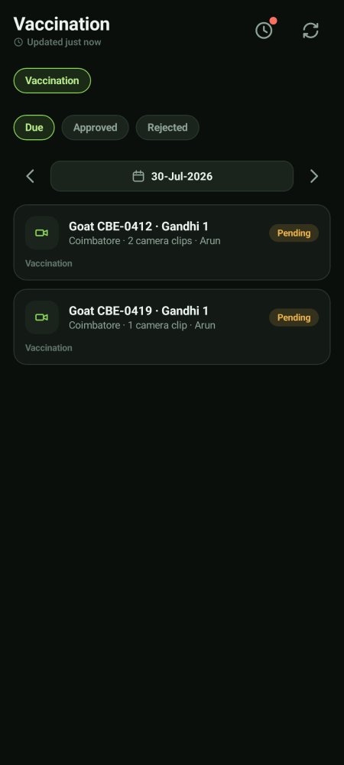  Vaccination evidence

Health
The Health area lists animals on a treatment course, split into Adults and Kids. You can diagnose an animal and put it onto a course. The standing treatment rulebook itself — which medicine, which dose, on which day — is written by the Health Director on the laptop, and an animal already mid-course finishes on the version it started on.
Sick animals are protected from vaccination automatically
An animal that is sick, under treatment, in quarantine or in ICU has its vaccination work held until it recovers. It is never cancelled and never left quietly due. This is a medical safety rule and it cannot be switched off.

What you do not get, and where it lives
Not yours | Why | Whose it is
Approving or rejecting a proof video | Independence of the second check | The Verifier
Weighing execution and oversight | One module, one director | The Growth Director
The feed sheet and the ration grid | One module, one director | The Feed Director
The herd register and tagging | Separate department | The Health Director
Raising a weighing round | Planning weighing is central | The CEO

If you also approve births, deaths and moves
Some people carry approval authority as an individual, on top of this job. If you do, an extra Approvals area appears in your menu. That authority is attached to you personally, not to the Preventive Care Director post — the next person to hold this job does not inherit it. See handbook 09 · Approver.

Your account and settings
The You screen  Tap You (in the bottom bar, or at the bottom of the areas panel) to see your name, the parks you cover, your app language, and Sign out. | 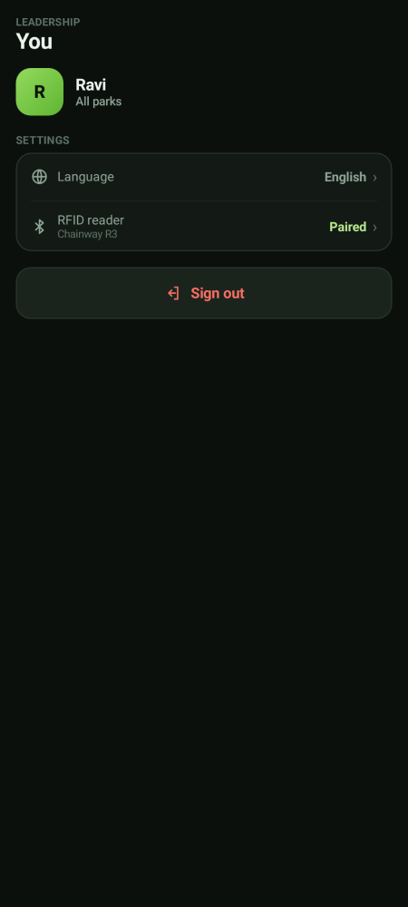  Your account

Pairing the RFID reader  From You, tap RFID reader. The reader behaves like a small keyboard: when you scan a tag it types the number straight into the app, so you never type a tag by hand.  - Use Test read to check the reader before you start a round.  - If it says not connected, tap Re-scan for readers, then Open Bluetooth settings if it still does not find it.  - Check the battery percentage on this screen before a long round. | 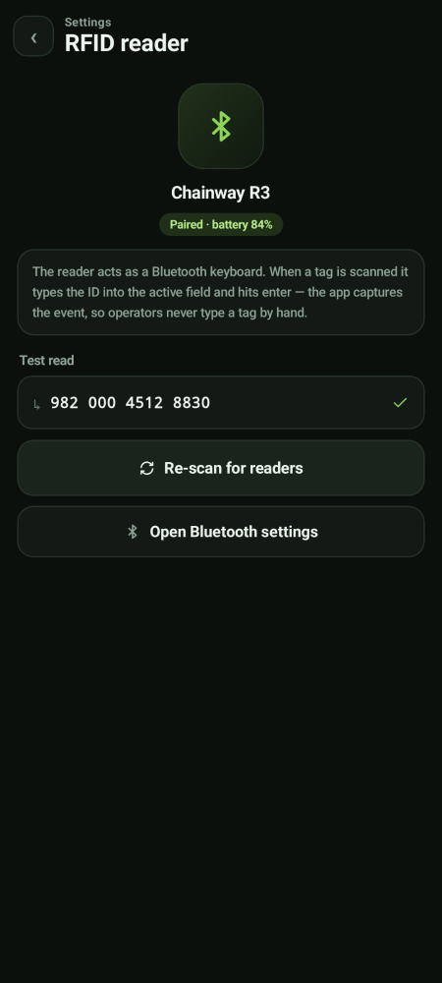  RFID reader settings

If you lose network
Keep working — nothing is lost  If the phone goes offline you will see a yellow bar at the top. Keep working. Everything you record is saved on the phone and sends itself the moment signal comes back.  - Do not sign out while the bar is showing — sign out only after it clears.  - Videos also queue up and upload in the background.  - Pull down or tap the refresh icon once you are back in signal. | 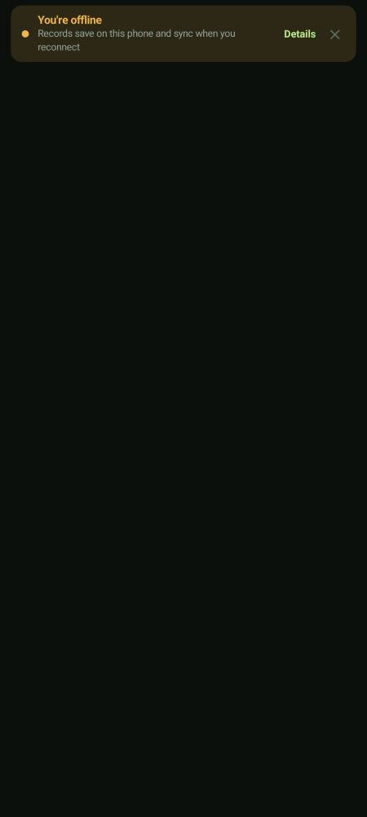  Offline notice

