MESHA · GOAT OS
Growth Director
Weighing, and only weighing

For the Growth Director · Weighing across both parks

This handbook shows what you see on the Mesha phone app, what you are
responsible for, and exactly which buttons to press for each job.
Every picture is a real screen from the app.

What this job is
You own weighing. You oversee the operators doing it, you can go and weigh yourself, you watch the videos, and you can close a finished shed or reopen one that needs more animals added.
One thing sits outside your job on purpose: you do not raise the weighing round. That is the CEO's decision. You run it once it exists.

Your bottom bar
Button | What it is
My work | Sheds assigned to you personally. This is the only list with a scan action.
Operators | Everybody else's weighing work, read-only. This is your oversight view.
Videos | The weighing evidence trail — pending, approved and rejected.
Alerts | Assignments, submissions, reopens, re-work and closures.
You | Your account, language and RFID reader.

Weighing is only one area for you, so there is no menu panel
You get a clean bottom bar with You on it rather than a slide-out list of areas. That is by design: you have one job on this app.

Getting into the app
Everyone at Mesha signs in the same way. Because Weighing is your only area, you land straight on weighing work — there is no menu of areas to pick from.
Step 1 · Open the Mesha app and sign in  Use your Mesha work email and password, or tap Continue with Google if your account is set up that way.  - You can change the app language at the bottom of this screen.  - Sign in once — the app keeps you signed in on that phone. | 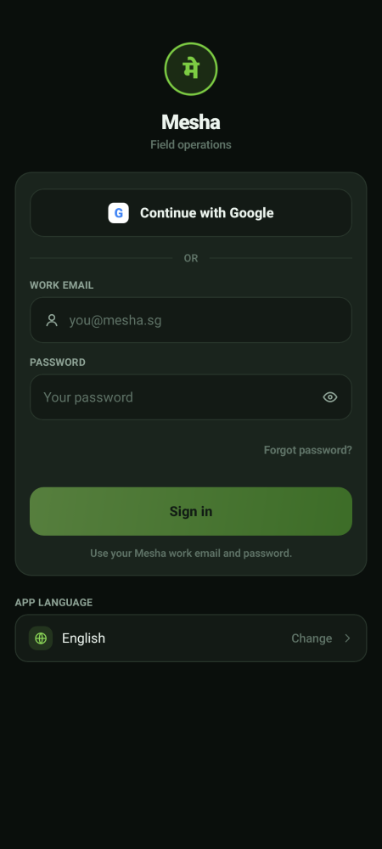  Sign-in screen

Step 2 · Land on My work  You land on the weighing sheds assigned to you. Each one names the park, the week and whether it is an Individual or a Lumpsum shed.  - There is no ☰ menu button — Weighing is your only area, so You sits on the bottom bar instead.  - Your five buttons are My work, Operators, Videos, Alerts and You. | 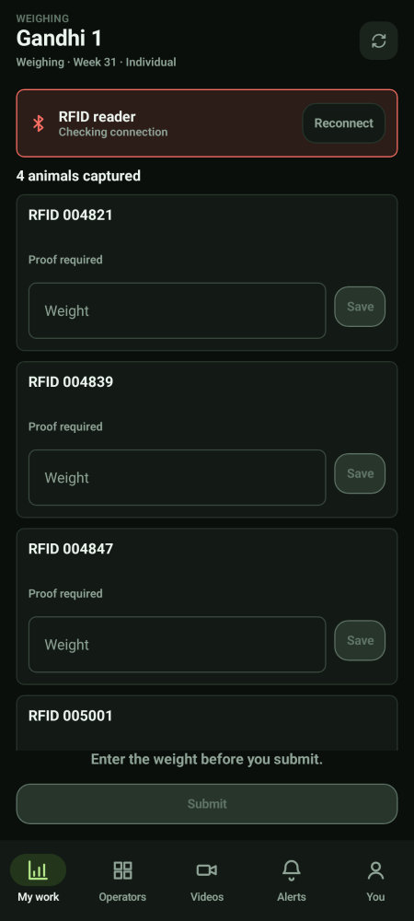  Where you land

How weighing works, end to end
Step | Who
Raise the round and assign each shed to one operator | CEO
Weigh the animals and record the videos | The assigned operator — or you
Approve or reject each video | The Verifier
Close the shed once every video has passed | You or the CEO
Reopen a closed shed to add more animals | You or the CEO

Weighing knows nothing about the animal
It records a scanned tag and a weight. It does not check the herd, the shed roster, vaccination status, or anything clinical, and it never rejects a tag for not being recognised. There is no expected animal count and no percentage. Progress is simply how many observations have been scanned, submitted and verified.

The one business rule
The same animal cannot be weighed twice in the same shed before you submit. That is it. The same tag may legitimately appear in a different shed.

Weighing a shed yourself
Step 1 · Open My work  My work shows only the sheds assigned to you. The subtitle on each tells you whether it is Individual (animal by animal) or Lumpsum (the whole group at once). | 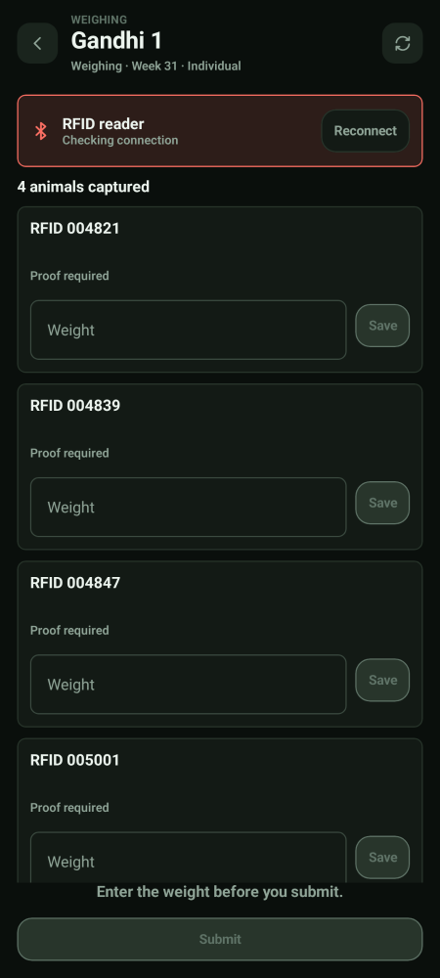  An individual shed

Step 2 · Individual · scan, weigh, film, save  Scan the ear tag, put the animal on the scale, type the weight, record the video, then tap Save on that card.  - Proof required means that animal still needs its video.  - Submit stays greyed out until every card has a weight. | 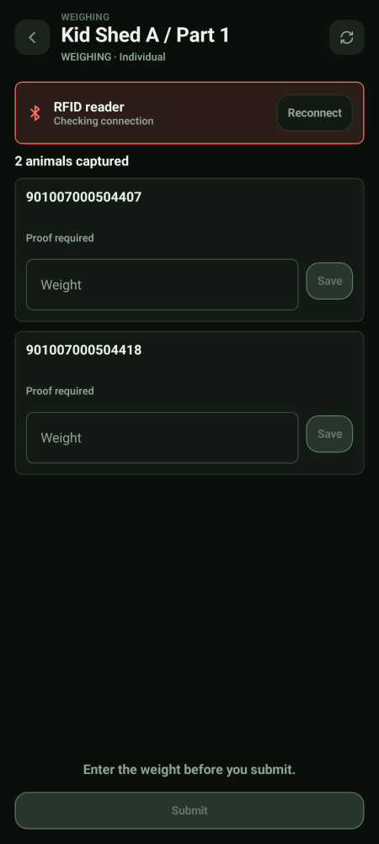  Cards awaiting weight and proof

Step 3 · Lump-sum · weigh the group  No scanning. Enter the total weight and the animal count, tap Capture group video and film the group on the scale, then submit. | 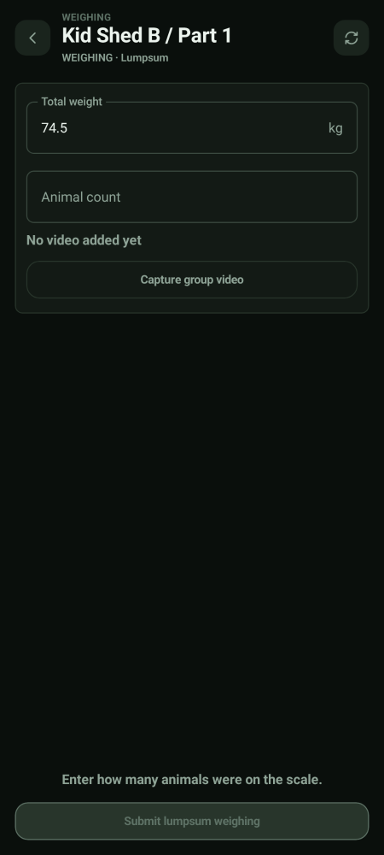  Lump-sum weighing

Step 4 · If you lose signal  You will see Saved on this phone. It will sync when network returns. Carry on — nothing is lost. | 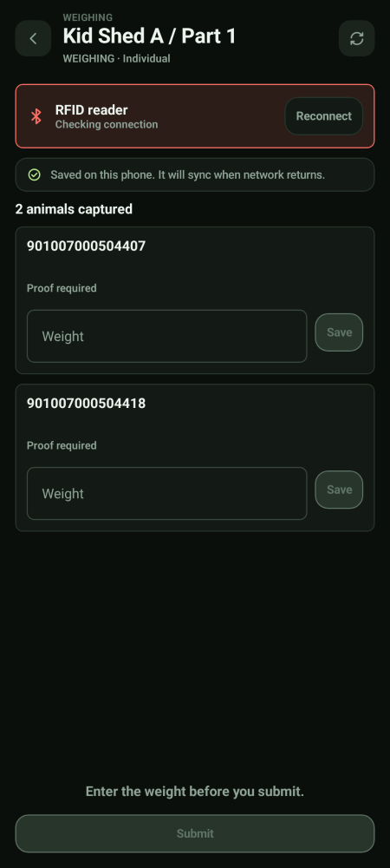  Saved offline

Overseeing the operators
The Operators tab
Operators is everyone else's weighing work, read-only. Use it to see who is behind, whose videos are piling up, and which sheds have not been started.
- You can look; you cannot record on somebody else's shed. The write always stays with the person the shed is assigned to.

The Videos tab  This is the weighing evidence trail. Filter by Due, Approved and Rejected, and move the date across the top. Individual and lump-sum work are shown separately.  - You can watch every clip and see every verdict.  - You cannot approve or reject. That is the Verifier's alone. | 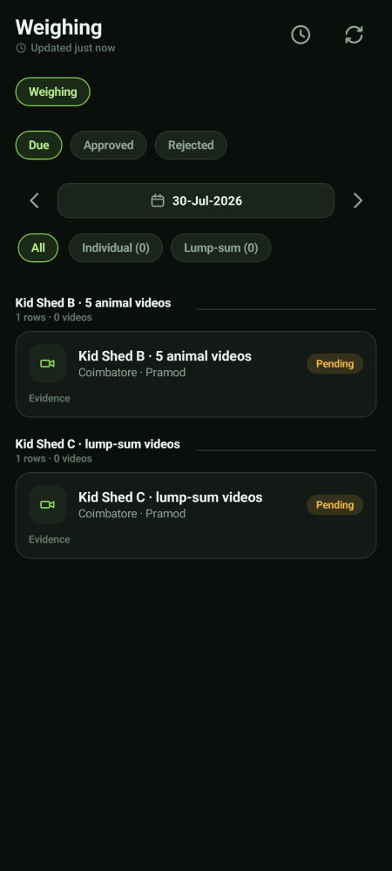  Weighing evidence

Closing and reopening a shed
Step 1 · Close only when everything is verified
A shed moves through Pending → In progress → Completed (operator has submitted) → Closed. It can only be closed once every submitted observation on it has been verified.
- A single rejected video does not close or reopen the shed — it just puts that one observation back in front of that operator.
- There is no force-close and no override. If a shed will not close, get the outstanding videos reviewed.

Step 2 · Reopen when more animals need adding
Reopening puts a closed or completed shed back to In progress, and the same assigned operator can scan more animals and submit again.
- The duplicate rule still holds after a reopen — the same tag cannot be recorded twice in that shed on the same day.
- Only you and the CEO can reopen.

What you do not get
Not yours | Whose it is
Raising a weighing round | The CEO
Approving or rejecting a video | The Verifier
Anything in Vaccination | The Preventive Care Director
The feed chain | The Feed Director
The herd register and tagging | The Health Director
The weight and growth read-outs | The CEO, as the planner

If you also approve births, deaths and moves
Some people carry approval authority as an individual, on top of this job. If you do, an Approvals area appears in your menu. It belongs to you personally, not to the Growth Director post. See handbook 09 · Approver.

Your account and settings
The You screen  Tap You (in the bottom bar, or at the bottom of the areas panel) to see your name, the parks you cover, your app language, and Sign out. | 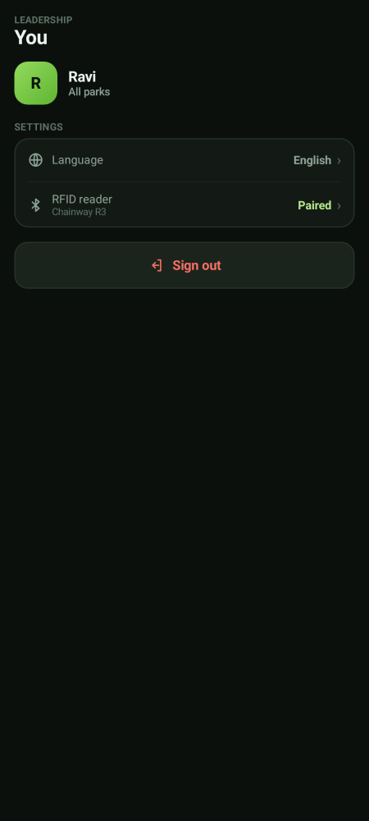  Your account

Pairing the RFID reader  From You, tap RFID reader. The reader behaves like a small keyboard: when you scan a tag it types the number straight into the app, so you never type a tag by hand.  - Use Test read to check the reader before you start a round.  - If it says not connected, tap Re-scan for readers, then Open Bluetooth settings if it still does not find it.  - Check the battery percentage on this screen before a long round. | 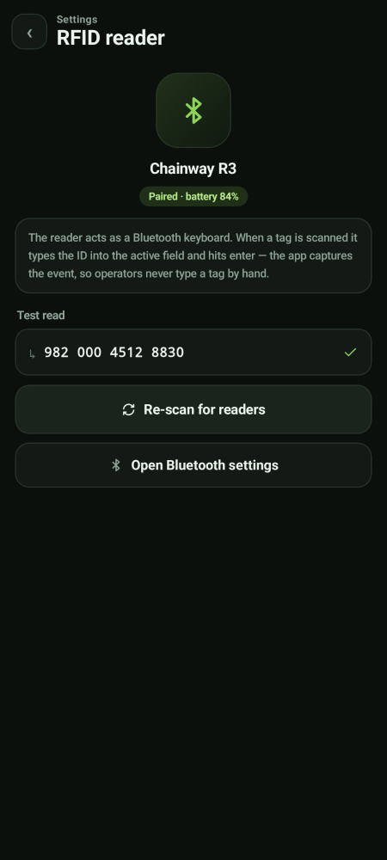  RFID reader settings

If you lose network
Keep working — nothing is lost  If the phone goes offline you will see a yellow bar at the top. Keep working. Everything you record is saved on the phone and sends itself the moment signal comes back.  - Do not sign out while the bar is showing — sign out only after it clears.  - Videos also queue up and upload in the background.  - Pull down or tap the refresh icon once you are back in signal. | 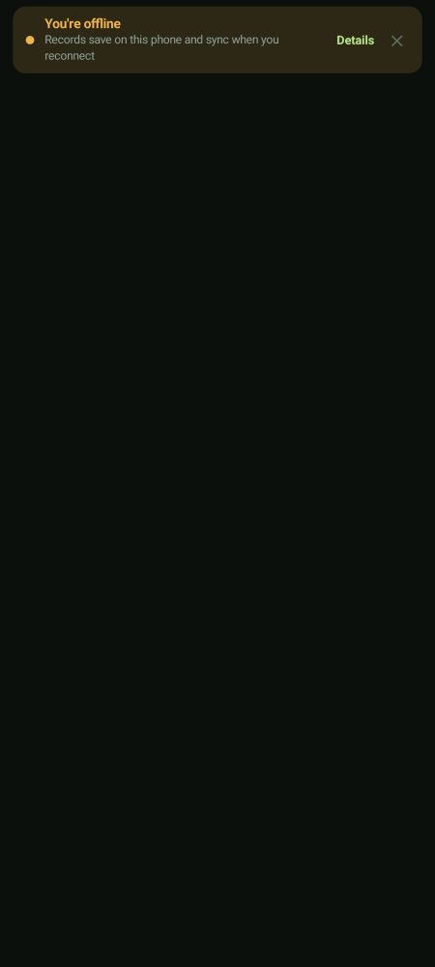  Offline notice

