MESHA · GOAT OS
Feed Director
You direct the feeding. You do not do the feeding.

For the Feed Director · The whole feed chain across both parks

This handbook shows what you see on the Mesha phone app, what you are
responsible for, and exactly which buttons to press for each job.
Every picture is a real screen from the app.

What this job is
You own the feed chain from end to end: the ration grid the daily sheet is calculated from, the sheet itself, the packing worklist, and the daily transport tasks. You issue the directions the day before, and you watch that they were carried out.
Directing is not executing
You can see every page of the chain, and you deliberately cannot record a feed job as done. Field execution goes through the Park Head and the ground team. You direct it; they perform it; the Verifier checks it.

Your bottom bar
Button | What it is
Feed Direction | Today's dispatch sheet — which shed gets what, and how much.
Feed Packing | The per-shed bag worklist and where each shed has got to.
Feed Transport | The daily transport task for each shed, created at 15:30.

Feed is your only area, so there is no slide-out menu — the three tabs are the whole app for you.

Getting into the app
Everyone at Mesha signs in the same way. Because Feed is your only area, you land straight on the feed chain — there is no menu of areas to pick from.
Step 1 · Open the Mesha app and sign in  Use your Mesha work email and password, or tap Continue with Google if your account is set up that way.  - You can change the app language at the bottom of this screen.  - Sign in once — the app keeps you signed in on that phone. | 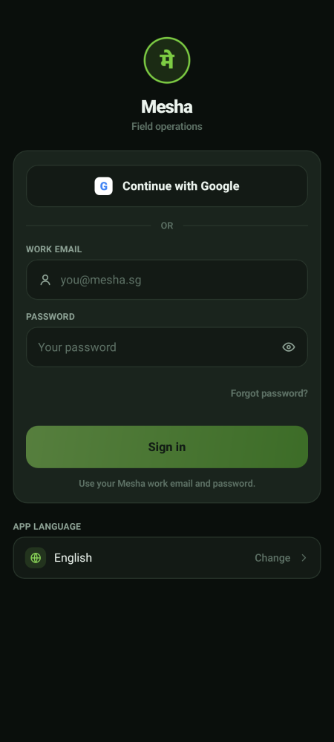  Sign-in screen

Step 2 · Land on the feed chain  Your three buttons are Feed Direction, Feed Packing and Feed Transport — the day's sheet, the bagging worklist, and the transport board. There is no ☰ menu button, because Feed is your only area.  - Every page carries filters for park, shed and status, so you can narrow to one park's outstanding work quickly.  - Status wording is the same across all three: Pending, In review, Completed, Rework. | 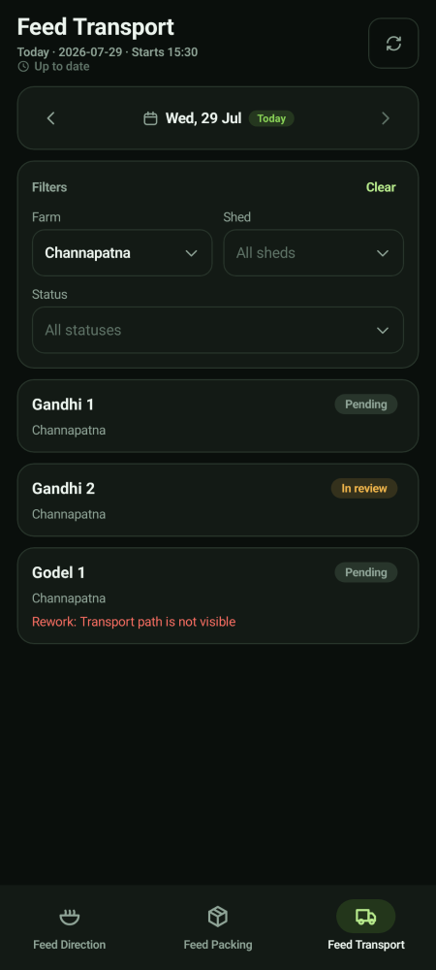  Where you land

The feed chain, and who does each part
Stage | Who does it | Proof | Who signs it off
Author the ration grid | You (on the laptop) | — | —
Issue the day's direction sheet | You, the day before | — | —
Pack the bags | Operator or Park Head | One packing video | Verifier
Transport to the shed | Operator or Park Head | One fresh transport video | Verifier
Feed the shed | Operator or Park Head | Feed video and water photo or video | Verifier

Nothing in this chain is finished until the Verifier approves
A packing job, a transport job and a feeding session all sit in review until the Verifier passes them. A rejection sends that job back to the same person for a fresh video; the rejected clip stays on file as history.

Feed Direction · the day's sheet
This is the instruction you issue. It is calculated from the ration grid you author — ration group by shed tag by feed item, in grams per head — adjusted by each shed's own factor and by how many animals the shed is expected to hold.
How the head count is projected
The sheet counts the animals living in the shed plus every move that has been authorised but not yet carried out — the destination shed gains those heads and the source shed loses them, from the moment the move is authorised. A move stops counting only once it has actually been applied on the ground. This is what stops a shed being double-fed or under-fed on a moving day.

You will see an overdue flag against a move that was authorised before the packing day and still has not been carried out. A move authorised today does not raise that flag.

Feed Packing
The packing worklist shows each shed's bags and where the job has got to. The operator or Park Head records one packing video per shed session and submits it; the Verifier approves, and only then is that packing counted as complete.
You watch this list for sheds that are stuck — not started, or sitting in review too long.

Feed Transport
Step 1 · Read the day's transport board  One task is created for every active shed at 15:30. Filter by park, shed or status.  - Pending — not started. In review — with the Verifier.  - A red line under a shed is a rejection with the reason, for example *Transport path is not visible*.  - Transport is per shed per day. It is never per feed session. | 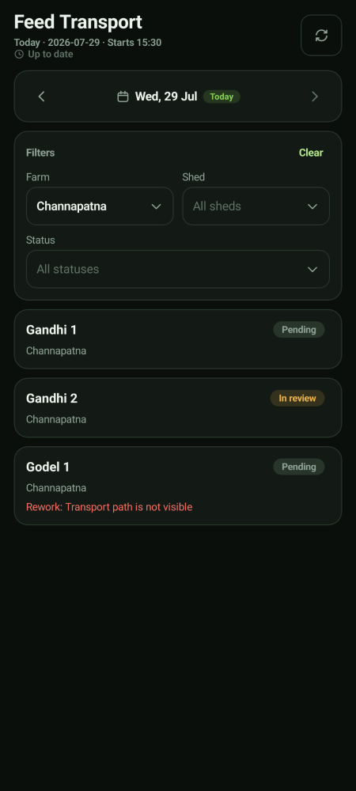  Today's transport board

Step 2 · What the person on the ground has to do  They open the shed and record one fresh in-app video of the transport, then submit it for verification. They cannot attach an older clip, and every re-work needs a brand new video. |   Transport capture

Feeding a shed
Two proofs, one verdict  The person feeding records a feed distribution video and a water distribution proof, which may be a photo or a video. Both are required — submit stays greyed out otherwise. One Verifier approval covers both and completes the session.  - This applies to both normal and experiment workflows.  - A rejection sends the session back for a re-shoot; nothing is completed in the meantime. | 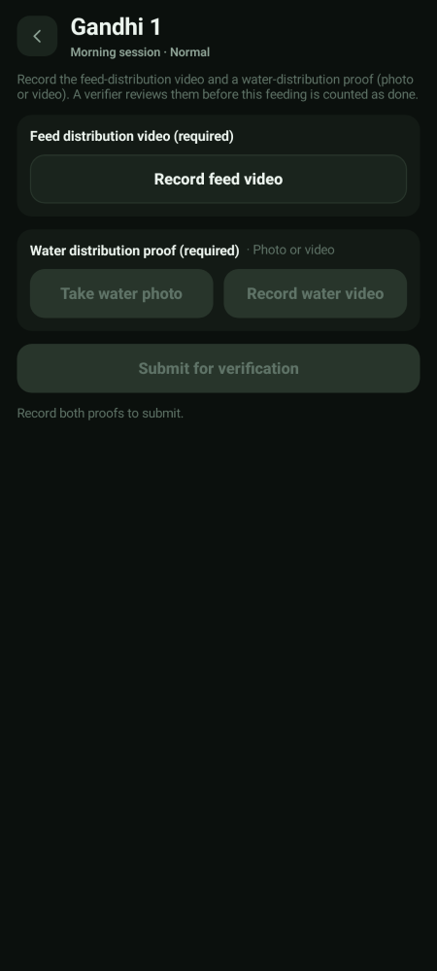  Feed and water proof

Your part in verification
Your duty here is to double-verify the verifier — to satisfy yourself that proofs really are being reviewed, and to act on anything flagged. You can close a feed job out, send it back for re-work and reassign it.
You are not the Verifier
You do not cast the approve/reject verdict on a feed video, and you do not see the review queue as a reviewer. Checking that the checking is happening is a different job from doing the checking.

What you do not get
Not yours | Why | Whose it is
Recording a feed job as done | Field execution runs through the Park Head | Operator or Park Head
Casting a proof verdict | Separation of duty | The Verifier
Vaccination, Weighing, the herd register | One module, one director | PC, Growth and Health Directors

Your account and settings
The You screen  Tap You (in the bottom bar, or at the bottom of the areas panel) to see your name, the parks you cover, your app language, and Sign out. | 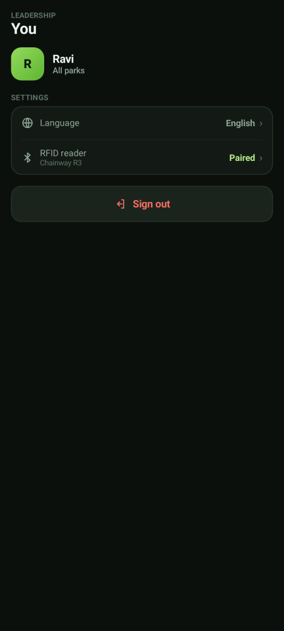  Your account

If you lose network
Keep working — nothing is lost  If the phone goes offline you will see a yellow bar at the top. Keep working. Everything you record is saved on the phone and sends itself the moment signal comes back.  - Do not sign out while the bar is showing — sign out only after it clears.  - Videos also queue up and upload in the background.  - Pull down or tap the refresh icon once you are back in signal. | 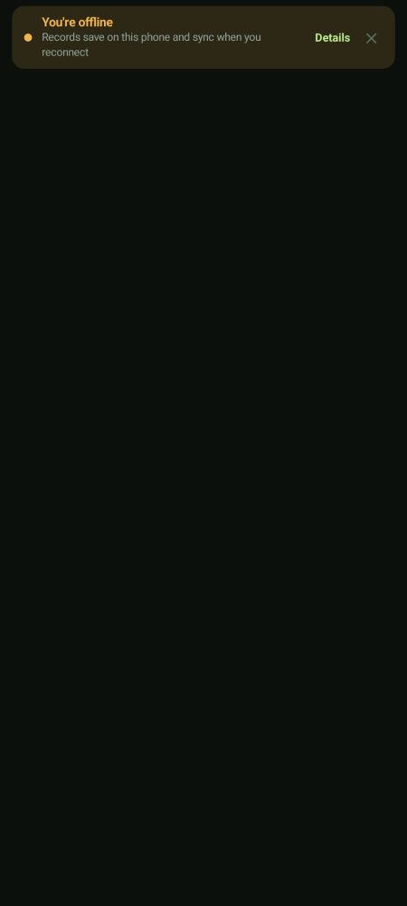  Offline notice

