MESHA · GOAT OS
Health Director
The treatment rulebook, animal identity, and the herd register

For the Health Director · Both parks · Mostly a laptop job today

This handbook shows what you see on the Mesha phone app, what you are
responsible for, and exactly which buttons to press for each job.
Every picture is a real screen from the app.

What this job is
You own three things: the treatment rulebook every sick animal is treated against, animal identity and tagging — ear tags and RFID at birth, at purchase, and whenever a tag is lost or replaced — and the herd register, the record of what the herd actually is.
You are not the Preventive Care Director
Health and Preventive Care are two separate departments in this business, and the two jobs are kept deliberately apart. You do not get vaccination. The Preventive Care Director does not get your rulebook.

Read this before you look for the app
Your phone app is empty today, and that is expected
Your work lives on the laptop. The census screens on the phone are switched off for the whole business at the moment, so when you sign in on a phone you will find no areas and no bottom bar. Nothing is broken and nothing is missing from your account. When the census feature is switched on, Herd Operations will appear here for you, because you are its recorded owner.

Until then, sign in on the laptop and work there. The rest of this handbook is about what you own and how it connects to what everyone else does.
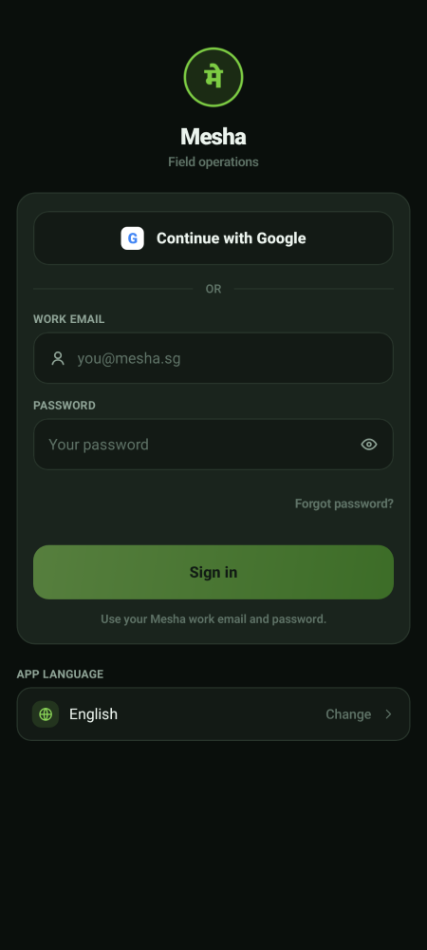
You sign in the same way as everyone else

The treatment rulebook
You write the standing course that every animal with a given disease is treated under: for each disease and age band, an ordered day-by-day, session-by-session course of medicine, dosage, unit and route, plus the plain actions and the points where a case must be handed on.

How editing works, and why it works that way
- Protocols are versioned. They are never edited in place. An edit builds a draft.
- Publishing promotes your draft and retires the version it replaces.
- An animal already being treated finishes on the version it started on. Its case is pinned to that version at the moment of diagnosis.
- The version an animal was actually treated from stays readable forever.
This is a medical safety rule, not a technical preference
If a protocol could be edited in place, changing a dosage would silently change the dose an animal currently mid-treatment receives. That is why the app makes you publish a new version instead.

The one-time import from the spreadsheet
The Adults SOP and Kids SOP spreadsheets were used once, to load the rulebook in at the start. They are not a live sync. Once anyone has edited a protocol in the app, re-running that import is blocked, because it would quietly throw the edit away. Reopening it is a deliberate, reviewed decision — never a routine step.

Tagging and identity
You are accountable for every animal being correctly tagged — at birth, at purchase, and whenever a tag is lost or replaced. Operators record a birth with either a permanent RFID or a temporary tag; the temporary tag is promoted to a permanent one later, and that identity work is yours.
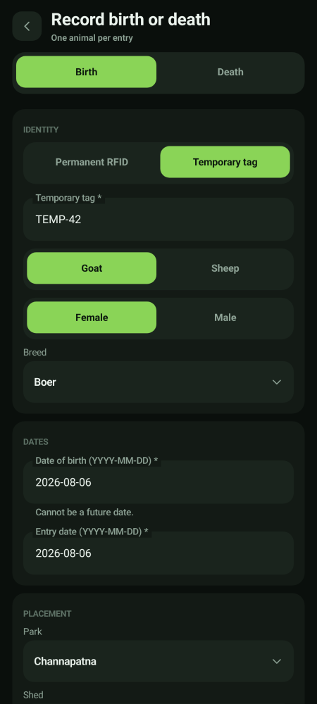  A birth recorded with a temporary tag | 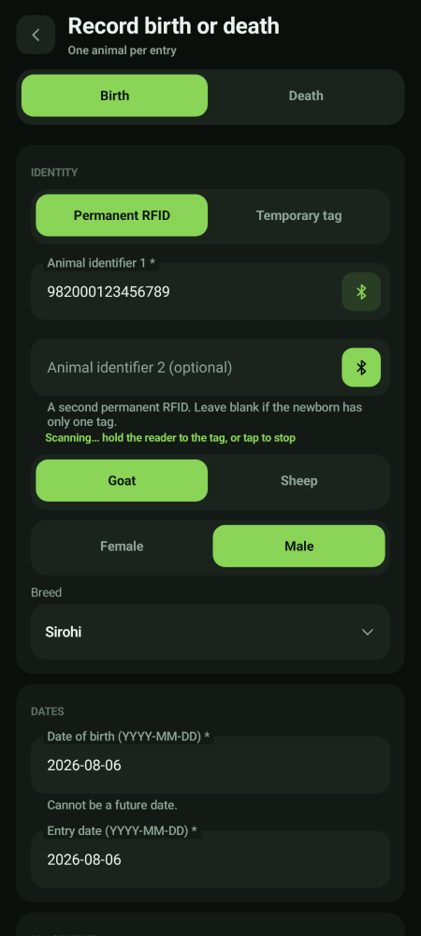  Scanning the permanent RFID

The herd register
The census — how many animals there are, where they are, and what changed — is yours. It is fed by three things operators record on their phones:
Event | Recorded by | Decided by | Effect on the register
Birth | Operator | An Approver or the CEO | The animal joins the herd once approved
Death | Operator | An Approver or the CEO | The animal leaves the herd once approved
Move between sheds | Operator raises it and does it | An Approver | The animal changes shed once both the approval and the operator's video exist

You own the register, but you do not approve the events
Birth and death admission sits with the CEO tier and the named approvers; shifting approval sits with them too. That split was a deliberate decision, and it means the person accountable for the census is not also the person waving the entries through.

Where each thing lives
What | Where you do it
Write and publish a treatment protocol | Laptop — the Health configuration screen
Review the herd register / census | Laptop
Tagging and identity corrections | Laptop
Watch proof videos for herd events | Laptop, or the phone once Herd Operations is switched on

What you do not get
Not yours | Why | Whose it is
Anything in Vaccination | Preventive Care is a separate department | The Preventive Care Director
Weighing | One module, one director | The Growth Director
Feed | One module, one director | The Feed Director
Recording births, deaths and moves | Capture is ground work | Operators
Approving births, deaths and moves | Owning the census is not waving entries through | Approvers and the CEO
Casting a proof verdict | Separation of duty | The Verifier

