MESHA · GOAT OS
Park Head
Your park, your people, your day

For a Park Head · One park · All field execution runs through you

This handbook shows what you see on the Mesha phone app, what you are
responsible for, and exactly which buttons to press for each job.
Every picture is a real screen from the app.

What this job is
You run one park. Every piece of field execution in that park goes through you: the roster, who is on which shed, feeding, and making sure the day's work actually gets recorded. The directors decide what should happen; you make it happen on your ground.
Your account is limited to your own park. You will only ever see your park's animals, sheds, staff and work.

Your areas on the phone
Area | What you get | Buttons along the bottom
Vaccination | The calendar for your park and the evidence trail | Calendar · Videos · Alerts
Weighing | Notices only, so you know what is happening | Alerts
Health | Animals under treatment in your park | Adults · Kids

Feed execution and staff management are laptop jobs for you — the phone is for watching the day and chasing it.

Getting into the app
Everyone signs in the same way. What you see after signing in depends on your job.
Step 1 · Open the Mesha app and sign in  Use your Mesha work email and password, or tap Continue with Google if your account is set up that way. If you forget your password, tap Forgot password? and follow the email.  - You can change the app language at the bottom of this screen.  - Sign in once — the app keeps you signed in on that phone. | 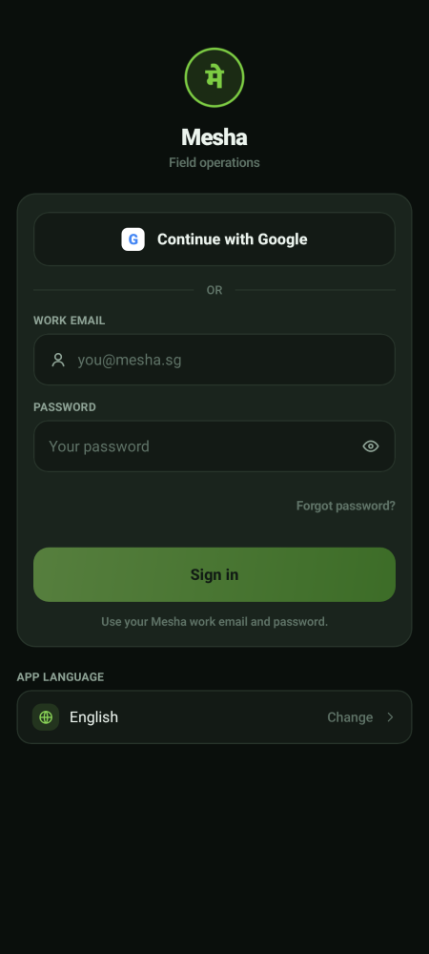  Sign-in screen

Step 2 · Land on your home screen  You land in Vaccination, on your park's sheds. The row of buttons across the bottom is your menu — those are the only places this job needs to go. | 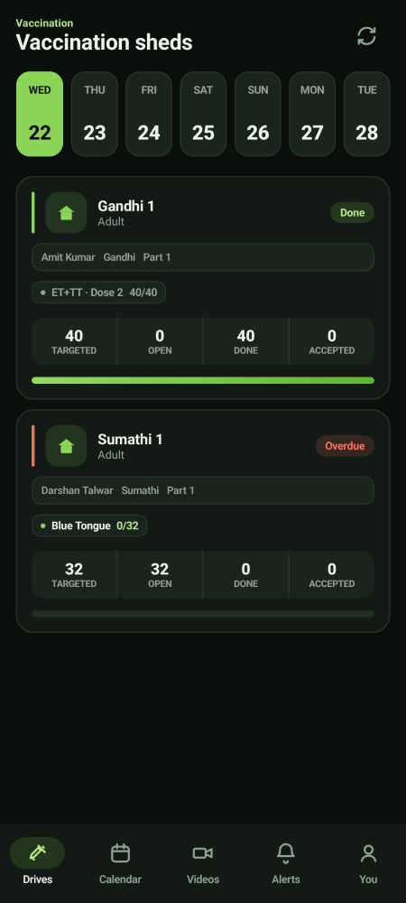  Your home screen

Step 3 · Switch between your areas of work  If you look after more than one area, a menu button (☰) appears at the top left. Tap it to slide open your list of areas and switch between them. Your name and Sign out sit at the bottom of that panel.  - Areas marked Soon are not built yet — they are there so you know what is coming.  - If you look after only one area there is no menu button, and everything you need is already on the bottom bar. | 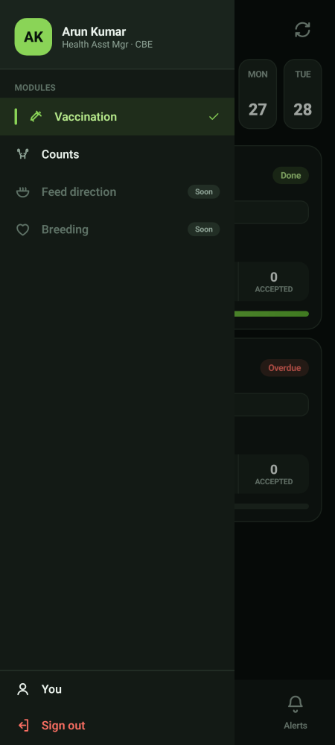  The areas panel

Watching the day
Step 1 · Start on the Calendar  Switch between Week and Month. A dot under a date means work exists. Tap a date for the sheds and animal counts. | 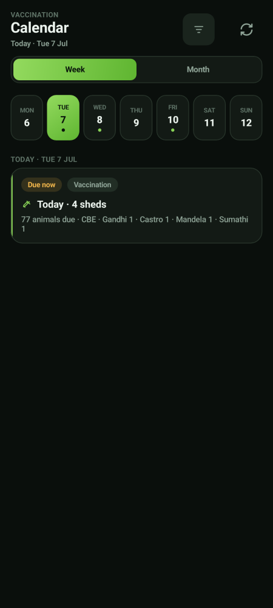  Your park's calendar

Step 2 · Read the shed cards  Each card gives you the shed, the stage, who it is assigned to, the vaccine, and four numbers: Targeted, Open, Done and Accepted.  - Open is your chase list.  - Done but not Accepted means the videos are waiting on the Verifier — chase the review, not the operator.  - A red Overdue label means it should already have happened. | 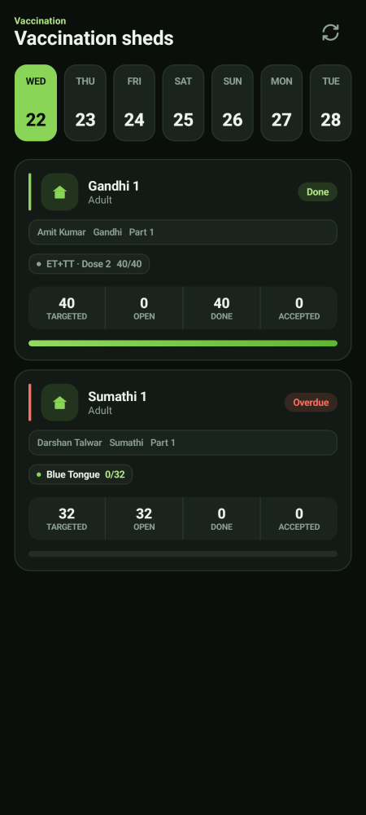  Today's sheds

Step 3 · Chase the right person  Read the state before you pick up the phone:  - Nothing scanned → chase the operator.  - Scanned but not submitted → chase the operator to finalise the shed.  - Submitted but not accepted → chase the Verifier.  - Accepted but the drive is still open → that is for the Preventive Care Director to close. | 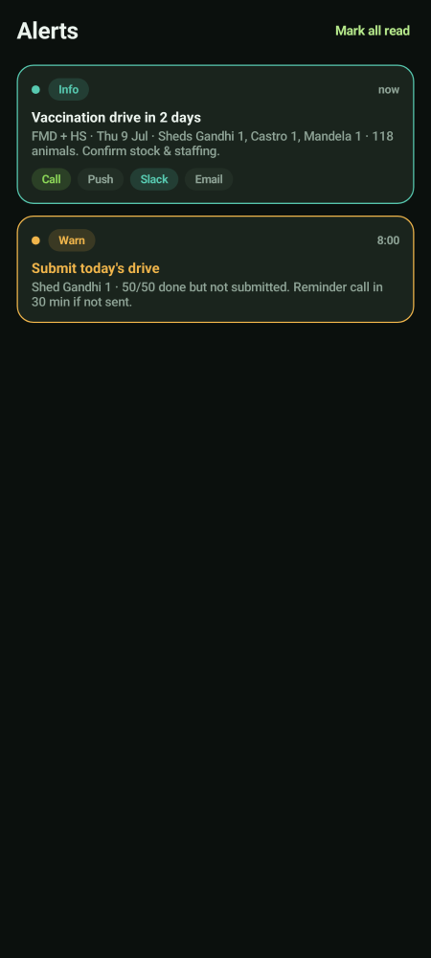  Alerts

Feed on your ground
The Feed Director issues the direction sheet the day before. Carrying it out is yours. You and your ground team pack, transport and feed, and you can record a shed session as fed.
Job | Proof needed | Signed off by
Packing a shed's bags | One packing video | Verifier
Transporting to the shed | One fresh transport video | Verifier
Feeding the shed | Feed video and water photo or video | Verifier

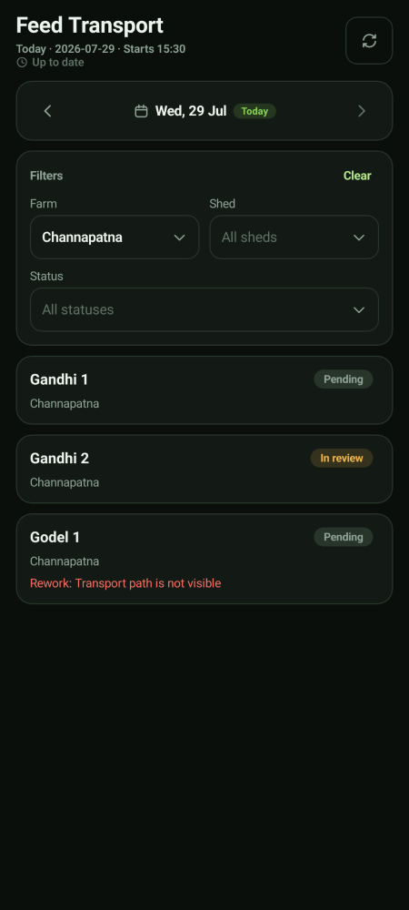  The day's transport tasks | 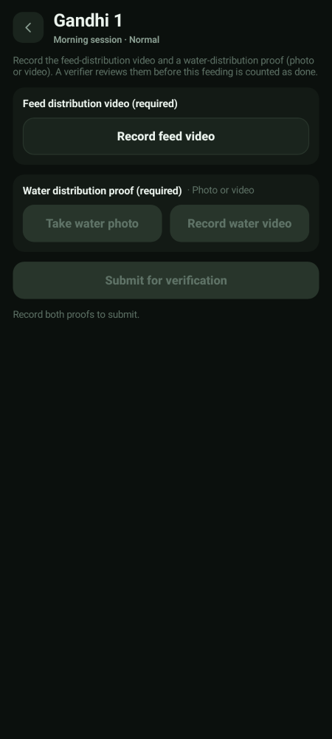  Feed and water proof

You execute; the Feed Director does not
You hold the ability to record feeding as done. The Feed Director does not — they issue the direction and check that it was followed. You do not author the ration grid; executing a ration is not writing one.

Your people
You manage your park's roster and the devices your team use. Those are laptop jobs. Keeping the roster right matters more than it looks: weighing sheds are assigned one operator each, and a rejected video always goes back to that same person.

Videos
You can see everything and close jobs out  The Videos tab is the evidence trail for your park. You can watch every clip, see every verdict, close a job out, send it back for re-work and reassign it.  - You cannot approve or reject a video. That is the Verifier's alone. | 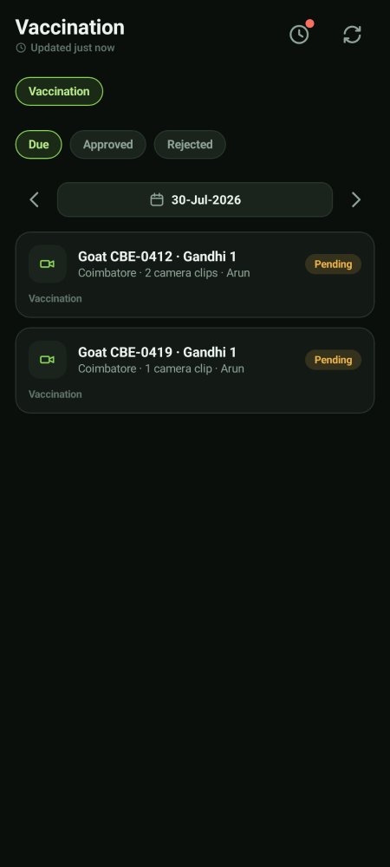  Evidence for your park

What you do not get
Not yours | Whose it is
Approving or rejecting a proof video | The Verifier
Approving a birth, a death or a move | Approvers and the CEO
Authoring the ration grid | The Feed Director and the CEO
Closing a vaccination drive | The Preventive Care Director or the CEO
Raising or closing a weighing round | The CEO, with the Growth Director
Anything outside your park | Directors, who cover both parks

Approvals used to sit here, and they no longer do
Birth, death and shifting approvals were moved off the Park Head. If you look for an approval queue and cannot find one, that is correct — send the request to an approver or the CEO.

Your account and settings
The You screen  Tap You (in the bottom bar, or at the bottom of the areas panel) to see your name, the parks you cover, your app language, and Sign out. | 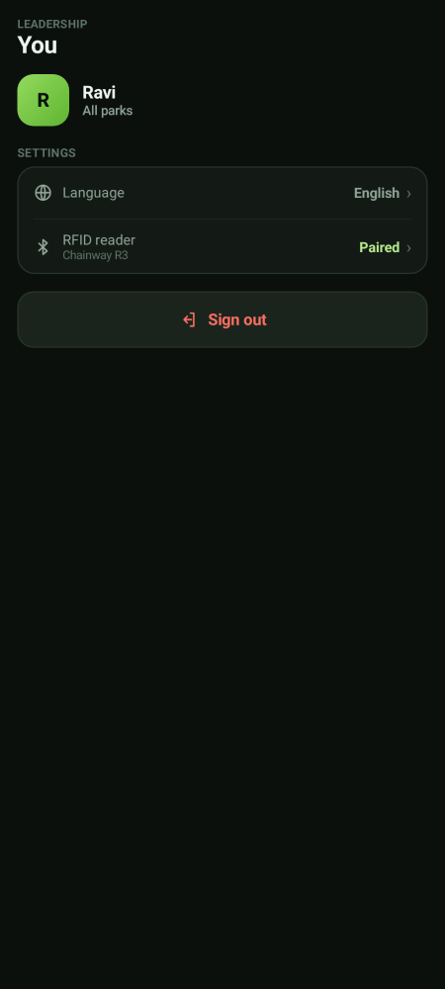  Your account

Pairing the RFID reader  From You, tap RFID reader. The reader behaves like a small keyboard: when you scan a tag it types the number straight into the app, so you never type a tag by hand.  - Use Test read to check the reader before you start a round.  - If it says not connected, tap Re-scan for readers, then Open Bluetooth settings if it still does not find it.  - Check the battery percentage on this screen before a long round. | 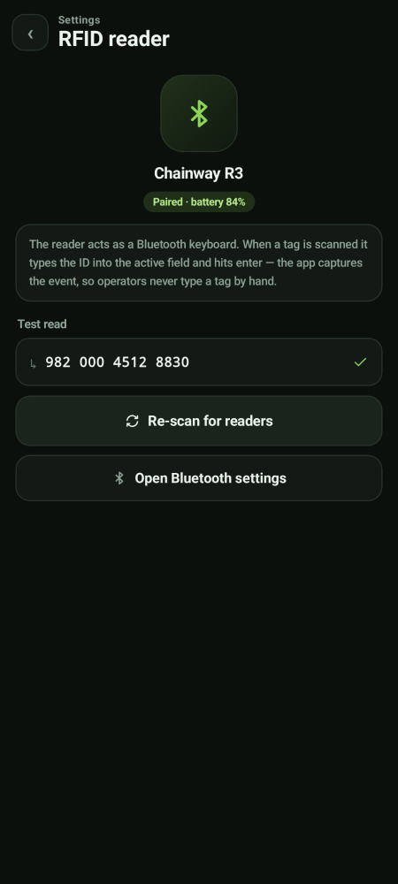  RFID reader settings

If you lose network
Keep working — nothing is lost  If the phone goes offline you will see a yellow bar at the top. Keep working. Everything you record is saved on the phone and sends itself the moment signal comes back.  - Do not sign out while the bar is showing — sign out only after it clears.  - Videos also queue up and upload in the background.  - Pull down or tap the refresh icon once you are back in signal. | 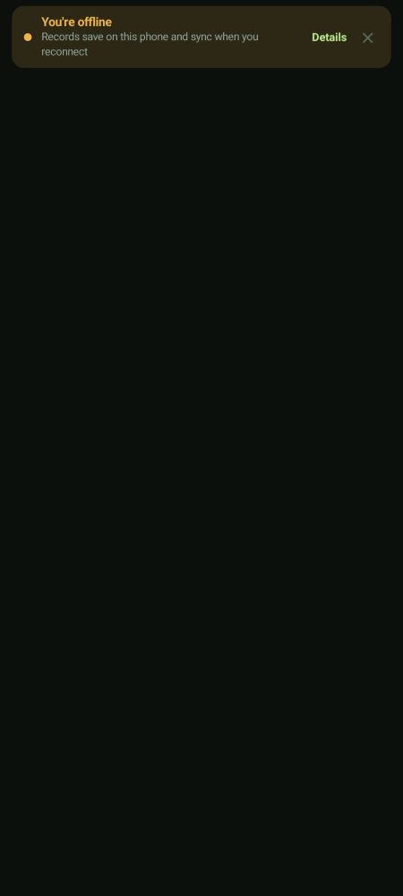  Offline notice

