MESHA · GOAT OS
Field Operator
Your day on the Mesha app, step by step

For operators on the ground · Vaccination, Weighing, Births & Deaths, Moves, Feed, Milk

This handbook shows what you see on the Mesha phone app, what you are
responsible for, and exactly which buttons to press for each job.
Every picture is a real screen from the app.

What this job is
You are the person who does the work and proves it was done. Almost everything you record in this app is backed by a short video, and a Verifier watches that video before the job counts as finished.
Three things are always true, in every part of the app:
- Record the video while you are doing the work, not afterwards. The camera opens in the app; you cannot pick an old video from the gallery.
- You never type a tag by hand. The RFID reader types it for you.
- Nothing is lost if you go offline. Keep working; the phone sends everything when signal returns.

What you will find in your app
Area | What it is for | Buttons along the bottom
Vaccination | Today's sheds to vaccinate | Drives · Alerts
Weighing | Sheds you have been assigned to weigh | My work · Alerts
Herd Operations | Recording a birth, a death, or a move between sheds | Birth · Death · Shifting
Feed | The daily feed sheet, packing the bags, transporting, and feeding | Feed Direction · Feed Packing · Feed Transport
Health | Animals under treatment | Adults · Kids
Milk | Preparing kid milk, feeding it, and colostrum for newborns | Milk Prep · Milk Feeding · Colostrum

You may not see all six
Your list depends on what your department covers and which park you work in. If an area you need is missing, that is a set-up question for your Park Head — it is not something you can turn on from the phone.

Getting into the app
Everyone signs in the same way. What you see after signing in depends on your job.
Step 1 · Open the Mesha app and sign in  Use your Mesha work email and password, or tap Continue with Google if your account is set up that way. If you forget your password, tap Forgot password? and follow the email.  - You can change the app language at the bottom of this screen.  - Sign in once — the app keeps you signed in on that phone. | 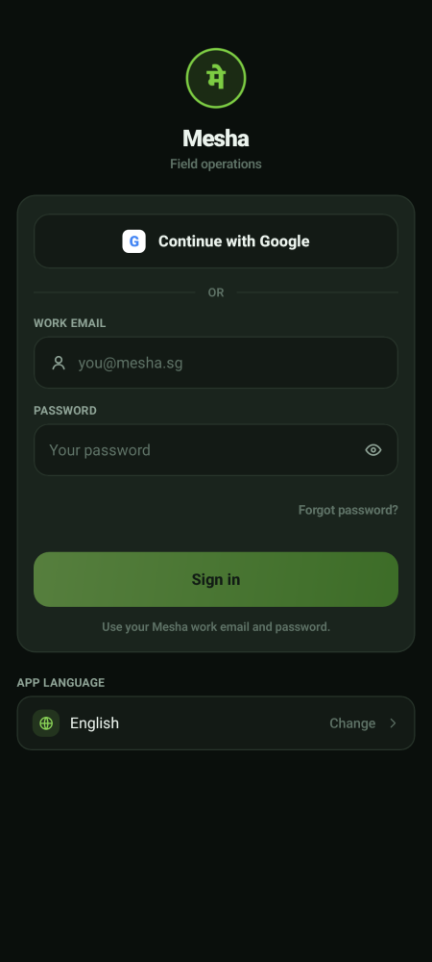  Sign-in screen

Step 2 · Land on your home screen  You land straight on your work. In the picture, the operator has opened Vaccination and is looking at today's sheds. The buttons along the bottom are that area's own pages. The row of buttons across the bottom is your menu — those are the only places this job needs to go. | 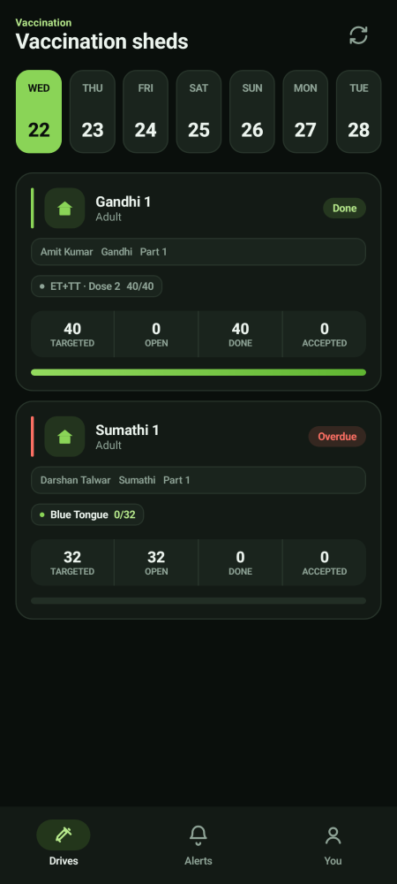  Your home screen

Step 3 · Switch between your areas of work  If you look after more than one area, a menu button (☰) appears at the top left. Tap it to slide open your list of areas and switch between them. Your name and Sign out sit at the bottom of that panel.  - Areas marked Soon are not built yet — they are there so you know what is coming.  - If you look after only one area there is no menu button, and everything you need is already on the bottom bar. | 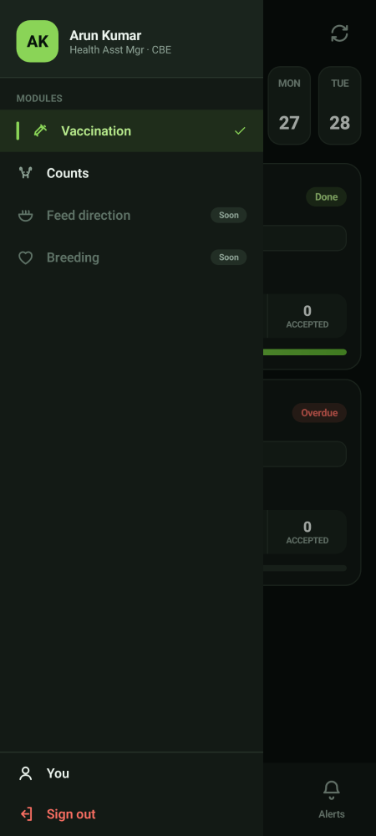  The areas panel

Good to know
If you only work in one area, there is no ☰ menu button. Your bottom bar will instead end with a You button so you can still reach your settings.

The bottom bar changes with the area
This is the part people find confusing at first, so it is worth being clear about. The buttons along the bottom are not fixed. They belong to whichever area you are standing in. Switch area in the ☰ panel and the whole bottom bar changes with it.
  Vaccination → Drives · Alerts · You | 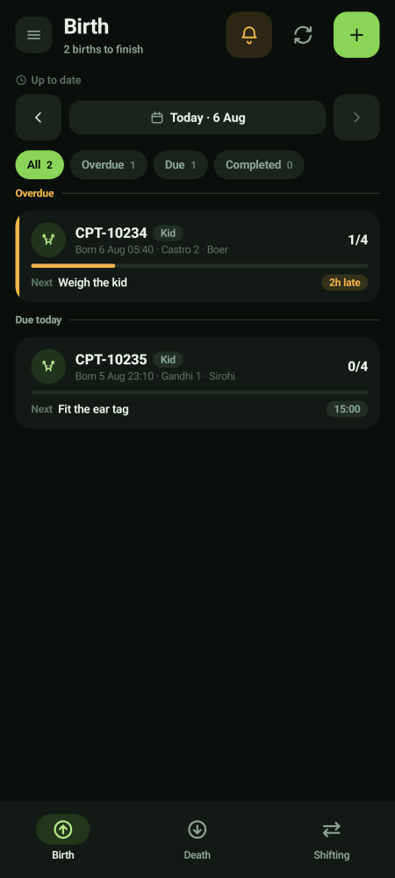  Herd Operations → Birth · Death · Shifting | 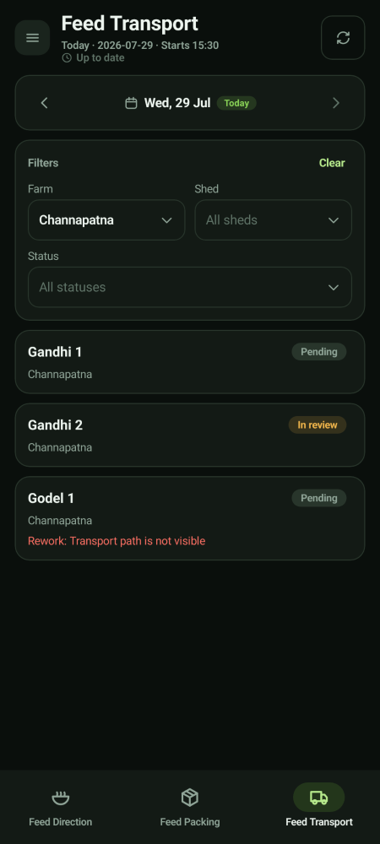  Feed → Feed Direction · Feed Packing · Feed Transport

So there is no single home screen
Your home is whichever area you last opened. Nothing is lost when you switch — work you have part-finished in one area is still there when you come back to it.

Your account and settings
The You screen  Tap You (in the bottom bar, or at the bottom of the areas panel) to see your name, the parks you cover, your app language, and Sign out. | 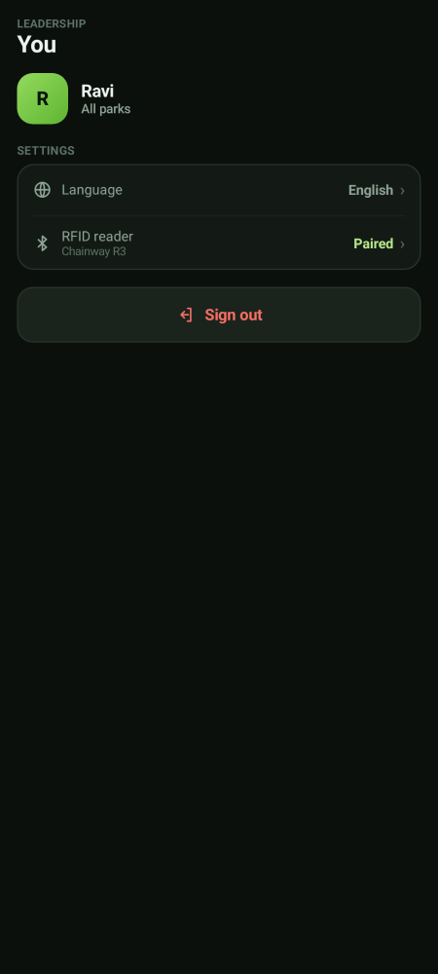  Your account

Pairing the RFID reader  From You, tap RFID reader. The reader behaves like a small keyboard: when you scan a tag it types the number straight into the app, so you never type a tag by hand.  - Use Test read to check the reader before you start a round.  - If it says not connected, tap Re-scan for readers, then Open Bluetooth settings if it still does not find it.  - Check the battery percentage on this screen before a long round. | 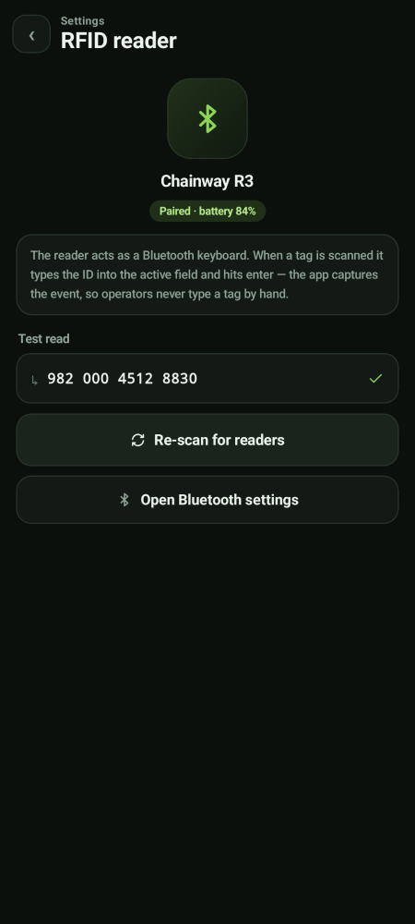  RFID reader settings

Vaccination · doing a shed
A vaccination drive is a visit to a park to vaccinate a set of sheds. You work one shed at a time: scan an animal, film it being vaccinated, move to the next one, then submit the shed when you are done.
Step 1 · Open Drives and pick today's shed  The Drives tab shows the sheds for the day you have selected. Slide the dates across the top to look at another day.  - Targeted is how many animals are in this shed for this drive.  - Open is how many are still to be done, Done is how many you have finished, and Accepted is how many the Verifier has already passed.  - A red Overdue label means this shed was due earlier and still is not done.  - The grey line under the name tells you who the shed is assigned to and which partition it is. | 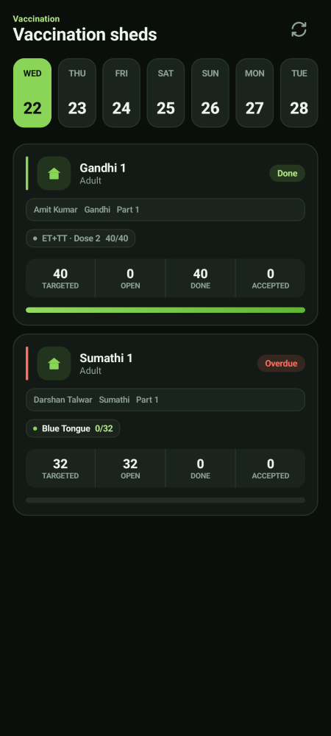  Today's sheds

Step 2 · Open the shed and check the reader  Tap the shed card. The green bar at the top should say the RFID reader is ready. The ring shows how many of this shed's animals are vaccinated so far.  - If the bar is red, go to You → RFID reader and reconnect before you start.  - Pending is how many animals are still waiting. Tap that box to see the list and search for a particular tag. | 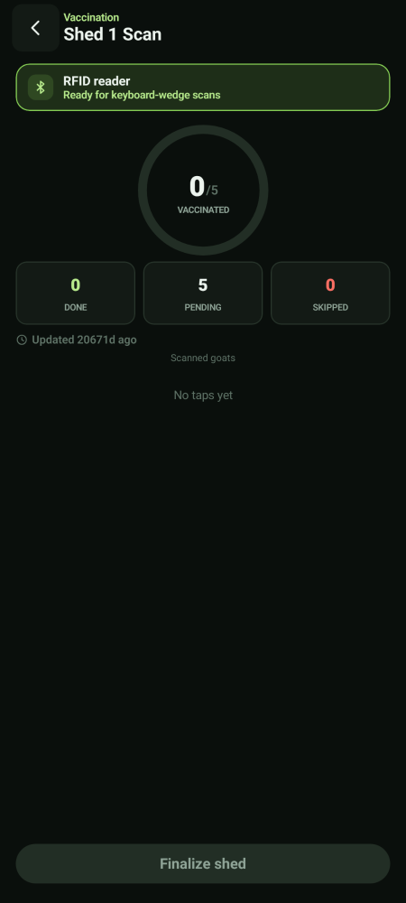  Shed scan screen, before you start

Step 3 · Scan the animal — the camera opens by itself  Point the reader at the ear tag and pull the trigger. If the animal belongs in this shed and is due, the camera opens and starts recording on its own. You do not press anything.  - Keep the ear tag and the injection in the frame.  - The tag number and the vaccine name are printed at the bottom of the screen so you can check you are giving the right thing. | 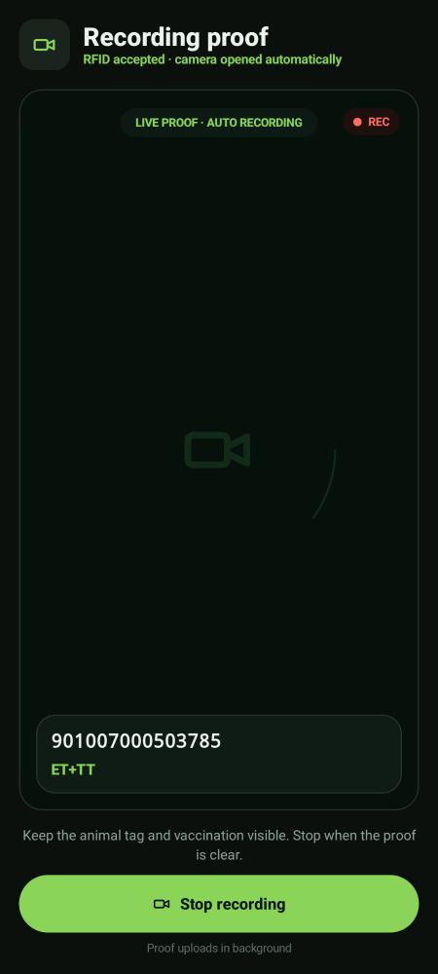  Recording proof

Step 4 · Stop recording and submit the clip  Tap Stop recording once the injection is clearly on film. Check the tag and vaccine on the review screen, then tap Submit proof.  - The clip is saved on the phone straight away and uploads in the background — you do not wait for it.  - Then go straight to the next animal. Repeat steps 3 and 4 until the shed is done. | 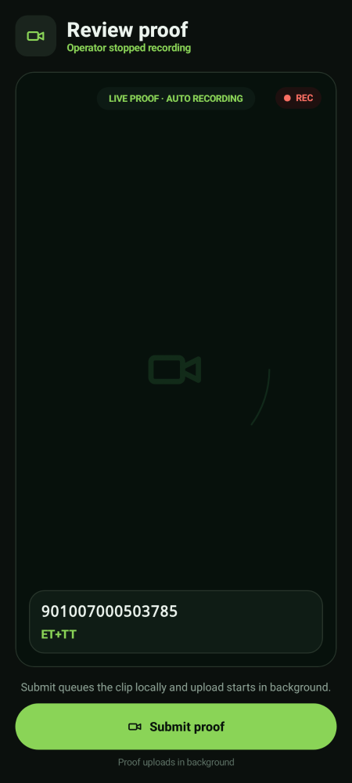  Review, then submit

Step 5 · Watch the list build up  Every accepted animal drops onto the list with a green tick, the time you scanned it and the vaccine given. The counters and the ring move as you go.  - An animal with two ear tags shows a small 2 tags label — that is normal. | 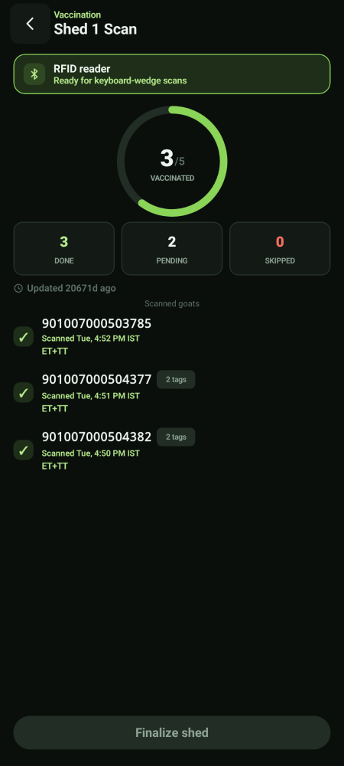  Three done, two pending

When a scan is refused
The app will refuse some scans. This is protection, not a fault — read the coloured bar and act on it. Refused scans never open the camera, so you are never filming for nothing.
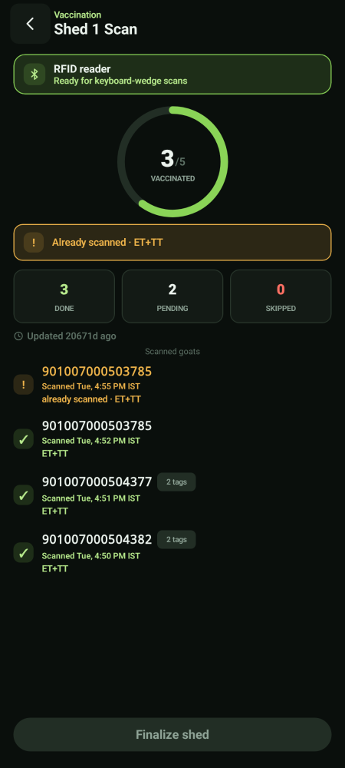  Already scanned — this animal is done | 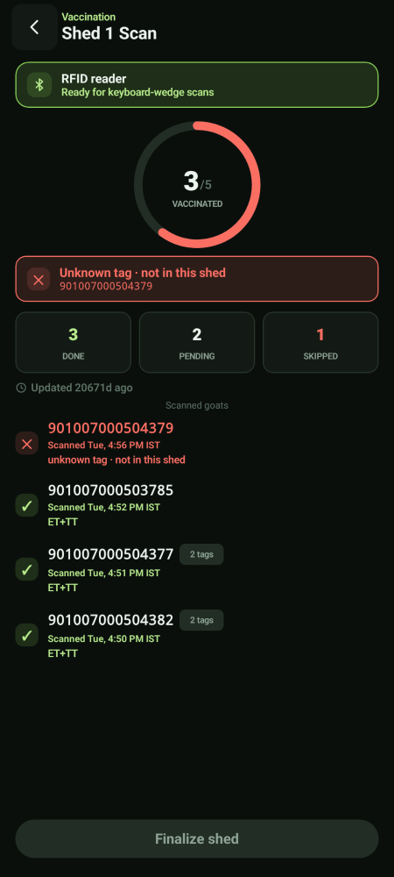  Unknown tag — not part of this shed | 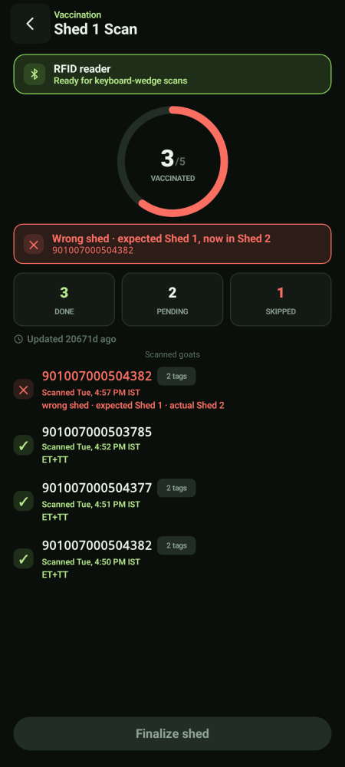  Wrong shed — the animal has been moved

What you see | What it means | What to do
Already scanned | You have vaccinated this animal in this shed today. | Move on. Do not vaccinate again.
Unknown tag · not in this shed | The tag does not belong to this shed's list for today. | Check you scanned the right animal. If the tag is genuinely unreadable or unknown, tell your Park Head — do not force it.
Wrong shed · expected Shed 1, now in Shed 2 | The system believes this animal now lives in a different shed. | Leave it. Report it so the move can be recorded properly, then carry on.

Refused animals show as Skipped
A refused scan raises the Skipped counter and shows the animal in red on the list. That is a record of what happened — it is not a mistake you have to clear.

Step 6 · Finish the shed  When every animal you can do is done, tap Finalize shed. You get a summary: the shed, the drive, how many were expected, how many you scanned, how many videos are ready, and a breakdown by vaccine.  - Check the numbers look right before you go on. | 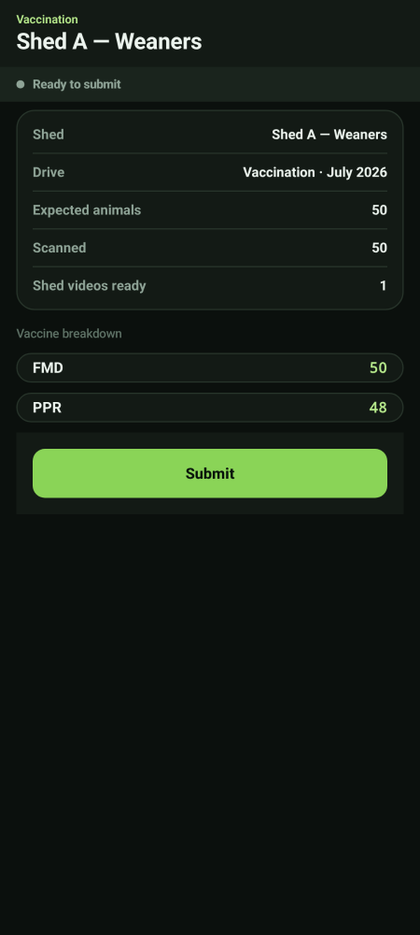  Shed summary before submitting

Step 7 · Submit the shed record  Tap Submit. A yellow bar shows the videos still uploading. You can put the phone in your pocket — this carries on by itself.  - Finalize checks the records that have synced. It does not upload the files — the uploads run separately in the background. | 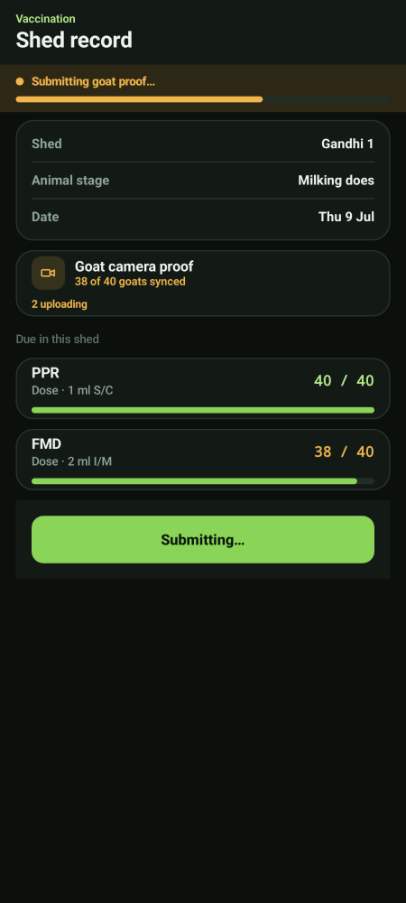  Submitting

Step 8 · Confirm it is on file  When the top bar turns green and says Synced · record on file, your part is done. The shed now goes to the Verifier. | 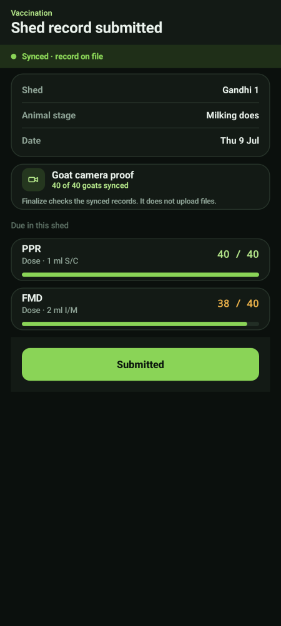  Submitted and synced

What happens next
The Verifier watches your clips. If they approve, the animals count as accepted and the Director closes the drive. If they reject, the shed comes back to you in Alerts with the reason, and you re-shoot only what was rejected.

Weighing · a shed you have been assigned
Weighing is deliberately simple. The app does not know which animal is which and does not check anything against the herd — it just records a tag and a weight, with a video. There is no expected number of animals and no percentage to chase.
The only rule in weighing
You cannot weigh the same animal twice in the same shed before you submit. That is the entire rule. Everything else is just recording what you weighed.

Way 1 · Weighing animals one by one
Step 1 · Open My work and pick your shed  My work lists only the sheds assigned to you. Tap one to open it. The subtitle tells you which mode it is — Individual or Lumpsum. | 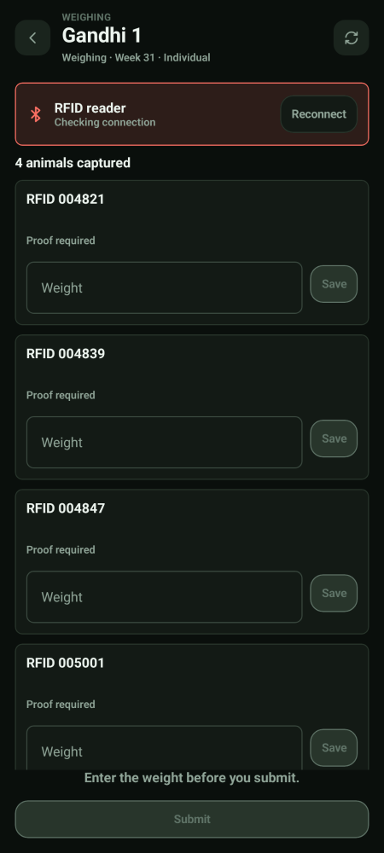  An individual weighing shed

Step 2 · Scan, weigh, film, save  Scan the ear tag. The animal appears as a card. Put the animal on the scale, type the weight, record the video, then tap Save on that card.  - Proof required on a card means that animal still needs its video.  - The Submit button stays greyed out until every card has a weight.  - Scanning the same tag twice in this shed is refused — that is the duplicate rule. | 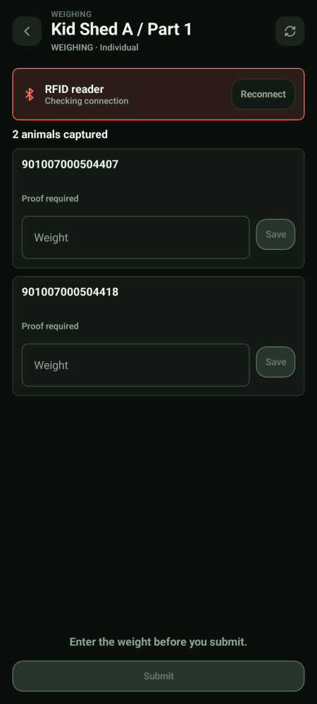  Cards waiting for weight and proof

Way 2 · Weighing a whole shed together (lump-sum)
Step 1 · Weigh the group and count them  For a lump-sum shed there is no scanning. Put the group on the scale, enter the total weight in kilograms and the animal count, then tap Capture group video and film the group on the scale.  - Submit lumpsum weighing stays greyed out until the count and the video are both there. | 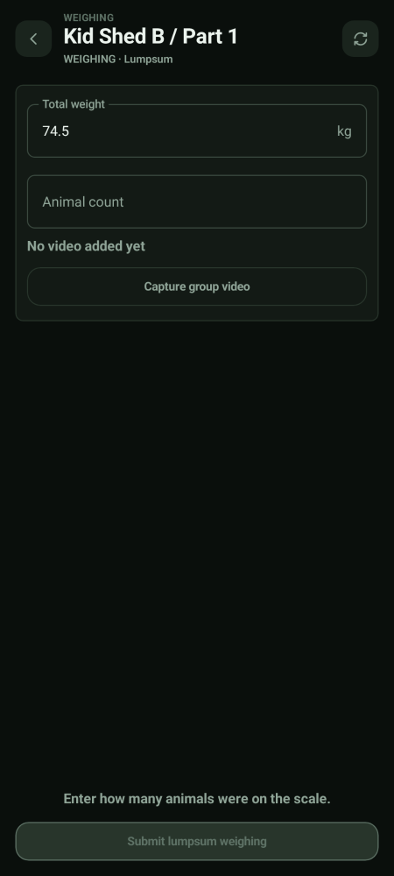  Lump-sum weighing

If you are out of signal while weighing
Carry on  You will see Saved on this phone. It will sync when network returns. Everything you type and film is held safely and goes up on its own later. | 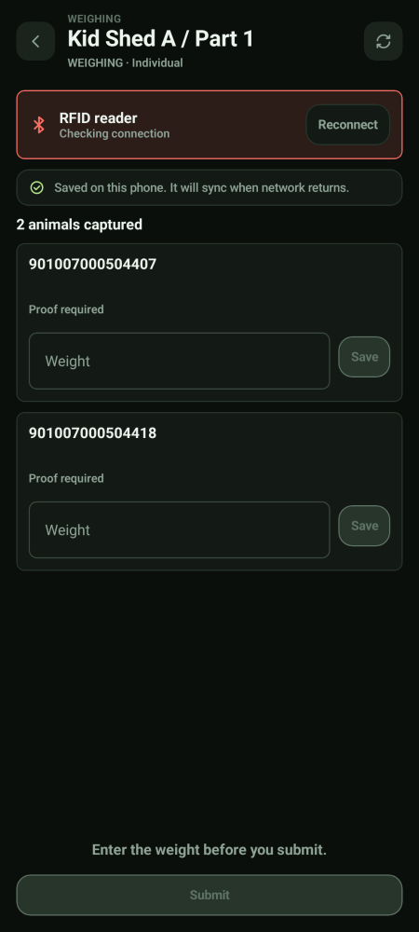  Saved offline

After you submit a weighing shed
The Verifier reviews your videos. If one is rejected it comes back to you — never to a different operator, because a weighing shed always belongs to exactly one person. Only the CEO or the Growth Director can close a shed or reopen a closed one.

Herd Operations · births, deaths and moves
This area is for recording things that change the herd. You record them; somebody with approval authority decides on them.
Getting here, and what the three buttons are  Open the ☰ panel and tap Herd Operations. The bottom bar becomes three buttons — and only these three. Herd Operations on the phone is recording only: there is no approval tab here, because approving is somebody else's job.  - Birth — record a kid that has been born.  - Death — record an animal that has died.  - Shifting — raise a move between sheds, and carry it out.  - The ＋ button on each page is what opens the recording form. |   Birth · Death · Shifting

What the Birth tab actually shows you
A work list, not a form  Tapping Birth does not open a blank form. It opens the list of births that still have work outstanding on them — because recording the birth is only the first of several jobs each kid needs.  - Each card is one kid: its id, its shed, its breed, and how many of its actions are done — `1/4`, `0/4`, `4/4`.  - Next names the very next thing to do for that kid — *Weigh the kid*, *Fit the ear tag*.  - The list is grouped into Overdue, Due today and Completed, and the chips at the top filter it. An amber 2h late label means that action is past its time.  - The ＋ button at the top right is how you record a new birth. | 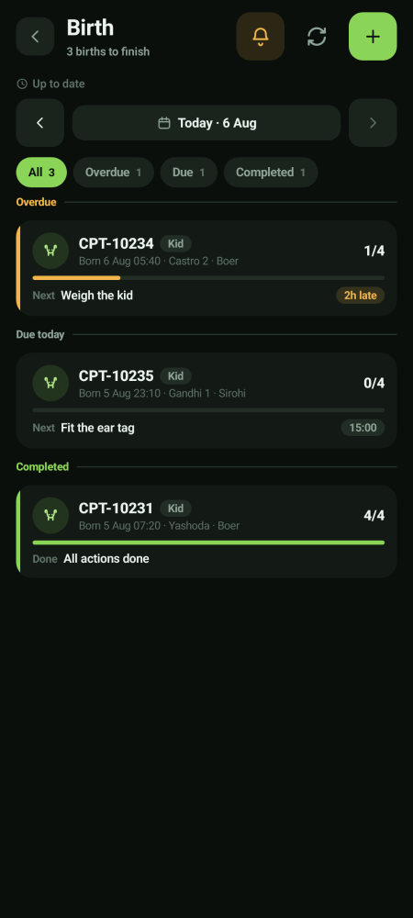  The Birth tab

Death works exactly the same way  The Death tab has the same shape — a work list of deaths with actions still outstanding, the same chips, and the same ＋ to record a new one.  - Cards here say Adult or Kid and name the shed and the date of death.  - Typical next actions are things like recording the post-mortem note or attaching the disposal photo. | 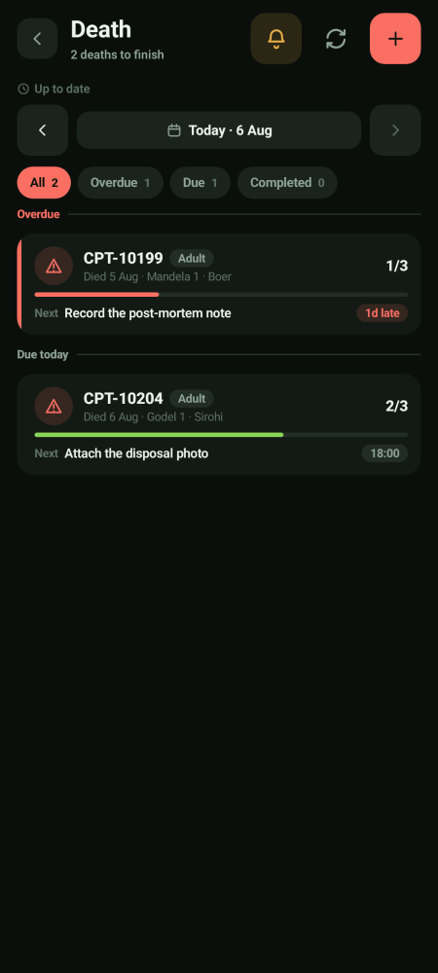  The Death tab

Recording a new birth or death
Step 1 · Tap the ＋ button  This opens the recording form. It records one animal per entry, and the tab at the top switches between Birth and Death.  - Permanent RFID — scan the ear tag if the animal already has one.  - Temporary tag — type the temporary tag if the permanent one has not been fitted yet. The permanent tag can be added later. | 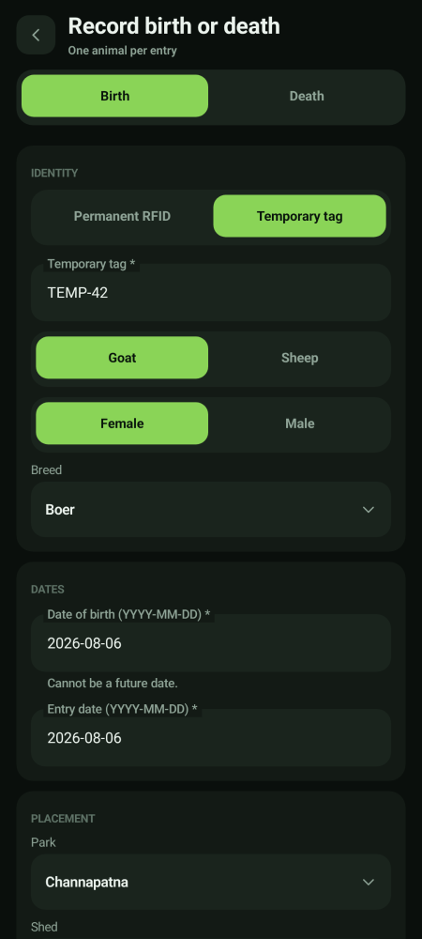  Recording a birth

Step 2 · Fill in the rest and save
Choose goat or sheep, male or female, and the breed. Enter the date of birth and the entry date, then choose the park and the shed the kid is in.
- The breed is chosen from a list, never typed — the list is the herd's own breeds.
- The date of birth cannot be in the future — the app will not accept it, and it cannot be later than the entry date.
- The shed list only shows sheds in the park you picked, and it names the pen too (for example Castro - 2) where the shed is divided.
- Mother's tag links the kid to its dam. Scan it the same way.

Step 3 · If the kid has two ear tags  On the Permanent RFID path there is a second tag field. Scan the first tag, then the second — the app listens to one field at a time and shows you which one it is waiting on.  - A temporary tag never carries a second RFID. Two tags is a permanent-RFID case only. | 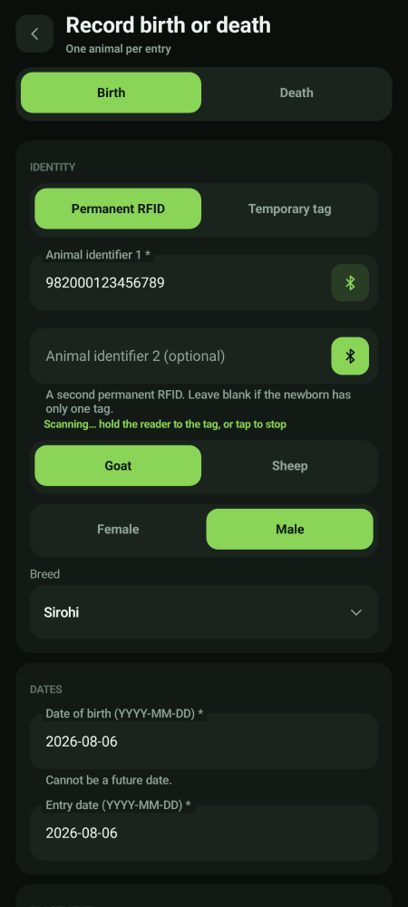  Second tag being scanned

Recording a death
Find the animal first, then say what happened  Switch the top tab to Death. Unlike a birth, you do not describe the animal — you find it. Scan or type its tag, pick it from the matches, and the app shows you which shed and pen it is in so you can be sure it is the right one.  - Type or scan the tag and tap Find animal. The card that comes back shows the id, the tag, the park and the shed — check the shed matches before you go on.  - Exactly one animal per entry. If nothing matches, the app tells you rather than letting you guess.  - Reason is required, between 3 and 500 characters. Write it in plain words — the approver reads it and it stays on file.  - It works offline. The entry is held on the phone and syncs by itself. | 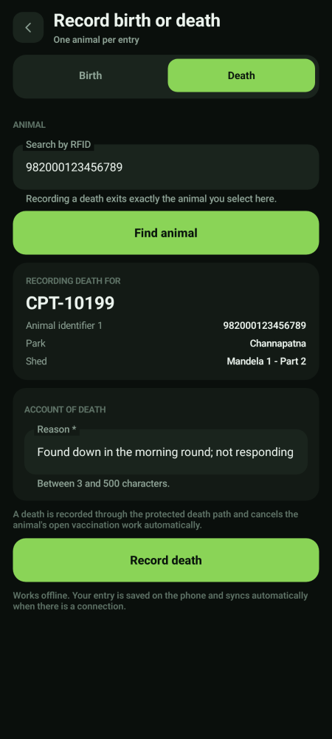  Recording a death

Recording a death stops that animal's vaccination work automatically
You do not have to go and cancel anything. The moment a death is recorded, the animal's open vaccination work is cancelled for you — so it will not keep appearing on somebody's shed list as still due.

A birth or death is a request until it is approved
Saving it does not change the herd count. It goes into an approval queue. Once an approver says yes, the animal is added to — or removed from — the herd.

Moving animals between sheds
A move has two halves that can happen in either order: somebody approves it, and you film yourself doing it. The animals only change shed once both have happened.
Step 1 · Raise the move  Open Shifting and tap the green ＋. Choose the shed the animals are leaving, the shed they are going to, which animals, and whether it is high priority.  - Animals never move between parks. A move is always inside one park.  - You do not choose a new stage for the animals — the destination shed decides that automatically. | 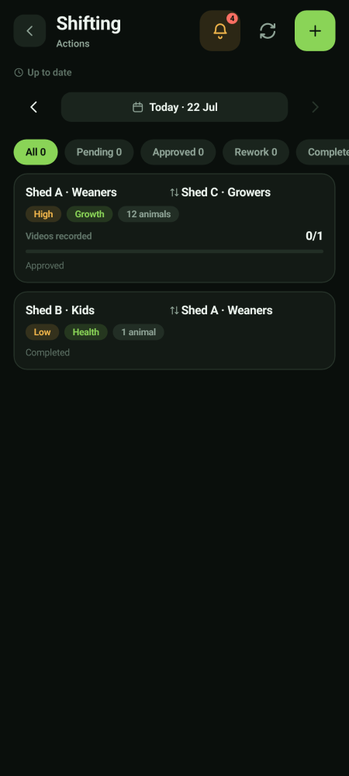  The shifting list

Step 2 · Do the move and film it  When it is time, open the move and tap through to Do the shifting. Record the shifting video, check the animals listed are the ones you moved, then tap Mark done.  - The video is compulsory. You cannot mark it done without one.  - A high priority move needs three videos: the move itself, the feed being packed, and that feed being given to the animals.  - The video is saved on the phone and uploads by itself. | 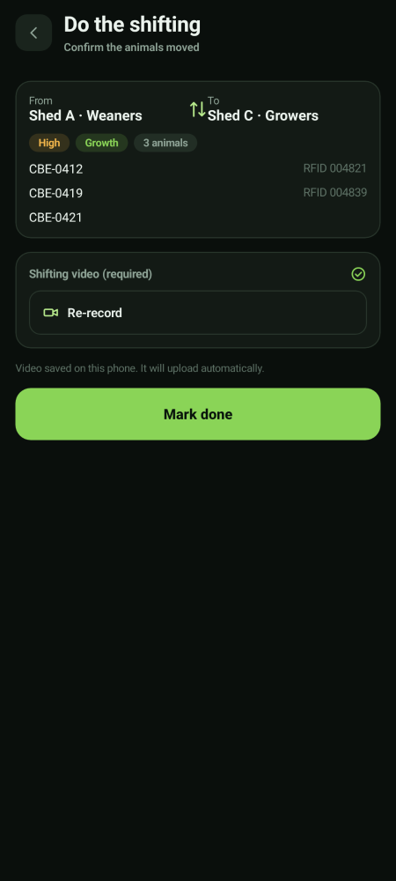  Doing the move

Filters at the top of the Shifting list
Pending is waiting for approval, Approved is cleared but not yet done on the ground, Rework has come back to you, and Completed is finished. Work through Approved first.

Feed · packing, transport and feeding
Feed has three tabs and they run in that order across the day: what to give (Feed Direction), bagging it (Feed Packing), carrying it to the shed (Feed Transport), and giving it (feeding). Each one that you carry out needs its own video.
Getting here, and what the three buttons are  Open the ☰ panel and tap Feed. The bottom bar becomes the three stages of the feed chain, left to right in the order the day runs.  - Feed Direction — the sheet telling you which shed gets what. Read only.  - Feed Packing — bagging it up. One video.  - Feed Transport — carrying it to the shed. One fresh video, from 15:30.  - Every page has the same filters — park, shed, status — and the same status words: Pending, In review, Completed, Rework. |   Feed Direction · Packing · Transport

Feed Direction — the day's sheet
Read what each shed is getting  This tab is your instruction sheet: which shed gets what, and how much. It is issued the day before. You read it — you do not change it.  - One row per shed session. The line under the shed name gives the stage, the breed and which session it is.  - The chips on the right are the state — Pending or Fed — and the feed type, Normal or Experiment.  - Filter by farm, shed, feed type, session or status to find your own sheds.  - The date bar at the top moves between days. A past day is view only. | 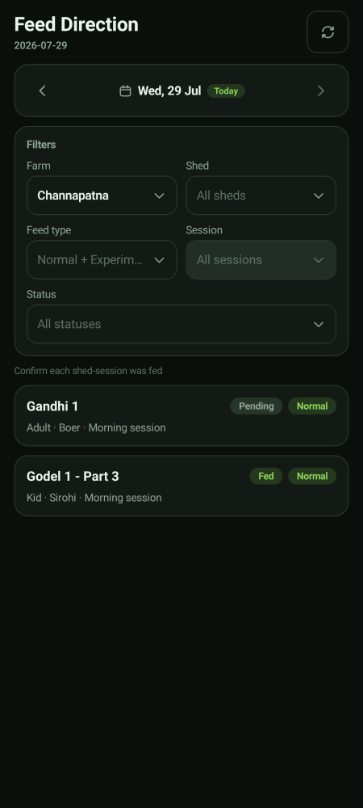  The day's feed sheet

Feed Packing — making up the bags
Pack what the sheet says, then film it  Packing happens the day before the feed day — the caption at the top says which feed day you are packing for. Each shed card lists every item and its weight, with a Pack total at the bottom.  - Totals (whole farm) at the top tells you sheds, lines and anything blocked.  - Weigh out each item to the gram figures shown. Do not round to make it easier.  - Record one packing video for the shed session, then submit.  - The chip shows where it has got to: Pending → In review → Completed. It is only complete once the Verifier approves. | 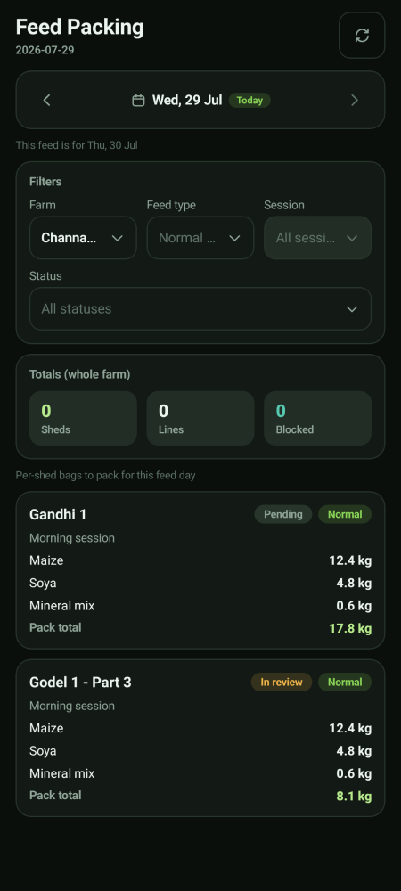  The packing worklist

Feed Transport
Step 1 · Open the day's transport list  Transport tasks are created for every shed at 15:30. Filter by park, shed or status to find yours.  - Pending — not done yet. In review — with the Verifier.  - A red line under a shed is a rejection with the reason, for example *Transport path is not visible*. Re-shoot it. | 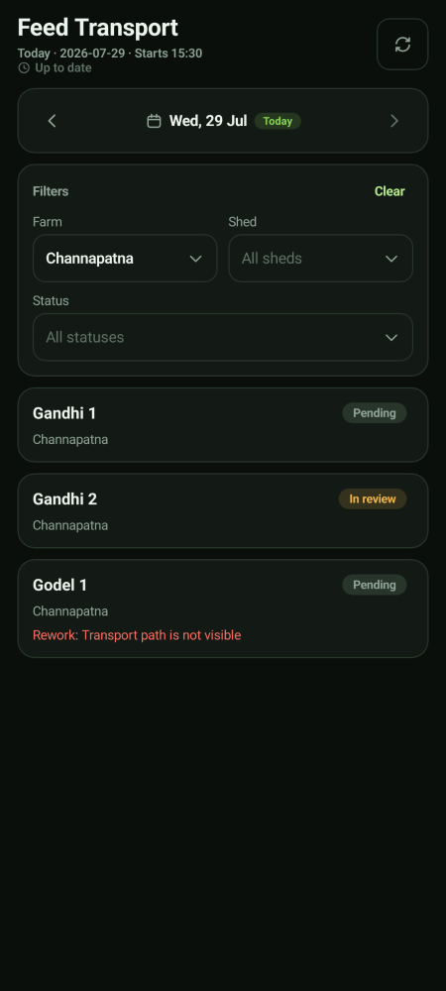  Today's transport tasks

Step 2 · Film the transport and submit  Tap the shed, then Record transport video. It must be a fresh clip filmed in the app — you cannot attach an older one. Then tap Submit for verification.  - Every re-work needs a new video. The rejected one stays on file as history. | 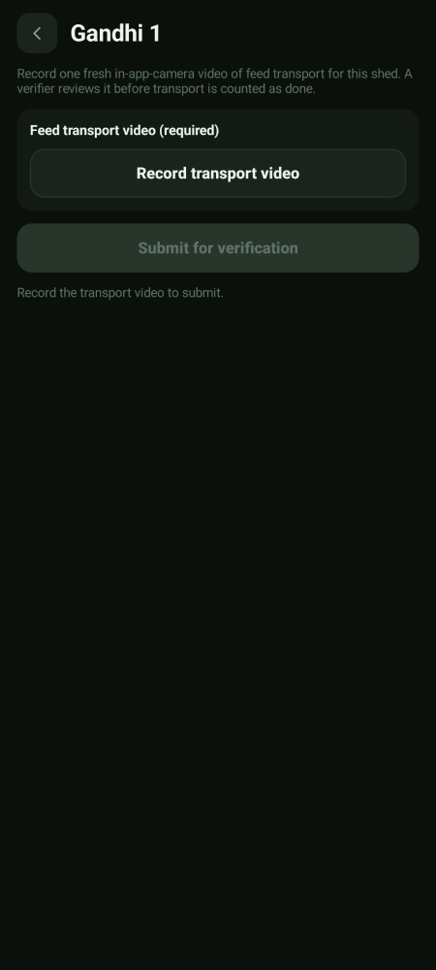  Transport video capture

Feeding a shed
Two proofs, both required  Open the shed session and record two things: a video of the feed being distributed, and a water proof, which can be either a photo or a video. Then tap Submit for verification.  - Submit stays greyed out until both proofs are there.  - The feeding is only counted as done once the Verifier approves — one approval covers both proofs. | 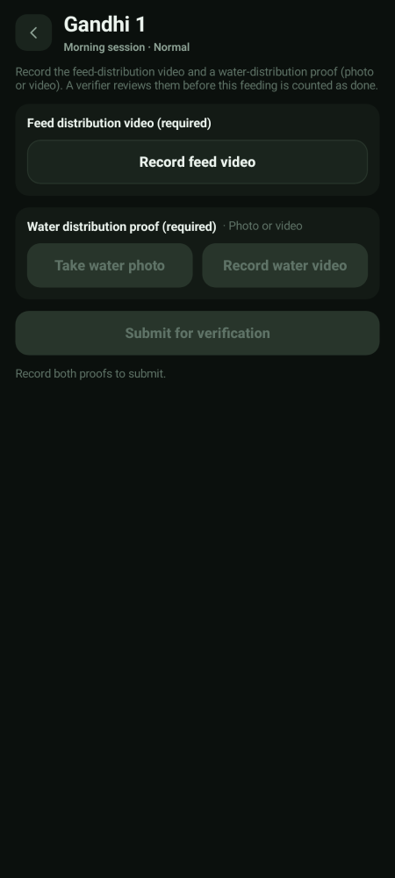  Feed and water proof

Feed Packing — recap
Packing works the same way: open the shed's packing job, record one packing video, and submit. It is completed when the Verifier approves it.

Milk · preparation, feeding and colostrum

Milk preparation
Step 1 · Open Milk Prep and pick your park  The list shows each park with how many cohorts and animals it covers, plus how much milk and citric acid to prepare. Tap Prepare.  - The chips at the top filter by To prepare, In review, Completed and Rework. | 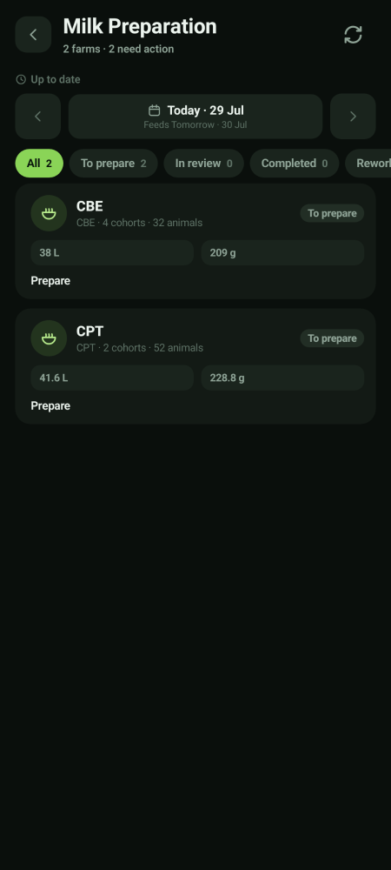  Milk preparation worklist

Step 2 · Work down the steps, filming each one  Answer Is goat milk used? first — this locks once you record the first video, so get it right. Then work down the steps: measure the milk, record the boiling temperature, record the cooled temperature, and so on. Each step wants a fresh video.  - The progress bar at the top shows how many of the videos are done.  - One Verifier reviews the complete set together. | 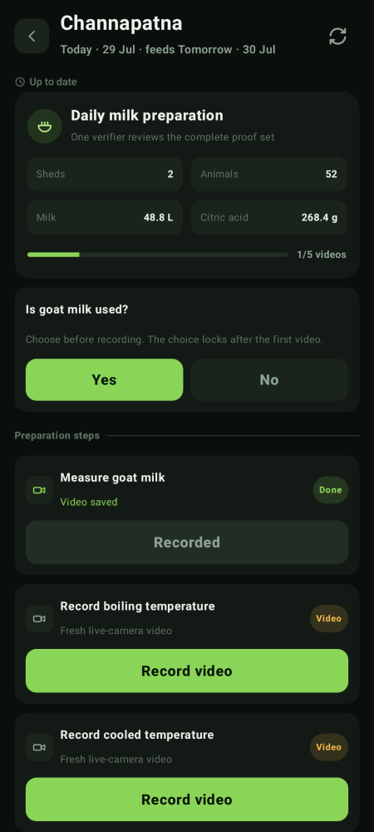  Preparation steps

Colostrum for newborn kids
Step 1 · Open Colostrum to see today's kids  Newborn kids need a set number of colostrum feeds on their birth day. The list groups them into Overdue, Due today and Completed, and shows progress like 2/5.  - A yellow 2h late label means that feed is past its session time. Do it now. | 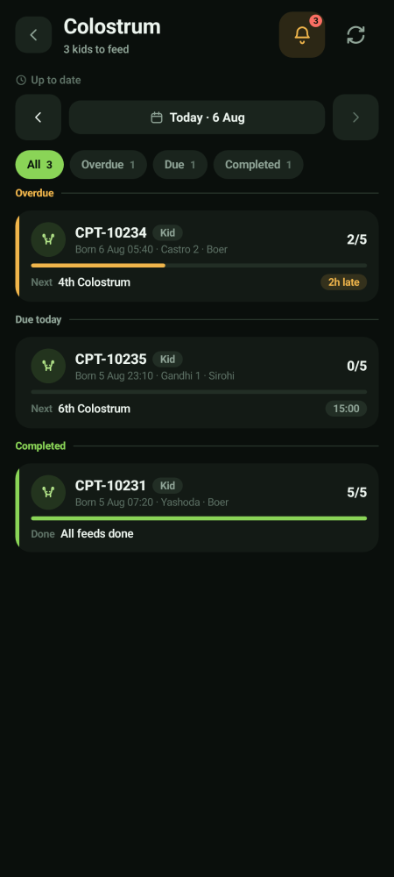  Colostrum list

Step 2 · Open a kid and record the feed  The kid's card shows when it was born, the park, the shed and the mother's tag. Each feed is listed with its session time. Tap Record video on the feed you are giving.  - Completed feeds show who recorded them, so the round is traceable.  - If the earlier birth steps for that kid are not finished, the feed will be blocked until they are. | 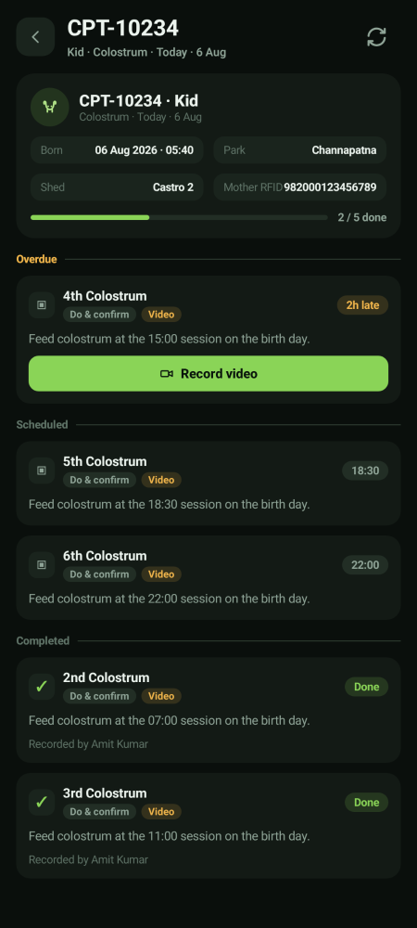  One kid's colostrum feeds

Health · animals under treatment
The Health area has two tabs, Adults and Kids. It lists animals that are on a treatment course. You can report a sick animal and carry out the treatment steps you are given; you do not decide the diagnosis or write the treatment course — that is the Health Director's and the Preventive Care Director's job.
An animal under treatment is protected
If an animal is marked sick, under treatment, in quarantine or in ICU, its vaccination work is automatically held back until it recovers. It is not cancelled and it is not left due. You do not need to do anything about it.

Alerts, and what to do when something goes wrong
Check Alerts at the start and the end of the day  Alerts is where the app tells you what is coming, what is late, and what has been sent back to you for re-work. Tap Mark all read once you have dealt with them. | 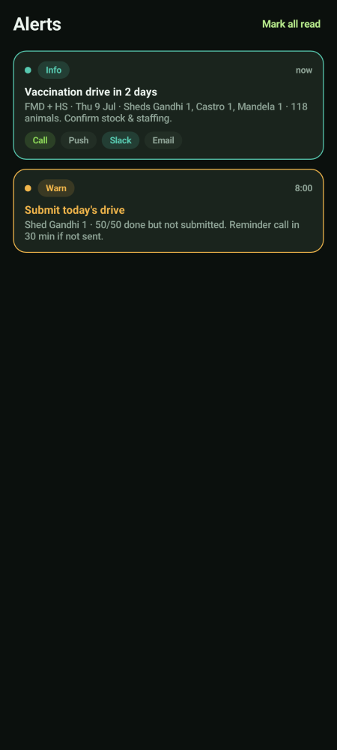  Alerts

If you lose network
Keep working — nothing is lost  If the phone goes offline you will see a yellow bar at the top. Keep working. Everything you record is saved on the phone and sends itself the moment signal comes back.  - Do not sign out while the bar is showing — sign out only after it clears.  - Videos also queue up and upload in the background.  - Pull down or tap the refresh icon once you are back in signal. | 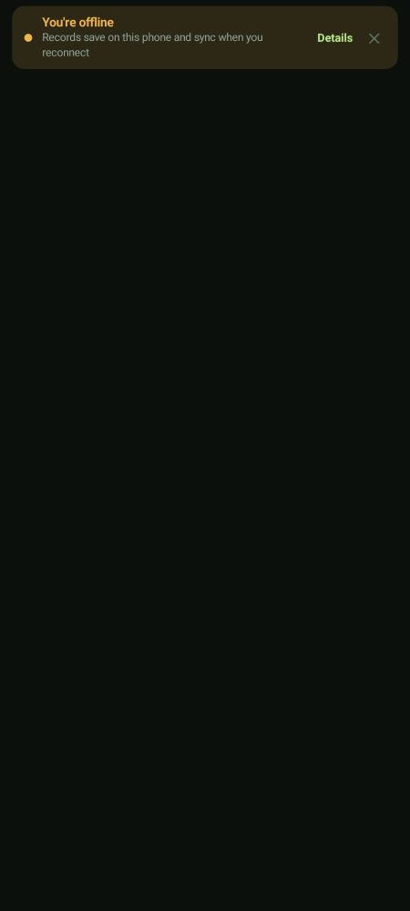  Offline notice

Quick fixes
Problem | What to do
The reader will not connect | You → RFID reader → Re-scan for readers. If that fails, Open Bluetooth settings. Check the battery percentage on the same screen.
A scan does nothing | Tap the weight or search box first so the app has somewhere to put the number, then scan again.
I scanned the wrong animal | If the camera opened, stop recording and submit it anyway — then tell your Park Head. Do not delete anything.
My video says it is still uploading | Leave the app open and stay in signal for a minute. Uploads continue in the background; do not sign out.
A shed came back as rejected | Open it from Alerts, read the reason, and re-shoot only what was rejected. The old clip stays on file.
The Submit button is grey | Something compulsory is missing — a weight, an animal count, or a video. The line just above the button tells you which.
A shed is missing from my list | It is not assigned to you, or it is on a different date. Slide the dates across the top first, then ask your Park Head.

The short version
- Check Alerts first thing.
- Check the RFID reader is paired before a round.
- Scan → the camera opens by itself → film the work → submit the clip → next animal.
- Read the coloured bar when a scan is refused. Never vaccinate an animal twice.
- Finish a shed with Finalize, then Submit, then wait for the green Synced bar.
- Every video is compulsory. A greyed-out button means something is missing.
- Offline is fine. Keep working.
- Your work is finished when the Verifier approves it — not when you submit it.

