MESHA · GOAT OS
Verifier
You watch the proof and you decide. Nobody else can.

For the Video Verification team · All parks · The independent second check

This handbook shows what you see on the Mesha phone app, what you are
responsible for, and exactly which buttons to press for each job.
Every picture is a real screen from the app.

What this job is
Work on this farm is not finished when somebody says it is finished. It is finished when you have watched the proof and approved it. You are the independent second check, and the approve and reject buttons exist in exactly one place on the whole system: your queue.
Not even the CEO can approve a video
Leadership can watch every clip and read every verdict you record. They cannot cast one. A check on people's work is not independent if those people can sign it off themselves — that is the entire reason this job exists.

You cover the whole business, not one park. One verifier reviews proof across every park and every shed.

Your areas
You get one entry in your menu for each thing you verify, and each one has its own queue. Three are live today. Two more are on the way.
Area | What you review | Status
Vaccination | Camera clips of animals being vaccinated, per animal or per shed | Live
Weighing | Videos of animals being weighed, individually or as a group | Live
Herd Operations | Births, deaths and moves between sheds | Live
Health | Proof from animals being treated, adults and kids | Coming later
Milk | Proof from the daily kid-milk preparation round | Coming later

Health and Milk are still being built
Operators are already recording this proof in the field today — it is just not yet routed to a review area of its own, so you will not find it in your menu and you are not missing work. When each one is switched on it simply appears as a new entry, with the same Verify and Alerts buttons as the areas you already have. Nothing you do now changes.

Each live area has two buttons at the bottom: Verify (your queue) and Alerts (what is coming in). Your account sits at the bottom of the areas panel.

Getting into the app
Everyone at Mesha signs in the same way. What you see afterwards depends on your job — and yours takes you straight to a review queue, not to a work list.
Step 1 · Open the Mesha app and sign in  Use your Mesha work email and password, or tap Continue with Google if your account is set up that way.  - You can change the app language at the bottom of this screen.  - Sign in once — the app keeps you signed in on that phone. | 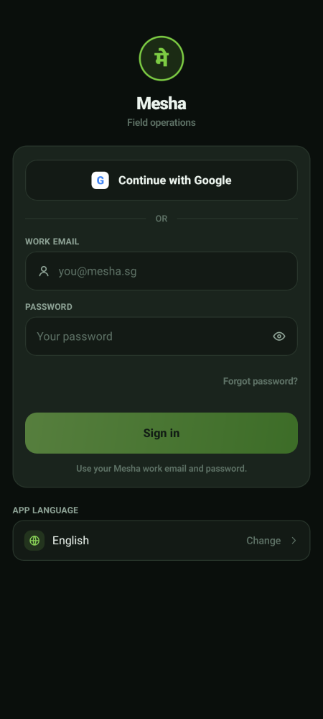  Sign-in screen

Step 2 · Land straight on a review queue  You do not get an overview screen or a work list. You land on the first of your queues, already filtered to Due — the items waiting on you today.  - The ☰ menu button at the top left opens your list of areas.  - Your two buttons are Verify and Alerts, and nothing else.  - If you verify only one thing there is no menu button, and You sits on your bottom bar instead. | 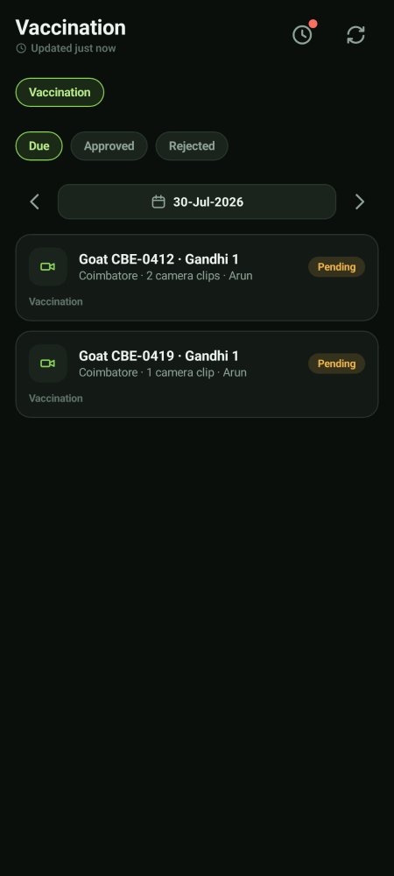  Where you land

Step 3 · Switch between your areas  Tap ☰ and pick another area. The queue changes to that area's proof, and the two buttons stay the same. Your name and Sign out sit at the bottom of that panel.  - Each area is a separate queue. Clearing one does not touch another. | 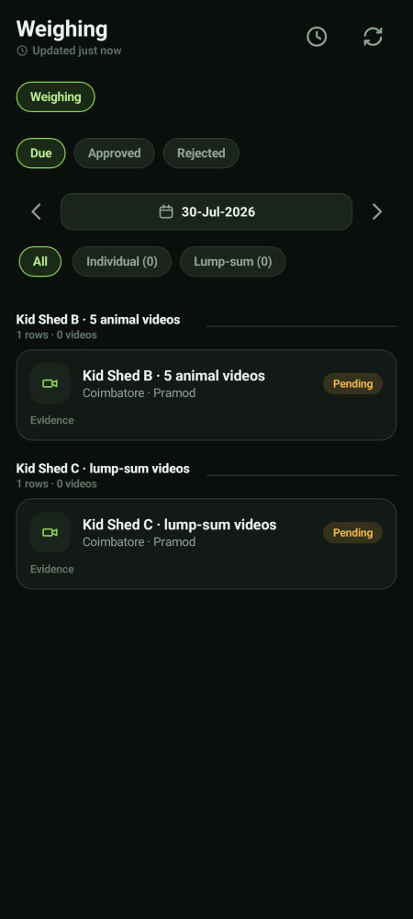  The same two buttons, a different queue

Working a queue
Step 1 · Open Verify and choose the day  Each queue opens on Due — the items waiting on you. Approved and Rejected show what you have already decided. Move the date across the middle to look at another day.  - Each row tells you the animal or shed, the park, how many clips there are, and who recorded them.  - Pending in amber means it is waiting on you. |   Vaccination queue

Step 2 · Open an item and watch every clip
Tap the row. Watch each clip through. Check three things:
- Is the work actually visible — the injection going in, the animal on the scale, the feed being given?
- Does the animal or shed match the one on the record?
- Is the clip clear enough for someone else to reach the same conclusion?

Step 3 · Approve, or reject with a reason
Approve if the proof stands up. Reject if it does not, and say why in plain words — the person who shot it will read exactly what you write.
- Good reasons look like: *Injection not visible*, *Wrong animal in frame*, *Transport path is not visible*, *Clip too dark*.
- A rejection goes back to the same person who recorded it. On weighing that is guaranteed, because a shed belongs to exactly one operator.
- A re-work always produces a new clip. Your rejected clip stays on file as history — nothing is deleted.

The Herd Operations queue is the one that mixes types
Use the chips to work one type at a time  Vaccination and Weighing each hold one kind of proof. Herd Operations holds several — births, deaths and shed moves side by side — so tap a chip across the top and clear one type before moving to the next.  - Each row names what moved, from which shed to which shed, how many animals, and who recorded it.  - Once Health and Milk are switched on they arrive as their own areas in your menu, not as extra chips here. | 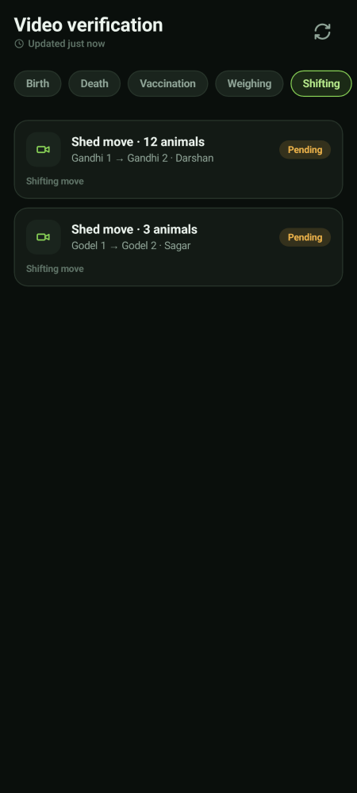  Herd Operations queue

What your decision actually does
What you are reviewing | Approve | Reject
Vaccination proof | The animals count as accepted; the Director can then close the drive | The shed comes back to that operator to re-shoot
Weighing proof | That observation is verified; once all of them are, the shed can be closed | That one observation goes back to the assigned operator. The shed does not reopen
A birth or death | The evidence is marked verified | Re-work is raised against the person who recorded it
A shed move | The evidence is marked verified | Re-work is raised — but the animals stay where they were moved to. A rejection does not un-move them

The same shape applies to Health and Milk proof when those areas are switched on: approve completes the job, reject sends it back to the same person for a fresh recording.
A shed move is the one that behaves differently
Animals move as soon as the approval and the operator's video both exist. Your review comes afterwards and is about the quality of the evidence. Rejecting it creates re-work and an audit record; it does not roll the animals back.

How much your decision holds up
- A weighing shed cannot be closed while any video on it is still waiting on you. There is no override anywhere in the app.
- Across the whole system, recording a video never completes a job — a feed packing, transport or feeding session sits in review the same way, waiting on a verdict.
- A vaccination drive shows the field work as done — the animals really were vaccinated — but stays flagged as awaiting review until you clear it, and cannot be closed before then.

Alerts
What is arriving  The Alerts tab for each area tells you what has just come in and what is building up. It is scoped to the area you are standing in. | 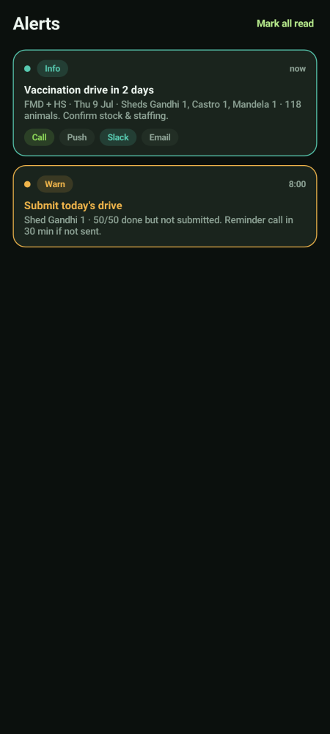  Alerts

On the laptop
The same review runs in a browser, with the same areas. Your laptop account opens the verification workspace and nothing else — every other screen is deliberately shut off, so a typed address simply will not open. Use whichever suits the clip you are reviewing; a bigger screen helps on a dark video.

What you do not do
Not yours | Whose it is
Closing a drive or a weighing shed | Leadership — the CEO and the owning Director
Reassigning a task or raising re-work on the job itself | Leadership
Approving a birth, a death or a move | Approvers and the CEO
Recording any work in the field | Operators
Changing a schedule, a ration or a protocol | The owning Director

Your independence is the product
You are not expected to help the work along, hurry a verdict, or approve something borderline because a shed needs closing. If the proof does not stand up, reject it and say why. That is the job.

Your account and settings
The You screen  Tap You (in the bottom bar, or at the bottom of the areas panel) to see your name, the parks you cover, your app language, and Sign out. | 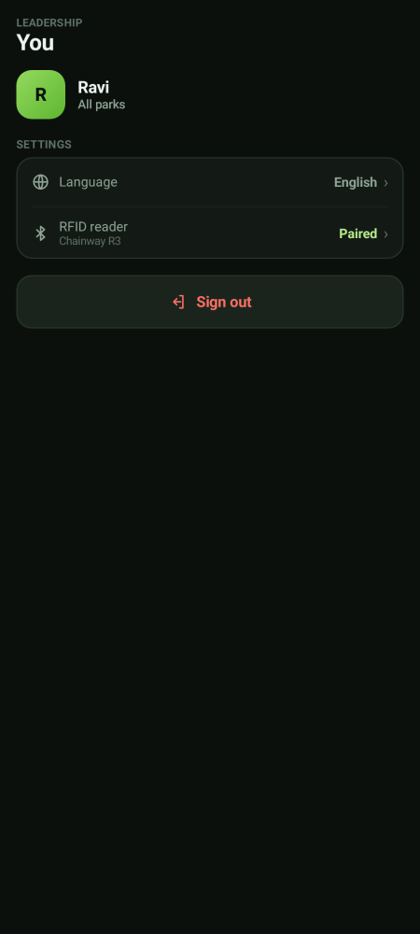  Your account

If you lose network
Keep working — nothing is lost  If the phone goes offline you will see a yellow bar at the top. Keep working. Everything you record is saved on the phone and sends itself the moment signal comes back.  - Do not sign out while the bar is showing — sign out only after it clears.  - Videos also queue up and upload in the background.  - Pull down or tap the refresh icon once you are back in signal. | 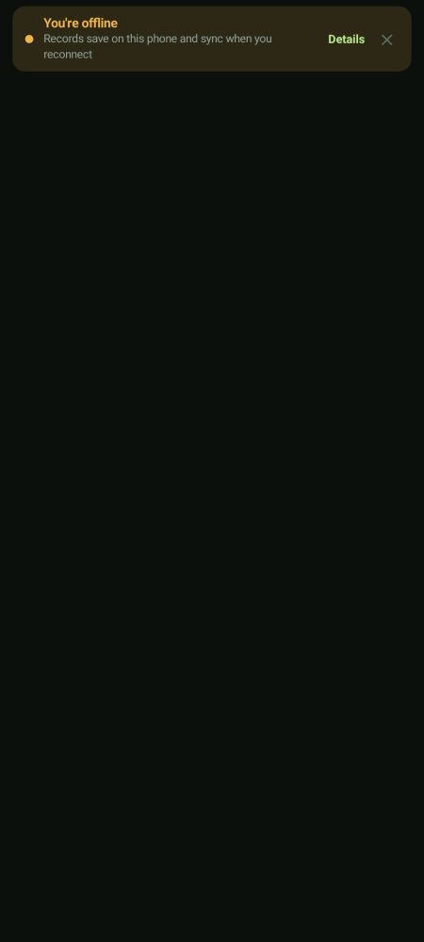  Offline notice

