MESHA · GOAT OS
Approver
Births, deaths, and moves between sheds

For named individuals holding approval authority · Alongside your normal job

This handbook shows what you see on the Mesha phone app, what you are
responsible for, and exactly which buttons to press for each job.
Every picture is a real screen from the app.

What this is
You decide on three kinds of request that operators raise from the field: a birth, a death, and a move between sheds. Nothing you approve here is a video review — that is the Verifier's job. What you are deciding is whether the event itself should stand.
This authority belongs to you, not to your job title
It is granted to you by name, on top of whatever your normal role is. If you move on, the next person in your post does not inherit it — somebody has to grant it to them by name. That is deliberate: it keeps approval a decision about a person rather than a side effect of a job.

Where it appears
An extra area called Approvals appears in your slide-out menu, alongside your normal areas. It has a single button at the bottom: Approval. It does not change anything else about your account.
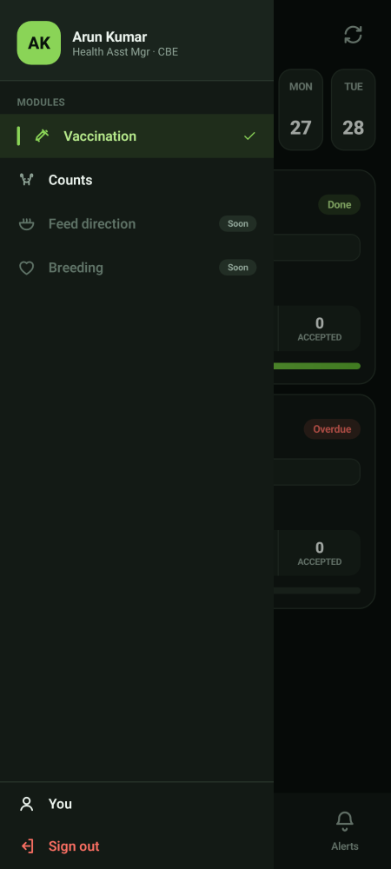
Approvals sits alongside your normal areas

Working the queue
Step 1 · Open Approvals  Every row is a request from the field. The row tells you, in plain words, who raised it and what they are asking for — the shed names and the person's name, never internal reference numbers.  - You are only ever shown the kinds of request you are entitled to decide.  - Use the filters to work one kind at a time. | 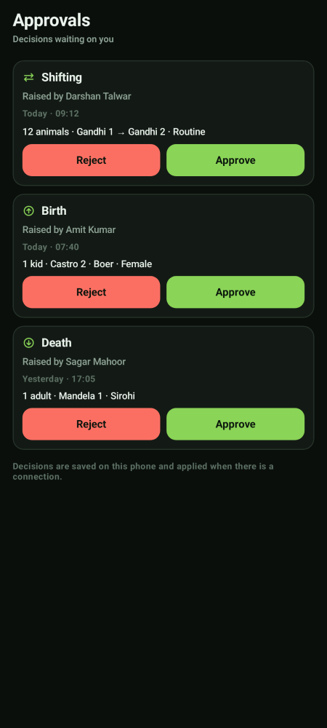  The approvals queue

Step 2 · Read it and decide
Check it against what you know of the park before you act.
- Birth — is the animal real, and is the shed right?
- Death — does it match what was reported on the ground?
- Move — does the destination shed make sense for these animals, and is it in the same park? Animals never move between parks.

Step 3 · Approve or reject
Approve lets the event take effect. Reject sends it back. Be specific about why — the operator reads your reason.

What each approval actually does
Request | When you approve | When you reject
Birth | The kid joins the herd and starts appearing in counts and schedules | Nothing joins the herd; the operator is asked to correct and resubmit
Death | The animal leaves the herd | Nothing changes; the operator is asked to correct it
Move between sheds | The move is authorised. The animals change shed the moment both your approval and the operator's video exist | The move is not authorised and does not happen

A move needs two things, in either order
Your approval and the operator's live video are independent. Neither one alone moves anything. Whichever arrives second is the moment the animals actually change shed, the herd register updates and the feed sheet follows. If you approve and nothing moves, the video has not been recorded yet.

What happens after you approve a move
- The animals' shed is updated, and the herd register and counts follow immediately.
- The animals adopt the destination shed's group automatically. Neither you nor the operator chooses a new stage — the destination decides it.
- Their vaccination work is re-scoped to the new shed, and anything already in progress or completed is preserved.
- The feed sheet starts counting those animals against the destination shed. In fact it does that from the moment you authorise the move, so a shed is never double-fed or under-fed on a moving day.
- The Verifier reviews the video afterwards. A rejection creates re-work; it does not move the animals back.

High-priority moves
A move marked high priority carries feed with it. The operator has to record three videos, not one: the move itself, the feed being packed, and that feed being given to the animals. All three are reviewed together as a single item. Your approval decision is unchanged; only the evidence is heavier.

What you do not do here
Not yours | Whose it is
Approving or rejecting a proof video | The Verifier
Recording a birth, a death or a move | Operators
Carrying out the move on the ground | The operator who raised it
Closing a drive or a weighing shed | The owning Director or the CEO

This authority carries nothing else
Holding approval rights gives you approval rights and nothing more — no extra reading, no extra recording, no wider access. Everything else you can do comes from your normal job.

