USER INTERFACE AND USER EXPERIENCE DESIGN
LAB ASSIGNMENTS
ASSIGNMENT NO: 7
Name | Arya Said
Roll No. / Division | 1262242560 /
Date of submission
Project | Flowspace: a redesign of ClickUp's first-run experience
Figma link (deliverable) | https://www.figma.com/proto/NGVBa9i4SpuI5o8qh3aflH/Untitled?page-id=83%3A15892&node-id=83-17003&starting-point-node-id=83%3A17003&scaling=min-zoom&content-scaling=fixed

Aim: To redesign the interface of the project developed in the previous lab assignments for users with special needs, and to create an accessible and inclusive interactive prototype.
Problem Statement: Use the same project and Figma file, redesign it for users with special needs, apply accessibility guidelines, and check the final design with an accessibility checklist.

Theory
Accessible (inclusive) design means designing a product so that people with different abilities can use it effectively, efficiently and with satisfaction. A limitation can be permanent (blindness), temporary (a broken arm) or situational (bright sunlight, a noisy room, exam stress). Designing for these users usually makes the product easier for everyone.
The Web Content Accessibility Guidelines (WCAG 2.2) are the standard used in this assignment. They are grouped under four principles: Perceivable, Operable, Understandable and Robust (explained in FAQ 1). The main guidelines applied here are text contrast of at least 4.5:1, no information by colour alone, targets of at least 44 × 44 px, full keyboard operation with a visible focus, an alternative to dragging, plain and consistent language, and a way to undo actions.

1. Problem definition
Flowspace was first designed for people who can read small grey text, drag cards with a mouse, and handle several prompts at once. The heuristic evaluation in Assignment 5 found these barriers:
- Secondary grey text had a contrast of only 3.2:1, below the WCAG minimum of 4.5:1.
- Task status was shown by a small coloured dot, and priority by colour.
- Changing a task's status needed dragging a card between columns.
- On the first visit, Home showed four prompts at once (tip, digest, checklist, group-project prompt).
- Removing a starter task or moving a card could not be undone.
- "Workspace" and "project" were used for the same thing; dates used the US format and the shortcut hint was Mac-only (⌘K).
Problem statement: Students with low vision, limited hand movement or cognitive and learning difficulties cannot set up Flowspace, see what is due, or update a task without relying on colour, a mouse, or a good memory.

2. Target user group
Students and small-team members with mixed special needs. The brief suggests choosing one group, but these needs often occur together (a student with dyslexia can also have a sprained wrist during exams), and a fix for one group usually helps the others. Every change in the redesign is tagged with the group it serves.
Group | Who | What they need from Flowspace
Vision | Low vision, colour blindness; users who zoom to 150–200% | Text at least 4.5:1, status in words and icons, a text-size setting, layouts that stay usable when enlarged
Motor | Tremor, RSI, one-handed or temporary injury; keyboard and trackpad users | No drag-only actions, targets at least 44 px, full keyboard use, a visible focus ring
Cognitive | Dyslexia, ADHD, memory difficulty, stress | One next step at a time, plain and consistent words, Undo, easier-reading spacing

3. Personas
These are proto-personas built from accessibility guidelines and our earlier student persona (Aditi Sharma), not from interviews.
 | Meera Joshi, 21 (Vision) | Rohan Deshpande, 23 (Motor) | Sana Khan, 20 (Cognitive)
Background | B.Tech (CS), 3rd year. Low vision (uses 175% zoom) and red-green colour blindness. | MBA, 1st year. Tremor in his right hand after a bike accident. | BBA, 2nd year. Dyslexia and ADHD.
Goal | Keep track of labs and assignments without squinting. | Update his group's tasks quickly between classes. | Know what to do next without reading everything.
Frustrations | Grey labels disappear at her zoom level; "red = urgent" means nothing to her. | Dragging cards across columns; tiny × buttons and checkboxes. | Several banners at once; jargon; things vanish with no way back.
Needs | Strong contrast, words and icons instead of colour, a text-size setting. | A Move button and keyboard keys instead of dragging; big targets; visible focus. | One next step, plain words, Undo on every change, easier-reading spacing.

4. Redesigned flow
The same first-run journey as before, with every step usable by keyboard alone:
A1 Step 3: Shape your project → A2 Home → A4 Coursework board → A4b Move dialog → A4c Board with the task moved and an Undo message.
Branches: the Display button in the top bar opens A3 (Display and accessibility) from any screen; Undo in A1b returns a removed task; Undo in A4c puts the moved task back in To do.
In the Figma file, the page "Flowspace accessible (Ass 7)" holds the documentation boards in the top row, grey wireframes of A1–A4 in the middle row, and the seven linked hi-fi screens in the bottom row, each with a "What changed and why" panel. The prototype link opens on A2 Home (flow "Accessible app (Ass 7)"); the onboarding screens A1 and A1b are in the second flow, "Accessible onboarding (Ass 7)", which can be chosen from the flows list in the prototype viewer.

5. Redesigned screens
Screen | Change | Group | Guideline
A1 Step 3 | "Remove" buttons with a text label, 44 px tall, instead of a 26 px × icon | Motor, Cognitive | 2.5.8 Target size; 1.1.1
A1b Step 3 | A removed task leaves a message with Undo | Cognitive | 3.3.4 Error prevention
A1 Step 3 | "Project" used everywhere ("Create project"); full dates (Due Mon 19 Oct) | Cognitive | 3.2.4 Consistent identification
A2 Home | One "Your next step" card replaces four prompts; others appear later, one at a time | Cognitive | Cognitive load; 3.2.3
A2 Home | Numbers explained in words; status = icon + word; priority = flag + "High priority" | Vision | 1.4.1 Use of colour
A2 Home | Display and Help buttons with text in the top bar; Ctrl K instead of ⌘K | Vision, Motor | 2.4.6 Labels
A3 Display | Text size (Default, Large, Extra large), High contrast, Easier reading, Reduce motion, Keyboard hints, Ask before removing; each switch says On or Off | Vision, Cognitive, Motor | 1.4.4 Resize text; 2.3.3 Motion
A4 Board | Move button on every card; keyboard hints (Tab, Enter, M); column status as icon + word + count | Motor, Vision | 2.5.7 Dragging; 2.1.1 Keyboard
A4b Move | Dialog with three large options, works with arrow keys and Enter | Motor | 2.1.1 Keyboard; 2.5.8
A4c Board | Status message "moved to In progress" with Undo and Close; stays until closed and is read by screen readers | Cognitive, Vision | 4.1.3 Status messages
A2, A4 | Urgent priority uses a warning-triangle icon, not only red (added after testing) | Vision | 1.4.1 Use of colour
All screens | Text 15–17 px base (+15%), secondary text 6.6:1, borders 4.2:1, 3 px blue focus ring (6.7:1) | Vision, Motor | 1.4.3; 1.4.11; 2.4.7
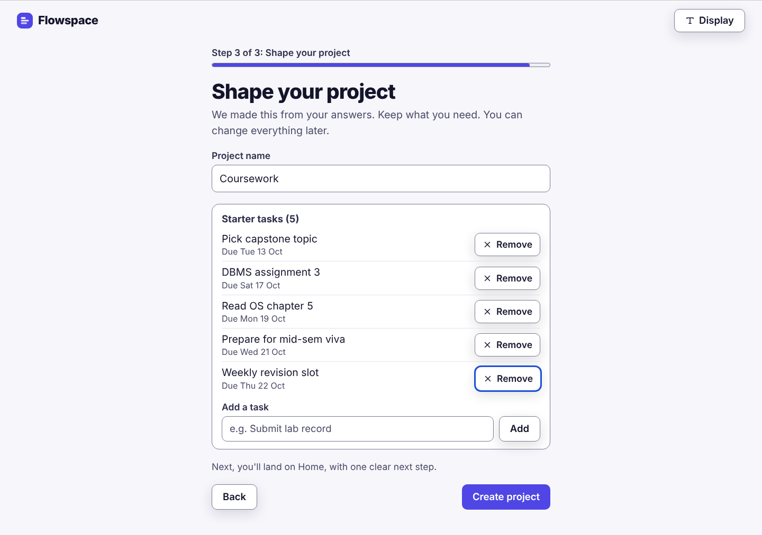
Fig. 1: A1 Step 3 with labelled Remove buttons and a visible keyboard focus ring.
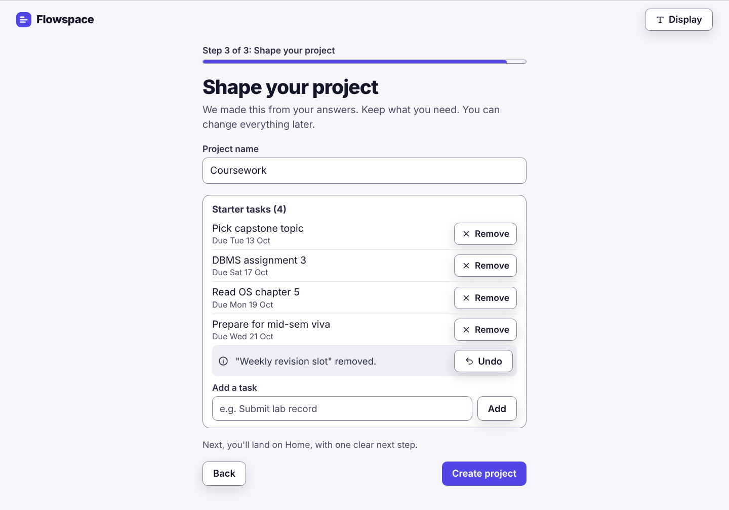
Fig. 2: A1b A removed task can be brought back with Undo.
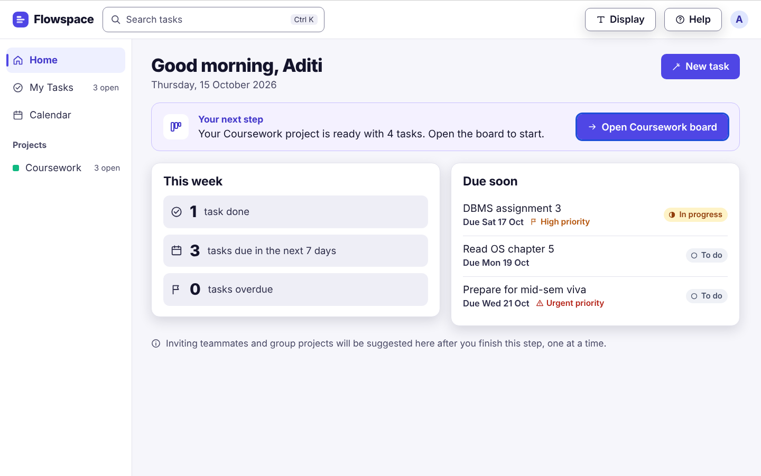
Fig. 3: A2 Home with one next step, numbers in words and status not shown by colour alone.
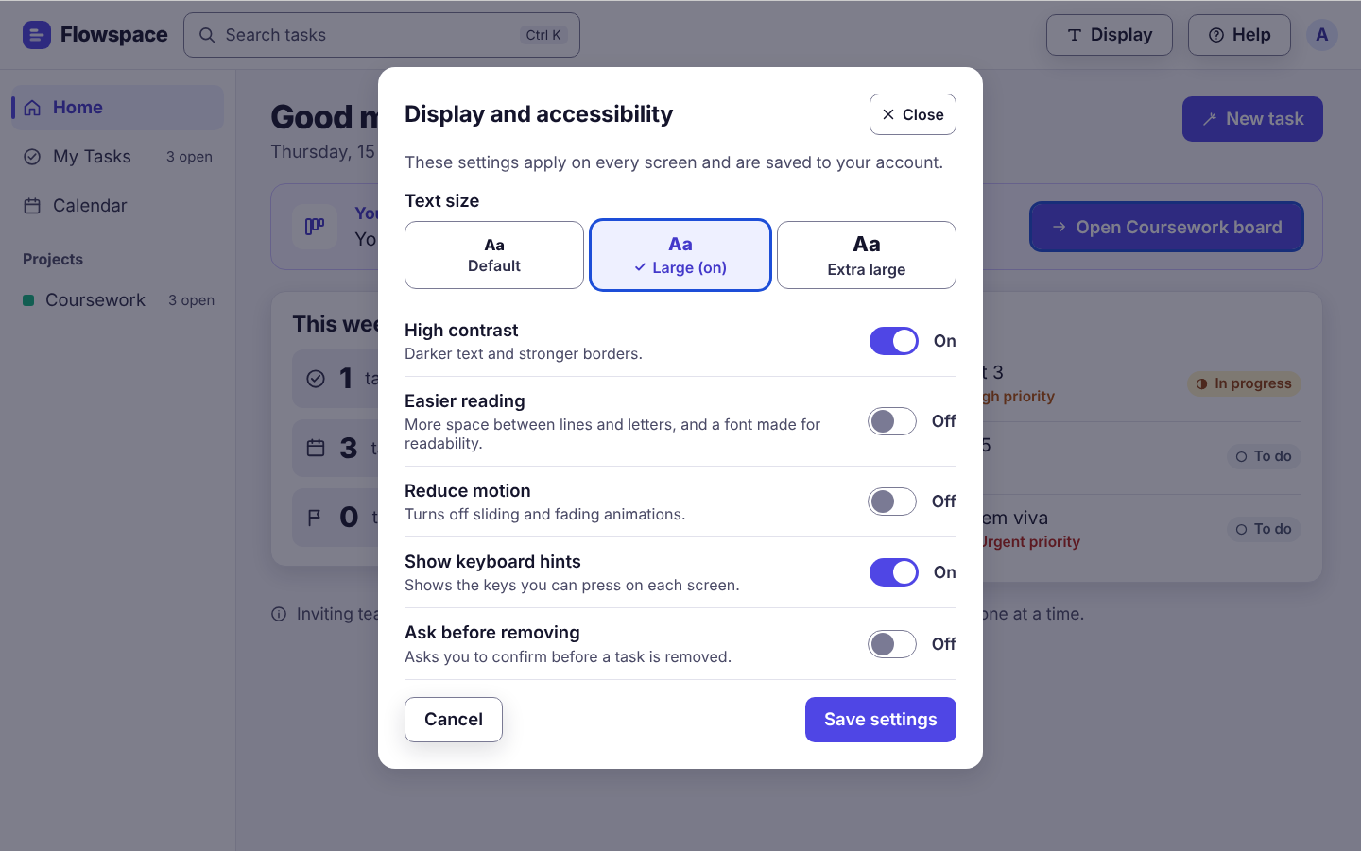
Fig. 4: A3 Display and accessibility settings.
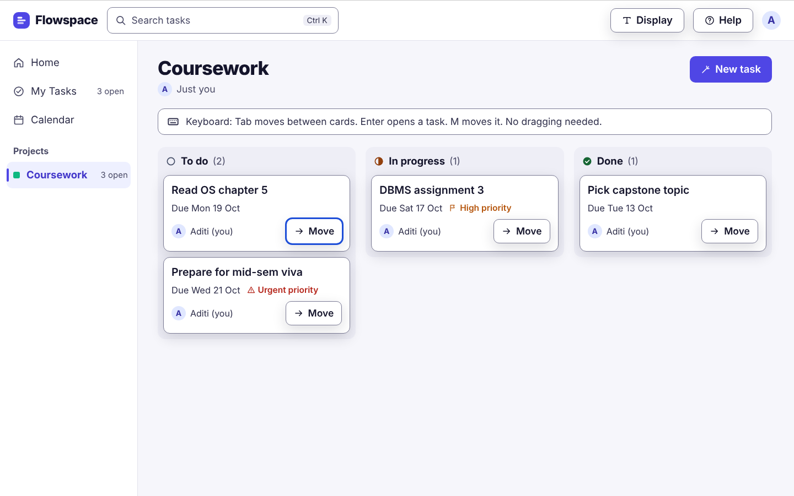
Fig. 5: A4 Coursework board with a Move button on every card and keyboard hints.
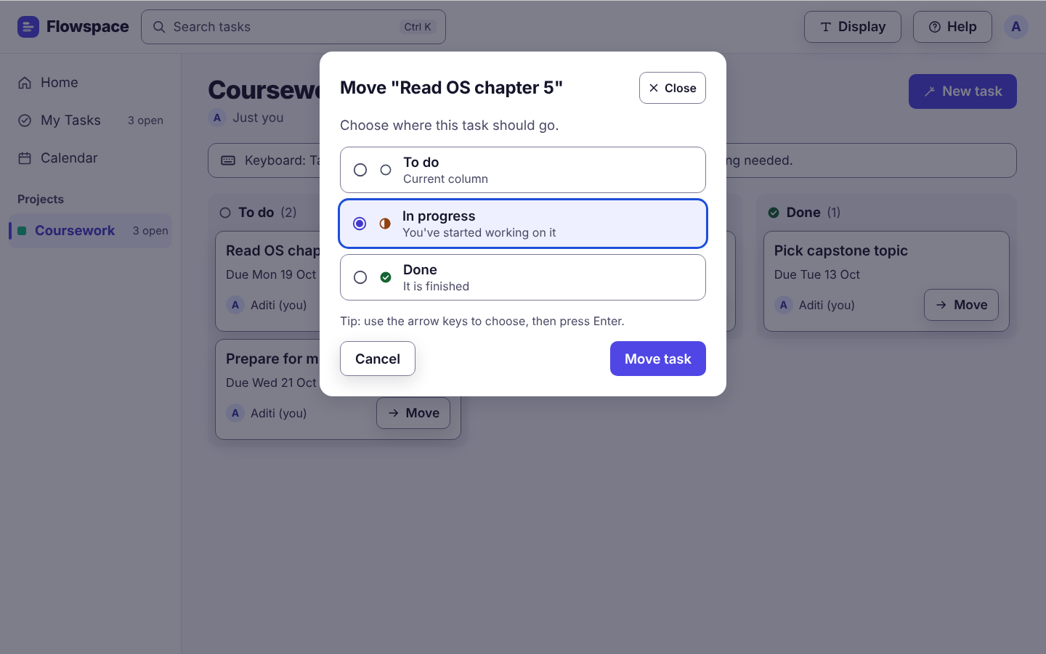
Fig. 6: A4b Move dialog that works with the arrow keys and Enter.
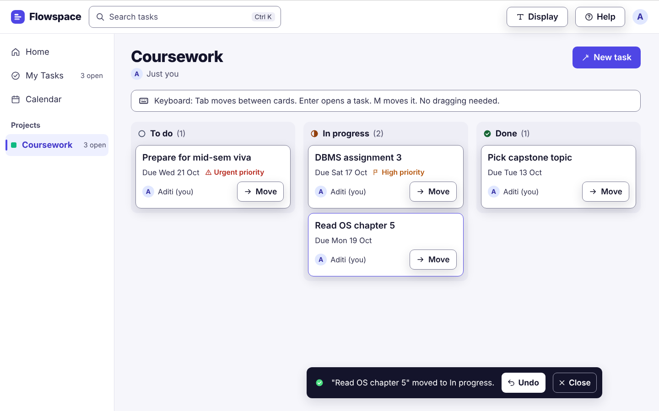
Fig. 7: A4c Announced status message with Undo and Close.
Figures are renders of the same frames the Figma plugin builds. You can replace them with screenshots from your Figma file.

6. Accessibility checklist
Check | WCAG 2.2 | Result | How the design meets it
Text contrast at least 4.5:1 | 1.4.3 AA | Pass | Body text 12.1:1, secondary text 6.6:1, primary button text 6.3:1
Controls and focus at least 3:1 | 1.4.11 AA | Pass | Input and button borders 4.2:1; focus ring 6.7:1
Colour is not the only cue | 1.4.1 A | Pass | Status = icon + word; priority in words; selected options show a tick and "(on)"
Text can be enlarged | 1.4.4 AA | Partly | Text size setting; reflow at 200% to be checked in the coded build (Figma frames are fixed)
Target size | 2.5.8 AA | Pass | Buttons 44–48 px; sidebar rows 48 px
Alternative to dragging | 2.5.7 AA | Pass | Move button and dialog on every card
Keyboard operable | 2.1.1 A | Pass (design) | Tab order follows the layout; M moves, Enter opens; to verify in the build
Focus visible | 2.4.7 AA | Pass | 3 px blue ring on the focused element
Labels and instructions | 3.3.2 A | Pass | Visible label above every field, with an example
Undo / error prevention | 3.3.4 AA (related) | Pass | Undo after removing and after moving a task
Status messages | 4.1.3 AA | Pass (design) | Move confirmation announced as a status message
Motion | 2.3.3 AAA | Pass | Reduce motion switch
Consistent wording and layout | 3.2.3 / 3.2.4 AA | Pass | "Project" everywhere; same top bar and sidebar; full dates
Text alternatives | 1.1.1 A | Pass | All icon buttons also show text
Skip repeated blocks | 2.4.1 A | Pass | "Skip to main content" link on the first Tab (added after testing)
Contrast values were calculated from the hex colours used in the design. You can confirm them with the Stark or WebAIM contrast checker in Figma.

7. Testing summary
No participants with disabilities were available, so the hi-fi screens were tested with impairment simulations and a keyboard-only walkthrough (an expert review). This method finds design barriers early, but it does not replace testing with disabled users; that remains the next step.
Tasks used: T1 remove "Weekly revision slot", undo it, then create the project; T2 set text size to Large; T3 move "Read OS chapter 5" to In progress without dragging.
Simulation | How it was done | Result | What we found and changed
Colour blindness | Deuteranopia and protanopia filters (Machado 2009) applied to the board, Home and settings screens | Pass, 1 fix | Statuses stay clear because they use an icon and a word. High (amber) and Urgent (red) priority looked the same colour; the words still differed. Fix: Urgent now has a warning-triangle icon.
Greyscale | All colour removed from the screens | Pass | To do, In progress and Done are told apart by icon shape and word; the focus ring is still visible.
Low vision (blur) | Gaussian blur over the full screen | Partly | Headings, buttons and task names stay readable. Small labels (status tags, "3 open", the hint line) blur out at the default size. The Large text setting fixes this; a 16 px minimum by default is suggested.
Keyboard only (motor) | T1–T3 walked through using only Tab, Enter, the arrow keys and M | Pass, 2 fixes | All three tasks can be done without a mouse. Missing: a way to skip the top bar and sidebar (added "Skip to main content"), and the status message had no Close button (added).
Focus after actions | Checked where keyboard focus should go after each action | Spec note | After Remove, focus moves to Undo; after the Move dialog closes, focus returns to that card's Move button.
Cognitive walkthrough | Read each screen for wording, number of steps and number of choices | Pass | One next step on Home and one word ("project") throughout. The settings dialog has 6 options; acceptable because users open it on purpose.
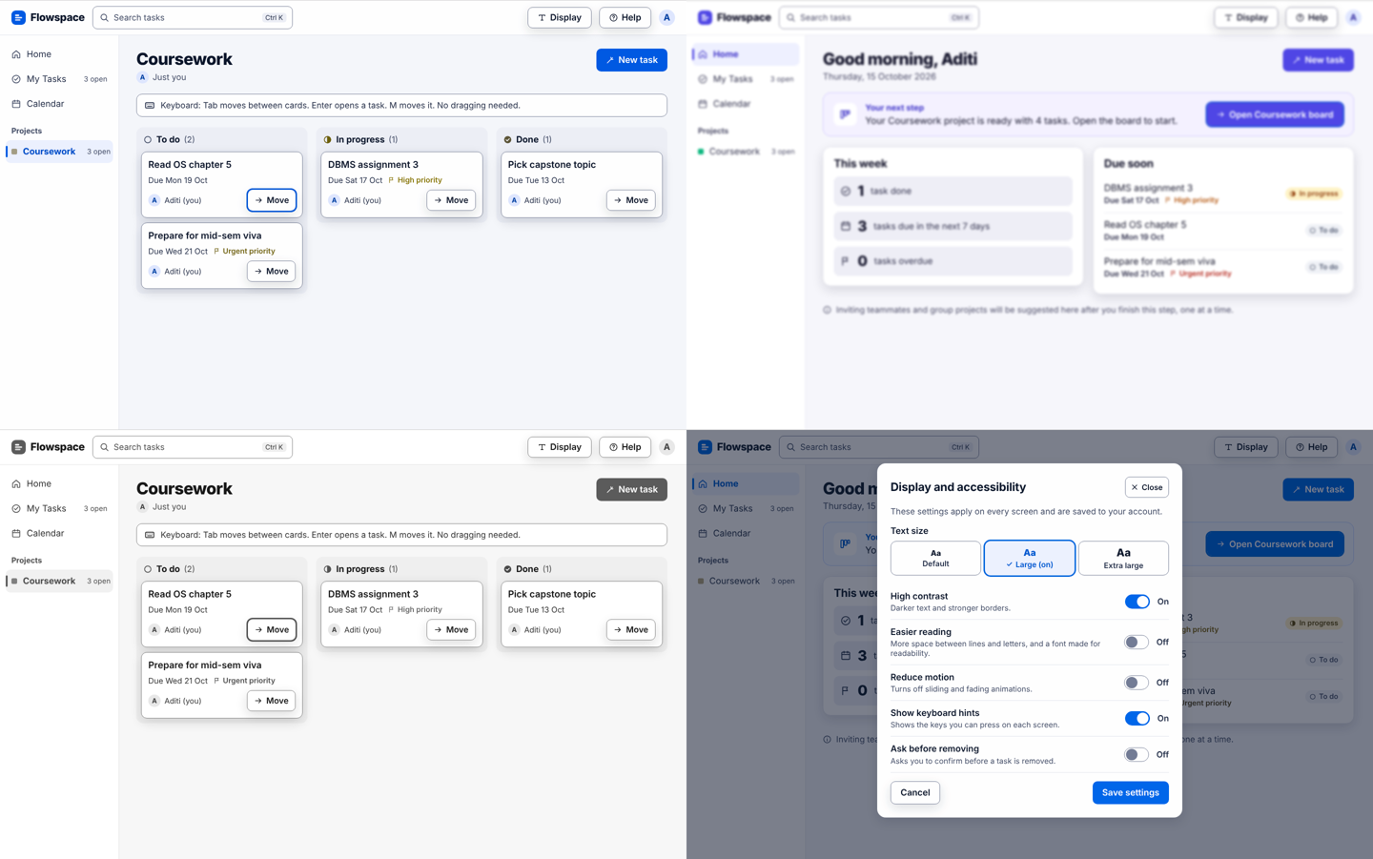
Fig. 8: Simulations: deuteranopia (top left), blur (top right), greyscale (bottom left), protanopia (bottom right).
Changes made after testing: warning-triangle icon for Urgent priority, a Close button on the status message, and a "Skip to main content" link on the first Tab press. These are in the Figma file and its notes panels.

Conclusion
In this assignment we redesigned the Flowspace first-run experience for users with low vision, limited hand movement and cognitive or learning difficulties. Starting from the problems found in our heuristic evaluation, we raised text and control contrast above the WCAG minimums, stopped using colour as the only cue, made every action possible without dragging or a mouse, added a visible focus ring, reduced Home to one next step, used the same words throughout, and added Undo to every change. A Display and accessibility panel lets each user choose text size, contrast, reading spacing and motion.
We checked the design with colour-blindness, greyscale and blur simulations and a keyboard-only walkthrough. All three test tasks could be completed without a mouse and without relying on colour. Testing found three gaps (Urgent and High looked the same to colour-blind users, there was no way to skip repeated navigation, and the status message could not be closed), which we fixed. Small labels at the default size remain a weakness, solved for now by the text-size setting. The next step is to test with users who have these needs. We also learned that most accessibility fixes made the product clearer for every user, not only for the target groups.

FAQs

1) Explain the four principles of WCAG (Perceivable, Operable, Understandable, Robust) with suitable examples.
Perceivable: information and interface parts must be presented in ways users can perceive with at least one of their senses. Examples: alt text for images, captions for video, text contrast of at least 4.5:1, and not using colour alone. In Flowspace, task status is shown with an icon and a word, not just a coloured dot.
Operable: every function must be usable with different input methods and within reasonable effort. Examples: everything works with a keyboard, focus is visible, targets are large enough, there is an alternative to dragging, and nothing flashes or moves without control. In Flowspace, each card has a Move button and the M key, so no dragging is needed.
Understandable: content and behaviour must be clear and predictable. Examples: plain language, consistent navigation and names, visible labels, helpful error messages and ways to undo. In Flowspace, "project" is used everywhere, every field has a label, and Undo appears after removing or moving a task.
Robust: content must work reliably with current and future technologies, including assistive technology. Examples: proper HTML elements and ARIA roles so screen readers know what each control is, and status messages that are announced. In Flowspace, the "moved to In progress" message is a status message that a screen reader reads out, and every control has a text name.

2) Discuss the design considerations for users with visual, hearing, motor and cognitive impairments, and explain how your interface supports your target users.
Visual: high contrast, resizable text, no colour-only information, text alternatives for images and icons, support for screen readers and zoom. Flowspace: secondary text raised from 3.2:1 to 6.6:1, a text-size setting, status and priority in words, and text on every icon button.
Hearing: captions and transcripts for audio and video, and visual alerts instead of sounds. Flowspace does not rely on sound; every alert is shown on screen as a message, so deaf and hard-of-hearing users get the same information.
Motor: large targets with spacing, full keyboard operation, no precise gestures such as dragging, no time limits, and a visible focus. Flowspace: 44–48 px buttons, a Move button and dialog instead of drag-only, keyboard keys (Tab, Enter, M), and a 3 px focus ring.
Cognitive: simple language, one main task per screen, consistent layout and terms, clear feedback, and the ability to undo mistakes. Flowspace: Home shows one next step instead of four prompts, the same words are used everywhere, full dates replace short ones, an Easier reading option adds spacing, and Undo follows every change.
Together these changes let Meera (low vision), Rohan (motor) and Sana (dyslexia and ADHD) complete the same journey as any other student: set up a project, see what is due, and move a task, without relying on colour, a mouse or memory.

