LAB ASSIGNMENT V : HUERISTIC EVALUATION
SYSTEM EVALUATED : Flowspace: redesign of ClickUp's sign-up, onboarding and first workspace (hi-fi Figma prototype and coded website)
Groups members NAME : Arya Said (Roll No. 1262242560)
**Evaluation to be done by other Group
PART I : HUERISTIC EVALUATION BASED ON NIELSEN'S 10 GENERAL PRINCIPLES FOR INTERACTION DESIGN. (0 is lowest and 5 is highest)
S.No. | Heuristic Evaluation Parameter | Mention Violation if any | Severity 0-5 (0- minimum and 5 is maximium) | Ways to improve
1 | User Control: Interface will allow the user to perceive that they are in control | Tasks cannot be deleted, and the task detail panel is read-only: once a task exists, only its status can be changed. Name, assignee, due date and priority cannot be edited. | 3 | Make the detail fields editable in place, and add Delete (or Archive) to the task panel.
2 | Human Limitations: Interface will not overload the users cognitive, auditory and motor skills | On the first visit, Home shows four things at once: a tip banner, the weekly digest, the "Get started" checklist and the "Group project coming up?" prompt. "Up next for you" repeats My Tasks. | 2 | Show one prompt at a time. Hide the group-project prompt until the checklist is done, and collapse the checklist after the first visit.
3 | Accommodation: The interface will fit the way each user group works and thinks (personas) | The templates fit both primary personas (Aditi: student "Coursework"; Priya: team/client). However, the submission-date field uses the US mm/dd/yyyy format, and the search box shows the Mac-only hint "⌘K" to Indian students who mostly use Windows. | 1 | Use the dd/mm/yyyy format for the IN locale, and show "Ctrl K" on Windows.
4 | Linguistic Clarity: Interface will communicate as efficiently as possible | "Workspace" and "project" are used for the same thing. Step 3 says "Shape your workspace" and the button says "Create workspace", but what gets created is a project called "Coursework". | 1 | Use one word throughout, e.g. "Shape your project" / "Create project".
5 | Aesthetic Integrity :The interface will have an attractive and appropriate design | The layout and colour tokens are clean and consistent. Secondary grey text (#8888A2 on #F6F6FB, e.g. dates and project names) has a contrast of only about 3.2:1, below the WCAG 4.5:1 minimum. The floating "Design notes" toggle covers content in the bottom-right corner. | 2 | Darken the muted text to about #5F5F78 (≥4.5:1). Move the Design notes toggle into the header, or remove it from the final build.
6 | Simplicity: The interface will have a simple design | No violation found. Onboarding is cut to three questions, and the extra fields ClickUp shows (D1–D8) are hidden behind "+ More fields". | 0 | Keep this level of simplicity as features are added.
7 | Predictability :The interface will behave in such a manner that the user can accurately predict what will happen next | In "New group project", tasks are assigned by matching the role text. If a role is typed differently (e.g. "Designer" instead of "Design"), the milestone silently goes to "You". The "See what Riya gets" toast also switches the whole app into the teammate's view, which users may not expect. | 2 | Make roles a dropdown, or show who each milestone will go to before creating it. Label the teammate view clearly as a "Preview" with a visible Exit button.
8 | Accuracy: Interface will be free from errors | A brand-new account already shows "You completed Pick capstone topic · 1 h ago" in "What moved", and "1 done" in the digest. This is activity the user never did; it comes from template seeding. | 2 | Start all template tasks as "To do", or tag them "Example" and keep them out of the digest.
9 | Technical Clarity: Interface will have the highest possible fidelity. | The Figma prototype uses pre-filled frames: text fields cannot be typed into, dragging on the board is simulated by a click, and dates are fixed sample dates. The coded website is fully interactive. | 2 | Use Figma interactive components and variables for text and date states, and give the coded website link alongside the Figma link.
10 | Fulfillment : The interface will provide a satisfying user experience | The first project with real tasks, owners and dates is ready in about a minute, and teammates land directly on their tasks. There are no reminders, though: users must open the app to find out a deadline is close. | 1 | Add due-soon reminders (in-app badge or email digest).
11 | Consistency: Interface will be consistent | The greeting says "Good evening, Aditi", but everywhere else the user appears as "You" with the avatar "Y". Mixed "workspace"/"project" wording (see 4). | 1 | Show the user's initial "A" in the avatar and "Aditi (you)" in lists.
12 | User Support: Interface will provide additional assistance as needed or requested | Tips (A6) appear on the first visit to Home, Board, My Tasks and Calendar. Once dismissed with "Got it", they cannot be brought back, and there is no help link. | 1 | Add a "?" button in the header that replays the tip for the current view and links to short help.
13 | Precision: The interface will allow the users to perform a task exactly | The task panel only lets you change status (see 1). In the group project, milestone dates are spread out automatically and cannot be adjusted individually before creating. | 2 | Let users edit each milestone's date and owner in the plan panel before "Create group project".
14 | Forgiveness: Interface will make action recoverable | Removing a starter task with × in step 3 is instant and cannot be undone. Moving a card shows a "Moved to…" toast with no Undo. The planned Undo feature (A4) was not built. | 3 | Add an "Undo" action to every toast for about 5 seconds, and a "Restore removed tasks" link in step 3.
15 | Responsiveness: The interface will inform users about the results of their actions and their interface status | Good feedback overall: toasts after moves, progress bars and counts update immediately. Minor issue: sign-up errors appear only after pressing Continue, not inline while typing. | 1 | Add inline email/password validation as the user types.
 | Total Score | 15 heuristics evaluated | 24 / 75 | Lower is better. No issue rated above 3 (major); the two 3s are Control and Forgiveness.

**Attach Screenshots
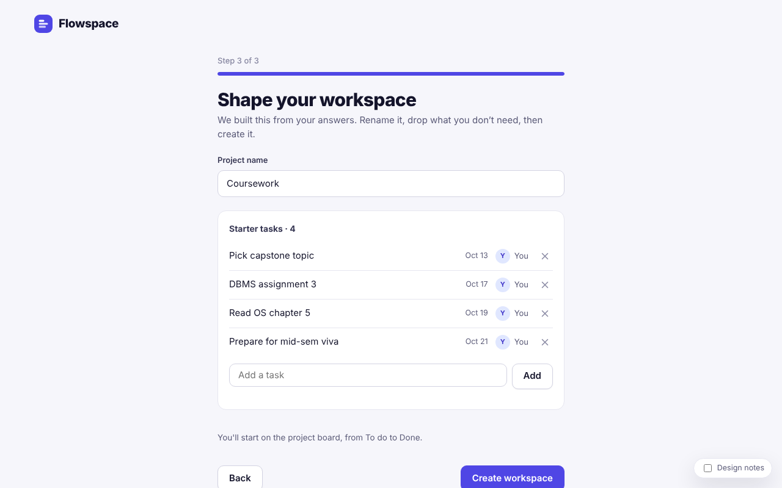
Fig. 1: Onboarding step 3. Removing a task with × cannot be undone; "workspace" vs "project" wording (H4, H14).
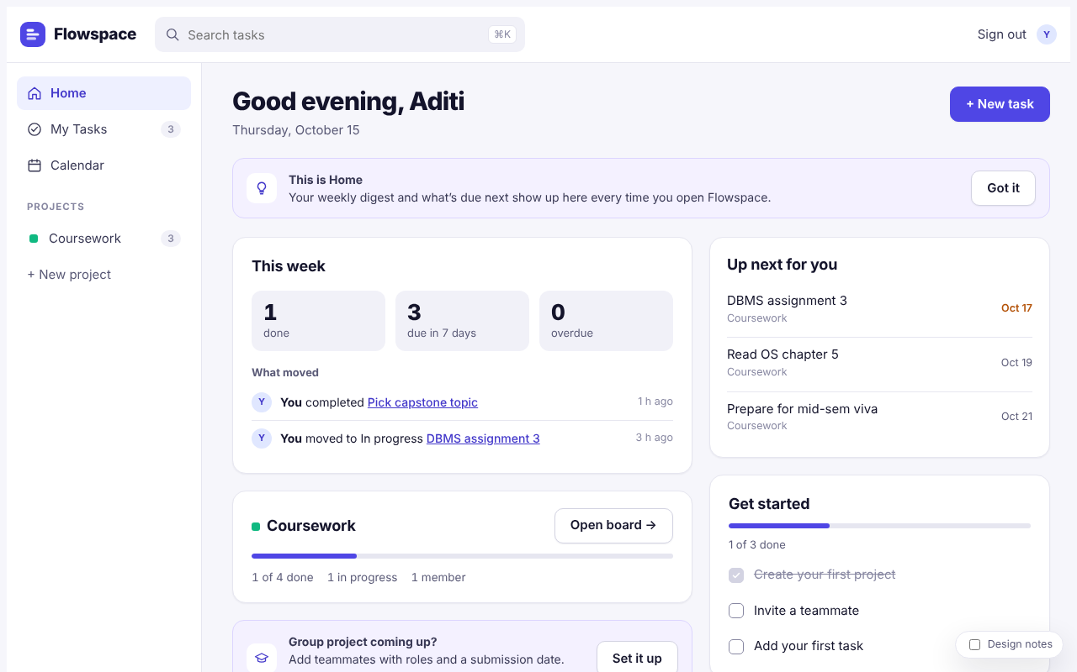
Fig. 2: Home on the first visit. Four stacked prompts; seeded "You completed…" activity; low-contrast grey text (H2, H5, H8).
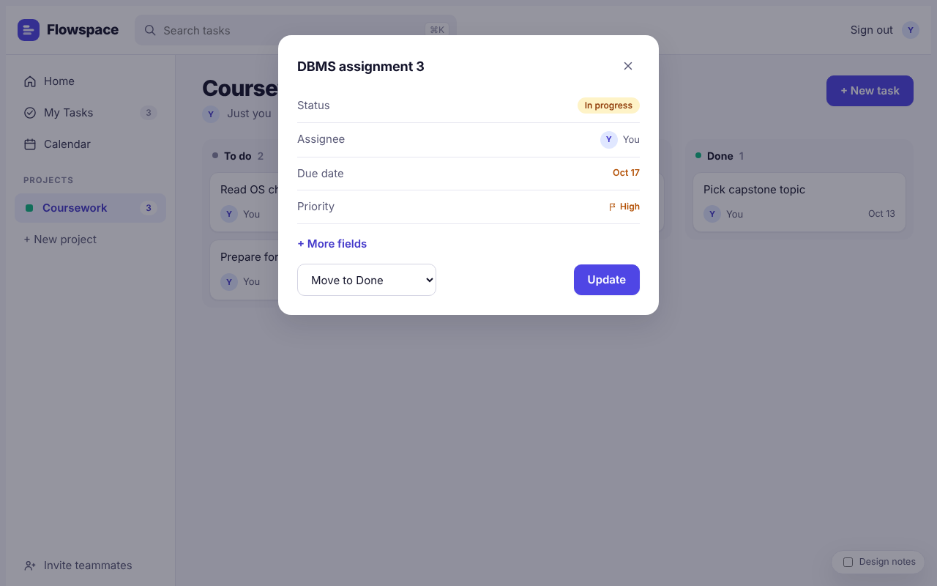
Fig. 3: Task detail. Only the status can be changed; no edit or delete (H1, H13).
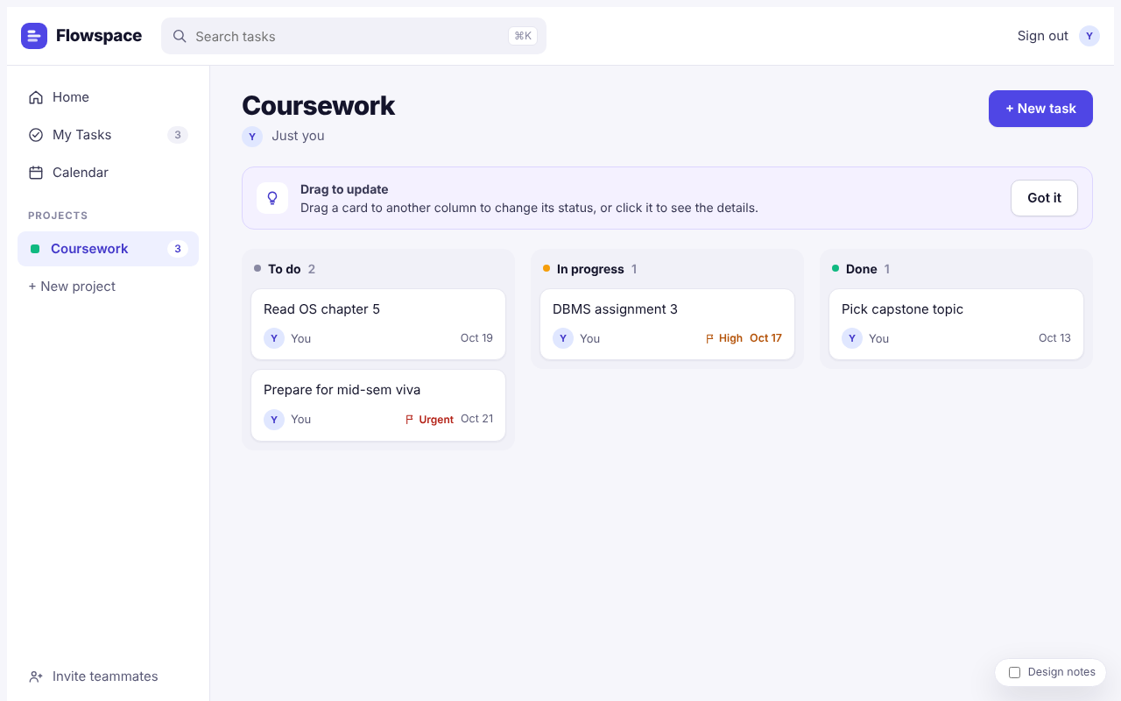
Fig. 4: Board with the first-visit tip (A6). Drag-only status change in the tip text (H12, Part II-1).
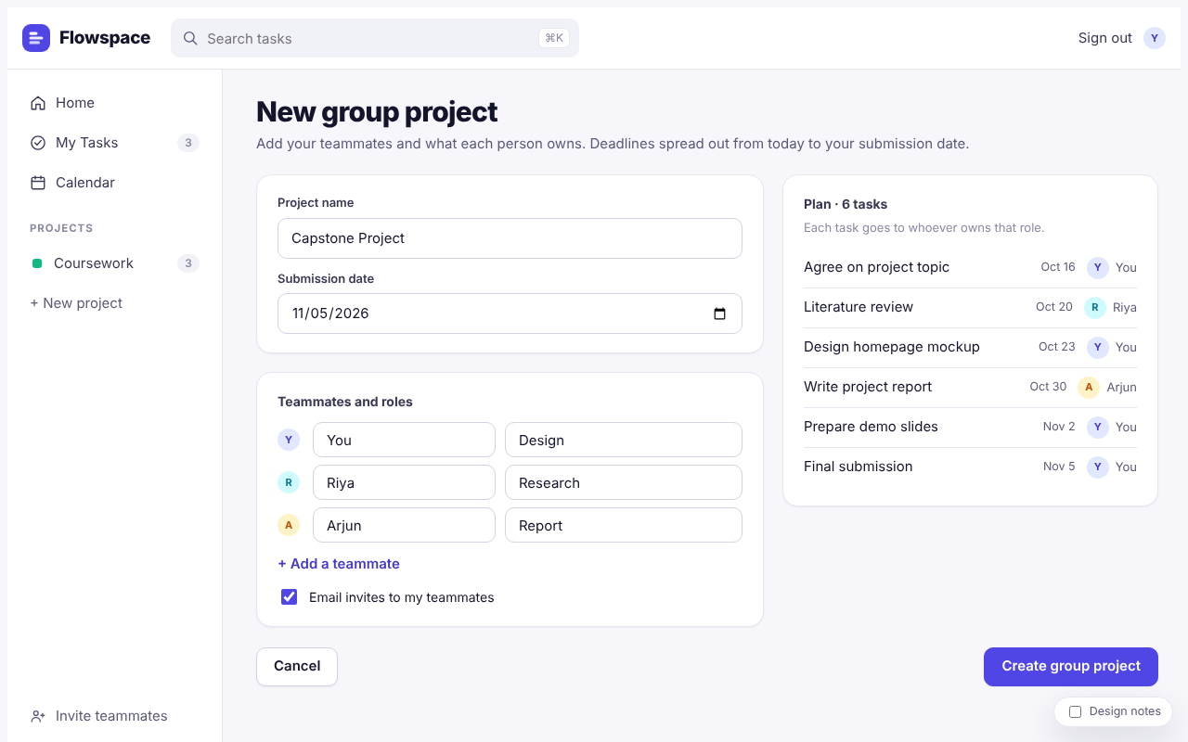
Fig. 5: New group project (A5). Roles matched by typed text; US date format (H3, H7).
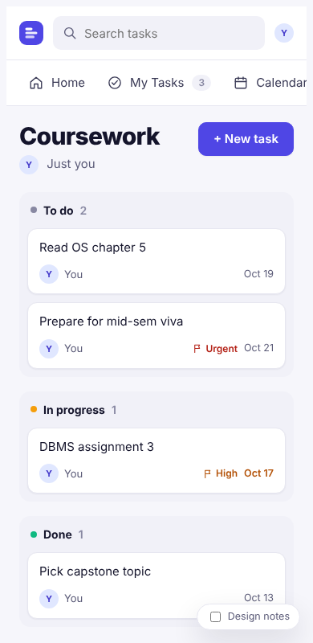
Fig. 6: Board at phone width. Nav strip cuts off "Calendar"; the notes toggle covers a date (Part II-2).

PART II : List out any other points that you may have missed out . (Other than Nielsen’s Principles)

S.NO | OBSERVATIONS | COMMENTS
1 | Accessibility: on the board, status changes rely on drag-and-drop. The keyboard alternative ("Move to…" dropdown in the task panel) exists but is not discoverable. Column status also uses small coloured dots. | Mention "or open a task to move it" in the board tip. Carry this into the Assignment 7 accessibility redesign.
2 | Mobile layout (390 px wide): the top nav becomes a horizontal strip in which "Calendar" is cut off. The project list is not reachable from the strip, and the Design notes toggle covers card dates. | Use a bottom tab bar (Home, My Tasks, Calendar, Projects) on small screens.
3 | Compared with ClickUp (Assignment 1 scored ClickUp's learnability at 7.5/10 and visual hierarchy at 7.5/10), first-run learnability is clearly better: the user starts on a filled board instead of an empty space. | Positive. Keep the template-first approach, and verify it with the Maze test (Assignment 6).
4 | Invite flow (A1): the invited teammate lands directly on "My Tasks" with a welcome banner, which is strong. However, the inviter cannot see whether an invite is pending or accepted. | Show the invite status next to each member on the project header.
5 | Data is saved only in the browser (localStorage), so signing in from another device shows an empty account. | Acceptable for a student prototype; mention it as a limitation in the report.

Students Evaluation Team : group that is evaluation ……………………………………………………………………………….. (Evaluator 1 of 1)

