# Final Evaluation Submission

Scenario: AT → CSQ → CMGF → CMGS → CMGR

Task: Run full sequence in emulator, take screenshots, and present flow.

## 1. Command Log Sheet

|  |  |  |  |  |
| --- | --- | --- | --- | --- |
| Step | Command | Expected Response | Actual Response | Notes |
| 1 | AT | OK | OK | Success |
| 2 | AT+CSQ | +CSQ: <rssi>,<ber> | +CSQ: 21,0 | Success |
| 3 | AT+CMGF=1 | OK | OK | Success |
| 4 | AT+CMGS="9847106390" > Hello World ^Z | > then +CMGS: <mr> OK | > Hello World ^Z +CMGS: 1 OK | Message Sent |
| 5 | AT+CMGR | +CMGR: ...(message stored in memory) | ERROR | Failed to retrieve message as message storage in memory is not possible in the CelerSMS Emulator |

## 2. Screenshots

* Step1_AT.png



* Step2_CSQ.png



* Step3_CMGF.png

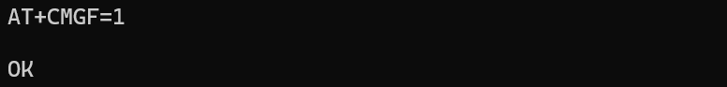

* Step4_CMGS.png

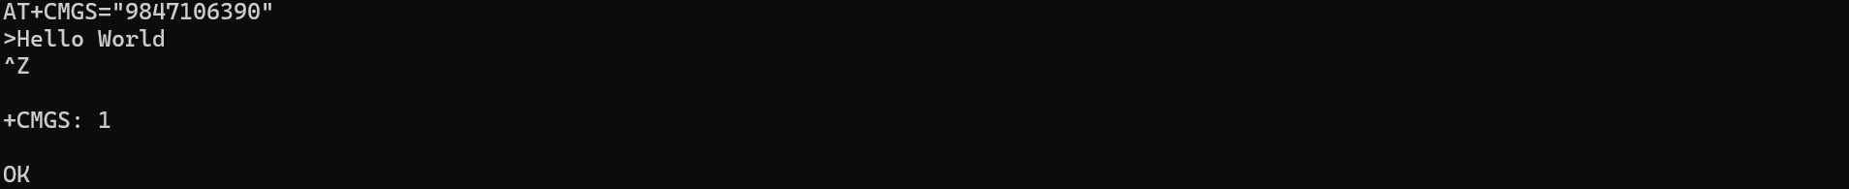

* Step5_CMGR.png



## 3. Flow Diagram

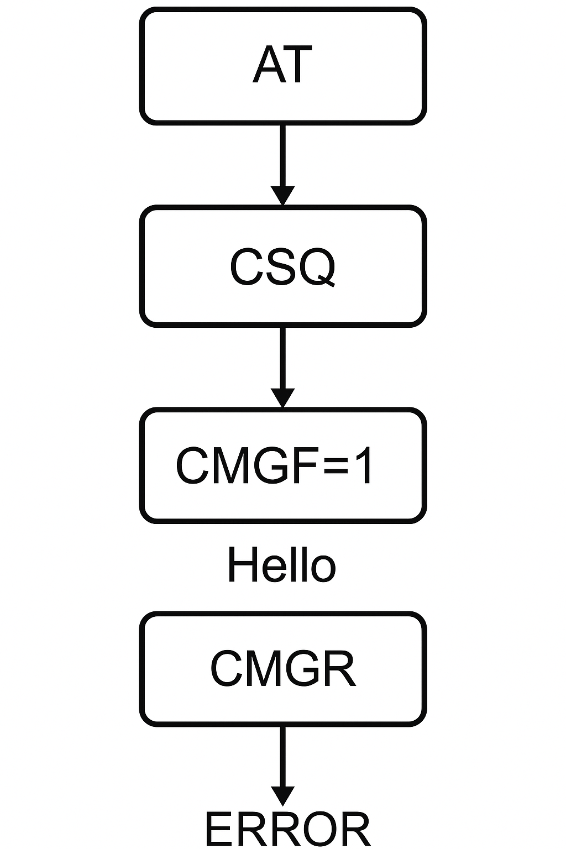

## 4. Summary

What was learned:

Gained hands-on experience using AT commands to configure the SMS format and send a message. Understood command-response flow in AT emulation.

Errors Encountered:

AT+CMGR resulted in an ERROR, suggesting the message could not be retrieved from memory.

Workarounds:

Since the AT+CMGR command fails with an ERROR, indicating that the message cannot be read back from memory, a practical workaround is to maintain a log of sent messages within our emulator interface so they can be referenced externally instead of relying on retrieval through AT commands.