COVID-19 SOLUTION CHALLENGE FOR myGov.in

Solution For COVID-19 Awareness And Safety For Containing The Spread Of The Virus In The Community

Aryyaraj Barua

Student B.tech 4th year

Department Of ECE

DSCSDEC

Kolkata, India

Abstract:

The rapid growth and effects of Covid-19 on the world of work are proving to be worse than any of the financial crisis happened before. What I have researched, there is a sharp spike of cases on 3rd and 4th week in other developed countries. India is the second largest populated country after China. If proper safety measures are not taken it might spread as rapidly that one can even think. According to WHO social distance and cleanliness is only the key to fight against this deadly virus. So therefore, our respected PM NaMo and govt officials followed it with an early lockdown so that the chain breaks as soon as possible. Due to lack of awareness among the people, it is still increasing in a certain rate.

Analysis:

Why the infected cases are increasing even after early lockdown in India? The reason is - India is a country of vast population with literacy rate of about 71.20% according to worldpopulationreview.com. Hence, the awareness is less. They do not have sufficient knowledge or information about what could actually happen if it effect 30-40% of the Indian population. Therefore, I decided various ways how to control and work on certain areas where people face difficulties. **All the solutions are for India.**

The three areas are:

1. **Less freedom.**
2. **Scarcity of food** (for non veg people) (Due to this people go the market and make gatherings)
3. **Lack of money** (for people who does daily income for daily food (have/do not have a bank account but no savings)).

Solution and Features of the Mobile Application:

* User will be able to order (veg/non-veg), medicines at the doorstep.
* Warning alert if anyone with the disease nearby (using GPS).
* **Special Awareness program** to make people more educated for e.g**.** what could happen if the virus does not contain. How it can effect humanity. What is the future? How it can impact growth of our country. How it will effect our economy. etc.
* Everyone can become a volunteer within the app and can register for food and own vehicle for delivery.
* Delivery will be done for a radius of 1.5-2km (max 25-30 volunteers allowed for different operations in this radius).
* User can also send homemade food for underprivileged peoples by registering as volunteers.
* **Different types of volunteers include** – volunteers for delivery of medicines and necessary items, volunteers for delivery of food, middle person volunteer for effortless picking up orders, screening and investigation team for proper transaction and delivery.
* In shortage of cash user have to verify with the local institution (prototype fund provider) available within the Mobile Application (only for underprivileged people and needy).
* Transaction will be made using either Cash on Delivery or through the in App Wallet (for a smooth transaction).
* People can add money into wallet using their bank account.
* The fund that is requested by the needy people can send a request to the location institution and after that, local institution will verify it using their agents and volunteers. After verification, a message will be sent to the needy people about the amount and processed money, which will be delivered within 3-4 day hours.
* The amount will be provided to the local volunteer from the local institution and he/she have to send that amount using Wi-Fi wallet transaction keeping a distance of 6-8ft.
* People who don’t want to use cash, for them transaction will be made through the Wallet keeping a 6-8ft distance using in App Wi-Fi connectivity for security and transparency purpose .

**This will make the gatherings much less. All the things is on the tip of the user finger**. The User Interface should be top notch for better understanding.

Below is a rough Use case diagram to depict the steps above (not up to mark though)

Use case diagram:

USER 2

DONATE MONEY

FOOD STOCK

VOL **

MIDMAN

REGISTRATION FOOD

NORMAL USER

VOL**

VEHICLE REGISTRATION

PM FUND

VERIFIED AMOUNT SMS

LOGIN

GPS/LANGUAGE VERIFICATION

DASHBOARD FOR VOLUNTEERS & NGO

LOCAL FUND INSTITUTION

DASHBOARD

FOR NORMAL USER

USER 1

LOGIN NGO NGOGO

THROUGH WALLET

SCREENING AND INVESTIGATION FUND TEAM

VOL** = VOLUNTEER

VOL** MIDMAN = MIDDLEMAN TEAM FOR MAKING THE PROCESS EFFORTLESS

WALLET = TO MAKE EVERY TRANSANCTION THROUGH IN APP WALLET

Rough App interface for simplicity to Understand:

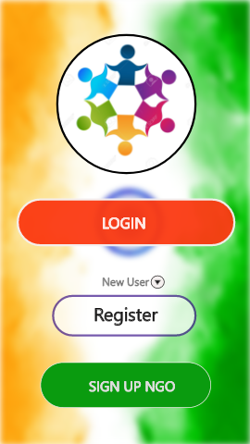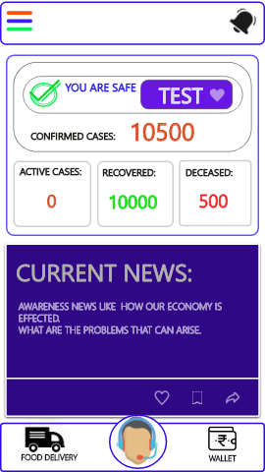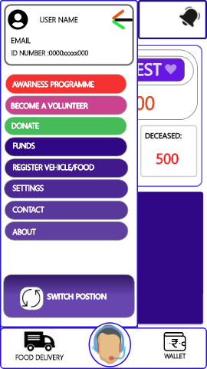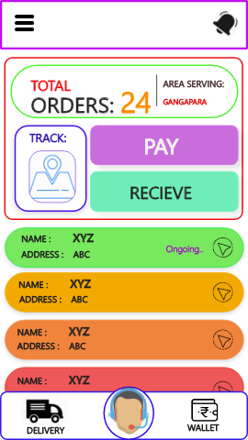

Conclusion:

The above steps are taken by watching and analyzing my neighbor’s and my area problem so therefore I made some possibilities that can work indirectly to control the rapid spread of virus. These are totally my thoughts and done by me. I claim all the rights for this particular project. I came to know about this and immediately started working on it from 13April 2020, so therefore time was less. To add more features, analyzing the problem was required and for that, time plays a major role. However, the steps can be refined in various ways. **Even these features can be added to newly implemented Arogya Setu app.**

**It can be used in any future pandemics that can happen.**

I am still a learner. Recently I started learning UI/UX. So, as a part of my project I made the prototype interfaces.

Thankyou.

My LinkedIn link - <https://www.linkedin.com/in/aryaraj-b-78897b152/>

©AryarajBarua2020