Practical-3

**Setup of Hadoop single node cluster**

**By Arya vishal(22BCE501)**

hadoop-env.cmd



core-site.xml

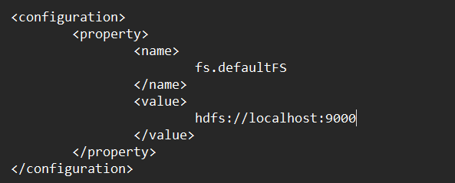

Create folders

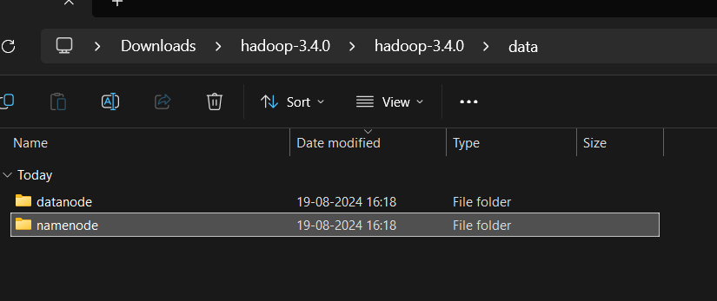

Hdfs-site.xml

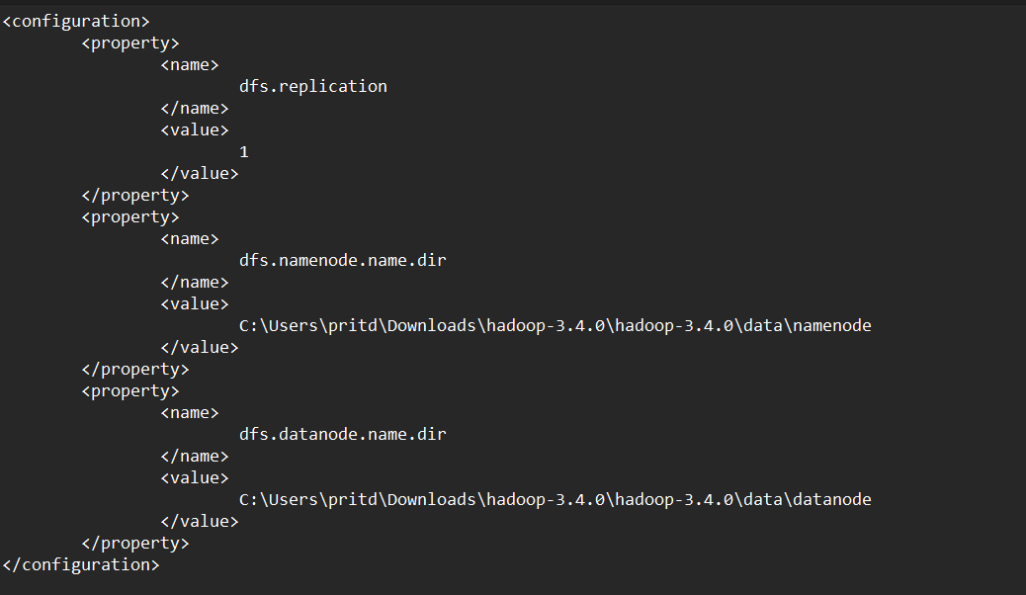

mapred-site.xml

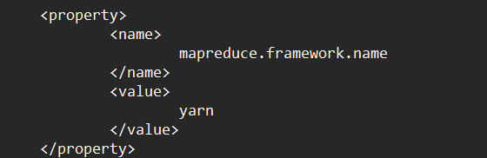

Yarn-site.xml

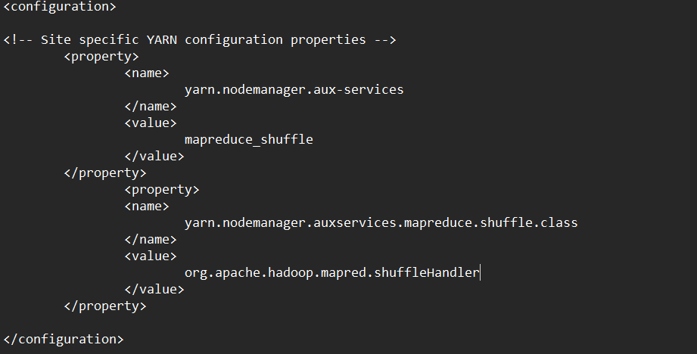

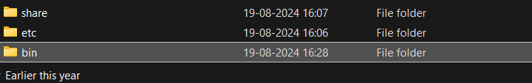Download bin folder from given link from video and replace in hadoop folder

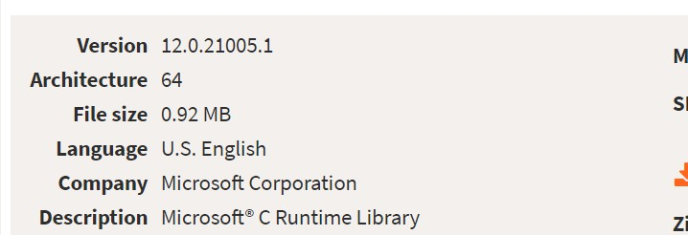Download require MSVCR120.DLL (if it’s require)

Set environment variable( copy path from hadoop/bin folder)

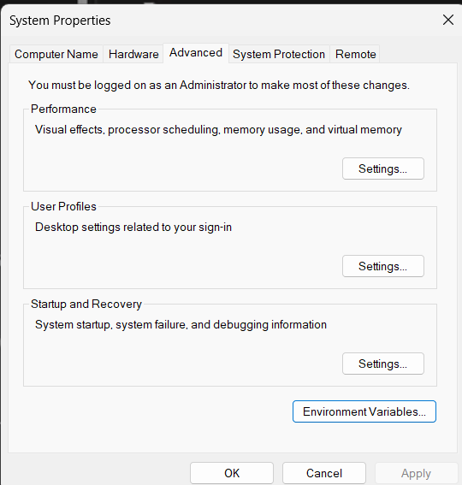

Check for all folders

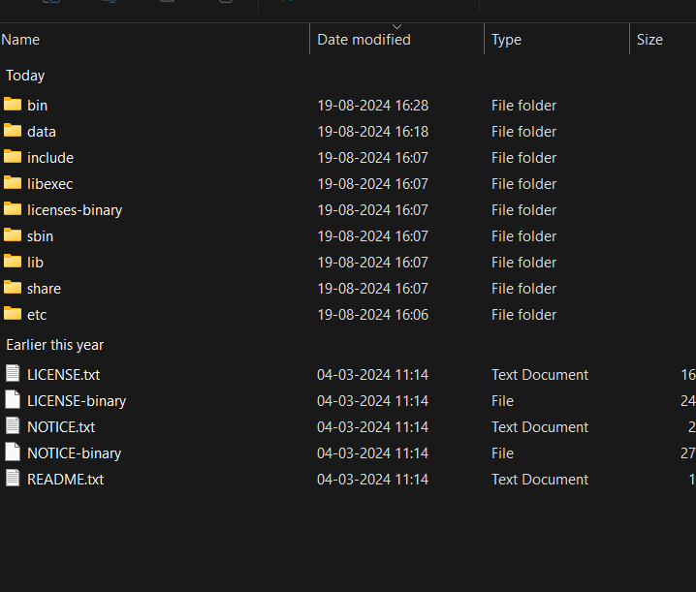Check for installation

