**Name**: Arya Vishal Y.

**Roll No**: 22BCE501

**Course**: 2CSDE93 - Blockchain Technology

# Practical No: 9

**Aim**: To write a Solidity contract that implements a distributed ticket sales system. Anybody can create an event (specifying the initial price and number of tickets). Anybody can then purchase one

of the initial tickets or sell those tickets peer-to-peer. At the event, gate agents will check that each attendee is listed in the final attendees list on the blockchain. (Ethereum programming)

# Code:

// SPDX-License-Identifier: MIT

/* To write a Solidity contract that implements a distributed ticket sales system. Anybody can create an event (specifying the initial price and number of tickets). Anybody can then purchase one

of the initial tickets or sell those tickets peer-to-peer. At the event, gate

agents will check that each attendee is listed in the final attendees list on the blockchain. (Ethereum programming)

**\*/**

pragma solidity ^0.8.18;

contract TicketSalesContract { struct Event {

address owner; uint256 eventId; uint256 ticketPrice; uint256 totalTickets;

uint256 availableTickets;

**}**

Event[] public events;

struct Ticket { address holder; uint256 ticketId; uint256 eventId;

bool used; bool forSale;

**}**

Ticket[] public tickets;

mapping(address => bool) public attendees;

event EventCreated( uint256 eventId, uint256 ticketPrice, uint256 totalTickets

**);**

event TicketPurchased(address buyer, uint256 ticketId);

event TicketSold(address seller, address buyer, uint256 ticketId);

function createEvent(uint256 _ticketPrice, uint256 _totalTickets) public {

uint256 eventId = events.length; events.push(

Event(

msg.sender, eventId,

_ticketPrice,

_totalTickets,

_totalTickets

**)**

**);**

**}**

function purchaseTicket( uint256 _eventId, uint256 _noOfTickets

) public payable {

Event storage eventInstance = events[_eventId]; require(events[_eventId].eventId > 0, "No event found!");

if (eventInstance.availableTickets < _noOfTickets) {

// run a for loop and find out how many other tickets are marked for the sale.

// if the tickets are available than buy them and transfer money to owner account.

// else abort the function.

uint256 isAllAvailable = _noOfTickets;

for (uint256 j = 0; j < tickets.length; j++) { Ticket storage ticket = tickets[j];

if (

isAllAvailable > 0 && ticket.eventId == _eventId &&

!ticket.used &&

!ticket.forSale

**) {**

isAllAvailable--;

**}**

**}**

if (isAllAvailable == 0) { require(

msg.value > (eventInstance.ticketPrice *

_noOfTickets),

"Invalid payment amount"

**);**

for (uint256 j = 0; j < tickets.length; j++) { Ticket storage ticket = tickets[j];

if (

isAllAvailable > 0 && ticket.eventId == _eventId &&

!ticket.used &&

!ticket.forSale

**) {**

ticket.holder = msg.sender; ticket.forSale = false;

payable(eventInstance.owner).transfer(eventInstance.ticketPrice);

**}**

**}**

} else {

revert("Tickets not available");

**}**

} else {

require(

msg.value > (eventInstance.ticketPrice * _noOfTickets), "Invalid payment amount"

**);**

Event storage e = events[_eventId]; e.availableTickets -= _noOfTickets;

for (uint256 i = 1; i <= _noOfTickets; i++) { uint256 ticketId = tickets.length; tickets.push(

Ticket(msg.sender, ticketId, _eventId, false, false)

**);**

**}**

payable(eventInstance.owner).transfer(eventInstance.ticketPrice *

_noOfTickets);

**}**

**}**

function markTicketForSale(uint256 _ticketId) public view { require(tickets[_ticketId].ticketId > 0, "No ticket found!"); require(

tickets[_ticketId].holder != msg.sender, "The ticket does not belong to you"

**);**

Ticket memory t = tickets[_ticketId]; t.forSale = true;

**}**

**}**

**Output:**

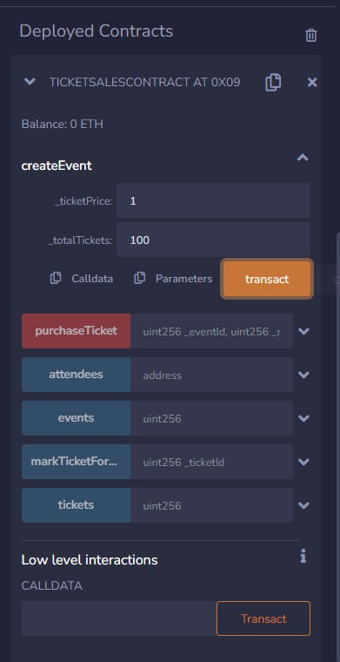

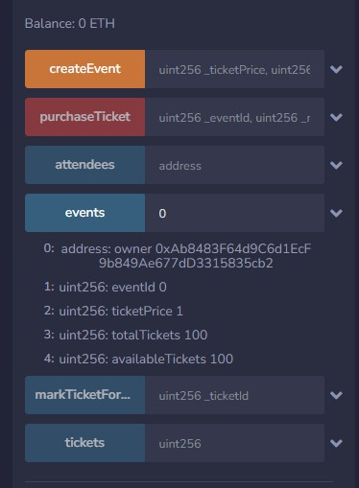

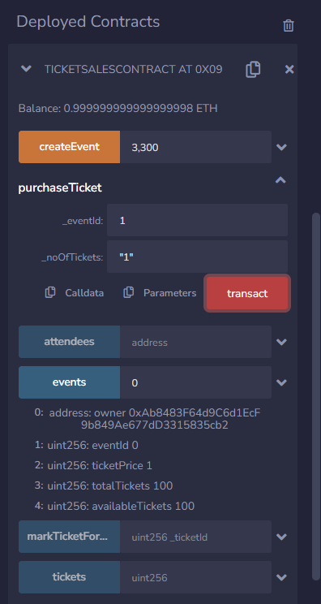

1□- x4B-2-'...c-a-2.- db,9l -8- 9- 9-,9-9-,9- 9-,9-

.-..

-_.~.,..1.

,;'

0x583...eddC4 (99.999999999998874576 ether)

0xAb8...35cb2 (96.999999999997126961 ether) 59

0x482...C02db (98.999999999999659012 ether)

0x787...cabaB (100 ether) 0x617...5E7f2 (100 ether)

0x17F...8c372 (100 ether)

0x5c6...21678 (100 ether)

0x03C...D1Ff7 (100 ether) 0x1aE...E454C (100 ether) 0x0A0...C70DC (100 ether)

0xCA3...a733c (100 ether) 0x147...C160C {100 ether)

0x4B0...4D2dB (100 ether) 0x583...40225 (100 ether)

0xdDB...92148 (100 ether)

At Address