**Name: Arya Kashikar**

**PRN: 22070521036**

**Lab 1- Certified System Administrator**

**Lab 1.1.1**

* **Download Class Resources**

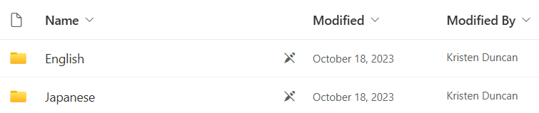

* **Unzip the files and save in folder**

