**Name: Arya Kashikar**

**PRN: 22070521036**

**Course- Certified System Administrator**

**Lab 1.2.1**

**Section 1: Add new users**

* **All > system security > user and groups**

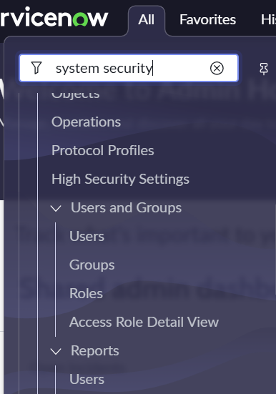

* **Mark users , roles and groups as favourite and pin the favourites**

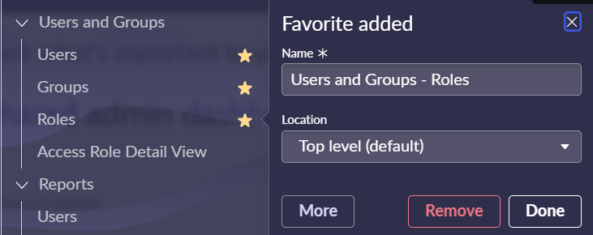

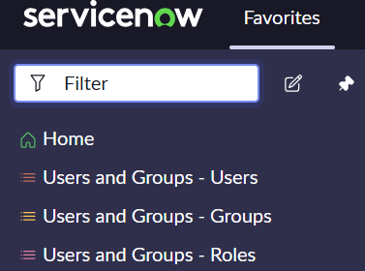

* **Go to Users and Groups > Users > Click New**
* **Enter the details as follows**

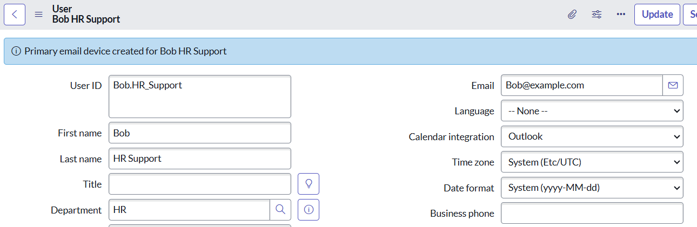

* **Right Click on header and save**
* **Create and enter details for one more**

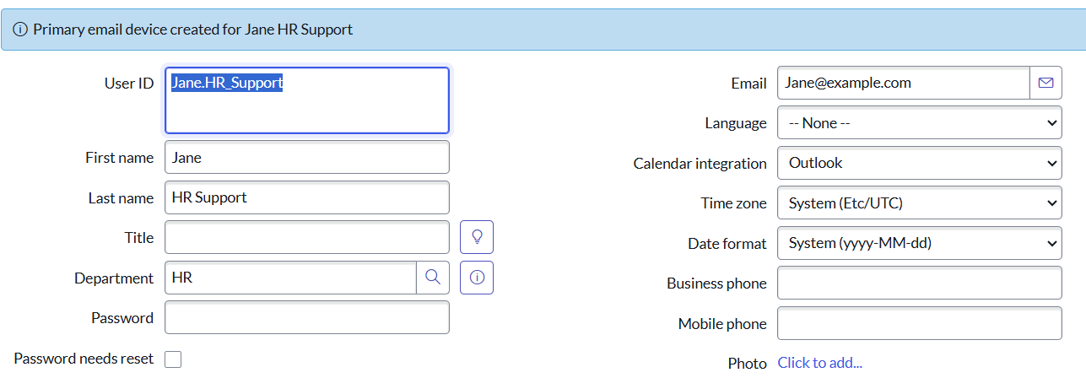

* **Right click on header and select insert and stay**

**Section 2: Identify HR groups and make it favourite**

* **Navigate to favourite > User and groups > groups**
* **On header click hide filter and add condition “Name contains HR” , “Name contains Human Resources”**

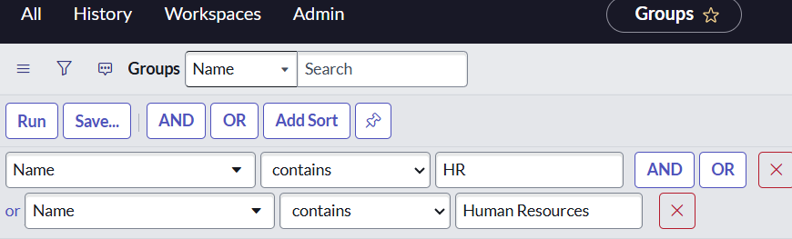

* **Run**
* **Right click on header > create favourites > edit fav name to HR groups**

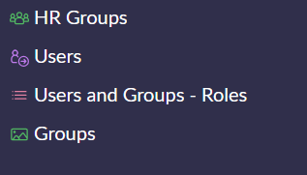

**Section 3: Real World assignment Groups**

* **Go to Groups > HR System**

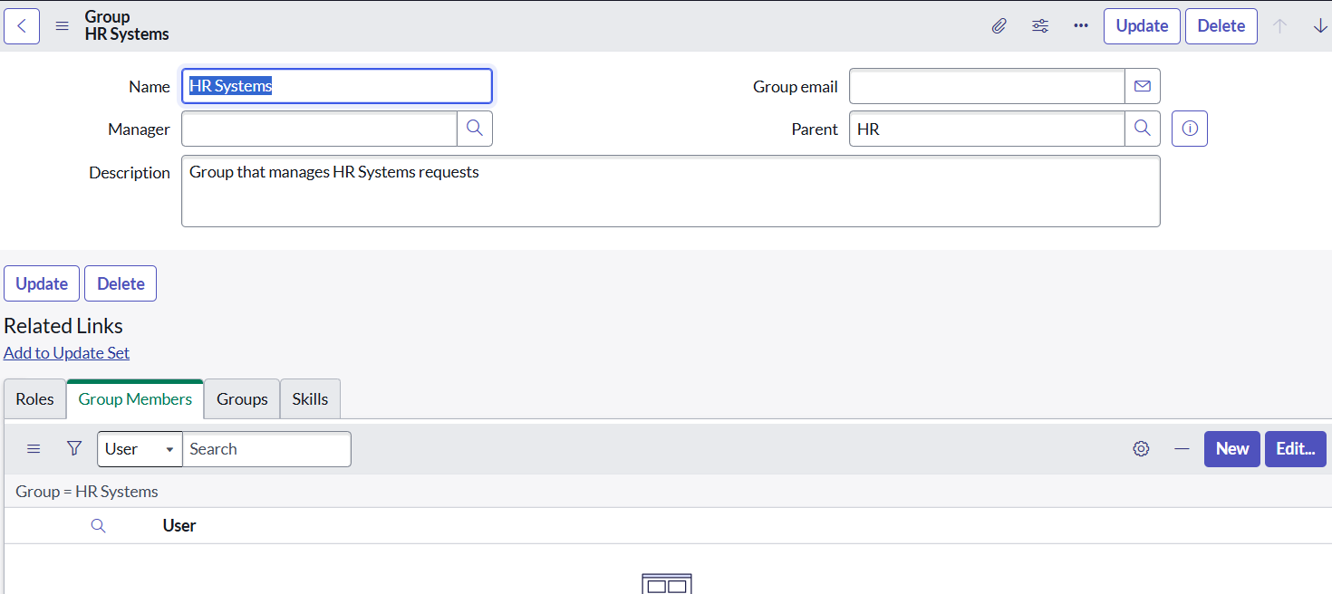

* **Select group members > edit > select Bob, Jane HR Support > add to members list > Save**

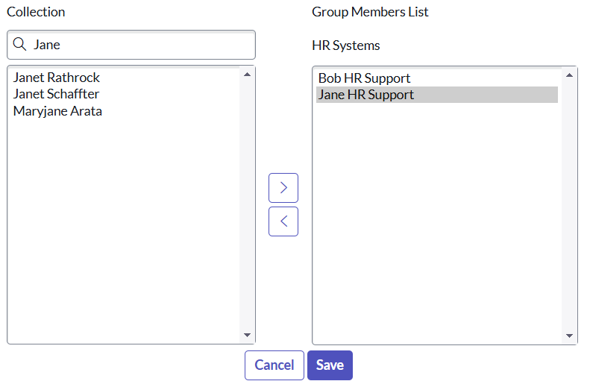

**Section 4: Impersonate HR Case Agents**

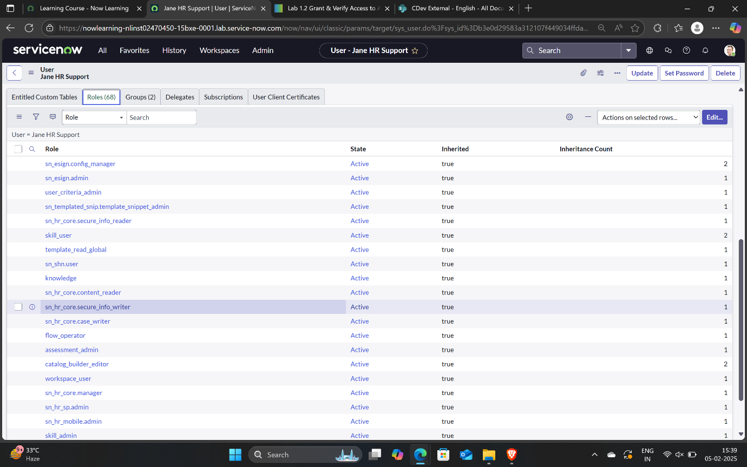

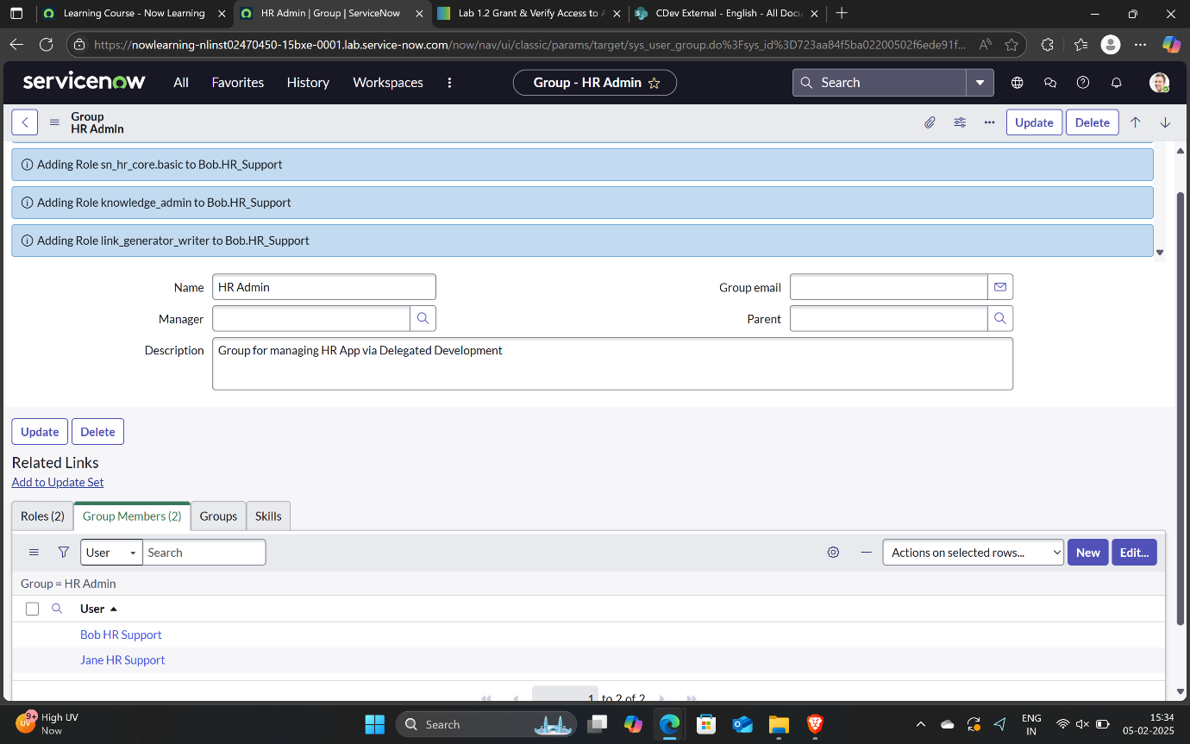

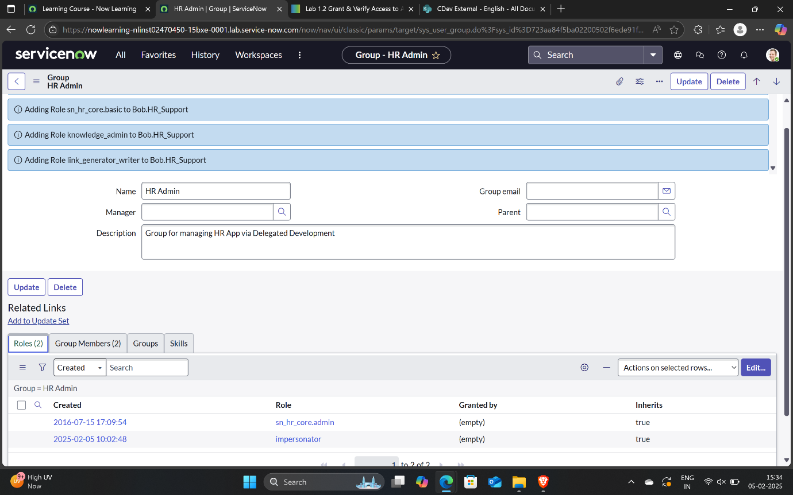

**Section 5: Verify HR Admin Can Impersonate**

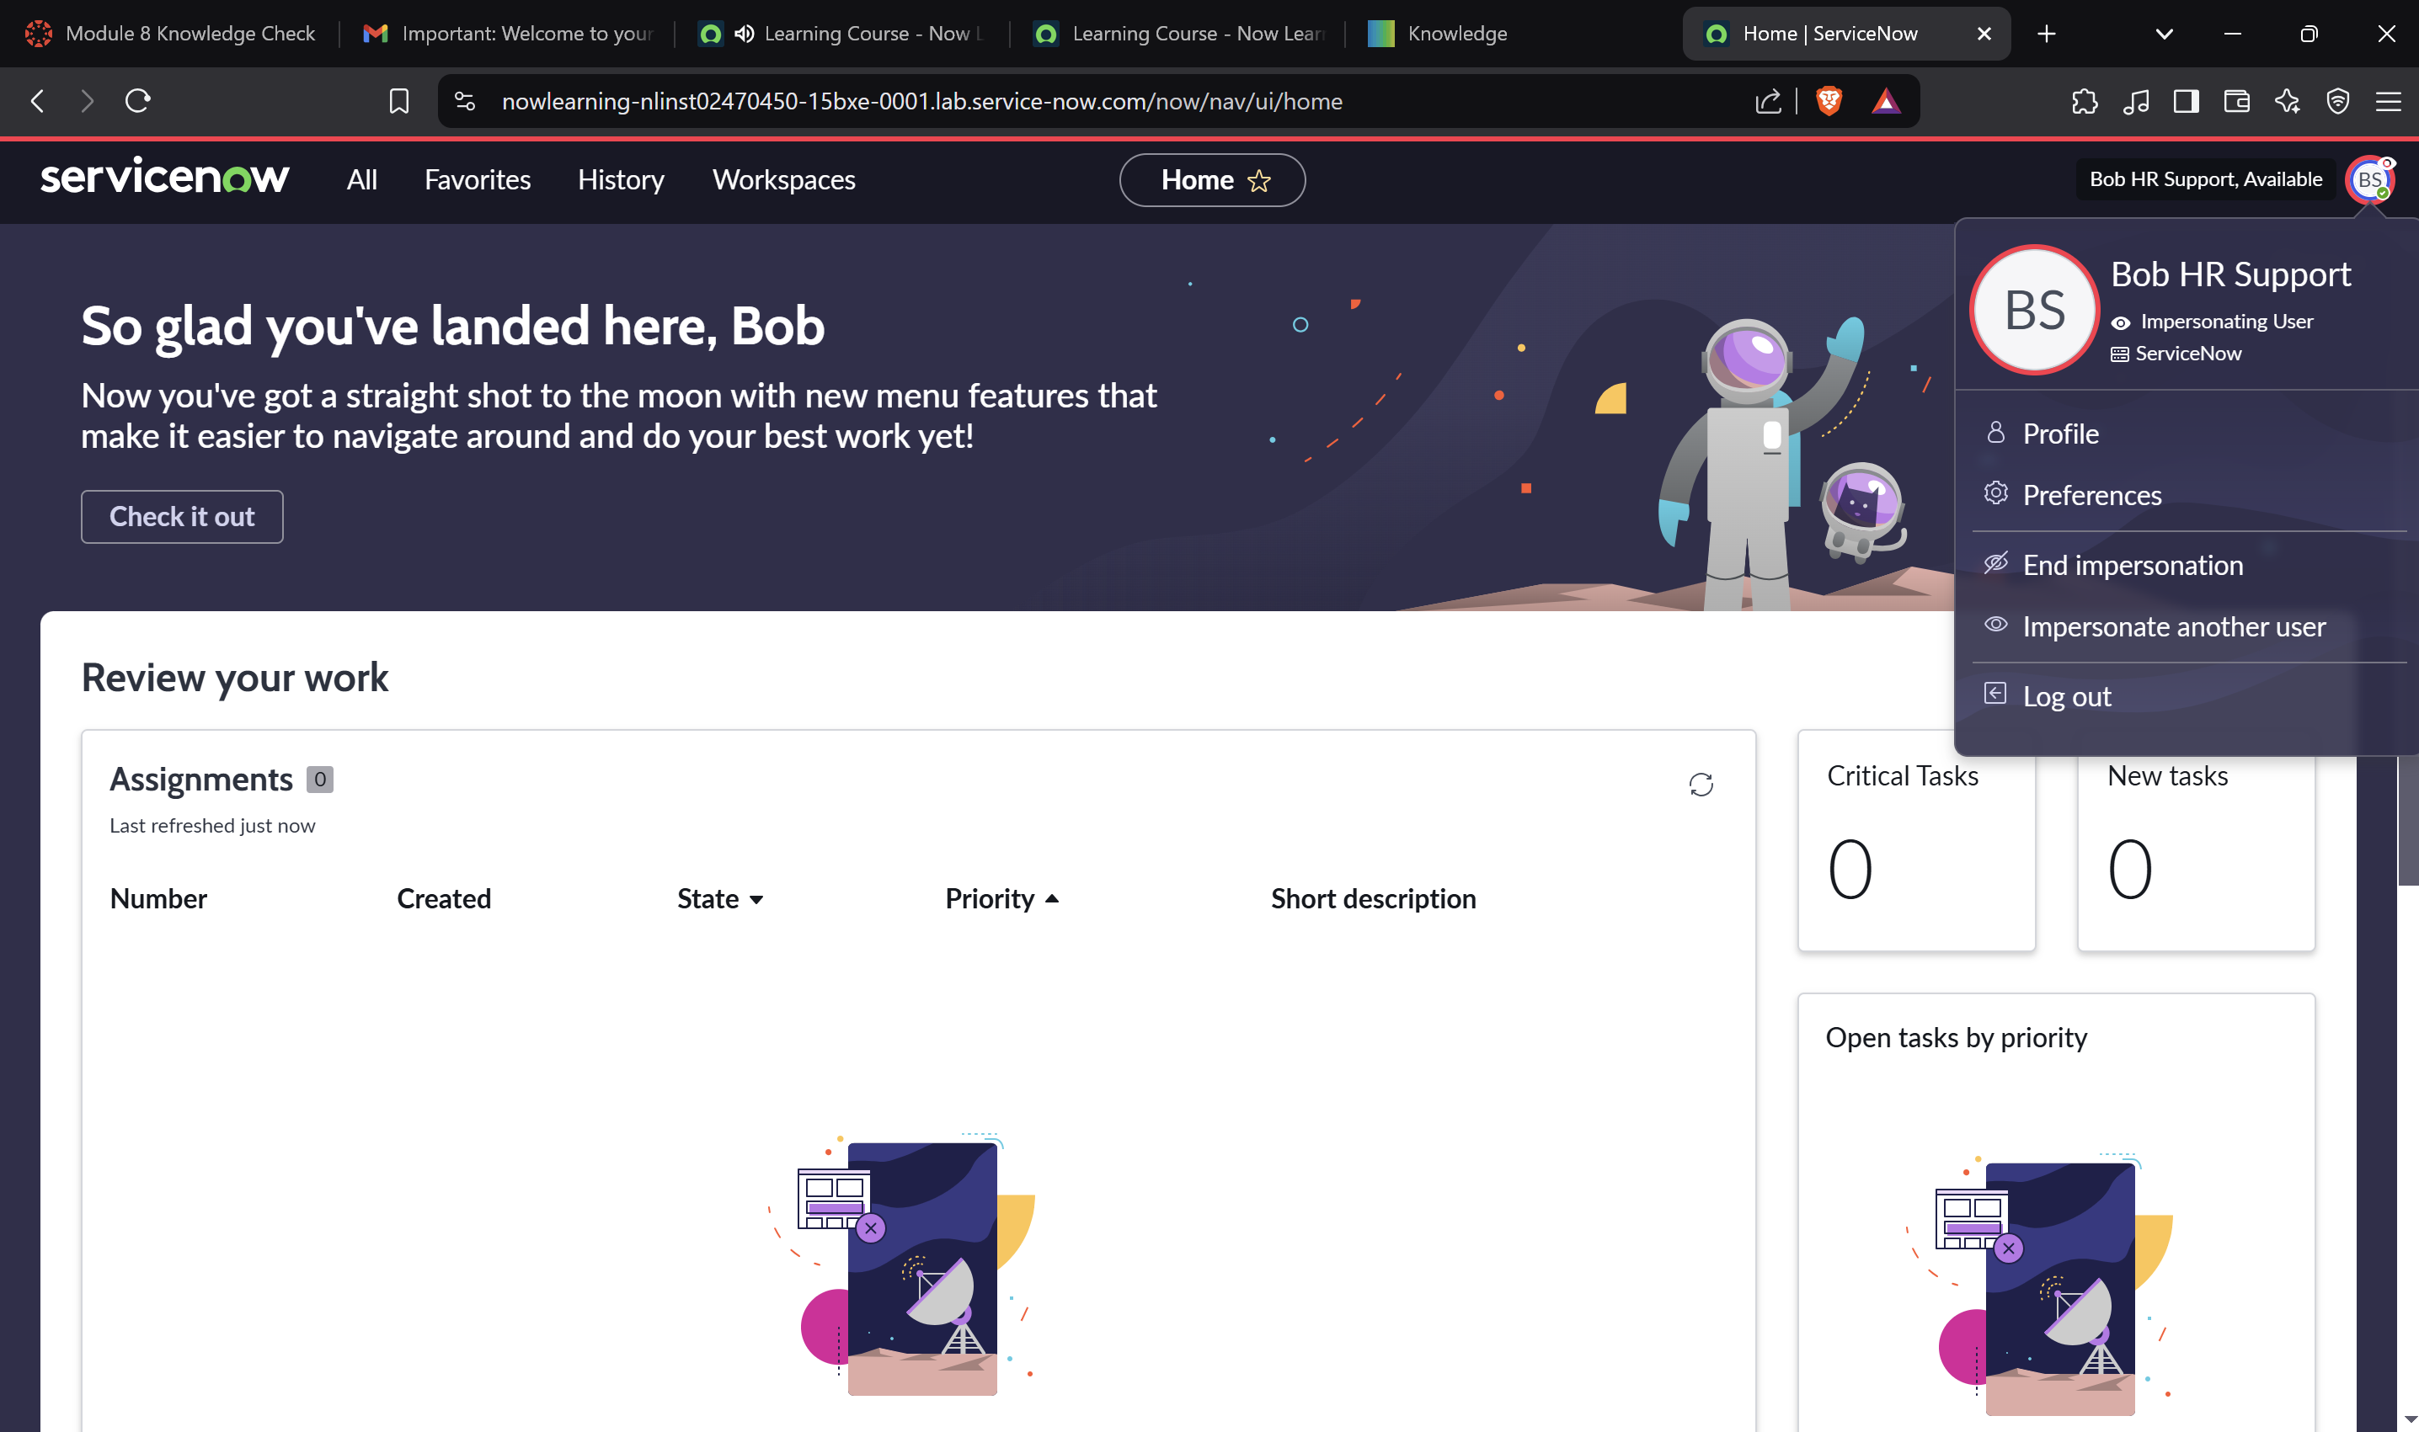

**Section 6: Verify HR Admin Can Create an HR Case**

